FitBite Colour Scheme
Brand palette and UI colour guidance for development
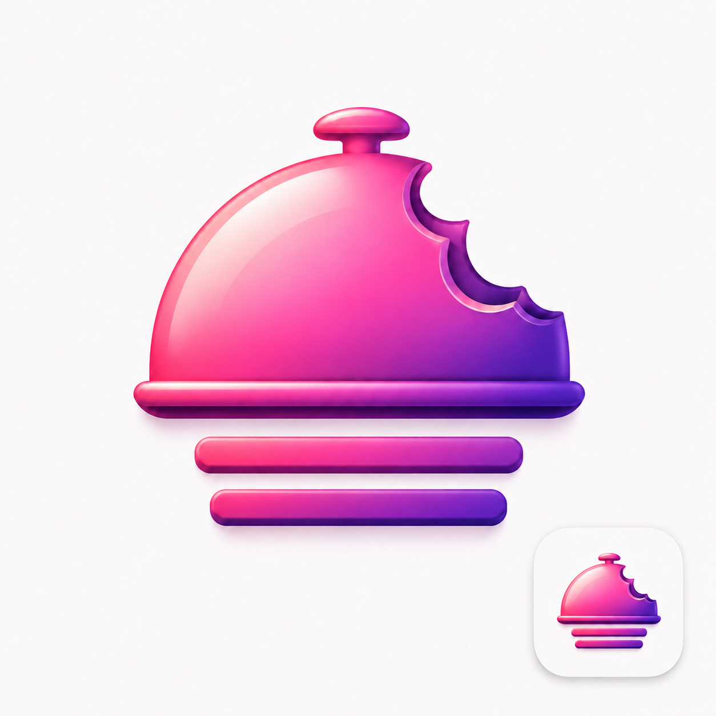

1. FitBite Colour Palette
Use | Colour Name | Hex Code | Preview
Primary brand pink | Bite Pink | #F13A94
Secondary pink | Candy Pink | #FA62AB
Soft highlight pink | Blush Pink | #F99BBE
Primary purple | Bite Purple | #6D21B2
Deep purple | Plum Shadow | #450B68
Magenta-purple accent | Berry Purple | #BA30B1
Soft background | Blush Mist | #EFDAE3
White background | App White | #FFFFFF

2. Recommended UI Usage
Main buttons: Use Bite Pink (#F13A94) for primary actions such as Scan Menu, Add Food, Save Meal and Get Recommendation. Button text should be App White (#FFFFFF).
Secondary buttons: Use Blush Pink (#F99BBE) as the button background with Plum Shadow (#450B68) as the text colour.
Main app background: Use App White (#FFFFFF) for a very clean modern look, or #FFF7FB for a softer pink-tinted background. Recommended background: #FFF7FB.
Cards: Use App White (#FFFFFF) for cards with a soft border colour of #F3D8E6.
Text: Use a deep purple instead of pure black so the app feels more branded. Primary text: #23112F. Secondary text: #6F5B7C.

3. Gradients
Main brand gradient: linear-gradient(135deg, #F13A94 0%, #FA62AB 45%, #6D21B2 100%)
Soft UI gradient: linear-gradient(135deg, #F99BBE 0%, #EFDAE3 50%, #D9C2FF 100%)

4. CSS Variables
:root {
--fitbite-pink: #F13A94;
--fitbite-candy-pink: #FA62AB;
--fitbite-blush-pink: #F99BBE;
--fitbite-purple: #6D21B2;
--fitbite-deep-purple: #450B68;
--fitbite-berry-purple: #BA30B1;
--fitbite-background: #FFF7FB;
--fitbite-card: #FFFFFF;
--fitbite-border: #F3D8E6;
--fitbite-text-primary: #23112F;
--fitbite-text-secondary: #6F5B7C;
--fitbite-gradient-main: linear-gradient(135deg, #F13A94 0%, #FA62AB 45%, #6D21B2 100%);
--fitbite-gradient-soft: linear-gradient(135deg, #F99BBE 0%, #EFDAE3 50%, #D9C2FF 100%);
}

5. Brand Direction
Recommendation: Use pink as the main brand colour and purple as the depth/shadow colour.
- Pink = friendly, fun, food, approachable.
- Purple = premium, modern, slightly techy.
- White/soft blush = clean, simple, health-focused.
Overall feel: FitBite should feel playful without looking childish, and clean enough to work as a health and food tracking app.

