Análisis de datos Ómicos - PAC 2

Maria Lucas

2023-05-14

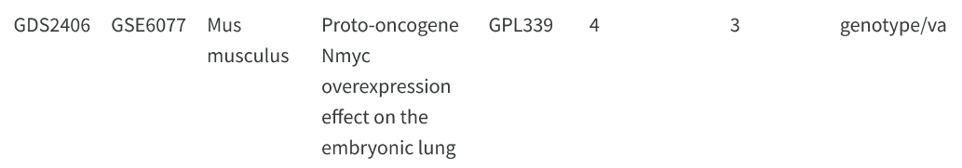

# Install and load GEOquery package  
if (!requireNamespace("BiocManager", quietly = TRUE))  
 install.packages("BiocManager")  
BiocManager::install("GEOquery")

## Bioconductor version 3.17 (BiocManager 1.30.20), R 4.3.0 (2023-04-21 ucrt)

## Warning: package(s) not installed when version(s) same as or greater than current; use  
## `force = TRUE` to re-install: 'GEOquery'

## Installation paths not writeable, unable to update packages  
## path: C:/Program Files/R/R-4.3.0/library  
## packages:  
## class, KernSmooth, MASS, nnet

## Old packages: 'tzdb'

library(GEOquery)

## Loading required package: Biobase

## Loading required package: BiocGenerics

##   
## Attaching package: 'BiocGenerics'

## The following objects are masked from 'package:stats':  
##   
## IQR, mad, sd, var, xtabs

## The following objects are masked from 'package:base':  
##   
## anyDuplicated, aperm, append, as.data.frame, basename, cbind,  
## colnames, dirname, do.call, duplicated, eval, evalq, Filter, Find,  
## get, grep, grepl, intersect, is.unsorted, lapply, Map, mapply,  
## match, mget, order, paste, pmax, pmax.int, pmin, pmin.int,  
## Position, rank, rbind, Reduce, rownames, sapply, setdiff, sort,  
## table, tapply, union, unique, unsplit, which.max, which.min

## Welcome to Bioconductor  
##   
## Vignettes contain introductory material; view with  
## 'browseVignettes()'. To cite Bioconductor, see  
## 'citation("Biobase")', and for packages 'citation("pkgname")'.

## Setting options('download.file.method.GEOquery'='auto')

## Setting options('GEOquery.inmemory.gpl'=FALSE)

# Set GEO accession number  
gse <- "GSE6077"  
  
# Download and load series matrix file  
gse_data <- getGEO(gse, GSEMatrix = TRUE)

## Found 1 file(s)

## GSE6077_series_matrix.txt.gz

gse_data <- gse_data[[1]]  
  
# Extract gene expression data  
exprs_data <- exprs(gse_data)  
  
# Extract sample annotation data  
sample_data <- pData(gse_data)