HUNARMAND PUNJAB PROGRAM
Batch 3
FINAL PROJECT
Artificial Intelligence

Student Name | Humna Maqbool

Project Description
Predict whether a customer will churn (leave a service) based on historical customer data.

Tasks Completed
- Loaded a real-world dataset (e.g., telecom churn CSV)
- Performed EDA using Pandas + Matplotlib
- Handled missing values (mean/median/drop)
- Encoded categorical variables (Label / One-hot)
- Scaled numerical features
- Trained Logistic Regression and KNN
- Compared models using accuracy, precision, recall, F1-score, and confusion matrix
- Explained overfitting vs underfitting
- Clean project report + notebook

1. Dataset Information
Dataset Detail | Your Actual Value
Dataset name | IBM Telco Customer Churn dataset
Dataset source / URL | Kaggle.com
Number of rows | 7043
Number of columns/features | 21
Target variable | Churn
Missing values found | 0

2. Exploratory Data Analysis (EDA)
Insert your actual EDA visualizations and briefly describe what each shows.

Churn distribution
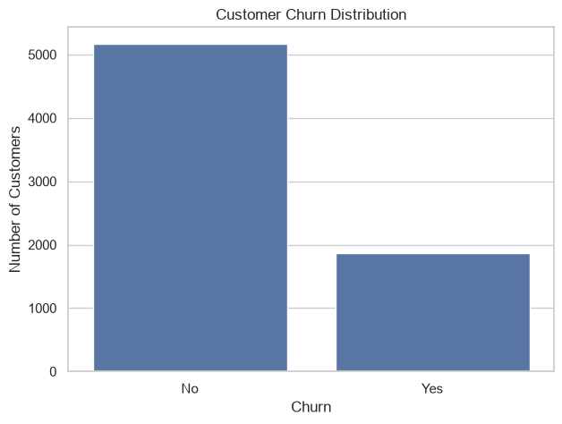

Important feature distributions
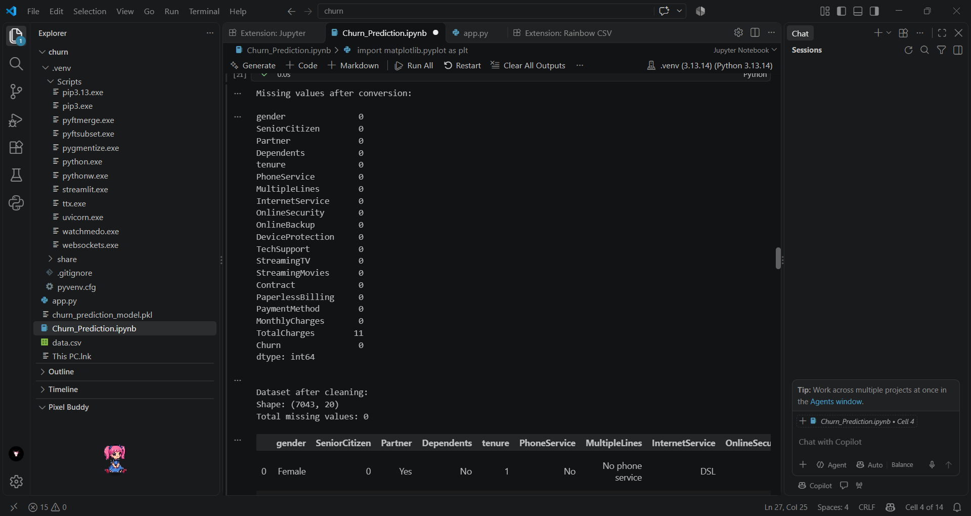

Other EDA visualization
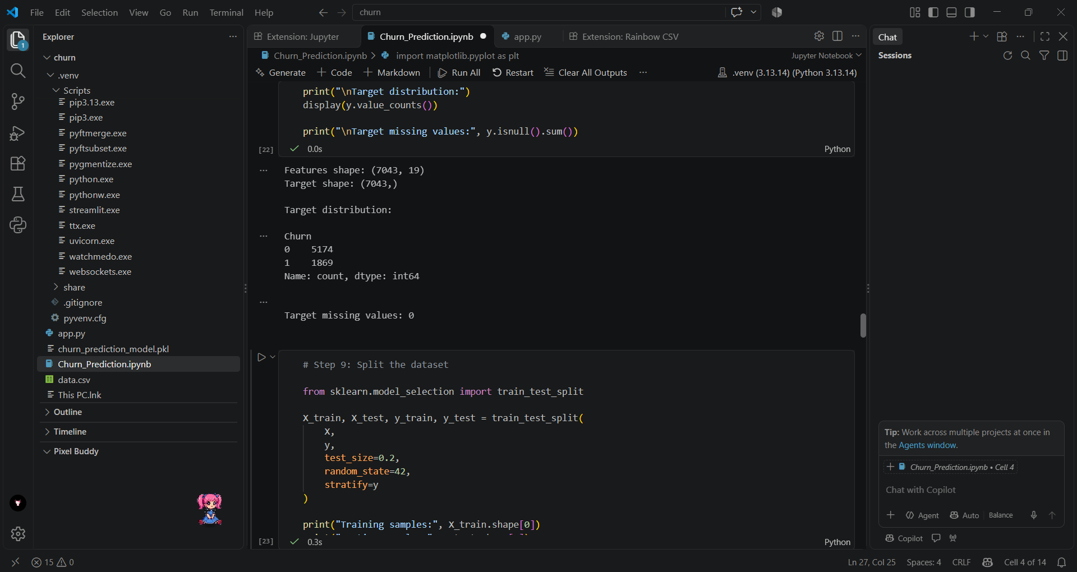

3. Model Training

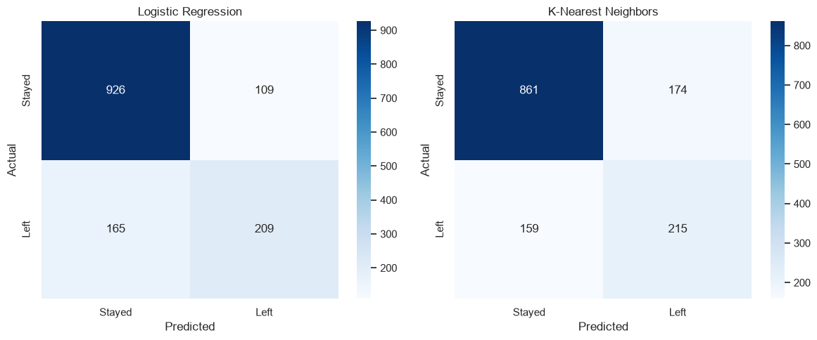

5. Evaluation Results
Best model based on F1-score: Logistic Regression

Detailed classification report:
precision recall f1-score support

Stayed 0.85 0.89 0.87 1035
Left 0.66 0.56 0.60 374

accuracy 0.81 1409
macro avg 0.75 0.73 0.74 1409
weighted avg 0.80 0.81 0.80 1409

5.1 Confusion Matrix
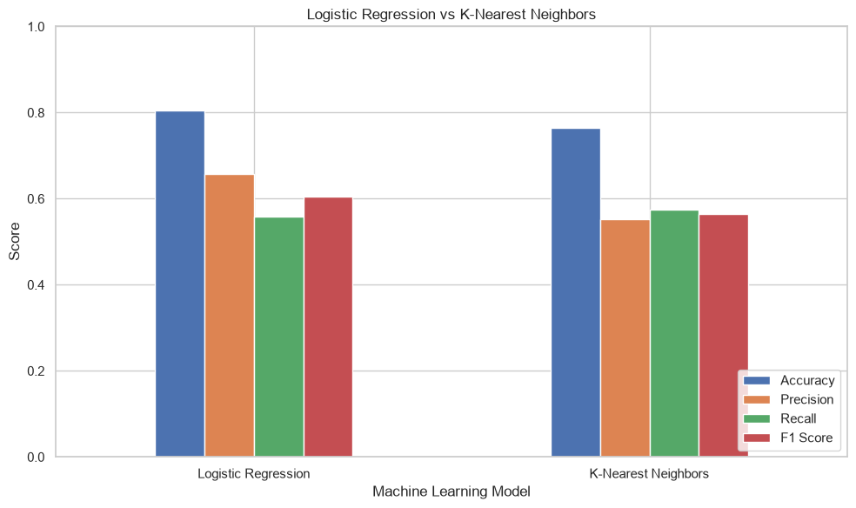

6. Overfitting vs Underfitting
Logistic Regression
Training Accuracy: 0.8060
Testing Accuracy: 0.8055
Accuracy Gap: 0.0005

KNN
Training Accuracy: 0.8372
Testing Accuracy: 0.7637
Accuracy Gap: 0.0736

8. Conclusion
The End-to-End Customer Churn Prediction System was developed to predict whether a customer is likely to leave a service using historical customer data. The project involved exploratory data analysis, data preprocessing, handling missing values, encoding categorical variables, scaling numerical features, and training Logistic Regression and K-Nearest Neighbors (KNN) classification models. The models were evaluated using accuracy, precision, recall, F1-score, and confusion matrices to compare their performance. Training and testing accuracy were also considered to assess generalization and identify possible overfitting or underfitting. Overall, this project demonstrates the practical application of machine learning in customer churn prediction and provides a foundation for helping businesses identify customers who may be at risk of leaving. The final model selection depends on the actual evaluation results.

Portfolio Summary
Built a complete churn prediction ML pipeline with preprocessing, classification models, and evaluation.

References / Dataset Source
http://localhost:8501/

