Angular <------------> node.js

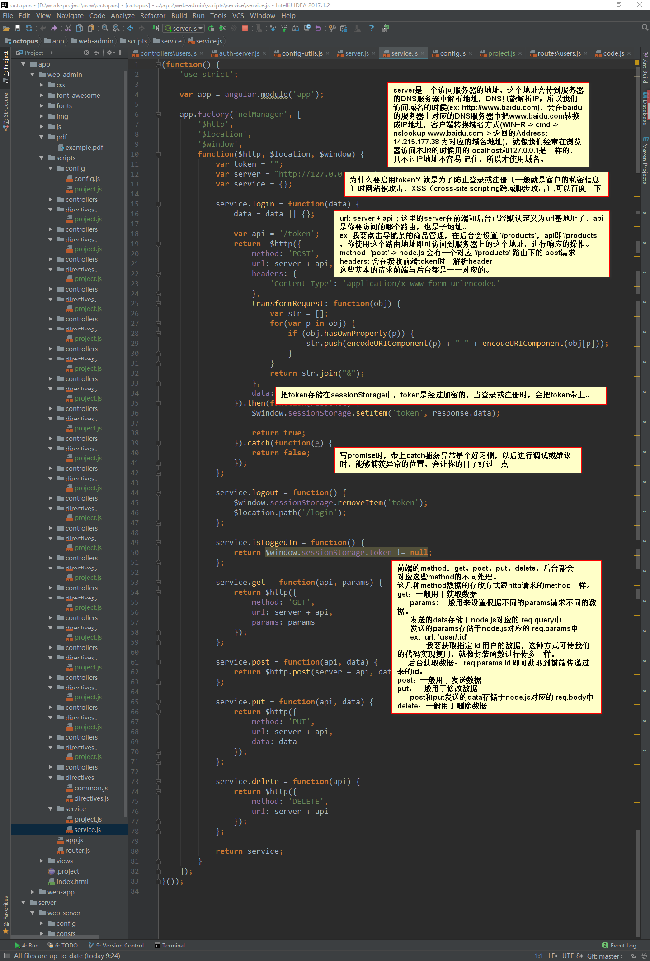

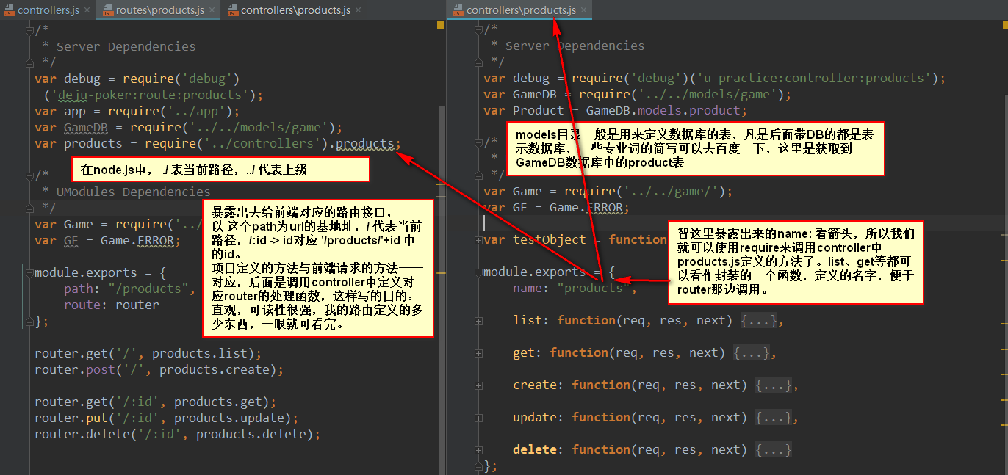

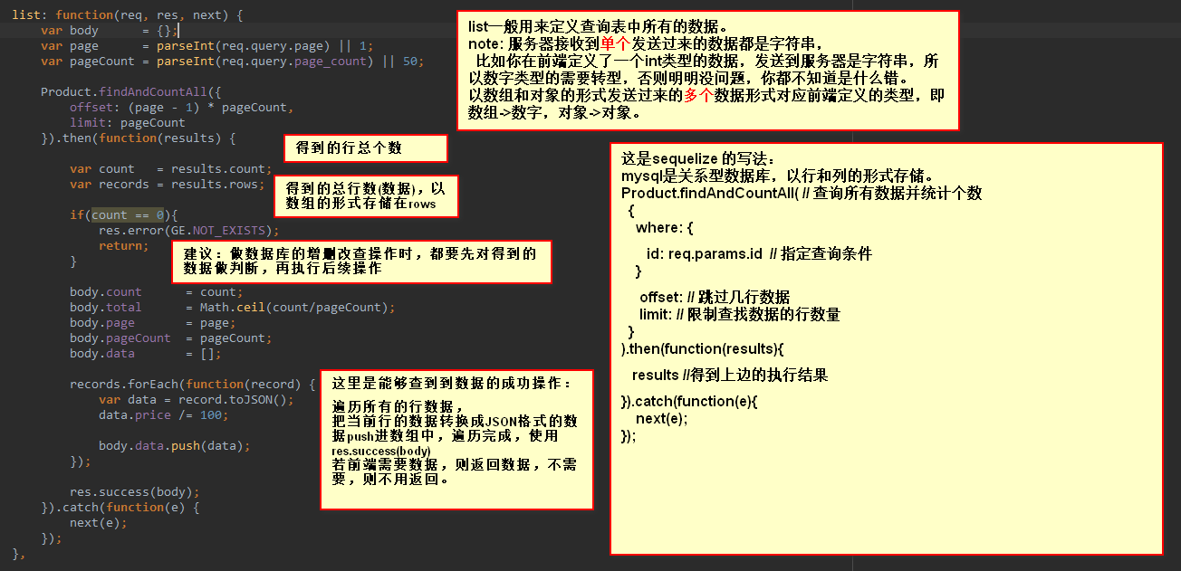

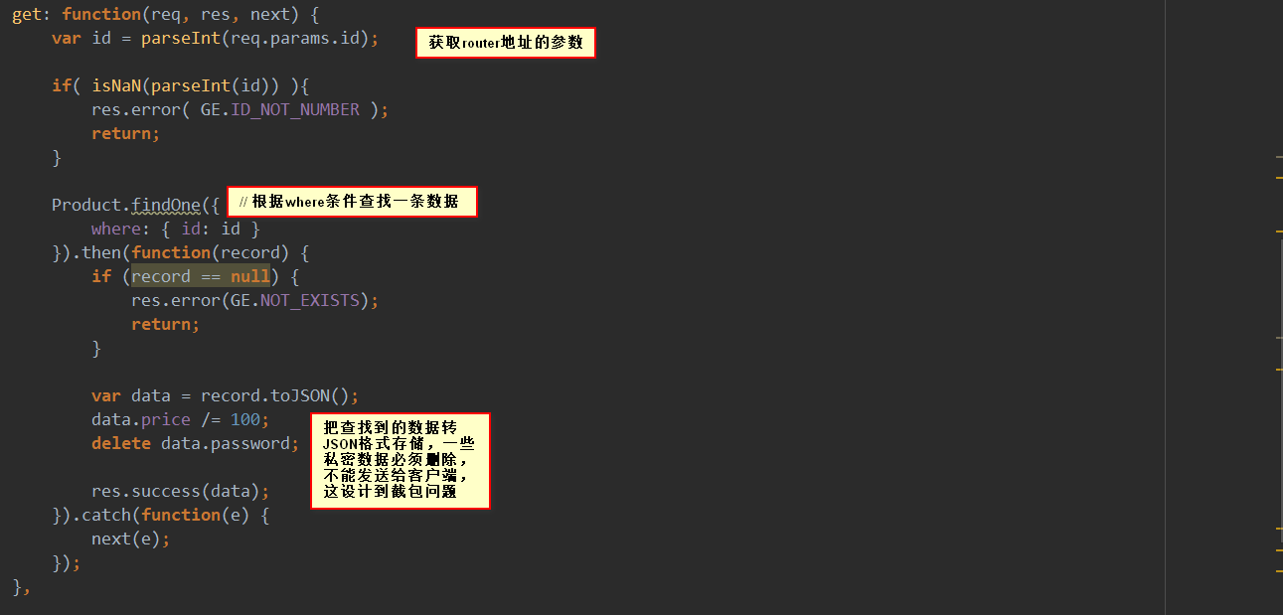

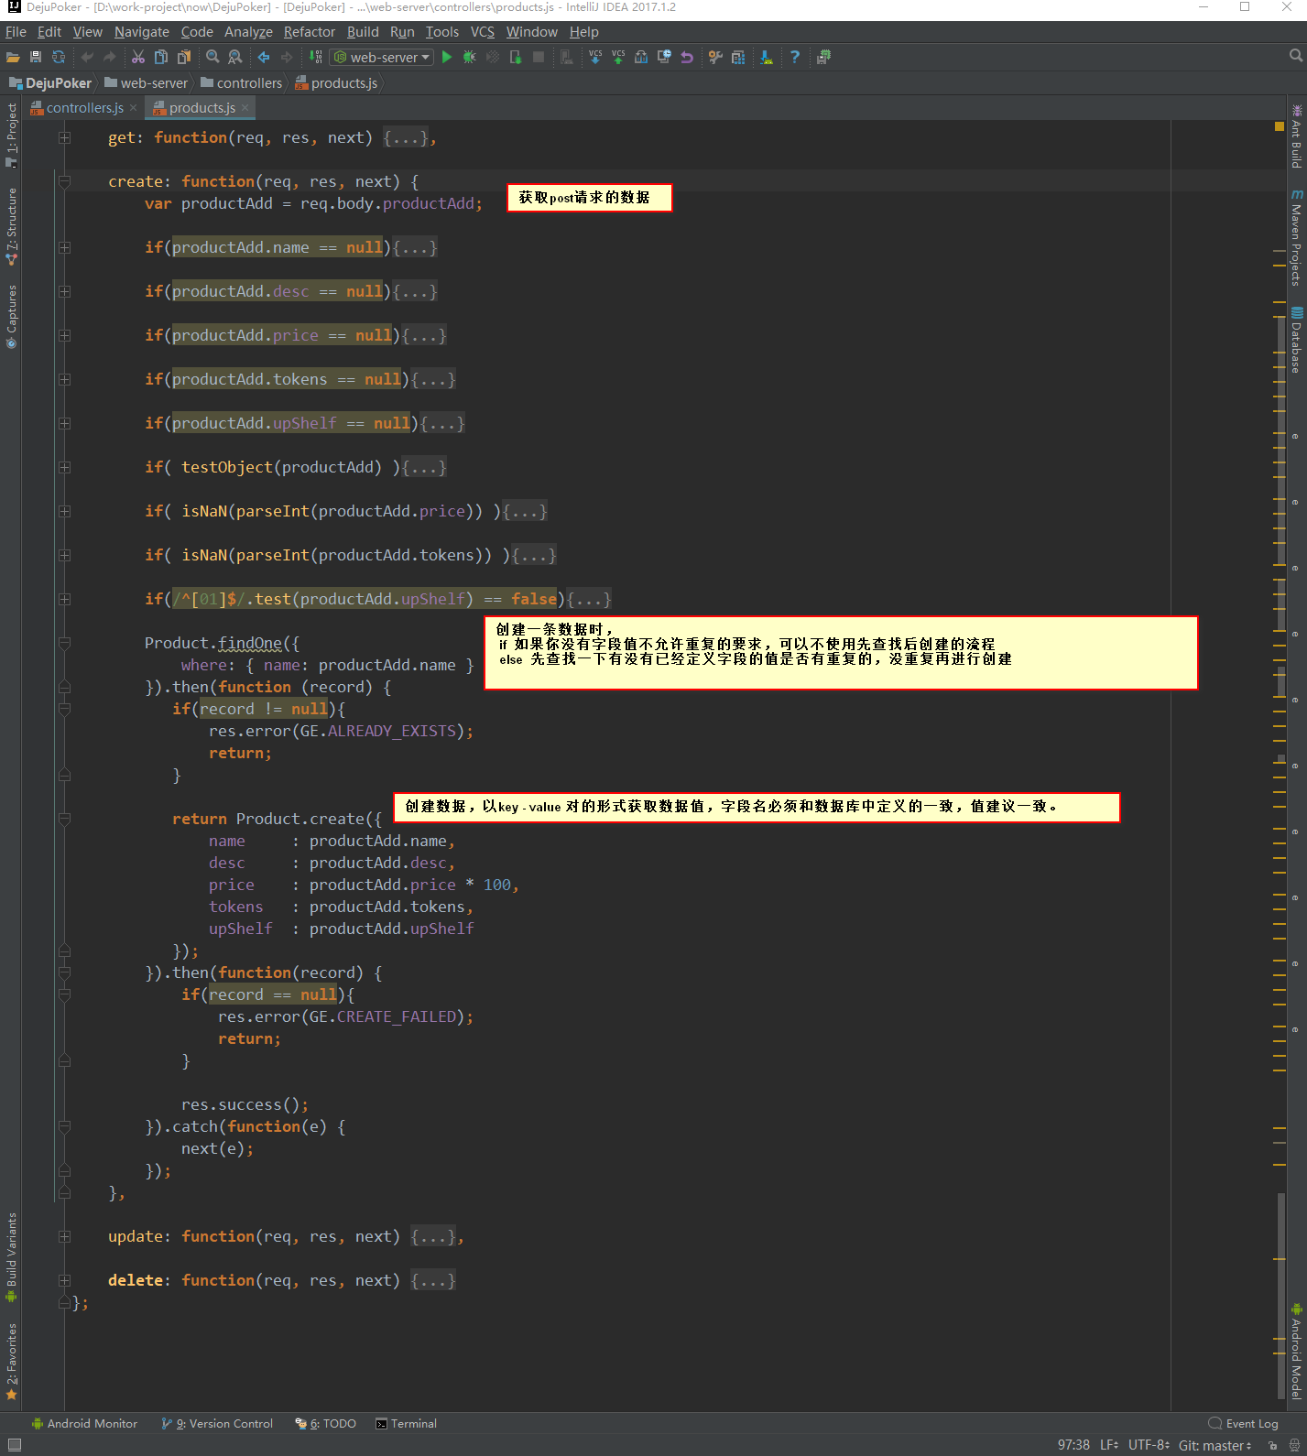

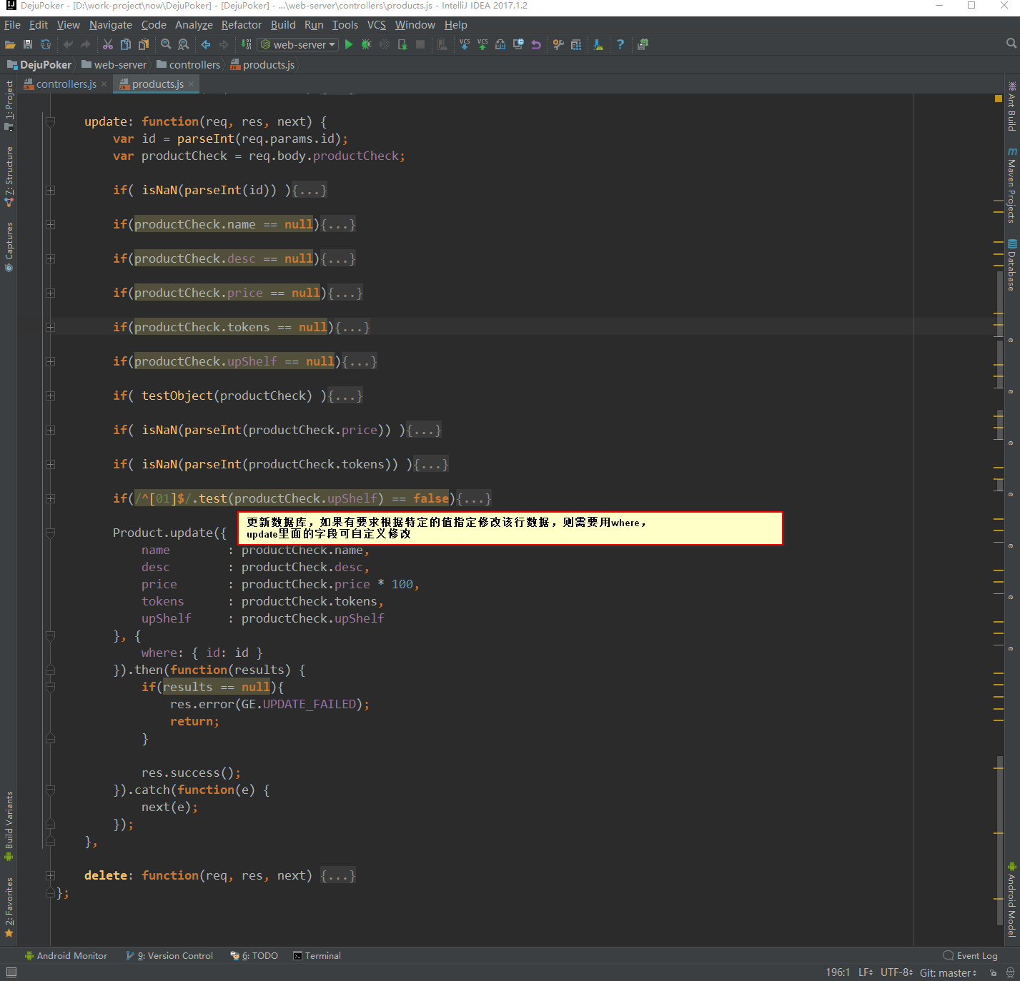

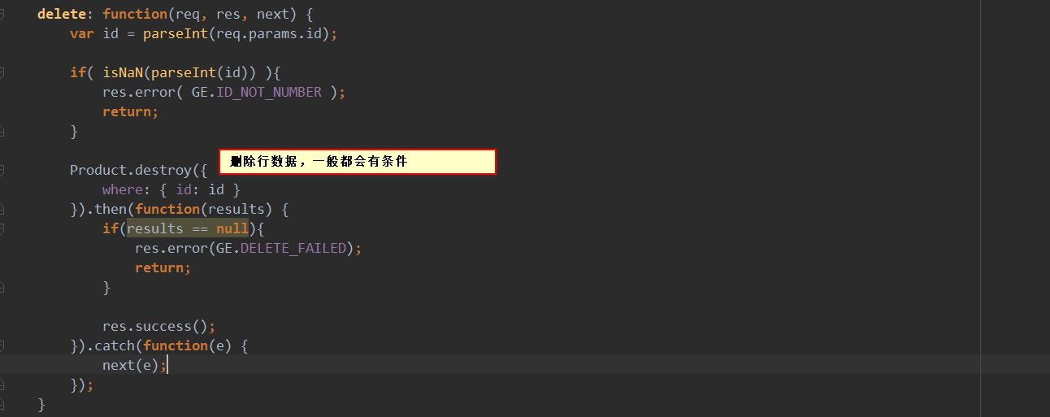

文档url：

Sequelize(英文)：https://sequelize.readthedocs.io/en/v3/

Sequelize(中文)：<https://itbilu.com/nodejs/npm/VkYIaRPz-.html>express(英文): http://www.expressjs.com.cn/4x/api.html  
express(中文)：<http://www.expressjs.com.cn/4x/api.html>

Bluebird(promise): <http://bluebirdjs.com/docs/getting-started.html>

http://fex.baidu.com/blog/2015/07/we-have-a-problem-with-promises/