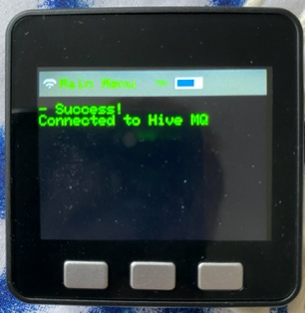

Activation sequence

Initiation

Connection

Relaxation sequence