AWS

AWS offers the most extensive selection of cloud services, global reach, and a proven track record in serving diverse business needs, making it a preferred choice for flexibility, scalability, and reliability in the cloud.

AWS Pricing

Approximate monthly cost for AWS services like RDS (Relational Database Service), EC2 instances (virtual servers), and image storage breakdown:

1. RDS: (PostgreSQL), basic RDS instance with minimal resources might start at around $10-20 per month, while larger and more powerful instances with high availability features can cost hundreds or thousands of dollars per month.
2. EC2 Instances: Small instances like t2.micro can cost as little as $10-20 per month, while high-performance instances like m5.large or c5.xlarge could cost around $50-100 or more per month.
3. Image Storage: (Standard). A few cents per gigabyte per month for standard storage, with costs potentially increasing for features like data retrieval from archival storage classes.

Why the app is not on Play Store Account Yet

I need money to setup cloud to host the API, currently the API is running on localhost for testing purposes, but once deployed, that would make it easier for the app to access and upload content to the API.

What it is going to cost for Deploying app to Play Store/Apple Store

1. Play Store (Google Play Console Account), 25 bucks
2. Apply Store (Nothing), however, I need a mac book to compile the code via xcode before deploying to the account the compiled apk.

Scan Code:

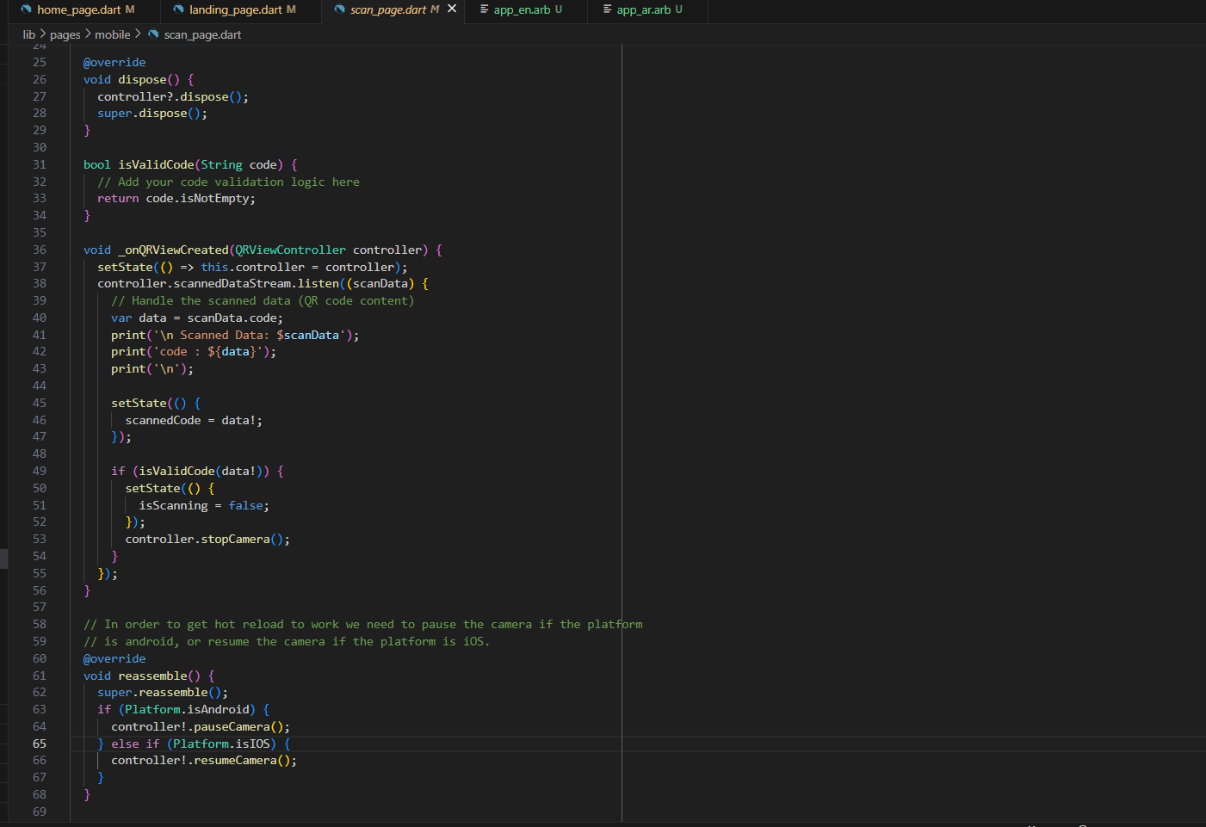

**qr_code_scanner**: is a Flutter package that enables easy integration of QR code scanning functionality into your mobile applications.

Database: RDS, (PostgreSQL)

IDE: Visual Studio Code

Framework: Fast API

In this tech stack, the database is powered by RDS (Relational Database Service), utilizing PostgreSQL as the database engine, providing a robust and scalable foundation for storing and managing structured data. The development environment is supported by Visual Studio Code, a popular and versatile integrated development environment (IDE) that offers extensive tooling and extensions for various programming languages and frameworks, making it a top choice for coding efficiency. The framework of choice here is FastAPI, a modern and high-performance web framework for building APIs with Python. Combining RDS, Visual Studio Code, and FastAPI, developers can create efficient, data-driven web applications with ease, harnessing the power of a reliable database, a user-friendly IDE, and a fast, asynchronous API framework.

Swagger API Output example

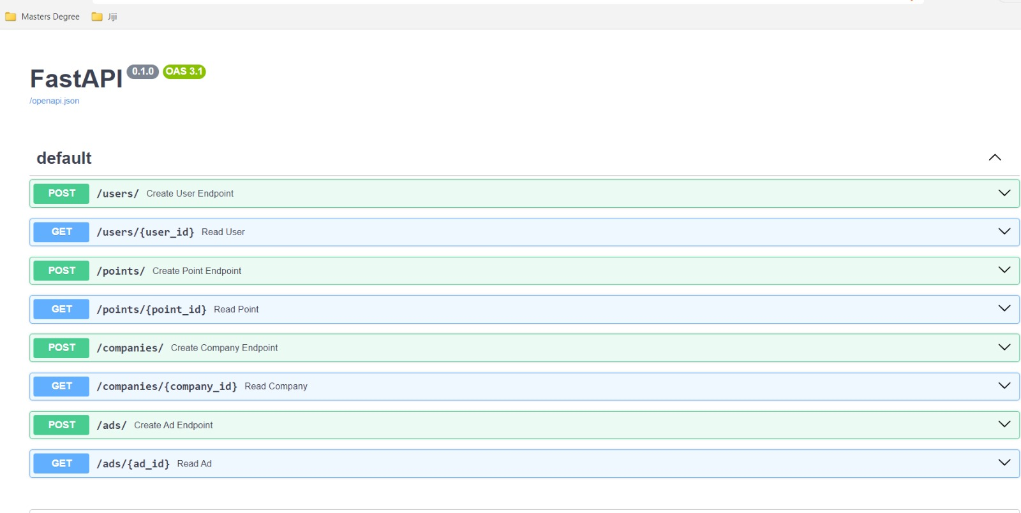

Domain:  
Most affordable :  
Namecheap

Jased.com : $11, 695 -> <https://www.namecheap.com/domains/registration/results/?domain=jased>

Jased6.com : $ 10.28