OS Lab

2022-CS-54

Lab-7 Tasks

1)

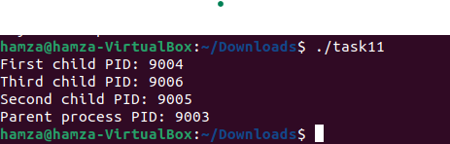

2)

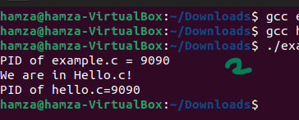

3)

