

**Quiz Online System(QOS)**

**Software Design Specification**

– Hanoi, May 2024 –

**Record of changeS**

| **Date** | **A* M, D** | **In charge** | **Change Description** |
| --- | --- | --- | --- |
| 23/5 | A | HungTV, DienON, |  |
|  |  |  |  |
|  |  |  |  |
|  |  |  |  |

*A - Added M - Modified D - Deleted

**Table of Contents………………………………………………………………………………… 2**

**I.Overview ………………………………………………………………………………………… 4**

1. Code packages ………………………………………………………………………….. 4
2. Database Schema ……………………………………………………………… 5
3. Table Description (main tables) ……………………………………………….. 6
4. User Table ………………………………………………………………. 6
5. UserRole table …………………………………………………………. 7
6. Question table ………………………………………………………… 7
7. Subject table ………………………………………………………….. 8
8. Subject cate table …………………………………………………….. 9
9. Dimension table……………………………………………………….. 9
10. Dimension type table …………………………………………………. 10

**II. Code Designs ………………………………………………………………………………… 10**

1. Log in……………………………………………………………………………………… 10

a. Class Diagram………………………………………………………………………….11

b. Class Specifications………………………………………………………………….. 11

c. Sequence Diagrams …………………………………………………………………. 12

d. Database Queries …………………………………………………………………… 12

**I.Overview**

**1.Code Packages**

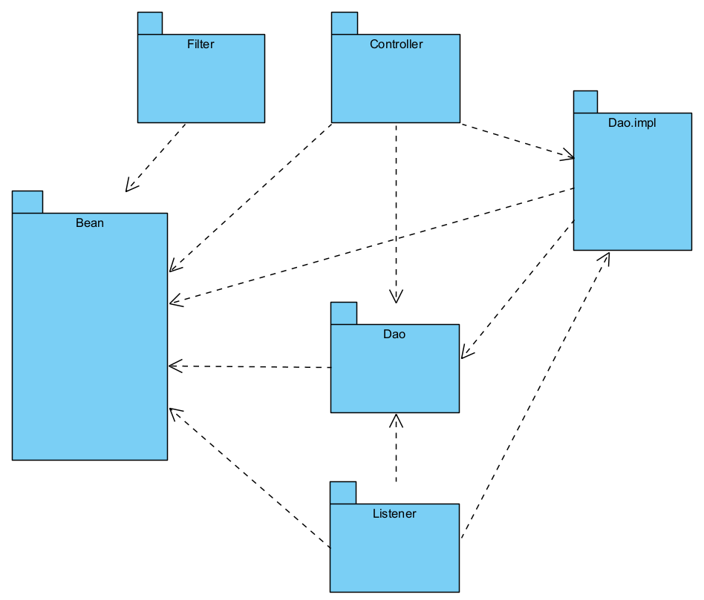

| **No** | **Package** | **Description** |
| --- | --- | --- |
| 01 | Dao | Contains database information |
| 02 | Filter | Authorise Admin with student and teacher |
| 03 | Listener | Control the amount of user entered the web |
| 04 | Controller | Contain controller classes that execute program function |
| 05 | Bean | Contain Database Access Object |

**2.Database Design**

**a.Database Schemas**

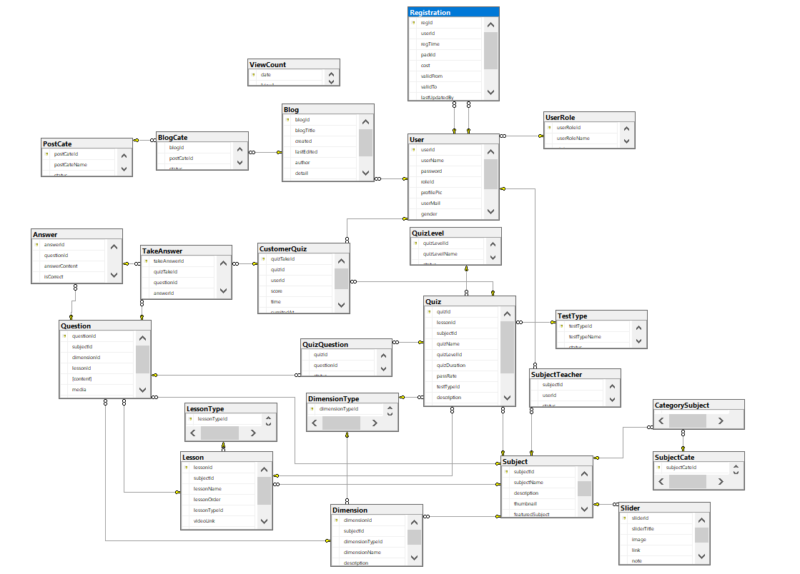

B. Table Description

1.User table

| Data element | Data type | Size | Allow null  value | Description |
| --- | --- | --- | --- | --- |
| userId | Int |  | N | Unique id of user,primary key,not null |
| userName | nvarchar | 63 | N | Name of user, not null |
| password | nvarchar | 255 | N | Password to login, not null |
| roleId | int |  | N | Accessibility |
| profilePic | nvarchar | 255 | Y | Profile image link |
| userMail | nvarchar | 255 | Y | Email |
| gender | bit |  | Y | 1-Male, 0-Female |
| userMobile | nvarchar |  | Y | Contact phone number |
| status | bit |  | Y | 1-Active,0-Inactive |

2.UserRole table

| Data element | Data type | Size | Allow null  value | Description |
| --- | --- | --- | --- | --- |
| userRoleId | Int |  | N | Primary key, not null |
| UserRoleName | Nvarchar | 63 | N | Name of role(Student,Teacher,Admin),not null |
| status | bit |  | Y | 1-Active,0-Inactive |

3.Question table

| Data element | Data type | Size | Allow null  value | Description |
| --- | --- | --- | --- | --- |
| questionId | int |  | N | Primary Key,unique id of question |
| subjectId | int | 63 | N | Id of subject |
| dimensionId | int |  | N | Id of dimension |
| lessonId | int |  | N | Id of lession |
| content | nvarchar | 1023 | N | Content of question |
| media | nvarchar | 255 | Y | Additional media(picture) |
| explanation | nvarchar | 1023 | Y | Additional explanation |
| status | bit |  | Y | 1-Active,0-Inactive |

4.Subject table

| Data element | Data type | Size | Allow null  value | Description |
| --- | --- | --- | --- | --- |
| subjectId | int |  | N | Id of subject |
| subjectName | nvarchar | 255 | N | Name of subject |
| description | nvarchar | 1023 | N | Description of subject |
| thumbnail | nvarchar | 255 | Y | Image |
| featuredSubject | bit | 3 | Y | Subject is featured or not |
| status | bit | 3 | Y | 1-Active,0-Inactive |

5.Subject cate table

| Data element | Data type | Size | Allow null  value | Description |
| --- | --- | --- | --- | --- |
| subjectCateId | Int |  | N | Primary key |
| subjectCateName | nvarchar | 63 | N | Name of subject category |
| status | bit | 3 | Y | 1-Active,0-Inactive |

6.Dimension table

| Data element | Data type | Size | Allow null  value | Description |
| --- | --- | --- | --- | --- |
| dimensionId | int |  | N | Primary key |
| subjectId | int |  | N | Foreign key to Subject table |
| dimensionTypeId | int |  | N | Foreign key to Dimension Type table |
| dimensionName | nvarchar | 255 | N | Name of subject |
| description | nvarchar | 511 | N | Description of subject |
| status | bit | 3 | Y | 1-Active,0-Inactive |

7. Dimension type table

| Data element | Data type | Size | Allow null  value | Description |
| --- | --- | --- | --- | --- |
| dimensionTypeId | int |  | N | Primary key |
| dimensionTypeName | nvarchar | 63 | N | Dimension type |
| status | bit | 3 | Y | 1-Active,0-Inactive |

# **II. Code Designs**

## **1. Log in**

* ***a. Class Diagram***

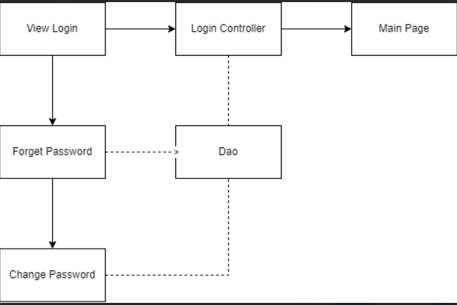

### ***b. Class Specifications***

Register class

| No | Method | Description |
| --- | --- | --- |
| 01 | register | This method allows the user to create a new account in the system. Users need to enter Email, Username, Password, re-password and click on the register button and a new email will be sended to the user by system. Users click on the active account button in the email. |

Login class

| No | Method | Description |
| --- | --- | --- |
| 01 | forgot password | This method allows the user to get back a new password if they forgot their password. Users need to enter email and click on the forgot password button after that user will get a new password in an email that the system sends to the user. |

Forgot password class

| No | Method | Description |
| --- | --- | --- |
| 01 | login | This method allows the user to login to the system. Users need to enter Email, Password and click on the login button |

Change password class

| No | Method | Description |
| --- | --- | --- |
| 01 | Change password | This method allows the user to change their password. Users need to enter a password, re-password and click on the change password button. |

**D. Database Queries**

***1.Login module queries***

-Login module queries:  
 +Get user by username and password:

SELECT[id_user],[full_name],[email],[password],[phone],[gender]FROM [dbo].[User]

WHERE[email] = email and [password] = password