

**Quiz Online System(QOS)**

**Software Requirement Specification**

– Hanoi, May 2024 –

**Record of changeS**

| **Date** | **A* M, D** | **In charge** | **Change Description** |
| --- | --- | --- | --- |
| 19/05 | A | HungTV | Initial version. |
| 20/05 | A, M | HungTV, DienON, Binh, Quy, Thich. | Everyone is adding the UseCase Diagram, Context Diagram, making the Screen flow and also making the detail for it. |
| 21/05 | A,M | HungTV, Dien | Add Functional Requirements.. |
|  |  |  |  |
|  |  |  |  |

*A - Added M - Modified D - Deleted

**Table of Content**

1. Overview …………………………………………………………. 3
2. Introduction ……………………………………………….. 3
3. Actors ………………………………………………..3
4. System function …………………………………………… 4
5. Screen Flow ………………………………………… 4
6. Screen Detail ……………………………………….. 5
7. User Authorization …………………………………. 8
8. Non-Screen Functions ……………………………… 9

3. Entity Relationship Diagram ………………………………. 11

II. Functional Requirements …………………………………………… 12

1. Common functions…………………………………………………….. 12

a. Register……………………………………………………………… 12

b. Login………………………………………………………………… 13

c. Forgot password……………………………………………………… 13

d. User profile…………………………………………………………… 13

1. Public features…………………………………………………………. 13

a. Homepage(Guest) …………………………………………………… 13

b. Homepage …………………………………………………………… 13

# **I. Overview**

## **1. Introduction**

The Quiz Programming system is new software that replaces paper tests with online exams. It will keep improving over time, making it possible for students to take tests from anywhere using devices that are connected to the internet.

## ***a. Actors***

| **#** | **Actor** | **Description** |
| --- | --- | --- |
| 1 | Admin | The system administrator, capable of controlling and managing all aspects of the system. They have access to all administrative features and functions of the application. |
| 2 | Teacher | The person responsible for managing courses in the system. They create, update and manage information related to courses and learning content. |
| 3 | Student | The person takes a quiz and develops their knowledge and skills. |
| 4 | Guest | Non-registered users who browse through the website. |

The system will be a companion to the user in the learning and exam process.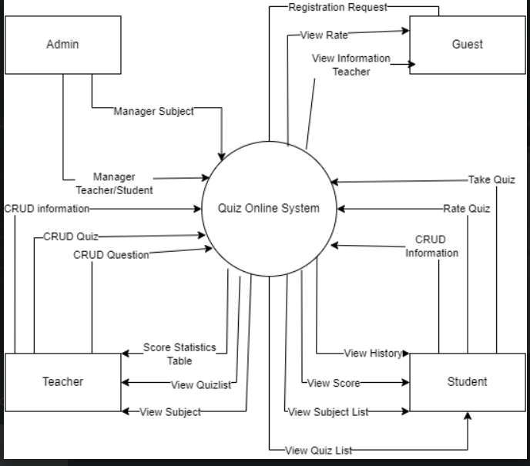

Fig 1. Context diagram

Fig 2. UseCase Diagram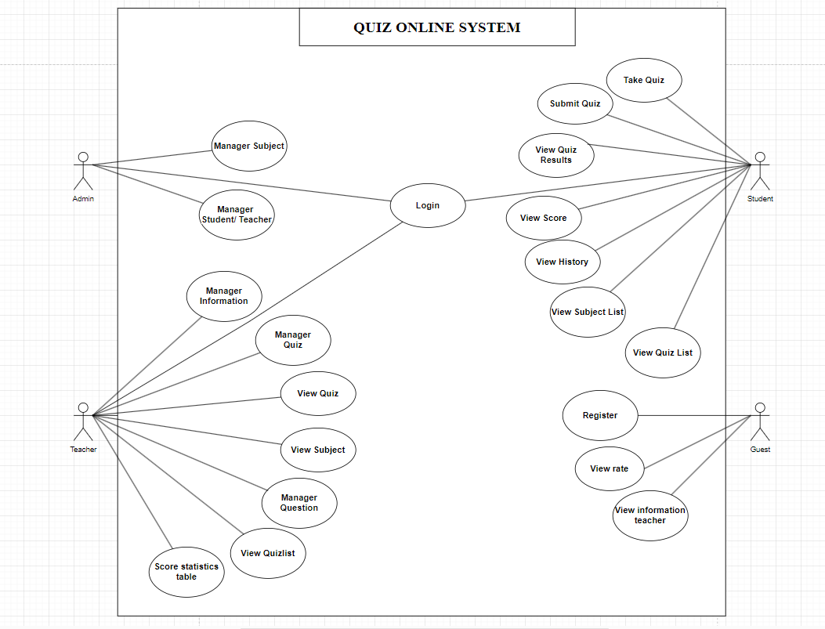

## **2. System Functions**

## ***a. Screen Flow***

Fig 3. Screen Flow

***b. Screen Detail***

| **#** | **Feature** | **Screen** | **Description** |
| --- | --- | --- | --- |
| 1 | Manage account | Manage account | Display all accounts in the system |
| 2 | Manage account | Edit account | Display pop-up form with account information to change user’s status, user’s role |
| 3 | Manage account | Search account | Display a list of accounts that contains keywords |
| 4 | Manage account | Delete account | Display confirmation message to delete an account in the system |
| 5 | Manage account | View account | Display account information |
| 6 | Manage account | Add account | Display pop-up form to add a new account into system |
| 7 | Manage Personal Profile | Enrol Subjects | Display subjects informations |
| 8 | Manage Personal Profile | View Subjects | Display subjects has been enrolled |
| 9 | Manage Personal Profile | Take quiz | Display 20 questions / 1 quiz |
| 10 | Manage Personal Profile | View Progress | Display user’s process in the test |
| 11 | Manage Personal Profile | Update Profile | Display form to change user information |
| 12 | Manage Personal Profile | Manage profile information | Display user’s information to update |
| 13 | Manage Subject | Display Results | Displaying the score , the number of questions students answered correctly with the teacher is the score statistics table |
| 14 | Manage Subject | Take quiz | Display questions according to student settings |
| 15 | Manage Subject | Rate quiz | Student can rate the quiz they have taken |
| 16 | Manage Subject | View Subject | Display Subject Information |
| 17 | Manage Subject | Search Subject | Display a list of subject that contains keywords |
| 18 | Manage Subject | Delete Subject | Display confirmation message to delete a lesson in the system |
| 19 | Manage Subject | Take quiz | Display questions according to student settings |
| 20 | Manage Subject | View Subject | Display subject information |
| 21 | Manage Subject | Search Subject | Display a list of subject that contains keywords |
| 22 | Manage Subject | Delete Subject | Display a confirmation message to delete a lesson in the system |
| 23 | Manage Subject | Edit Subject | Display form to change subject information |
| 24 | Manage Subject | Add Subject | Display pop-up form to add a new subject into the system |
| 25 | Manage quiz | Search quiz | Display a list of quizzes that contains keywords |
| 26 | Manage quiz | Delete quiz | Display confirmation message to delete a quiz in the system |
| 27 | Manage quiz | Update quiz | Display form to change quizzes information |
| 28 | Manage quiz | Add quiz | Display a pop-up form to add a new quiz into the system |
| 29 | Common | Register | Register an account for new user |
| 30 | Common | Login | Allow users to login to use services |
| 31 | Common | Homepage | Main functionally page for user |
| 32 | Common | Forgot password | Allow users to input email to receive forgot password link |
| 33 | Common | View Subject | Everyone can see and interact course such as comment but guest only can view courses |
| 34 | Common | View Rate Quiz | Display the list of each quiz |
| 35 | Common | View About | Everyone can see and interact course such as comment but guest only can view courses |
| 36 | Common | View Contact | Display Contact Information (social media , email address , phone number) |

#### ***c. User Authorization***

| **Screen** | **Admin** | **Teacher** | **Student** | **Guest** |
| --- | --- | --- | --- | --- |
| Manage Account | X |  |  |  |
| Edit Account | X |  |  |  |
| Add Account | X |  |  |  |
| Delete Account | X |  |  |  |
| View Account | X |  |  |  |
| Search Account | X |  |  |  |
| Enrol Course |  | X | X |  |
| Manage profile information |  | X | X |  |
| Display results |  | X | X |  |
| Take quiz |  |  | X |  |
| Create quiz |  | X |  |  |
| View quiz |  | X |  |  |
| Update quiz |  | X |  |  |
| Delete quiz |  | X |  |  |
| Rate quiz |  |  | X |  |
| View rate quiz |  | X | X | X |
| View Score Statistics table |  | X |  |  |
| Create question |  | X |  |  |
| View question |  | X |  |  |
| Update question |  | X |  |  |
| Delete question |  | X |  |  |
| View subject | X | X | X | X |
| Search subject | X | X | X | X |
| Add subject | X |  |  |  |
| Register |  |  |  | X |
| Login | X | X | X |  |
| Homepage | X | X | X | X |
| Forgot Password | X | X | X |  |

#### ***d. Non-Screen Functions***

## 

| # | Feature | System Function | Description |
| --- | --- | --- | --- |
| 1 | Confirmation Dialog for Test Submission | Display Confirmation Dialog | A pop-up screen to confirm that students want to submit the test.  The student can choose to confirm the submission by clicking on an "Confirm" button within the dialog or cancel the submission by clicking on a "Cancel" button.  If the student confirms the submission, the system performs the necessary actions to collect the student's answers, calculating the score, and saving the result. Otherwise, return to the test |
| 2 | Confirmation Dialog for Test Creation | Display Confirmation Dialog for Test Creation | The system opens a pop-up dialog box on the screen, containing a message asking the teacher to confirm their intent to create a test.  The teacher can choose to confirm the test creation by clicking on the "Create" button within the dialog or cancel the creation by clicking on the "Cancel" button. |
| 3 | Automated Test Scoring and Result Generation | Test Scoring and Result Calculation | The system implements a scoring algorithm to evaluate the correctness of student answers and calculate the score for each question. The algorithm can vary depending on the question type (multiple-choice) and scoring rules defined for the test.  Answer Evaluation: Multiple-choice Questions: For multiple-choice questions, the system compares the selected answer option(s) with the correct answer(s) stored in the database. If the selected option(s) match the correct answer(s), the system assigns the specified score for that question. |
| 4 | Randomised Test Generation | Randomised Test Generation | The system randomly arranges the selected questions within the test. This ensures that each test version presents questions in a different order, preventing bias or cheating during exams. |

## 

## **3. Entity Relationship Diagram**

Fig 3. Screen Flow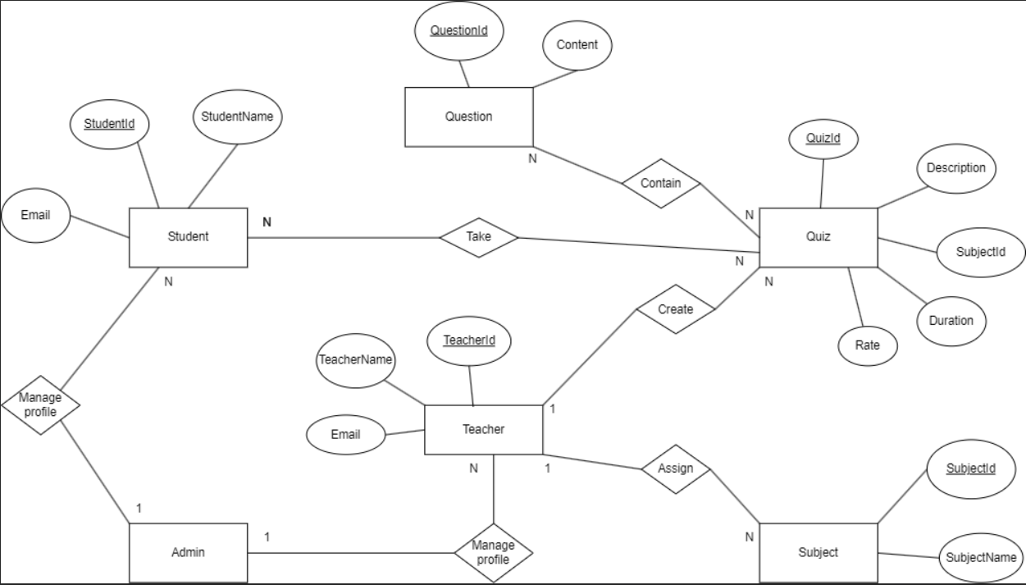

**Entities Description**

| **#** | **Entity** | **Description** |
| --- | --- | --- |
| 1 | User | Represents the users of the system, including students, teachers, and admins. |
| 2 | Admin | Represents the admin users in the system, who manage all users. |
| 3 | Teacher | Represents the teacher users in the system, who enrol to create examinations |
| 4 | Student | Represents the student users in the system, who enrol to take examinations |
| 5 | Subject | Represents the subjects offered in the system |
| 6 | Quiz | Represents the quiz created by teachers. |

# 

# **II. Functional Requirements**

## **1. Common functions**

### **a. Register**

* Function trigger: When you click sign in button
* Function description: For guest to register
* Screen layout:
* Function Details:   
  + Guest can register with email  
  +The user can log in to access the features after creating an account.

### **b. Login**

* Function trigger: When you click login button
* Function description:User login with registered email account and password
* Screen layout:
* Function Details: Enabling people to employ services according to their various roles, such as administrator, instructor, and student.

### **c. Forgot Password**

* Trigger when user clicks on “Forgot password ?” in sign in page
* Ask user to enter their email of the account that their password has forgotten
* Send email to verify
* Ask users to enter their new password with the same requirement.

### **d.User profile**

* View user’s profile with their full name, dob, role, profile photo and “Detail about you”
* Edit user’s profile trigger when user click on “My profile” in home page

## **2. Public features**

### **Home Page (Guest)**

* Function trigger: is opened when you first enter the page
* Function description: This function shows Our Subject Categories
* Screen layout:
* Function Details:   
  + Guest can sign up with email  
  +The user can log in to access the features after creating an account.

### **Home Page ()**

* Function trigger: appear after you log in
* Function description: This function shows paginated “Subject” list
* Screen layout:
* Function Details:   
  +Display the subjects students can participate in

# 