LAB ASSIGNMENT NO. 3
Diamond Price Prediction using 10-Fold Cross Validation
Submitted By
MUHAMMAD HUNAIN (FA24-BSE-083) “B”
Submitted To
Dr. Rao Muhammad Adeel Nawab
Course
Machine Learning Fundamentals (AIC354)
Date
18 October 2026
COMSATS University Islamabad, Lahore Campus

1. Introduction
This assignment is about comparing several machine learning algorithms fairly on the same large dataset. Instead of training one model on one train/test split, I used K-Fold Cross Validation so that every diamond is used for testing exactly once, and then compared five regression algorithms using Root Mean Squared Error (RMSE).
The assignment has two tasks. Task 1 was to run and understand the instructor's Car Price Prediction notebooks on Google Colab. Task 2 was to pick a similar problem of my own, evaluate five new algorithms on the full dataset with 10-fold cross validation, and deploy the model to the cloud with a web app. This document explains what I did for Task 2.

1.1 Problem selected
I chose diamond price prediction. Given the weight, shape and quality grades of a diamond, the model predicts its price in US dollars. It is a regression problem just like the car price system, but with a bigger dataset, so it is a good test of how the algorithms behave on large data.
 | Car Price (instructor) | Diamond Price (mine)
Task | Regression (MSRP) | Regression (price)
Rows | About 11,900 | 53,940
Numeric features | Engine HP, Year, MPG... | carat, depth, table, x, y, z
Categorical features | Market Category, Style | cut, colour, clarity
Price distribution | Skewed (supercars) | Skewed (large stones)
Table 1: Why diamond price prediction is similar to the car price system

2. Dataset
The classic Diamonds dataset has 53,940 rows and 10 columns. I downloaded it from the public seaborn-data repository on GitHub (github.com/mwaskom/seaborn-data) and used the whole file, not a sample. The first rows look like this:
# | carat | cut | colour | clarity | depth | table | price | x | y | z
0 | 0.23 | Ideal | E | SI2 | 61.5 | 55.0 | 326 | 3.95 | 3.98 | 2.43
1 | 0.21 | Premium | E | SI1 | 59.8 | 61.0 | 326 | 3.89 | 3.84 | 2.31
2 | 0.23 | Good | E | VS1 | 56.9 | 65.0 | 327 | 4.05 | 4.07 | 2.31
3 | 0.29 | Premium | I | VS2 | 62.4 | 58.0 | 334 | 4.2 | 4.23 | 2.63
4 | 0.31 | Good | J | SI2 | 63.3 | 58.0 | 335 | 4.34 | 4.35 | 2.75
Table 2: First five rows of diamonds.csv
The price is the output (target). The other nine columns are the inputs. Prices are strongly skewed: half of the diamonds cost less than about $2,400, but the most expensive one costs $18,823.
Statistic | Price ($)
count | 53,940
mean | 3,932.8
std | 3,989.44
min | 326
25% | 950
50% | 2,401
75% | 5,324.25
95% | 13,107.1
99% | 17,378.22
max | 18,823
Table 3: Summary statistics of the price

3. Data Pre-processing
Three problems in the raw data needed attention before training:
- Duplicates. 146 rows were exact duplicates. In cross validation a duplicate can sit in both the training and the test fold, so the model would be tested on a diamond it has already seen and the RMSE would look better than it really is. They were removed, leaving 53,794 unique diamonds.
- Impossible values. A few diamonds had a length, width or depth of 0 (7 in x, 6 in y and 19 in z), which cannot happen for a real stone. I turned these into missing values.
- Missing values and scaling. Missing numbers are filled with the median, numeric columns are standardised, and the text columns (cut, colour, clarity) are one-hot encoded. All of this is done inside a scikit-learn pipeline, so in every fold it is learned from the training part only. This avoids data leakage.
numeric_features = ["carat", "depth", "table", "x", "y", "z"]
categorical_features = ["cut", "color", "clarity"]

numeric_pipeline = Pipeline([("imputer", SimpleImputer(strategy="median")),
("scaler", StandardScaler())])
categorical_pipeline = Pipeline([("imputer", SimpleImputer(strategy="most_frequent")),
("onehot", OneHotEncoder(handle_unknown="ignore"))])
preprocessor = ColumnTransformer([("num", numeric_pipeline, numeric_features),
("cat", categorical_pipeline, categorical_features)])
Code 1: The pre-processing pipeline

4. The Five Algorithms
The assignment says to use algorithms that were not used in the Car Price notebook (Linear Regression, KNN, Decision Tree, Random Forest and Gradient Boosting). I therefore chose these five:
# | Algorithm | How it predicts a price
1 | Ridge Regression | A weighted sum of the features with a penalty that keeps the weights small
2 | AdaBoost | 50 small trees in a row; each pays more attention to the diamonds the previous one got wrong
3 | Extra Trees | 100 fully grown trees with random split points, averaged together
4 | Hist Gradient Boosting | Trees built one after another on binned features, each fixing the remaining error
5 | Neural Network (MLP) | Two hidden layers (64 and 32 neurons) trained with gradient descent
Table 4: The five algorithms compared
All algorithms use their default settings so that the comparison stays simple and fair, and random_state=42 makes the results repeatable. The only non-default choice is early stopping for the neural network.

5. K-Fold Cross Validation and RMSE

5.1 10-fold cross validation
The data is shuffled and split into 10 equal folds. In each round, 9 folds (about 48,400 diamonds) are used for training and the remaining fold (about 5,400 diamonds) for testing. After 10 rounds every diamond has been tested once. The same folds are used for all five algorithms, so each algorithm is tested on exactly the same diamonds.
In every round a fresh copy of the pipeline is created with clone(), trained, and used to predict the test fold. The notebook shows a tqdm progress bar with 50 steps (5 algorithms × 10 folds) with the elapsed and remaining time.
kfold = KFold(n_splits=10, shuffle=True, random_state=42)
for name, algorithm in algorithms.items():
model = Pipeline([("preprocessor", preprocessor), ("regressor", algorithm)])
for fold_number, (train_index, test_index) in enumerate(folds, start=1):
fold_model = clone(model)
fold_model.fit(X.iloc[train_index], y.iloc[train_index])
predictions = fold_model.predict(X.iloc[test_index])
rmse = np.sqrt(mean_squared_error(y.iloc[test_index], predictions))
Code 2: The cross validation loop

5.2 RMSE
RMSE is the square root of the average squared error. It is measured in dollars, so an RMSE of $551 means a typical prediction is about $551 away from the real price. Lower is better. Because errors are squared, a few big mistakes on expensive diamonds raise it a lot.
Fold | Training Diamonds | Testing Diamonds | Avg Test Price ($) | Most Expensive Test Diamond ($)
1 | 48,414 | 5,380 | 3,863 | 18,791
2 | 48,414 | 5,380 | 3,908 | 18,779
3 | 48,414 | 5,380 | 3,876 | 18,818
4 | 48,414 | 5,380 | 3,965 | 18,823
5 | 48,415 | 5,379 | 3,923 | 18,787
6 | 48,415 | 5,379 | 3,921 | 18,797
7 | 48,415 | 5,379 | 3,914 | 18,803
8 | 48,415 | 5,379 | 4,047 | 18,795
9 | 48,415 | 5,379 | 3,862 | 18,795
10 | 48,415 | 5,379 | 4,051 | 18,760
Table 5: Size and content of each fold

6. Results

6.1 RMSE on every fold
The table shows the RMSE of each algorithm on each fold. The lowest value in each row (the best algorithm on that fold) is highlighted in green.
Fold | Ridge Regression | AdaBoost | Extra Trees | Hist Gradient Boosting | Neural Network (MLP)
Fold 1 | $1,098 | $1,374 | $531 | $535 | $615
Fold 2 | $1,192 | $1,379 | $500 | $504 | $1,087
Fold 3 | $1,138 | $1,389 | $549 | $552 | $649
Fold 4 | $1,123 | $1,439 | $538 | $555 | $643
Fold 5 | $1,113 | $1,366 | $561 | $553 | $649
Fold 6 | $1,130 | $1,402 | $542 | $536 | $622
Fold 7 | $1,146 | $1,409 | $544 | $541 | $682
Fold 8 | $1,148 | $1,441 | $561 | $588 | $605
Fold 9 | $1,082 | $1,418 | $532 | $544 | $605
Fold 10 | $1,193 | $1,416 | $571 | $601 | $667
Table 6: RMSE of each algorithm on each fold (best per fold in green)

6.2 Summary comparison
Rank | Algorithm | Mean RMSE | Std RMSE | Best Fold | Worst Fold | % of Avg Price | Time (s)
1 | Extra Trees | $543 | $20 | $500 | $571 | 13.8% | 88.4
2 | Hist Gradient Boosting | $551 | $27 | $504 | $601 | 14.0% | 7.54
3 | Neural Network (MLP) | $682 | $144 | $605 | $1,087 | 17.3% | 143.89
4 | Ridge Regression | $1,136 | $36 | $1,082 | $1,193 | 28.9% | 1.13
5 | AdaBoost | $1,403 | $26 | $1,366 | $1,441 | 35.7% | 31.09
Table 7: Summary of the 10-fold cross validation (average price in the data: $3,933)

6.3 Visual comparison
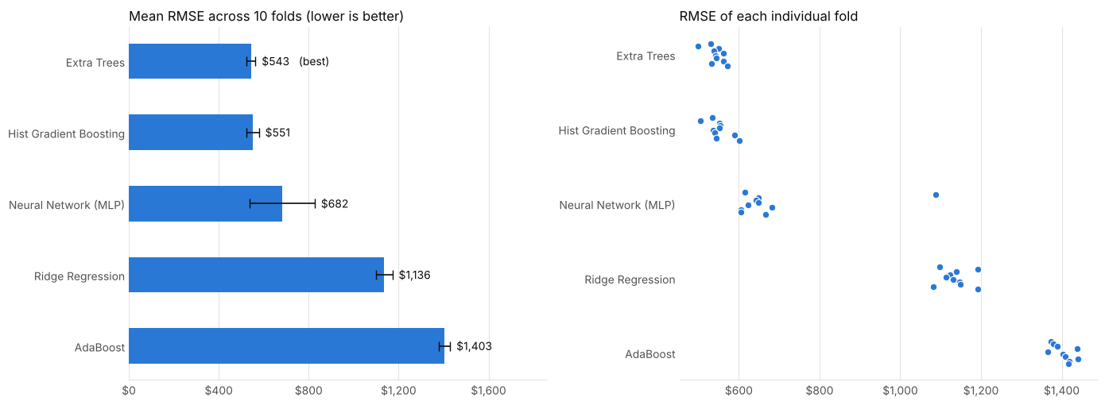
Figure 1: Mean RMSE of the five algorithms (left) and the RMSE of each individual fold (right)

7. Observations
- Extra Trees and Hist Gradient Boosting are practically tied. Extra Trees has the lowest mean RMSE ($543) and Hist Gradient Boosting follows at $551. The $8 gap is small compared with their standard deviation ($20 and $27).
- Tree-based models clearly beat the straight line. Ridge Regression has an RMSE of $1,136, more than twice that of the top two. The price of a diamond rises much faster than a straight line when the carat increases, which a linear formula cannot follow.
- AdaBoost was the weakest ($1,403). Its 50 shallow trees are not flexible enough for this much data; it would need many more estimators or deeper trees.
- The neural network is in the middle ($682) and unstable. Its RMSE changes a lot between folds (worst fold $1,087 against a best of $605) and it was the slowest to train, about 144 seconds.
- Accuracy versus speed. Extra Trees took about 88 seconds for the 10 folds, Hist Gradient Boosting only about 7.5 seconds, roughly 12 times faster for almost the same error.
- Size of the error. The best models are off by about 14% of the average price, so there is still room for improvement, for example with tuning.

8. Choosing the Model to Deploy
Cross validation is used to choose an algorithm; the ten models built inside it are thrown away. The chosen algorithm is then trained again on all 53,794 diamonds.
Extra Trees had the best RMSE, but a deployed model also has to fit on the hosting service. Extra Trees keeps 100 fully grown trees in memory and its saved file came out at about 682 MB, far above the roughly 100 MB limit for a GitHub file. So I added a rule to the notebook: go down the ranking and deploy the first model whose saved file is at most 50 MB.
Algorithm | Mean RMSE ($) | Model file size (MB) | Fits the limit?
Extra Trees | 542.84 | 682.25 | No
Hist Gradient Boosting | 551.05 | 0.37 | Yes
Table 8: Deployment size check
Hist Gradient Boosting was selected. It costs only $8 of extra RMSE, trains much faster, and its file is only 0.37 MB. It was saved, together with the whole pipeline, as diamond_price_model.pkl. Because the imputer, scaler and encoder are inside the file, the app can send raw diamond properties straight to the model.

9. Application Phase
The notebook loads the saved model and predicts the price of a new diamond (a 1.00 carat, Ideal cut, colour G, clarity VS2 stone). The feature vector must have the same columns in the same order as the training data.
example_diamond = {"carat": 1.00, "depth": 61.8, "table": 57.0, "x": 6.40, "y": 6.43,
"z": 3.97, "cut": "Ideal", "color": "G", "clarity": "VS2"}
feature_vector = pd.DataFrame([example_diamond])[numeric_features + categorical_features]
loaded_model = pickle.load(open("diamond_price_model.pkl", "rb"))
predicted_price = loaded_model.predict(feature_vector)[0]
# Predicted Price: $6,194.91
Code 3: Loading the saved model and predicting

10. Web Application and Deployment
The model is deployed as a Streamlit web app on Streamlit Community Cloud. The user enters the six measurements, picks the cut, colour and clarity, and presses Predict Price. The app shows the estimated price and the typical error of the model.
Live link: https://diamond-price-hunain.streamlit.app/
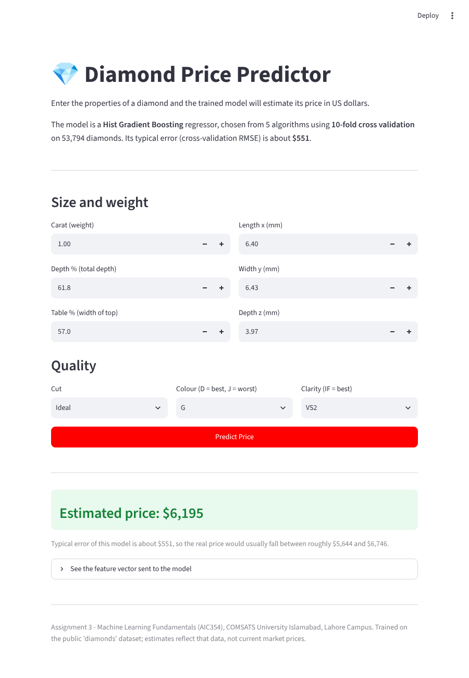
Figure 2: The Diamond Price Predictor web app returning $6,195 for the default diamond
Deployment steps:
- Create a public GitHub repository and upload the notebook, dataset, model file and the streamlit-app folder (app.py, requirements.txt, runtime.txt and the model).
- Sign in at share.streamlit.io with GitHub and choose Create app.
- Select the repository, the main branch and the main file path streamlit-app/app.py.
- Choose Python 3.13 (the version used to save the model) and press Deploy.
- Copy the public link and paste it at the very top of the notebook, as required by the assignment.

11. Feedback Phase
After deployment, feedback from users such as jewellers would help improve the system. Possible improvements are:
- Tune the hyper-parameters (learning rate, number of iterations, tree depth) of the best models using GridSearchCV; all five algorithms here used default settings.
- Predict the logarithm of the price instead of the price, which may reduce the error for cheap stones.
- Add information that affects real prices but is not in the data, such as the grading certificate or fluorescence.
- Retrain regularly, because the dataset is a snapshot and real prices change.
- Report an easier measure such as MAE or percentage error next to RMSE.

12. Conclusion
I compared Ridge Regression, AdaBoost, Extra Trees, Hist Gradient Boosting and a Neural Network on 53,794 unique diamonds using 10-fold cross validation and RMSE. Extra Trees was best ($543) with Hist Gradient Boosting almost identical ($551); the neural network ($682), Ridge Regression ($1,136) and AdaBoost ($1,403) were clearly worse.
The most useful lesson was that the best score is not always the model you can deploy. Extra Trees needed a file of about 682 MB, so I deployed Hist Gradient Boosting, which is faster, tiny (0.37 MB) and only $8 worse. The model was trained on all data, saved, and deployed as a live web application.

Files Submitted
- diamond_price_kfold_full_dataset_10fold.ipynb (notebook with the live link at the top)
- diamonds.csv (dataset)
- diamond_price_model.pkl (trained model)
- Live app: https://diamond-price-hunain.streamlit.app/

