COMSATS UNIVERSITY ISLAMABAD
Lahore Campus
Machine Learning Fundamentals (AIC354)
Assignment 2
Developing an End-to-End Machine Learning System
Item | Detail
Student Name | Hunain
Registration No. | FA24-BSE-083
Section | B
Program | BS Software Engineering
Instructor | Dr. Rao Muhammad Adeel Nawab
Semester | Fall 2026
Submission Deadline | Sunday, October 11, 2026, 23:59
Task 1 | Titanic Passenger Survival Prediction System (run, understand, deploy)
Task 2 | Heart Disease Prediction System (4 input attributes, UCI data)
Live Deployment Link | https://heart-disease-hunain-uci.streamlit.app/
GitHub Repository | https://github.com/Hunain-Riasat/HEART-DISEASE-PREDICTOR/tree/With-UCI-data

1. Introduction and Aim
The aim of this assignment is to learn how a complete Machine Learning system is built, from data collection to deployment, using structured data. The instructor provided the full code of a Titanic Passenger Survival Prediction System (the "half-cooked" approach). This report documents every step followed while running the Titanic project and then, in exactly the same way, building and deploying a Heart Disease Prediction System.

1.1 Learning outcomes covered
- Data collection, data understanding, data pre-processing and label encoding.
- The four phases of the Machine Learning cycle: Training, Testing, Application and Feedback.
- Deploying a trained model on the cloud so that anybody can use it from a browser.

1.2 Deliverables
Deliverable | File / Location
Jupyter Notebook (live link on top) | Heart_Disease_Prediction.ipynb (+ .html copy)
Dataset | sample-data.csv, heart-disease-original-cleveland.csv, encoded CSV files
Trained model | svc_trained_model.pkl
Cloud app | streamlit-app/ (app.py, requirements.txt, runtime.txt, model)
Documentation | This Word report

2. Task 1: Titanic Passenger Survival Prediction System
Before building the new system, the provided Titanic project was executed and studied. The same method was then re-used for the Heart Disease project.

2.1 Running the Titanic project on a local machine
- Extract the provided project folder and open a terminal inside the folder "1 - Titanic Survival Prediction".
- Create a virtual environment: python -m venv venv
- Activate it (Windows: venv\Scripts\activate.bat, macOS/Linux: source venv/bin/activate).
- Install the required libraries: pip install -r requirements.txt
- Register the Jupyter kernel and start Jupyter: python -m ipykernel install --user --name=titanic-venv, then jupyter notebook.
- Open the notebook and choose Kernel > Restart & Run All. All cells ran without error and gave an accuracy of 0.80.

2.2 Understanding the Titanic system
Aspect | Titanic System | Explanation
Problem type | Binary classification | Predict whether a passenger survived (1) or not (0).
Inputs | PClass, Gender, Sibling, Embarked | Four categorical attributes stored as text.
Output | Survived (Yes / No) | Target label.
Encoding | LabelEncoder | Converts text categories into numbers.
Model | Support Vector Classifier | svm.SVC(gamma="auto", random_state=0).
Split | 80% train / 20% test | train_test_split(test_size=0.2, random_state=0, shuffle=False).
Deployment | Streamlit Community Cloud | app.py loads the .pkl model and exposes a web form.

2.3 Deploying the Titanic model
The Titanic model was deployed with exactly the same procedure that is described in Section 5 (GitHub repository, requirements.txt, app.py and Streamlit Community Cloud). The assignment allows any cloud platform (for example PythonAnywhere or Streamlit), and Streamlit Community Cloud was used because the instructor's live demo uses it.

3. Task 2: Heart Disease Prediction System
The Titanic notebook was modified step by step. The structure of the notebook was not changed: Import Libraries, Load Data, Understand and Pre-process, Label Encode, Training Phase, Testing Phase, Application Phase, Feedback Phase and Deployment. Only the data, attribute names and labels were replaced.

3.1 Step 1: Data collection (download from UCI)
- Open https://archive.ics.uci.edu/dataset/45/heart+disease (UCI Machine Learning Repository, Heart Disease dataset).
- Click the Download button on the right side to get heart+disease.zip and extract it.
- Use the file processed.cleveland.data (Cleveland database, 303 patients, no header row) and keep it as the original data.
- Add the 14 column names (age, sex, cp, trestbps, chol, fbs, restecg, thalach, exang, oldpeak, slope, ca, thal, num) and save it as heart-disease-original-cleveland.csv inside the project folder.
The Cleveland file has 303 patients, 13 input attributes and one outcome column (num: 0 = no disease, 1 to 4 = disease). Missing values are written as ? (4 in ca and 2 in thal).
Column | Meaning | Type
age | Age in years | Numeric
sex | 1 = male, 0 = female | Binary
cp | Chest pain type | Categorical
trestbps | Resting blood pressure | Numeric
chol | Serum cholesterol (mg/dl) | Numeric
fbs | Fasting blood sugar > 120 mg/dl | Binary
restecg | Resting ECG result | Categorical
thalach | Maximum heart rate achieved | Numeric
exang | Exercise-induced angina (1 = yes) | Binary
oldpeak | ST depression induced by exercise | Numeric
slope | Slope of the peak exercise ST segment | Categorical
ca | Number of major vessels coloured by fluoroscopy (0-3) | Count
thal | Thalassemia result | Categorical
num | Outcome (0 = no disease, 1 to 4 = disease) | Categorical

3.2 Step 2: Data understanding and selection of 4 input attributes
The assignment constraint is to select only 4 input attributes. Candidate attributes with a clear meaning were converted into text categories and every combination of four attributes was compared with 5-fold cross-validation using the same SVC model. The selected combination gives about 78% cross-validated accuracy and every attribute has a clear medical meaning.
Input attribute | UCI column | Conversion to text labels | Possible values
Gender | sex | 1 = Male, 0 = Female | Male, Female
ExerciseAngina | exang | 1 = Yes, 0 = No | No, Yes
STDepression | oldpeak | 0 = Absent, 0 to 1.5 = Mild, above 1.5 = High | Absent, Mild, High
Vessels | ca | 0..3 mapped to words (Zero, One, Two, Three) | Zero, One, Two, Three
HeartDisease (output) | num | 0 = No, 1 to 4 = Yes (disease present) | Yes, No

Important data note: 6 patients have a missing value (?) in ca or thal. Because ca is one of the selected inputs, these 6 rows were removed, leaving 297 patients (137 with heart disease and 160 without). The output num was converted into a binary label: Yes when num is 1 to 4, otherwise No.

3.3 Step 3: Data pre-processing
The 4 attributes were converted to text labels (as in the Titanic file, where values such as First, Male, Zero are text) and the 6 rows with missing values were removed. The result was saved as sample-data.csv (297 rows).
Gender | ExerciseAngina | STDepression | Vessels | HeartDisease
Male | Yes | Mild | One | Yes
Male | No | Mild | Zero | Yes
Male | No | Mild | One | No
Female | Yes | High | Two | Yes
Female | No | Absent | One | No

Sample rows of sample-data.csv
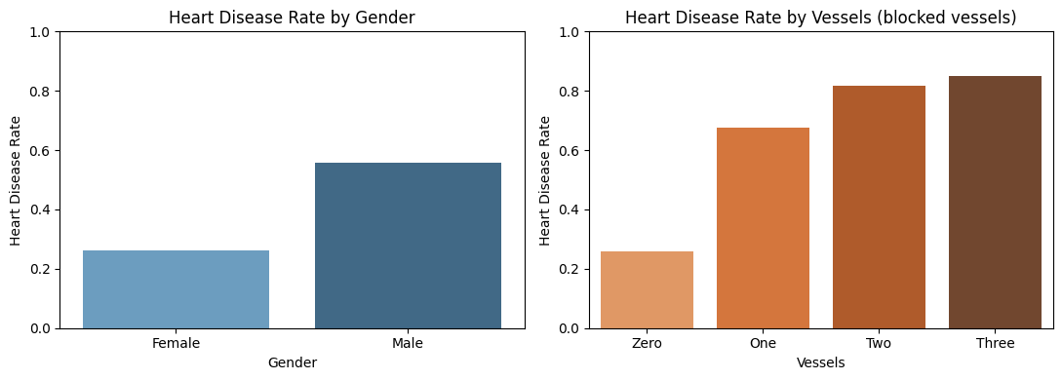
Figure 1: Heart disease rate by Gender and by number of coloured vessels

3.4 Step 4: Label encoding
Machine learning models need numbers, so every text attribute was converted with scikit-learn LabelEncoder. One encoder is trained per attribute, using the fixed list of possible categories. LabelEncoder assigns codes in alphabetical order.
Attribute | Learned codes
Gender | Female = 0, Male = 1
ExerciseAngina | No = 0, Yes = 1
STDepression | Absent = 0, High = 1, Mild = 2
Vessels | One = 0, Three = 1, Two = 2, Zero = 3
HeartDisease (output) | No = 0, Yes = 1

gender_label_encoder = LabelEncoder()
gender_label_encoder.fit(np.ravel(gender))
# ... same for ExerciseAngina, STDepression, Vessels, HeartDisease
sample_data_encoded.to_csv("sample-data-encoded.csv", index=False)

3.5 Step 5: Training phase
- Split the encoded data: 80% training (237 rows) and 20% testing (60 rows) using the same train_test_split call as the Titanic notebook with random_state=0, plus shuffle=True and stratify on the output so that both parts keep the same share of patients with and without heart disease; saved as training-data-encoded.csv and testing-data-encoded.csv.
- Separate the input vectors (first 4 columns) from the output label (last column).
- Train the Support Vector Classifier on the training data.
- Save the trained model with pickle as svc_trained_model.pkl.
svc_model = svm.SVC(gamma="auto", random_state=0)
svc_model.fit(input_vector_train, np.ravel(output_label_train))
pickle.dump(svc_model, open("svc_trained_model.pkl", "wb"))

Additionally (as in the enhanced Titanic notebook), Logistic Regression and a Decision Tree were trained on the same data to compare models. The SVC was saved and deployed, consistent with the original notebook.
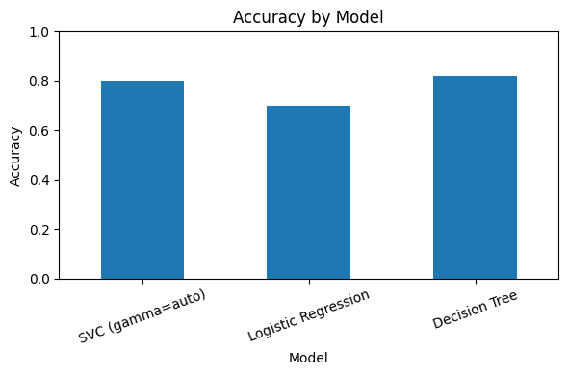
Figure 2: Accuracy of the three compared models

3.6 Step 6: Testing phase
The saved model was loaded and used to predict the 60 unseen test patients. The predictions were saved in model-predictions.csv and compared with the true labels.
Model | Accuracy | Precision | Recall | F1-score
SVC (gamma=auto) - deployed | 0.80 | 0.80 | 0.80 | 0.80
Logistic Regression | 0.70 | 0.70 | 0.70 | 0.70
Decision Tree | 0.82 | 0.82 | 0.82 | 0.82

Confusion matrix of the deployed SVC: 25 healthy patients and 23 patients with heart disease were classified correctly; 7 healthy patients were wrongly flagged and 5 patients with disease were missed (recall for heart disease = 0.82).
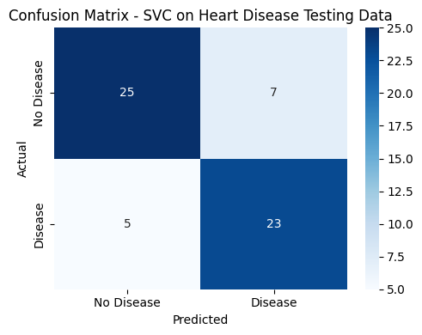
Figure 3: Confusion matrix of the SVC on the test data

3.7 Step 7: Application phase
A new patient is entered as text, converted into the same feature vector, label-encoded with the same encoders, and passed to the loaded model. Example: Male, ExerciseAngina = Yes, STDepression = High, Vessels = Two gives the encoded vector [1, 1, 1, 2] and the prediction HEART DISEASE.
user_input = pd.DataFrame({"Gender": ["Male"], "ExerciseAngina": ["Yes"],
"STDepression": ["High"], "Vessels": ["Two"]})
unseen = user_input.copy() # each column encoded with its LabelEncoder
prediction = model.predict(unseen) # 1 -> HEART DISEASE, 0 -> NO HEART DISEASE

3.8 Step 8: Feedback phase
Feedback from domain experts and users is collected and used to improve the system. Suggested improvements recorded in the notebook:
- Use more input attributes (age, chest pain type, cholesterol, maximum heart rate).
- Keep numeric attributes as numbers with feature scaling instead of grouping them.
- Use cross-validation and larger datasets for a more reliable evaluation.
- Compare more models and prefer high recall, because missing a sick patient is more costly than a false alarm.

4. Project Folder Structure
Heart_Disease_Project/
README.md, requirements.txt, runtime.txt, .gitignore
2 - Heart Disease Prediction/
Heart_Disease_Prediction.ipynb (+ .html)
sample-data.csv, sample-data-encoded.csv, sample-data-encoded-output.csv
training-data-encoded.csv, testing-data-encoded.csv, model-predictions.csv
heart-disease-original-cleveland.csv, svc_trained_model.pkl, requirements.txt
streamlit-app/
app.py, requirements.txt, runtime.txt, svc_trained_model.pkl, README.md

5. Deployment on GitHub and Streamlit Community Cloud
The trained model is deployed as a public web app. The steps below were followed for both the Titanic and the Heart Disease model.

5.1 Test the app locally
cd streamlit-app
pip install -r requirements.txt
streamlit run app.py
# opens http://localhost:8501

5.2 Upload the project to GitHub
- Create a free account at https://github.com and sign in.
- Click + (top right) > New repository. Name it HEART-DISEASE-PREDICTOR, select Public and click Create repository.
- Either upload with the browser: Add file > Upload files, drag the complete project folder contents and click Commit changes.
- Or upload with git from the project folder: git init, git add ., git commit -m "Heart disease predictor", git branch -M main, git remote add origin https://github.com/Hunain-Riasat/HEART-DISEASE-PREDICTOR.git, git push -u origin main.
- Make sure the file streamlit-app/app.py, requirements.txt and svc_trained_model.pkl are visible in the repository.

5.3 Deploy on Streamlit Community Cloud
- Go to https://share.streamlit.io and choose Sign in with GitHub, then authorize Streamlit.
- Click Create app > Deploy a public app from GitHub.
- Repository: Hunain-Riasat/HEART-DISEASE-PREDICTOR. Branch: main. Main file path: streamlit-app/app.py.
- Optionally choose a custom app URL in Advanced settings and select Python 3.11 (or 3.12).
- Click Deploy and wait one to two minutes while requirements.txt is installed.
- Copy the public URL (https://<name>.streamlit.app) and paste it at the very top of the Jupyter notebook and on the title page of this report.

5.4 Troubleshooting
Problem | Solution
ModuleNotFoundError for a package in requirements.txt | Settings > General > Python version: select 3.11 or 3.12 and save.
App stuck on "in the oven" | Click Manage app, read the build log, fix requirements.txt and reboot.
requirements.txt ignored | Keep it in the same folder as app.py (streamlit-app/).
Pickle / scikit-learn version warning | Keep scikit-learn==1.7.2 (version used for training) in requirements.txt.

Screenshot of the live application (paste here after deployment):

6. Submission Checklist (Google Classroom)
- Upload the project zip: notebook, dataset, trained model and app files.
- Live cloud deployment link written at the very top of the Jupyter notebook.
- Run the notebook once with Restart & Run All so that all outputs are saved.
- Submit before Sunday, October 11, 2026, 23:59 (5% deduction per day late; not accepted after 3 days).

7. Conclusion
A complete end-to-end machine learning system was built for heart disease prediction by modifying the Titanic code while keeping exactly the same steps. Using only four input attributes (Gender, ExerciseAngina, STDepression, Vessels) from the UCI Heart Disease dataset, the Support Vector Classifier reached 80% accuracy on unseen data, with a recall of 82% for patients with heart disease. The model was packaged as a Streamlit web application and deployed on the cloud through GitHub. The system is an educational example and must not be used for real medical decisions.

