Architecture Documentation
Enterprise Document Intelligence Platform
The platform is a full-stack Retrieval-Augmented Generation (RAG) system built as a single linear pipeline: a question or document enters at the top through the user, and moves stage by stage down to a grounded, cited answer. Each stage has one responsibility and passes a well-defined artifact to the next — raw files become cleaned text, cleaned text becomes chunks, chunks become vectors, vectors become retrieved evidence, and evidence becomes an answer. The diagram below shows this flow end to end.
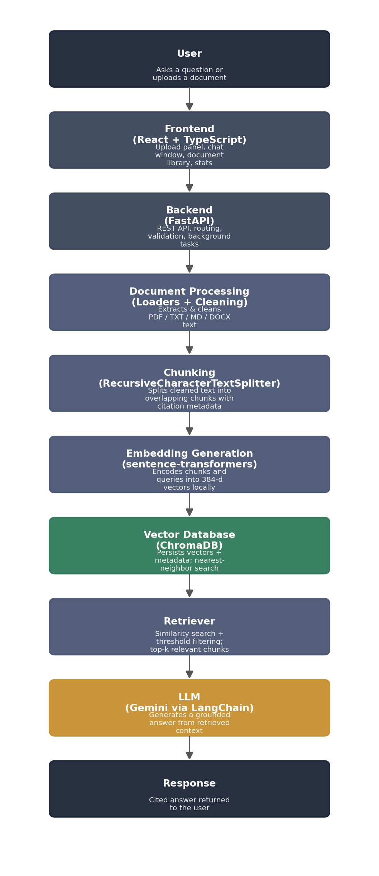
Figure 1. End-to-end system architecture, from user request to cited response.

Component Descriptions
1. User
The end user of the platform is someone who uploads business documents and asks natural-language questions about them. The user never talks to the backend directly; every action (upload, ask, delete, refresh) is mediated through the frontend dashboard, and every response the user sees carries source citations so claims can be verified against the original document.
2. Frontend (React + TypeScript)
A Vite/React dashboard with four panels including Upload, Chat, Document Library, and Stats communicate with the backend through a shared Axios client. It handles drag-and-drop or file-picker uploads with per-file progress, polls document status until processing completes, renders chat as bubbles with collapsible source citations, lets users filter chat and search by selected documents, and offers dark mode and chat export. The frontend holds no business logic it only calls REST endpoints and renders their responses.
3. Backend (FastAPI)
The single entry point for all requests. FastAPI validates incoming data (file extensions, request schemas via Pydantic), exposes the REST surface (/api/documents, /api/chat, /api/search, /api/stats), enables CORS for the frontend origin, and schedules long-running work such as document processing as background tasks so uploads return immediately instead of blocking on parsing. It also owns persistence: a SQLite database tracks document metadata, chat sessions, and logged Q&A turns.
4. Document Processing (Loaders + Cleaning)
Once a file is uploaded and saved to disk, a background task picks the loader matching its type from PDF, TXT, Markdown, or DOCX and extracts raw text. Every loader returns the same shape, a list of {page_number, text} records, so later stages never need to know the source format. A cleaning step then strips non-printable characters, collapses whitespace, removes empty lines, and conservatively drops repeated headers/footers across multi-page documents before anything is chunked.
5. Chunking
Cleaned page text is split into overlapping segments using LangChain's RecursiveCharacterTextSplitter (500 characters per chunk, 50-character overlap by default). Overlap prevents meaning from being lost exactly at a chunk boundary. Every chunk keeps citation metadata, document_id, filename, page_number, chunk_index, so it can later be traced back to an exact location in the source document.
6. Embedding Generation
Each chunk's text is encoded into a 384-dimensional vector using a locally-run sentence-transformer model (all-MiniLM-L6-v2), batched for efficiency. Running embeddings locally, rather than through a hosted API, keeps ingestion free of LLM quota and independent of network latency. The same encoder is reused at query time, which is essential: document and query vectors must come from the identical model to be meaningfully comparable.
7. Vector Database (ChromaDB)
A persistent ChromaDB collection stores every chunk's vector alongside its text and metadata, with documents logically separated by a document_id field rather than by physical collection. It supports insert, delete-by-document, and metadata-filtered nearest-neighbor query. Stable IDs (document_id:chunk_index) make reprocessing idempotent and refreshing a document deletes its old vectors before inserting new ones, so nothing is duplicated.
8. Retriever
At query time, the user's question is embedded with the same model used for documents, then matched against the vector store to find the nearest chunks. A similarity-score threshold (derived from vector distance) filters out weakly related results before they reach the prompt, and an optional document_id filter scopes retrieval to a user-selected subset. When a conversation has history, the retriever first rewrites a contextual follow-up into a standalone query so pronouns and implicit references don't degrade the embedding.
9. LLM (Gemini via LangChain)
The retrieved, threshold-passing chunks are assembled into a versioned, strictly-grounded prompt, keeps source-labeled context blocks, recent conversation history for reference resolution only, and explicit instructions to answer solely from context and say “I don't know” otherwise. This prompt is sent to Gemini through LangChain, with low temperature (0.2) for extractive rather than creative answers, and retry/backoff around quota or rate-limit errors.
10. Response
The model's answer is paired with de-duplicated source citations like filename, page number, exact chunk text, and similarity score logged to SQLite for the session, and returned to the frontend along with the session ID for continued conversation. This is the artifact the user actually sees: a grounded answer that can be checked, turn by turn, against the documents it came from.

