Designing Enterprise Retrieval-Augmented Generation Systems
Technical Research Report
Retrieval-Augmented Generation (RAG) has become the default architecture for grounding large language models (LLMs) in private, up-to-date, or domain-specific knowledge. Rather than retraining or fine-tuning a model on proprietary documents, RAG retrieves relevant text at query time and injects it into the model's context window, letting the LLM reason over facts it was never trained on. This report examines the core design decisions behind an enterprise-grade RAG system, using a working Document Intelligence Platform (FastAPI, LangChain, Gemini, ChromaDB, React) as the reference implementation.

1. Architecture
An enterprise RAG system has two distinct pipelines that share a single vector store: an ingestion pipeline that runs once per document, and a query pipeline that runs on every user question. Separating them lets each be scaled, cached, and monitored independently — ingestion is I/O- and CPU-bound (parsing, chunking, embedding), while the query path is latency-sensitive and LLM-bound.
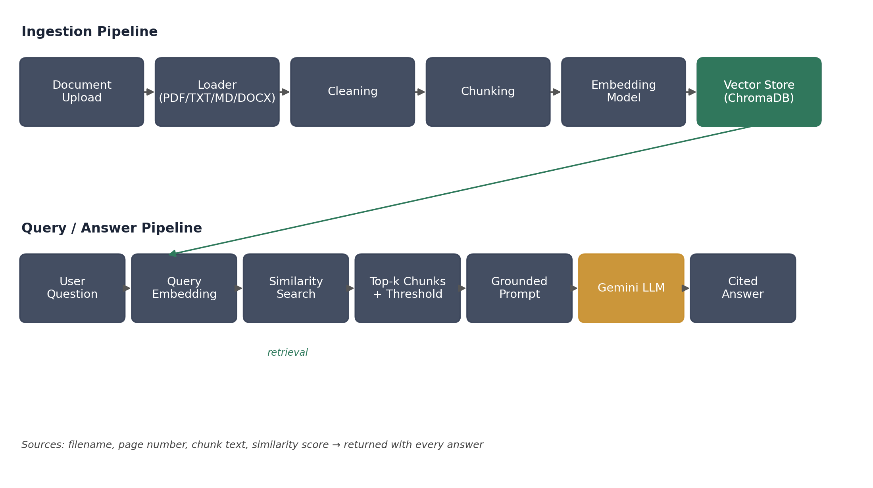
Figure 1. Ingestion and query pipelines, connected through a shared vector store.
Key architectural principles: (1) statelessness at the API layer, with all durable state — document metadata, chunks, chat sessions — in SQLite and the vector index; (2) asynchronous ingestion, so uploads return immediately while background tasks parse, chunk, embed, and index; (3) a uniform document-loader interface (a list of {page_number, text} records) so PDF, TXT, Markdown, and DOCX sources are indistinguishable to every downstream stage; and (4) graceful degradation, where a failed pipeline stage marks the document “failed” without crashing the service.

2. Chunking
LLMs and embedding models both have finite context windows, and retrieval precision degrades when chunks are too large (diluted relevance) or too small (lost context). A recursive character splitter with a fixed chunk size and overlap — 500 characters with a 50-character overlap, in the reference system — balances these concerns: overlap prevents a sentence from being severed exactly at a chunk boundary and losing meaning on both sides.
- Metadata carried per chunk: document_id, filename, page_number, chunk_index — the minimum needed to cite a source precisely.
- Chunking happens after cleaning (whitespace collapse, header/footer removal), so chunk boundaries reflect real content, not extraction noise.
- Chunk size is a tunable trade-off: larger chunks reduce the number of vectors and preserve more context per retrieval, but increase the chance that a chunk mixes multiple topics and dilutes its embedding.

3. Embeddings
Embeddings map text into a fixed-length vector space where semantic closeness corresponds to geometric closeness — typically measured with cosine similarity. Running embeddings locally through a sentence-transformer (all-MiniLM-L6-v2, 384 dimensions) rather than through a hosted API keeps ingestion cost-free and independent of LLM provider quota, and is fast enough to batch-encode chunks (batch_size=32) without a GPU.
The same embedding function must be used for both documents and queries, and its output dimension is fixed for the lifetime of a vector collection — changing embedding models requires re-embedding the entire corpus, since vectors from different models are not comparable.

4. Vector Databases
A vector database indexes embeddings for approximate nearest-neighbor search at scale and, critically for enterprise use, stores metadata alongside each vector so results can be filtered (by document, tenant, date, permission) without a separate lookup. ChromaDB was used here as an embedded, persistent store; FAISS is a lighter-weight alternative for pure similarity search without built-in metadata filtering or persistence.
- Collections separate logical indexes; a single shared collection with document_id metadata avoids the overhead of one collection per document while still allowing scoped retrieval.
- Stable, content-derived IDs (document_id:chunk_index) make re-indexing idempotent — deleting-then-inserting on refresh avoids duplicate vectors.
- Embedding dimension is locked to a collection after first insert; production systems should version collections alongside embedding-model versions rather than mutate them in place.

5. Retrieval
At query time the user's question is embedded with the same model used for documents, then compared against the stored vectors to retrieve the k nearest chunks. Distance alone is not a reliable stopping condition: a similarity threshold (score = 1 / (1 + distance), floor of 0.25 in the reference system) discards weakly related chunks so the LLM is not handed irrelevant context, and the system can honestly answer “I don't know” without ever calling the LLM when nothing clears the bar.
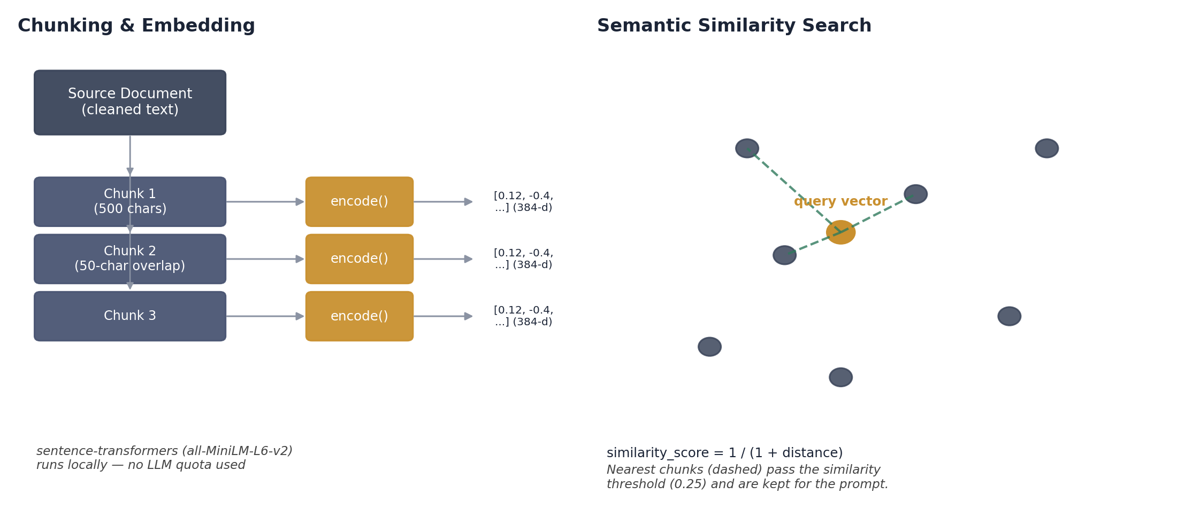
Figure 2. Chunk → vector encoding, and nearest-neighbor retrieval against a query vector.
Two retrieval refinements matter in conversational settings. First, metadata filtering restricts search to a user-selected subset of documents (where={document_id: [...]}). Second, follow-up questions (“what about the second one?”) are ambiguous out of context, so the reference system rewrites them into standalone queries using recent chat history before embedding — otherwise a pronoun-laden query embeds poorly and retrieves unrelated chunks.

6. Prompt Construction
The prompt is the contract between retrieval and generation. A versioned, strictly-grounded template instructs the model to answer only from supplied context, to say “I don't know” when context is insufficient, and to cite the source document and page for every claim. Recent conversation turns are placed before the retrieved context and are explicitly scoped to reference resolution, not as evidence — keeping the model from treating its own prior answers as ground truth.
- Source-labeled context blocks (filename + page number) let the model attribute claims directly, rather than inferring which chunk supported which sentence.
- Prompt versioning (e.g. rag_prompt_v1) lets answer quality be tracked against a specific template as it evolves.
- Caching answers by (normalized query, document filter, session context) avoids repeated LLM calls for repeated demo or FAQ-style questions.

7. Hallucination Reduction
Hallucination in RAG is reduced, not eliminated, by narrowing what the model is allowed to draw on and making that boundary enforceable rather than aspirational.
- Similarity thresholding removes low-relevance chunks before they ever reach the prompt.
- Grounding instructions plus an explicit “I don't know” escape hatch reduce the incentive to fabricate when evidence is thin.
- Source citations (filename, page, exact chunk text, score) make every claim independently checkable by the reader — verifiability is a stronger defense than a lower temperature setting.
- Low temperature (0.2) reduces creative drift in claims that should be extractive rather than generative.
- Chat logging (query, sources, answer) creates an audit trail for later evaluation of retrieval quality and context precision.

8. Future Improvements
- Hybrid search: combine dense vector similarity with sparse keyword/BM25 matching so exact terms (IDs, names, codes) aren't lost to semantic approximation.
- Re-ranking: apply a cross-encoder over the top-k retrieved chunks to reorder by true relevance before prompting, improving context precision beyond raw cosine distance.
- Automatic summarization and suggested questions on upload, to help users discover what a document can answer.
- Token-usage and cost dashboards, and structured evaluation (retrieval precision/recall, answer faithfulness) instead of ad-hoc spot checks.
- Access-controlled retrieval, filtering chunks by user/tenant permissions at query time rather than trusting client-supplied document IDs.

