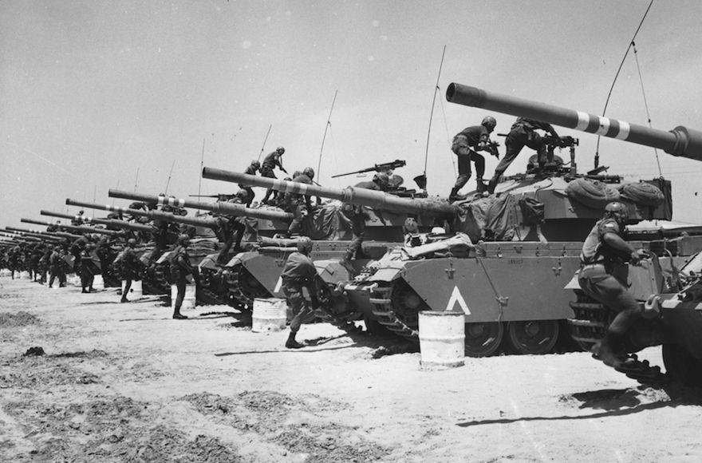

Wars of the middle east

A song of stats and data

Eli Hundia

By Eli Hundia – I.D. 037028636

Data Visualization course, MSC, Haifa university

Dr. Peter Bak

2.9.2017

table of contents

Introduction 2

The data – The "What stage" 2

Background 2

Format 2

Usage manner 3

The reason – "Why" the data is an interesting one 3

General user task: How do wars in the middle east effect economy of a country in the region? 3

Specific user task: Discover how wars effects High-technology exports in the 20th century 3

General user task: How do wars in the middle east effect the population of a country in the region? 4

General user task: How do wars in the middle east effect the military financially? 4

General user task: How do wars in the middle east effect the education and science? 4

General user task: Enjoy exploring data from different times in correlation to dates of wars. 5

# 

# Introduction

The project is about a range of different stats and data over the years about Israel and its tier-1 neighbors, Joran, Egypt, Lebanon and the Palestinian authority.

The project focuses the times of wars between the countries, several years before and after each war in hope to see how a war has influenced the countries involved in different aspects such as population stats, financial stats, education and military.

I believe that presenting the raw data collected, in an aspect of how the past wars in the middle east had affected the fighting countries and the region in a scope of before and after each war, can be an extremely useful tool for researchers from different fields, fields like economics, history, social researchers and more that wish to study the effects of wars on their fields of research.

# The data – The "What stage"

## Background

The source for all the data was the "World bank of data", <https://data.worldbank.org/>, in which I extracted a subset of data for the countries mentioned above. I Also relied on Wikipedia for a general description of each war.

The data gathered is a subset of a larger data about countries worldwide, Data that is categories over 1506 different categories about a variety of different interests and topics such a population, economics, education and much more.

The subset data collected is of the years 1960 to 2016, and for the tier-1 countries surrounding Israel.

## Format

The data itself comes in a CSV format, which is a Table dataset type with items and attributes which are categories and ordered sequentially by years. The values themselves are quantitative.

The dataset has 3 key attributes that play a role in defining the dataset

* The country
* The Type of data called Category
* The value in a given year.

The dataset comes in 3 separate files

1. The primary dataset file contains lines of the following attributes:

* Country name
* Country code
* Category indicator name
* Category Indicator code
* Values for the indicator per year, ranging from 1960 to 2016.

1. A category explanation file, which maps a category to its extended explanation / information about it.
2. A mapping file form the country indicator code to its actual country name. (Unnecessary since in the primary file there is both).

## Usage manner

For convenience, the dataset was converted from CSV files to JSON files to ease of work in JavaScript in which JSON format comes naturally in the language.

The way I treated the data is in a three-dimensional manner where the 3rd dimension is by looking at each year at several countries per category.

# The reason – "Why" the data is an interesting one

The list of questions you can ask about such data is pretty much endless, it can be interesting for different researches in a wide range of research fields to ask different questions.

I have assembled a number of user tasks, from different categories in to ask different types of questions.

## General user task: How do wars in the middle east effect economy of a country in the region?

### Specific user task: Discover how wars effects High-technology exports in the 20th century

#### User task 1

##### Action

Analyze operation pillar of defense in 2012 effect on High-Tech exports in Israel and the Palestinian Authority.

##### Target

Find Trends in the high-technology exports for Israel and Palestine Authority caused in the year following the operation.

#### User task 2

##### Action

Analyze Lebanon war in 2006 effect on High-Tech exports in Israel and Lebanon.

##### Target

Find Trends in the high-technology exports for Israel and Lebanon caused in the year following the operation.

## General user task: How do wars in the middle east effect the population of a country in the region?

#### User task 3

##### Action

Analyze 1973 Yom Kippur war effect on the annual population growth.

##### Target

Identify outliers that may result due to the war.

## General user task: How do wars in the middle east effect the military financially?

#### User task 4

##### Action

Query both intifada's and record the data on the year before during and after the intifada.

##### Target

Identify trends and similarities between the two to find if there is a similar effect on the arms import for Israel.

## General user task: How do wars in the middle east effect the education and science?

#### User task 5

##### Action

Analyze the first Lebanon war in 1982 and analyze its effect on the amount of trademark applications registered for Israel and Lebanon.

##### Target

Identify trends in the year before and after the war.

## General user task: Enjoy exploring data from different times in correlation to dates of wars.

#### User task 6

##### Action

Scroll through the different wars, reading general information about each war.

##### Target

Read general information about each war / conflict, who participated and how it concluded to enjoy a good history lesson.

#### User task 7

##### Action

Scroll through the different wars, look at random arbitrary stats from different categories.

##### Target

Get exposed to some interesting stats topics that aren’t necessarily war related, some sort of fun facts for casual people.

# A story about a server and the browser – "How" to represent our cool data

Talk:

1. What – explain the data
2. Why - User task – Questions and what can you learn.
   1. Action
   2. Target
3. how – Why this visualization – Show visualization example screenshot for each action target.
   1. Explain the process, tried bar chart show the bar chart and show why its bad.
   2. Why line chart is better
4. Evaluation