Nguyễn Hùng Anh 21064051

Exercises 3: Preprocessing with WEKA-Explorer on the dataset student.arff
- Loading the dataset into Explorer.
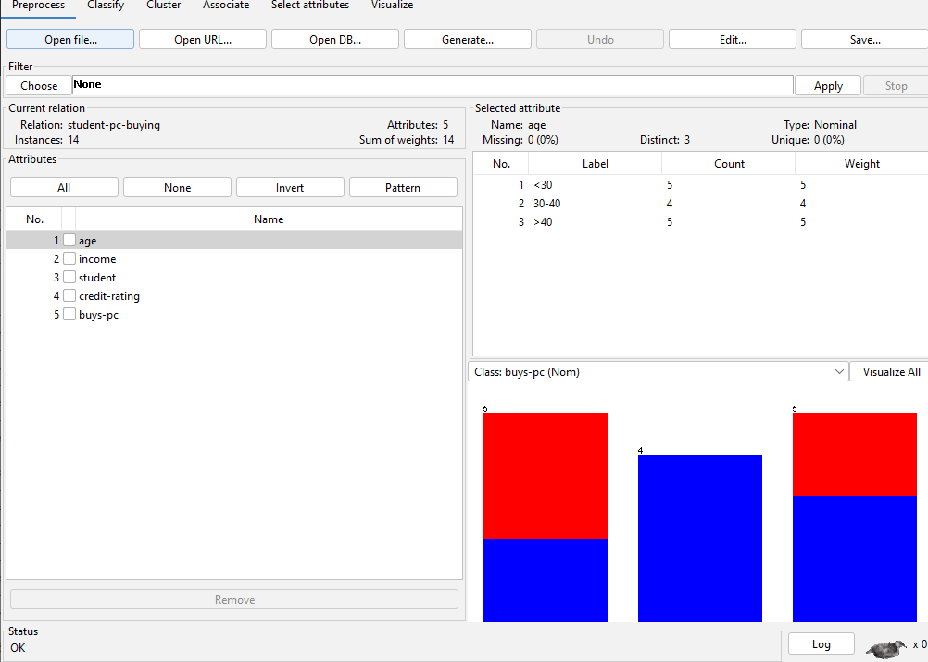
- Examming dataset with requirements in exercise 1

 | student
What’s the name of the relation? | 14
Number of records in each dataset | 14
How many instances does each dataset have? | 5
How many attributes?
  Attribute | Type
  age | Nominal
  income | Nominal
  student | Nominal
  credit-rating | Nominal
  buyspc | Nominal
List attribute names and their types.
   | Values can have | Missing | Distinct | Unique | Basic statistics
   |  |  |  |  | Lable | Count | Weigth
  age | 3 | 0(0%) | 3 | 0(0%) | <30  30-40  >40 | 5  4  5 | 5  4  5
  income | 3 | 0(0%) | 3 | 0(0%) | high  medium  low | 4  6  4 | 4  6  6
  student | 2 | 0(0%) | 2 | 0(0%) | yes  no | 7  7 | 7  7
  credit-rating | 2 | 0(0%) | 2 | 0(0%) | fair  excellent | 8  6 | 8  6
  buyspc | 2 | 0(0%) | 2 | 0(0%) | yes  no | 8  6 | 8  6
Click on each attribute, observe, and tell:
• What are the values that each attribute can have?
• Missing: The number (and percentage) of instances in the data for which this
attribute is missing (unspecified)
• Distinct: The number of different values that the data contains for this attribute.
• Unique: The number (and percentage) of instances in the data having a value for
this attribute that no other instances have.
• Show the basic statistics on the attributes for the categorical attributes the
frequency of each attribute, or for the continuous attributes, show the value of
min, max, mean, standard deviation and deviation etc.,
Identify the class attribute (if any). Determine the number of records for each class | buyspc: 14
Plot Histogram
  Attribute | Plot Histogram
  age | 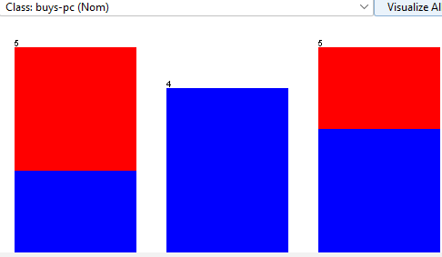
  income | 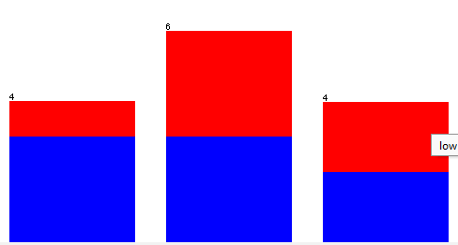
  student | 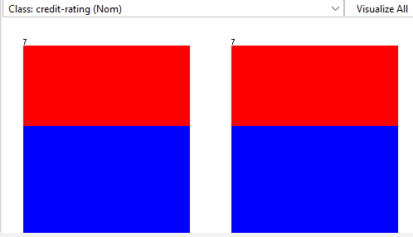
  credit-rating | 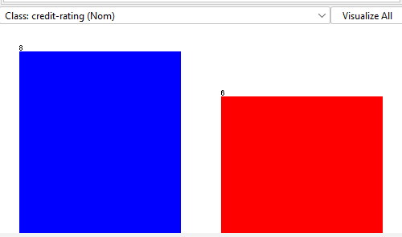
  buyspc | 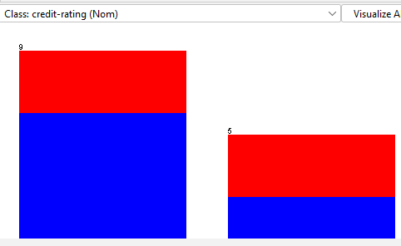

- What is the class value of instance number 8 in the student data?
Giá trị của class số 8 là: “no”
- Preprocessing data by selecting or filtering attributes.
• Removing an attribute
Trước khi xóa:
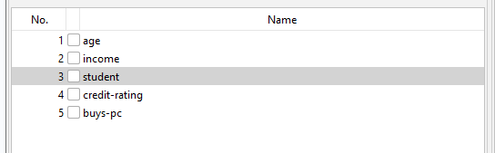
Sau khi xóa:
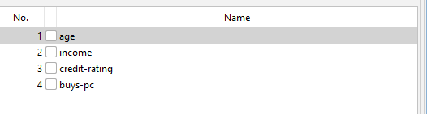
• Saving the new working relation as an arff file
Bản lưu mới được đặt tên là student2.arff
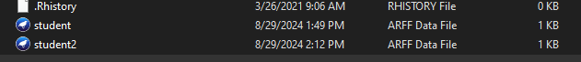
• Discretizing the age attribute with the number of bins is 3
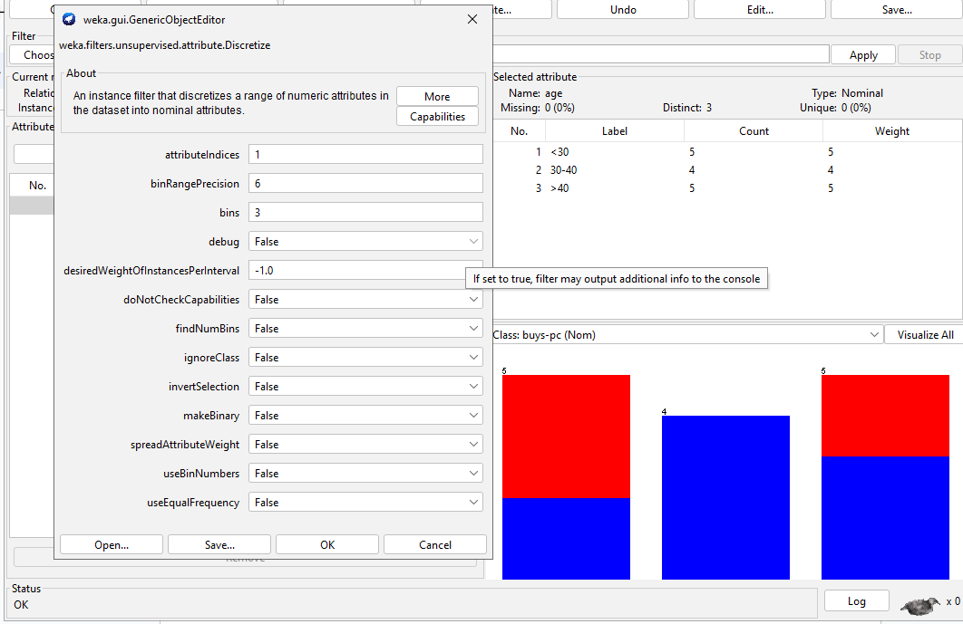
• Saving the new working relation in a file called student-data-discretized.arff
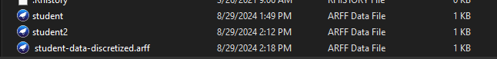
Exercises 4: Preprocessing with WEKA-Explorer on Nominal data: the Weather (nominal) dataset.
- Loading the dataset into Explorer.
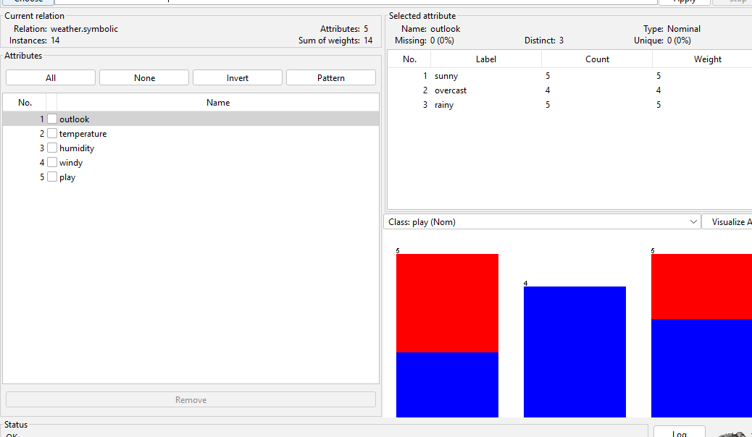
- How many instances are listed in the dataset?
14
- How many attributes?
5
-What’s the attributes names?
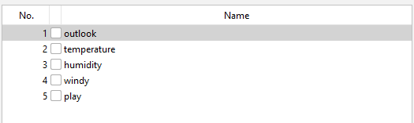
-What type of attributes are these? Which one is the class?
outlook: Nominal
temperature: Nominal
humidity : Nominal
windy: Nominal
play: Nominal

- What is the function of the first column in the Viewer window?
Soft view, menu outlook
- What is the class value of instance number 8 in the weather data?
“no”

- Proprocessing data
• Removing an attribute from the dataset:
Trước khi xóa:
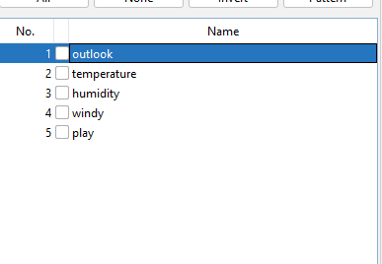
Sau khi xóa:
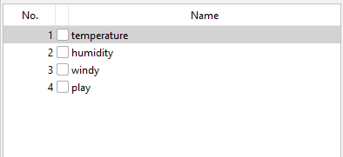

• Saving the new working relation as an arff file

• Using the filter weka.unsupervised.instance.RemoveWithValues to remove all instances in which the humidity attribute has the value high.
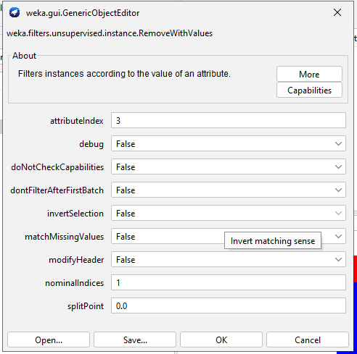
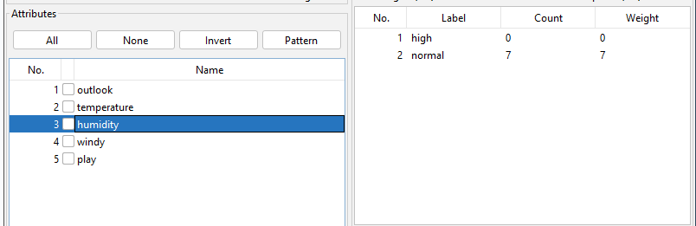

• Observing changes throught a viewer for editing
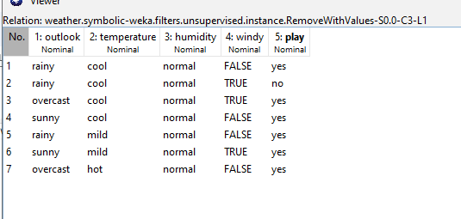
Exercises 5: Apply Preprocessing techniques to the dataset of Weather.

-Add a Climate attribute.
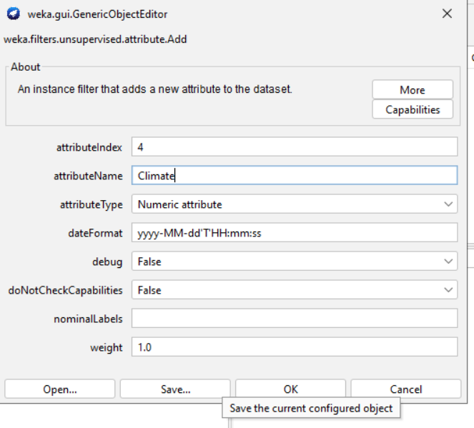
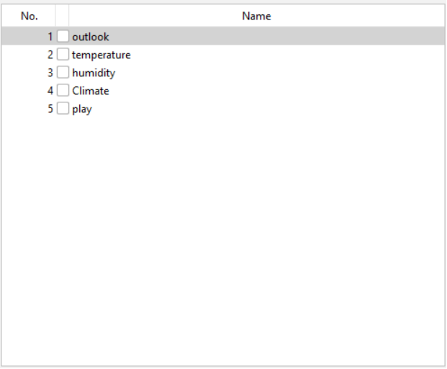
-Remove an attribute (select any attribute)
Trước khi xóa
Sau khi xóa:
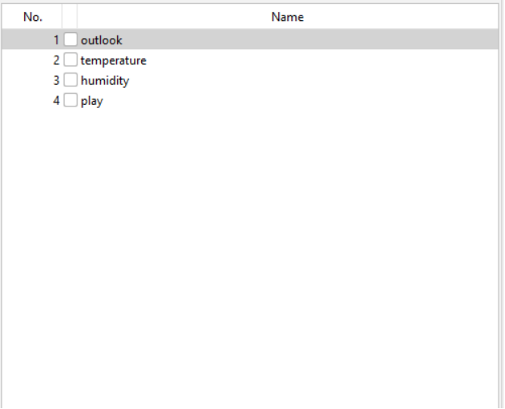
-Normalization: select numeric attributes to normalize
Trước khi chuẩn hóa:
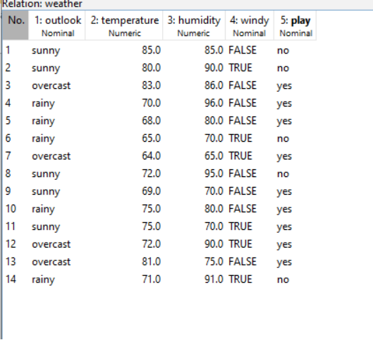
Sau khi chuẩn hóa:
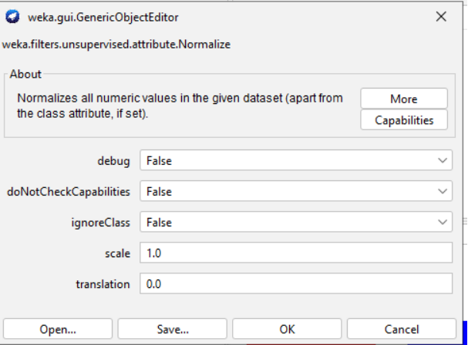
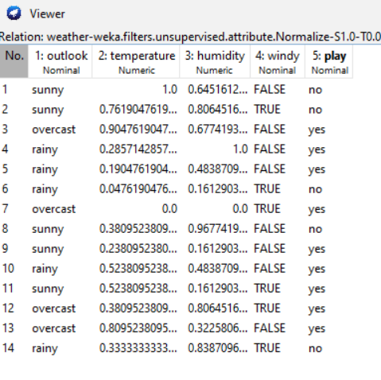
Exercises 6: - Create a dataset Employee as
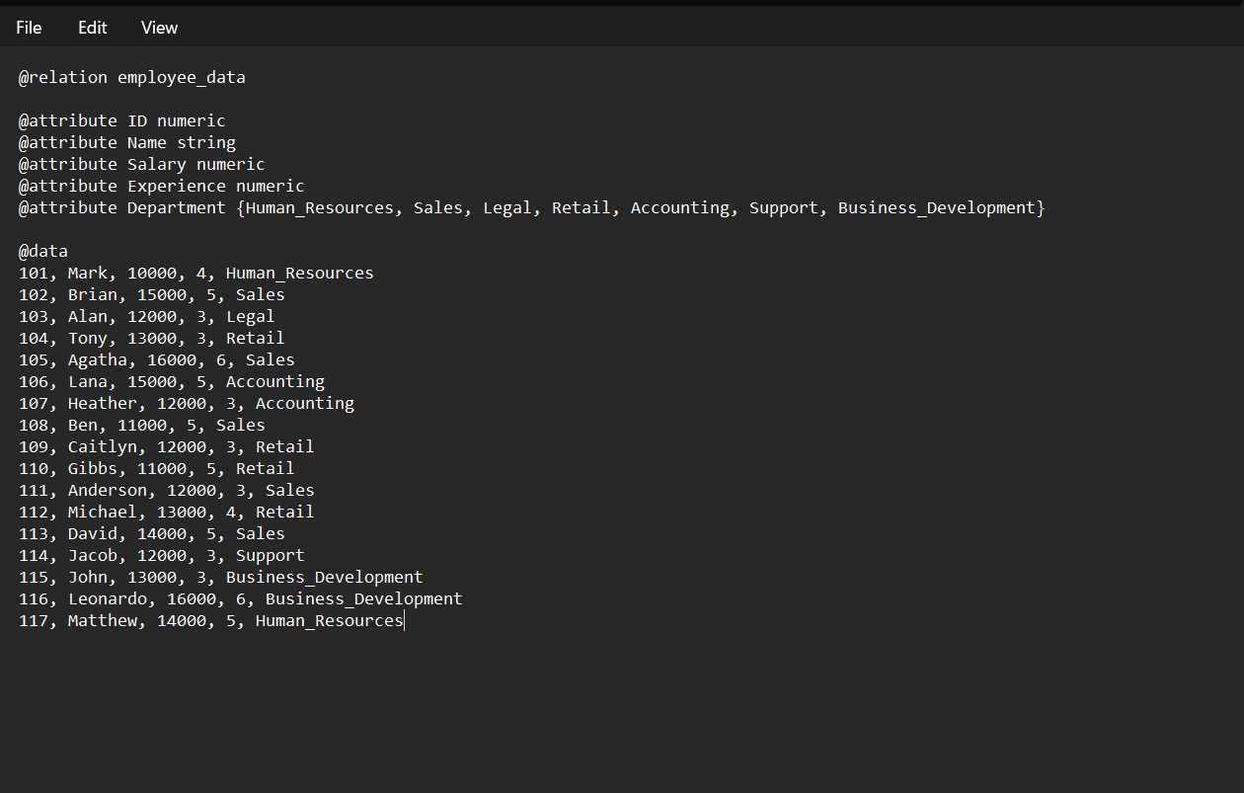
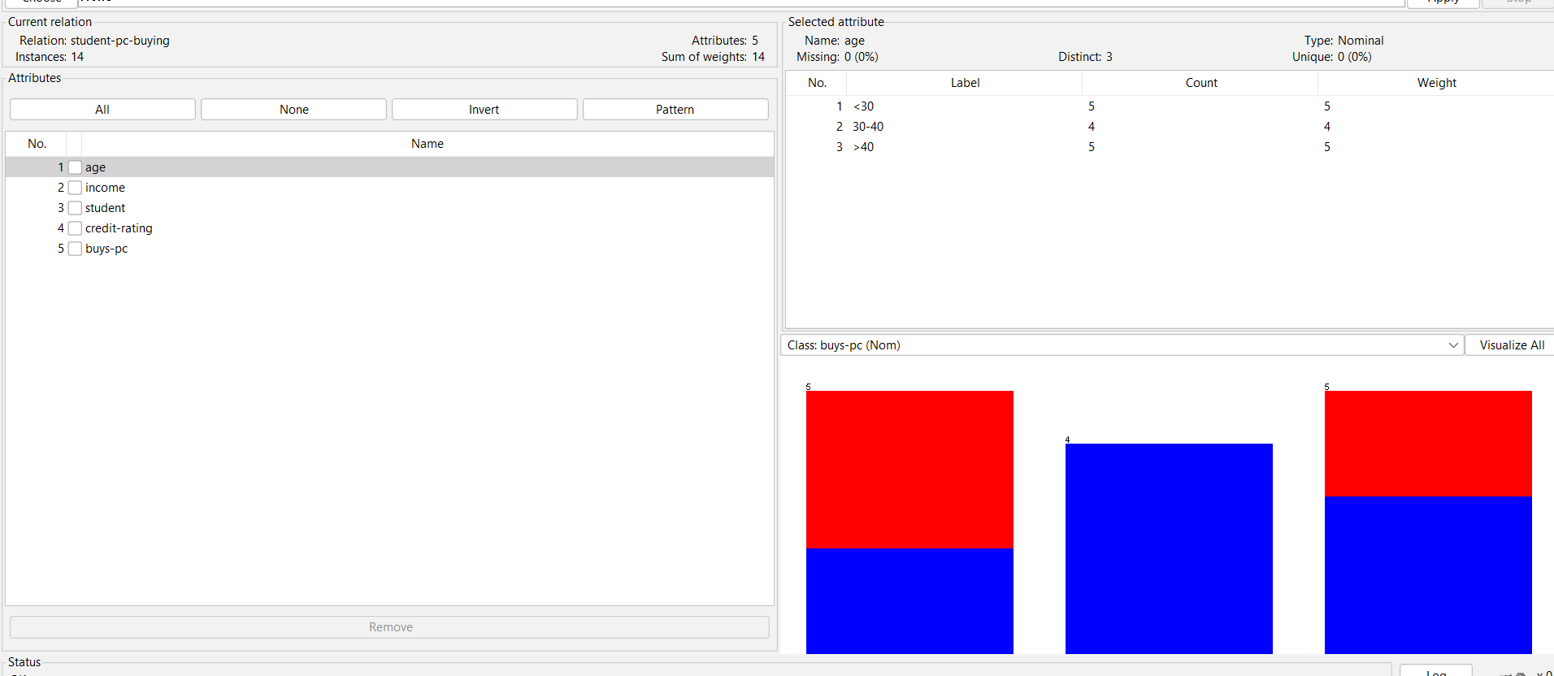
- Apply Preprocessing techniques to this dataset
. • Add a phone number attribute.
Trước:
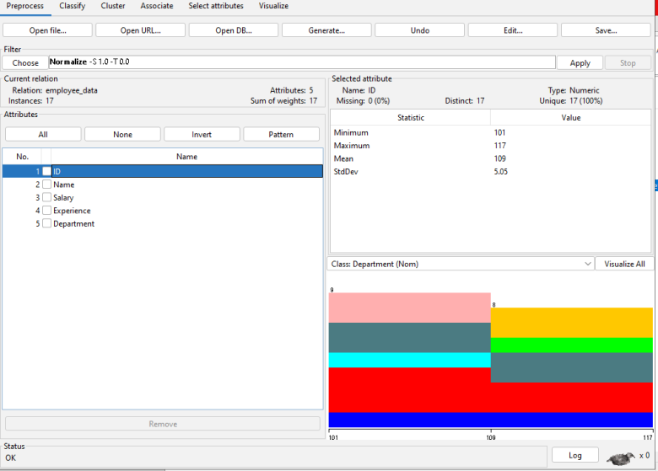
Using Filter:
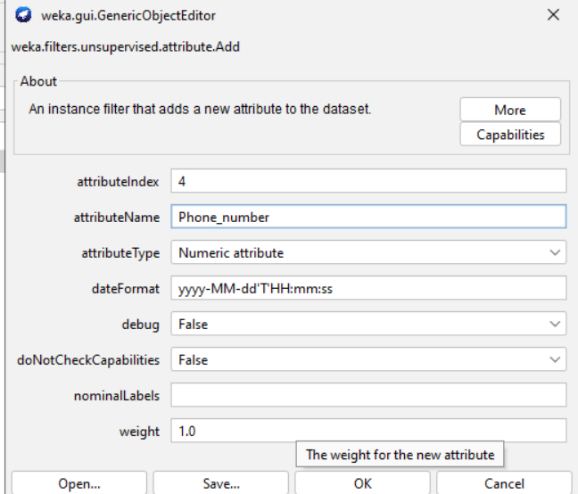
Sau:
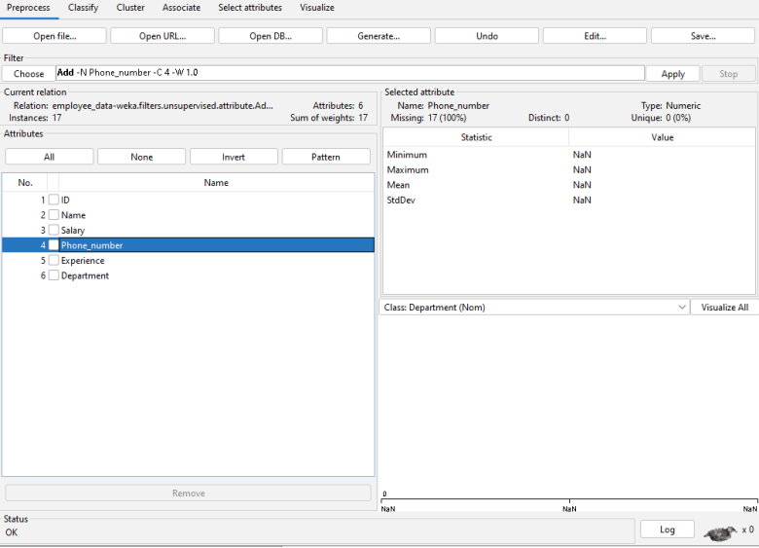
• Remove an attribute (select any attribute)
Trước:
Sau:
• Normalization: select numeric attributes to normalize Data Mining and Applications Department of Computer Science 14 Exercises
Trước:
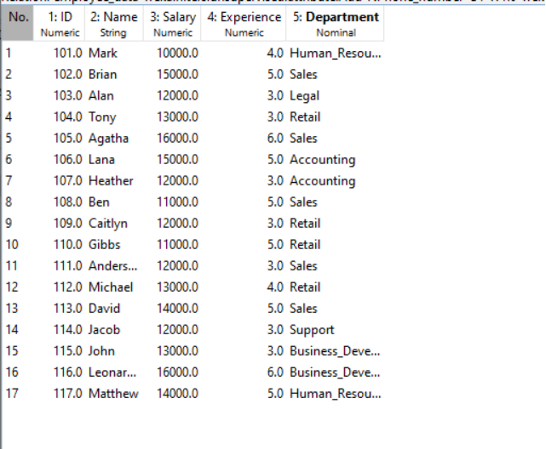
Using filter:
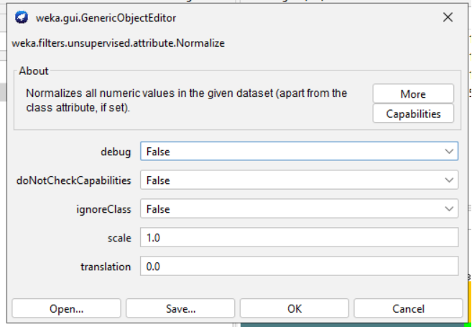
Sau:
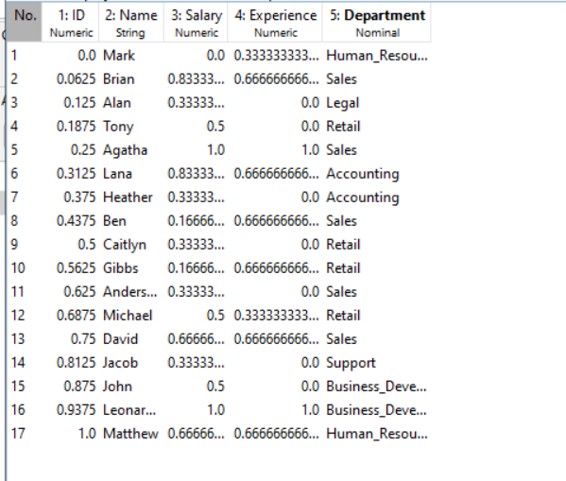

7: Download and Exam dataset horse-colic
Data: https://archive.ics.uci.edu/ml/machine-learning-databases/horse-colic/horse-colic.data
Descriptions: https://archive.ics.uci.edu/ml/machine-learning-databases/horse-colic/horse-colic.names

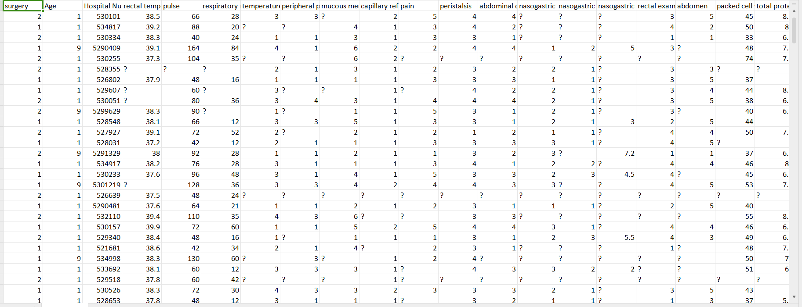
- Title: Horse Colic Database
- Source Information:
- Creators: Mary McLeish & Matt Cecile from the Department of Computer Science, University of Guelph, Ontario, Canada.
- Donor: Will Taylor (from NASA).
- Date: August 6, 1989.
- Past Usage: The dataset’s usage history is unknown.
- Relevant Information:
- There are two data files: horse-colic.data with 300 training instances and horse-colic.test with 68 test instances.
- There are 28 attributes in total, with some attributes being continuous, discrete, and nominal.
- Number of Instances: 368 in total (300 for training and 68 for testing).
- Number of Attributes: 28.

7. Attribute Information:
- Surgery:
  - 1 = Yes (It had surgery)
  - 2 = No (It was treated without surgery)
- Age:
  - 1 = Adult horse
  - 2 = Young (< 6 months)
- Hospital Number:
  - Numeric ID assigned to the horse (may not be unique).
- Rectal Temperature:
  - Linear, in degrees Celsius (Normal: 37.8°C).
- Pulse:
  - Heart rate in beats per minute (Normal: 30-40 for adults).
- Respiratory Rate:
  - Linear, normal rate is 8-10.
- Temperature of Extremities:
  - Subjective indication of peripheral circulation:
    - 1 = Normal
    - 2 = Warm
    - 3 = Cool
    - 4 = Cold
- Peripheral Pulse:
  - Subjective, indicating circulation:
    - 1 = Normal
    - 2 = Increased
    - 3 = Reduced
    - 4 = Absent
- Mucous Membranes:
  - Subjective color measurement:
    - 1 = Normal pink
    - 2 = Bright pink
    - 3 = Pale pink
    - 4 = Pale cyanotic
    - 5 = Bright red/injected
    - 6 = Dark cyanotic
- Capillary Refill Time:
  - Clinical judgment:
    - 1 = < 3 seconds
    - 2 = ≥ 3 seconds
- Pain:
  - Subjective judgment:
    - 1 = Alert, no pain
    - 2 = Depressed
    - 3 = Intermittent mild pain
    - 4 = Intermittent severe pain
    - 5 = Continuous severe pain
- Peristalsis:
  - Indication of gut activity:
    - 1 = Hypermotile
    - 2 = Normal
    - 3 = Hypomotile
    - 4 = Absent
- Abdominal Distension:
  - Important parameter:
    - 1 = None
    - 2 = Slight
    - 3 = Moderate
    - 4 = Severe
- Nasogastric Tube:
  - Refers to gas coming out of the tube:
    - 1 = None
    - 2 = Slight
    - 3 = Significant
- Nasogastric Reflux:
  - Amount of reflux:
    - 1 = None
    - 2 = > 1 liter
    - 3 = < 1 liter
- Nasogastric Reflux pH:
  - Linear, scale from 0 to 14 (Normal: 3-4).
- Rectal Examination - Feces:
  - Observation of feces:
    - 1 = Normal
    - 2 = Increased
    - 3 = Decreased
    - 4 = Absent
- Abdomen:
  - Condition of the abdomen:
    - 1 = Normal
    - 2 = Other
    - 3 = Firm feces in the large intestine
    - 4 = Distended small intestine
    - 5 = Distended large intestine
- Packed Cell Volume:
  - Linear, normal range: 30-50.
- Total Protein:
  - Linear, normal range: 6-7.5 g/dL.
- Abdominocentesis Appearance:
  - Fluid appearance:
    - 1 = Clear
    - 2 = Cloudy
    - 3 = Serosanguinous
- Abdominocentesis Total Protein:
  - Linear, in g/dL.
- Outcome:
  - What happened to the horse:
    - 1 = Lived
    - 2 = Died
    - 3 = Euthanized
- Surgical Lesion?:
  - Was the problem surgical?
    - 1 = Yes
    - 2 = No
25-27. Type of Lesion: - Site, type, and subtype of lesion.
- CP Data:
  - Is pathology data present?
    - 1 = Yes
    - 2 = No

8. Missing Values:
- Approximately 30% of the values in the dataset are missing.

