Exercise 1: This experiment illustrates the use of simple k-mean clustering with Weka. The sample data set used for this example is based on the vote.arff data set. This document assumes that appropriate pre-processing has been performed.

1. Using Weka Explore 1. Open weka tool and click Explorer.

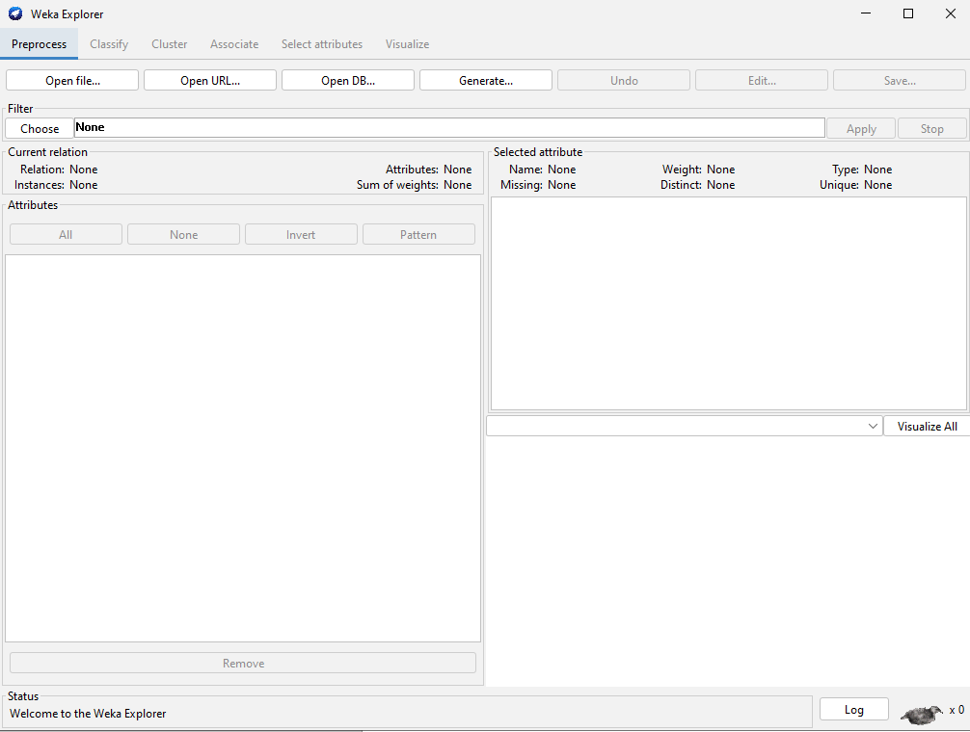

Using cluster:

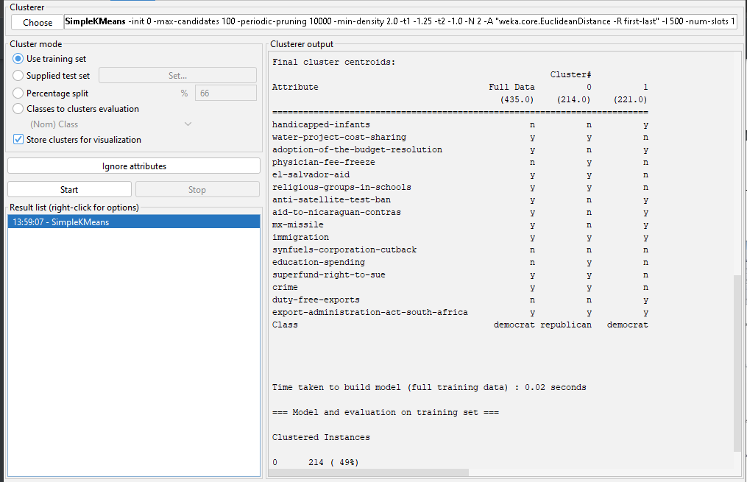

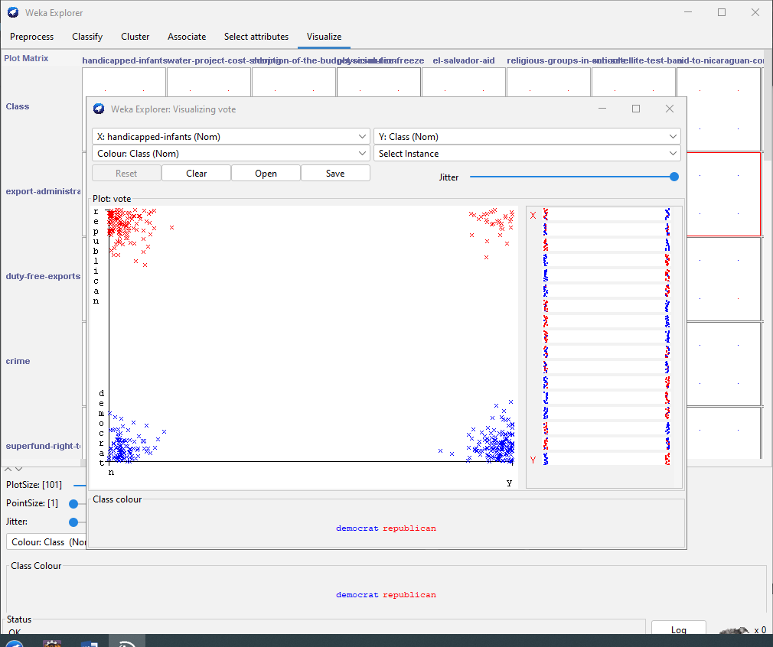

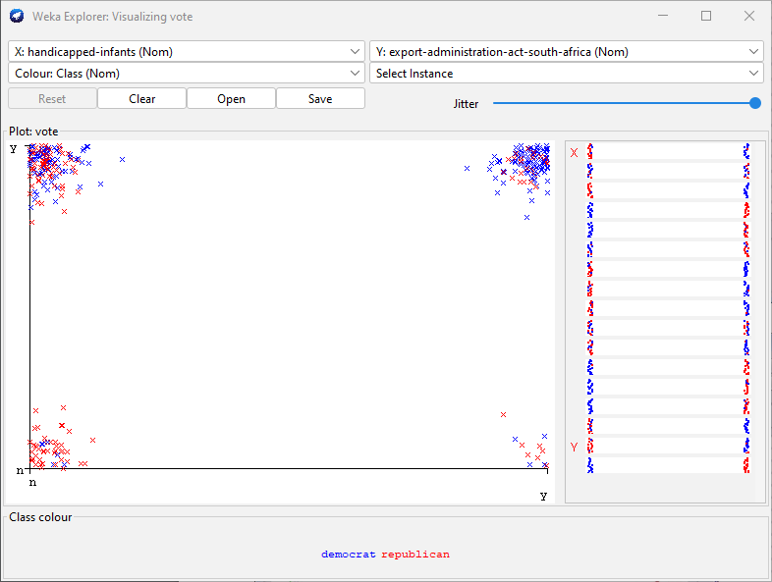

1. Using Weka KnowledgeFlow

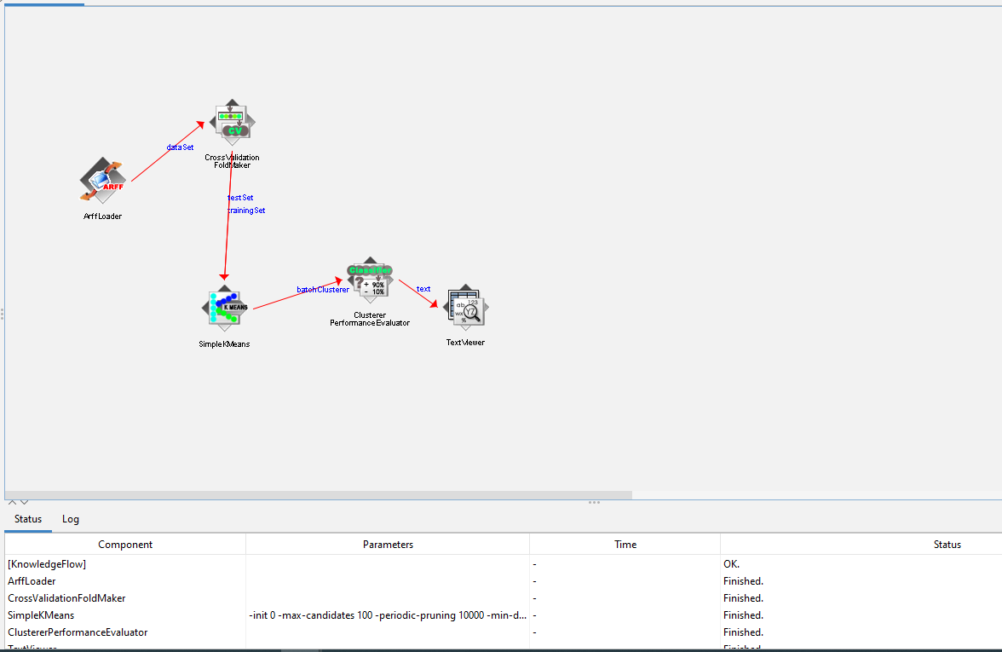

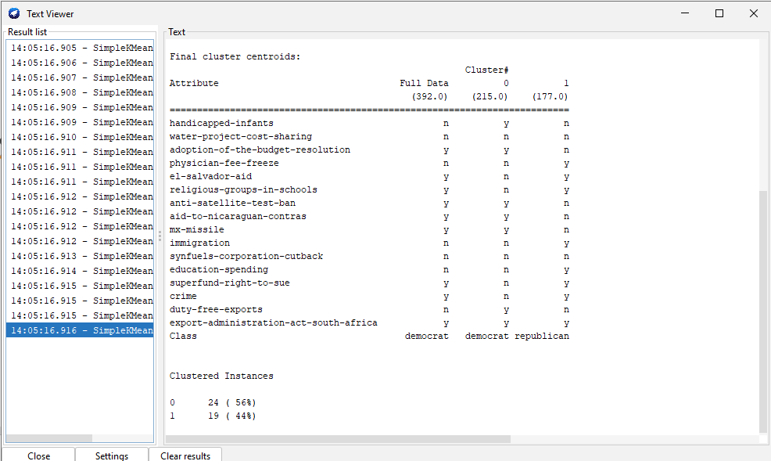

Code:

Classify_Model.java

import weka.classifiers.Evaluation;

import weka.classifiers.trees.J48;

import weka.core.Instances;

import weka.core.converters.ConverterUtils.DataSource;

import weka.filters.Filter;

import weka.filters.unsupervised.instance.RemovePercentage;

public class Classify_Model {

DataSource source;

Instances dataset;

J48 j48_Model;

Evaluation eval;

public void load_Data(String filename) throws Exception {

source = new DataSource(filename);

dataset = source.getDataSet();

}

public Instances create_Datatrain_Test(double per, boolean instrain) throws Exception {

RemovePercentage rm = new RemovePercentage();

rm.setPercentage(per);

rm.setInvertSelection(instrain);

rm.setInputFormat(dataset);

return Filter.useFilter(dataset, rm);

}

public void build_J48Model(Instances datatrain) throws Exception {

datatrain.setClassIndex(datatrain.numAttributes()-1);

j48_Model= new J48();

j48_Model.setConfidenceFactor(0.25f);

j48_Model.setMinNumObj(2);

j48_Model.buildClassifier(datatrain);

}

public String outputJ48() {

return j48_Model.toString();

}

public void eval_J48Model(Instances datatest) throws Exception {

datatest.setClassIndex(datatest.numAttributes()-1);

eval =new Evaluation(datatest);

eval.evaluateModel(j48_Model, datatest);

}

public String outputevaluation() {

return eval.toSummaryString();

}

}

**public** **void** predict_Class(Instances datapredict) **throws** Exception

{

datapredict.setClassIndex(datapredict.numAttributes()-1);

**for**(Instance obj: datapredict)

{

**double** class_value = j48_Model.classifyInstance(obj);

obj.setClassValue(class_value);

System.***out***.println(obj.toString());

}

}

Demo.java

**import** weka.core.Instances;

**public** **class** Demo {

**public** **static** **void** main(String[] args) **throws** Exception {

Classify_Model a = **new** Classify_Model();

a.load_Data("C:\\Program Files\\Weka-3-8-6\\data\\weather.nominal.arff");

a.build_J48Model(a.dataset);

System.***out***.println(a.outputJ48());

a.eval_J48Model(a.dataset);

System.***out***.println(a.outputevaluation());

Instances datatest = a.create_Datatrain_Test(70, **false**);

a.predict_Class(datatest);

}

}