**PRACTICE 5: MODERN IoT**

**1. LCD from code editor**

Create a project that display message on a LCD. Program runs the simulation

inside VS Code

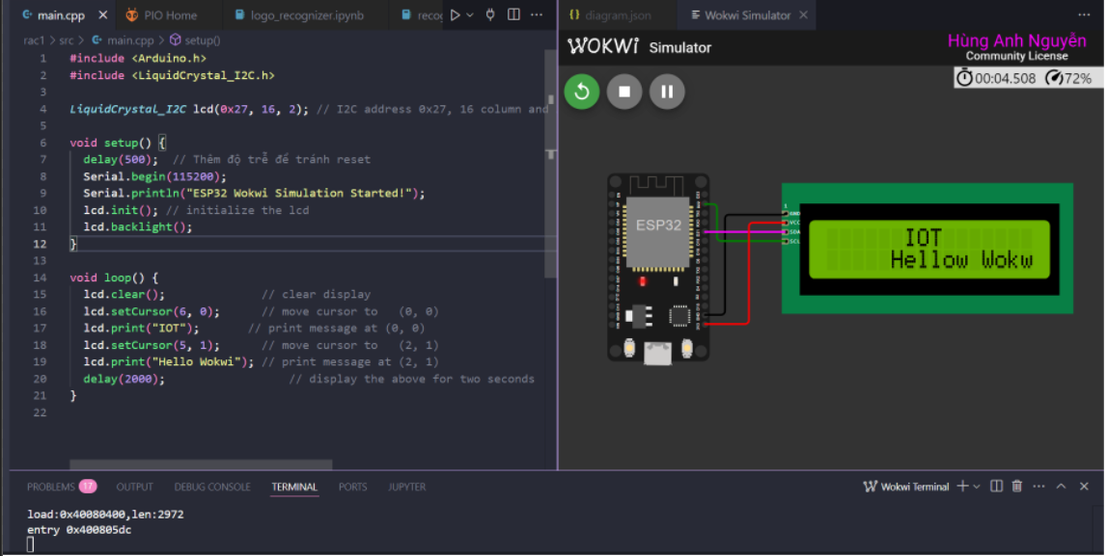

**Code:**

#include <LiquidCrystal_I2C.h>

LiquidCrystal_I2C lcd(0x27, 16, 2); // I2C address 0x27, 16 column and 2 rows

void setup() {

lcd.init(); // initialize the lcd

lcd.backlight();

}

void loop() {

lcd.clear(); // clear display

lcd.setCursor(6, 0); // move cursor to (0, 0)

lcd.print("IOT"); // print message at (0, 0)

lcd.setCursor(5, 1); // move cursor to (2, 1)

lcd.print("Hellow Wokwi"); // print message at (2, 1)

delay(2000); // display the above for two seconds

}

**2. Weather Station**

Develop an IoT Weather Station program

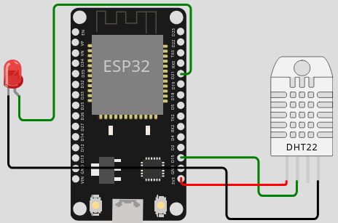

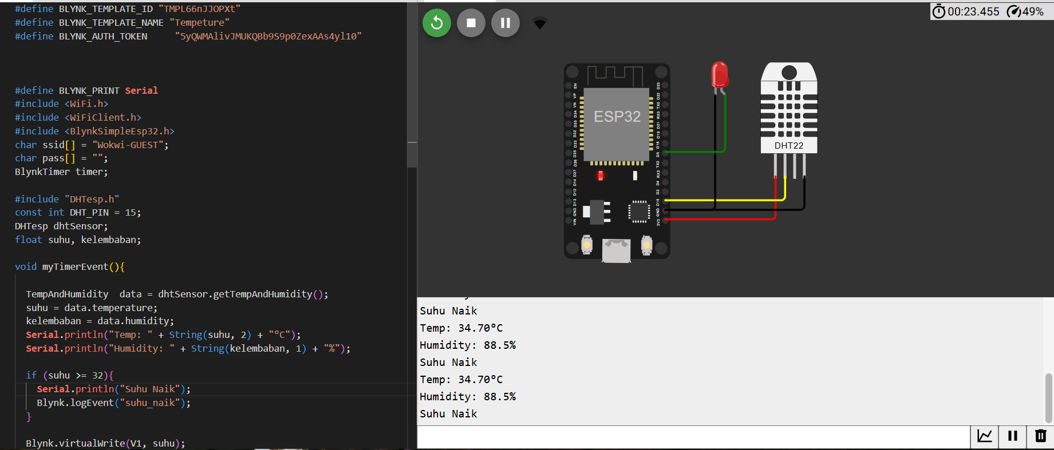

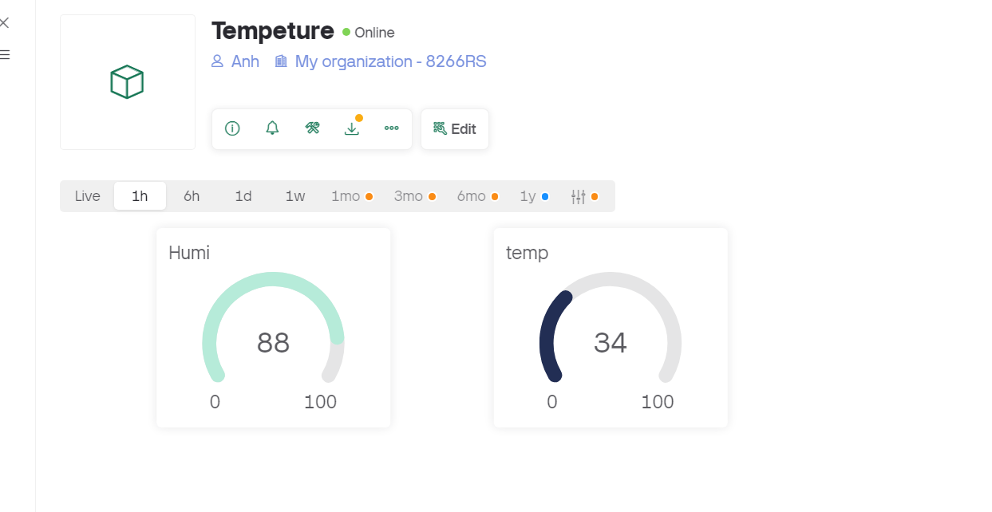

**Code:**

#define BLYNK_TEMPLATE_ID "TMPL66nJJOPXt"

#define BLYNK_TEMPLATE_NAME "Tempeture"

#define BLYNK_AUTH_TOKEN "5yQWMAlivJMUKQBb9S9p0ZexAAs4yl10"

#define BLYNK_PRINT Serial

#include <WiFi.h>

#include <WiFiClient.h>

#include <BlynkSimpleEsp32.h>

char ssid[] = "Wokwi-GUEST";

char pass[] = "";

BlynkTimer timer;

#include "DHTesp.h"

const int DHT_PIN = 15;

DHTesp dhtSensor;

float suhu, kelembaban;

void myTimerEvent(){

TempAndHumidity data = dhtSensor.getTempAndHumidity();

suhu = data.temperature;

kelembaban = data.humidity;

Serial.println("Temp: " + String(suhu, 2) + "°C");

Serial.println("Humidity: " + String(kelembaban, 1) + "%");

if (suhu >= 32){

Serial.println("Suhu Naik");

Blynk.logEvent("suhu_naik");

}

Blynk.virtualWrite(V1, suhu);

Blynk.virtualWrite(V0, kelembaban);

}

byte led = 5;

BLYNK_WRITE(V2)

{

int pinValue = param.asInt();

Serial.print("V2 Switch value is: ");

Serial.println(pinValue);

digitalWrite(led, pinValue);

}

void setup(){

Serial.begin(115200);

pinMode(led, OUTPUT);

dhtSensor.setup(DHT_PIN, DHTesp::DHT22);

Blynk.begin(BLYNK_AUTH_TOKEN, ssid, pass);

timer.setInterval(1000L, myTimerEvent);

}

void loop(){

Blynk.run();

timer.run();

}

**3. Weather Station from code editor**

Develop a program to uns the simulation inside VS Code for above Weather

Station program

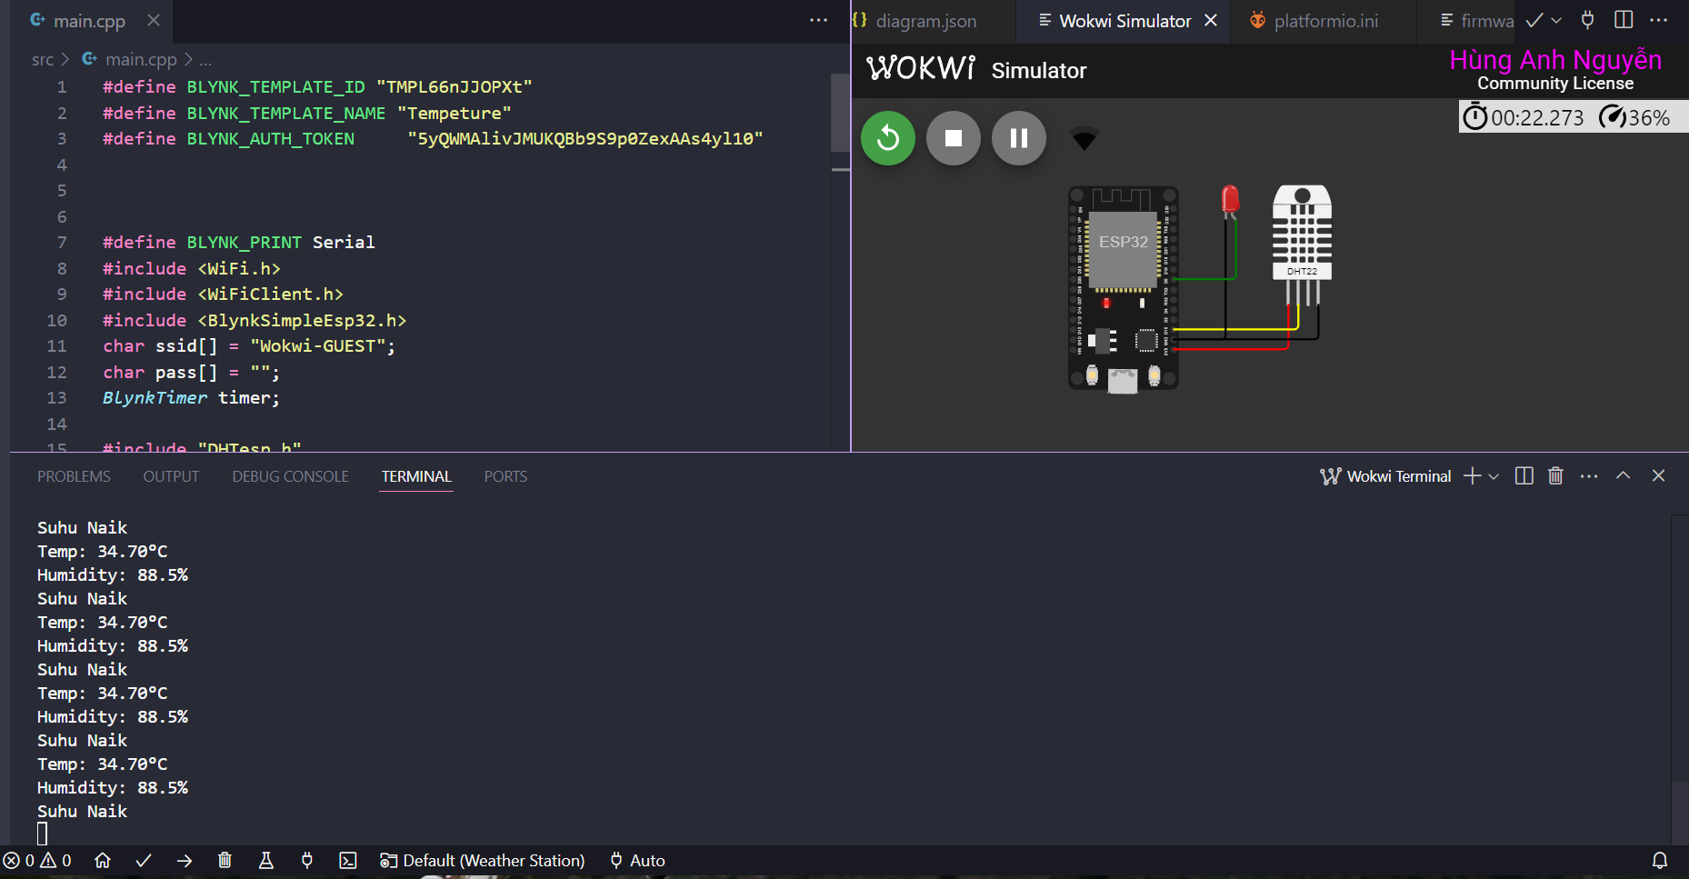



**Code**

#define BLYNK_TEMPLATE_ID "TMPL66nJJOPXt"

#define BLYNK_TEMPLATE_NAME "Tempeture"

#define BLYNK_AUTH_TOKEN "5yQWMAlivJMUKQBb9S9p0ZexAAs4yl10"

#define BLYNK_PRINT Serial

#include <WiFi.h>

#include <WiFiClient.h>

#include <BlynkSimpleEsp32.h>

char ssid[] = "Wokwi-GUEST";

char pass[] = "";

BlynkTimer timer;

#include "DHTesp.h"

const int DHT_PIN = 15;

DHTesp dhtSensor;

float suhu, kelembaban;

void myTimerEvent(){

TempAndHumidity data = dhtSensor.getTempAndHumidity();

suhu = data.temperature;

kelembaban = data.humidity;

Serial.println("Temp: " + String(suhu, 2) + "°C");

Serial.println("Humidity: " + String(kelembaban, 1) + "%");

if (suhu >= 32){

Serial.println("Suhu Naik");

Blynk.logEvent("suhu_naik");

}

Blynk.virtualWrite(V1, suhu);

Blynk.virtualWrite(V0, kelembaban);

}

byte led = 5;

BLYNK_WRITE(V2)

{

int pinValue = param.asInt();

Serial.print("V2 Switch value is: ");

Serial.println(pinValue);

digitalWrite(led, pinValue);

}

void setup(){

Serial.begin(115200);

pinMode(led, OUTPUT);

dhtSensor.setup(DHT_PIN, DHTesp::DHT22);

Blynk.begin(BLYNK_AUTH_TOKEN, ssid, pass);

timer.setInterval(1000L, myTimerEvent);

}

void loop(){

Blynk.run();

timer.run();

}