PRACTICE 7: MODERN IoT

1. Devices Communication

Let’s write a program to connect Arduino to Arduino by using:

● C/C++

● Python

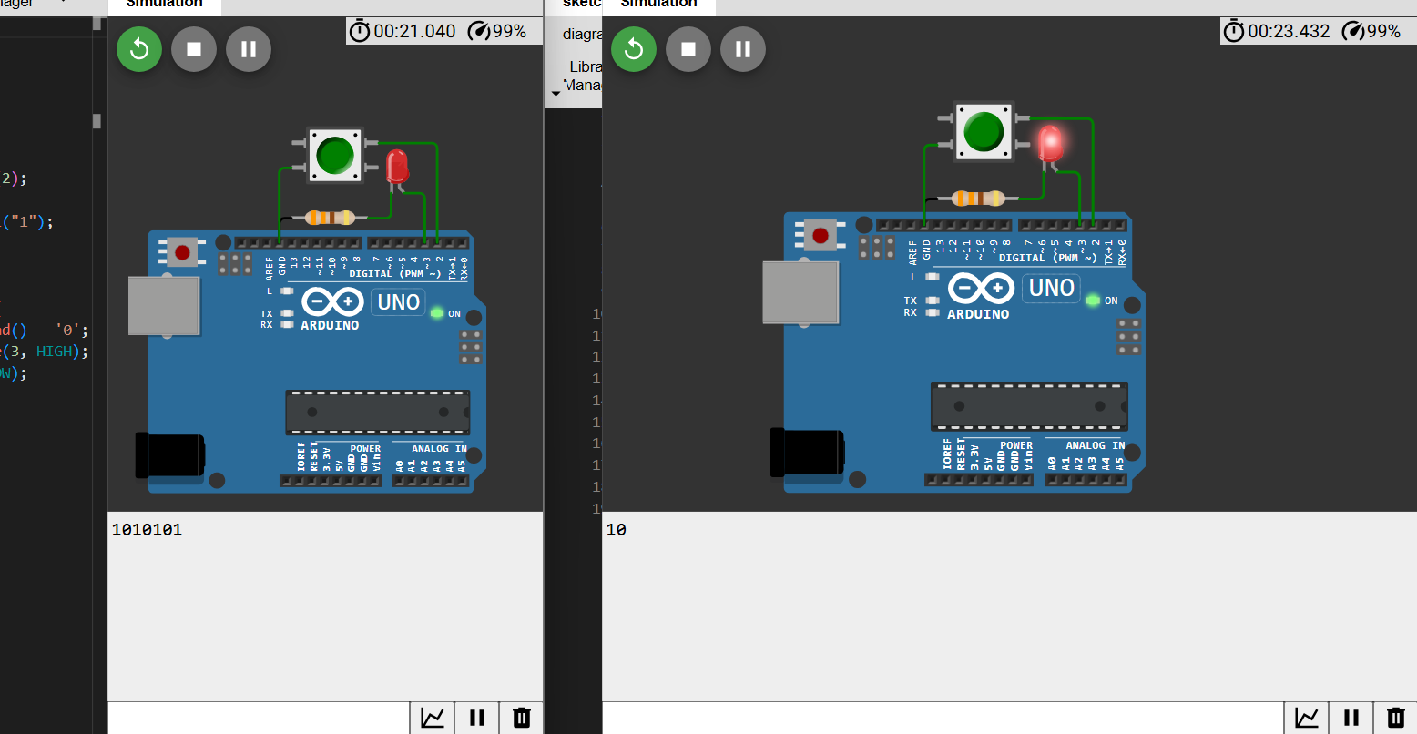

Code C++:

int prev = 0;

void setup() {

Serial.begin(9600);

pinMode(2, INPUT_PULLUP);

pinMode(3, OUTPUT);

}

void loop() {

int press = !digitalRead(2);

if (press != prev) {

if (press) Serial.print("1");

else Serial.print("0");

}

prev = press;

if (Serial.available()) {

char light = Serial.read() - '0';

if (light) digitalWrite(3, HIGH);

else digitalWrite(3, LOW);

}}

Code Python:

import machine

import utime

import sys

button = machine.Pin(2, machine.Pin.IN, machine.Pin.PULL_UP)

led = machine.Pin(3, machine.Pin.OUT)

prev = 0

while True:

press = not button.value() # Đọc trạng thái nút nhấn

if press != prev:

if press:

sys.stdout.write("1")

else:

sys.stdout.write("0")

sys.stdout.flush()

prev = press

if sys.stdin in select.select([sys.stdin], [], [], 0)[0]:

light = sys.stdin.read(1)

if light == '1':

led.value(1)

else:

led.value(0)

utime.sleep_ms(10)

2. Devices Communication

Let’s write a program to connect Arduino to ESp32 by using:

● C/C++

● Python

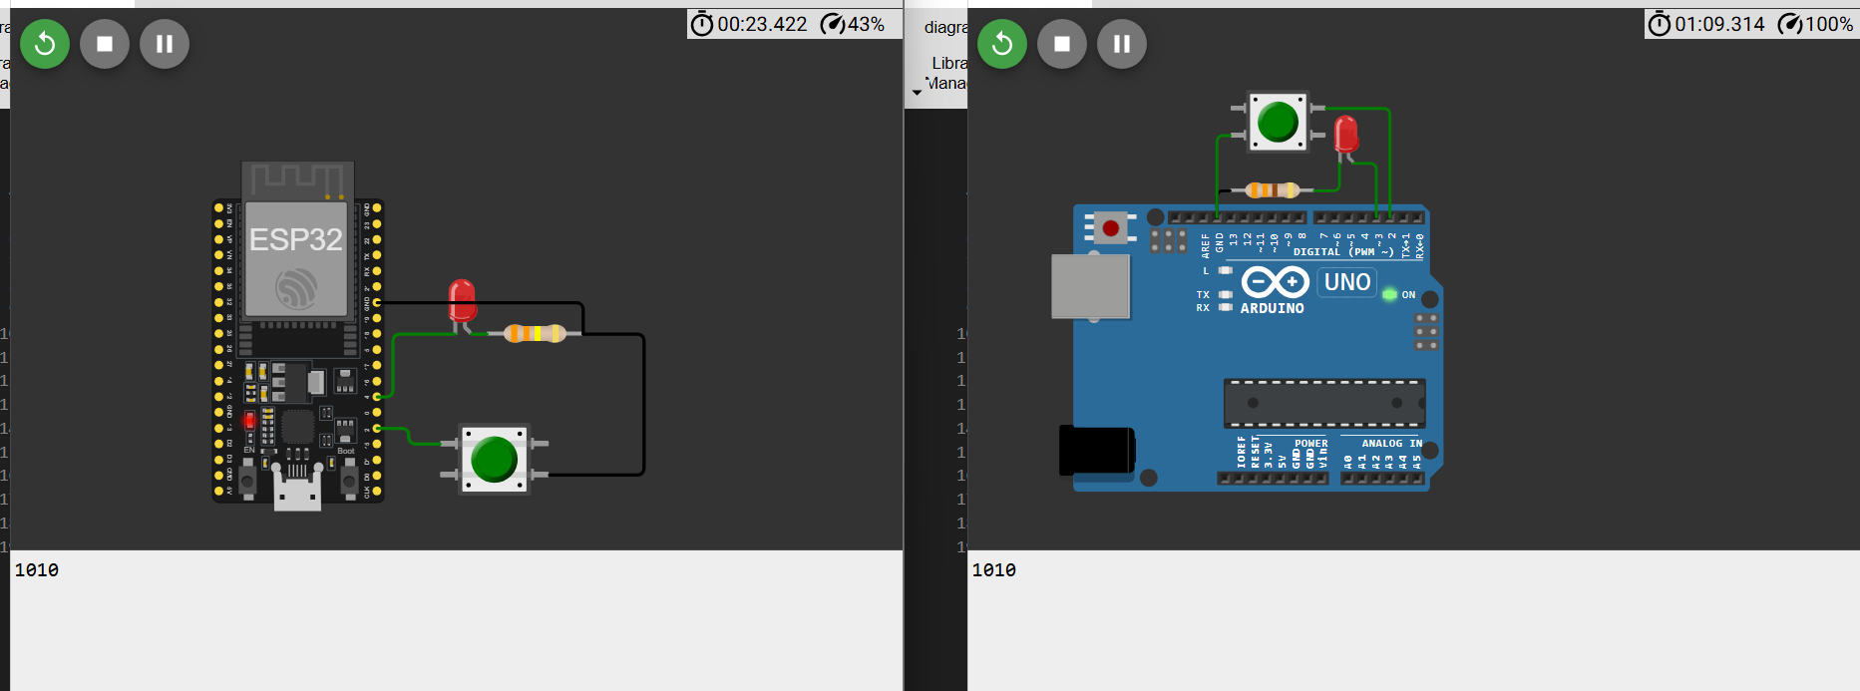

Code C++:

ESP32

int prev = 0;

void setup() {

Serial.begin(9600);

pinMode(2, INPUT_PULLUP);

pinMode(4, OUTPUT);

}

void loop() {

int press = !digitalRead(2);

if (press != prev) {

if (press) Serial.print("1");

else Serial.print("0");

}

prev = press;

if (Serial.available()) {

char light = Serial.read() - '0';

if (light) digitalWrite(4, HIGH);

else digitalWrite(4, LOW);

}

}

Arduino

int prev = 0;

void setup() {

Serial.begin(9600);

pinMode(2, INPUT_PULLUP);

pinMode(3, OUTPUT);

}

void loop() {

int press = !digitalRead(2);

if (press != prev) {

if (press) Serial.print("1");

else Serial.print("0");

}

prev = press;

if (Serial.available()) {

char light = Serial.read() - '0';

if (light) digitalWrite(3, HIGH);

else digitalWrite(3, LOW);

}

}

Code Python:

ESP32

from machine import Pin

import sys

button = Pin(2, Pin.IN, Pin.PULL_UP)

led = Pin(4, Pin.OUT)

prev = 0

while True:

press = not button.value()

if press != prev:

if press:

sys.stdout.write("1")

else:

sys.stdout.write("0")

sys.stdout.flush()

prev = press

if sys.stdin in select.select([sys.stdin], [], [], 0)[0]:

light = sys.stdin.read(1)

if light == '1':

led.value(1)

elif light == '0':

led.value(0)

Arduino:

import machine

import utime

import sys

button = machine.Pin(2, machine.Pin.IN, machine.Pin.PULL_UP)

led = machine.Pin(3, machine.Pin.OUT)

prev = 0

while True:

press = not button.value() # Đọc trạng thái nút nhấn

if press != prev:

if press:

sys.stdout.write("1")

else:

sys.stdout.write("0")

sys.stdout.flush()

prev = press

if sys.stdin in select.select([sys.stdin], [], [], 0)[0]:

light = sys.stdin.read(1)

if light == '1':

led.value(1)

else:

led.value(0)

utime.sleep_ms(10)

3. Devices Communication

Let’s write a program to connect ESp32 to ESp32 by using:

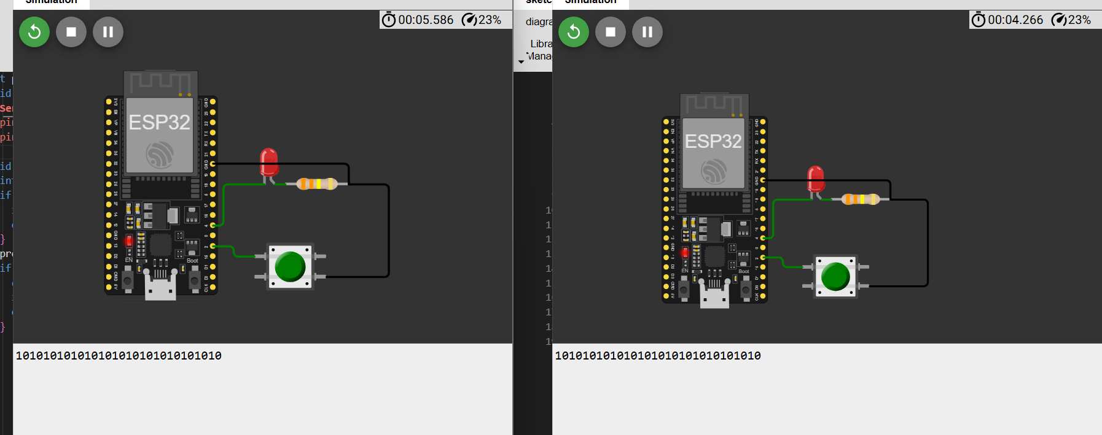

● C/C++

int prev = 0;

void setup() {

**Serial**.begin(9600);

pinMode(2, INPUT_PULLUP);

pinMode(4, OUTPUT);

}

void loop() {

int press = !digitalRead(2);

if (press != prev) {

if (press) **Serial**.print("1");

else **Serial**.print("0");

}

prev = press;

if (**Serial**.available()) {

char light = **Serial**.read() - '0';

if (light) digitalWrite(4, HIGH);

else digitalWrite(4, LOW);

}

}

● Python

from machine import Pin

import sys

button = Pin(2, Pin.IN, Pin.PUL’L_UP)

led = Pin(4, Pin.OUT)

prev = 0

while True:

press = not button.value()

if press != prev:

if press:

sys.stdout.write("1")

else:

sys.stdout.write("0")

sys.stdout.flush()

prev = press

if sys.stdin in select.select([sys.stdin], [], [], 0)[0]:

light = sys.stdin.read(1)

if light == '1':

led.value(1)

elif light == '0':

led.value(0)