PRACTICE 8: MODERN IoT

1. Controlling AC Light

Let’s write a program to control a lamp by Arduino UNO using C/C++

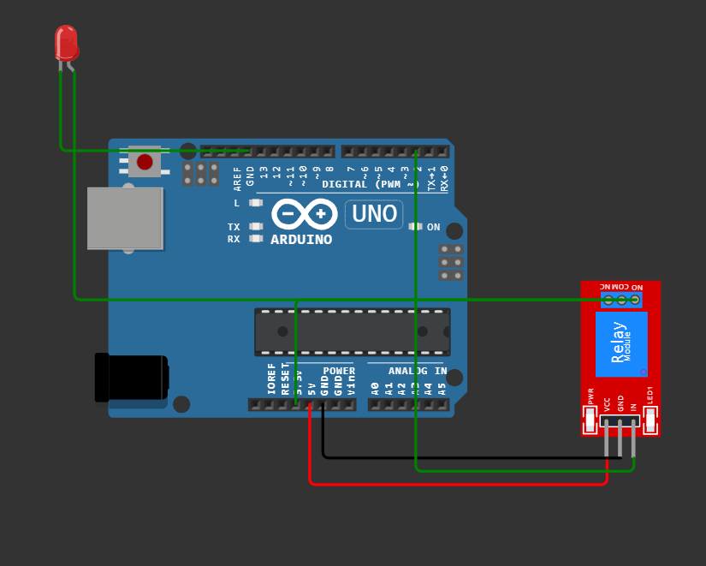

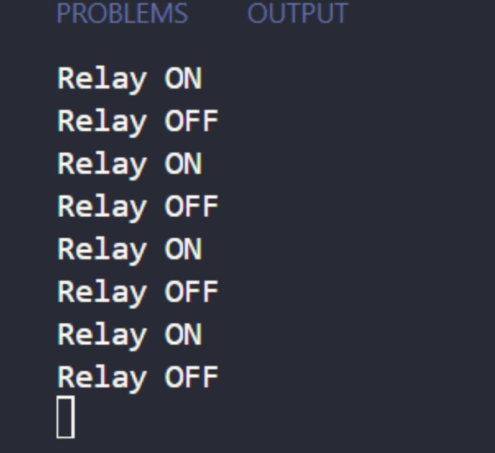

Code:

C++:

#include <Arduino.h>

#define Relay_Pin 2

void setup() {

// put your setup code here, to run once:

pinMode(Relay_Pin, OUTPUT);

Serial.begin(9600);

}

void loop() {

// put your main code here, to run repeatedly:

digitalWrite(Relay_Pin, HIGH);

Serial.println("Relay ON");

delay(2000);

digitalWrite(Relay_Pin, LOW);

Serial.println("Relay OFF");

delay(2000);

}

Python:

from machine import Pin

from time import sleep

relay = Pin(2, Pin.OUT)

while True:

relay.value(1)

print("Relay ON")

sleep(2)

relay.value(0)

print("Relay OFF")

sleep(2)

2. Controlling AC Light

Let’s write a program to control a lamp by ESp32 using:

● C/C++

● Python

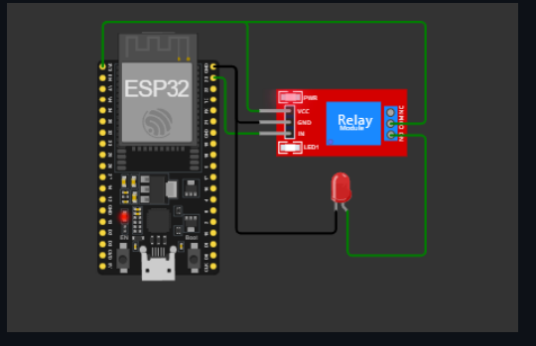

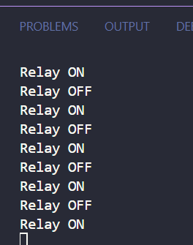

Code:

C++:

#include <Arduino.h>

#define Relay_Pin 23

void setup() {

// put your setup code here, to run once:

pinMode(Relay_Pin, OUTPUT);

Serial.begin(9600);

}

void loop() {

// put your main code here, to run repeatedly:

digitalWrite(Relay_Pin, HIGH);

Serial.println("Relay ON");

delay(2000);

digitalWrite(Relay_Pin, LOW);

Serial.println("Relay OFF");

delay(2000);

}

Python:

from machine import Pin

from time import sleep

relay = Pin(23, Pin.OUT)

while True:

relay.value(1) # Bật relay

print("Relay ON")

sleep(2)

relay.value(0) # Tắt relay

print("Relay OFF")

sleep(2)

3. Controlling AC Light

Let’s write a program to control a lamp by Raspberry Pi using:

● C/C++

● Python

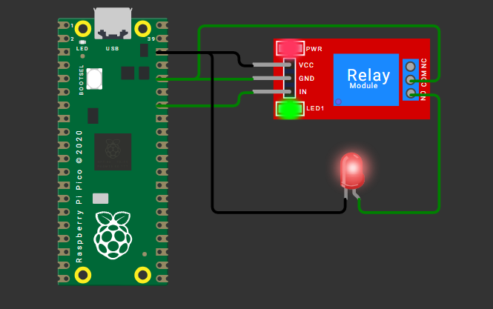



Code:

C++:

#include <Arduino.h>

#define Relay_Pin 28

void setup() {

// put your setup code here, to run once:

pinMode(Relay_Pin, OUTPUT);

Serial.begin(9600);

}

void loop() {

// put your main code here, to run repeatedly:

digitalWrite(Relay_Pin, HIGH);

Serial.println("Relay ON");

delay(2000);

digitalWrite(Relay_Pin, LOW);

Serial.println("Relay OFF");

delay(2000);

}

Python:

from machine import Pin

from time import sleep

relay = Pin(28, Pin.OUT)

while True:

relay.value(1) # Bật relay

print("Relay ON")

sleep(2)

relay.value(0) # Tắt relay

print("Relay OFF")

sleep(2)

4. Use the relay to control a DC motor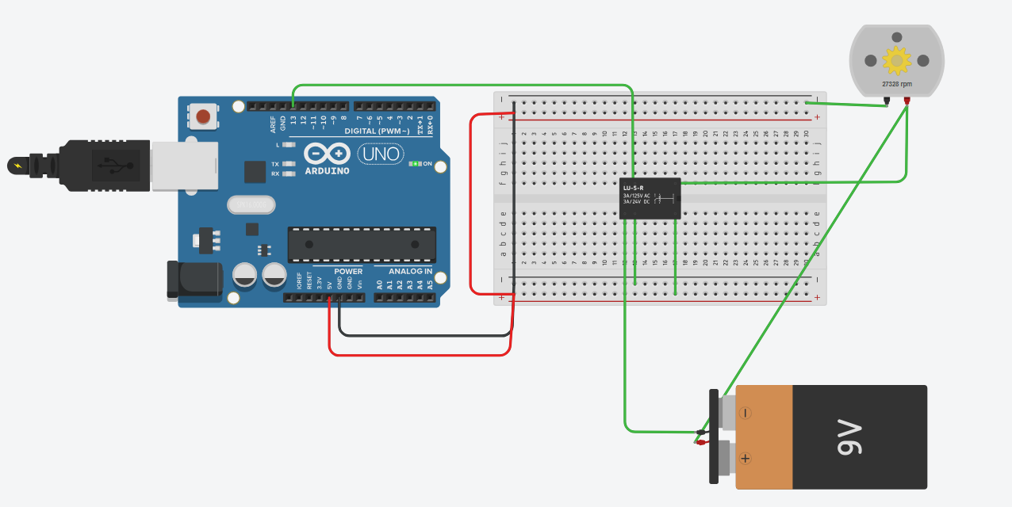

Code:

void setup()

{

pinMode(13, OUTPUT);

}

void loop()

{

digitalWrite(13, HIGH);

delay(5000);

digitalWrite(13, LOW);

delay(5000);

}

5. Use the relay to control a DC motor, Lamp