Week3_21064051_Nguyễn Hùng Anh

Exercise:

1. Design

Create materials for walls, player ball, and the change in wall color upon collision.

Rename them to wall-color, ball-color, and after-collision and set RGB values to

(255,255,255), (240,240,0), and (241,107,8) respectively.

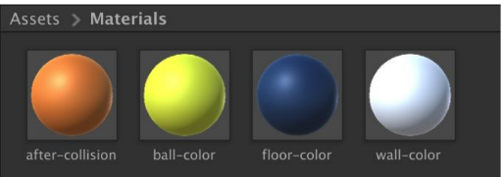

Bài làm

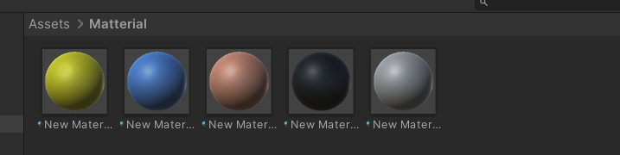

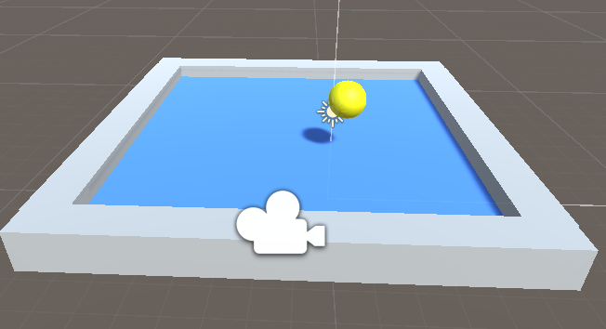

2. Build Your First VR App

The objective of the game is to keep the ball rolling without colliding with the

walls:

- For input, you need to use your keyboard:

o Using keys such left arrow, right arrow, up arrow, down arrow to control

the ball.

o Speed up moving when keep keys

- If it collides with either of the walls, the wall color should change and some text

should display on the screen indicating the collision

The following code to grab the input from the keyboard and add forces to move the

ball.

