To use this example:

* Create a new C# script in your Project, and name it “InstantiationExample”.
* Copy and paste in the script example above into your new script, and save it.
* Create an empty GameObject using the menu **GameObject > Create Empty**.
* Add the script to the new GameObject as a component by dragging it onto the empty GameObject.
* [Create any Prefab](https://docs.unity3d.com/Manual/CreatingPrefabs.html), and drag it from the **Project window**
* into the **My Prefab** field in the script component

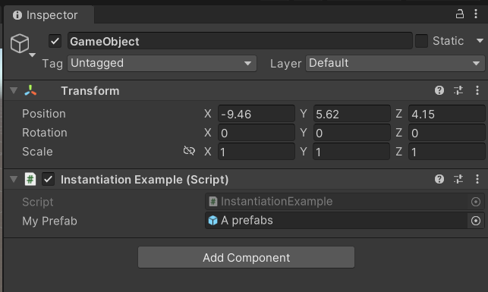.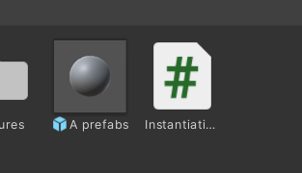

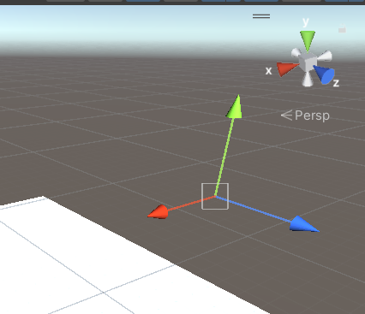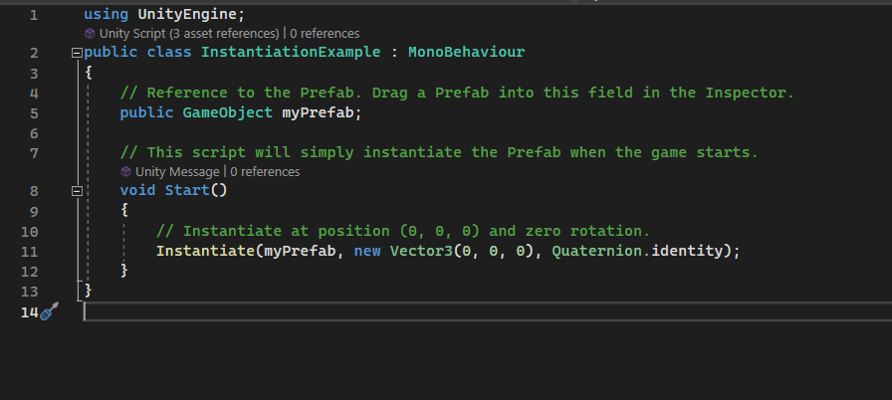

The example script above won’t work until you assign a Prefab to the **Block** variable. To create a simple block Prefab:

1. Choose **GameObject > 3D Object > Cube.**
2. Drag the cube from the **Hierarchy** w**indow** into the **Assets** folder in the **Project** **window.** This creates a Prefab Asset.
3. Rename your Prefab to “Block”.
4. Now that your **Block** Prefab exists as an Asset, you can safely delete the cube from your Hierarchy.

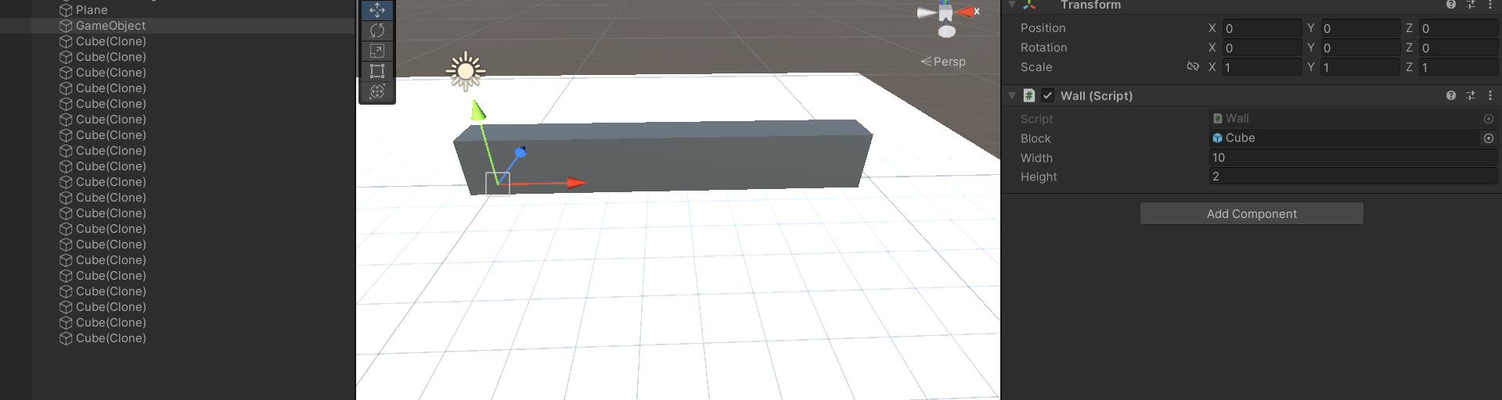

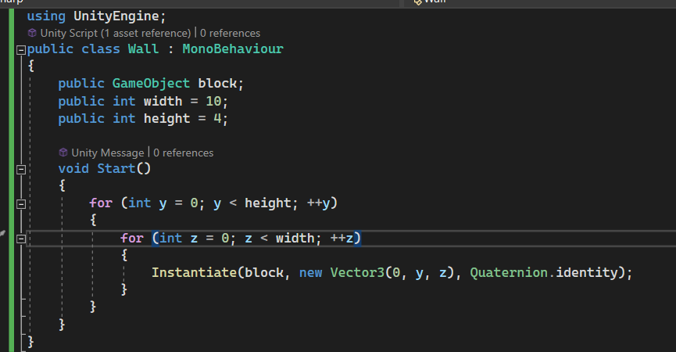

Ví dụ về xe tăng

Các thành phần của xe tăng gồm có:

1 Cube (Head)

1 Cude (Case)

2 Capusle (BanhXe)

1 Capusle (NongSung)

1 Emty Object (ViTriKhaiHoa)

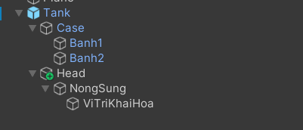

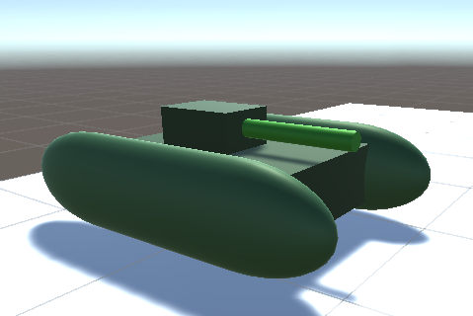

Material

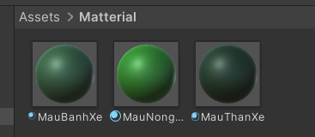

Cơ chế xoay nòng súng được đưa vào Head

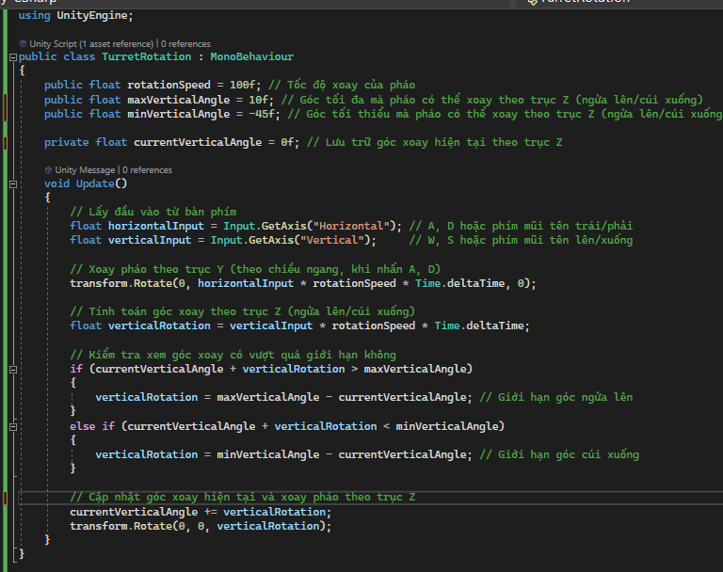

Cơ chế bắn đạn

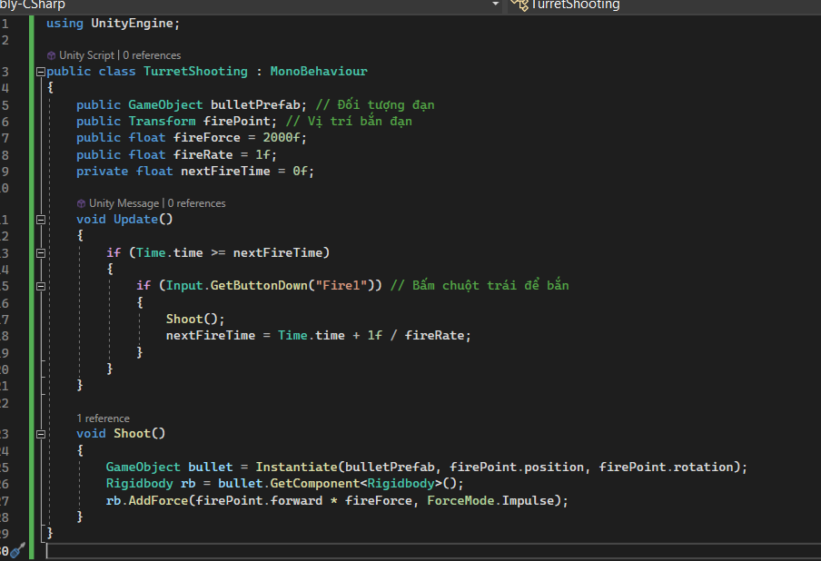

Thông số bullet

