ADVANCED BACKEND DEVELOPMENT
Practice 2
CHAPTER 2: WORKING WITH DATABASES
Topic: LIBRARY MANAGEMENT SYSTEM
Phạm Trần Gia Hưng – 2331200153

QUESTION 1: DEVELOPMENT APPROACHES & INHERITANCE
(Development Approaches + Inheritance in Relational Databases)
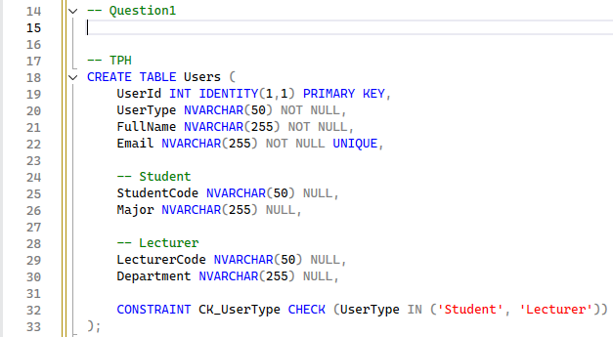
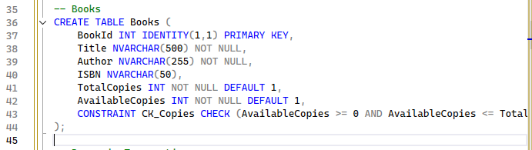
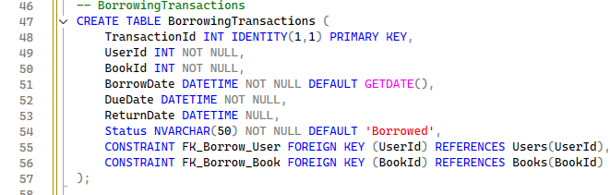
Task 1:

1.1 Database-First Approach
Database-First is a development approach where the database schema is designed and created first, then the application code and models are generated from the existing database structure. Help provides full control over database design and optimization
Advantage: Easier to implement complex database features like stored procedures, triggers, and custom indexing
Disadvantage: Not versatile for fast prototyping and iterative development

1.2 Code-First Approach
Code-First is a development approach where developers define entity classes in code, and the database schema is automatically generated or updated based on these classes. Entity classes are written in programming language (C#, Java). Provides an object-oriented approach to database design
Advantage: Faster development, easier to maintain
Disadvantages: Difficult to implement complex database features without raw SQL

→ Indicate which approach is more suitable for a library management system and justify your choice
Suitable approach: Code-First Approach

Justification: The library system is data centric and requires strong consistency, integrity, transactional control. Since multiple users access the system concurrently, a stable and well defined database schema is better
- Agile: Library systems might require iterative improvements and feature. Code-First allow fast prototyping, easy schema modifications through migration.
- Version Control: Migration files provide history of changes, make it easier for dev to collab and view changes.
- Inheritance Support: Code-First framework (like Entity Framework) provide support for implementing inheritance patterns (TPH, TPT, TPC) through annotation or config.

Task 2 Design the database schema to represent inheritance in a relational database using one of the following strategies
Design with TPH
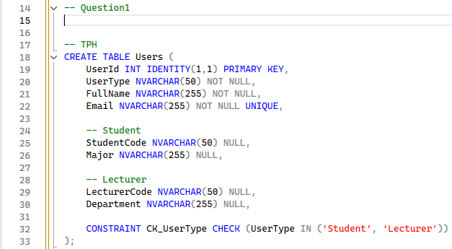
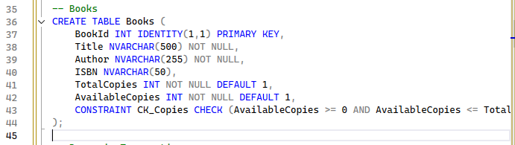
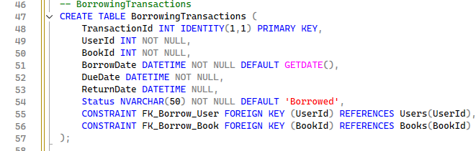
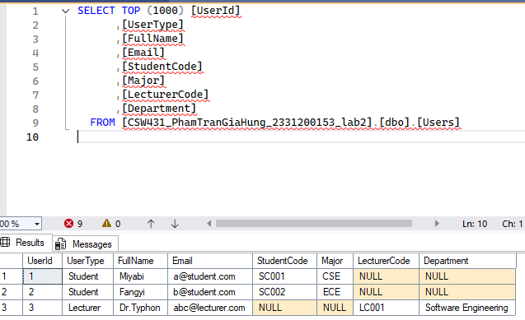
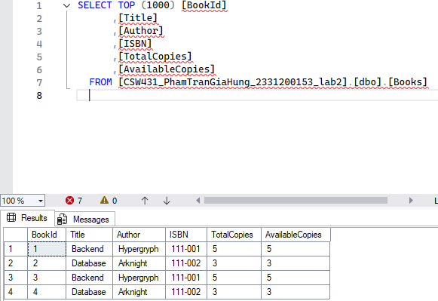

Task 3
Provide an ERD diagram or SQL schema for the selected design
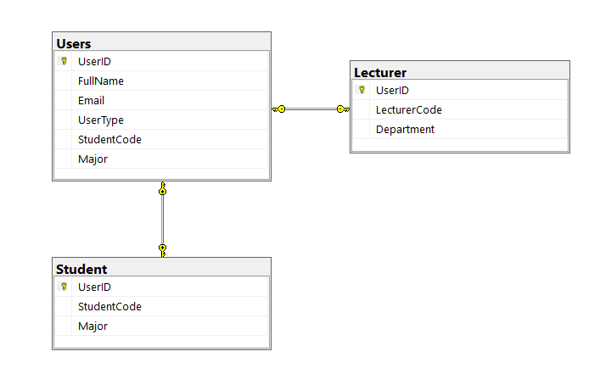

QUESTION 2: CONCURRENCY HANDLING & TRANSACTIONS
(Concurrency Handling and Transactions)
Scenario
Two students attempt to borrow the same book at the same time, while only one copy of the book is available.
Tasks
- Analyze potential concurrency issues, such as:
  - Lost Update
  - Dirty Read
  - Race Condition
- Design a book borrowing process using transactions, including:
  - Checking the number of available copies
  - Creating a borrowing record
  - Decreasing the available book quantity
- Provide pseudo-code or SQL examples illustrating:
  - BEGIN TRANSACTION
  - COMMIT
ROLLBACK

Task 1: Analyze potential concurrency issues
When two students attempt to borrow the same book simultaneously with only one copy available, several concurrency issues can occur:
- Lost Update Problem: This occurs when two transactions read the same data, modify it independently, and write it back. The last write overwrites the first, causing the first update to be lost.
Ex: Both students read AvailableCopies = 1, both check availability (pass), both decrement to 0. Result: Both successfully borrow but only 1 copy exists - data integrity violated!

- Dirty Read Problem: This occurs when a transaction reads data that has been modified by another transaction but not yet committed. If the modifying transaction rolls back, the reading transaction has used invalid data.
Ex : Student A decrements AvailableCopies to 0 (uncommitted). Student B reads 0 and is rejected. Student A rolls back. Result: Student B was incorrectly rejected based on uncommitted data!

- Race Condition: A race condition occurs when the system behavior depends on the sequence or timing of uncontrollable events. Multiple processes compete for the same resource.
Ex : Both requests arrive simultaneously. Without proper locking, both pass availability check before either decrements the counter. Result: AvailableCopies becomes negative, data integrity violated!
Task 2: Design a book borrowing process using transactions
- Process flow: Must follow ACID property
1.Begin transaction with appropriate isolation level
2.Lock the book record for update (prevent concurrent modification)
3.Check if available copies > 0
4.If available create borrowing record
5.Commit transaction, rollback if error
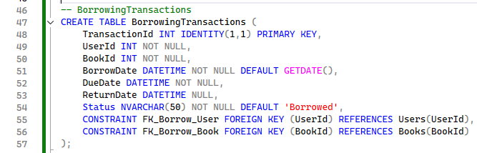
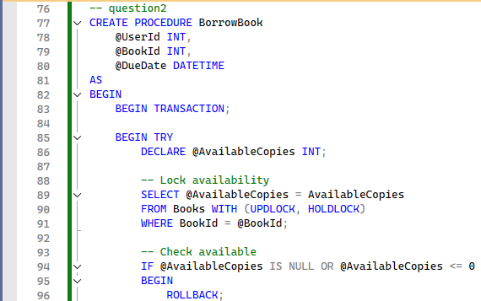
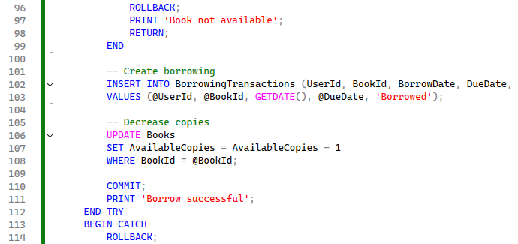
-- question2
CREATE PROCEDURE BorrowBook
@UserId INT,
@BookId INT,
@DueDate DATETIME
AS
BEGIN
BEGIN TRANSACTION;

BEGIN TRY
DECLARE @AvailableCopies INT;

-- Lock availability
SELECT @AvailableCopies = AvailableCopies
FROM Books WITH (UPDLOCK, HOLDLOCK)
WHERE BookId = @BookId;

-- Check available
IF @AvailableCopies IS NULL OR @AvailableCopies <= 0
BEGIN
ROLLBACK;
PRINT 'Book not available';
RETURN;
END

-- Create borrowing
INSERT INTO BorrowingTransactions (UserId, BookId, BorrowDate, DueDate, Status)
VALUES (@UserId, @BookId, GETDATE(), @DueDate, 'Borrowed');

-- Decrease copies
UPDATE Books
SET AvailableCopies = AvailableCopies - 1
WHERE BookId = @BookId;

COMMIT;
PRINT 'Borrow successful';
END TRY
BEGIN CATCH
ROLLBACK;
PRINT 'Error: ' + ERROR_MESSAGE();
END CATCH
END;
GO
Task 3: Provide pseudo-code or SQL examples illustrating
Pseudo:
BEGIN TRANSACTION
READ AvailableCopies FROM Books WHERE BookID = 1
IF AvailableCopies > 0 THEN
INSERT INTO BookBorrow (UserID, BookID, BorrowDate, DueDate)
UPDATE Books SET AvailableCopies = AvailableCopies - 1
COMMIT
ELSE
ROLLBACK
RETURN "Book is not available"
END IF

QUESTION 3: QUERY OPTIMIZATION & NoSQL DATABASES
Requirements
The library system provides the following functionalities:
- Search books by title or author
- View a user’s borrowing history
- Generate statistics for the most frequently borrowed books
Tasks
- Propose query optimization techniques for:
  - Book searching
  - Borrowing statistics
(e.g., indexing, efficient joins, avoiding SELECT *)
- Identify:
  - Which parts should use a Relational Database
  - Which parts could use NoSQL databases (MongoDB, Redis, etc.)
- Compare Relational Databases vs NoSQL in the library system based on:
  - Data consistency
  - Performance
Scalability

Task 1
Book Selection: Avoid select *
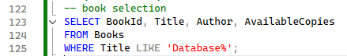
Borrowing: use index
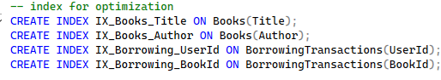
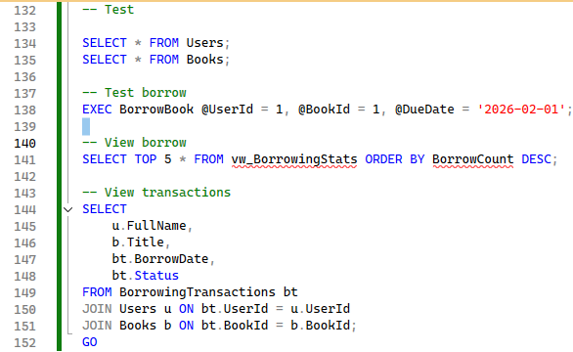

- Why use avoid * : Specifying only needed columns (SELECT BookId, Title, Author, AvailableCopies) instead of SELECT * (select all attr) reduces data transfer and memory usage, resulting in faster search responses
- Why use index: Indexes improve query performance for borrowing statistics by creating a sorted data structure that allows the database to quickly locate without scanning the entire table

Task 2
2.1 Components Using Relational Database (SQL Server)
- User Management: Requires ACID compliance and referential integrity
- Book Inventory: Structured data with complex relationships
- Borrowing Transactions: Requires transactions and atomicity
- Financial Records: Critical data requiring strict consistency

2.2 Components Using NoSQL Databases
- Search Index (Elasticsearch): Full-text search with fuzzy matching
- Session Data (Redis): In-memory storage for fast access
- Cache Layer (Redis): Reduce database load for popular queries
- Activity Logs (MongoDB): Flexible schema for varied log formats
- Analytics Data (MongoDB): Aggregation pipelines for statistics

Task 3
- Data Consistency
+ Relational (SQL): Strong consistency (ACID), full transaction support, enforced via constraints and foreign keys. Best for financial transactions and inventory management.
+ NoSQL: Eventual consistency (BASE), limited or document-level transactions, application-level validation required. Best for logs, caching, and analytics where eventual consistency is acceptable.

- Performance
+ Relational (SQL): Good read performance with proper indexing, slower for complex joins. Moderate write performance constrained by ACID compliance. Good for complex queries with JOINs and aggregations.
+ NoSQL: Good read performance especially for key-value lookups. High write throughput optimized for writes. Limited complex querying, optimized for simple lookups. Built-in memory caching.

- Scalability
+ Relational (SQL): Good vertical scaling. Difficult horizontal scaling. Best for medium-scale applications with complex relationships.
+ NoSQL: Good vertical scaling but not primary method. Good horizontal scaling, designed for distributed systems. Best for large-scale applications, big data, and high traffic

