1.1. Create a table soil_sensors if it does not exist with the following columns:
• sensor_id (INT, Primary Key)
• moisture_level (INT)
• recorded_time (DATETIME)
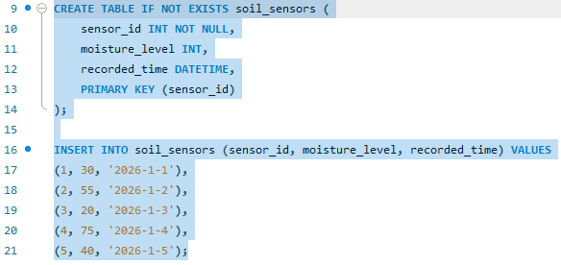
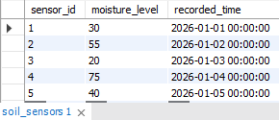

1.2. Then Create a stored procedure GetDryFields that:
• Accepts a moisture threshold as an input parameter
• Displays all sensor records where moisture_level is below the given threshold.
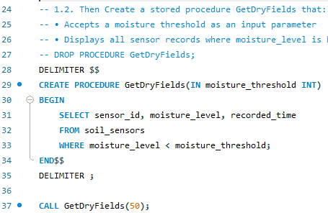
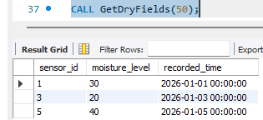
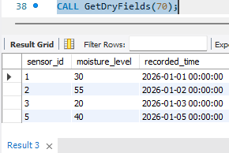

2.1. Create a table fields if it does not exist with the following columns:
• field_id (INT, Primary Key)
• area_sq_meters (INT)
• crop_type (VARCHAR(50))
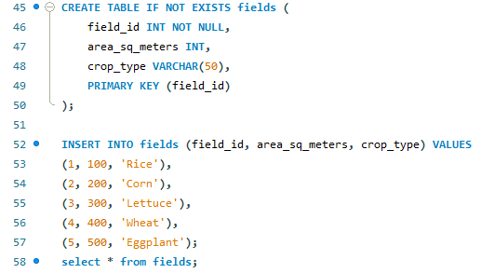
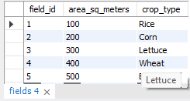

2.2. Create a stored function CalculateWaterRequirement that:
• Accepts area_sq_meters as input
• Returns the total water required per irrigation cycle
• Assume 5 liters of water per square meter
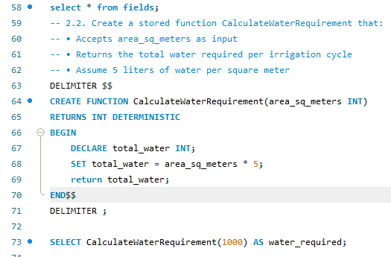
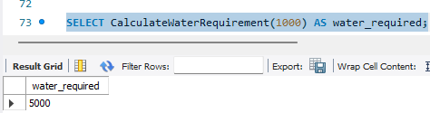
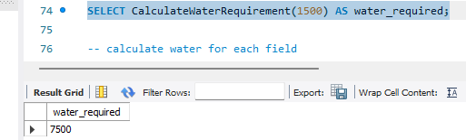
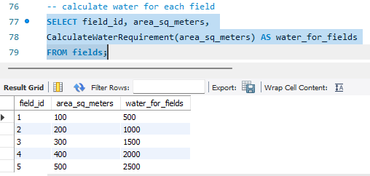

3.1. Create a table irrigation_logs if it does not exist with the following columns:
• log_id (INT, Primary Key)
• field_id (INT)
• water_used_liters (DECIMAL(10,2))
• irrigation_date (DATE)
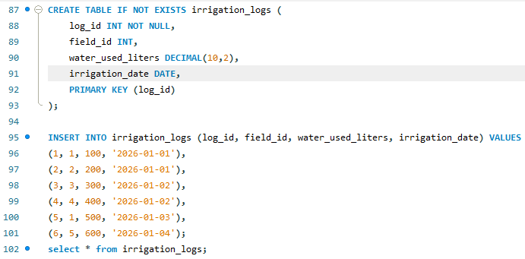
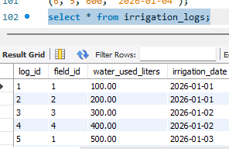

3.2. Create a stored procedure GetTotalWaterUsage that:
• Accepts a date as an input parameter
• Returns the total water used on that date using an OUT parameter.
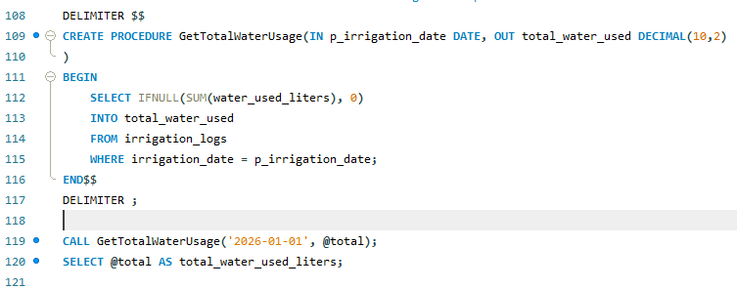
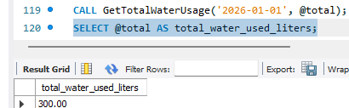
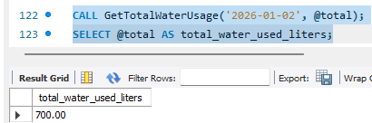

4.1. Create a table field_status if it does not exist with the following columns:
• field_id (INT, Primary Key)
• moisture_level (INT)
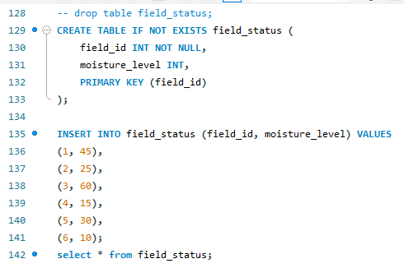
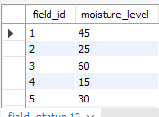

4.2. Create a stored procedure CountCriticalFields that:
• Uses a cursor
• Iterates through all records
• Counts how many fields have a moisture level below 30
• Displays the total count
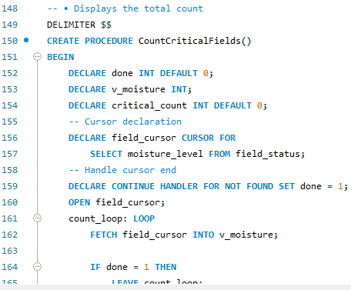
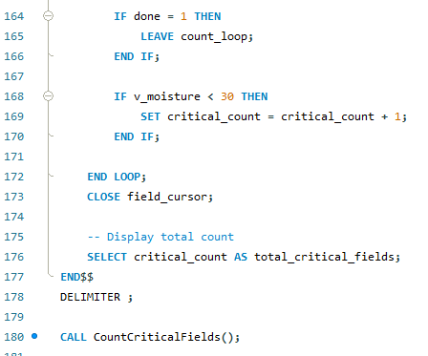
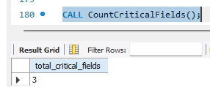

5.1. Create a table irrigation_schedule if it does not exist with the following columns:
• schedule_id (INT, Primary Key)
• field_id (INT)
• irrigation_duration (INT) (in minutes)
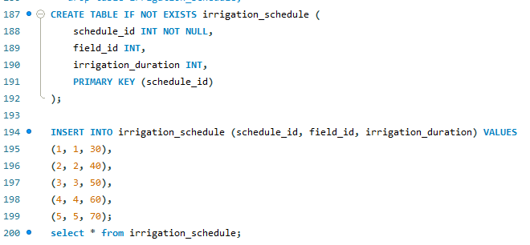
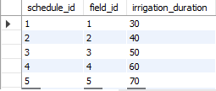

5.2. Create a stored procedure AdjustIrrigationDuration that:
• Uses a cursor
• Increases irrigation duration by 20%
• Updates each row individually
