EASTERN INTERNATIONAL UNIVERSITY  SCHOOL OF COMPUTING  AND  INFORMATION TECHNOLOGY  | Week 6 Practice Assignment – Quarter 2, 2025-2026  Method: LAB 5 Practice 5  Course Name: Advanced Databases Course Code: CSW 436 Student’s Full Name: Phạm Trần Gia Hưng  Student ID: 2331200153

Important Instructions –
- Implement each question using MongoDB.
- find(), update(), delete().
- Use $group, $count, $avg, $max and other NoSQL method for query processing and optimization.
- Document all question Output/results properly by capturing the screenshots of the output/results and NoSQL code for every question in a Word / PDF document and save it.
- After completing all questions, upload the document to Moodle.

Topic: Key-value databases and Document databases

- Create Database & Collection
  - Create a database named schoolDB

  - Create a collection called students


- Insert Documents

  - one document using insertOne()
db.students.insertOne({insert stuff})

  - multiple documents using insertMany()
db.students.insertOne([{ insert stuff }])
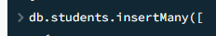

  - Insert 5 student documents with:
o name
o age
o department o marks
o email
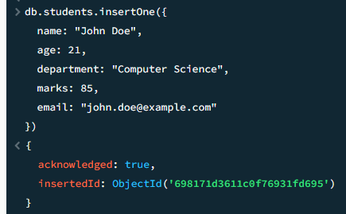
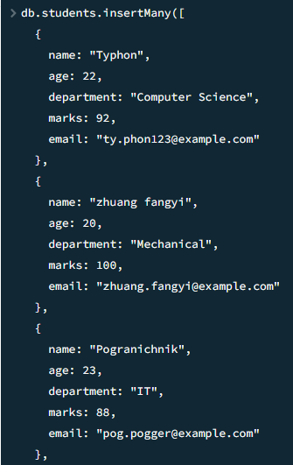
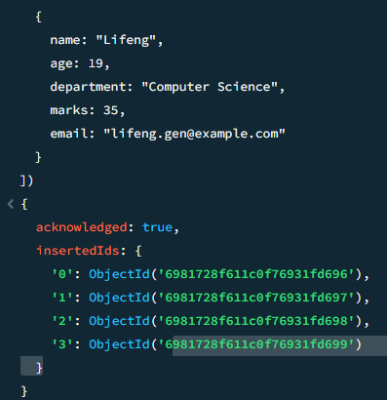

- Find Data
  - Write queries to:
    - Display all students
db.students.find({})
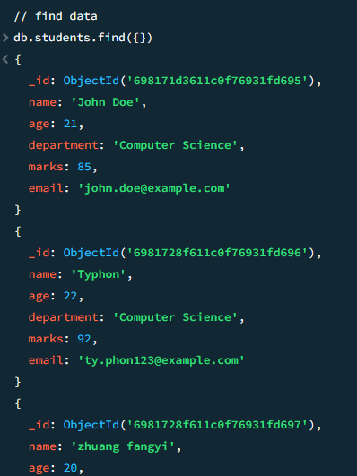
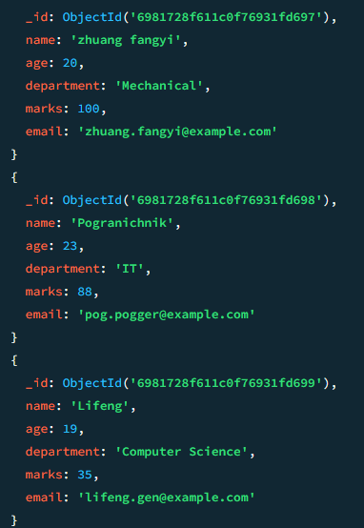

    - Display only name and marks
db.students.find({}, { name: 1, marks: 1, _id: 0 })
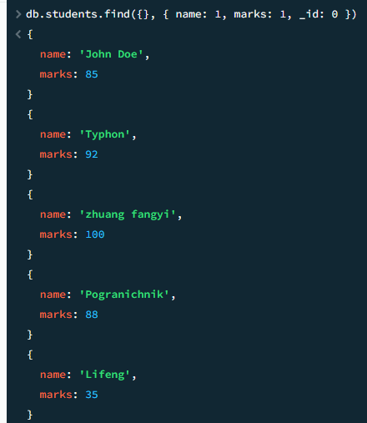

    - Find student with age > 20
db.students.find({ age: { $gt: 20 } })
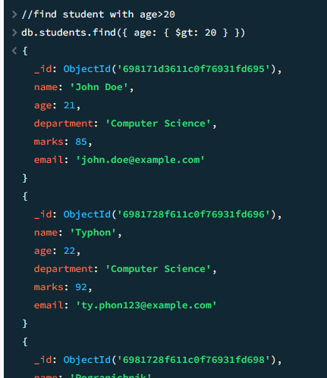
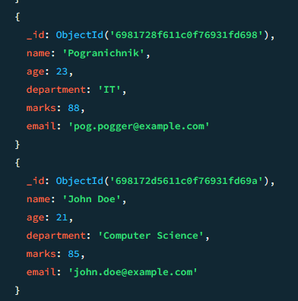

    - Find students from "Computer Science" department
db.students.find({ department: "Computer Science" })
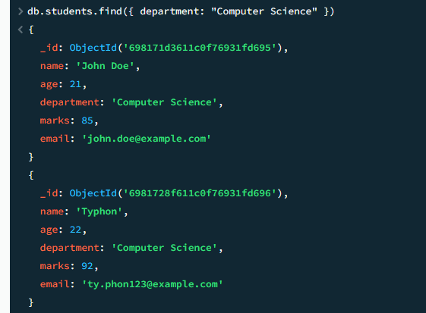
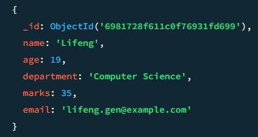

o Find one student using email
db.students.findOne({ email: "alice.smith@example.com" })
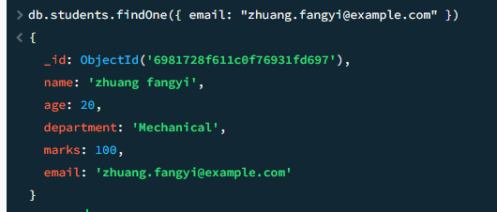

- Update Data
  - Write queries to:
    - Update marks of one student
db.students.updateOne({ name: "Lifeng" },{ $set: { marks: 50 } })
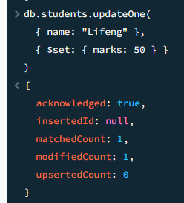

Before:
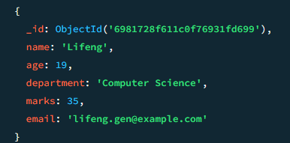

After:
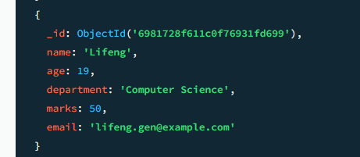

    - Increase all students’ marks by 5
db.students.updateMany({},{ $inc: { marks: 5 } })
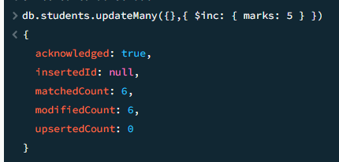

Before:
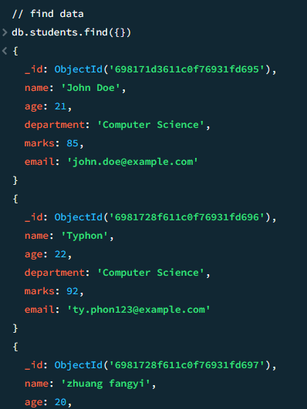
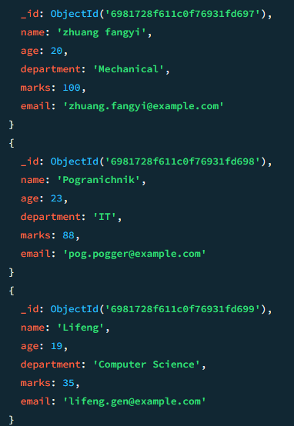

After:
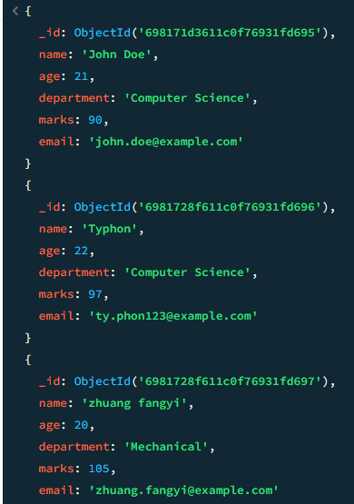
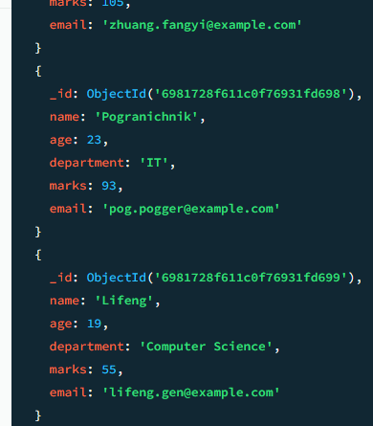

    - Add new field status: "active" to all students
db.students.updateMany({},{ $set: { status: "active" } })
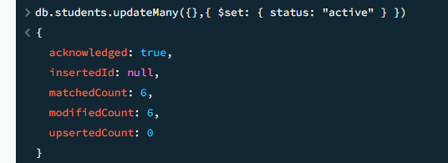
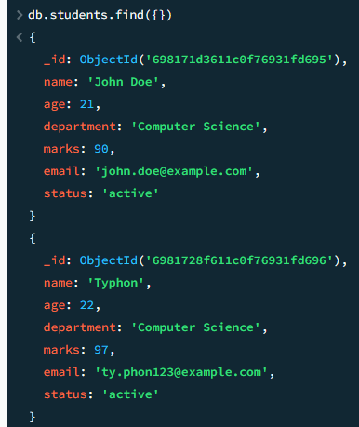
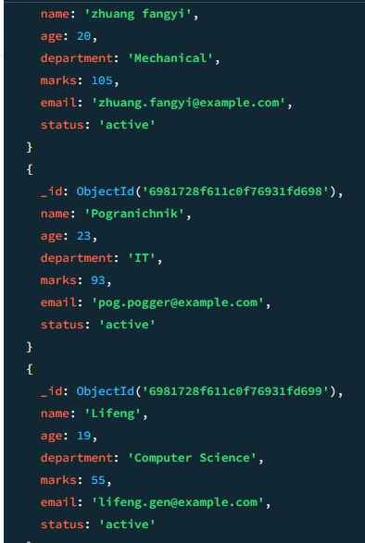

- Delete Data
• Write queries to:
    - Delete one student by name
db.students.deleteOne({ name: "John Doe" })
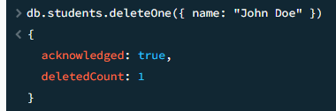
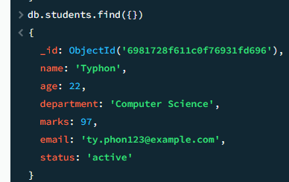
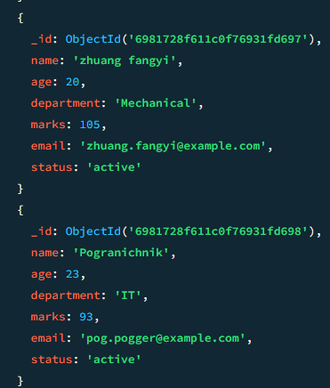
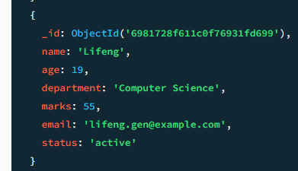

    - Delete all students with marks < 40
db.students.deleteMany({ marks: { $lt: 40 } })

-Insert 2 student lower than 40
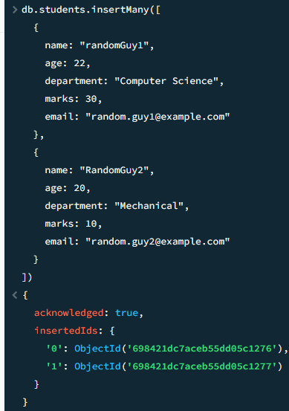
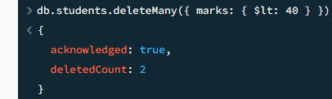
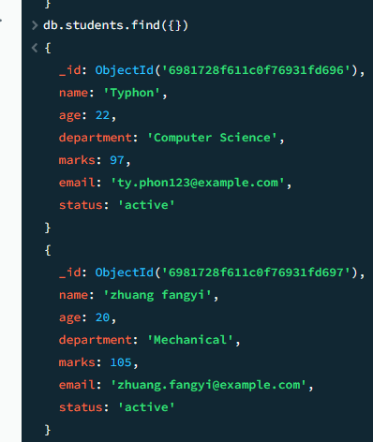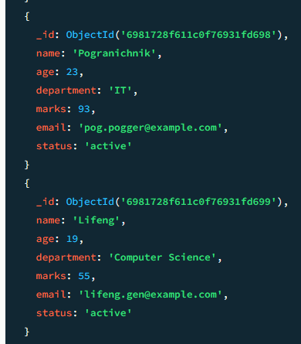
-> Successfully delete all student that score is <40

- Filtering with Operators
• Write queries using:
o $gt, $lt
o $in
o $and, $or
o $ne
Tasks:
    - Students with marks between 60 and 90
// Use $gt and $lt
-Insert 2 student with point 60 and 68
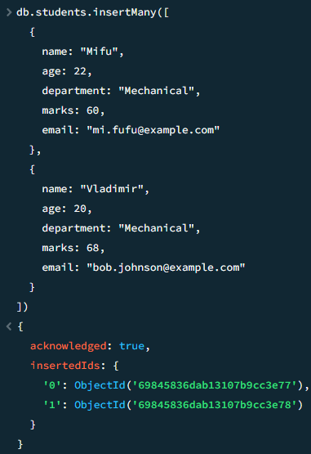

db.students.find({marks: { $gt: 60, $lt: 90 }})
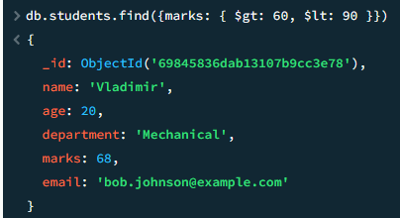

o Students not from "Mechanical"
// Use $ne
db.students.find({department: { $ne: "Mechanical" }})
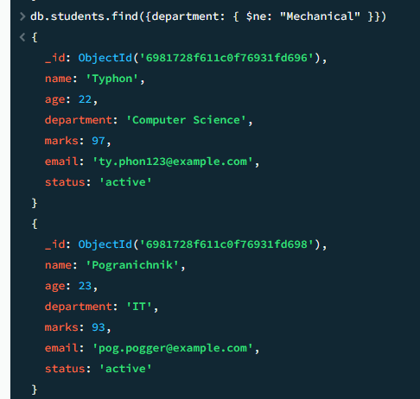
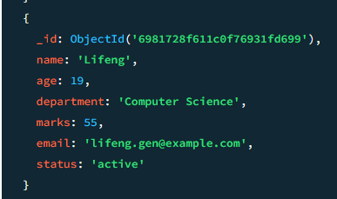

    - Students from "CS" or "IT"
// Use $in
db.students.find({department: { $in: ["Computer Science", "IT"] }})
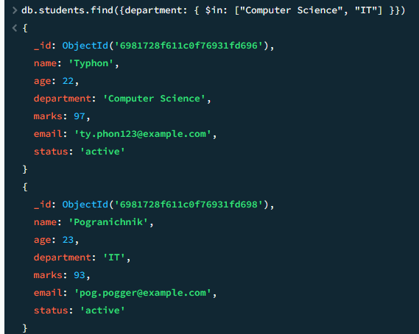
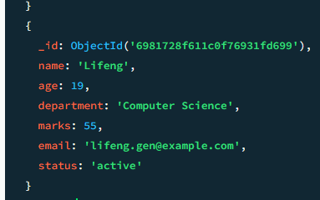

// Use $and
db.students.find({$and: [{ age: { $gte: 20 } },{ marks: { $gte: 80 } }]})
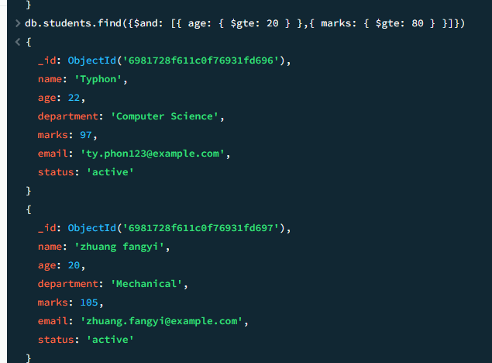
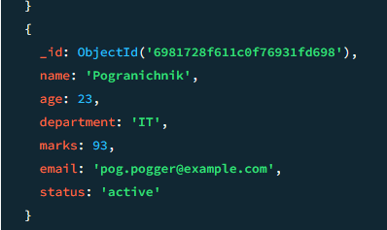

//Using $or operator
db.students.find({$or: [{ department: "Computer Science" },{ department: "IT" }]})
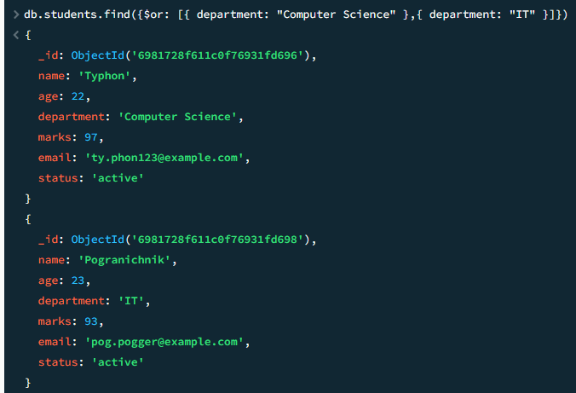
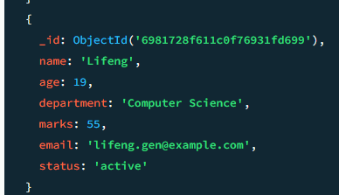

- Sorting & Limiting
  - Sort students by marks descending
db.students.find({}).sort({ marks: -1 })
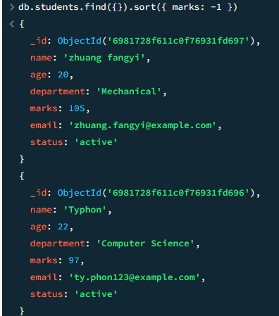
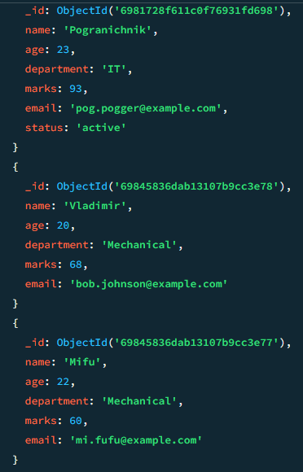
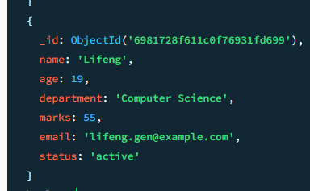

  - Show top 3 students
db.students.find({}).sort({ marks: -1 }).limit(3)
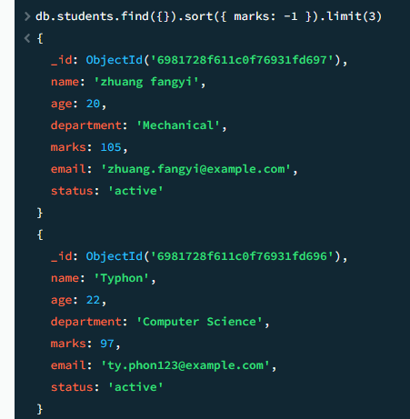
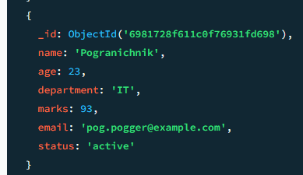

  - Skip first 2 and show next 3
db.students.find({}).sort({ marks: -1 }).skip(2).limit(3)
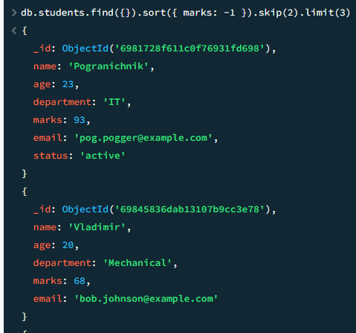
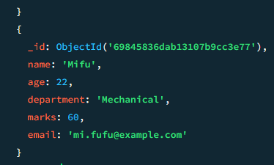

- Arrays Practice
• Add field:
o subjects: ["DBMS", "OS", "CN"]
db.students.updateMany({},{$set:{subjects:["DBMS","OS","CN"]}})
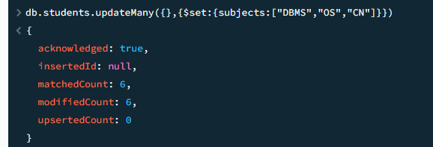

Tasks:
  - Find students who have "DBMS"
db.students.find({subjects: "DBMS"})
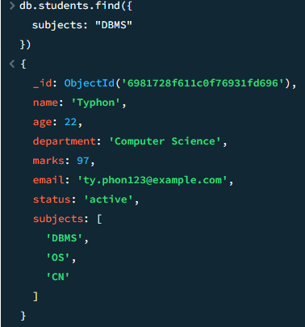
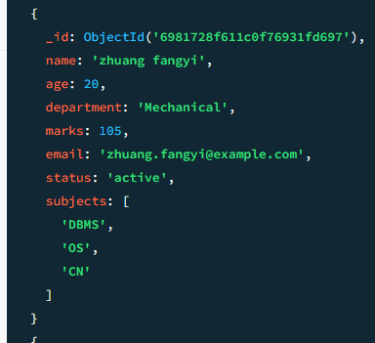
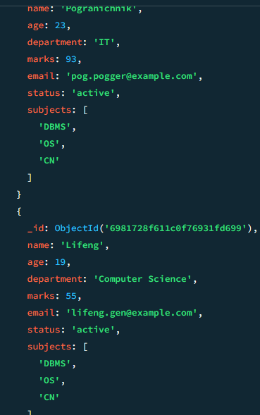
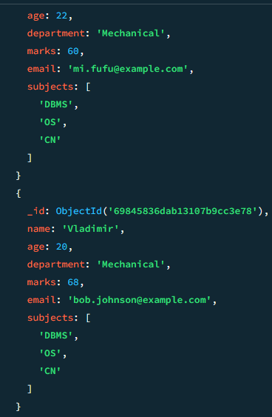

  - Add new subject
db.students.updateOne({ name: "Mifu" },{ $push: { subjects: "Endfield" } })
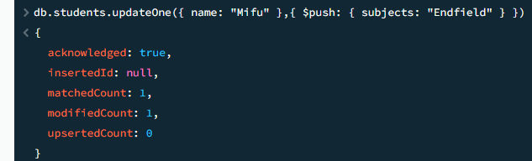
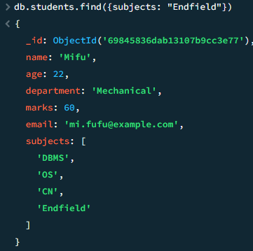

  - Remove one subject
db.students.updateOne({ name: "Mifu" },{ $pull: { subjects: "CN" } })
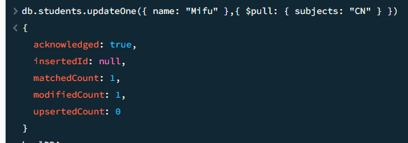
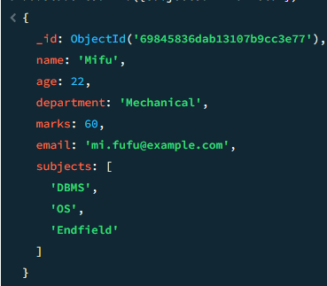

- Embedded Documents
• Add:
address: {
city: "Ho chi Minh", pincode: 234569
}
db.students.updateMany({},{$set:{address:{city: "Ho Chi Minh",pincode:234569}}})
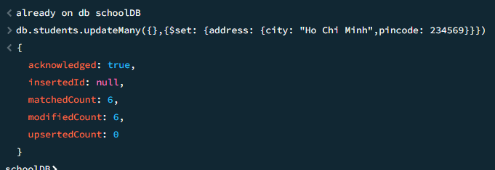

Tasks:
  - Find students from Delhi
db.students.find({"address.city": "Delhi"})

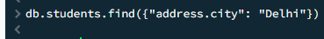
- Insert a student live at delhi:
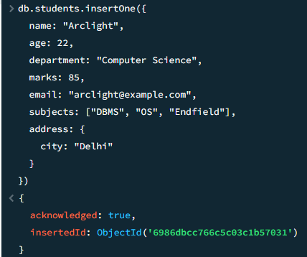
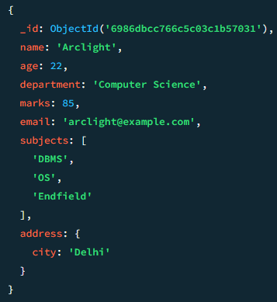

  - Update pincode
db.students.updateMany({"address.city": "Ho Chi Minh"},{$set:{ "address.pincode":700000}})
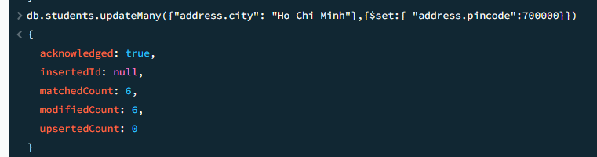
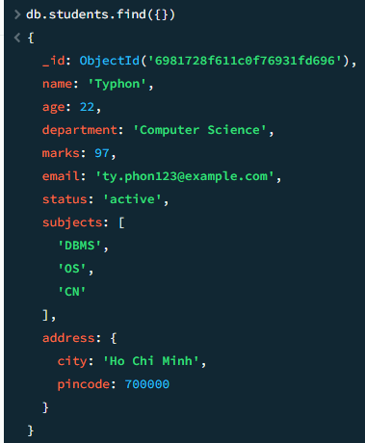
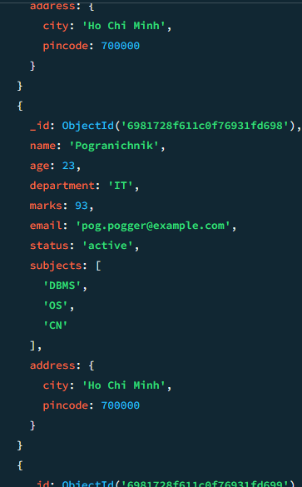

  - Add street field
db.students.updateOne({ name: "Lifeng" },{ $set: { "address.street": "Wuling" }})
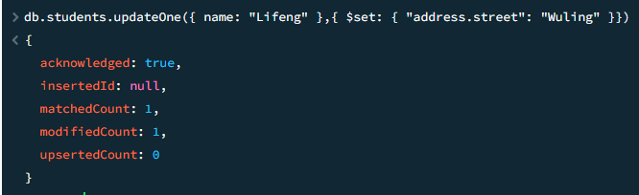
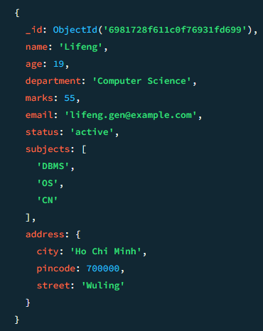

- Aggregation Framework Use aggregate() to:
  - Count total students
db.students.aggregate([{ $count: "totalStudents" }])
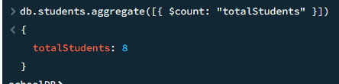

  - Find average marks
db.students.aggregate([{$group: {_id: null,averageMarks: { $avg: "$marks" }}}])
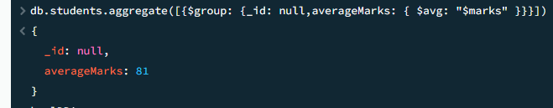

  - Find highest marks
db.students.aggregate([{$group:{_id:null,highestMarks:{$max:"$marks"}}}])
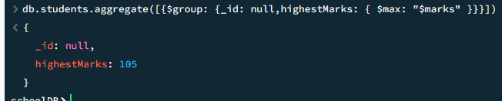

  - Group students by department and count them
db.students.aggregate([{$group:{_id:"$department",count:{ $count:{}}}}])
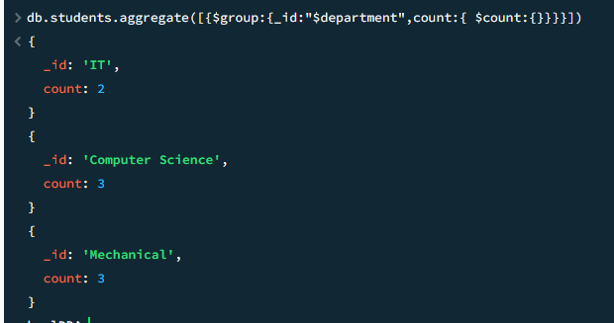

  - Find department with highest average marks
db.students.aggregate([{$group: {_id: "$department",averageMarks: { $avg: "$marks"}}},{$sort: { averageMarks: -1 }},{$limit: 1}])
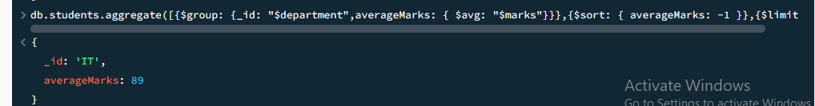

- Indexing
  - Create index on email
db.students.createIndex({email:1})
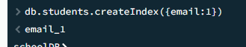

  - Create compound index on department + marks
db.students.createIndex({department: 1, marks: -1})
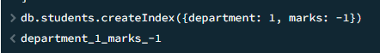

View all index:
db.students.getIndexes()
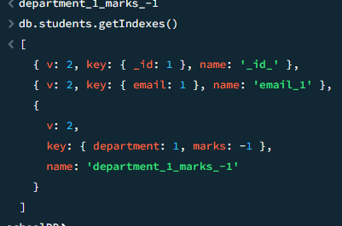

  - Explain why indexing is useful
- Performance:
+Index speed up query operations
+Without index: MongoDB scans every column and row
+With index: MongoDB uses B-tree structure

-Useful for queries that filter on multiple fields

- Relationships
Create:
  - courses
  - enrolments
Tasks:
  - Insert courses
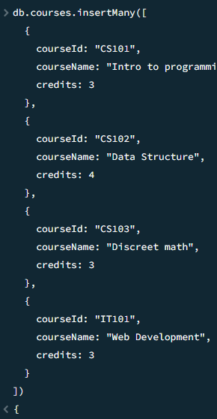
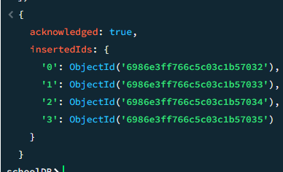

  - Enrol students
- get student id
db.students.find({}, { _id: 1, name: 1 })
- insert enrollment
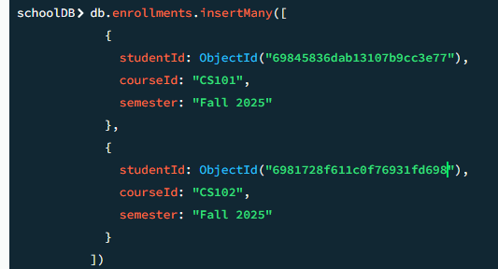
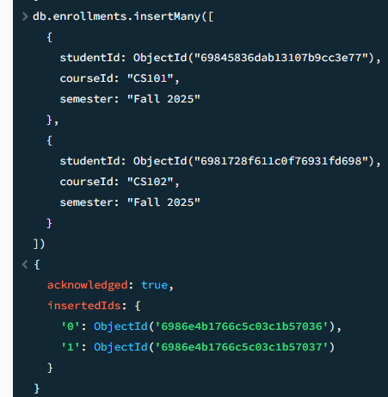

  - Use $lookup to join students with courses
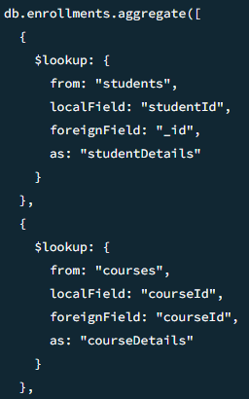
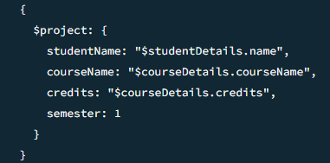
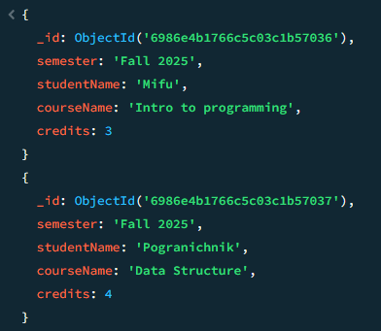

- Build Student Result Management System Students must:
  - Insert 20 records
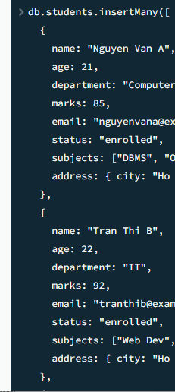
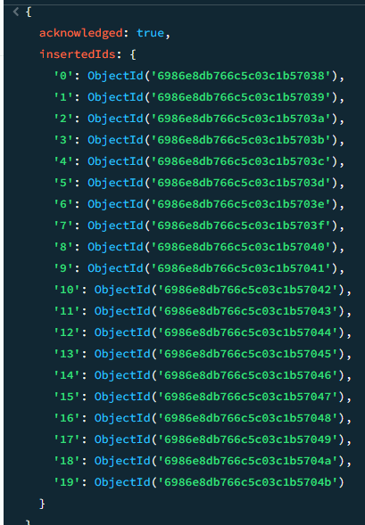

  - Query failed students
db.students.find({marks:{ $lt: 50}})
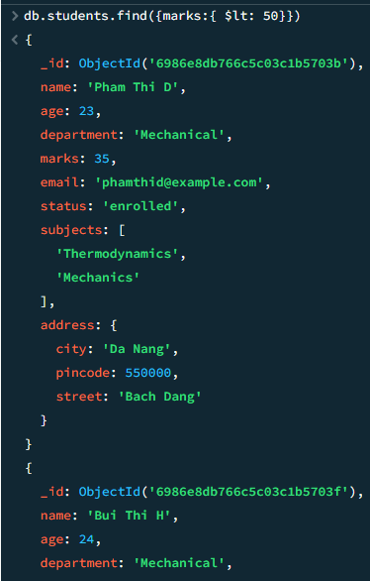
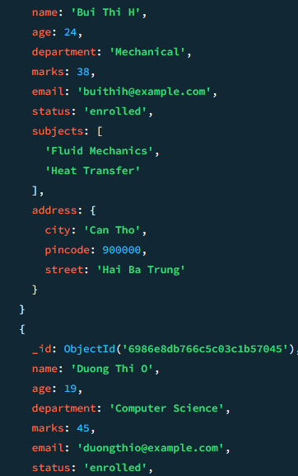

  - Top 5 scorers
db.students.find({},{ name: 1, marks: 1, department: 1,_id: 0}).sort({ marks: -1 }).limit(5)
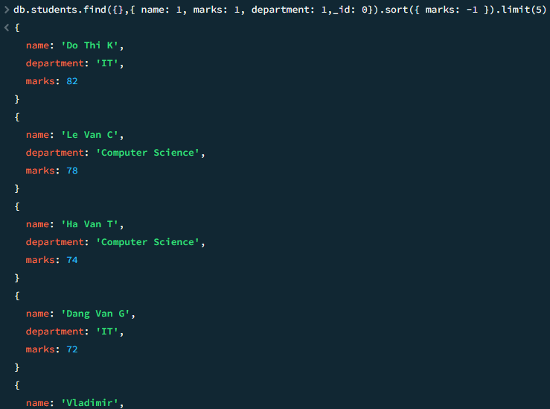

  - Department wise average
db.students.aggregate([{$group: {_id: "$department",averageMarks: { $avg: "$marks" },totalStudents: { $sum: 1 },maxMarks: { $max: "$marks" },minMarks: { $min: "$marks" }}},{$sort: { averageMarks: -1 }}])
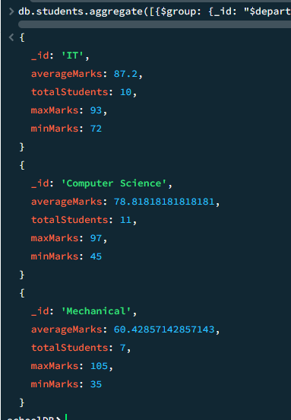

  - Update results
// give +5 for student who have <50 point
db.students.updateMany({ marks: { $lt: 50 } },{ $inc:{ marks: 5}})
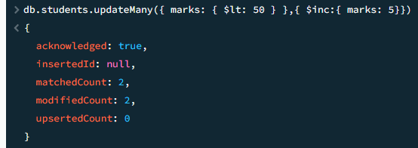

• Delete graduated students
// update for student with point >85 to graduate
db.students.updateMany({ marks:{ $gte: 85}},{ $set:{status:"graduated" }})
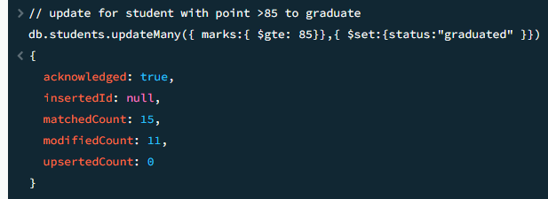

// delete student graduated
db.students.deleteMany({status: "graduated"})
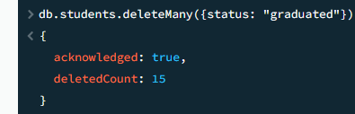

  - find(), update(), delete().
//find student who pass, point must >=50
db.students.find({marks: { $gte:50}})
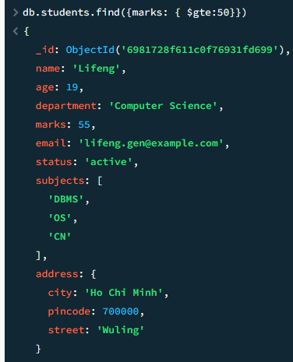
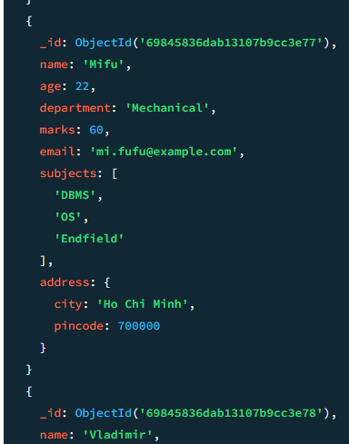
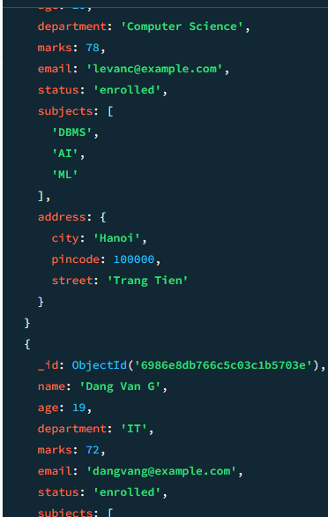

  - Use $group, $count, $avg, $max,
- group
db.students.aggregate([{$group: {_id: "$department",totalStudents:{$sum:1}}}])
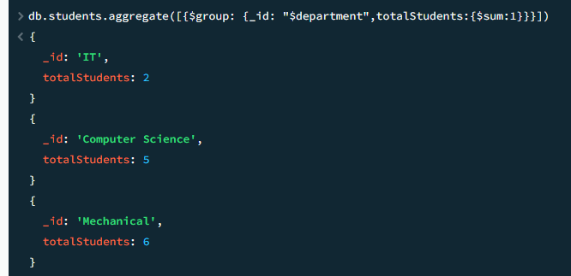

-count
db.students.aggregate([{ $count: "totalStudents" }])
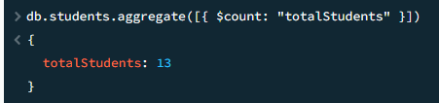

- avg
db.students.aggregate([{$group:{_id: null,averageMarks:{$avg:"$marks"}}}])
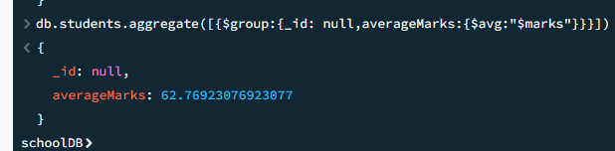

-max
db.students.aggregate([{$group:{_id: null,highestMarks:{$max:"$marks"}}}])
