
EASTERN INTERNATIONAL UNIVERSITY  SCHOOL OF COMPUTING  AND  INFORMATION TECHNOLOGY  | Week 7 Practice Assignment – Quarter 2, 2025-2026  Method: LAB 6 Practice 6  Course Name: Advanced Databases  Course Code: CSW 436  Student’s Full Name: Phạm Trần Gia Hưng  Student ID: 2331200153

Important Instructions –
- Implement each question using MongoDB.
- find(), update(), delete().
- Use $group, $count, $avg, $max and other NoSQL method for query processing and optimization.
- Document all question Output/results and NoSQL code for every question in a Word / PDF document and save it.
- After completing all questions, upload the document to Moodle.

Topic: MongoDB (CRUD, schema design)

- Create a database named schoolDB and a collection called students. Insert 5 student records with the following fields:
student_id, name, class, age, marks, city
Asnwer:
db.students.insertMany([
{ student_id: 101, name: "Zhuang Fangyi", class: "10A", age: 16, marks: 90, city: "Ho Chi Minh" },
{ student_id: 102, name: "Perlica", class: "10B", age: 15, marks: 72, city: "Binh Duong" },
{ student_id: 103, name: "Chen Qianyu", class: "10A", age: 16, marks: 65, city: "Dong Nai" },
{ student_id: 104, name: "Antal", class: "10B", age: 15, marks: 85, city: "Binh Duong" },
{ student_id: 105, name: "Nefarith", class: "10A", age: 16, marks: 30, city: "Ho Chi Minh" }
])
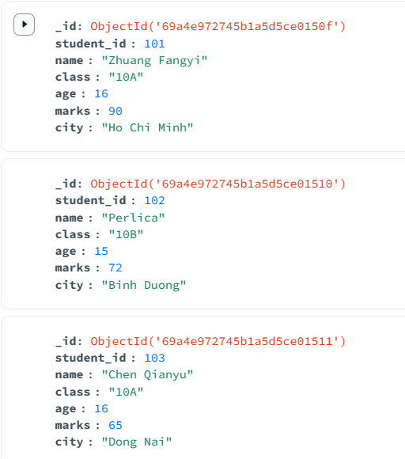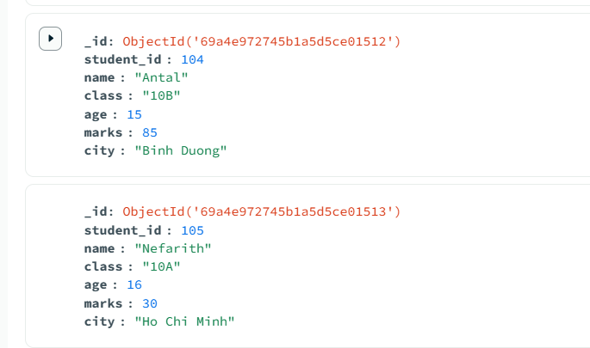

- Write queries to:
  - Display all students.
  - Display students who scored more than 70 marks.
  - Display students from class "10A".
Asnwer:
  - Display all students.
db.students.find()
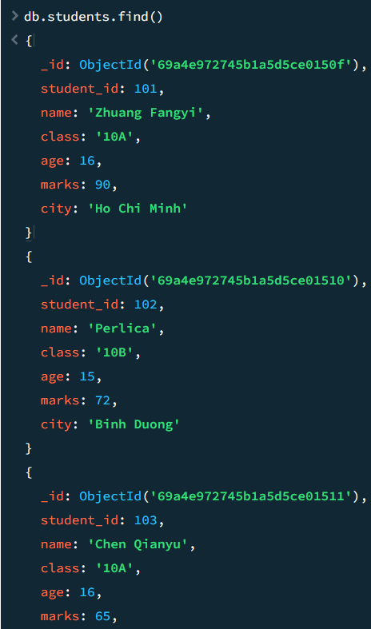
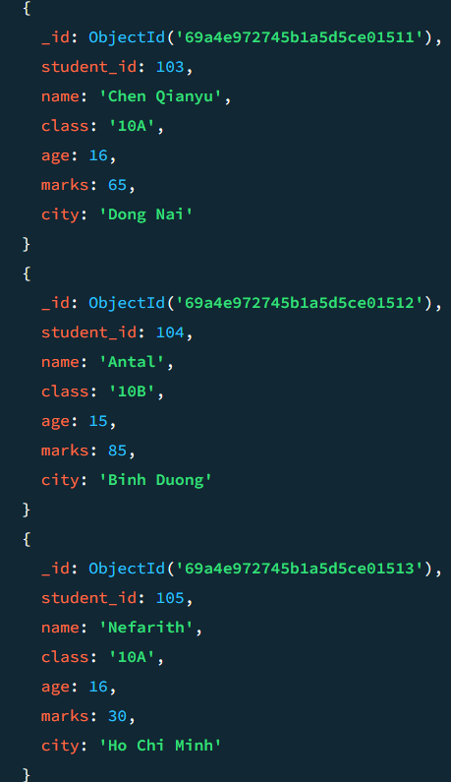

Display students who scored more than 70 marks.
db.students.find({marks:{$gt:70}})
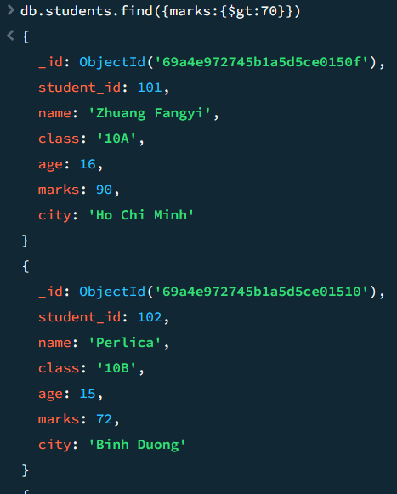
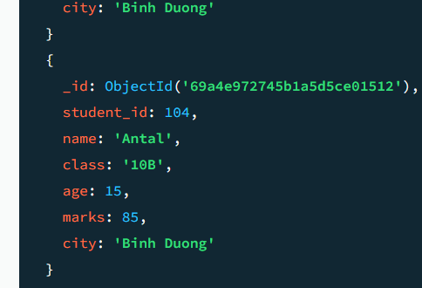

Display students from class "10A".
db.students.find({ class: "10A" })
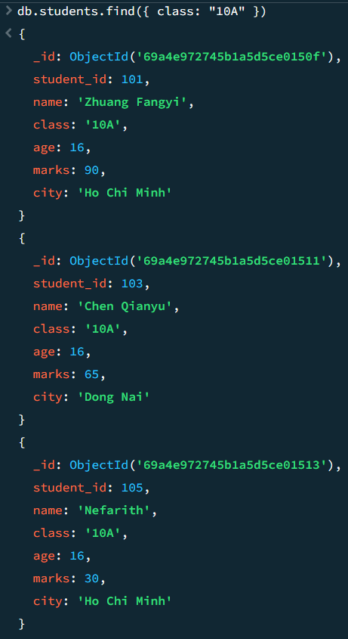

- Write queries to:
  - Update the marks of the student whose student_id is 101.
  - Increase marks by 5 for all students in class "10A".
Asnwer:
  - Update the marks of the student whose student_id is 101.
db.students.updateOne(
{ student_id: 101 },
{ $set: { marks: 95 } }
)
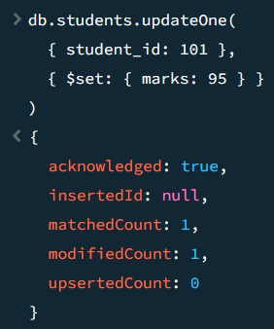
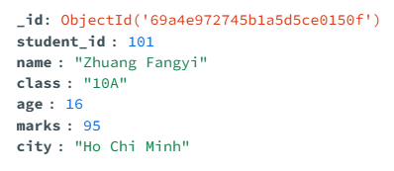

  - Increase marks by 5 for all students in class "10A".
db.students.updateMany(
{ class: "10A" },
{ $inc: { marks: 5 } }
)
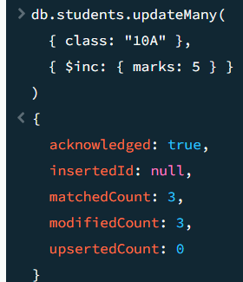
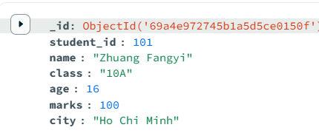
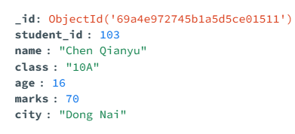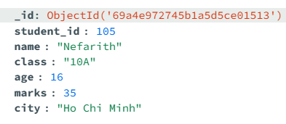

- Write queries to:
  - Delete the student whose student_id is 105.
  - Delete students who scored less than 35 marks.
Asnwer:
• Delete the student whose student_id is 105.
db.students.deleteOne({ student_id: 105 })
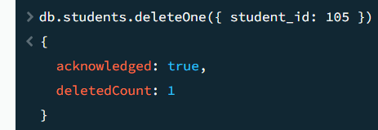
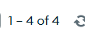

• Delete students who scored less than 35 marks.
Insert for delete:
db.students.insertMany([
{ student_id: 106, name: "random guy 1", class: "10A", age: 16, marks: 10, city: "Ho Chi Minh" },
{ student_id: 107, name: "random guy 2", class: "10B", age: 15, marks: 22, city: "Binh Duong" }
])
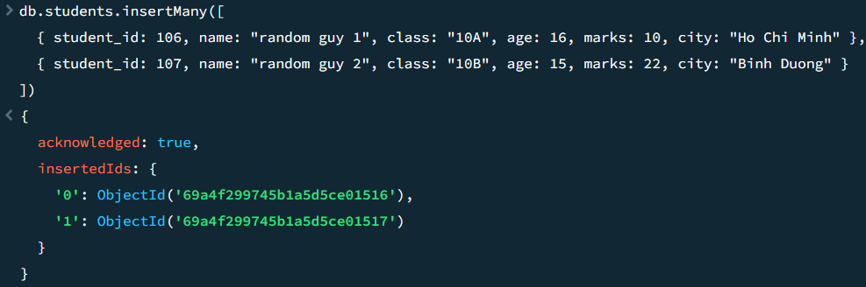


db.students.deleteMany({ marks: { $lt: 35 } })
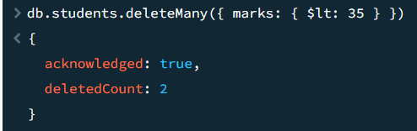
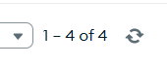

- Perform All CRUD Operations for the following:
  - Insert a new student record.
  - Update the student’s marks.
  - Display the updated record.
  - Delete the same student record.
Asnwer:
• Insert a new student record.
db.students.insertOne({
student_id: 108,
name: "random guy",
class: "10B",
age: 15,
marks: 75,
city: "Ho Chi Minh"
})
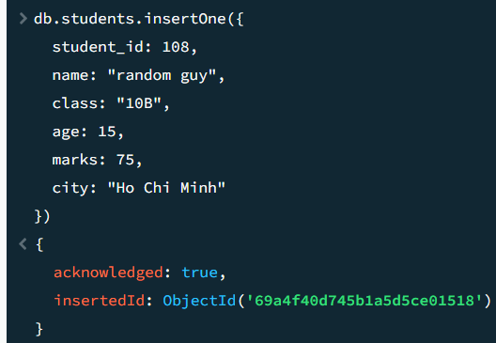
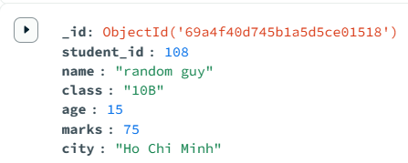

• Update the student’s marks.
db.students.updateOne(
{ student_id: 108},
{ $set: { marks: 90 } }
)
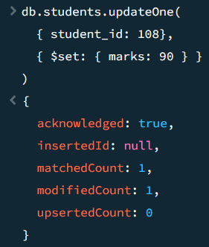
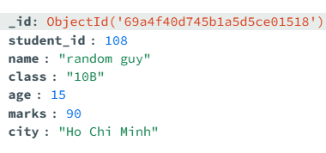

• Display the updated record.
db.students.find({ student_id: 108})
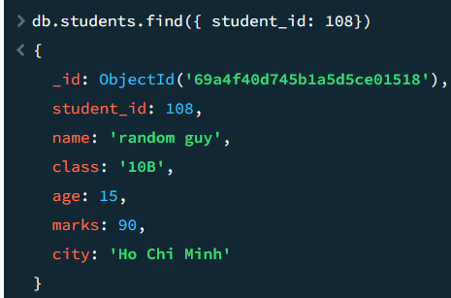

• Delete the same student record.
db.students.deleteOne({ student_id: 108})
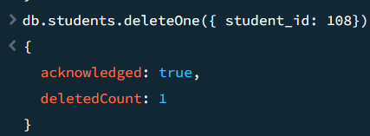
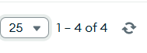

OLAP Operations (Aggregation in MongoDB): Use the students collection for the following aggregation queries.
- Use - Group By: write an aggregation query to calculate the average marks of students in each class.
- Sum of Marks: write an aggregation query to calculate the total marks of students in each class.
- Write an aggregation query to count the number of students in each city.
- Filter and Group - write an aggregation query to:
  - Find the average marks of students from the city "Binh Doung".
- Sort and top results - write an aggregation query to:
  - Display classes sorted by average marks in descending order.
Asnwer:

Use - Group By: write an aggregation query to calculate the average marks of students in each class.
db.students.aggregate([
{
$group: {
_id: "$class", averageMarks: { $avg: "$marks" }
}
}
])
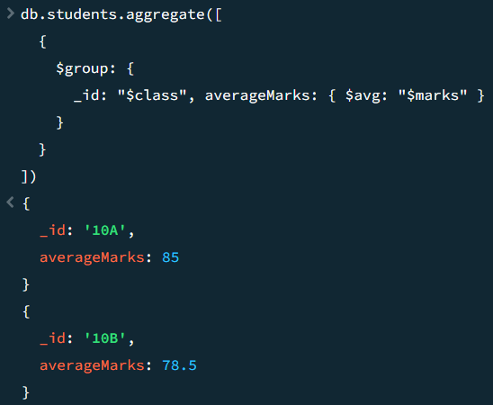

Sum of Marks: write an aggregation query to calculate the total marks of students in each class.
db.students.aggregate([
{
$group: {
_id: "$class", totalMarks: { $sum: "$marks" }
}
}
])
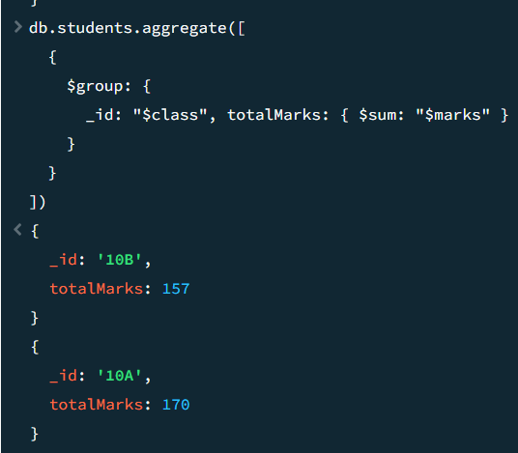

Write an aggregation query to count the number of students in each city.
db.students.aggregate([
{
$group: {
_id: "$city", studentCount: { $count: {} }
}
}
])
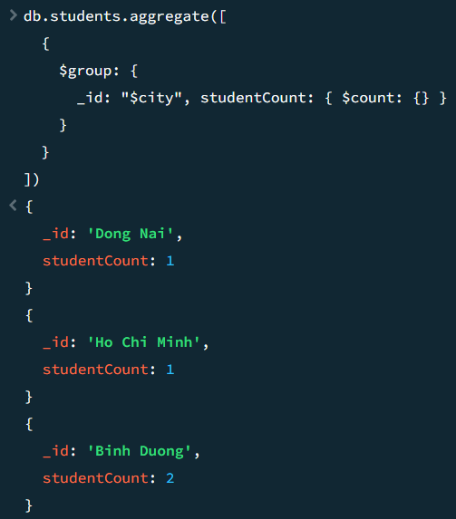

Filter and Group - write an aggregation query to:
  - Find the average marks of students from the city "Binh Doung".
db.students.aggregate([
{
$match: { city: "Binh Duong" }
},
{
$group: {
_id: "$city", averageMarks: { $avg: "$marks" }
}
}
])
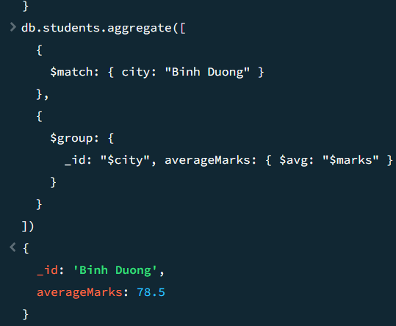

Sort and top results - write an aggregation query to:
  - Display classes sorted by average marks in descending order.
db.students.aggregate([
{
$group: {
_id: "$class", averageMarks: { $avg: "$marks" }
}
},
{
$sort: { averageMarks: -1 }
}
])
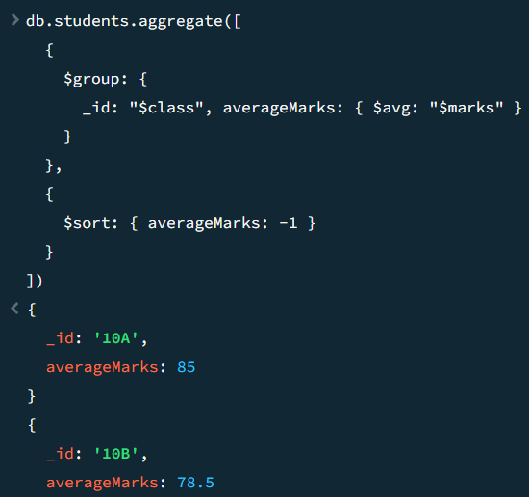

Migrating from mysql to mongoDb
Mysql:
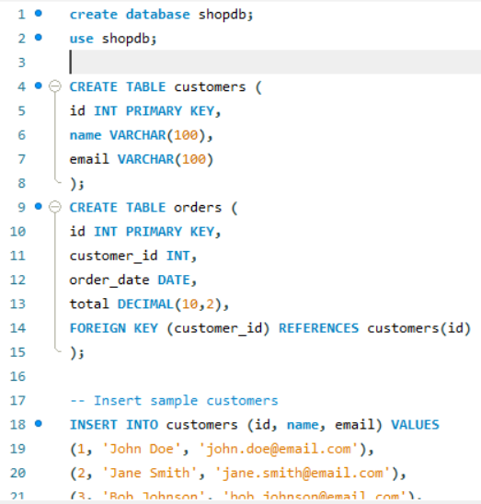

Command line
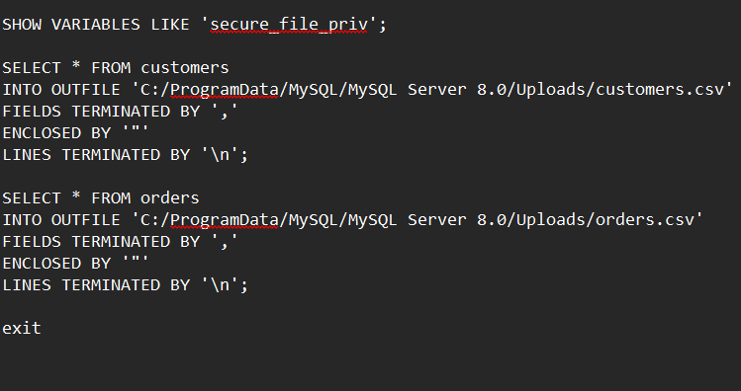
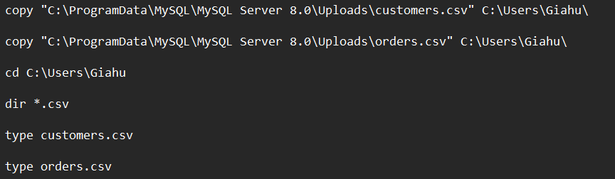

MongoDB
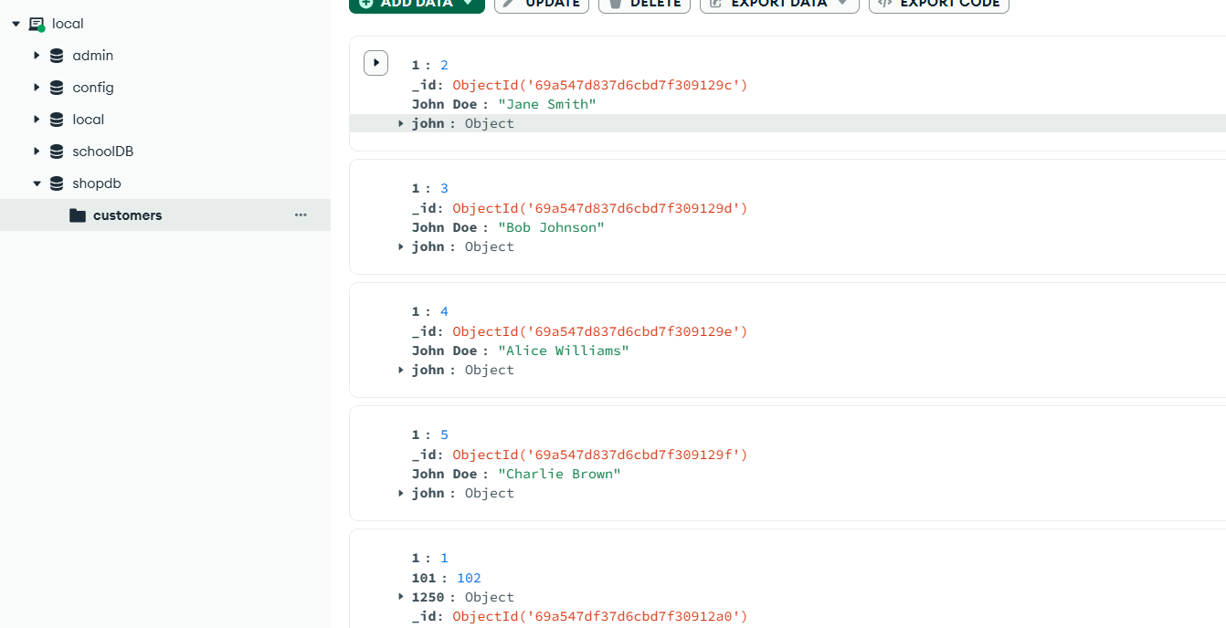
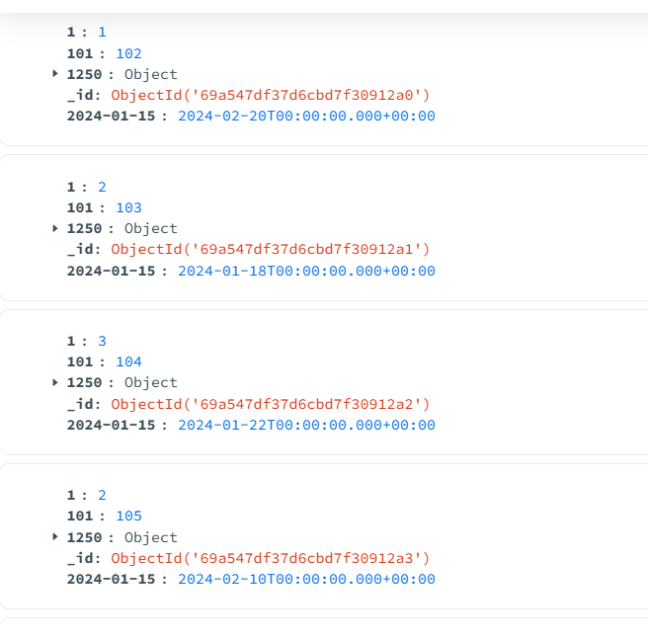
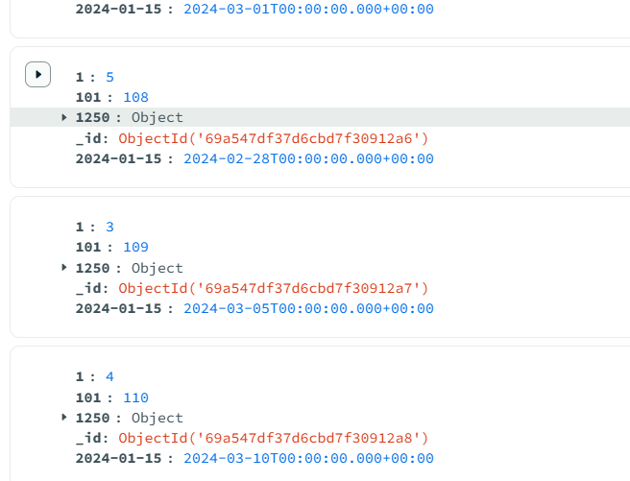
Lecturer
Rohit Kumar Kasera

