LAB 2: 2331200153
1. Create a table named STUDENT, COURSE, ENROLLMENT
Student
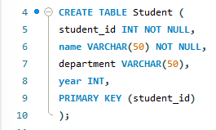
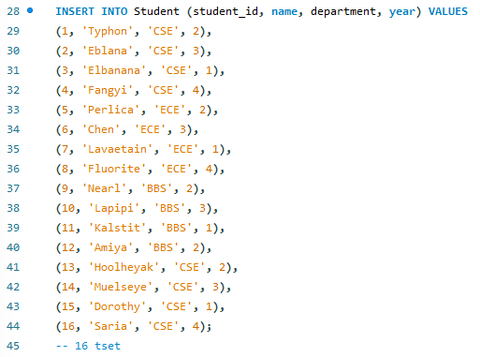

Course
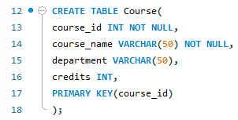
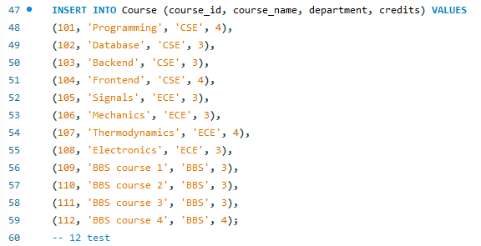

Enrollment
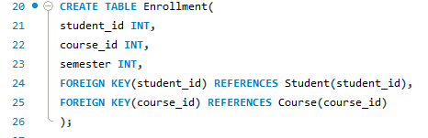
- student_id as a FOREIGN KEY referencing STUDENT(student_id)
- course_id as a FOREIGN KEY referencing COURSE(course_id)

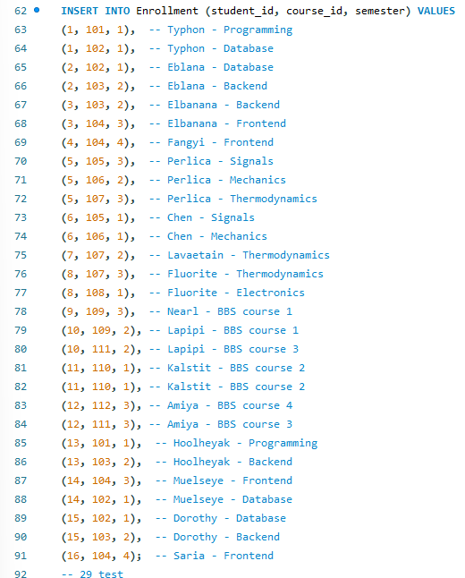

2. Write an SQL query to display the names of all students enrolled in any course or display all student, course and enrolment tables. Include outcome in the assignment file also.
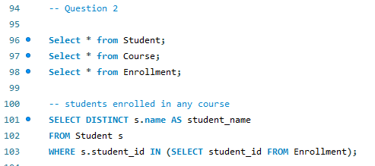
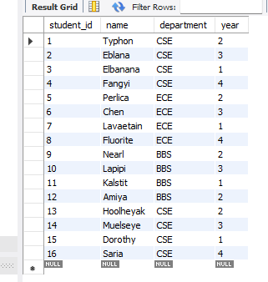
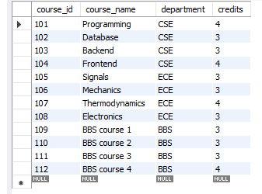
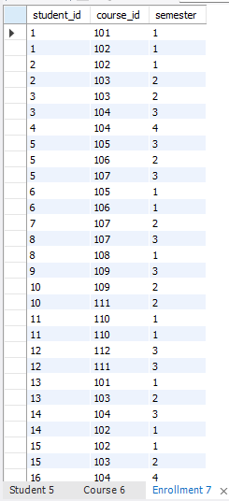
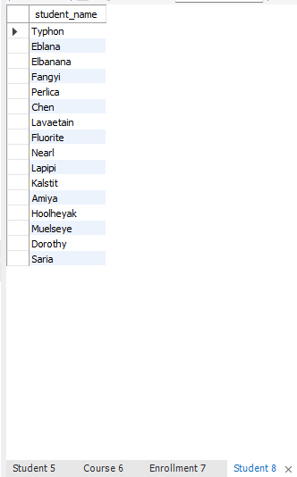

3. Write an SQL query using INNER JOIN to display:
- Student name
- Course name
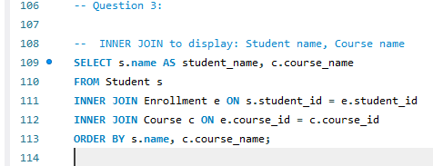
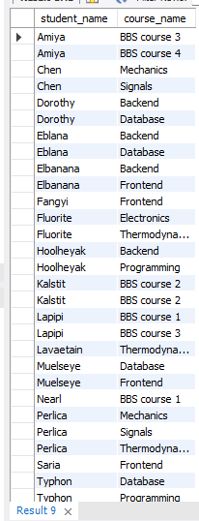

4. Use the EXPLAIN command on the join query discussed in Question 3 to identify:
- The join algorithm used
- The order of table access
- Note - DBMS uses a Nested Loop / Hash Join based on optimization
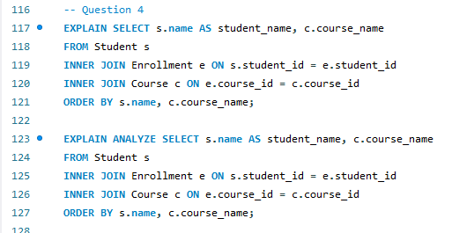
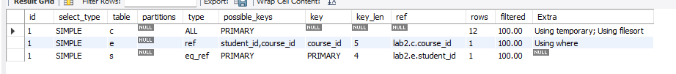
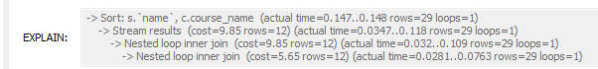
- The join algorithm used: Nested Loop Join
- The order of table access: Course -> Enrollment -> Student

5. Write an SQL query to display the names of students enrolled in courses offered by the CSE department. Use EXPLAIN to observe pipelining of operations
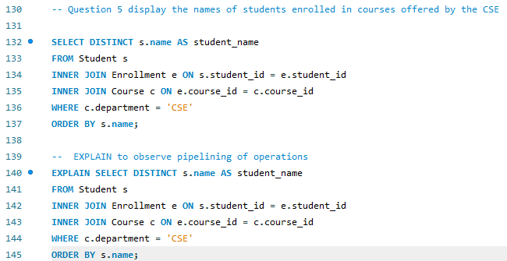
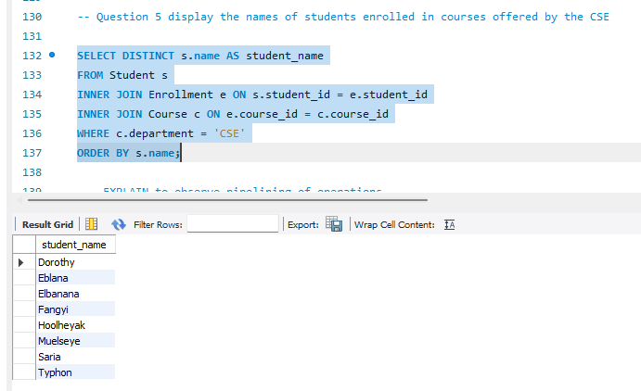
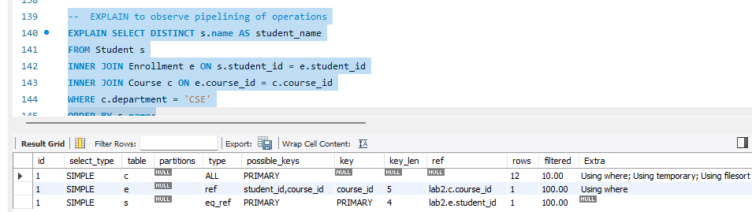

6. Write an SQL query to find students who are enrolled in more than one course. Use
EXPLAIN to analyze the execution plan and note:
- Estimated cost
- Number of rows processed
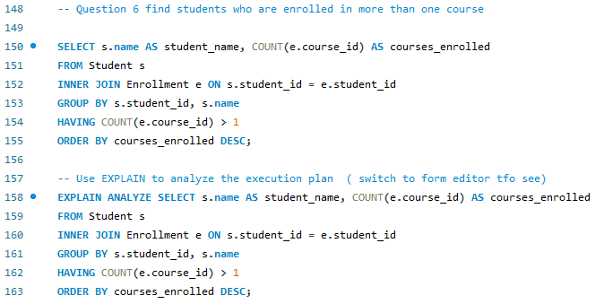

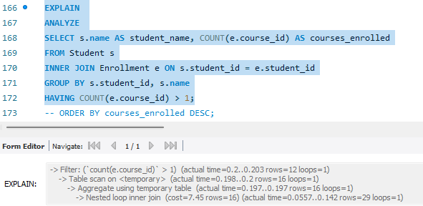

- Estimated cost: 7.45
- Number of rows processed:
+ 16 rows during aggregation
+ 12 rows returned after HAVING and ORDER BY

7. Write two equivalent SQL queries to display student names: Using JOIN and Using a subquery. Use EXPLAIN to compare the execution plans of both queries. Explain outcome in brief of both in the assignment work
JOIN
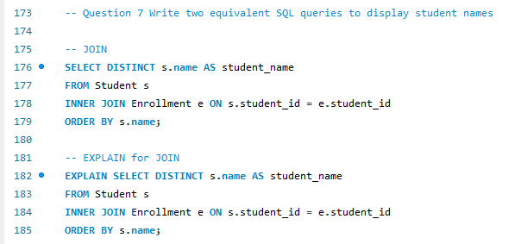
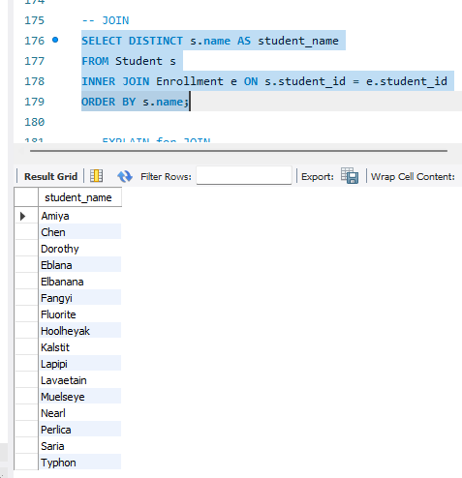
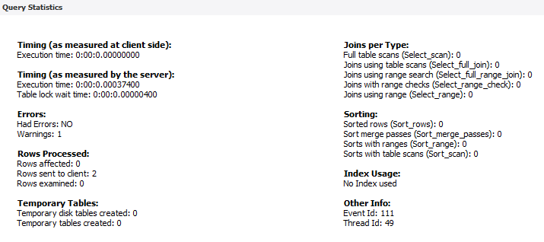

Subquery
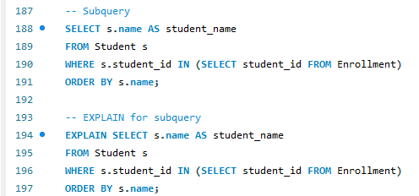
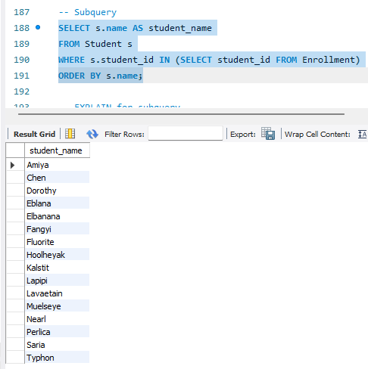
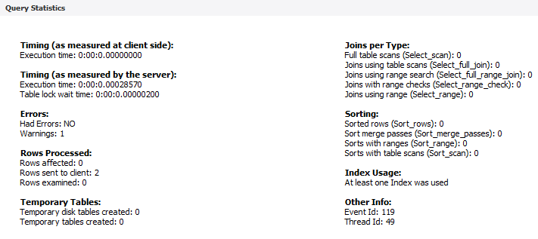
Explain:
Inner Join: Join to connect 3 table then it scan the table and filter
Subquery: It only join connect 2 table Student with Enrollment then scan and lookup
Because lookup is faster than join so subquery is faster than innerjoin

8. Create an index on student_id in the ENROLLMENT table. Execute a join query again and use EXPLAIN. Compare the execution cost before and after the index is created
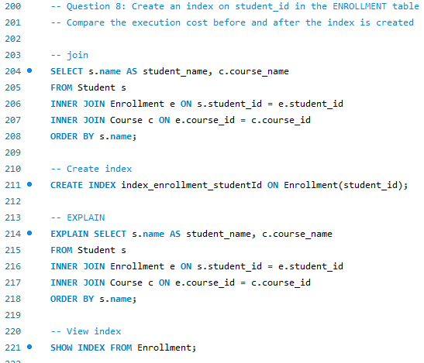
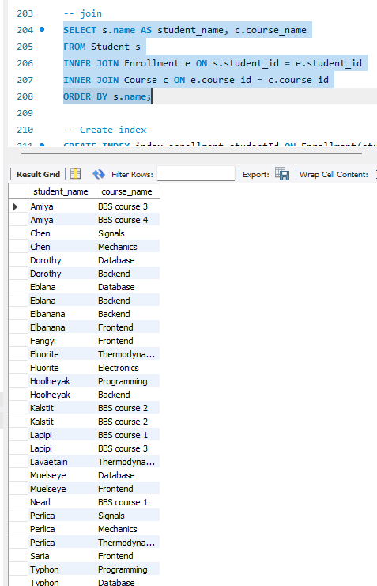

Before using index:
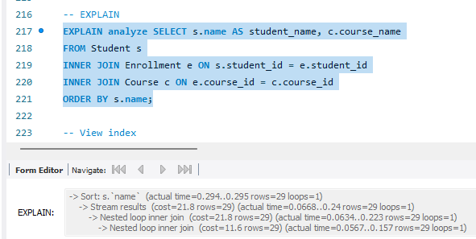

After using index:
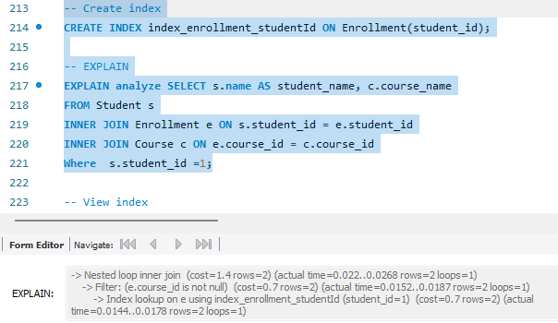

Not using index cost 11.6.
While using index cost 1.7

- Consider the ENROLLMENT table. Perform the following operations using transaction control commands:
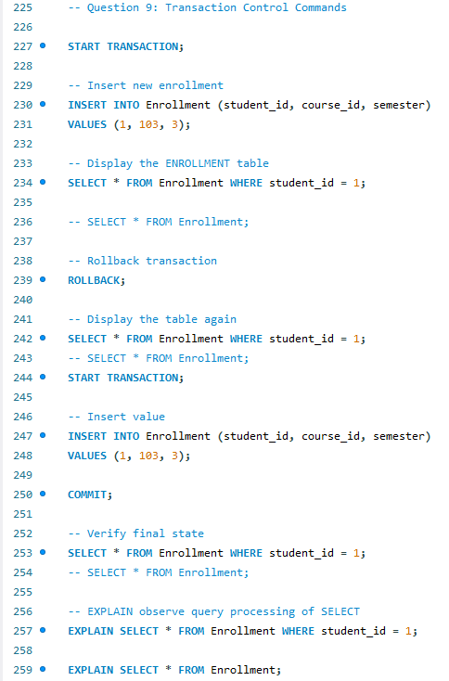
- Start a transaction.
- Insert a new enrollment record for a student.
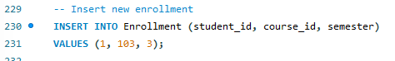

- Display the ENROLLMENT table.
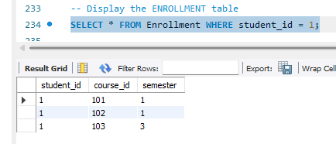
- Rollback the transaction and display the table again.
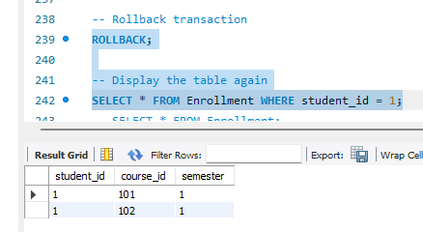
- Commit the transaction and verify the final state.
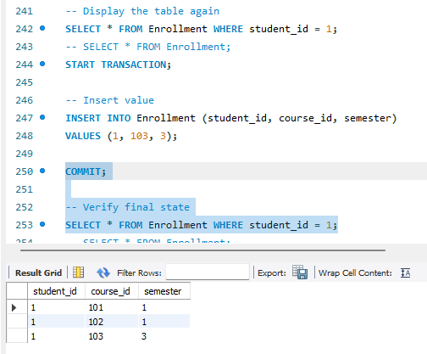
- Use EXPLAIN to observe the query processing of the SELECT statement.
