EASTERN INTERNATIONAL UNIVERSITY  SCHOOL OF COMPUTING  AND  INFORMATION TECHNOLOGY | Week 4 Practice Assignment – Quarter 2, 2025-2026
 | Method: LAB 2 Practice 3
 | Course Name: Advanced Databases
 | Course Code: CSW 436
 | Student’s Full Name: Phạm Trần Gia Hưng
 | Student ID: 2331200153

Important Instructions –
- Implement each question using MySQL Workbench.
- Document all question Output/results properly by capturing the screenshots of the output/results and SQL code for every question in a Word document and save it.
- After completing all questions, upload the document to Moodle.

Topic: Stored procedures and functions

- Create a stored procedure named getTodayDate that:
- Uses no IN parameters
- Uses one OUT parameter to return the current system date
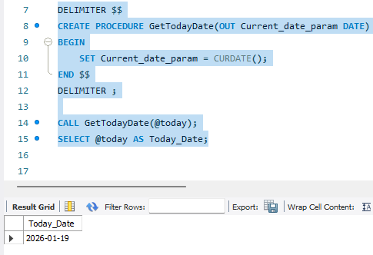
- Create a stored procedure named checkEvenOdd that:
- Takes one IN parameter (an integer number)
- Uses one OUT parameter to return:
  - "Even" if the number is even
  - "Odd" if the number is odd
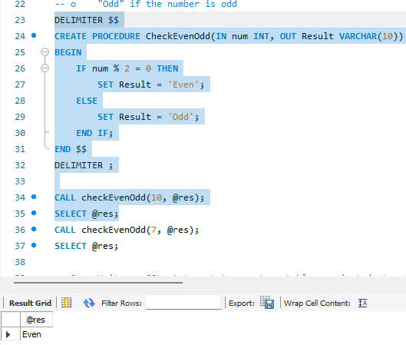
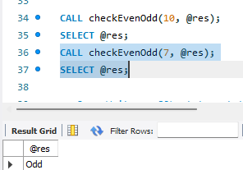

- Write an SQL statement to create a table named students with the following columns:
- student_id (INT, Primary Key, Auto Increment)
- name (VARCHAR(50))
- marks (INT).
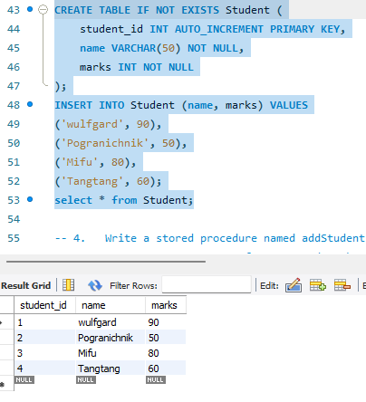
- Write a stored procedure named addStudent that:
- Accepts IN parameters for name and marks.
- Inserts a new student record into the students table.
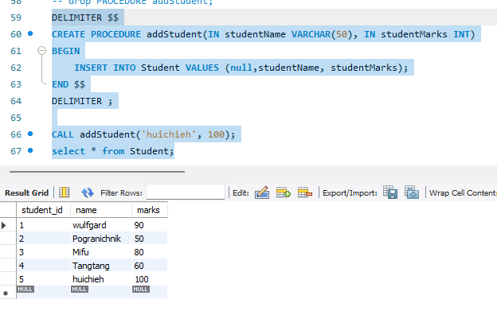
- Write a stored procedure named getStudentById that:
- Accepts one IN parameter (student_id).
- Displays the name and marks of the student with the given ID
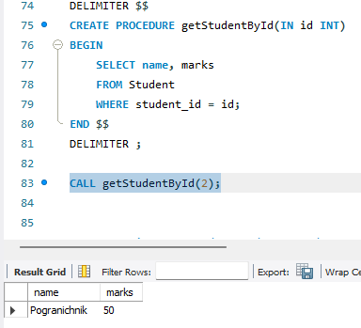
- Write a stored procedure named getTotalStudents that:
- Uses one OUT parameter.
- Returns the total number of students present in the students table.
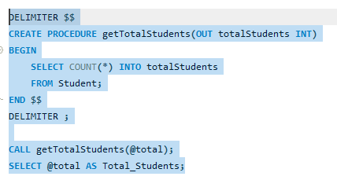
- Write a stored procedure named getResultStatus that:
- Accepts one IN parameter (student_id).
- Uses one OUT parameter to return: "Pass" if marks ≥ 40 and "Fail" if marks < 40.
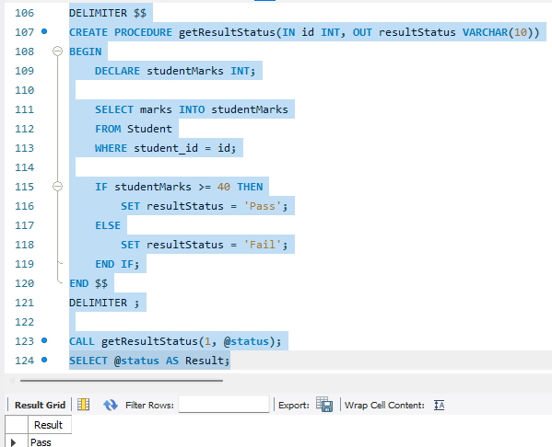
Student id 1 have 90 so pass
With fail condition:
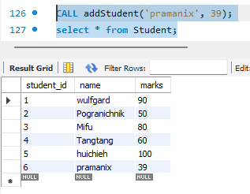
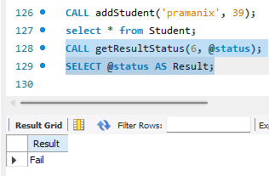

- Write a stored procedure named updateMarks that:
- Accepts IN parameters (student_id, new_marks).
- Updates the marks of the specified student.
Before:
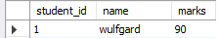
After:
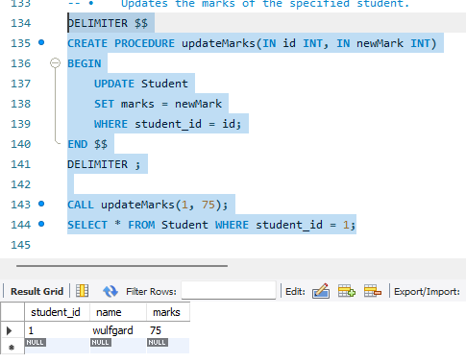
- Write a stored procedure named deleteStudent that:
- Accepts one IN parameter (student_id).
- Deletes the student record with the given ID from the table.
Before:
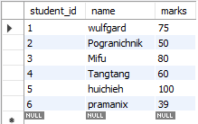
After:
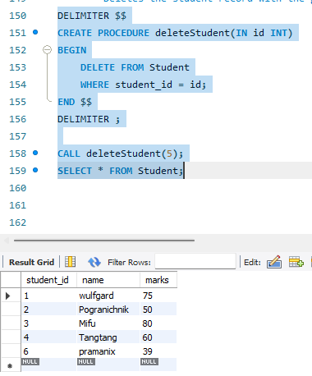

- Write a function to calculate grade that:
- Accepts marks as input
- Returns:
      - 'A' if marks ≥ 80
      - 'B' if marks ≥ 60
      - 'C' if marks ≥ 40
      - ‘F' if marks < 40

If grade is 85
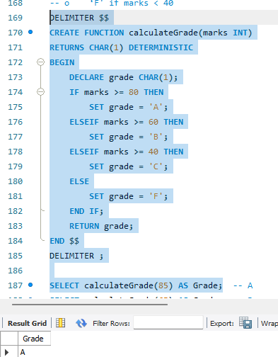

If grade is 65
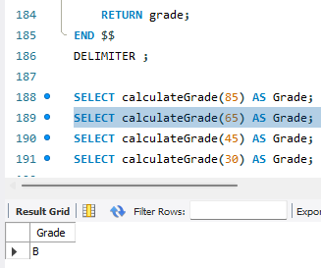

If grade is 45
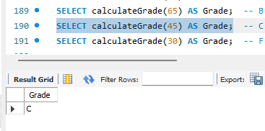

If grade is 30
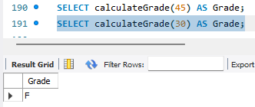

- Write a function named checkPassFail that used to return Pass or Fail
- Accepts student marks as input
- Returns 'Pass' if marks ≥ 40
- Returns 'Fail' if marks < 40

Student mark: ( id 1 updated to 75 after question 8)
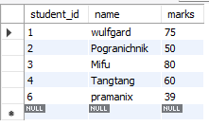
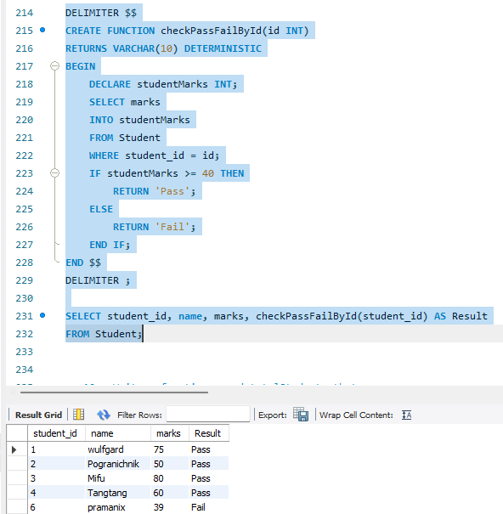

- Write a function named totalStudents that:
- Returns the total number of records present in the students table

