EASTERN INTERNATIONAL UNIVERSITY  SCHOOL OF COMPUTING  AND  INFORMATION TECHNOLOGY | Week 5 Practice Assignment – Quarter 2, 2025-2026
 | Method: LAB 4 Practice 4
 | Course Name: Advanced Databases
 | Course Code: CSW 436
 | Student’s Full Name:Phạm Trần Gia Hưng
 | Student ID: 2331200153

Important Instructions –
- Implement each question using MySQL Workbench.
- Document all question Output/results properly by capturing the screenshots of the output/results and SQL code for every question in a Word document and save it.
- After completing all questions, upload the document to Moodle.

Topic: Triggers and handle errors

- Create a trigger that prevents inserting an employee record if the salary is less than 20,000.
- Create an employee table if it does not exist.
- Insert at least two valid records.
- Create a BEFORE INSERT trigger to check salary.
- Display a meaningful error message when the salary is invalid.
- Test the trigger with an invalid salary value.
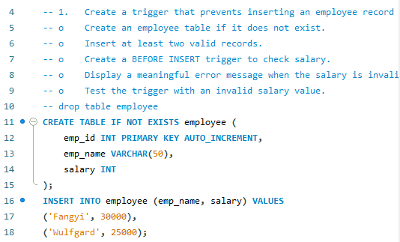
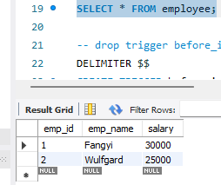
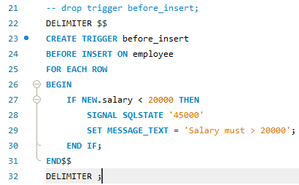
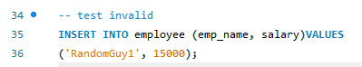
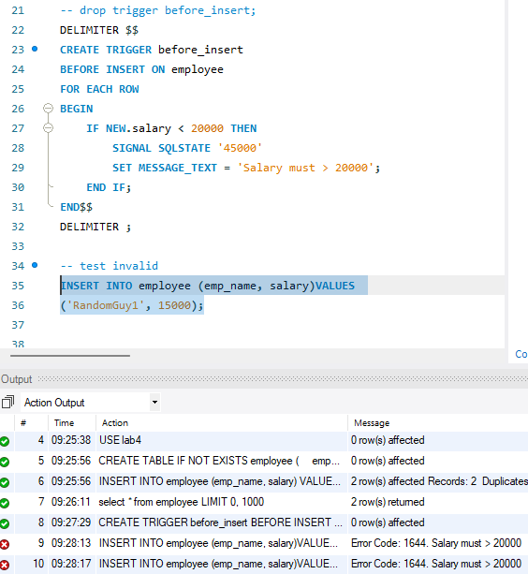
Result:

- Create a trigger that prevents updating product quantity to zero or negative value. (Trigger to Maintain Stock Quantity)
- Create a product table if it does not exist.
- Insert sample records.
- Create a BEFORE UPDATE trigger to validate quantity.
- Display an error message if quantity is less than 1.
- Test the trigger using an UPDATE statement.
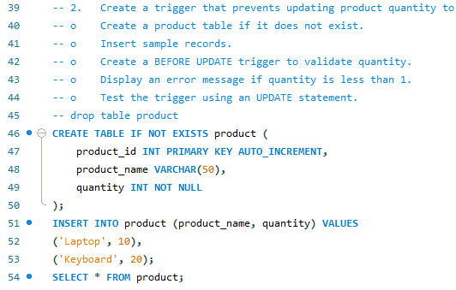
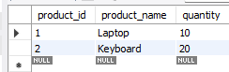
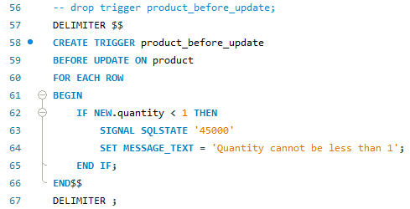
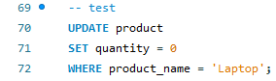
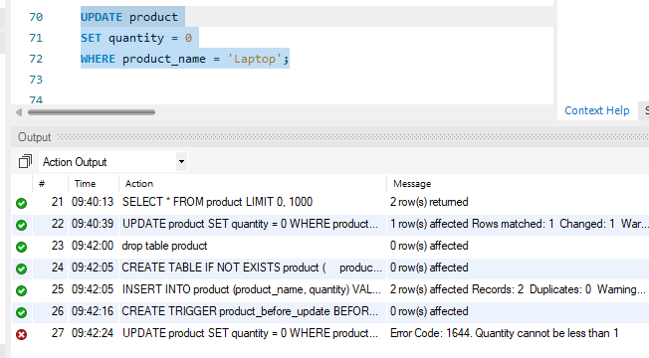
Result:

- Create a trigger that automatically records update operations on a student table into a student_log table.
- Create both tables if they do not exist.
- Insert sample data into the student table.
- Create an AFTER UPDATE trigger to store old and new values.
- Update a record and display the log table.
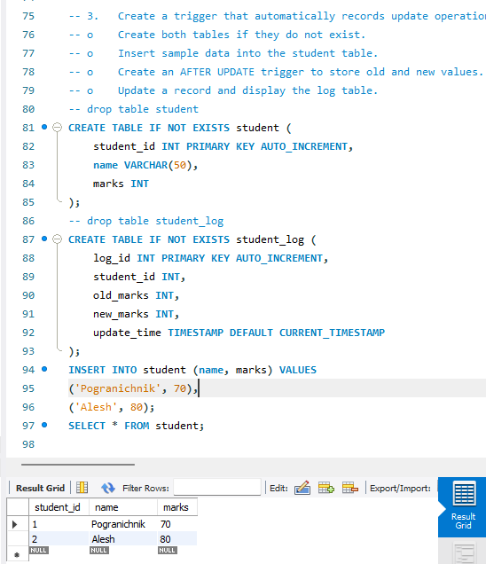
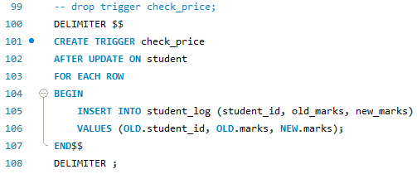
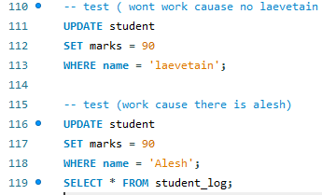
Result:
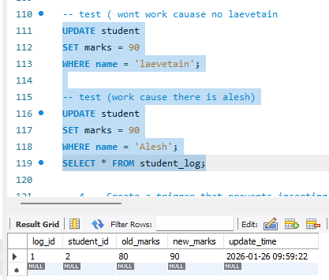

- Create a trigger that prevents inserting duplicate email addresses into a user’s table.
- Create the users table if it does not exist.
- Insert initial user data.
- Create a BEFORE INSERT trigger to check for duplicate emails.
- Display a meaningful error message when a duplicate email is inserted.
- Test the trigger with duplicate data.
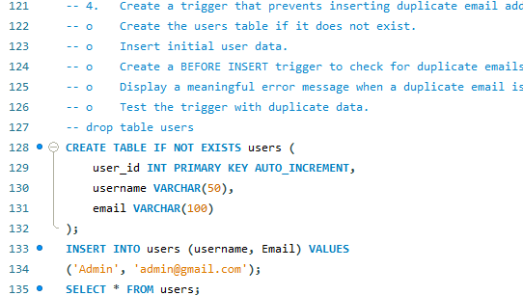
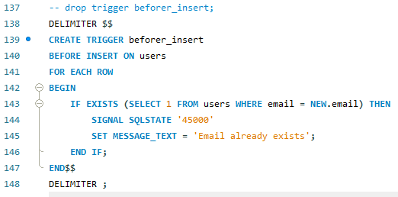
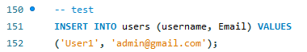
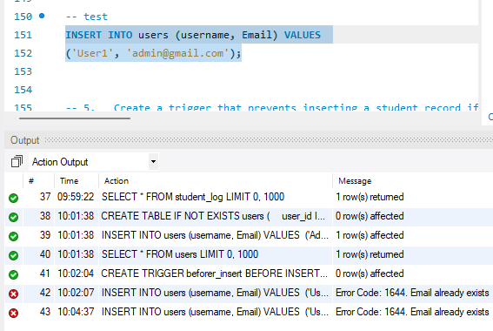
Result:

- Create a trigger that prevents inserting a student record if age is less than 18.
- Create a student table if it does not exist.
- Insert valid student records.
- Create a BEFORE INSERT trigger using SIGNAL for error handling.
- Display a custom error message if age is invalid.
- Test the trigger with age less than 18.
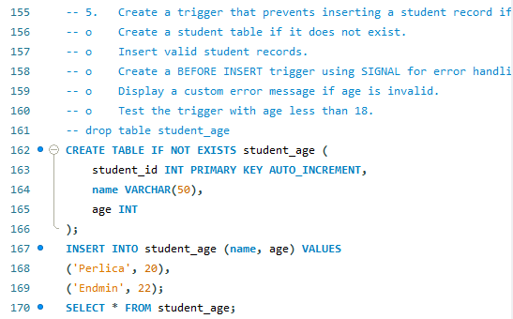
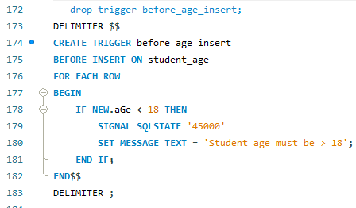
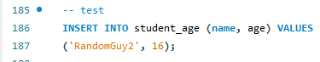
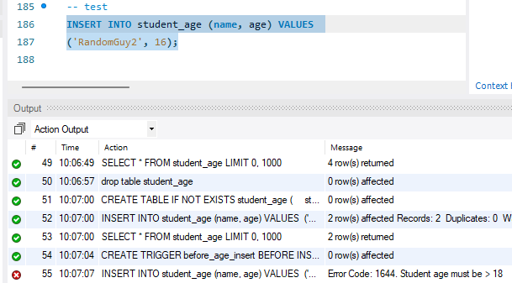
Result:

