Assignment 4: Load Balancing & Scaling on Local Machine

Phạm Trần Gia Hưng – 2331200153

1. Task Completion (70 points total)
Step 1: Go to Python’s official website
- Download Python 3.x https://www.python.org/downloads/windows/ • IMPORTANT During installation:
  - Check “Add Python to PATH”
Step 2: Verify installation
- Open Command Prompt (cmd) or PowerShell o Run the command: python –version o Run the command: pip --version o Install pip if missing Step 3: Create project folder
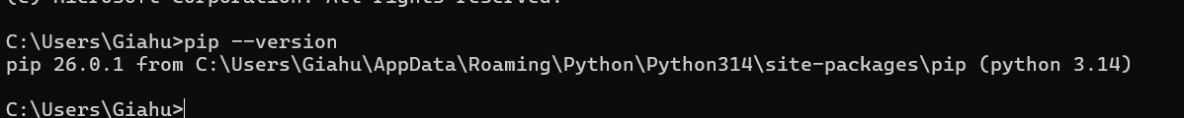
- Open command prompt and run this command to create folder o mkdir load-balancing-lab
- Navigate to the folder which you have created using the command below:
  - cd load-balancing-lab
Step 4: Create server file
- Open Notepad (or VS Code if installed)
- Save as: server.py
from http.server import BaseHTTPRequestHandler, HTTPServer import sys
PORT = int(sys.argv[1])
INSTANCE = sys.argv[2]

class Handler(BaseHTTPRequestHandler): def do_GET(self):
self.send_response(200) self.end_headers()
message = f"Hello from instance {INSTANCE}" self.wfile.write(message.encode())

server = HTTPServer(("localhost", PORT), Handler) print(f"Running instance {INSTANCE} on port {PORT}") server.serve_forever()
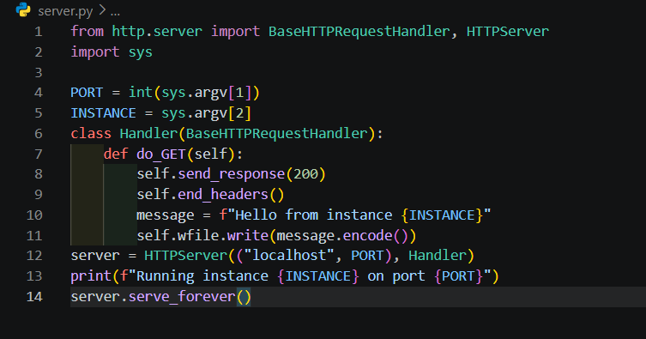

Step 5: Run multiple servers, and simulate scaling.
- Open 3 Command Prompt individually in your windows machine from different port
o python server.py 8001 1
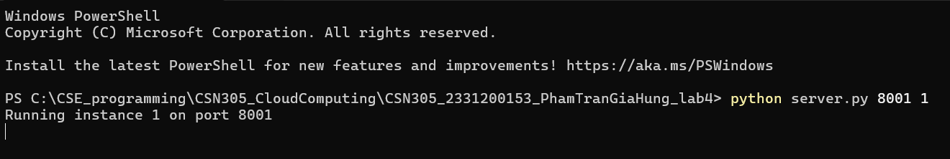

o python server.py 8002 2
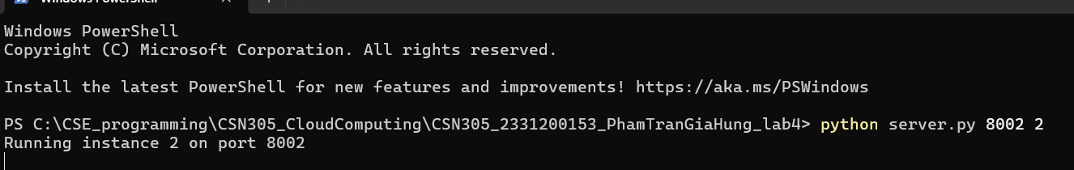

o python server.py 8003 3

Step 6: Open browser and Test in browser
- http://localhost:8001
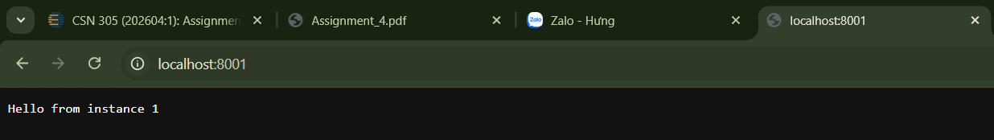

- http://localhost:8002
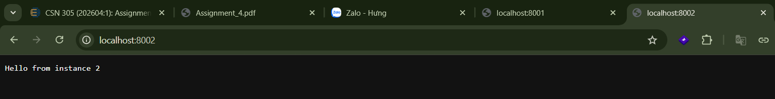

• http://localhost:8003
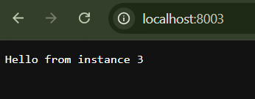

Each shows different instance
Step 7: open another command prompt and Install requests library
- pip install requests
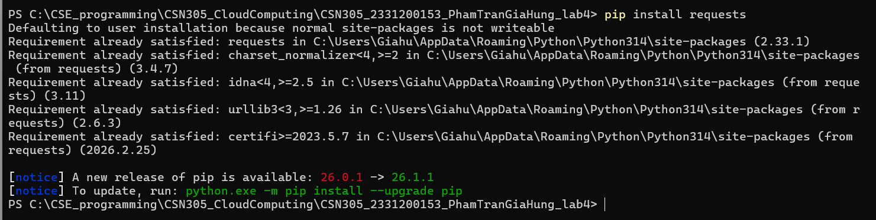

Step 8: Create load balancer
• Create a load_balancer.py file.

import itertools
from http.server import BaseHTTPRequestHandler, HTTPServer import requests

servers = [
"http://localhost:8001",
"http://localhost:8002",
"http://localhost:8003"
]

cycle = itertools.cycle(servers)

class Handler(BaseHTTPRequestHandler): def do_GET(self):
target = next(cycle)
response = requests.get(target)

self.send_response(200) self.end_headers()
self.wfile.write(response.content)

server = HTTPServer(("localhost", 9000), Handler) print("Load balancer running on port 9000") server.serve_forever()
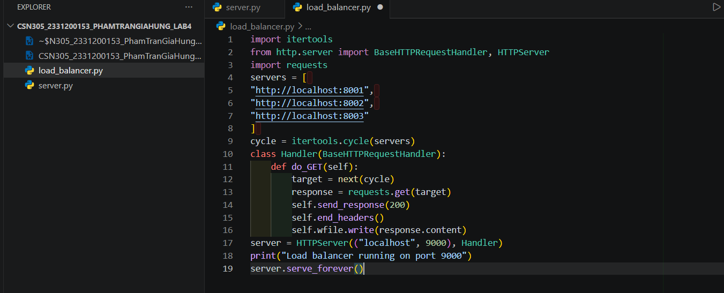

Step 9: Open another command prompt and Run load balancer
- python load_balancer.py

Step 10: Demonstrate load balancing
- Open browser and test the following URL http://localhost:9000

- Refresh multiple times. You’ll see:
  - Hello from instance 1
  - Hello from instance 2
  - Hello from instance 3
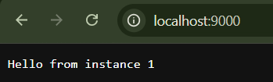
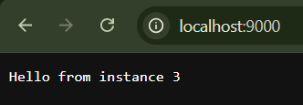
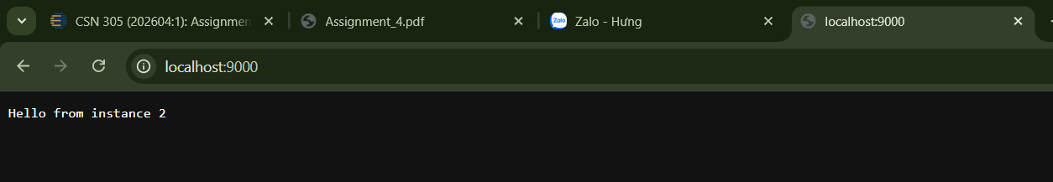
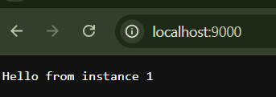
- This proves load balancing works on local machine. This is round-robin load balancing. Requests are distributed evenly
Step 11: Demonstrate Scaling
- More servers = more capacity. So add one more server.
- Open new command prompt and run python server.py 8004 4

- Update the file load_balancer.py by:
  - servers = [
"http://localhost:8001",
"http://localhost:8002",
"http://localhost:8003",
"http://localhost:8004"
]

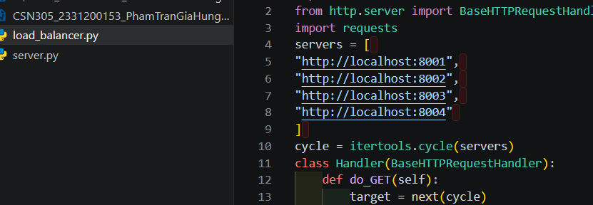

- Now restart the load balancer again by python load_balancer.py

- Now 4 servers handle traffic
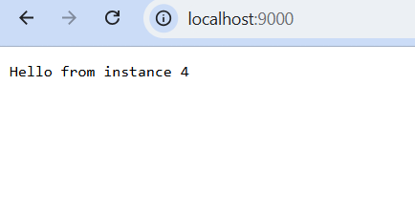
Step 12: Demonstrate Slow Server Problem.
- Modify server.py. by
o import time time.sleep(3)
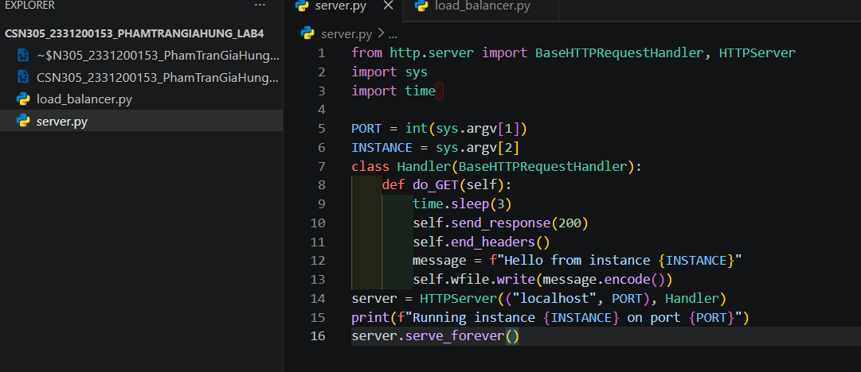

- Restart instance 2 (Test only for instance 2). Sometimes response is slow. Explain uneven performance
- The round-robin load balancer distributes requests blindly it dont have awareness of how long each server takes to respond. It simply cycles through the list in order. So when instance 2 is slow, the load balancer still sends it the same share of traffic, it assumes all servers are equally capable and equally fast at all times
Step 13: Demonstrate Failure Handling
- Stop any one server by
o Ctrl + C
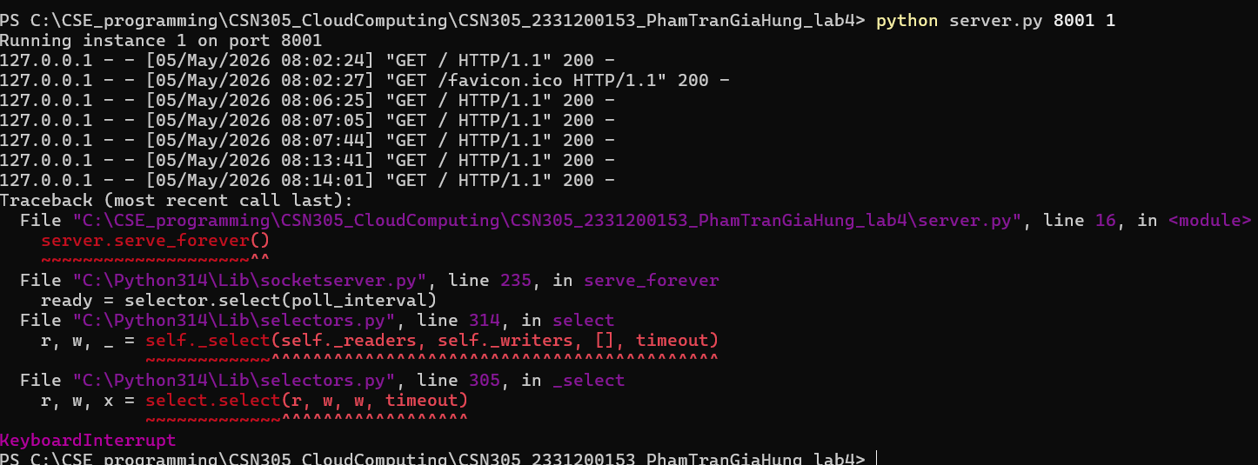

- Now refresh browser. You will see it may crash or hang.
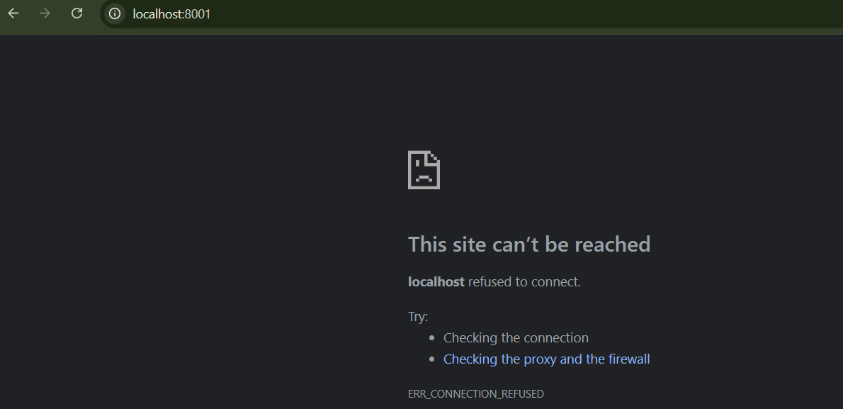

- Explain real systems must handle failures
- Health checks: periodically pinging each backend; if it fails to respond, it is removed from the pool automatically
- Automatic failover: traffic is instantly rerouted to the remaining healthy servers without any visible error
-Retry logic: like the try/except, which retries the next available server before giving up

Step 14: Improve Load Balancer (basic fault tolerance)
- By taking this step dead servers are skipped.
- Update the load balancer by modifying do_GET method in load_balancer.py class Handler(BaseHTTPRequestHandler): def do_GET(self): for _ in range(len(servers)):
target = next(cycle) try:
response = requests.get(target, timeout=1) self.send_response(200) self.end_headers()
self.wfile.write(response.content) return except:
continue # If all servers fail self.send_response(500) self.end_headers()
self.wfile.write(b"All servers are down")
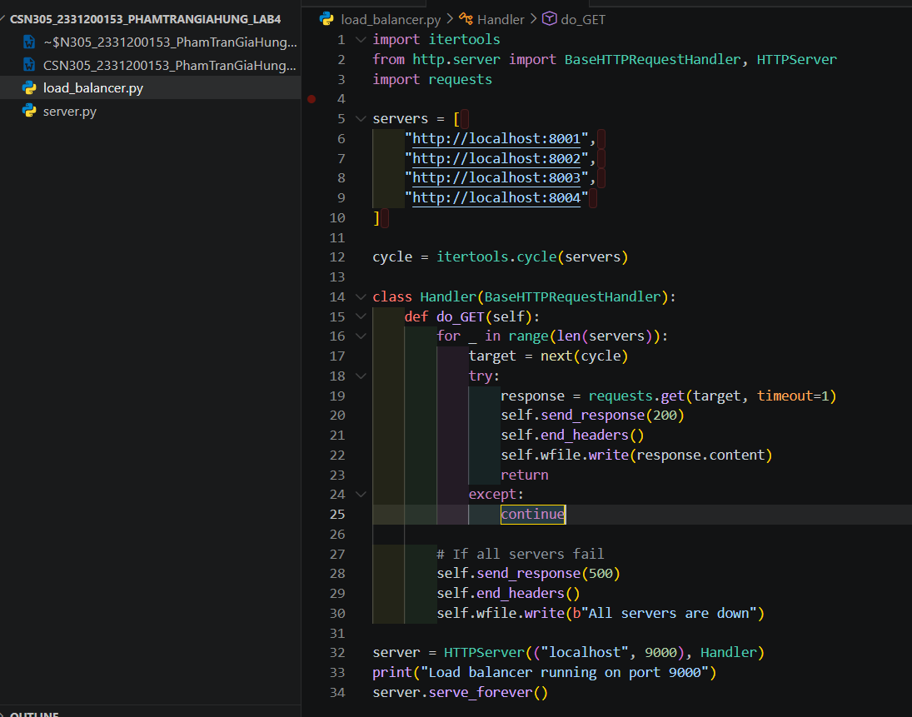

• Stop and restart python load_balancer.py
o You will observe if one server is down → system still works
o If all servers are down → error message shown
This is a real-world concept used in systems such as AWS load balancer, NGINX etc webserver.

