Assignment 5: Creating a VPC with Subnets

Phạm Trần Gia Hưng – 2331200153
Deliverables
Each student must submit the following:
1. Presentation Slides (15–30 slides maximum) o Title slide with student name(s), course, and assignment title.
- Clear explanation of each completed task: (Access AWS academy: Module 5 Networking and Content Delivery - Lab 2: Build your VPC and Launch a Web Server)
  - Task 1- Create a VPC.
In the search box to the right of Services, search for and choose VPC to open the VPC console.
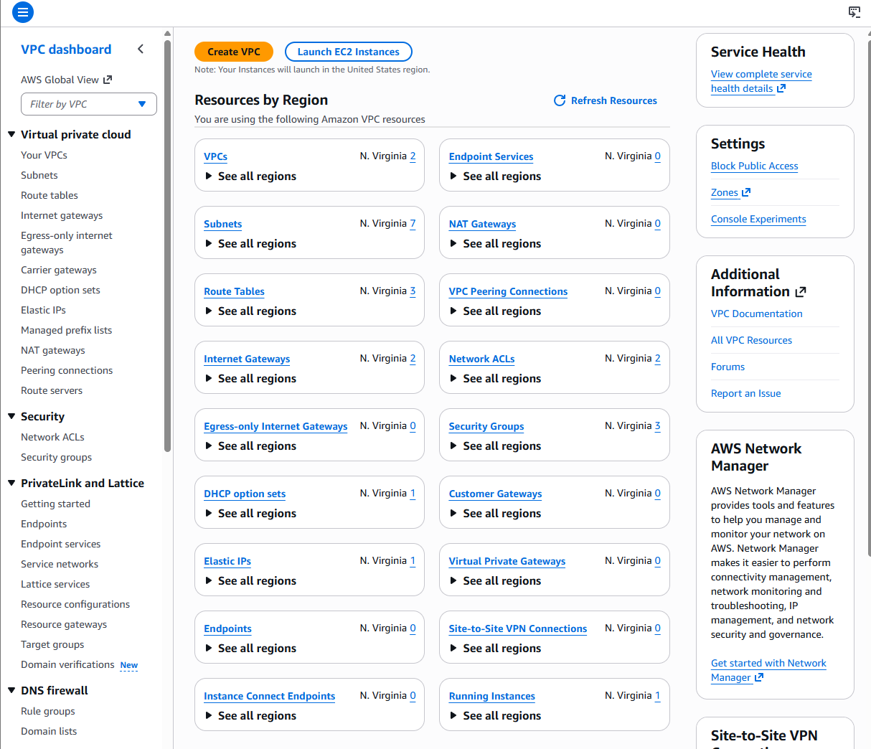

Begin creating a VPC.
In the top right of the screen, verify that N. Virginia (us-east-1) is the region.
Choose the VPC dashboard link which is towards the top left of the console.
Next, choose Create VPC.
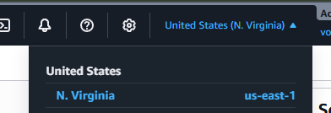
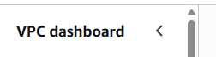
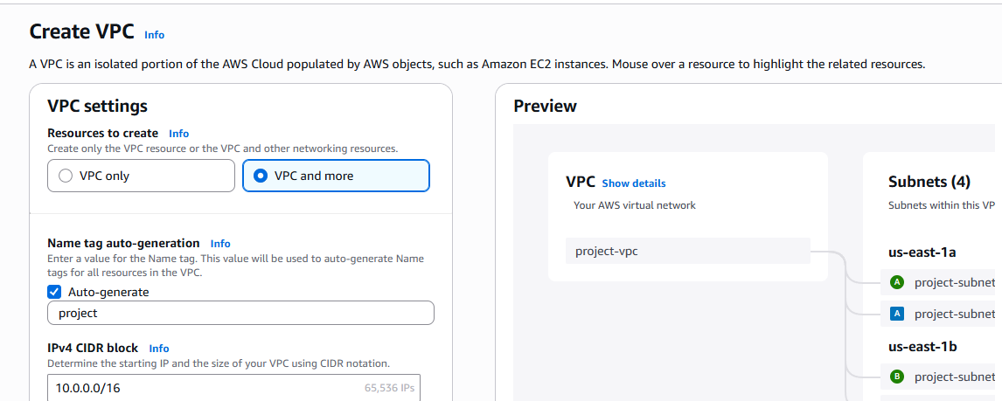

Configure the VPC details in the VPC settings panel on the left:
Choose VPC and more.
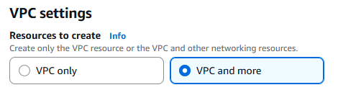
Under Name tag auto-generation, keep Auto-generate selected, however change the value from project to lab.
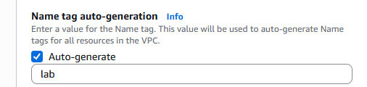
Keep the IPv4 CIDR block set to 10.0.0.0/16
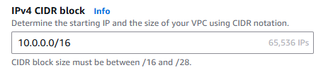
For Number of Availability Zones, choose 1.
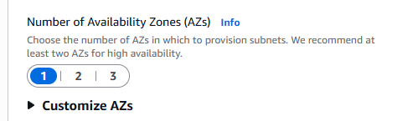
For Number of public subnets, keep the 1 setting.
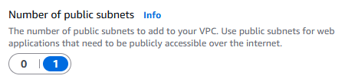
For Number of private subnets, keep the 1 setting.
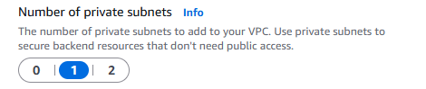
Expand the Customize subnets CIDR blocks section
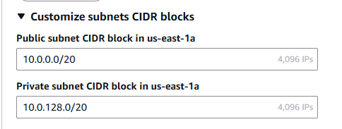
Change Public subnet CIDR block in us-east-1a to 10.0.0.0/24
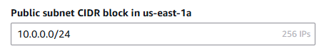
Change Private subnet CIDR block in us-east-1a to 10.0.1.0/24
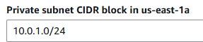
Set NAT gateways to In 1 AZ.
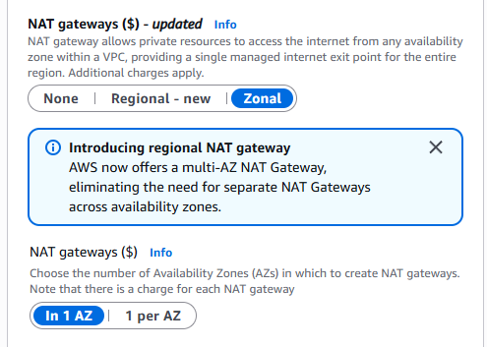
Set VPC endpoints to None.
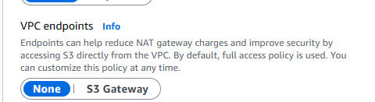
Keep both 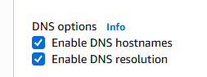DNS hostnames and DNS resolution enabled.

In the Preview panel on the right, confirm the settings you have configured.
VPC: lab-vpc
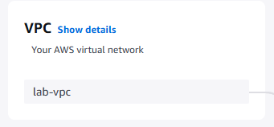
Subnets:us-east-1a
Public subnet name: lab-subnet-public1-us-east-1a
Private subnet name: lab-subnet-private1-us-east-1a
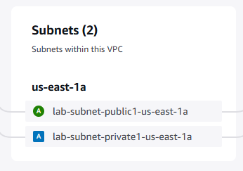
Route tables
lab-rtb-public
lab-rtb-private1-us-east-1a
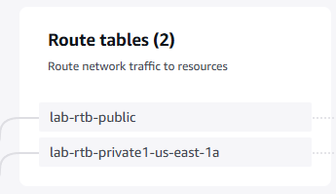
Network connections
lab-igw
lab-nat-public1-us-east-1a
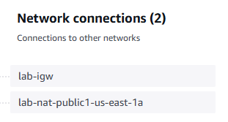
At the bottom of the screen, choose Create VPC
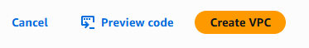

The VPC resources are created. The NAT Gateway will take a few minutes to activate.
Please wait until all the resources are created before proceding to the next step
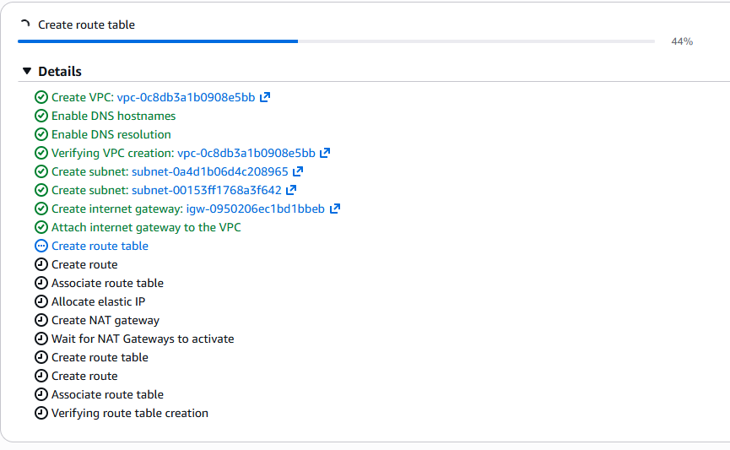
Once it is complete, choose View VPC

The wizard has provisioned a VPC with a public subnet and a private subnet in one Availability Zone with route tables for each subnet. It also created an Internet Gateway and a NAT Gateway.
To view the settings of these resources, browse through the VPC console links that display the resource details. For example, choose Subnets to view the subnet details and choose Route tables to view the route table details. The diagram below summarizes the VPC resources you have just created and how they are configured
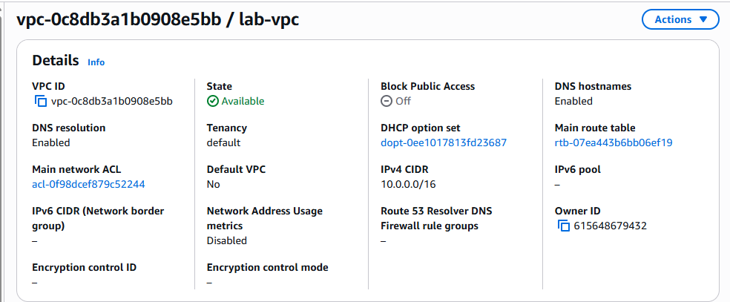
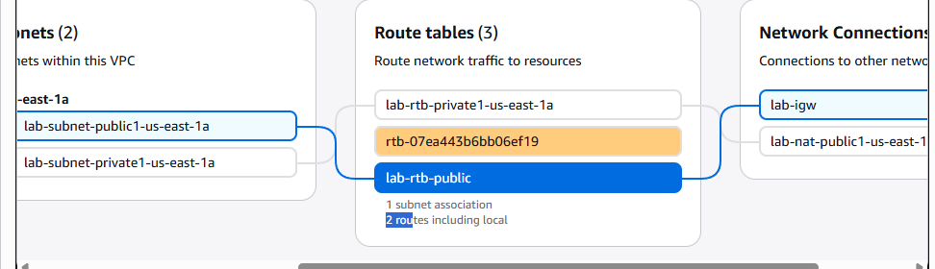

Task 2 - Create subnets.
In the left navigation pane, choose Subnets.
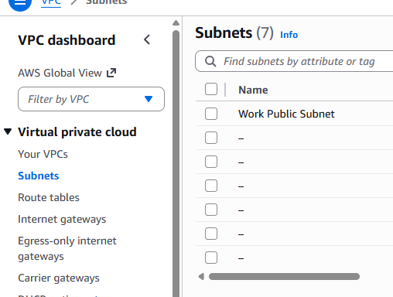
First, you will create a second public subnet
Choose Create subnet then configure:
VPC ID: lab-vpc (select from the menu).
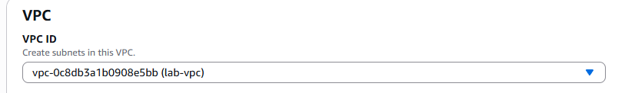
Subnet name: lab-subnet-public2
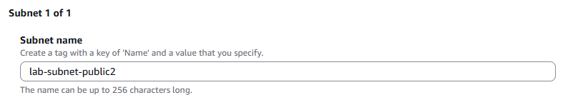
Availability Zone: Select the second Availability Zone (for example, us-east-1b)
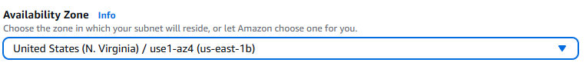
IPv4 CIDR block: 10.0.2.0/24
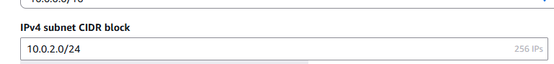
The subnet will have all IP addresses starting with 10.0.2.x.
Choose Create subnet
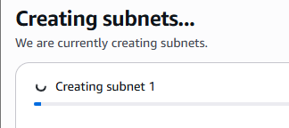
The second public subnet was created. You will now create a second private subnet.
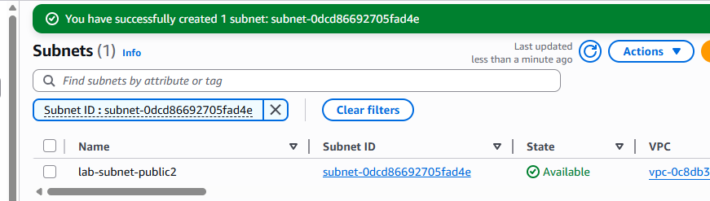
Choose Create subnet then configure:
VPC ID: lab-vpc
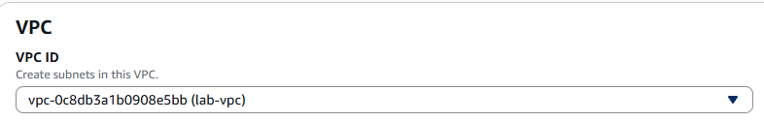
Subnet name: lab-subnet-private2
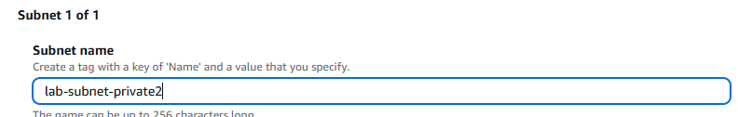
Availability Zone: Select the second Availability Zone (for example, us-east-1b)
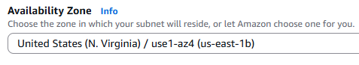
IPv4 CIDR block: 10.0.3.0/24
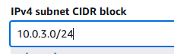
The subnet will have all IP addresses starting with 10.0.3.x
Choose Create subnet
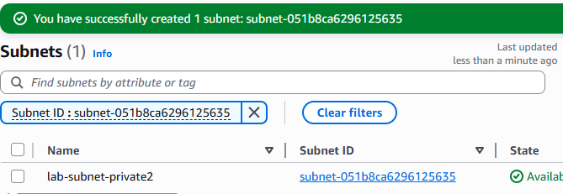
In the left navigation pane, choose Route tables
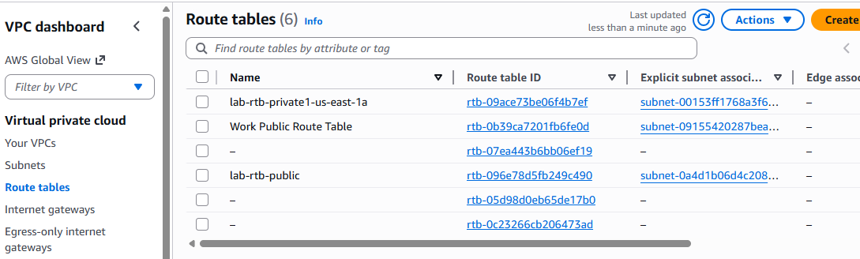
Select the lab-rtb-private1-us-east-1a route table
In the lower pane, choose the Routes tab
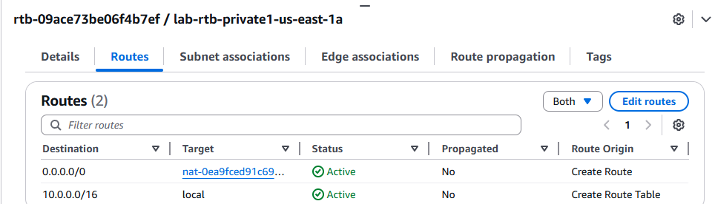
Choose the Subnet associations tab
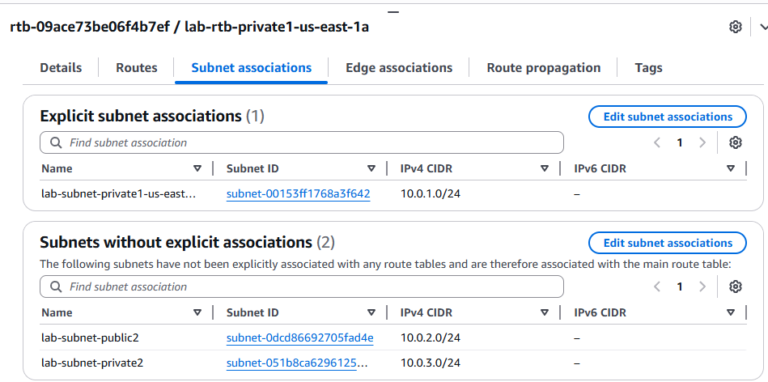
In the Explicit subnet associations panel, choose Edit subnet associations
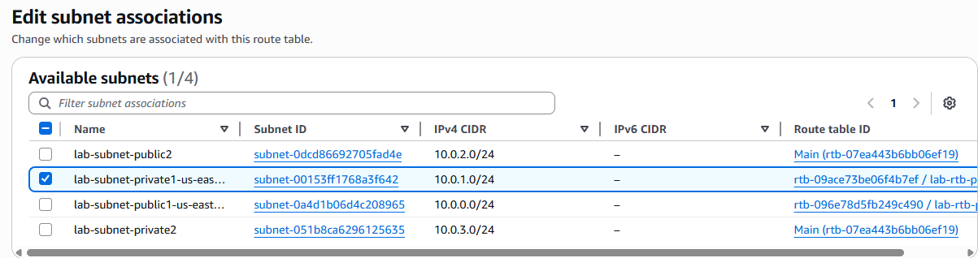
Leave lab-subnet-private1-us-east-1a selected, but also select lab-subnet-private2
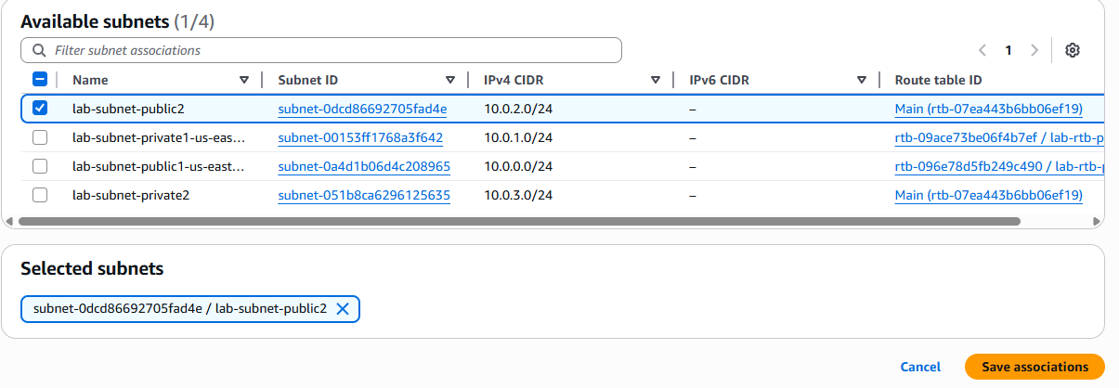
Choose Save associations
Select the lab-rtb-public route table (and deselect any other subnets)
In the lower pane, choose the Routes tab
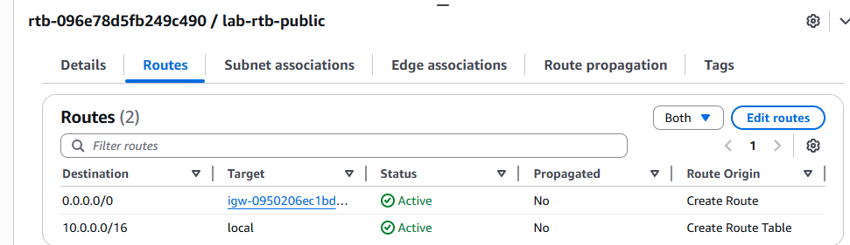
Choose the Subnet associations tab
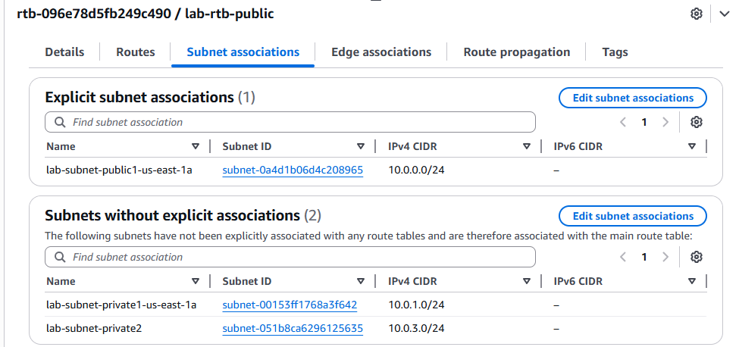
In the Explicit subnet associations area, choose Edit subnet associations
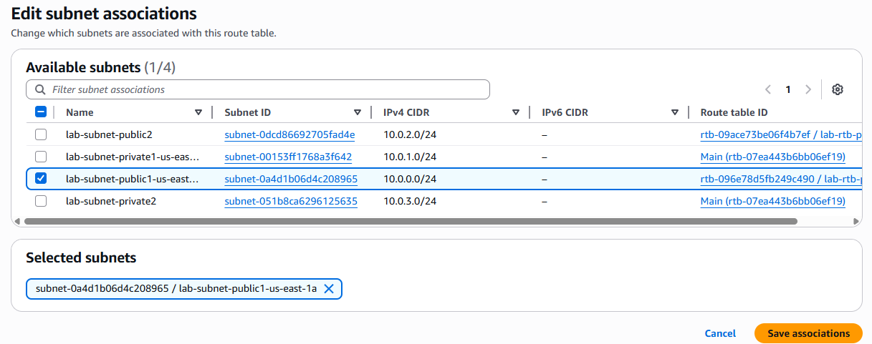
Leave lab-subnet-public1-us-east-1a selected, but also select lab-subnet-public2
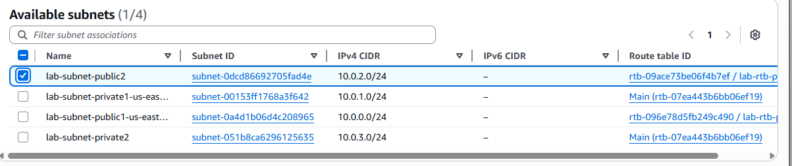
Choose Save associations
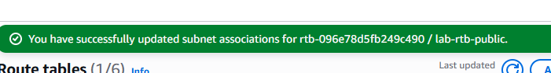


Task 3 - Configure a security group.
In the left navigation pane, choose Security groups
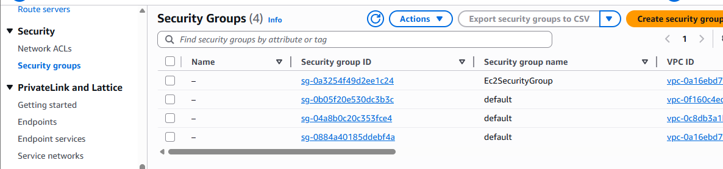
Choose Create security group and then configure:
Security group name: Web Security Group
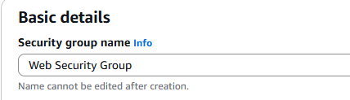
Description: Enable HTTP access
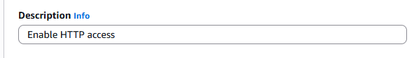
VPC: choose the X to remove the currently selected VPC, then from the drop down list choose lab-vpc
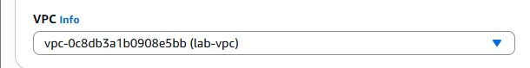
In the Inbound rules pane, choose Add rule
Configure the following settings:
Type: HTTP
Source: Anywhere-IPv4
Description: Permit web requests
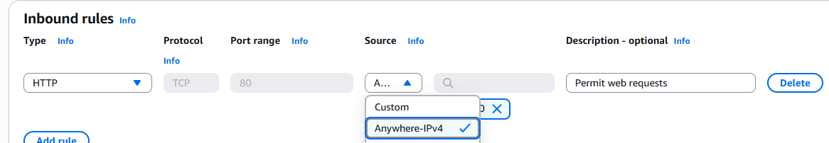

Scroll to the bottom of the page and choose Create security group
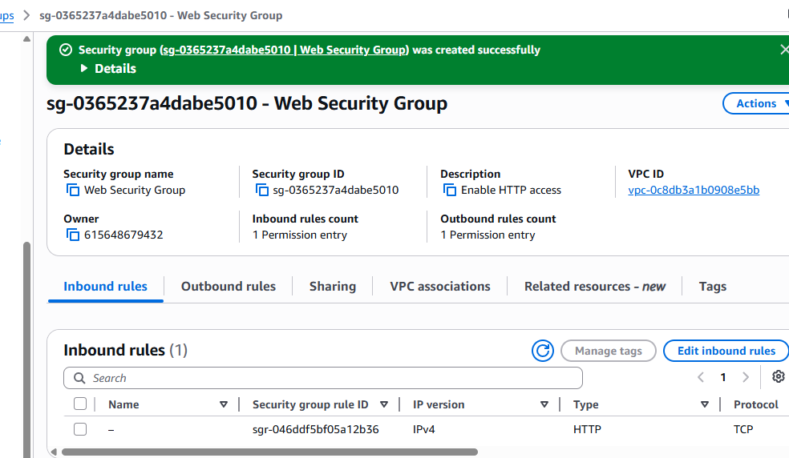

Task 4 - Launch an EC2 instance into a VPC.
In the search box to the right of Services, search for and choose EC2 to open the EC2 console
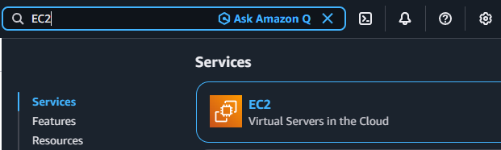
From the Launch instance menu choose Launch instance
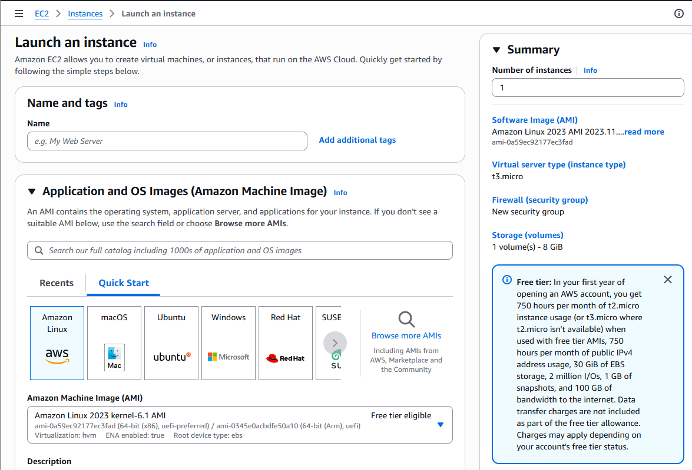
Name the instance:
Give it the name Web Server 1
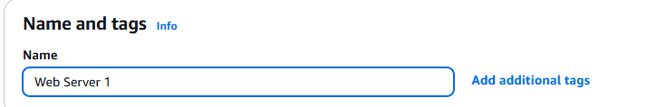
Choose an AMI from which to create the instance:
In the list of available Quick Start AMIs, keep the default Amazon Linux selected.
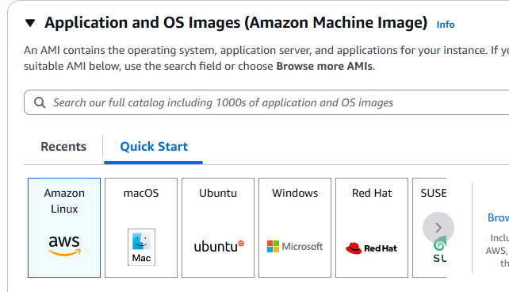
Also keep the default Amazon Linux 2023 AMI selected
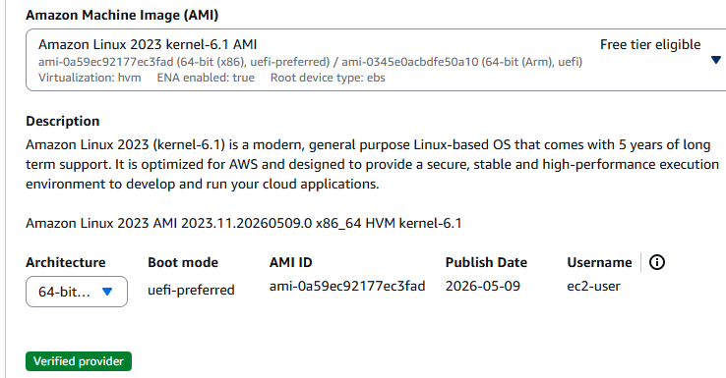
Choose an Instance type:
In the Instance type panel, keep the default t2.micro selected.
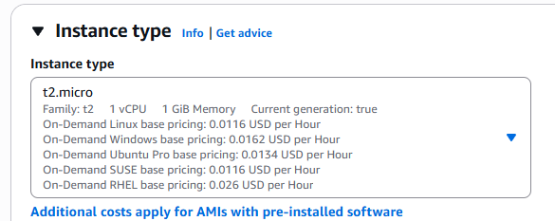
Select the key pair to associate with the instance:
From the Key pair name menu, select vockey
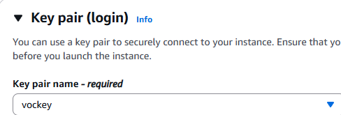

Configure the Network settings:
Next to Network settings, choose Edit, then configure:
Network: lab-vpc
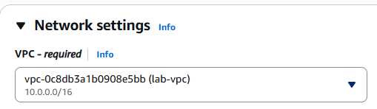
Subnet: lab-subnet-public2 (not Private!)
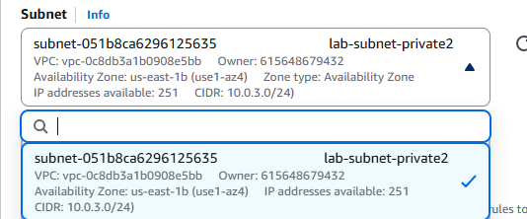
Auto-assign public IP: Enable
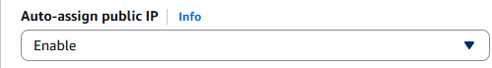
Next, you will configure the instance to use the Web Security Group that you created earlier.
Under Firewall (security groups), choose Select existing security group.
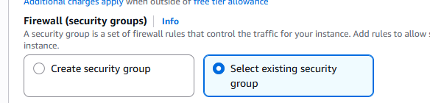
For Common security groups, select Web Security Group
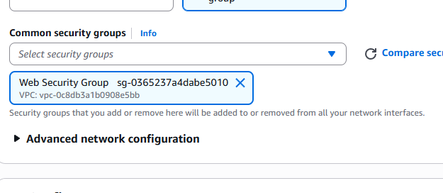
In the Configure storage section, keep the default settings
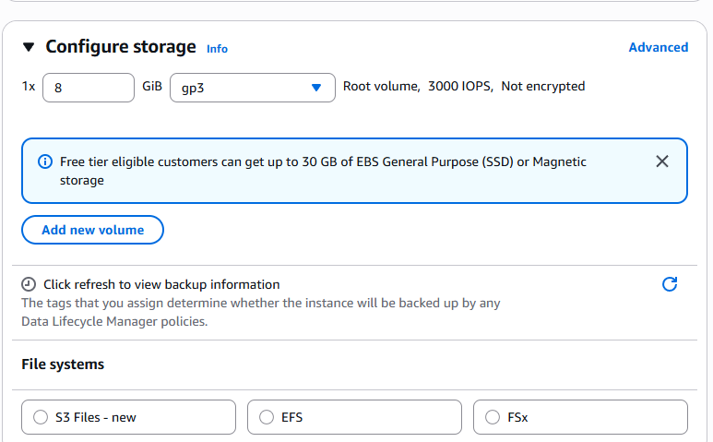
Configure a script to run on the instance when it launches:
Expand the Advanced details panel.
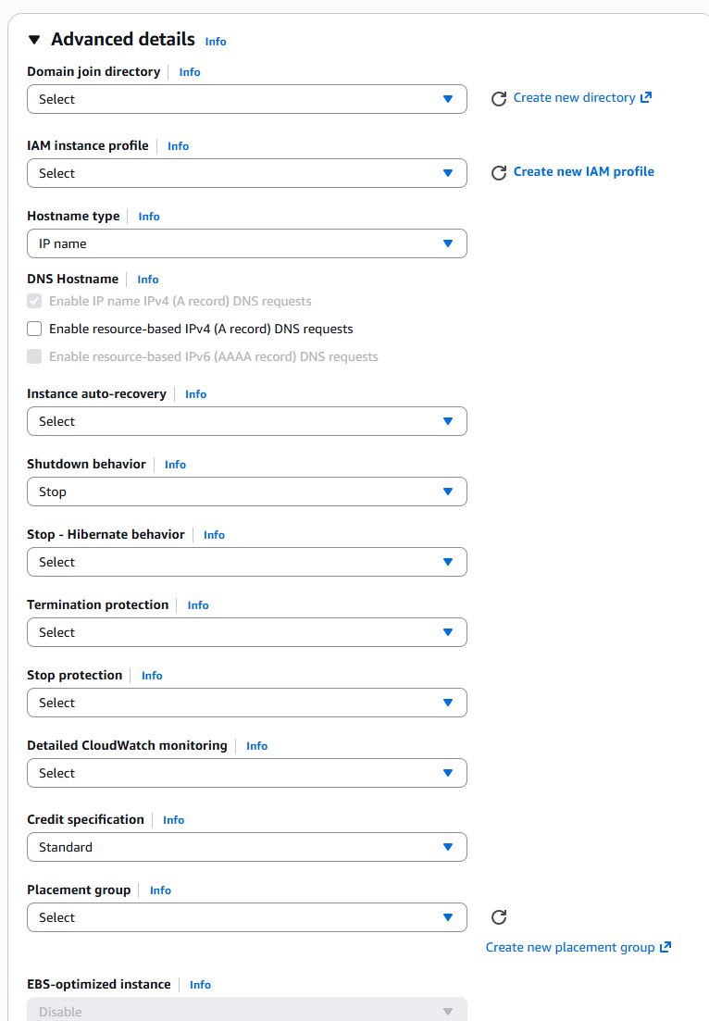
Scroll to the bottom of the page and then copy and paste the code shown below into the User data box:
#!/bin/bash
# Install Apache Web Server and PHP
dnf install -y httpd wget php mariadb105-server
# Download Lab files
wget https://aws-tc-largeobjects.s3.us-west-2.amazonaws.com/CUR-TF-100-ACCLFO-2/2-lab2-vpc/s3/lab-app.zip
unzip lab-app.zip -d /var/www/html/
# Turn on web server
chkconfig httpd on
service httpd start
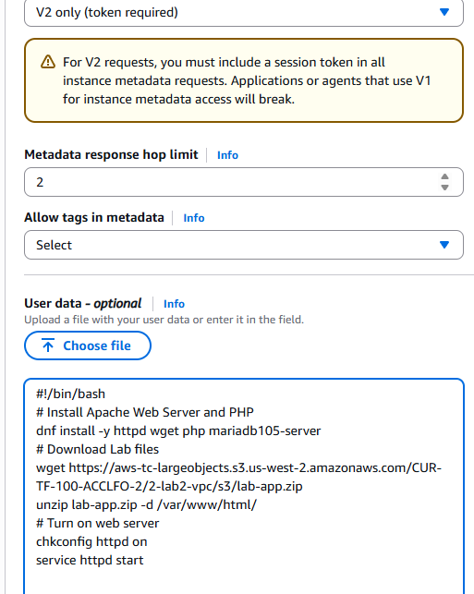
At the bottom of the Summary panel on the right side of the screen choose Launch instance
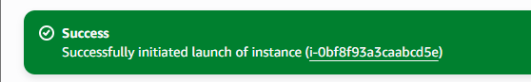
Choose View all instances
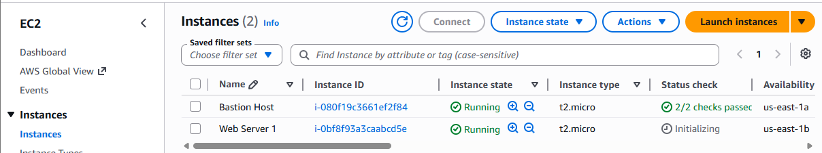
Wait until Web Server 1 shows 2/2 checks passed in the Status check column
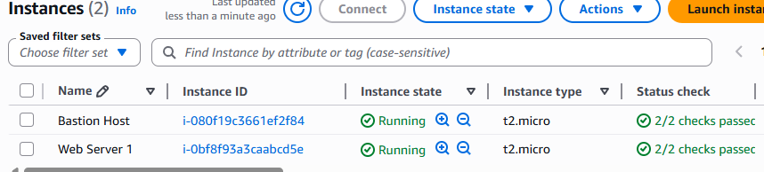
Select Web Server 1.
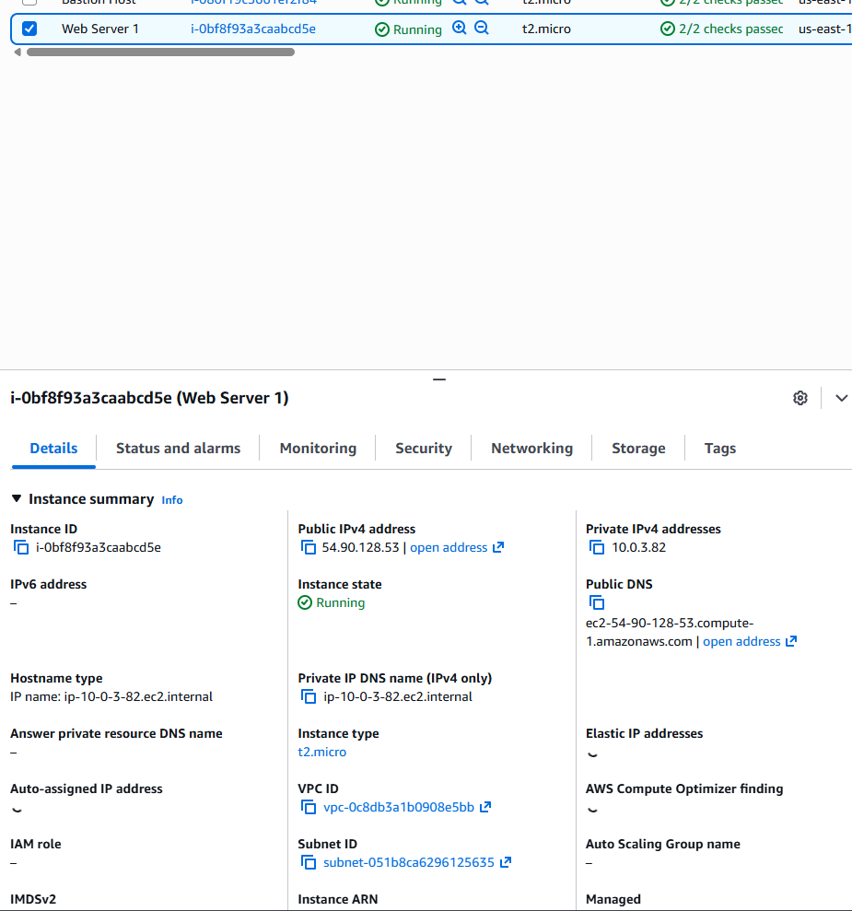
Copy the Public IPv4 DNS value shown in the Details tab at the bottom of the page
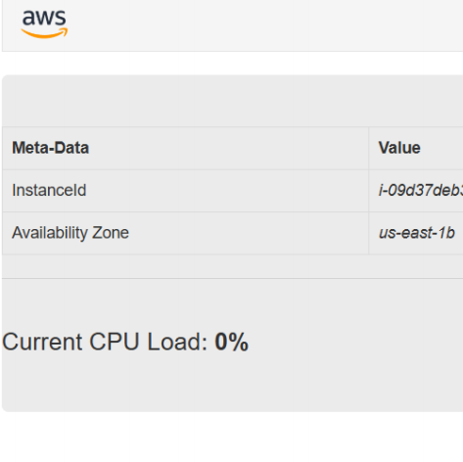

Task 5 - Creating a VPC Endpoint for S3 (Follow Lesson - 4 PPT (Create a VPC endpoint for S3 in the us-east1 region instruction)
vpc-s3-endpoint is the name ○ Select AWS services as the service category
○ Select com.amazonaws.us-east-1.s3 as the service name
○ Select VPC1 to create the endpoint ○ Select the
VPC1-Pri route table to associate with the endpoint
○ Enable policies for resource-based policies to
control access to the bucket
○ Click Create endpoint to create the VPC endpoint
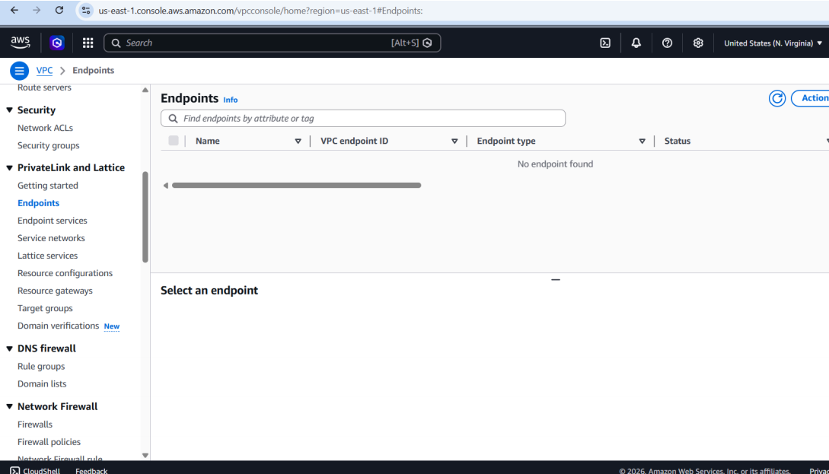
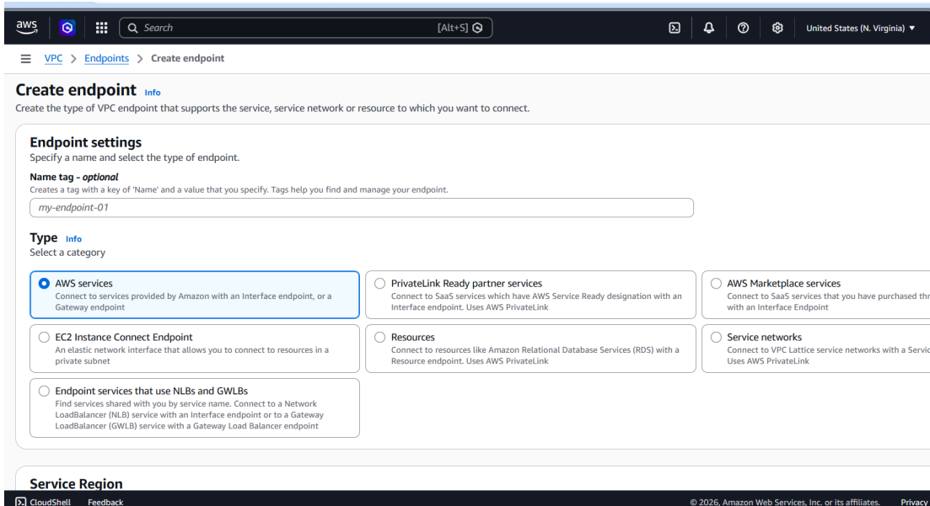
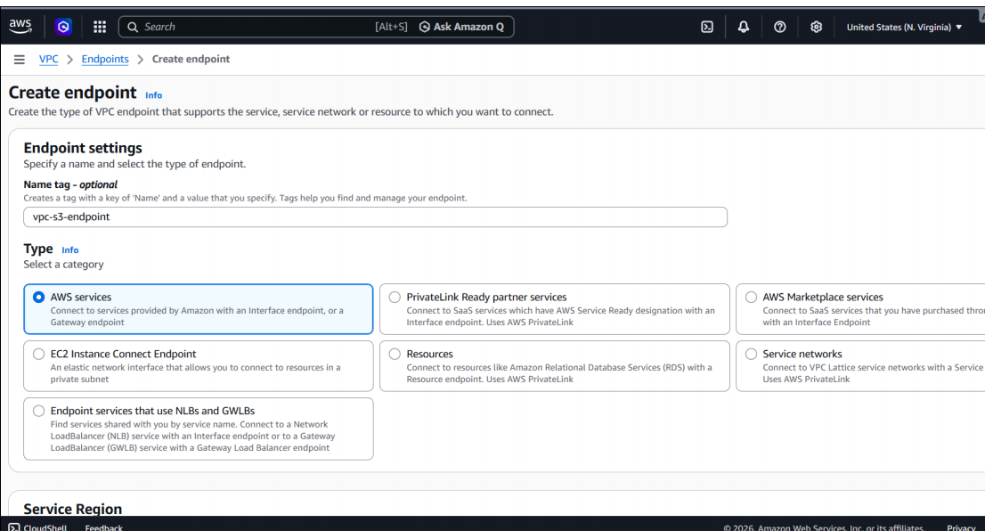
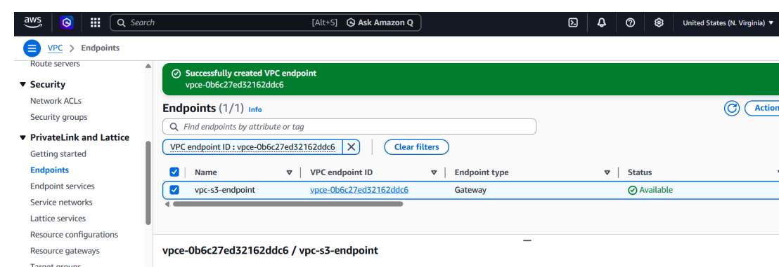

- Task 6 – Answering Reflection Questions

- Reflection question responses (Choose any three (3). Must be included in slides with appropriate answer). Provide clear, concise, and well-reasoned answers in your presentation.
  - What is the key difference between an Internet Gateway and a NAT Gateway? Explain the specific purpose each one served in this assignment's architecture.
Answer: An Internet Gateway (IGW) enables two-way communication between resources in public subnets and the public internet external users can initiate inbound connections through it. In this lab, the IGW was attached to the VPC so the public subnet and the NAT Gateway itself could reach the internet.
A NAT Gateway allows instances in private subnets to make outbound requests to the internet without exposing them publicly no external host can initiate a connection inbound through it. In this lab, the NAT Gateway was placed in the public subnet so the private EC2 instance could reach external services (such as S3 or package repositories) without having a public IP
- IGW: bidirectional, used by public subnets, allows inbound traffic from the internet
- NAT Gateway: outbound-only, used by private subnets, blocks unsolicited inbound connections

  - Explain the difference between a Security Group (stateful) and a Network ACL (stateless). Why is it a best practice to use both as a "defense in depth" strategy?
Answer: A Security Group operates at the instance level and is stateful when you allow inbound traffic on a port, the return traffic is automatically permitted without a separate rule. It supports allow rules only. A Network ACL (NACL) operates at the subnet level and is stateless return traffic must be explicitly permitted by its own rule. It supports both allow and deny rules, evaluated in numbered order
Using both together is “defense in depth”: the NACL filters traffic at the subnet boundary before it even reaches an instance. Even if something slips past the NACL, the Security Group provides a second independent check at the instance level. A misconfiguration in one layer does not automatically expose the system because the other layer remains in effect
- Security Group: instance-level, stateful, allow-only rules
- Network ACL: subnet-level, stateless, supports allow and deny rules

  - Why must a NAT Gateway be placed in a public subnet, and what other two components did it depend on to function correctly?
Answer: The NAT Gateway translates private IP addresses into a public Elastic IP so that private instances can reach the internet. For that translation to work, the NAT Gateway itself must have a route to the internet — which only exists in a public subnet (a subnet whose route table sends 0.0.0.0/0 traffic to an Internet Gateway). A private subnet has no such route, so placing the NAT Gateway there would leave it with nowhere to forward the translated packets, breaking outbound access for all private instances
The two components it depended on:
- Internet Gateway (IGW): the public subnet’s route table must point 0.0.0.0/0 to the IGW. Without it, the NAT Gateway can translate addresses but has no actual path to the internet
- Elastic IP Address (EIP): the NAT Gateway must be assigned a static public EIP at creation. This is the address that remote servers see when a private instance makes an outbound request. AWS will not create a NAT Gateway without one.

Dr. Rohit Kumar Kasera
Lecturer

