Assignment 1: Exploring AWS Global Infrastructure
Phạm Trần Gia Hưng - 2331200153

1. Task Completion (70 points total)
Each AWS task is evaluated based on correctness, completeness, and evidence (e.g., screenshots, output).
- Task 1 – AWS Account Setup & Console Exploration o AWS account created / logged
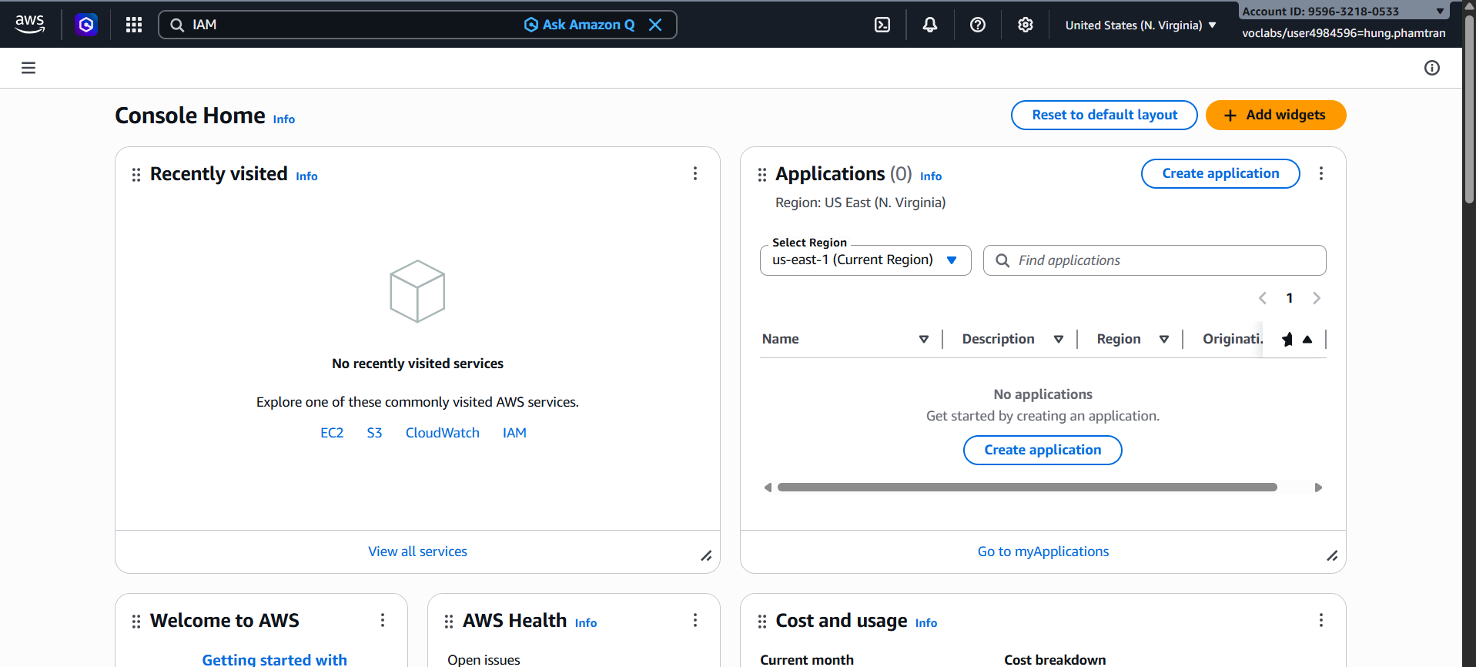
- Task 2 -- In the search box to the right of Services, search for and choose IAM to open the IAM console. In the navigation pane on the left, choose Users. The following IAM Users have been created for you: user-1, user-2, user-3.
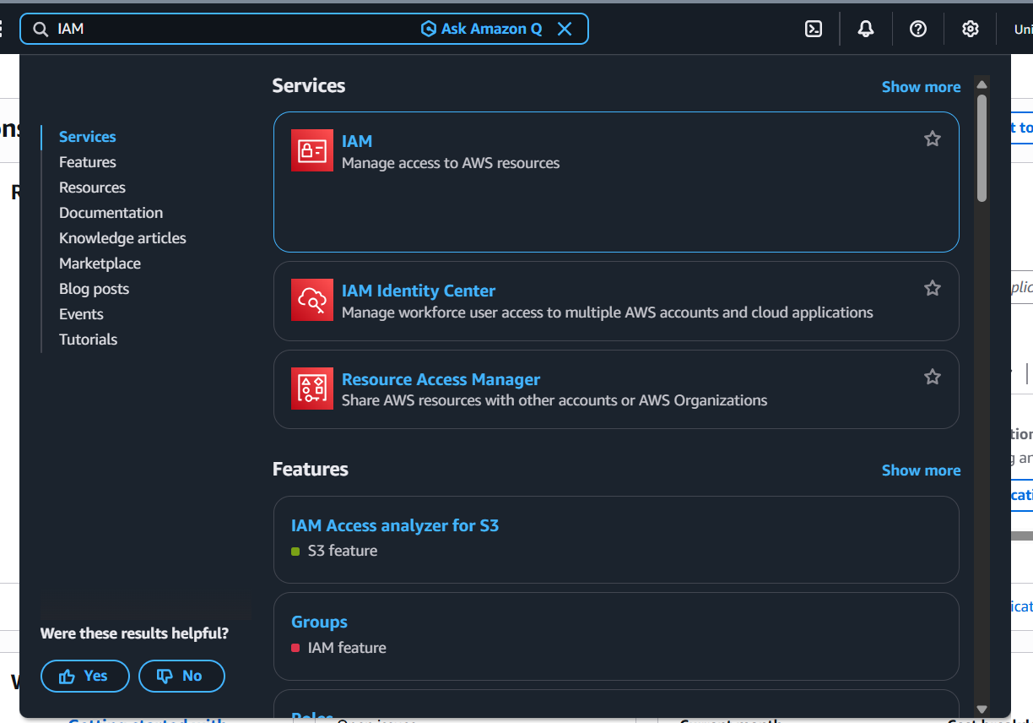

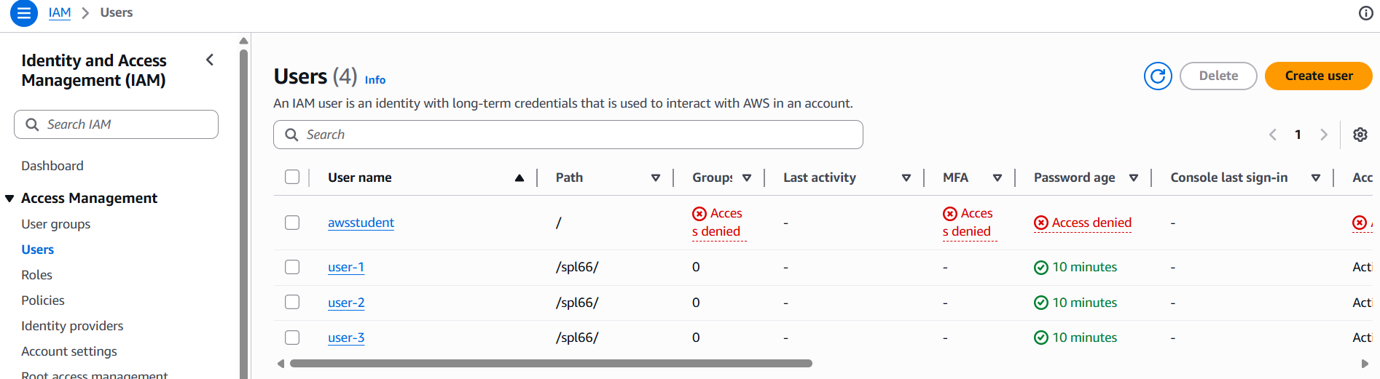

    - Choose the user-1 link: This will bring to a summary page for user-1. The Permissions tab will be displayed. Notice that user-1 does not have any permissions.
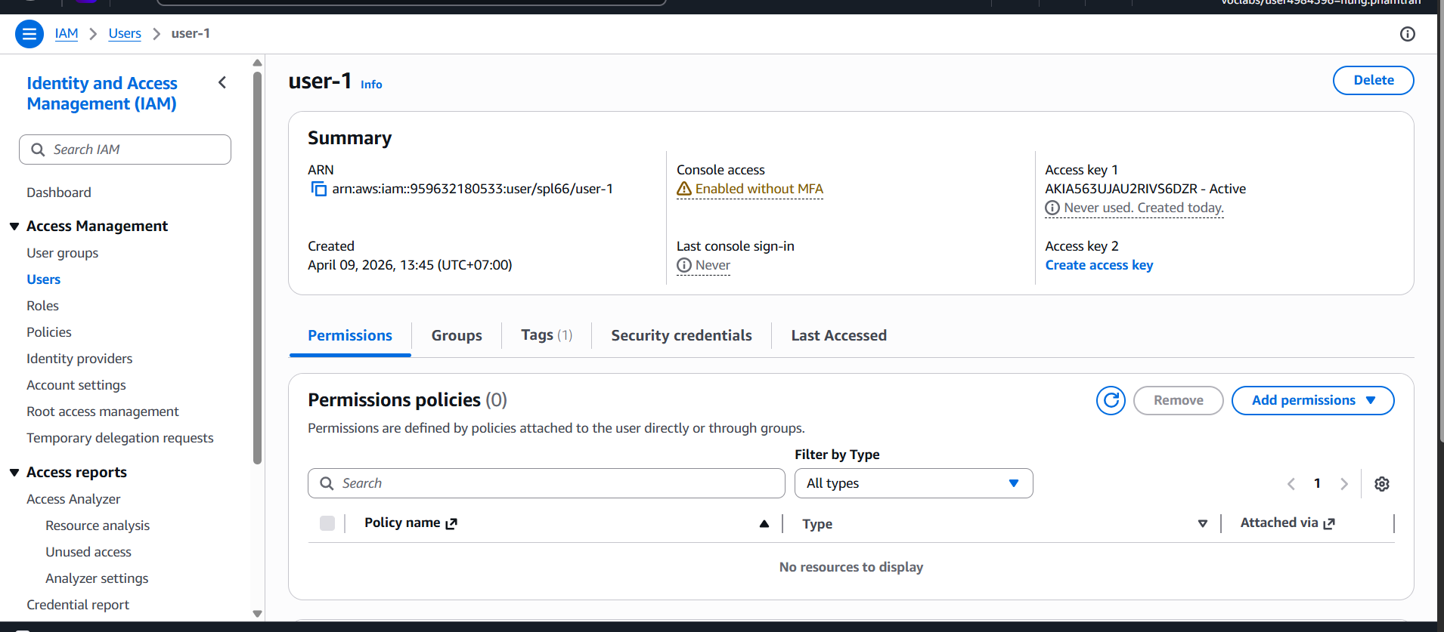

    - Choose the Groups tab: user-1 also is not a member of any groups.
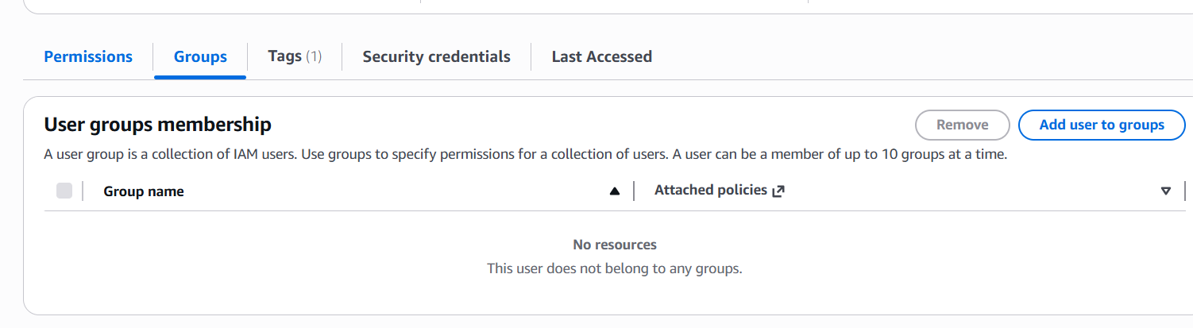
    - Choose the Security credentials tab: user-1 is assigned a Console password.
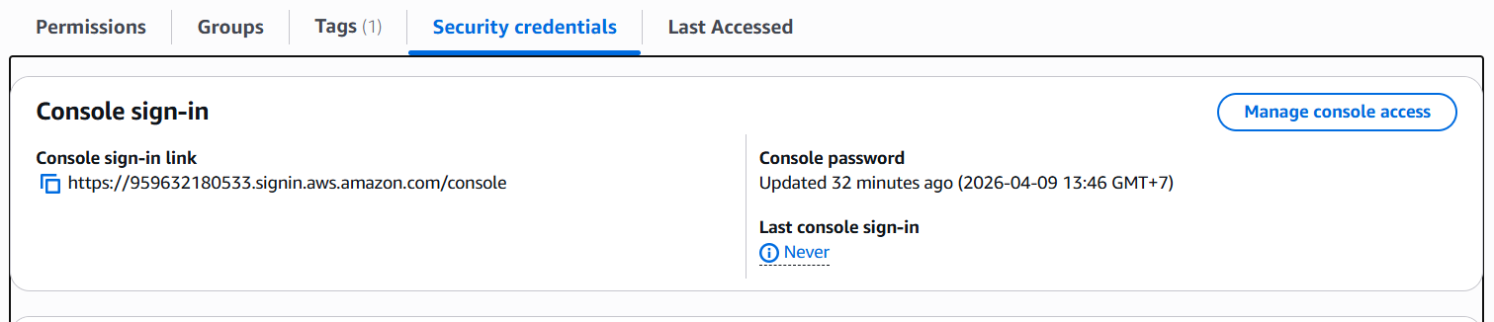

    - In the navigation pane on the left, choose User groups: The following groups have already been created for you: EC2-Admin, EC2-Support, S3-Support
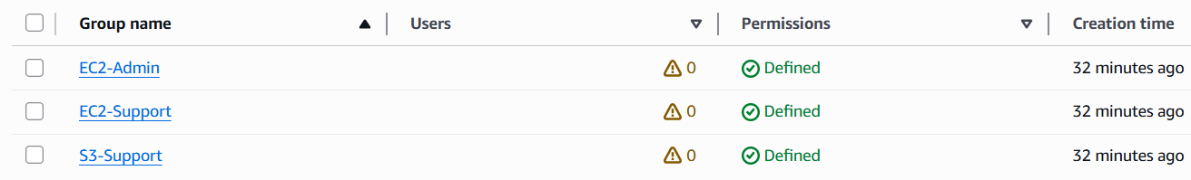

    - Choose the EC2-Support group link: This will bring you to the summary page for the EC2-Support group.
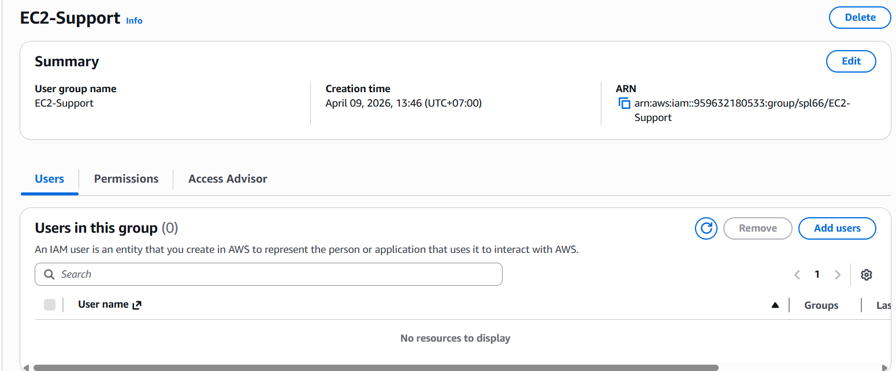

    - Choose the Permissions tab: This group has a Managed Policy associated with it, called AmazonEC2ReadOnlyAccess. Managed Policies are pre-built policies (built either by AWS or by your administrators) that can be attached to IAM Users and Groups. When the policy is updated, the changes to the policy are immediately apply against all Users and Groups that are attached to the policy.
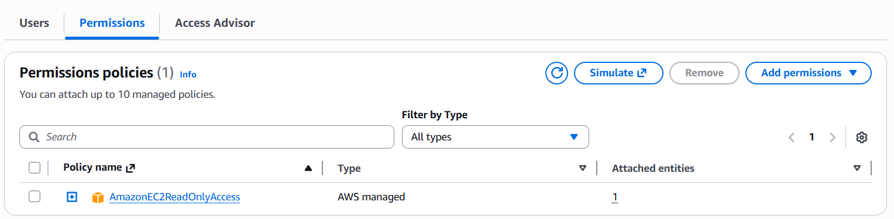

    - Choose the plus (+) icon next to the AmazonEC2ReadOnlyAccess policy to view the policy details. Note: A policy defines what actions are allowed or denied for specific AWS resources. This policy is granting permission to List and Describe information about EC2, Elastic Load Balancing, CloudWatch and Auto Scaling. This ability to view resources, but not modify them, is ideal for assigning to a Support role. The basic structure of the statements in an IAM Policy is: Effect says whether to Allow or Deny the permissions. Action specifies the API calls that can be made against an AWS Service (eg cloudwatch:ListMetrics). Resource defines the scope of entities covered by the policy rule (eg a specific Amazon S3 bucket or Amazon EC2 instance, or * which means any resource).
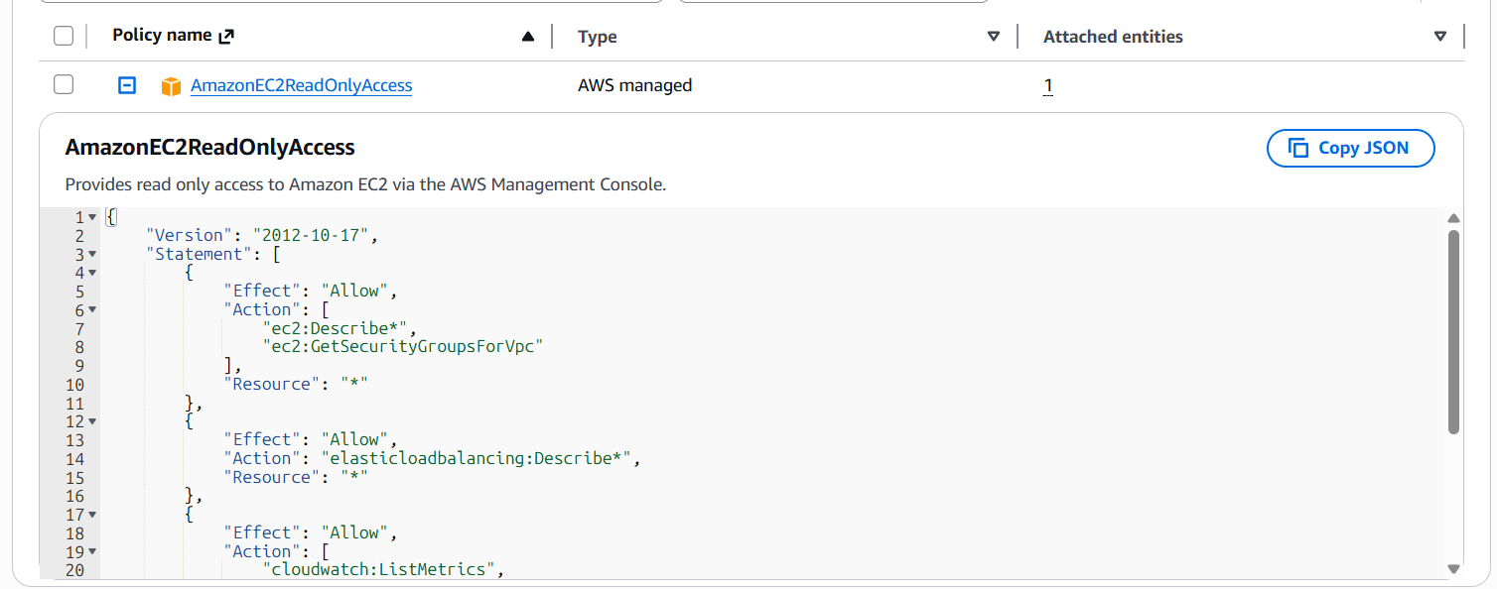

    - Choose the minus icon (-) to hide the policy details.

o In the navigation pane on the left, choose User groups:
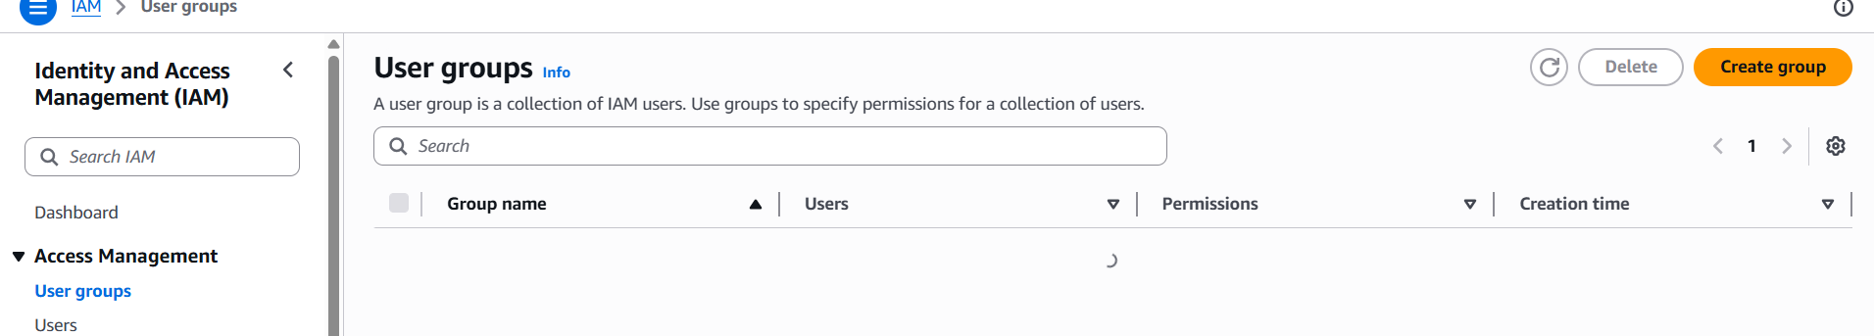

o Choose the S3-Support group link and then choose the Permissions tab. The S3Support group has the AmazonS3ReadOnlyAccess policy attached.
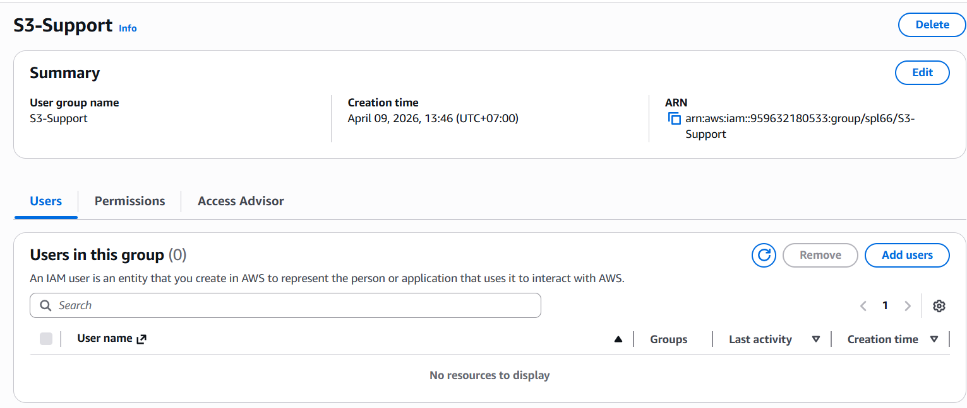
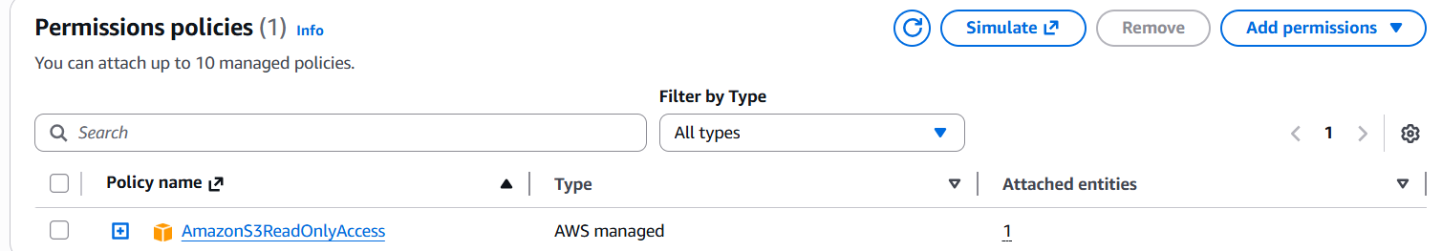

    - Choose the plus (+) icon to view the policy details. This policy grants permissions to Get and List resources in Amazon S3.
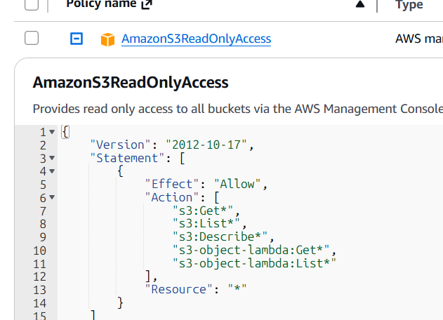

o Choose the minus icon (-) to hide the policy details.

o In the navigation pane on the left, choose User groups:
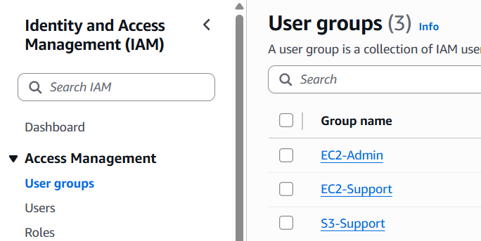

    - Choose the EC2-Admin group link and then choose the Permissions tab: This Group is slightly different from the other two. Instead of a Managed Policy, it has an Inline Policy, which is a policy assigned to just one User or Group. Inline Policies are typically used to apply permissions for one-off situations.
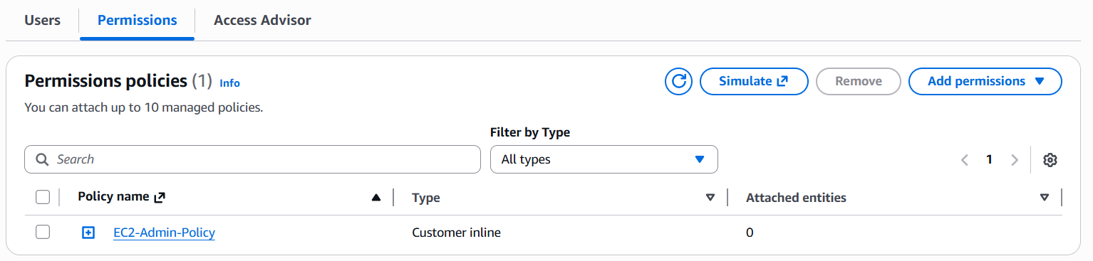

    - Choose the plus (+) icon to view the policy details: This policy grants permission to view (Describe) information about Amazon EC2 and also the ability to Start and Stop instances.
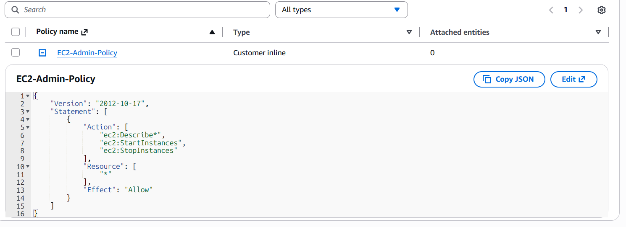

    - Choose the minus icon (-) to hide the policy details.

- Task 3 - Task 2: Add Users to Groups
o You have recently hired user-1 into a role where they will provide support for Amazon S3. You will add them to the S3-Support group so that they inherit the necessary permissions via the attached AmazonS3ReadOnlyAccess policy.

  - Ignore any "not authorized" errors that appear during this task. They are caused by your lab account having limited permissions and will not impact your ability to complete the lab.

  - Add user-1 to the S3-Support Group: In the left navigation pane, choose User groups. Choose the S3-Support group link. Choose the Users tab. In the Users tab, choose Add users.
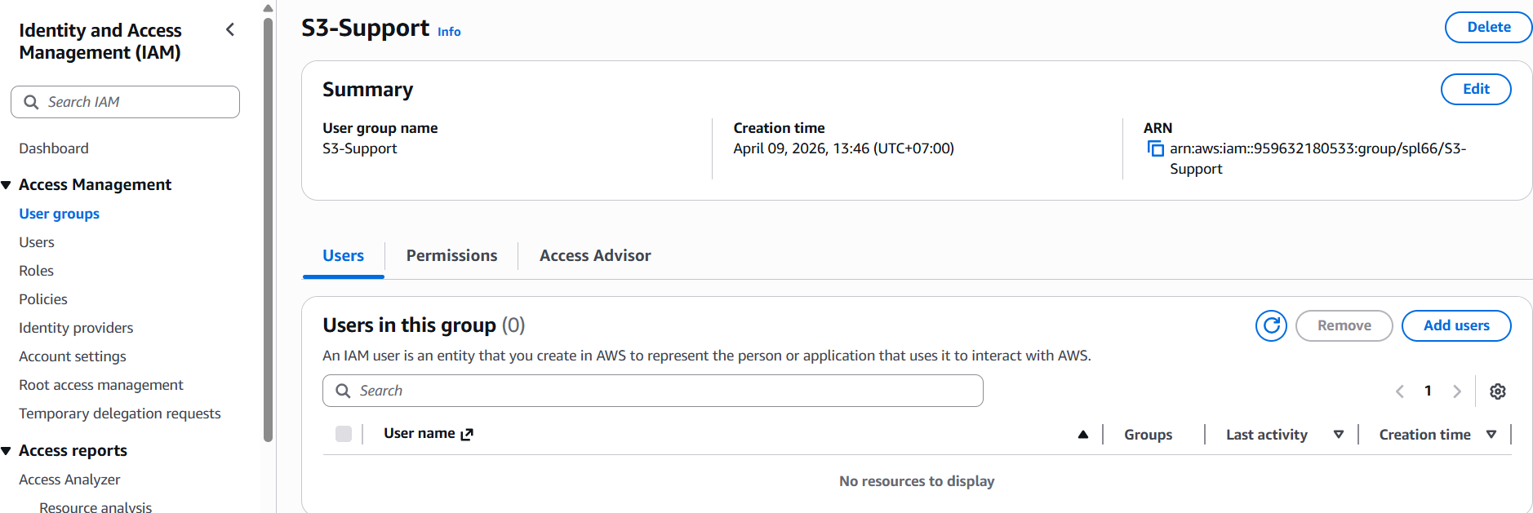
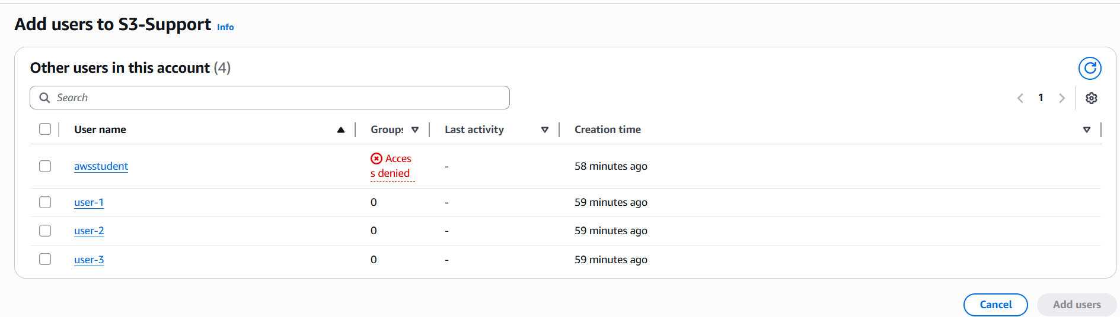

  - In the Add Users to S3-Support window, configure the following: Select user-1. At the bottom of the screen, choose Add users. In the Users tab you will see that user-1 has been added to the group.
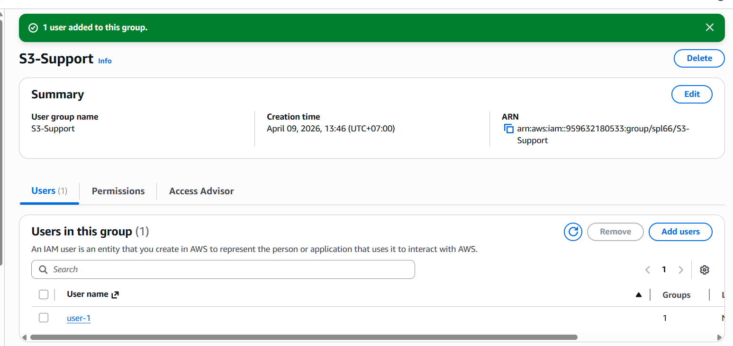

  - Add user-2 to the EC2-Support Group: You have hired user-2 into a role where they will provide support for Amazon EC2. Using similar steps to the ones above, add user-2 to the EC2-Support group. user-2 should now be part of the EC2-Support group.
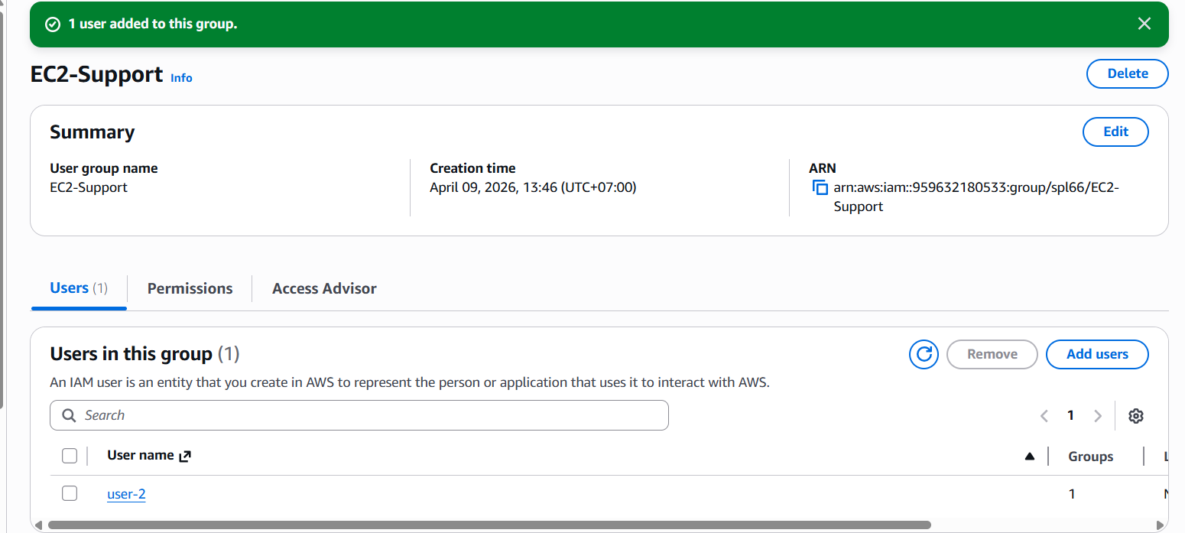

o Add user-3 to the EC2-Admin Group: You have hired user-3 as your Amazon EC2 administrator, who manage your EC2 instances. Using similar steps to the ones above, add user-3 to the EC2-Admin group. user-3 should now be part of the EC2-Admin group. o In the navigation pane on the left, choose User groups. Each Group should now have a 1 in the Users column, indicating the number of Users in each Group.
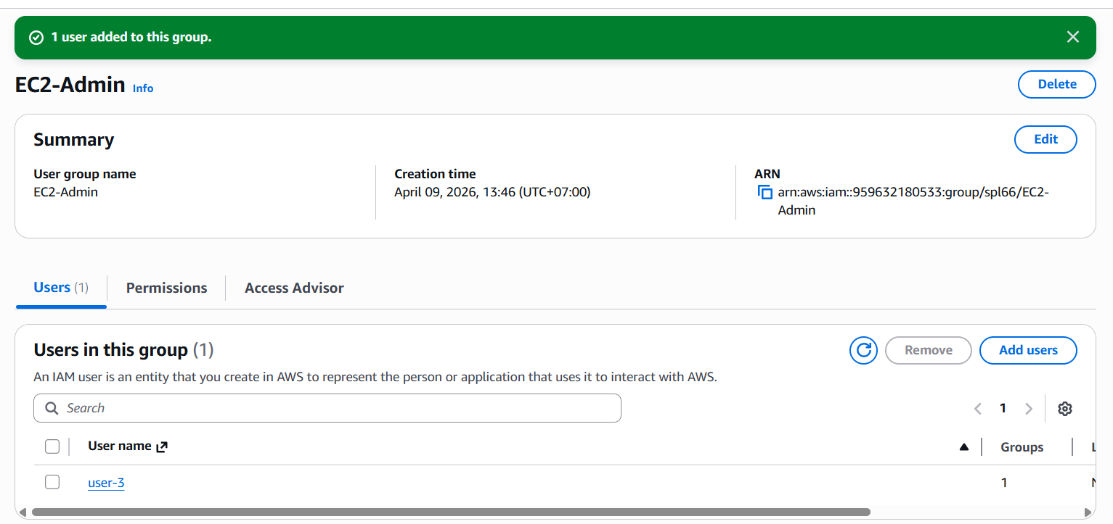

- Task 4 – Static Website with S3
o S3 bucket successfully created with proper naming
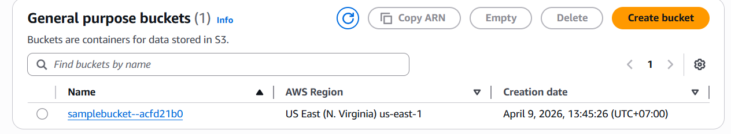

o Static website hosting enabled correctly
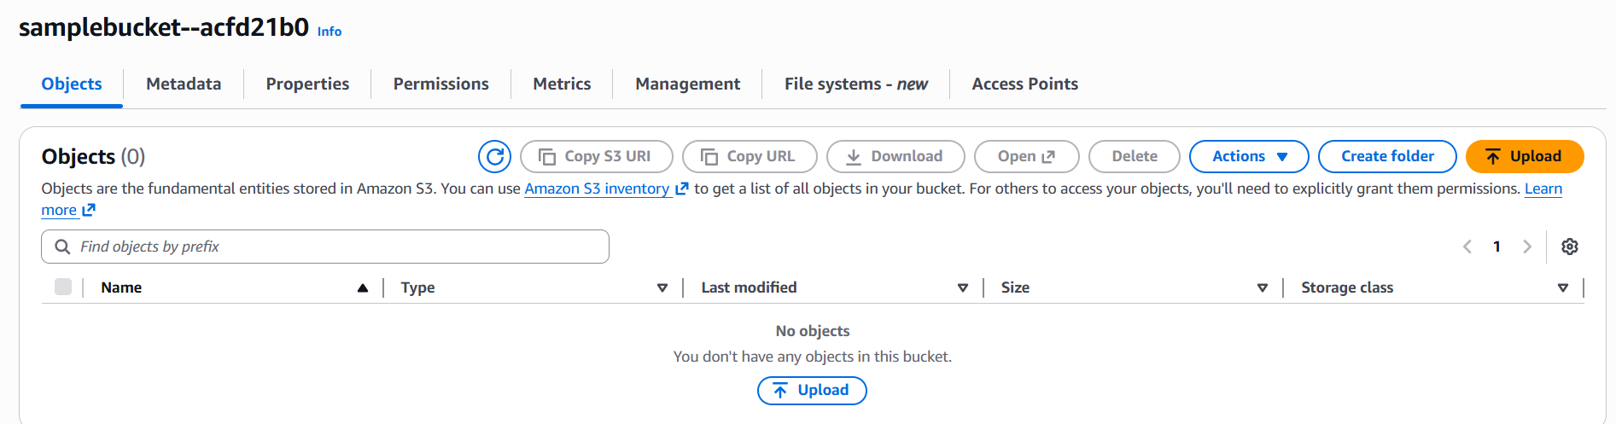
o index.html uploaded and accessible

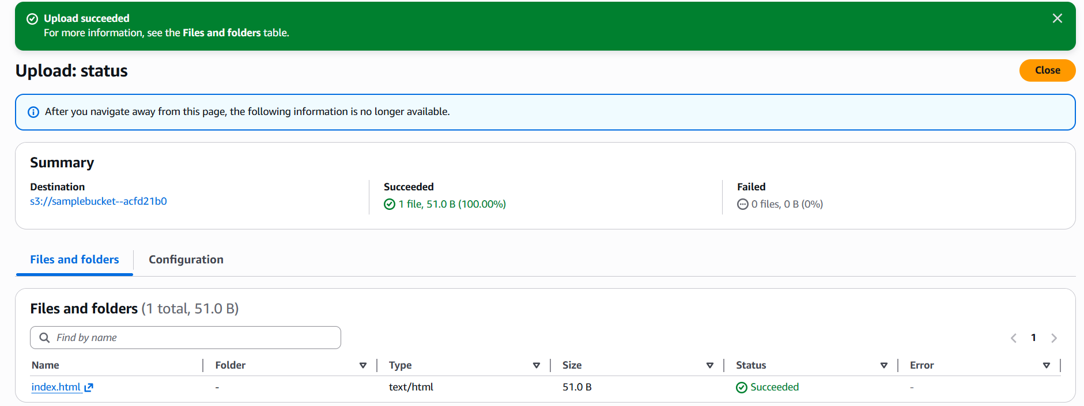

o Website endpoint tested and working
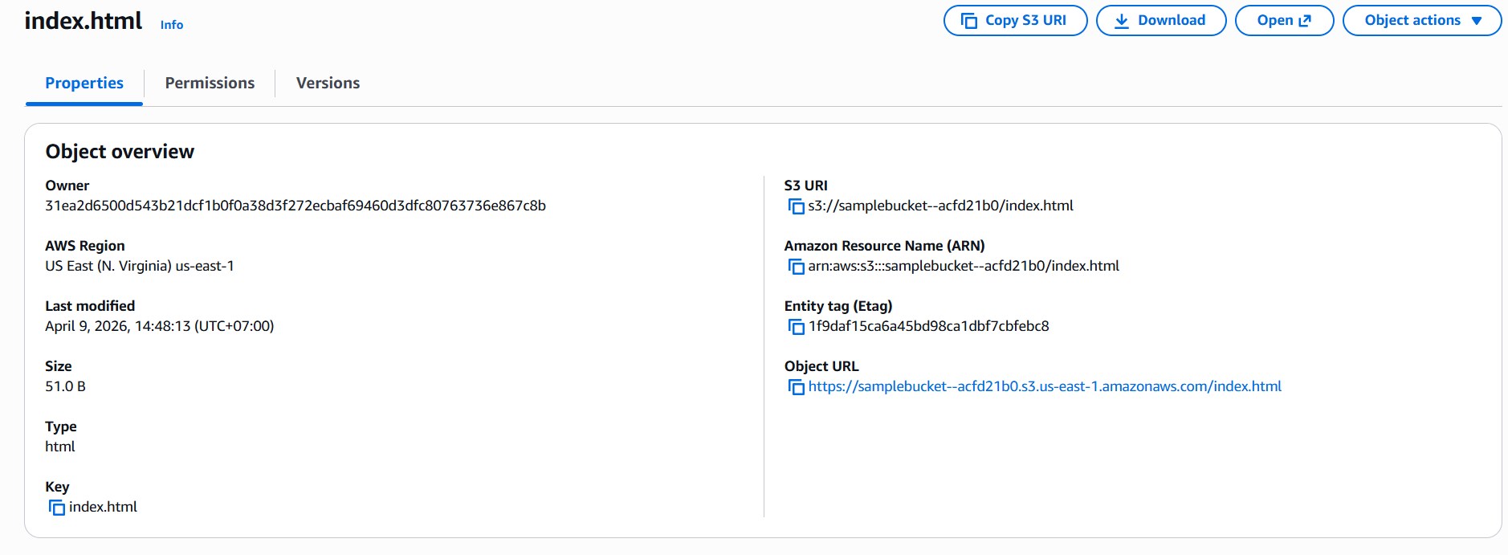

- Task 5 – Launching EC2 Instance
o Instance launched correctly (AMI, type, security group)
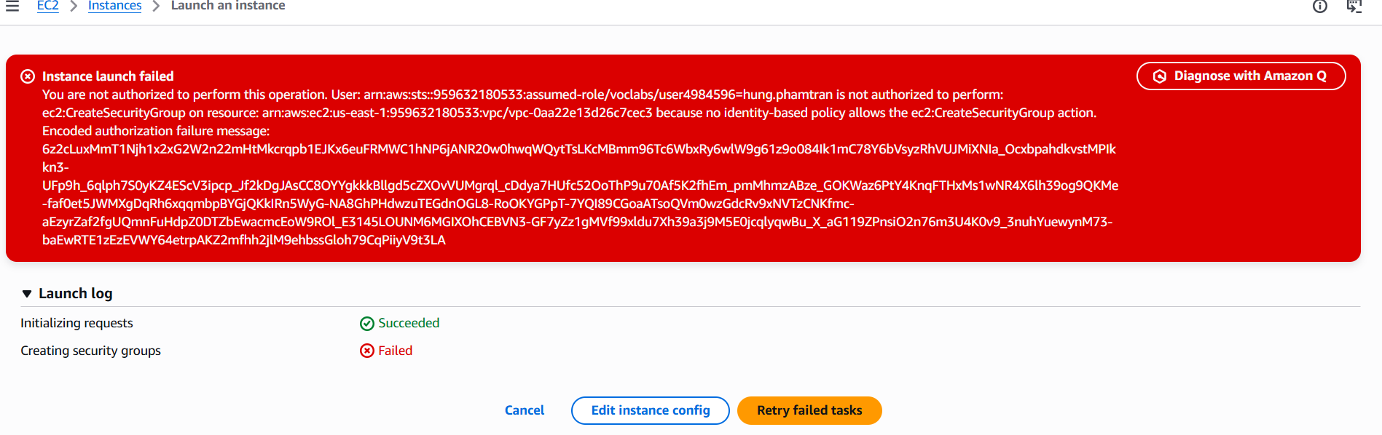
o Connection established via SSH (GUI/CLI/Terraform method)

o Evidence of system info command uname -a output

- Task 6 – Terminating or Stop EC2 Instance
o Proper termination using Console/CLI/Terraform

o Screenshot or log confirming termination
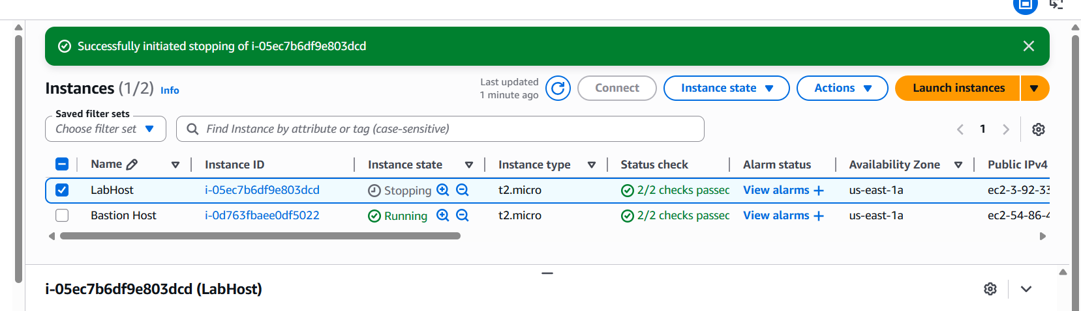

- Task 7 – Reflection Questions
o Complete and thoughtful answer for question 1
- What felt different about deploying resources in the cloud vs. using your personal computer?
Answer: Deploying resources on AWS felt different from working on a personal computer. On local machine, im limited by the hardware I own. Having a server on my computer means dealing with power, cooling, networking.
With AWS there no physical setup, no hardware to worry about. Pricing model meant only pay for what I use, and scaling up or down is simple.
There is also layer of identity access control that not exist on a personal computer. Instead of one machine used by all, AWS lets the user define what each user or service is allowed to. This makes cloud environments more secure than a local machine.

o Complete and thoughtful answer for question 2
- How do you think cloud computing changes the way organizations build and deliver software?
Answer: Cloud computing changed how organizations build and ship software. Before the cloud, companies invest heavily in physical data centers, purchase servers. This made it slow and expensive to launch new services, and scaling to meet unexpected demand was difficult.
With platforms like AWS, teams can provision global infrastructure on demand and scale automatically based on real traffic. CI/CD pipelines allow developers to push updates multiple times a day and deploy to production fast, shortening release cycles and reducing time for the product to go live.
Cloud services like S3, EC2, RDS, and IAM help developer from managing servers, letting them focus entirely on writing code logic. The cloud improves reliability so services can survive hardware failures automatically without manual intervention. Cloud computing enables organization to operate faster,at lower cost and globally distributed more easily

