
Assignment 2: Launching, Load balancing & Scaling on AWS EC2
Phạm Trần Gia Hưng - 2331200153

Overview
This assignment provides hands-on experience with core AWS services and modern cloud computing patterns. You will start by launching and managing EC2 instances using AWS Console. Building on this foundation, you will configure load balancing and auto-scaling groups to understand how AWS handles fault tolerance and dynamic scaling under traffic. Finally, you will reflect on the trade-offs between AWS services to make informed architectural decisions for real-world cloud applications.
Task 1 (Access Module 6 Lab - 3 Introduction to Amazon EC2 from AWS academy account) – Launching an EC2 Instance using AWS console
- Name and tag:
The Name you give this instance will be stored as a tag. Tags enable you to categorize your AWS resources in different ways, for example, by purpose, owner, or environment
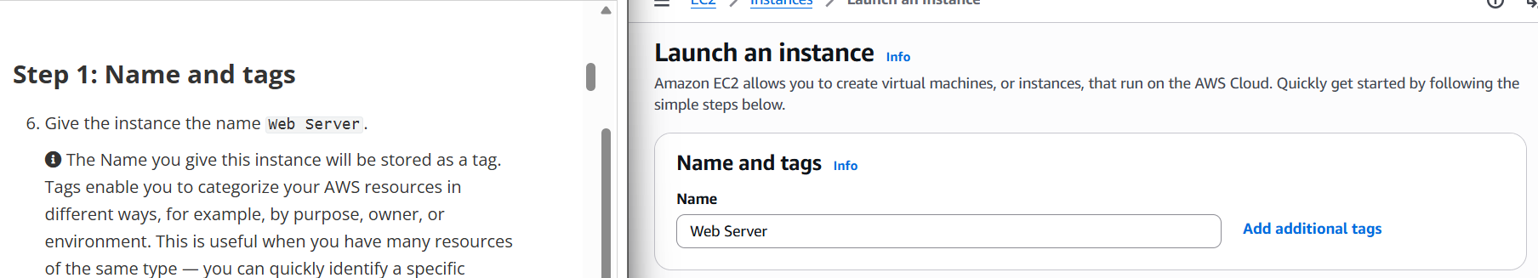

- Application and OS Images (Amazon Machine Image)
In the list of available Quick Start AMIs, keep the default Amazon Linux AMI selected
An Amazon Machine Image (AMI) provides the information required to launch an instance, which is a virtual server in the cloud
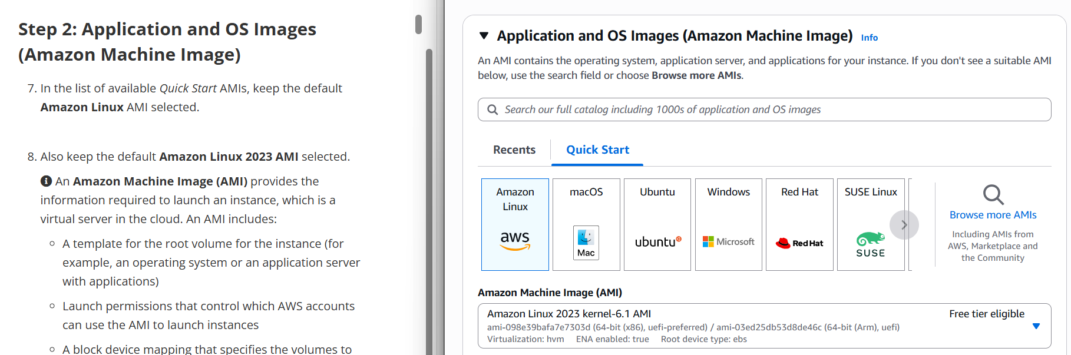

- Instance type
In the Instance type panel, keep the default t2.micro selected
Amazon EC2 provides a wide selection of instance types optimized to fit different use cases
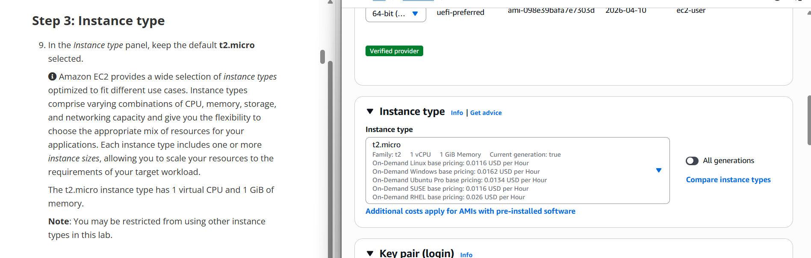
- Key pair
Amazon EC2 uses public–key cryptography to encrypt and decrypt login information
Amazon EC2 uses public–key cryptography to encrypt and decrypt login information
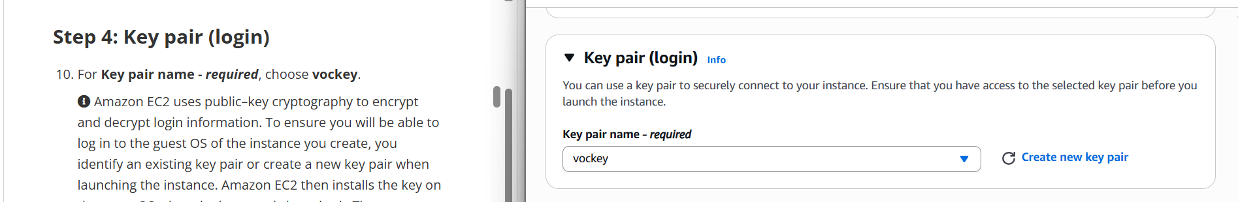

- Network setting
The Lab VPC was created using an AWS CloudFormation template during the setup process of your lab. This VPC includes two public subnets in two different Availability Zones
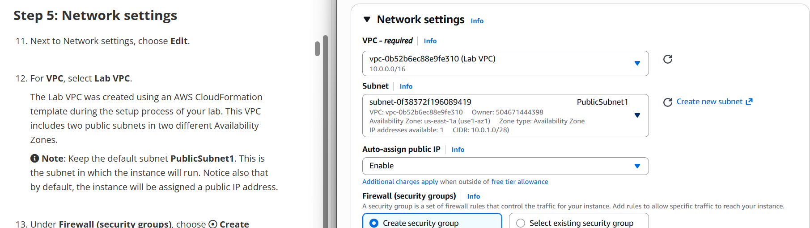
- Firewall setting
Security group name: Web Server security group
Description: Security group for my web server
Under Inbound security group rules, notice that one rule exists. Remove this rule
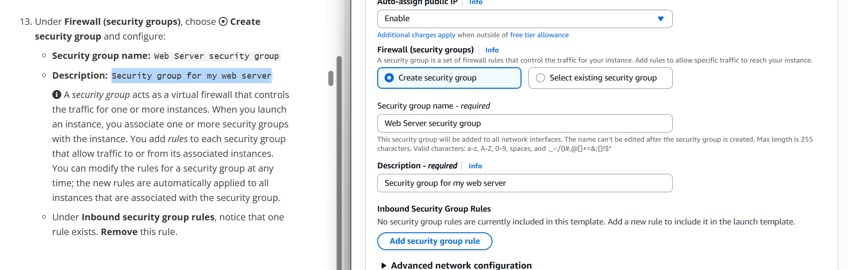
-Configure storage
Description: Security group for my web server
launch the Amazon EC2 instance using a default 8 GiB disk volume. This will be your root volume
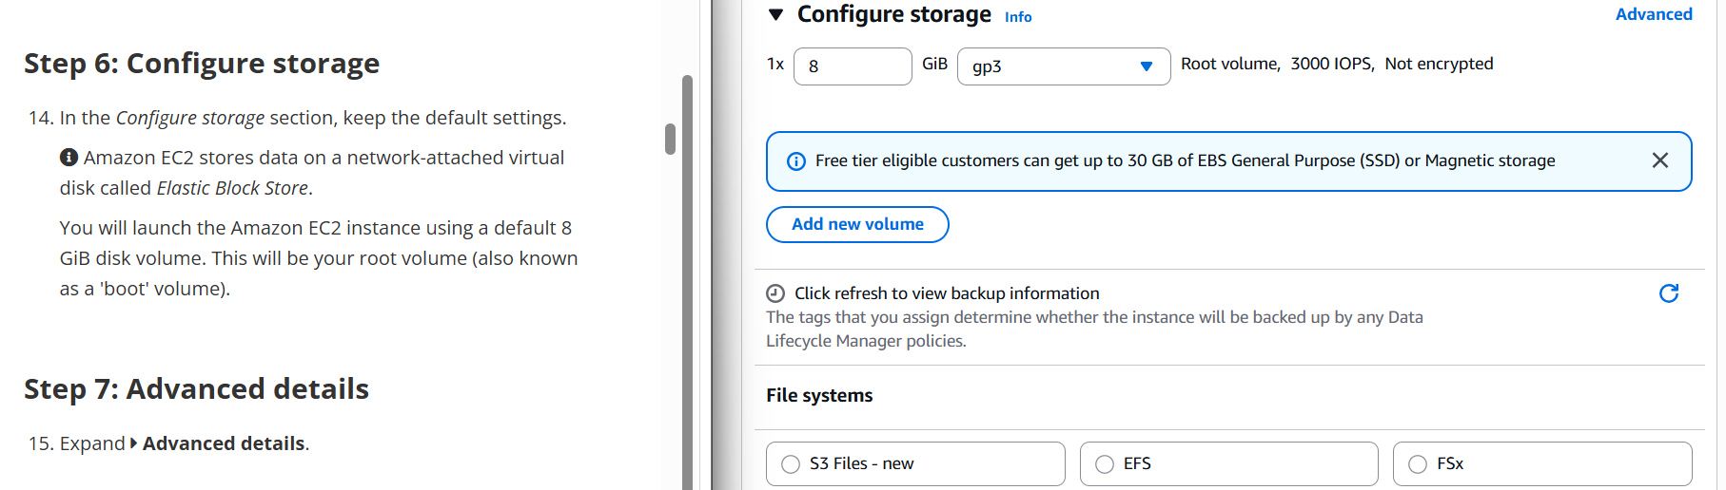

- Advanced Detail
Expand -> Advanced details
For Termination protection, select Enable
For Termination protection, select Enable
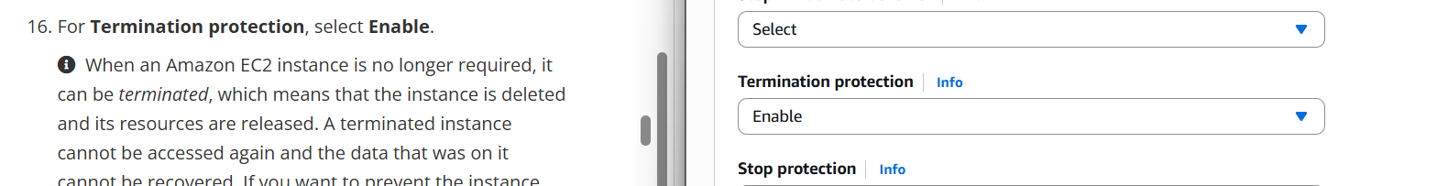
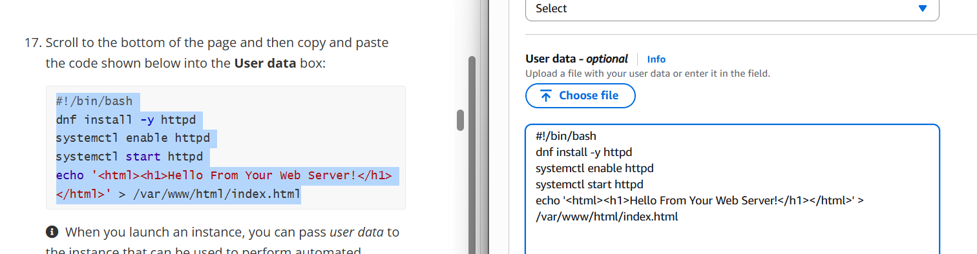

- Launch the instance
At the bottom of the Summary panel choose Launch instance
Choose View all instances
In the Instances list, select Web Server.
Review the information displayed in the Details tab
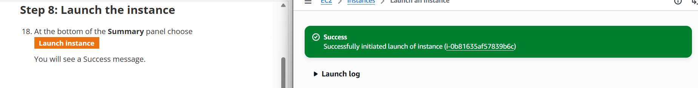

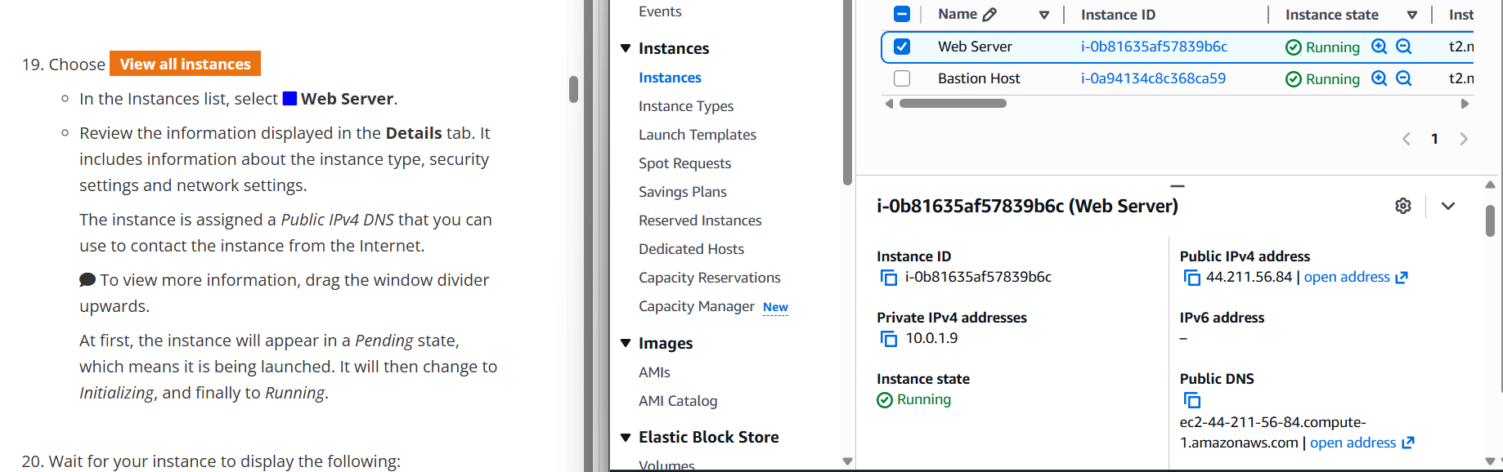

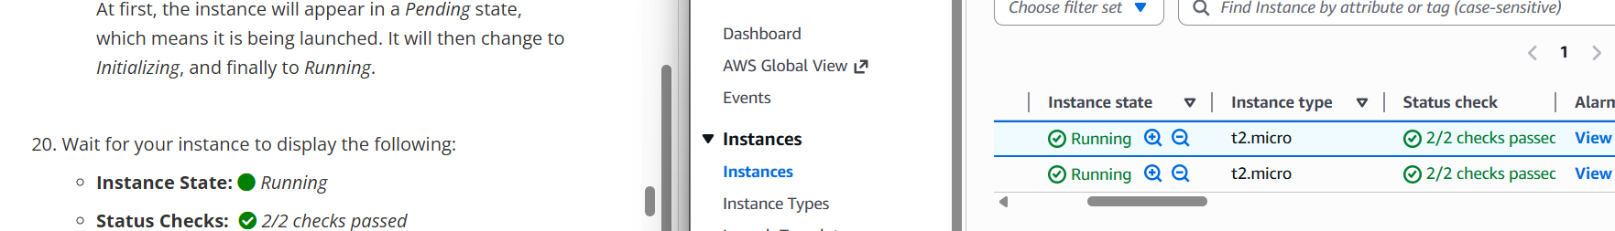

Task 2 (Access Module 6 Lab - 3 Introduction to Amazon EC2 from AWS academy account) – Access AWS EC2 instance through console for monitoring, managing activities.
-Monitor Your Instance
- Choose the status check
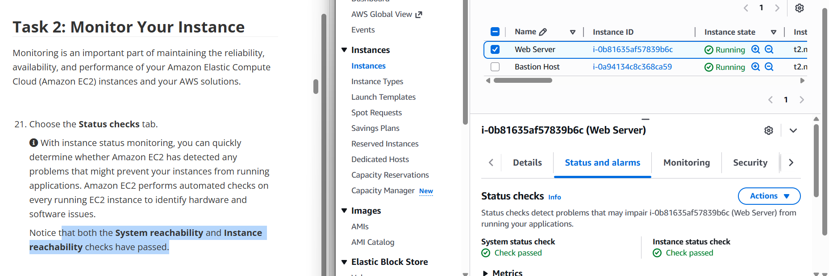

- Choose the monitoring tab
displays Amazon CloudWatch metrics for your instance
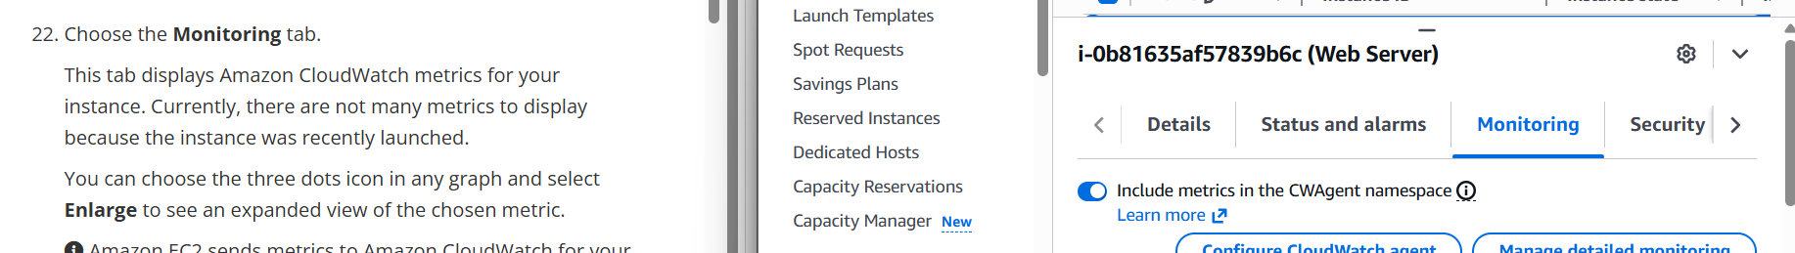
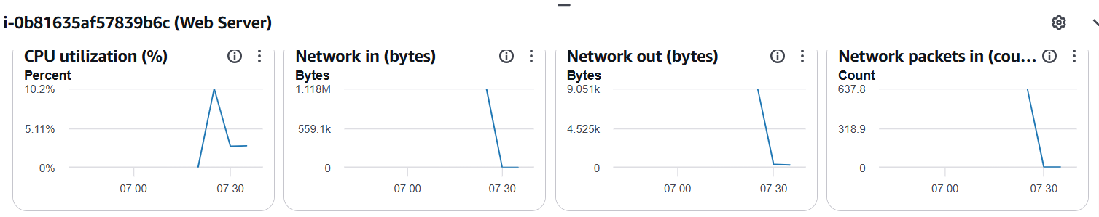
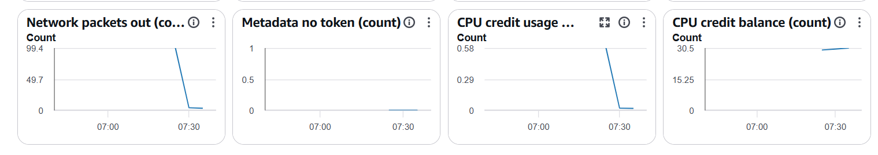

- Get system log
In the Actions menu towards the top of the console, select Monitor and troubleshoot -> Get system log
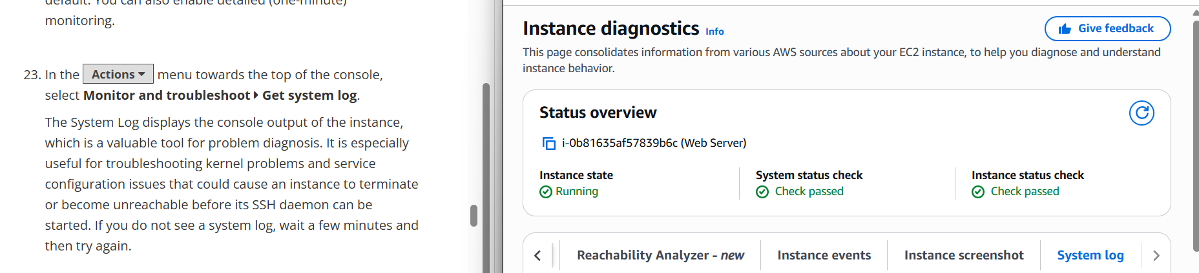
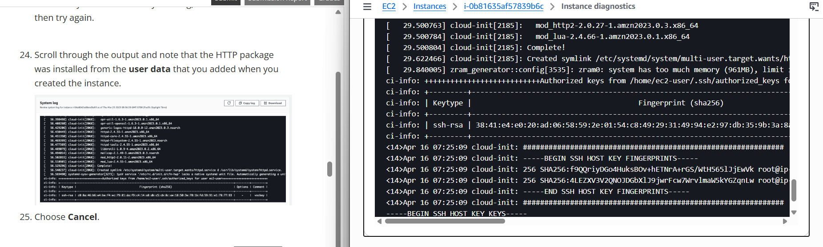

-Get instance screenshot
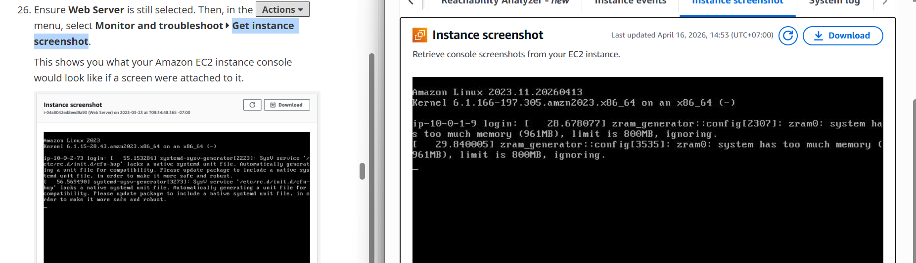

- Update Your Security Group and Access the Web Server
- Detail tab
- Copy ipv4

- Paste ipv4 url
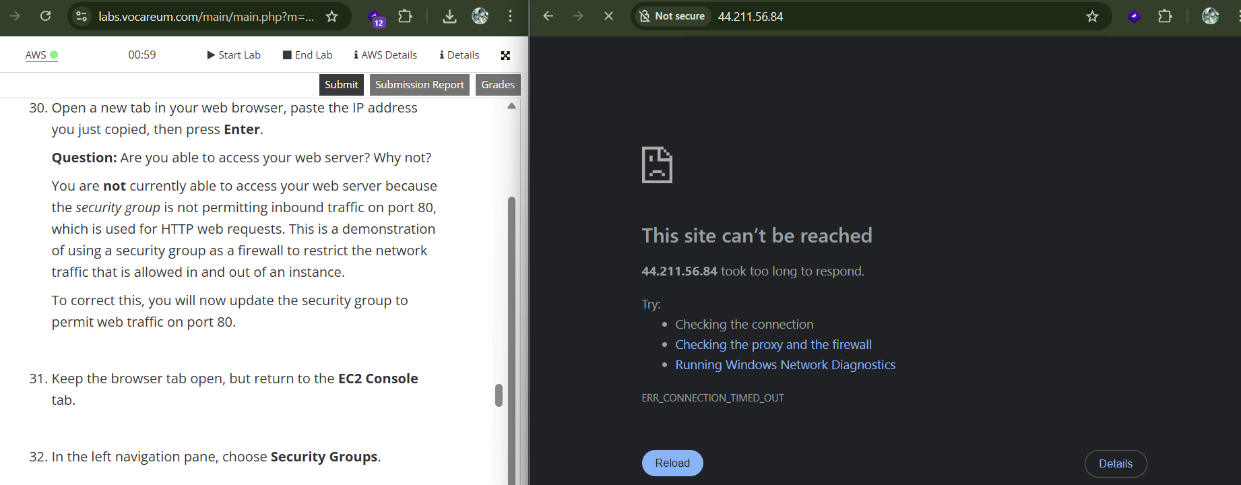
- Web server security service
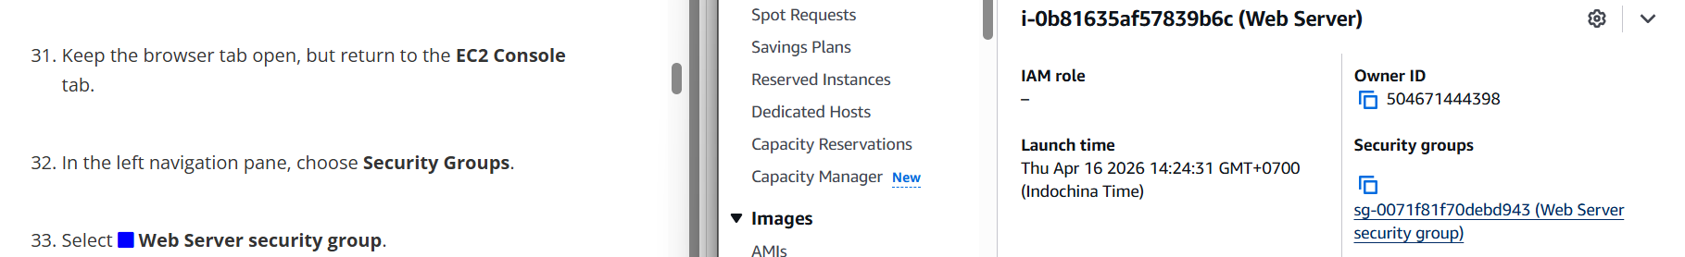
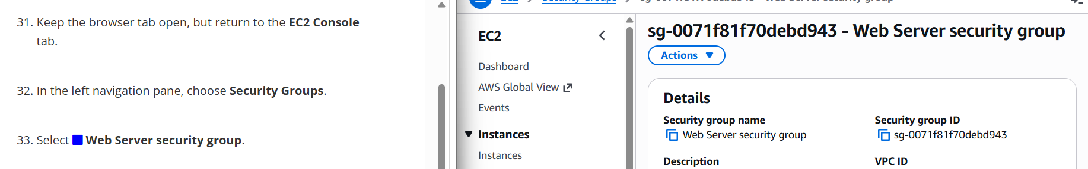
- Select inbound rule
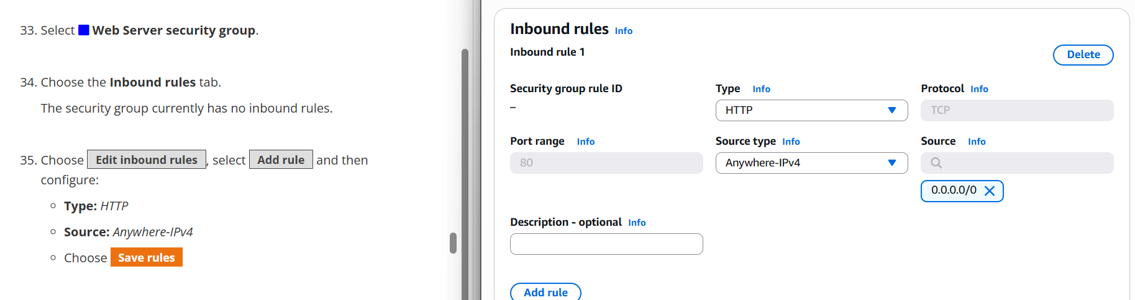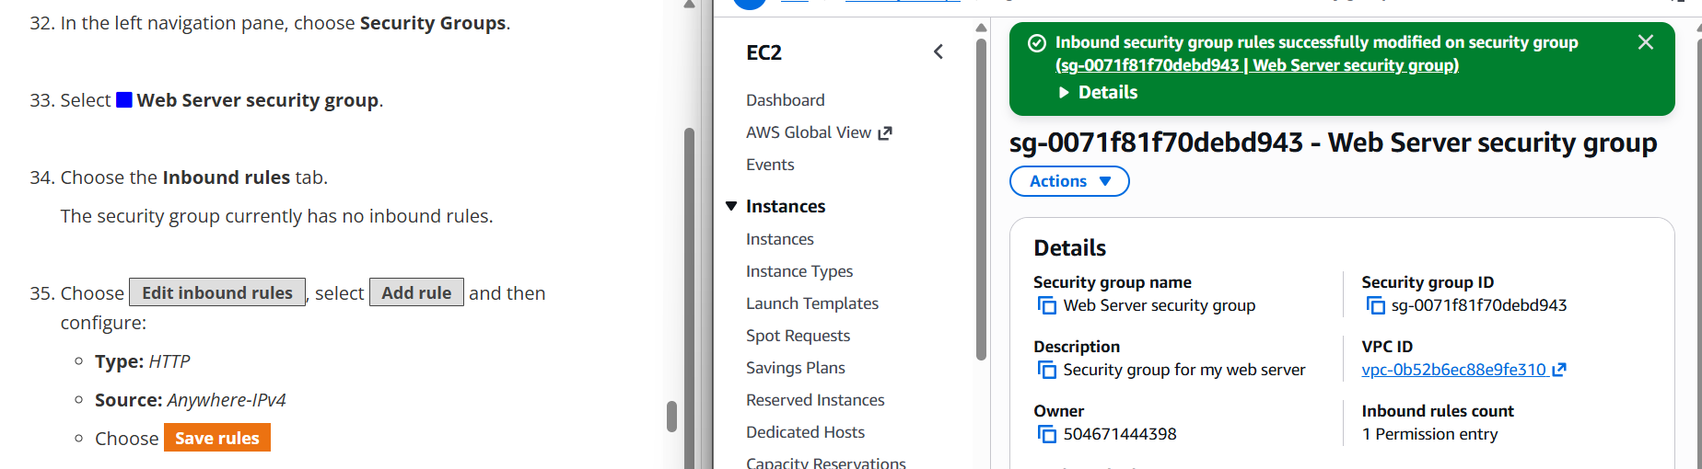
- Refresh page
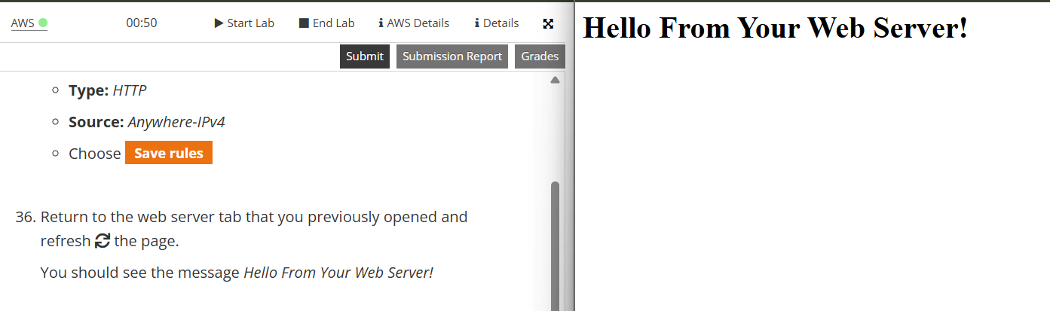

- Resize Your Instance: Instance Type and EBS Volume
- Stop instance
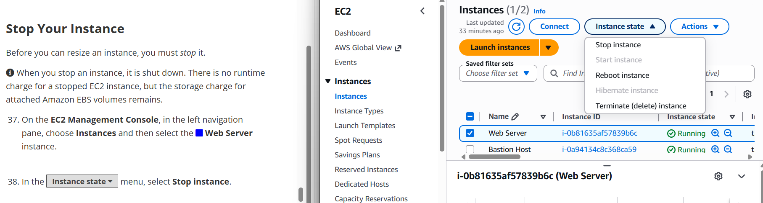
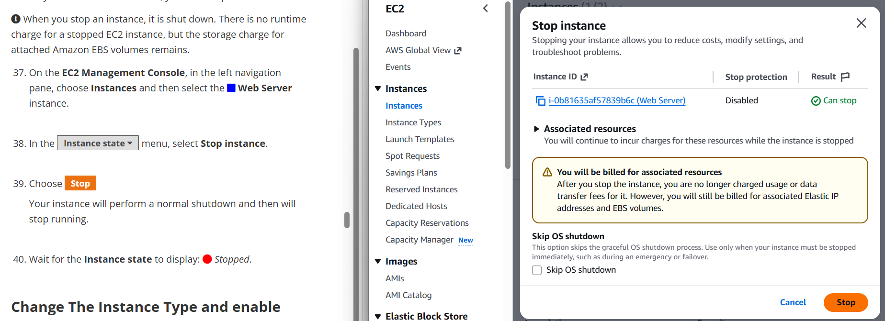

-Change The Instance Type and enable stop protection
- Change instance type
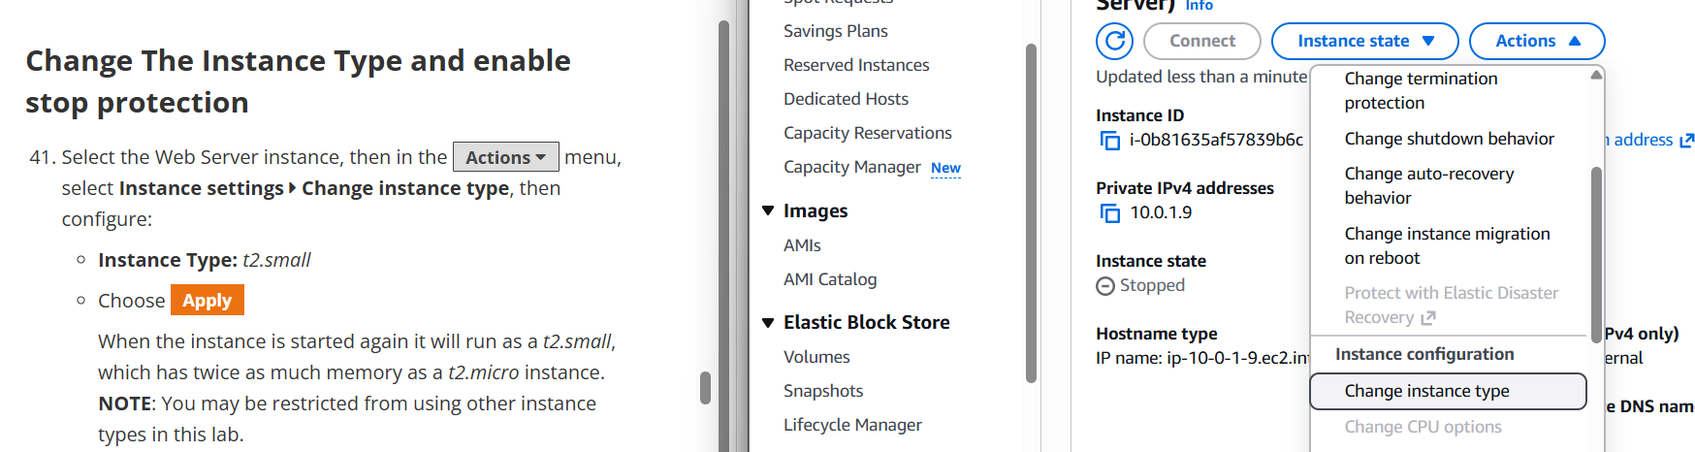
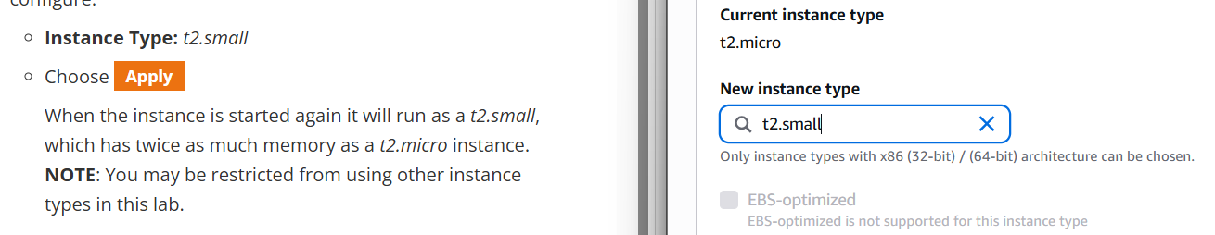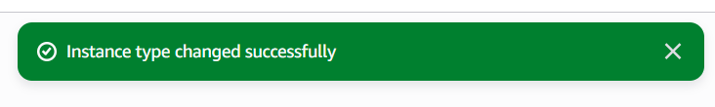
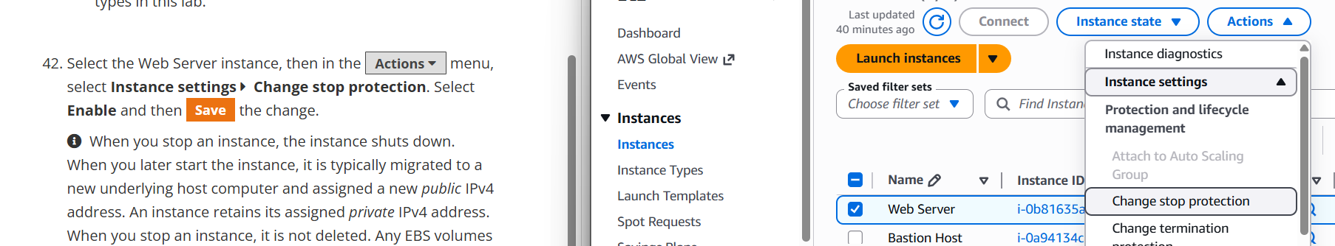
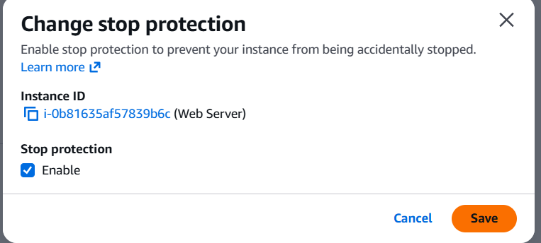

-Resize the EBS Volume
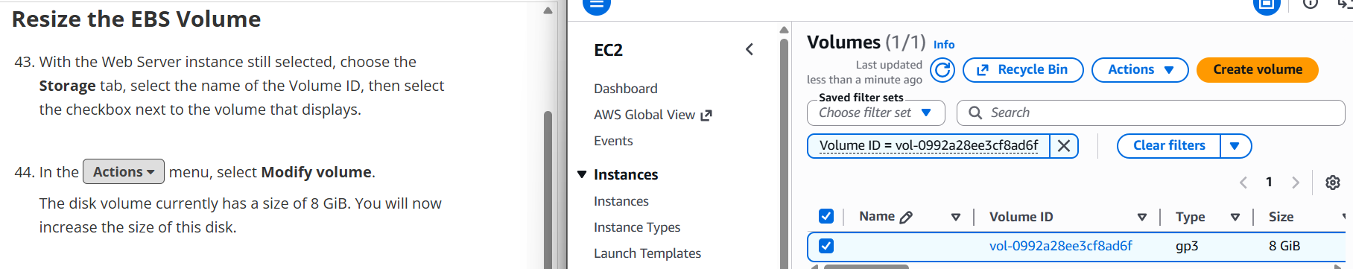
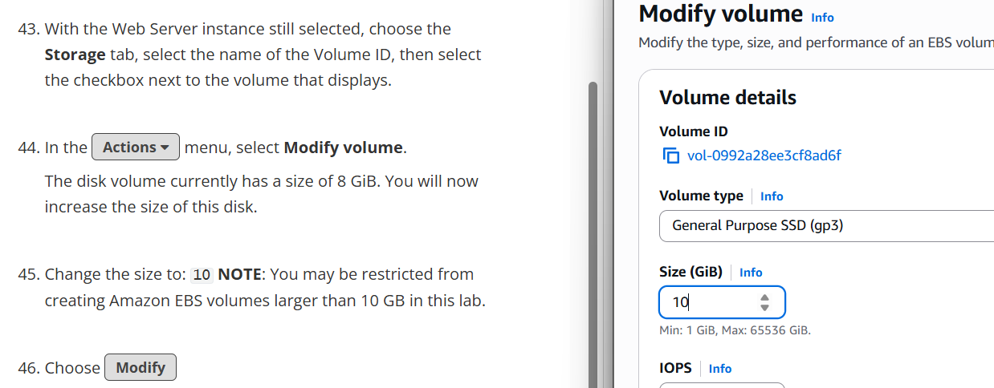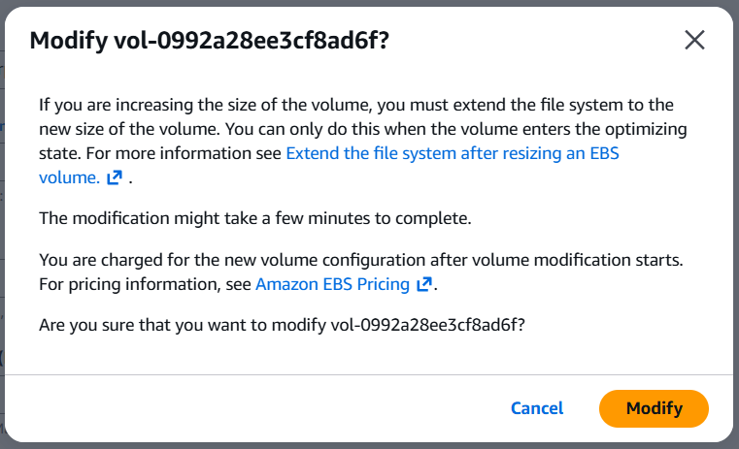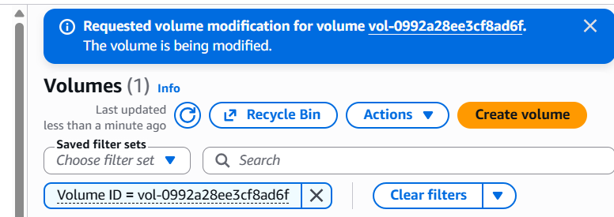

-Start the Resized Instance
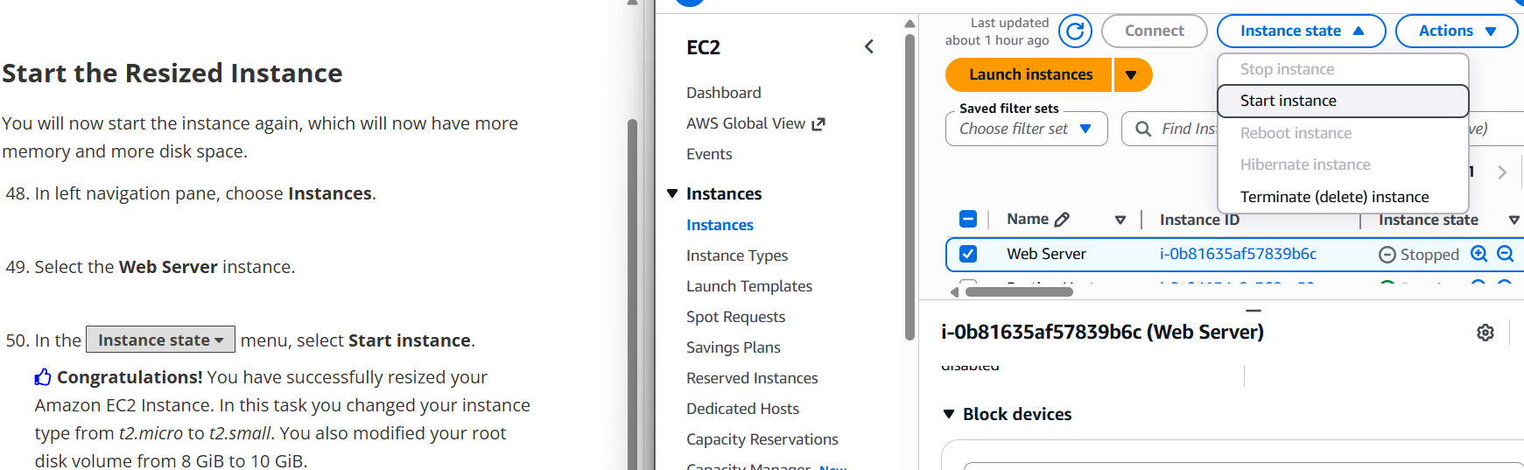

- Explore EC2 Limits
- Service quota
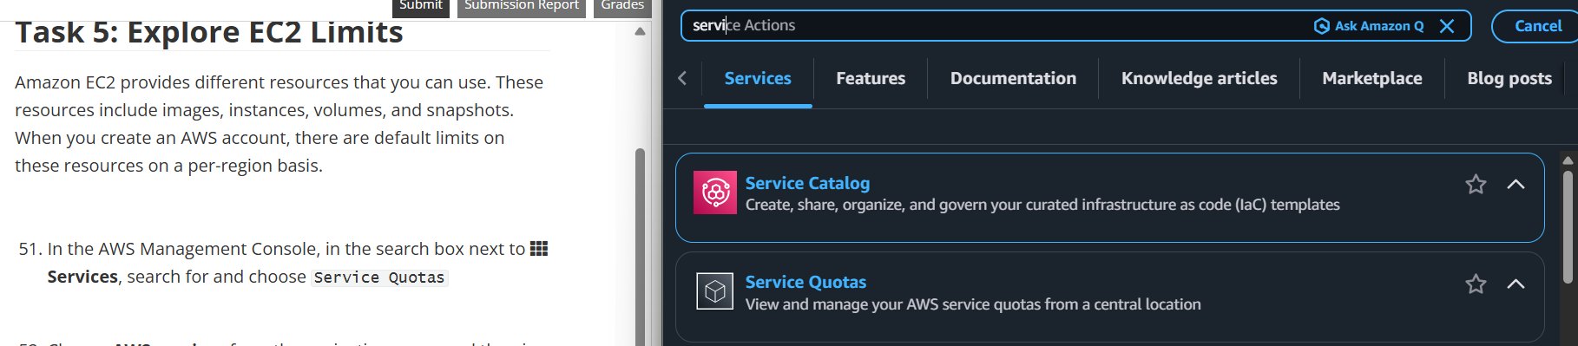

- Amazon Elastic Compute Cloud (Amazon EC2)
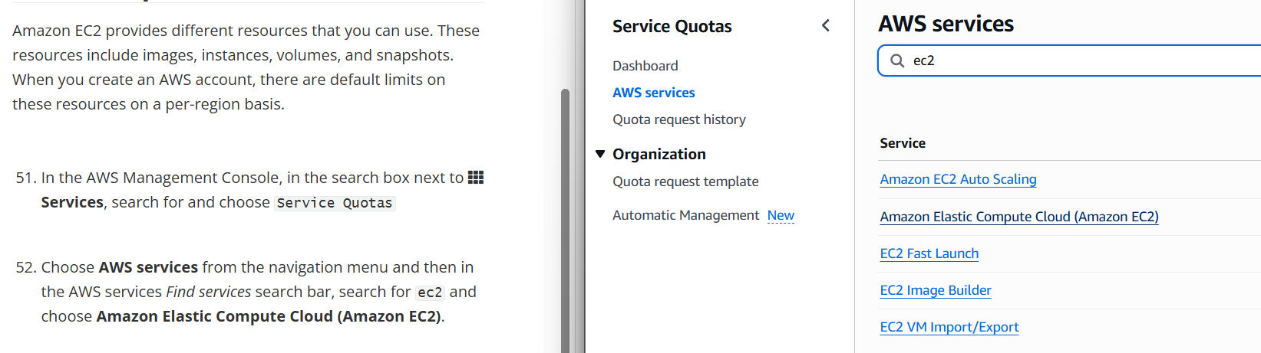
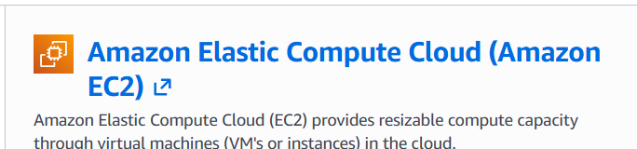

- find running on-demand
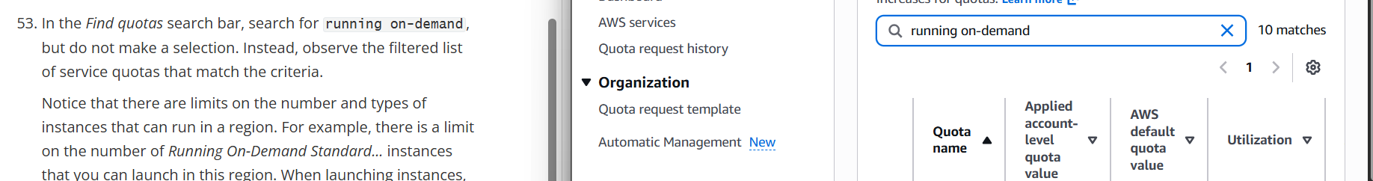

- Test Stop Protection
- choose instance
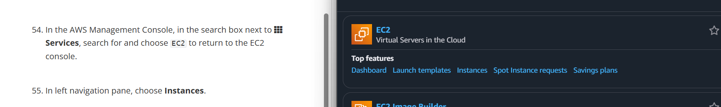

- stop instance
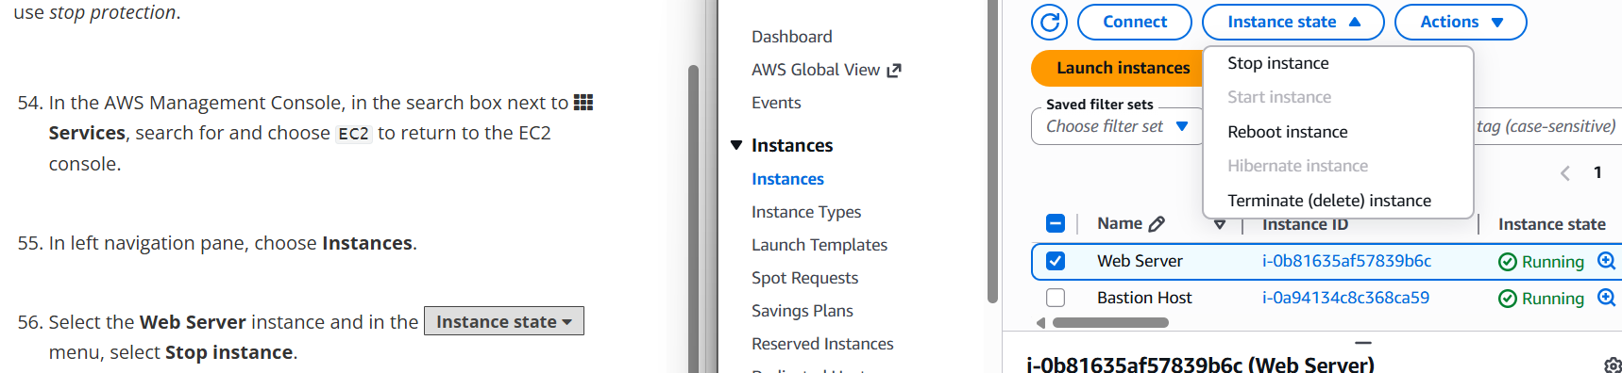
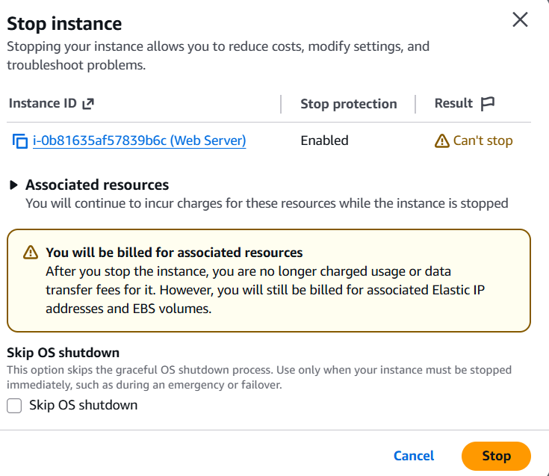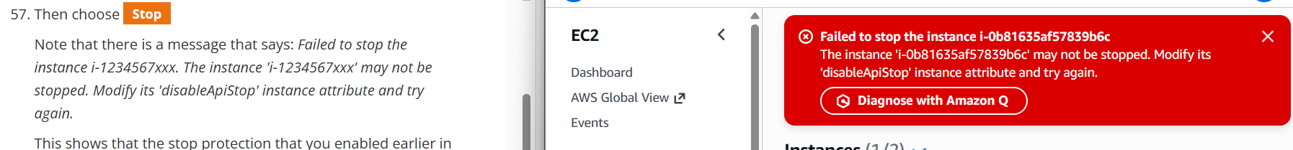

- Change stop protection
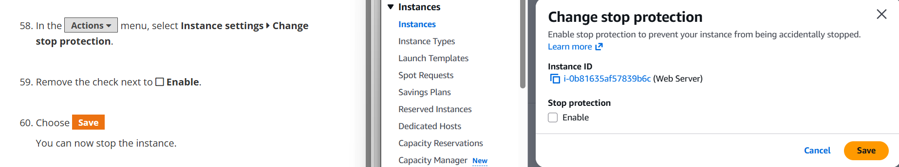
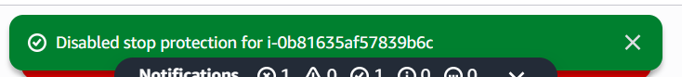
- Stop instance again
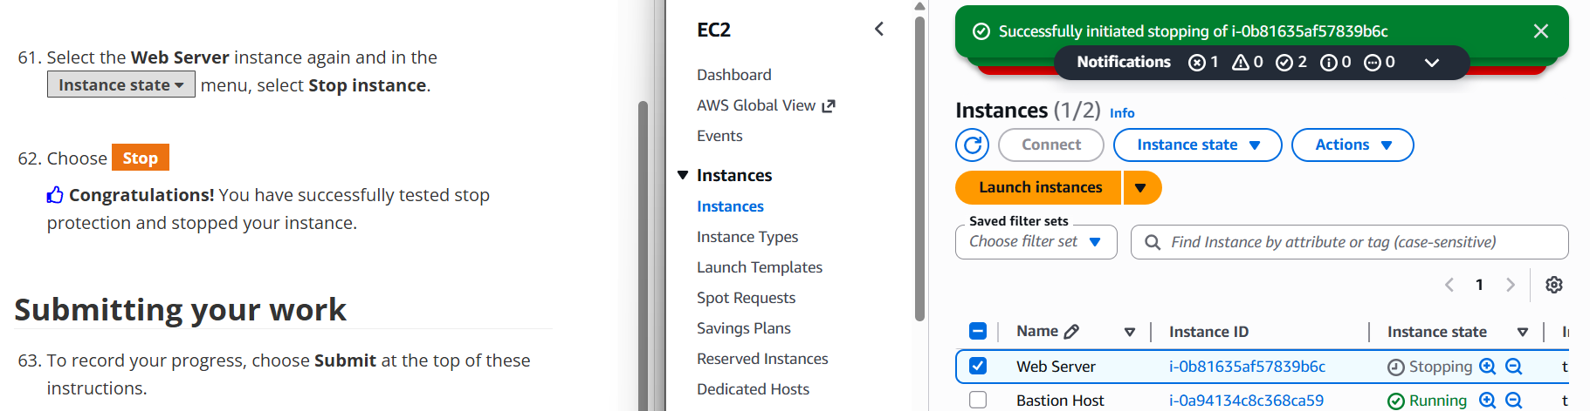
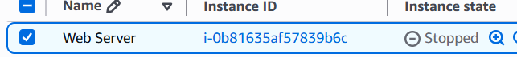

Task 3 (Access Module 10 Lab - 6 Scale & Load Balance your Architecture from AWS academy account) – Load Balancer & Auto Scaling Group setup and traffic network

- Create an AMI for Auto Scaling
- find EC2
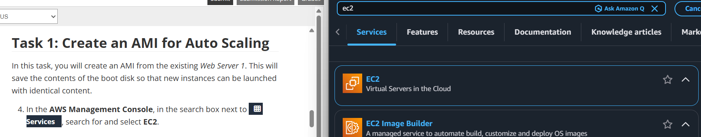

- Choose Instances
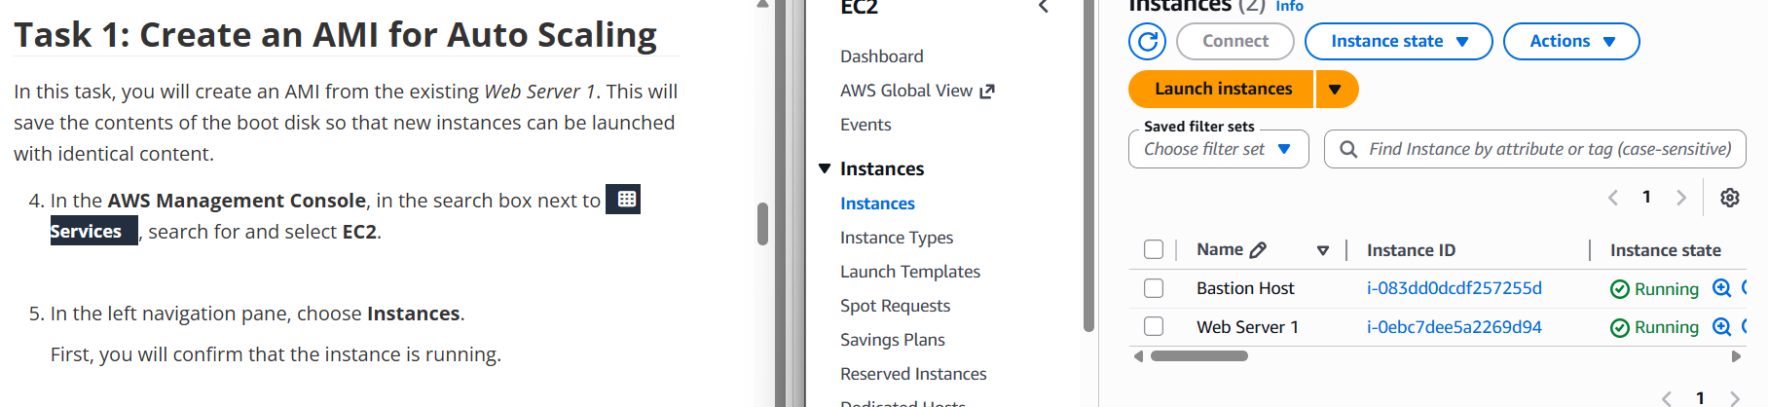

- Select web server 1

-Create image
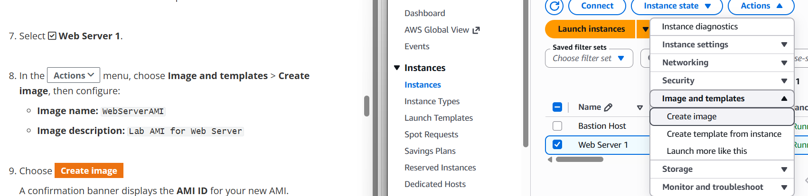

- Config
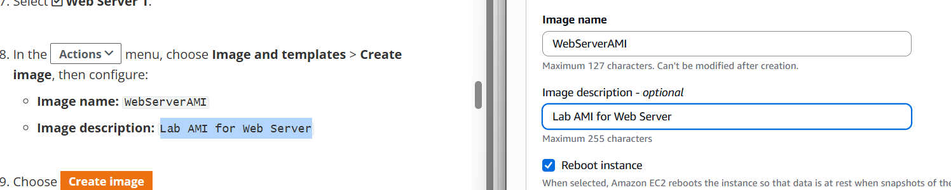

- Create
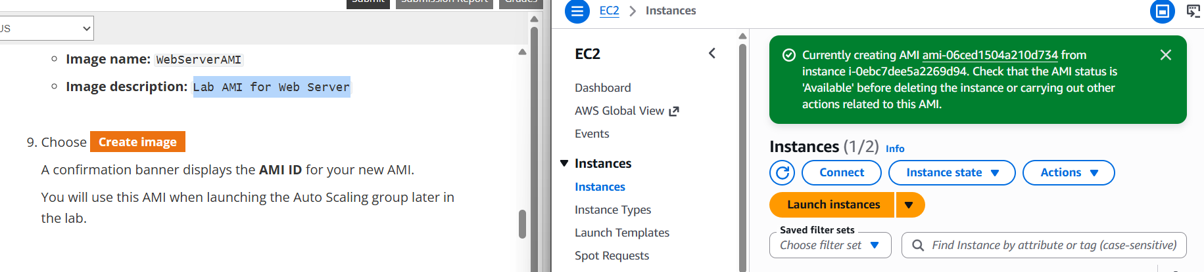

- Create a Load Balancer
- choose Target Groups
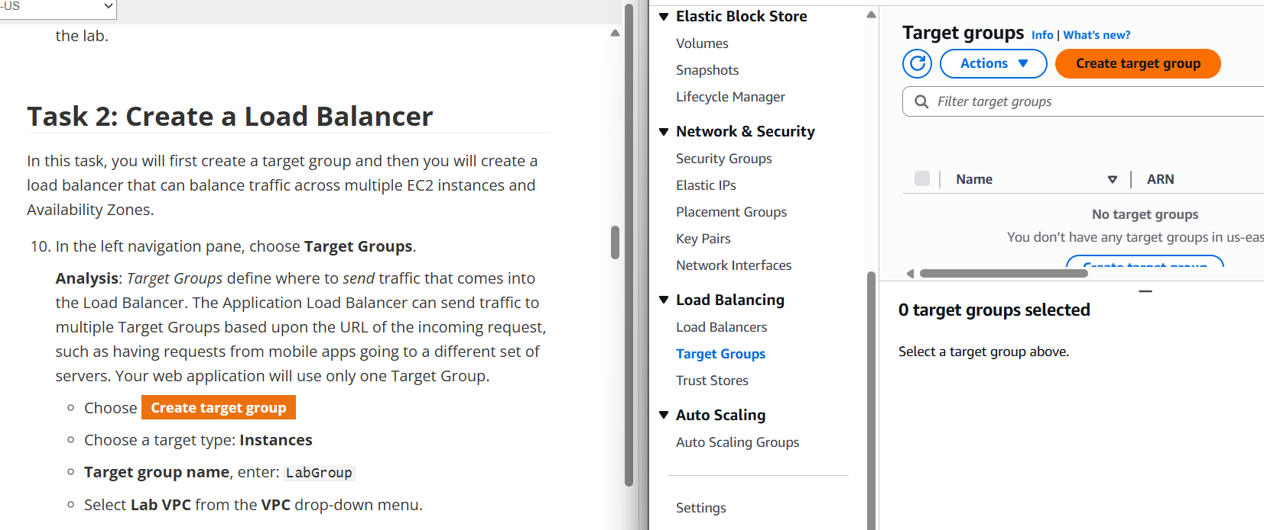

- create target group
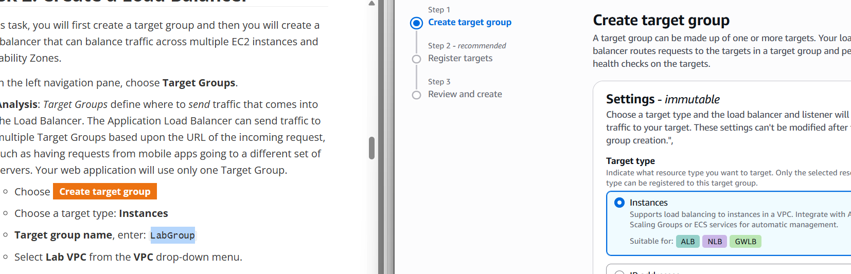
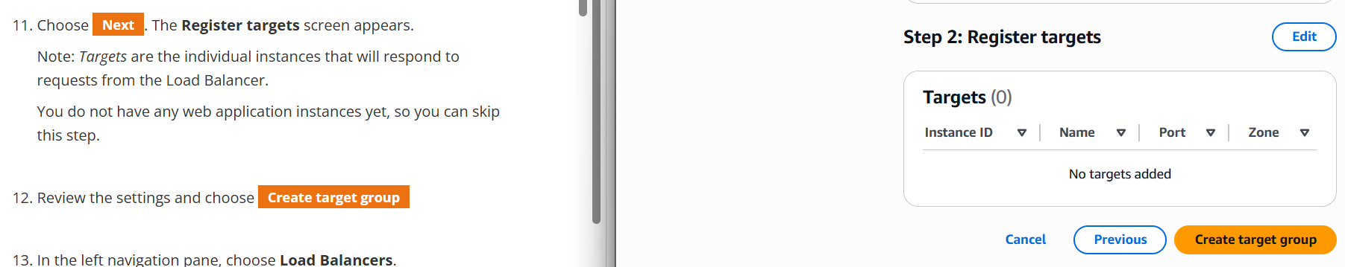
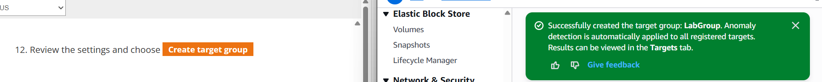

- choose load balancer
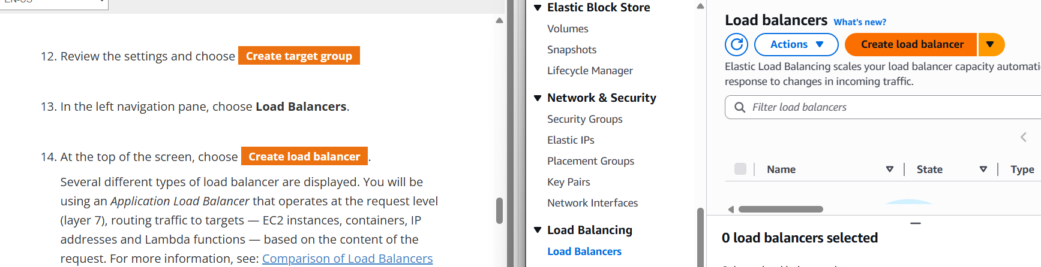

- Create load balancer
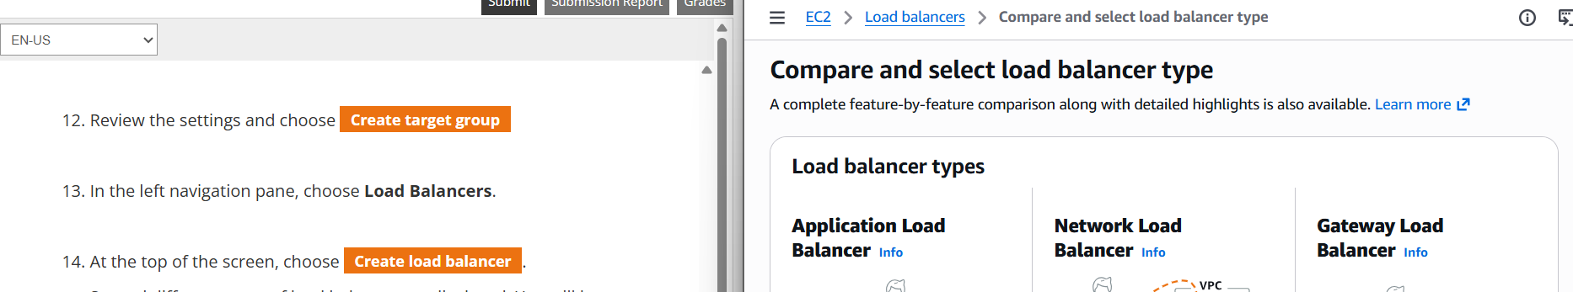

- Choose application load balancer
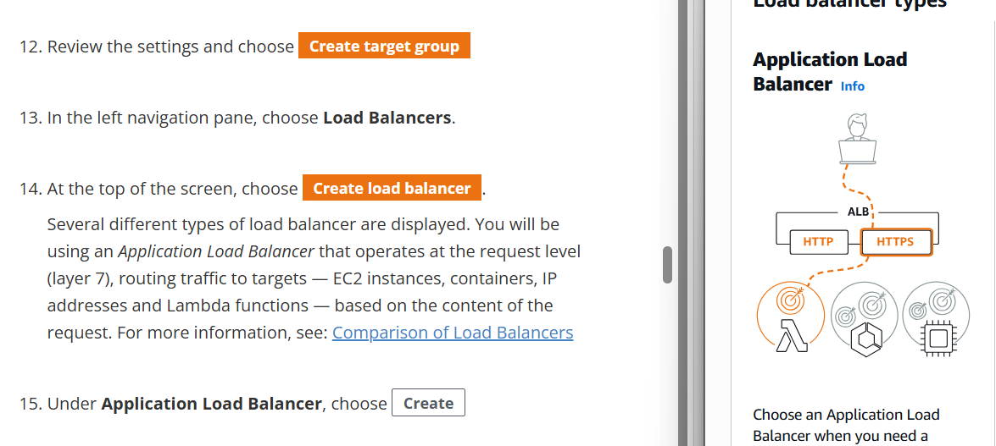
- Enter name
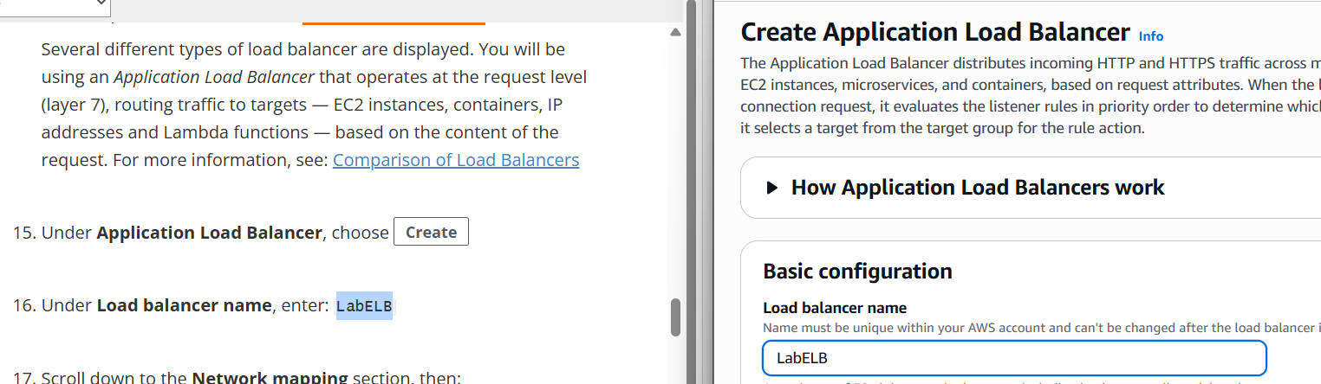

- network mapping
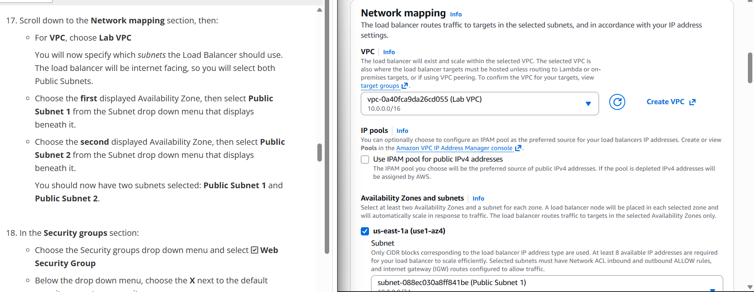
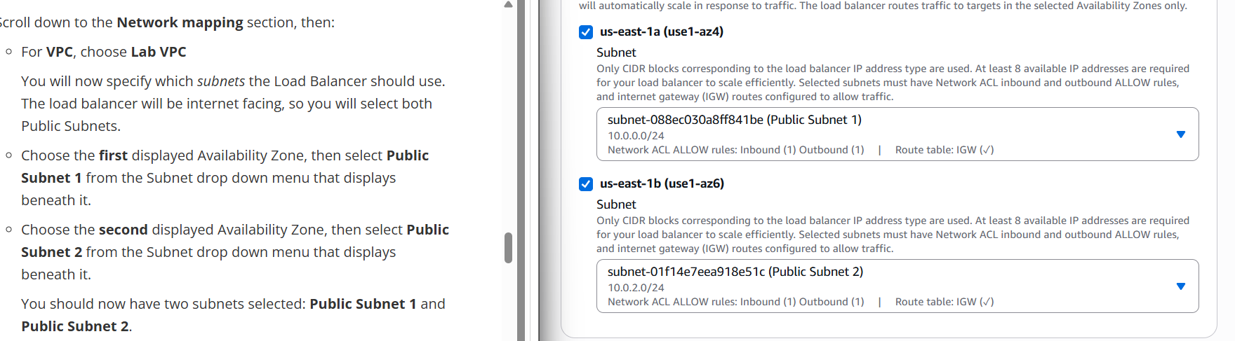

- Security group
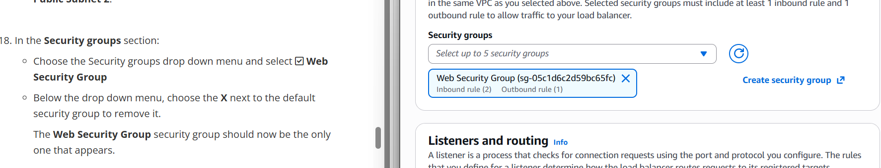

- For the Listener HTTP:80 row, set the Default action to forward to LabGroup
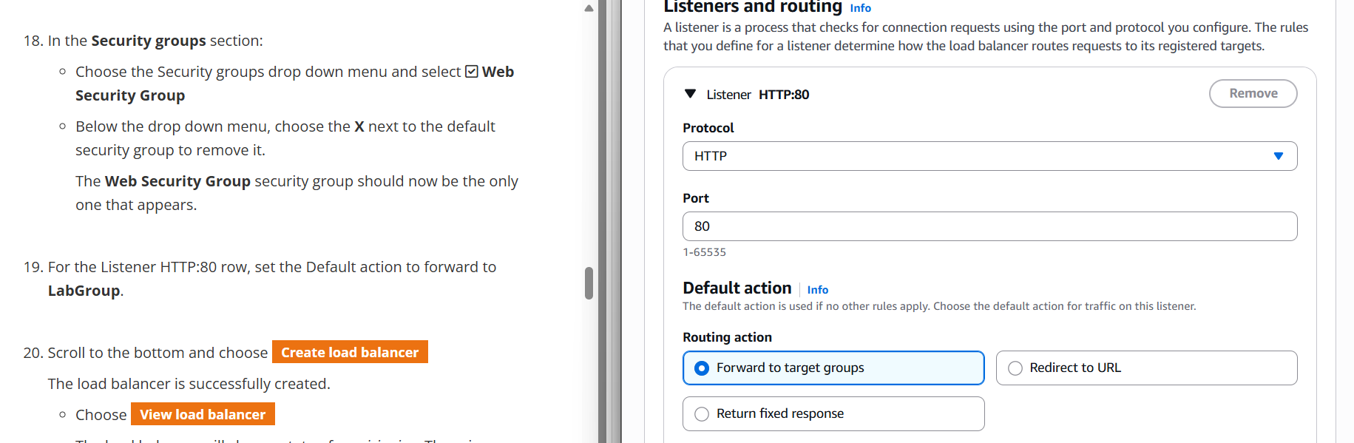

- Create load balancer
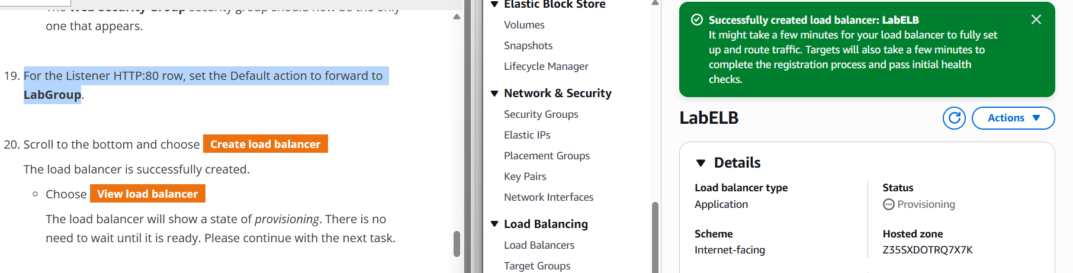

- Create a Launch Template and an Auto Scaling Group
- choose Launch Templates
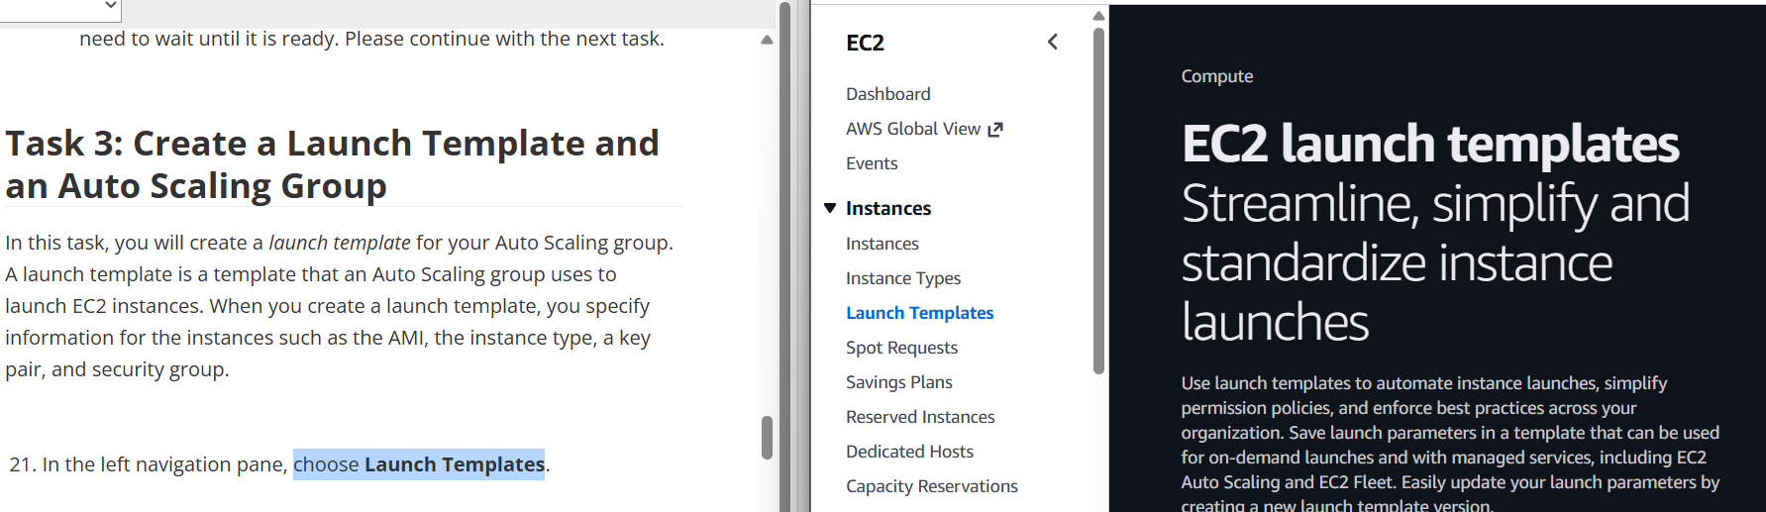

- create launch template
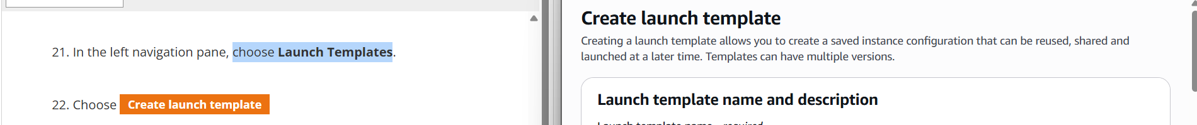

- template name
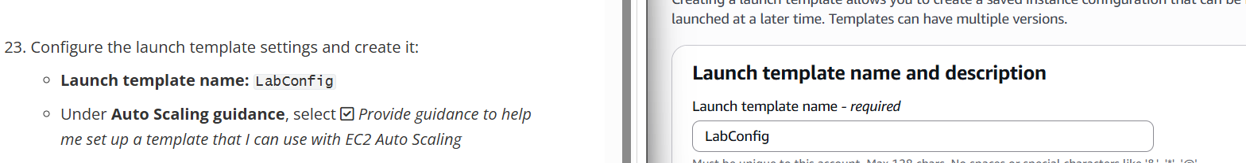
- select Provide guidance
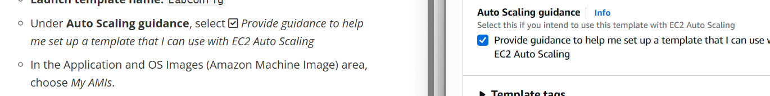
- choose Web Server AMI
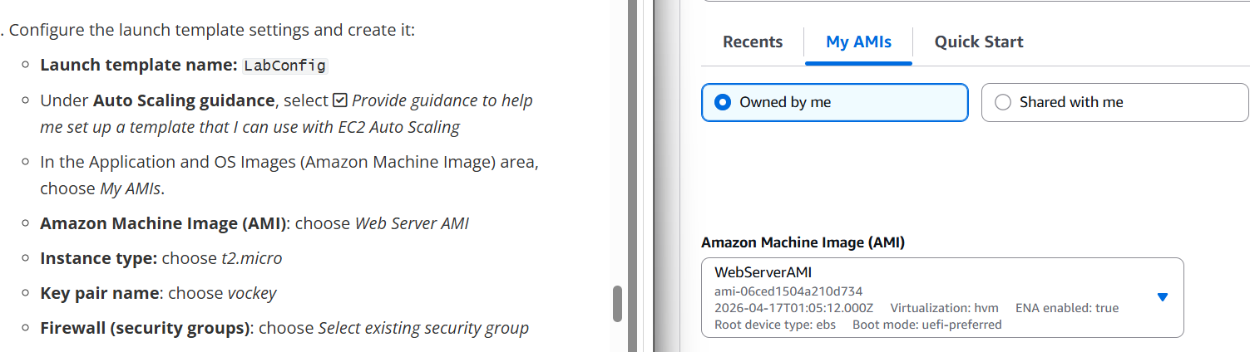
- instance type
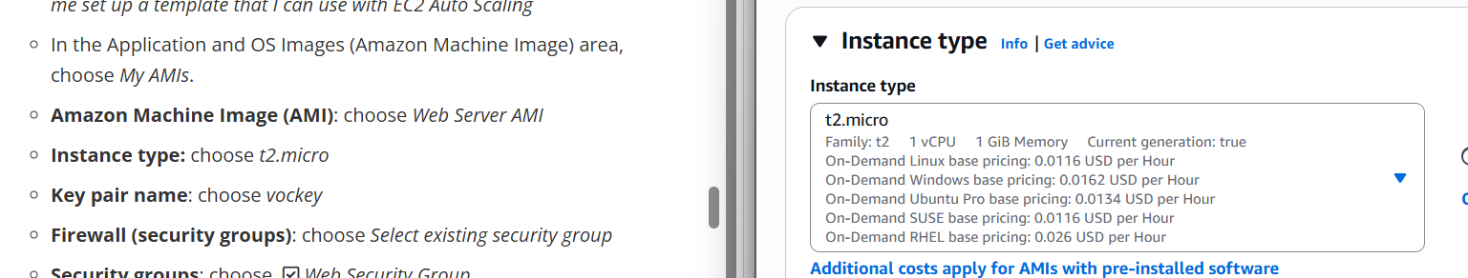
- key pair
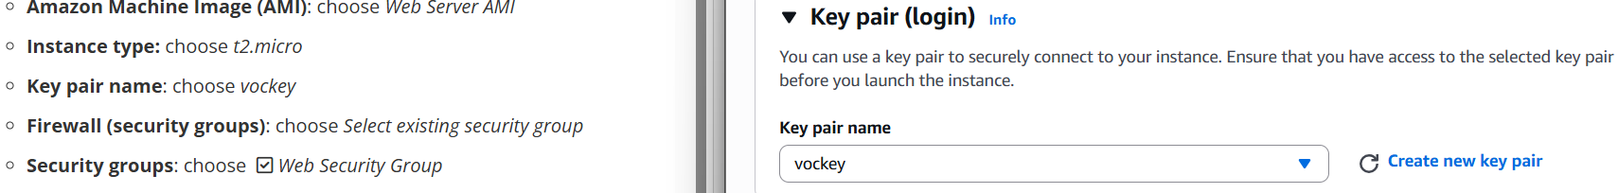
- Firewall (security groups)
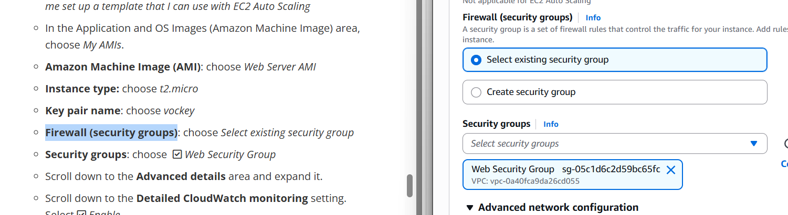
- Advanced details
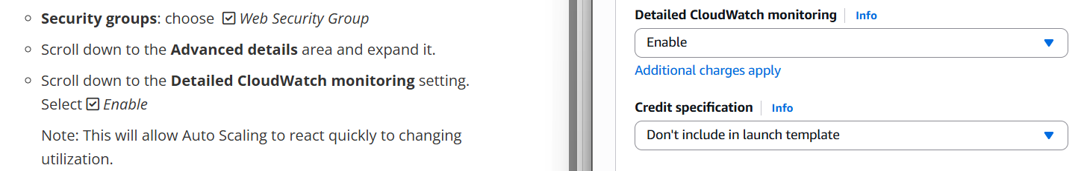

- Create launch template
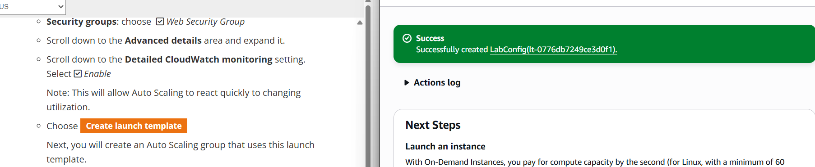

- choose lab config
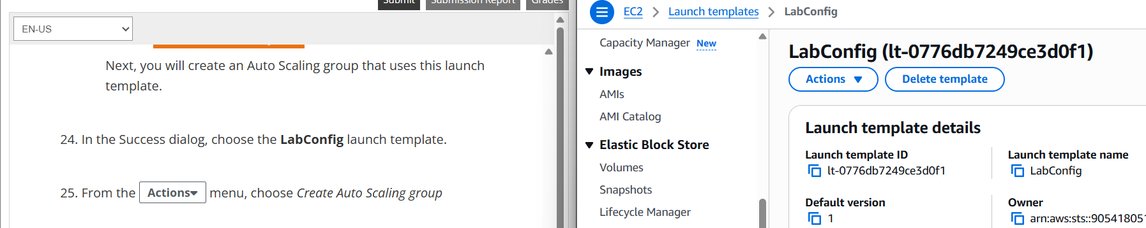

- Choose Create Auto Scaling group
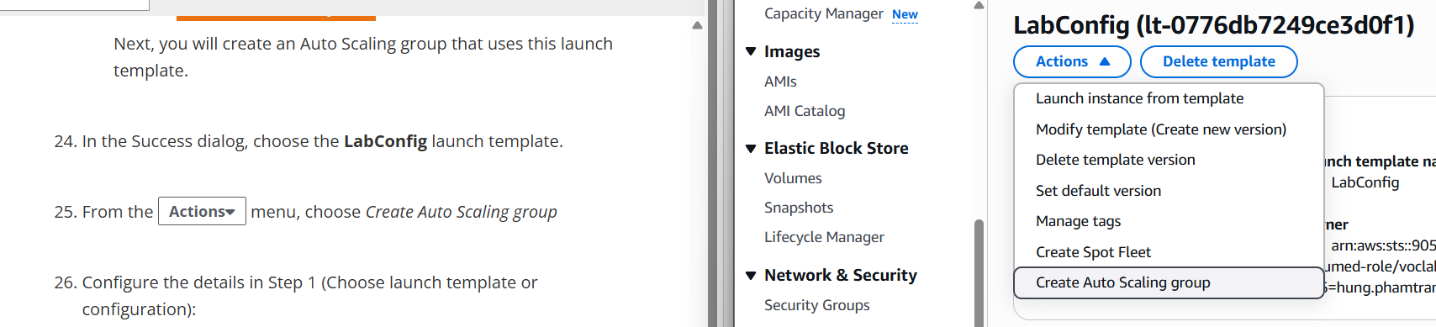

-Step 1 (Choose launch template or configuration
- Auto Scaling group name: Lab Auto Scaling Group
- Launch template: confirm that the LabConfig template you just created is selected.
- Choose Next

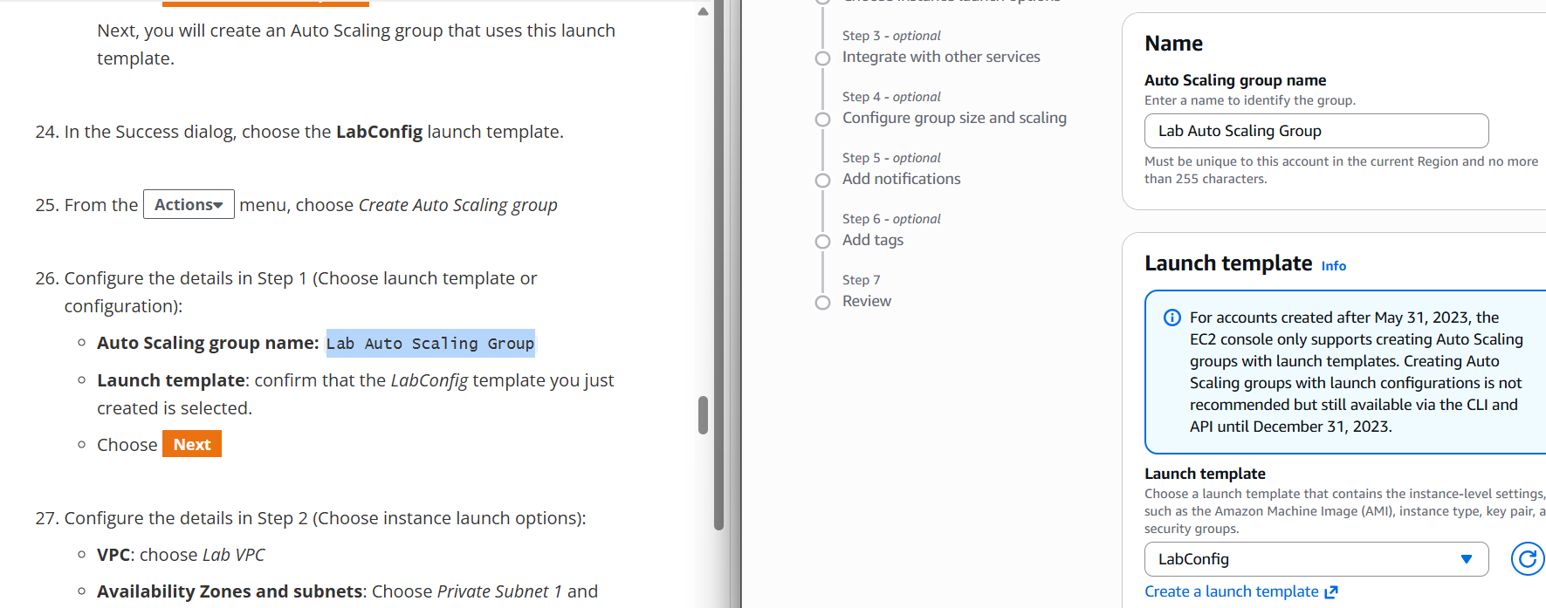

- Step 2 (Choose instance launch options)
- VPC: choose Lab VPC
- Availability Zones and subnets: Choose Private Subnet 1 and then choose Private Subnet 2.
- Choose Next

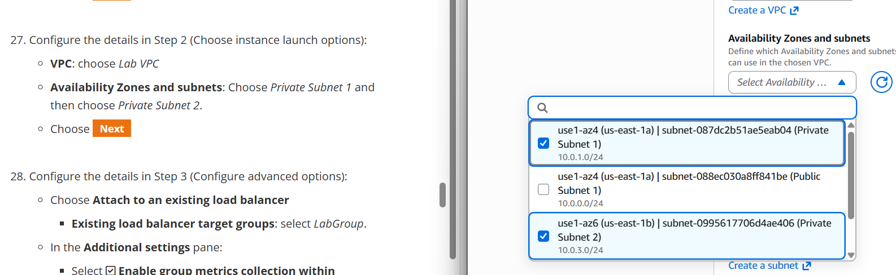
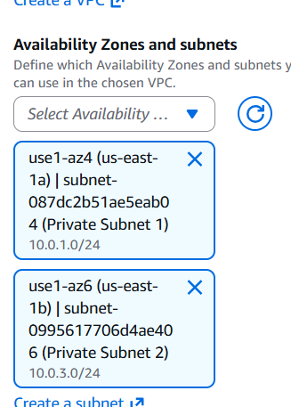

- Step 3 (Configure advanced options)
- Choose Attach to an existing load balancer
    - Existing load balancer target groups: select LabGroup.
- In the Additional settings pane:
    - Select Enable group metrics collection within CloudWatch
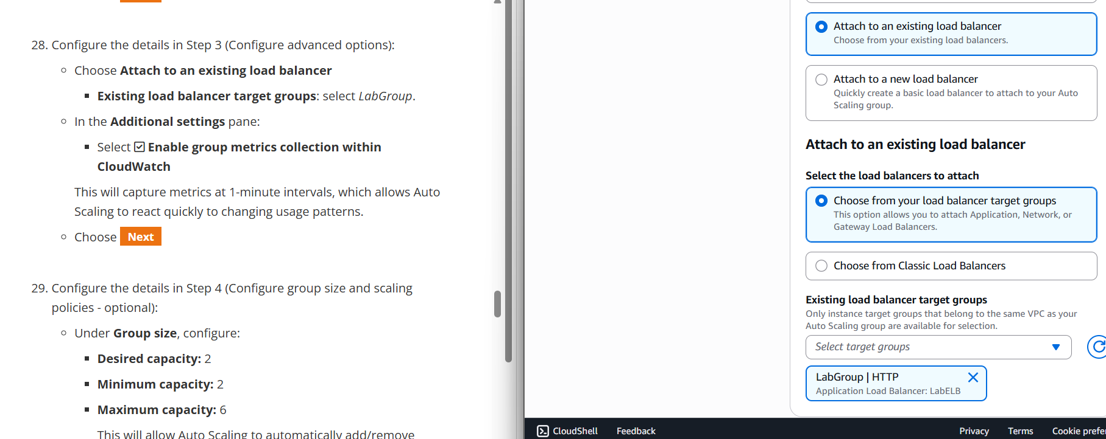

Configure the details in Step 4 (Configure group size and scaling policies - optional):
- Under Group size, configure:
  - Desired capacity: 2
  - Minimum capacity: 2
  - Maximum capacity: 6
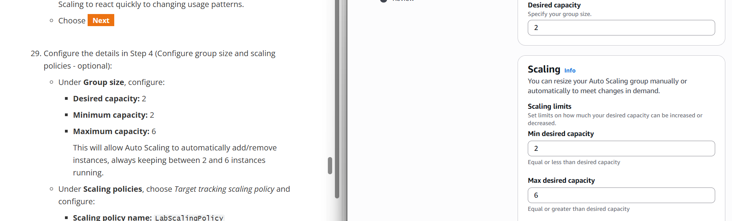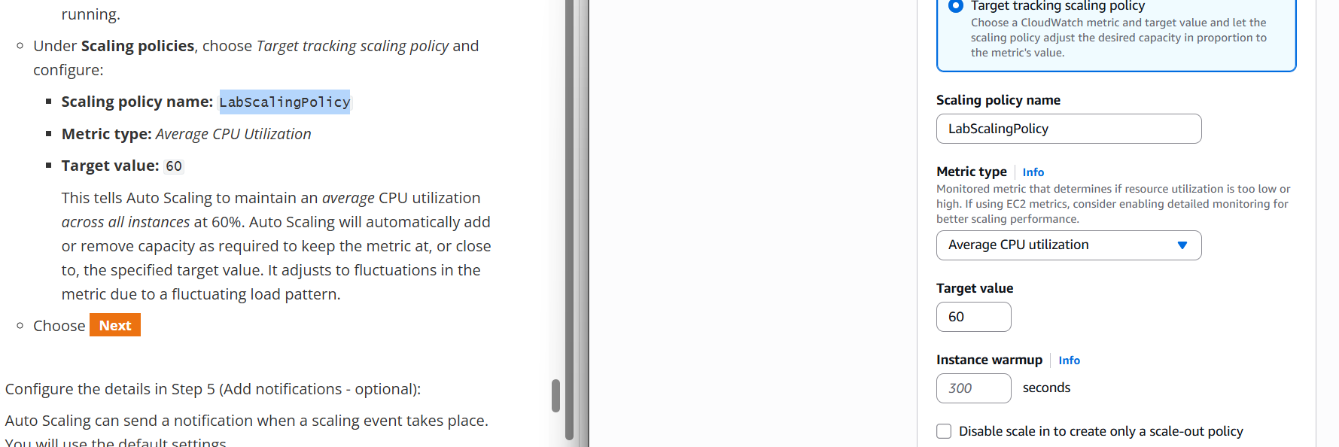

- Under Scaling policies, choose Target tracking scaling policy and configure:
  - Scaling policy name: LabScalingPolicy
  - Metric type: Average CPU Utilization
  - Target value: 60
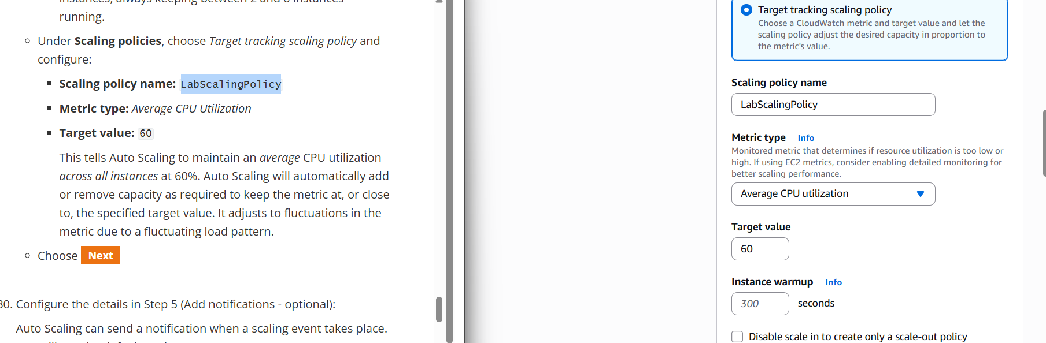

- Configure the details in Step 5 (Add notifications - optional):
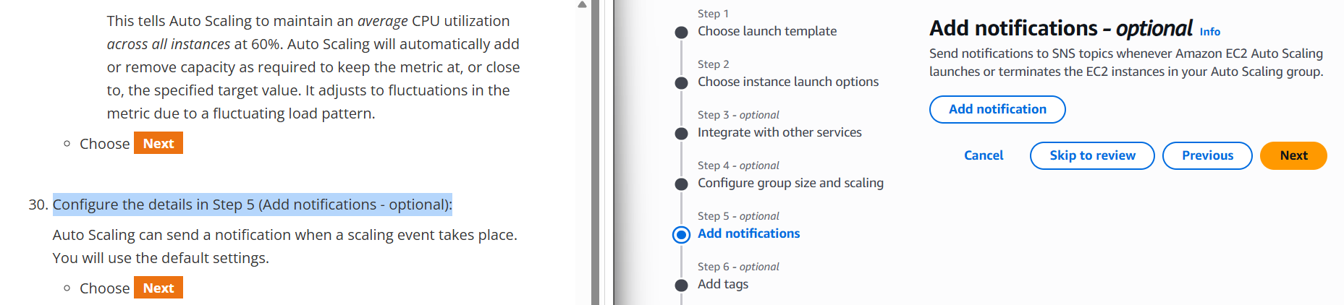

- Configure the details in Step 6 (Add tags - optional):
Tags applied to the Auto Scaling group will be automatically propagated to the instances that are launched.
- Choose Add tag and Configure the following:
  - Key: Name
  - Value: Lab Instance
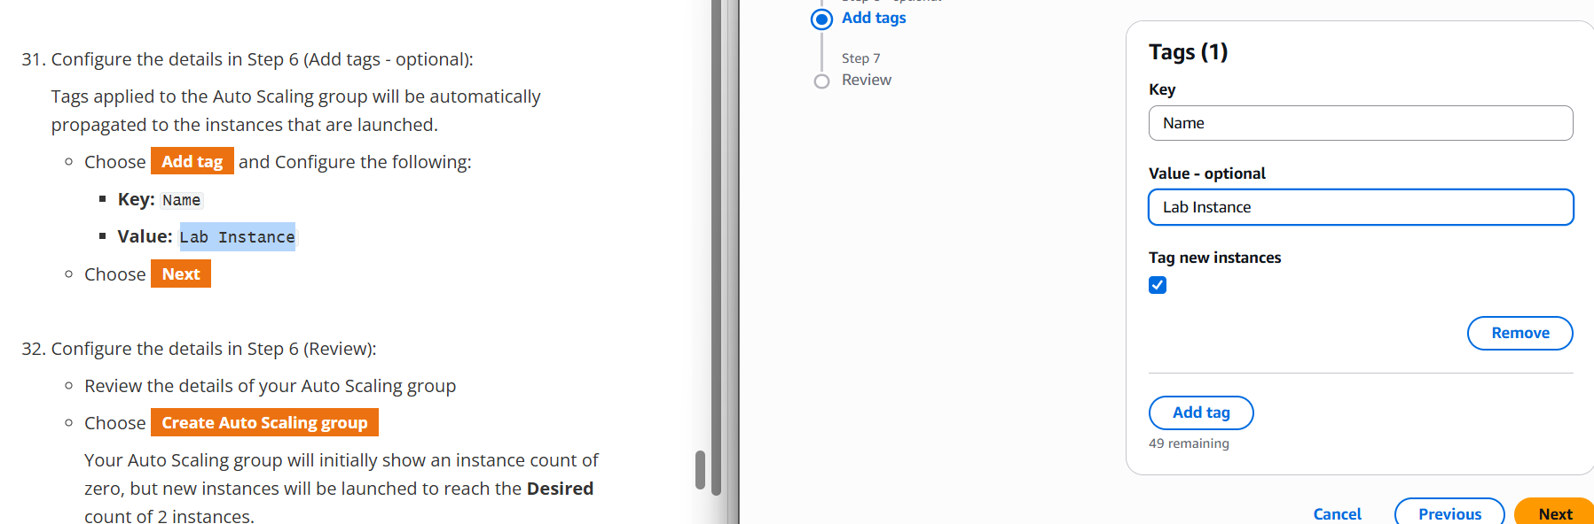

- Configure the details in Step 6 (Review):
  - Review the details of your Auto Scaling group
  - Choose Create Auto Scaling group
Your Auto Scaling group will initially show an instance count of zero, but new instances will be launched to reach the Desired count of 2 instances.
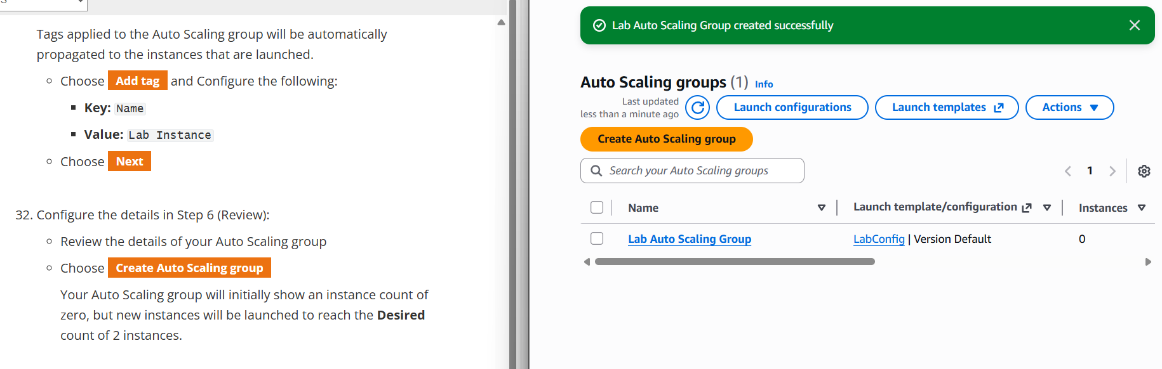

-Verify that Load Balancing is Working
choose Instances
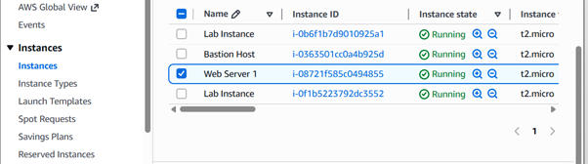

choose Target Groups
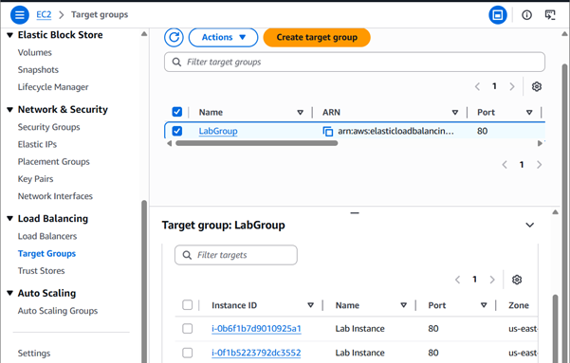

In the left navigation pane, choose Load Balancers
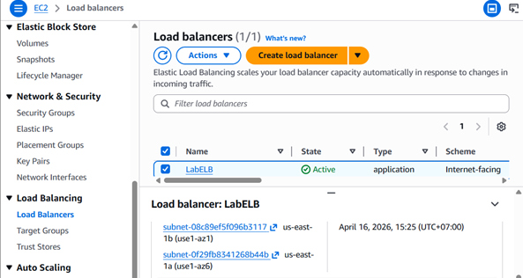

Open a new web browser tab, paste the DNS Name you just copied, and press Enter
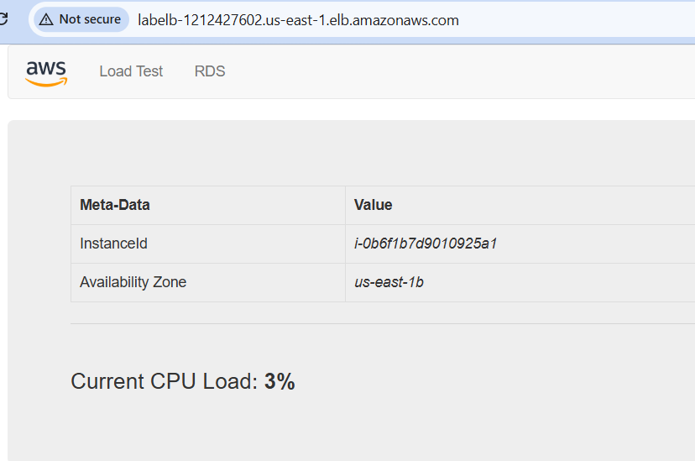

Test Auto Scaling
created an Auto Scaling group with a minimum of two instances and a maximum of six instances. Currently two instances are running because the minimum size is two and the group is currently not under any load. You will now increase the load to cause Auto Scaling to add additional instances
In the left navigation pane, choose All alarms
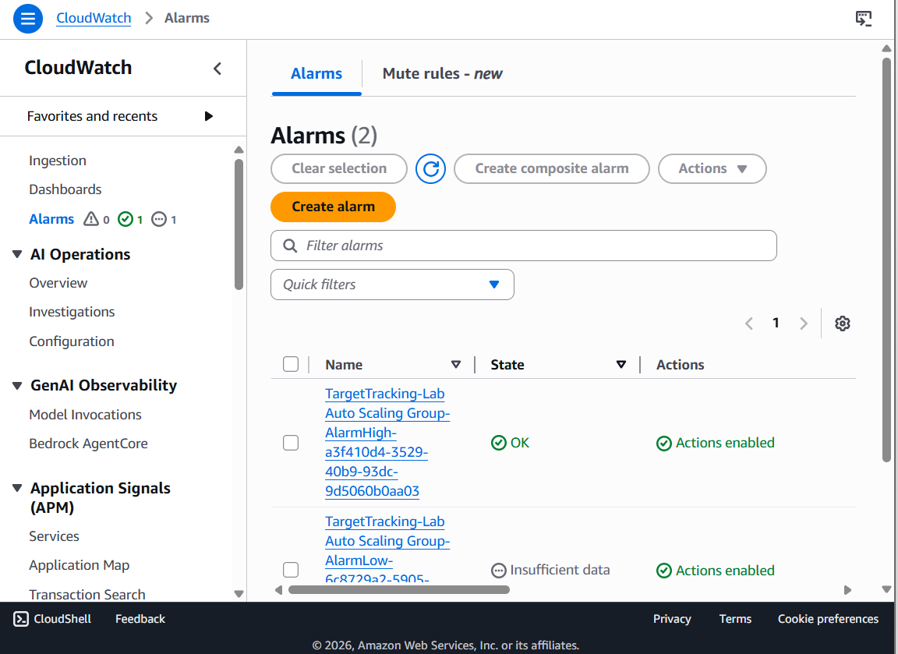

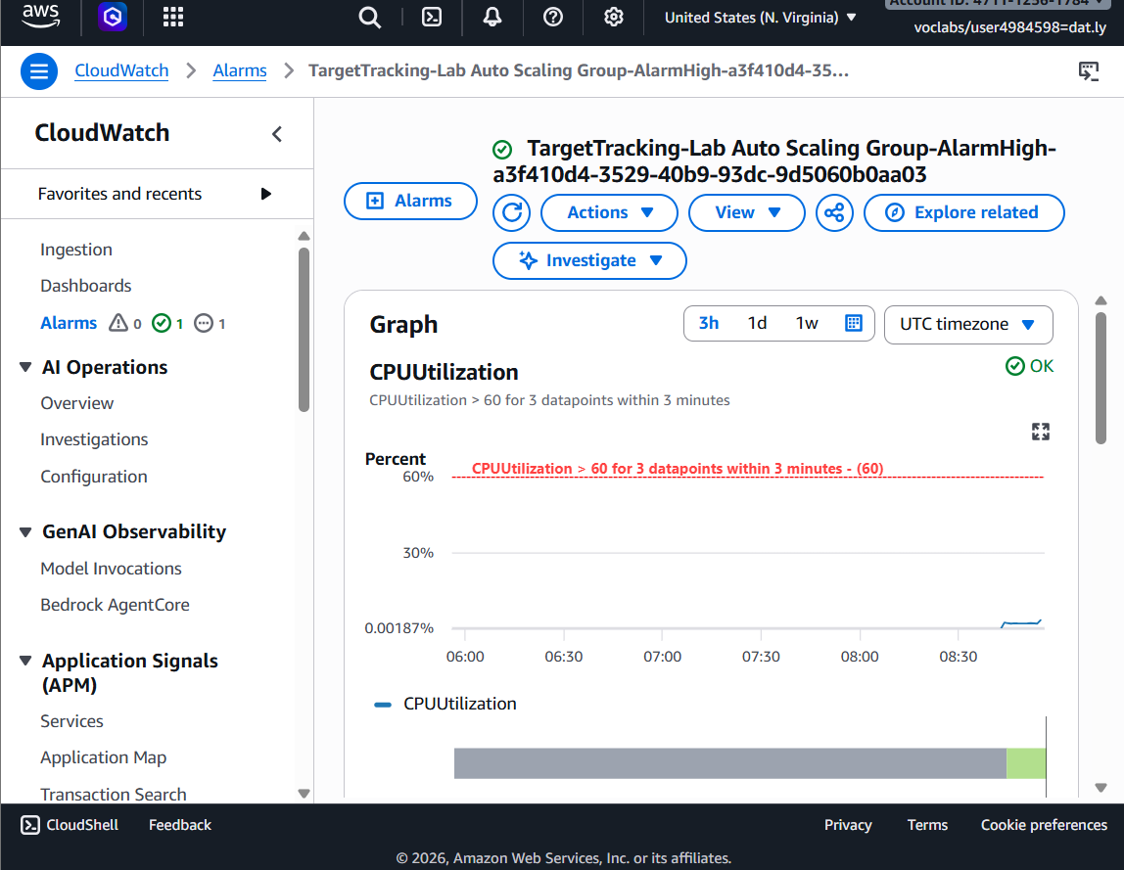

Return to browser tab with the CloudWatch console
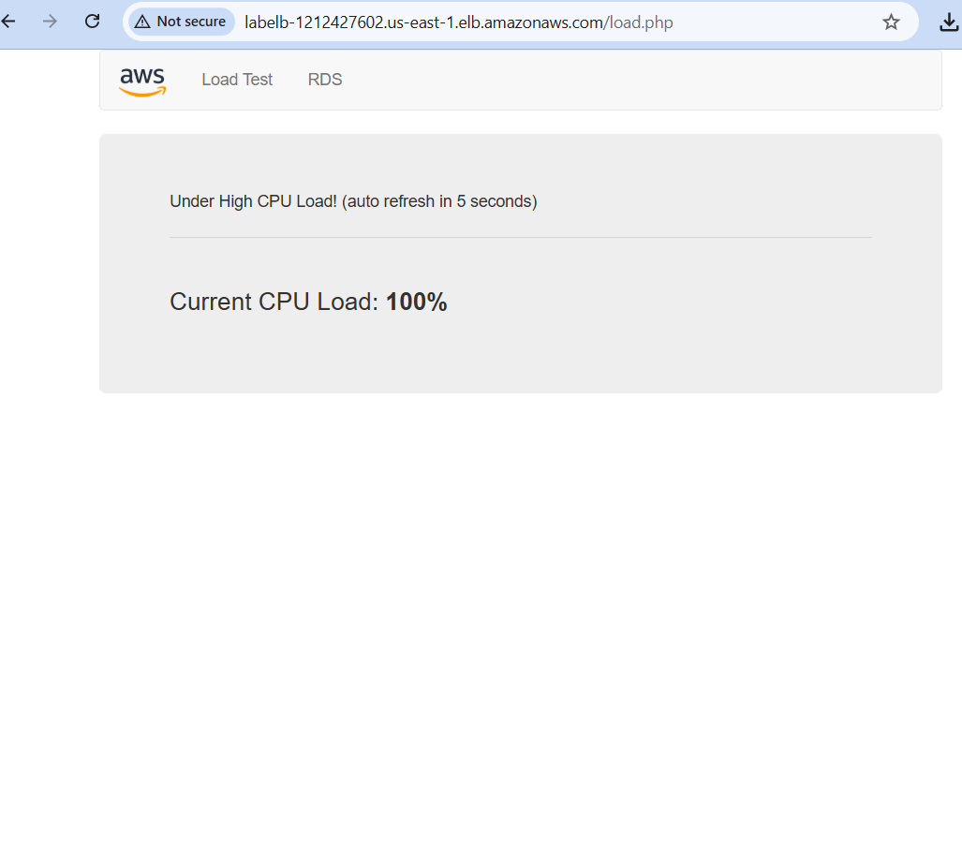

Wait until the AlarmHigh alarm enters the In alarm state
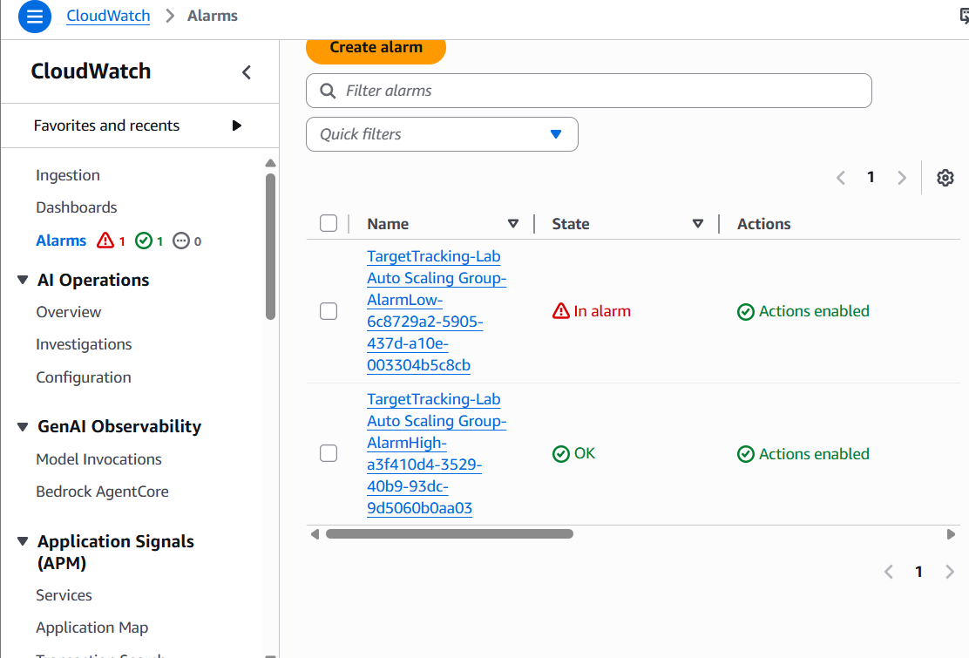
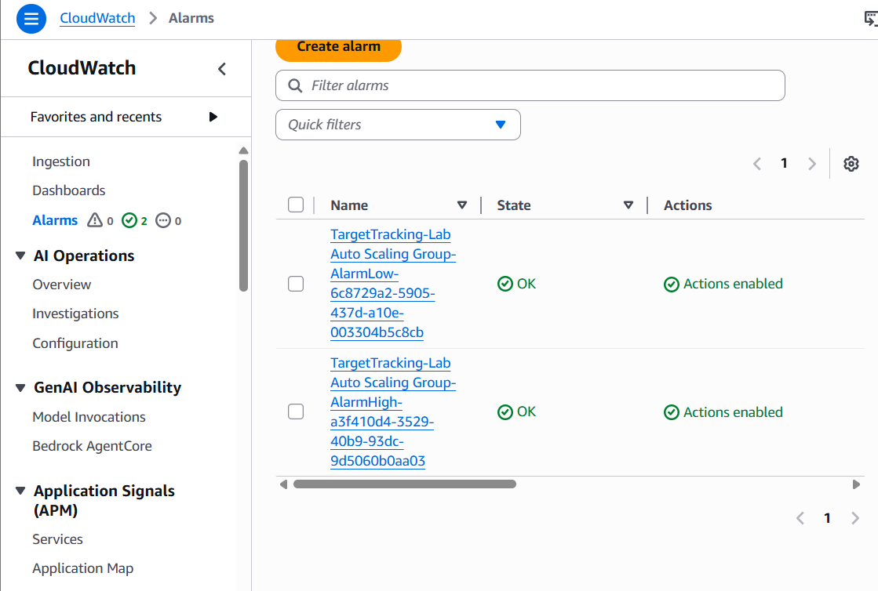

select EC2
choose Instances
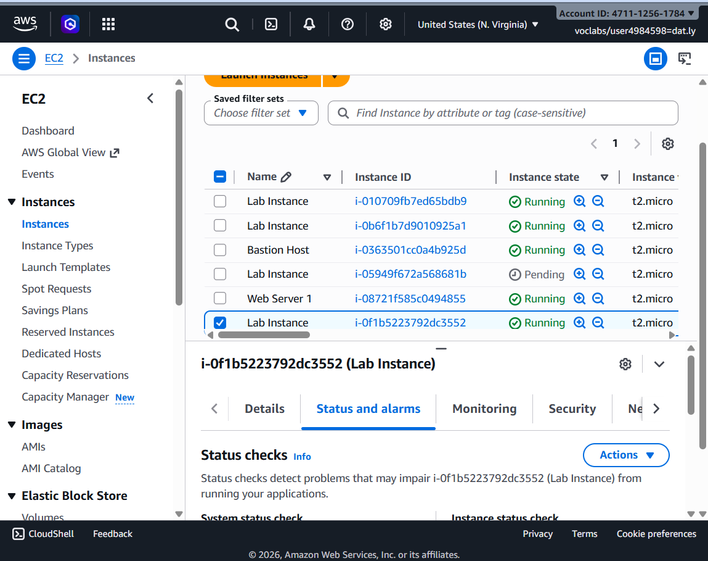
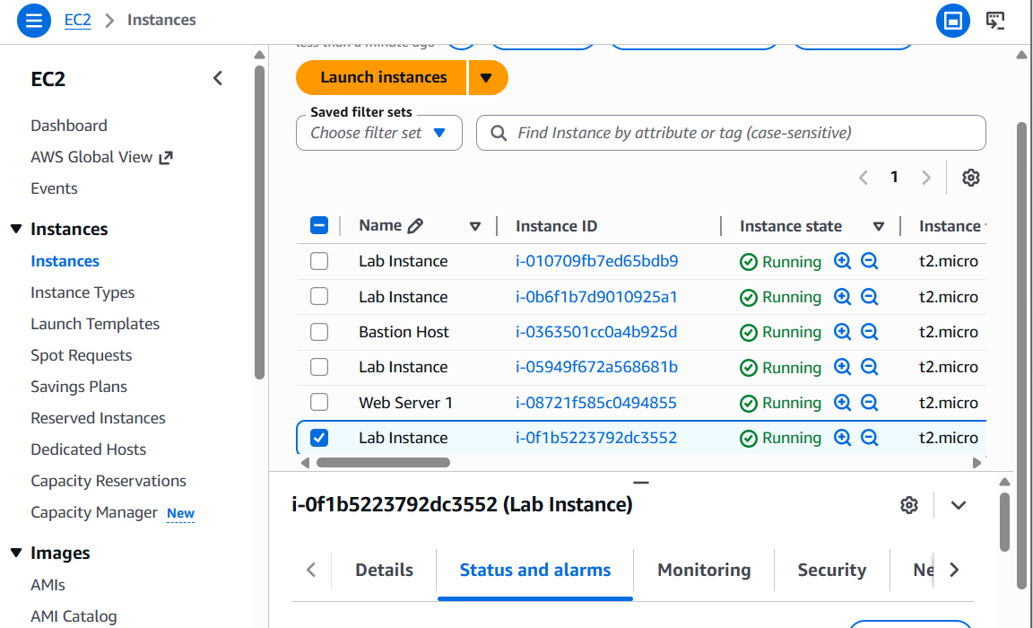

Terminate Web Server 1
choose Instance State > Terminate Instance
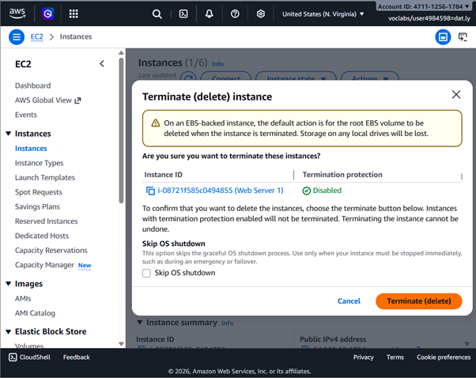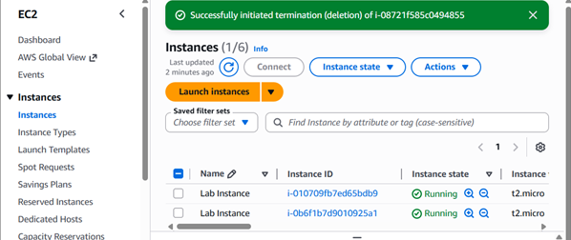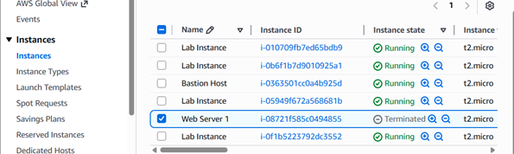

▪ Task 4 – Reflection questions
1. Why was termination protection enabled while launching the EC2 instance?

Answer: Termination protection was enabled to prevent the instance from being accidentally terminated either by a user mistake, an automated process, or an unintended API call. Since the EC2 instance serves as the foundation for the entire lab (hosting the web application, being used to create an AMI, and forming the base of the Auto Scaling setup), accidental termination would mean losing all configuration work done on it. With termination protection on, any termination attempt is blocked unless the protection is explicitly disabled first, adding a critical safety layer during the setup phase

2. Which metrics did you monitor to check the EC2 instance performance?

Answer: Through Amazon CloudWatch and the EC2 Monitoring tab, the key metrics monitored included:
- CPU Utilization: the percentage of allocated compute units in use, indicating whether the instance is under load or idle.
- Network In / Network Out: the volume of incoming and outgoing network traffic, useful for detecting traffic spikes or connectivity issues.
- Disk Read / Disk Write (I/O) : the read and write operations on the instance's storage, helping identify I/O bottlenecks.
- Status Check metrics: both system status checks (AWS infrastructure health) and instance status checks (OS-level health), confirming the instance is reachable and operational.

3. Why did you modify the security group to allow HTTP access?

Answer: By default, a new security group only allows outbound traffic and blocks all inbound traffic. HTTP access (port 80) had to be explicitly allowed so that users and the Load Balancer could reach the web server running on the instance through a browser. Without this inbound rule, all web requests would be silently dropped by the firewall, and the application would be unreachable even if the web server was running perfectly inside the instance. Security groups act as virtual firewalls, so every required port must be opened intentionally

4. What is the purpose of using a Load Balancer in this lab?

Answer: The Load Balancer serves several purposes:

- Traffic distribution evenly spreads incoming HTTP requests across all healthy EC2 instances in the Auto Scaling group, preventing any single instance from being overwhelmed.
- High availability routes traffic only to healthy instances (health checks), so if one instance fails, users are transparently redirected to a working one.
- Single entry point provides one stable DNS endpoint for the application, even as instances behind it are added or removed dynamically by Auto Scaling.
- Decoupling: users never interact with individual instances directly, making the architecture more scalable and fault-tolerant.

5. What happens in the Auto Scaling group when application traffic increases?

Answer: When traffic increases and a defined scaling metric threshold is crossed, the Auto Scaling group triggers a scale out action:
- It launches new EC2 instances using the configured Launch Template. The new instances are automatically registered with the Load Balancer.
- Traffic is redistributed across all healthy instances, reducing the load on each one.
Once traffic subsides and metrics drop below the threshold, the group performs a scale-in terminating excess instances down to the minimum count optimizing cost. At all times, the group ensures the number of running instances stays within the defined minimum and maximum boundaries

6. Why did you create an Amazon Machine Image (AMI) before creating the launch template?

Answer: The AMI was created first because it serves as the blueprint that the Launch Template references. An AMI is a snapshot of the EC2 instance at a specific point in time capturing the operating system, installed software in a ready to run state.
When Auto Scaling needs to launch a new instance during a scale out event, it uses the Launch Template, which points to that AMI. This guarantees that every new instance launched is identical to the original pre configured, pre installed, and immediately ready to serve traffic without any manual setup. Without the AMI, the Launch Template would have no consistent image to base new instances on, making automated and repeatable scaling impossible

1. Task Completion (70 points total)
Each AWS task is evaluated based on correctness, completeness, and evidence (e.g., screenshots output).
- Task 1 – Launch EC2 via Console
- Task 2 – Monitor and Manage activity such as status checks, troubleshoot, system log, CPU Utilization, Network In, Network Out, trigger the alarm, manage security group, resize the instance, stop and terminate the instance.
- Task 3 – Load Balancer & Auto Scaling Group. Such as Create an AMI for Auto Scaling, create a load balancer, create a launch template and an auto scaling group, verify that load balancing is working, test auto scaling, Terminate Web Server 1.
- Task 4 – Reflection Questions. Complete and thoughtful answers for all questions
  - Why was termination protection enabled while launching the EC2 instance?
  - Which metrics did you monitor to check the EC2 instance performance?
  - Why did you modify the security group to allow HTTP access?
  - What is the purpose of using a Load Balancer in this lab?
  - What happens in the Auto Scaling group when application traffic increases?
  - Why did you create an Amazon Machine Image (AMI) before creating the launch template?

Rohit Kumar Kasera
Lecturer

