Assignment 3: Working with Amazon Storage Services

Phạm Trần Gia Hưng - 2331200153

Task 1 – Working with EBS and shared storage with EFS (Access Module 7: Storage Lab - 4 Working with EBS from AWS academy)
- Create a New EBS Volume
-In the AWS Management Console, on the Services menu, click EC2
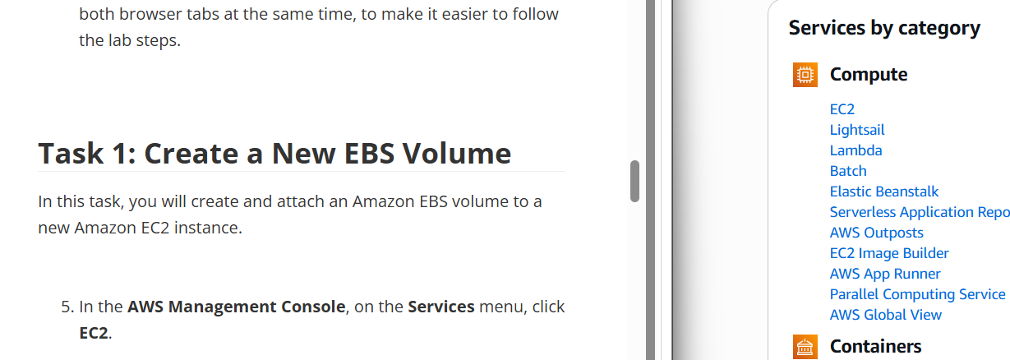
- choose Instances
v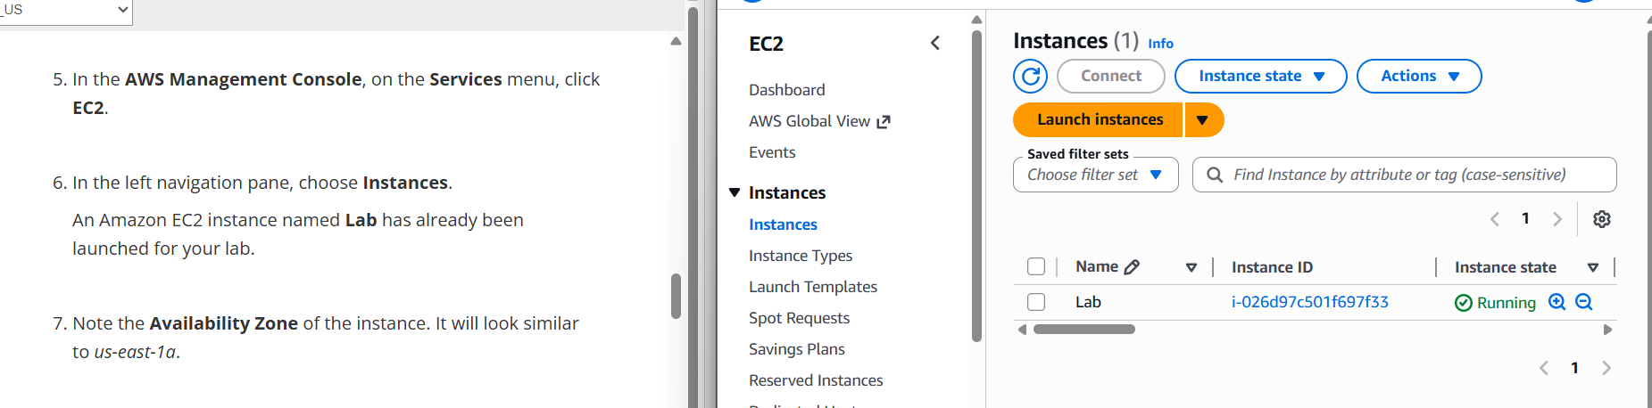
- choose Volumes
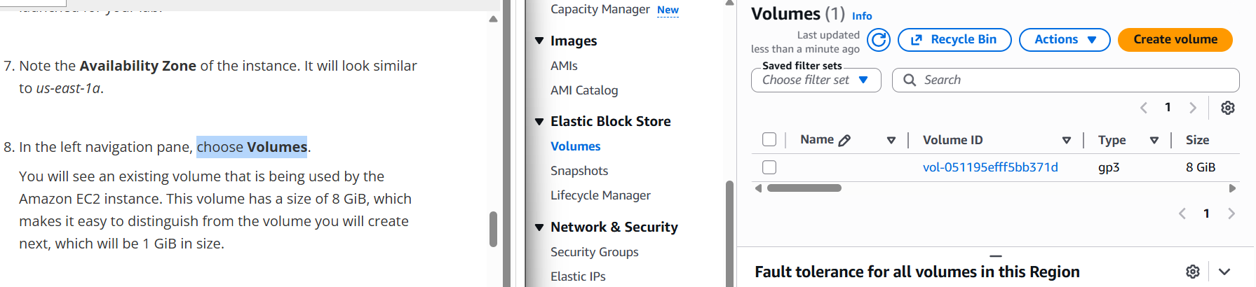
- Choose Create volume then configure
- Volume Type: General Purpose SSD (gp2)
- Size (GiB): 1. NOTE: You may be restricted from creating large volumes.
- Availability Zone: Select the same availability zone as your EC2 instance.
- Choose Add Tag
- In the Tag Editor, enter:
  - Key: Name
  - Value: My Volume

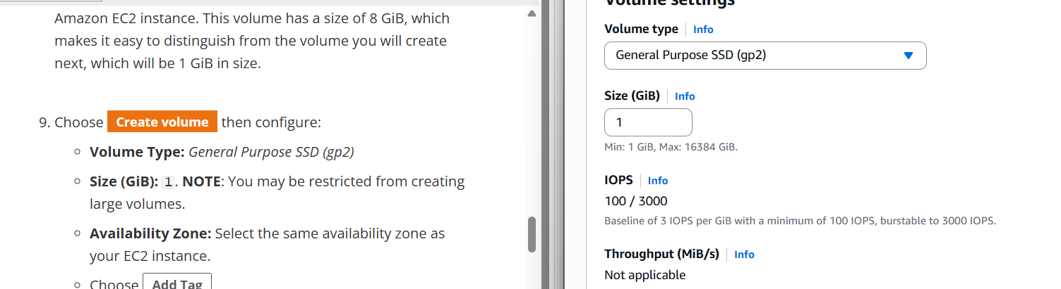
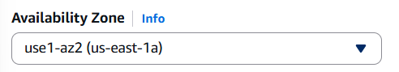
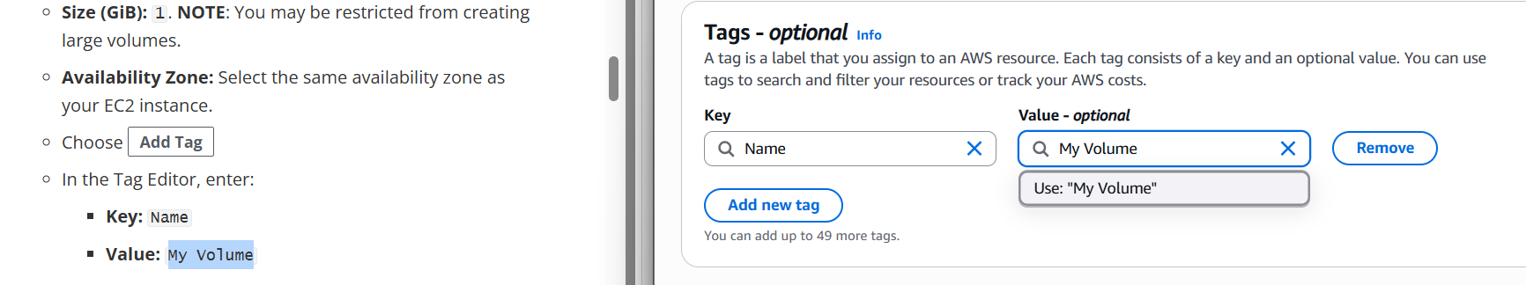

Choose Create Volume
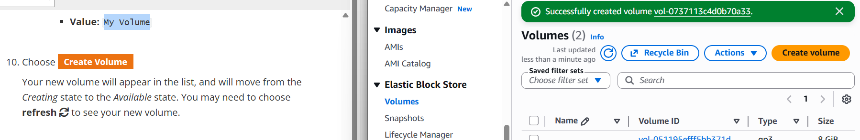

Attach the Volume to an Instance
- Select My Volume
- In the Actions menu, choose Attach volume
Choose the Instance field, then select the instance that appears (Lab)
For the Device Name, choose /dev/sdb/ from the dropdown.
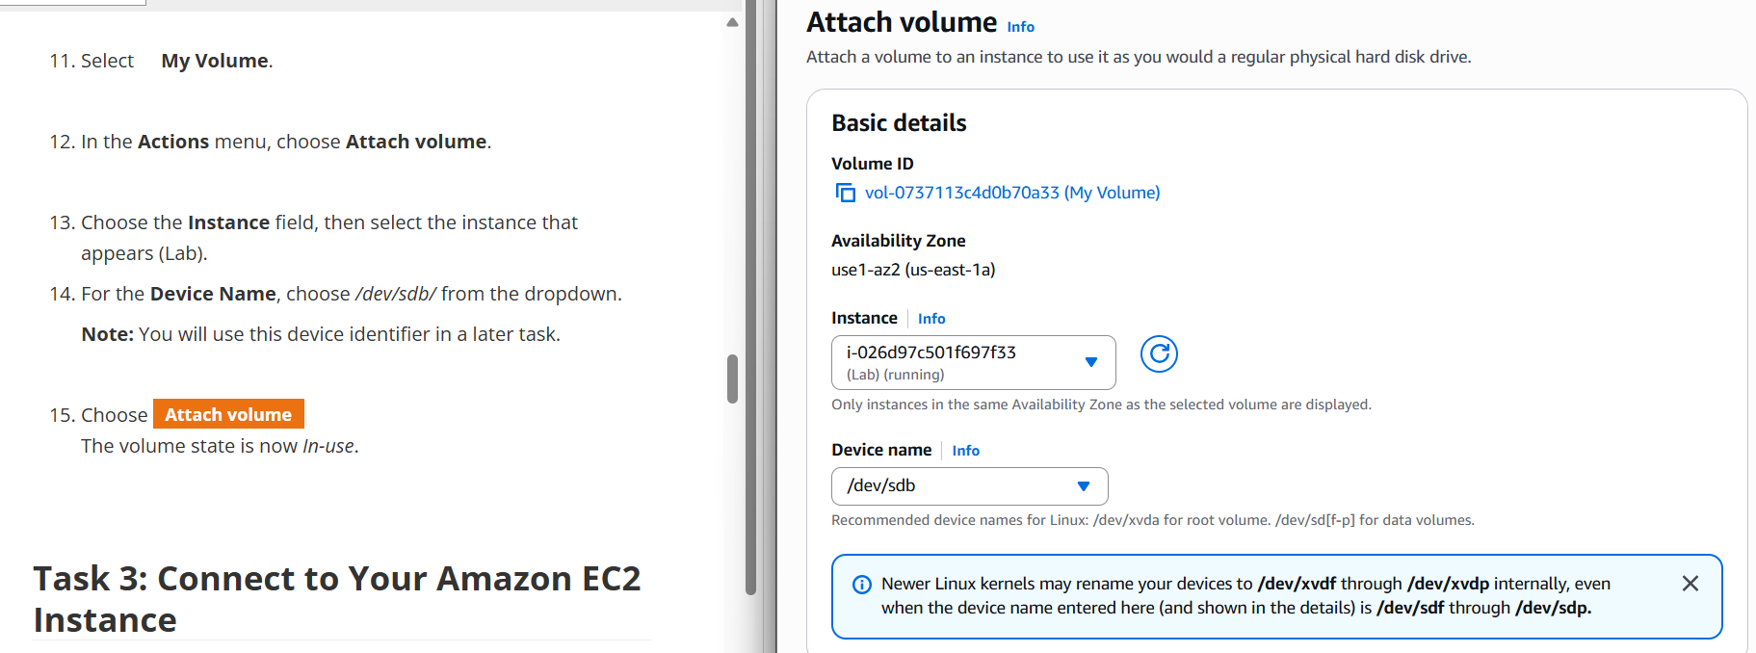

- Choose Attach volume
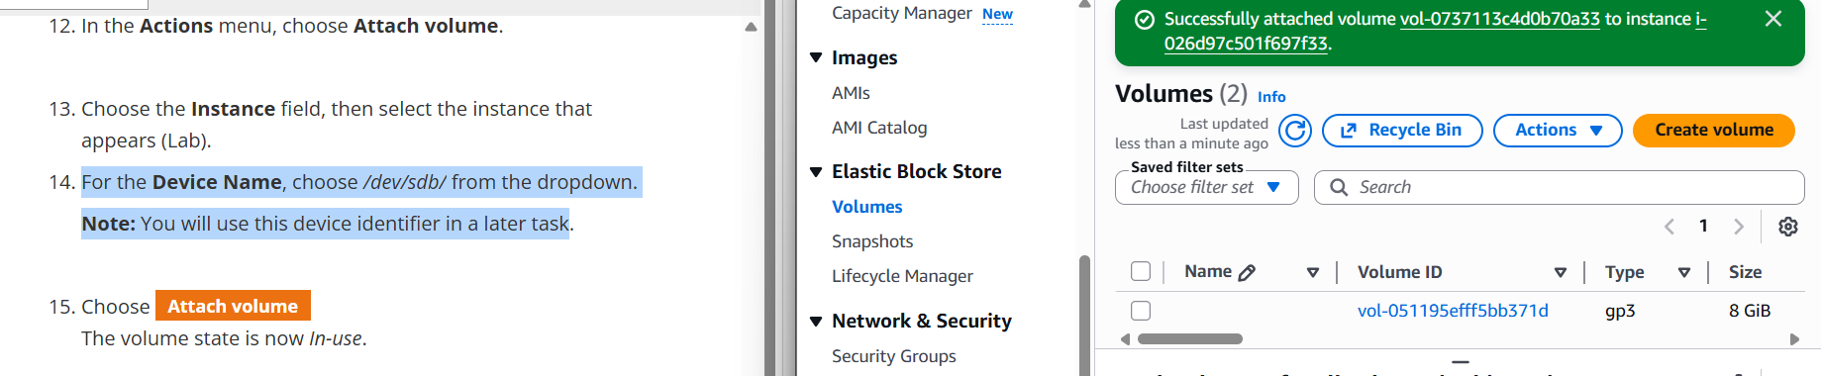

Connect to Your Amazon EC2 Instance
- In the AWS Management Console, in the EC2 service, choose Instances
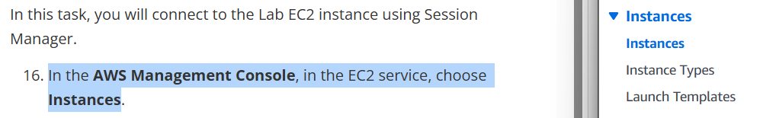
- Select the Lab instance
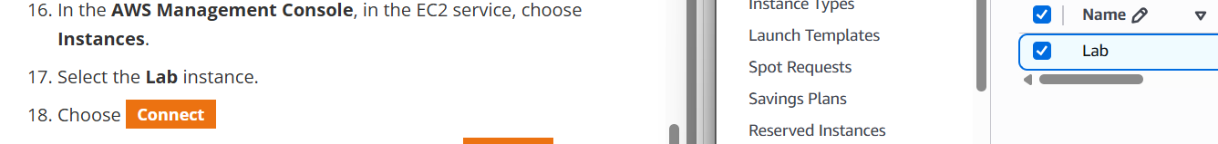
- Choose Connect
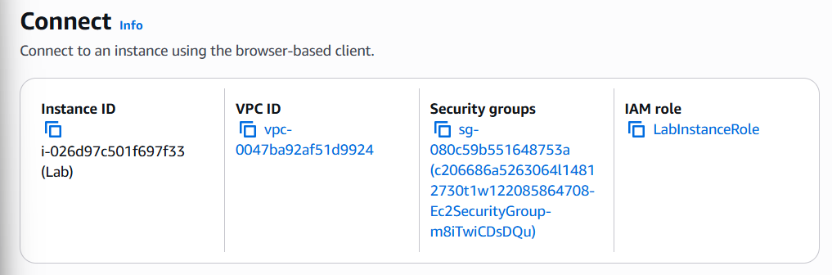
-Choose the Session Manager tab, then choose Connect
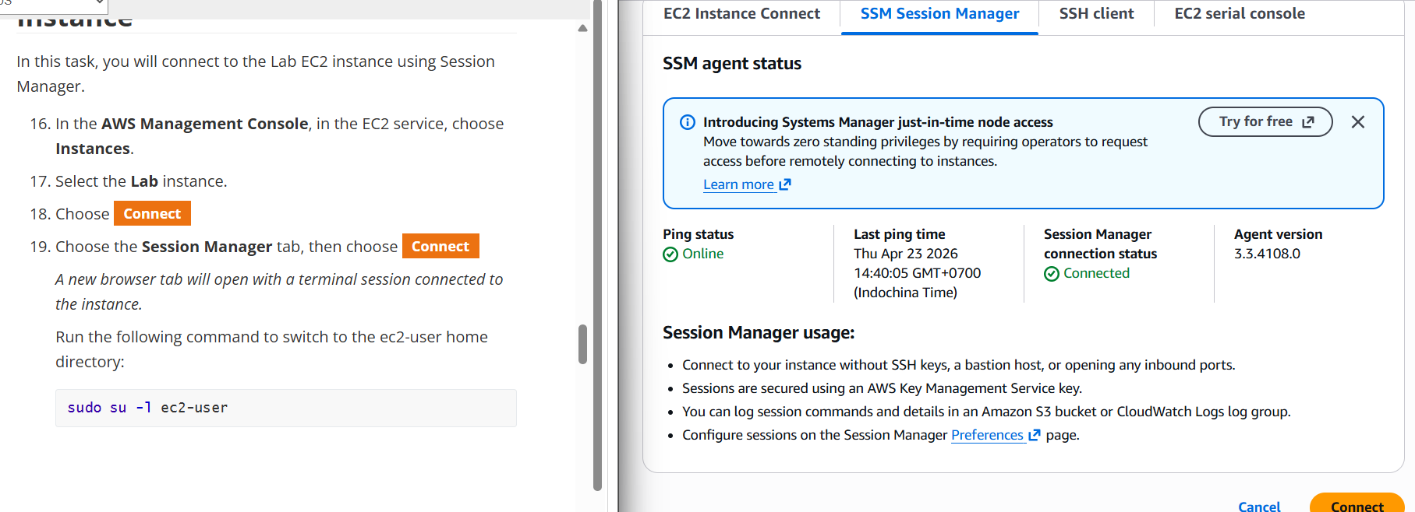
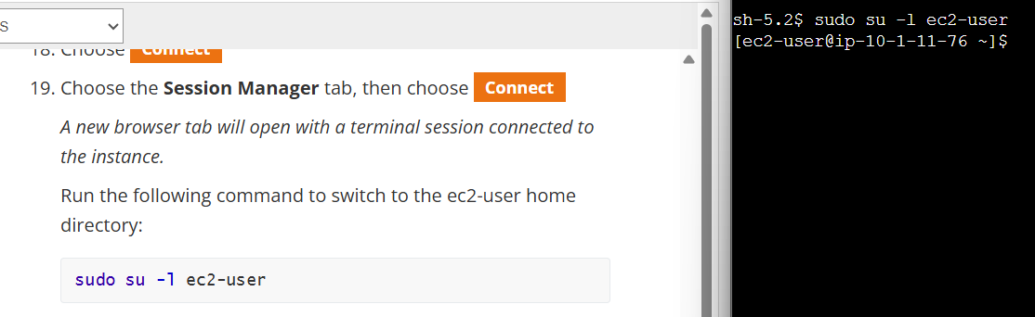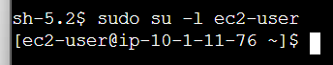

Create and Configure Your File System
- View the storage available on your instance
df -h

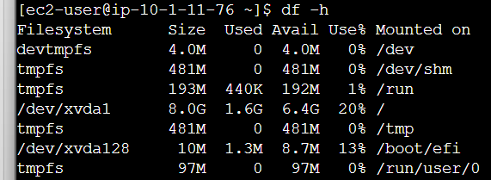
- Create an ext3 file system on the new volume
sudo mkfs -t ext3 /dev/sdb
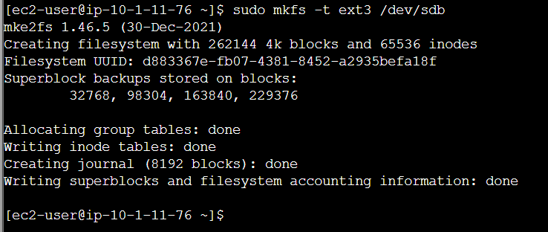
- Create a directory for mounting the new storage volume
sudo mkdir /mnt/data-store
- Mount the new volume
sudo mount /dev/sdb /mnt/data-store
To configure the Linux instance to mount this volume whenever the instance is started, you will need to add a line to /etc/fstab
echo "/dev/sdb /mnt/data-store ext3 defaults,noatime 1 2" | sudo tee -a /etc/fstab

- View the configuration file to see the setting on the last line
cat /etc/fstab
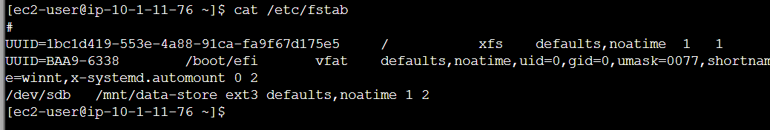

- View the available storage again:
df -h
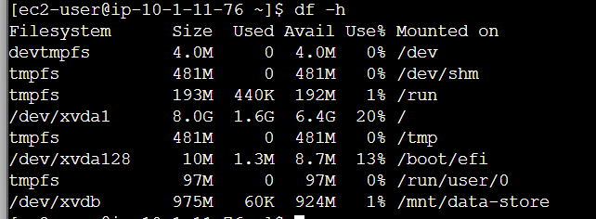

- On your mounted volume, create a file and add some text to it
sudo sh -c "echo some text has been written > /mnt/data-store/file.txt"
- Verify that the text has been written to your volume
cat /mnt/data-store/file.txt
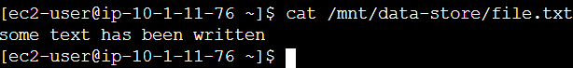

Create an Amazon EBS Snapshot
- In the AWS Management Console, choose Volumes and select My Volume.
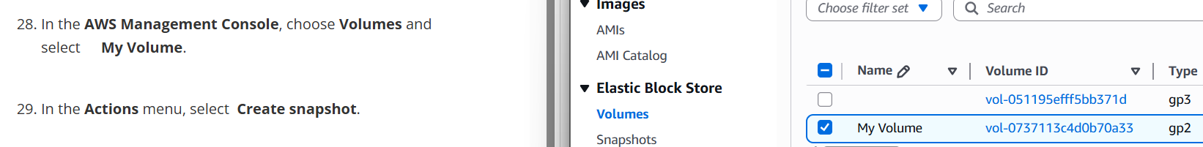
- In the Actions menu, select Create snapshot
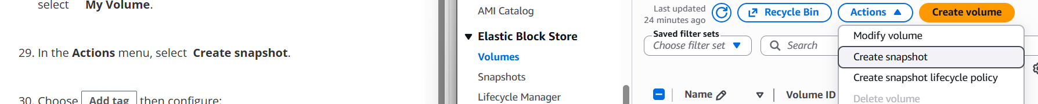

- Choose Add tag then configure:
  - Key: Name
  - Value: My Snapshot
  - Choose Create snapshot
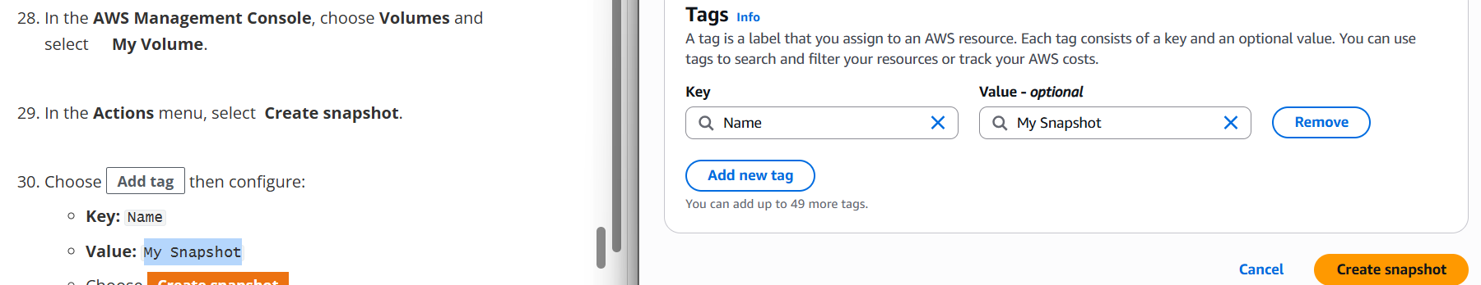
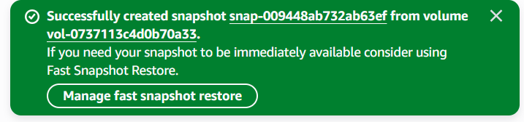

In the left navigation pane, choose Snapshots
- In your terminal session, delete the file that you created on your volume
sudo rm /mnt/data-store/file.txt

- Verify that the file has been deleted
ls /mnt/data-store/
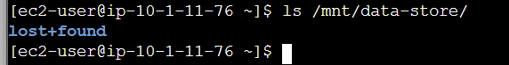

Restore the Amazon EBS Snapshot
Create a Volume Using Your Snapshot
In the AWS Management Console, select My Snapshot
- In the Actions menu, select Create volume from snapshot
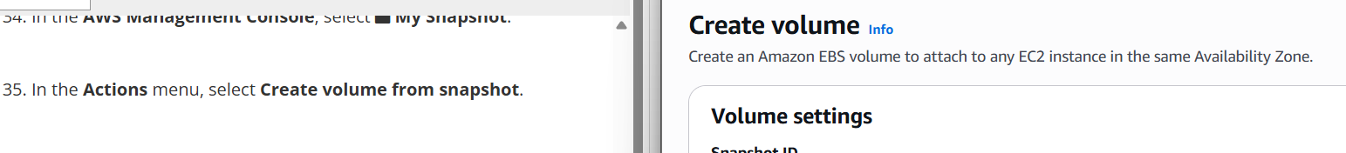
- For Availability Zone Select the same availability zone that you used earlier
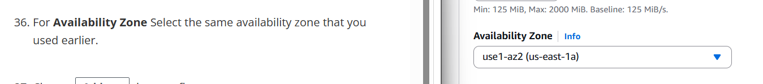
- Choose Add tag then configure:
- Key: Name
- Value: Restored Volume
- Choose Create volume
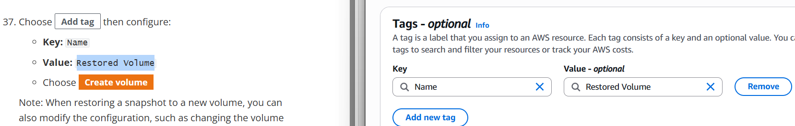

Attach the Restored Volume to Your EC2 Instance
- In the left navigation pane, choose Volumes
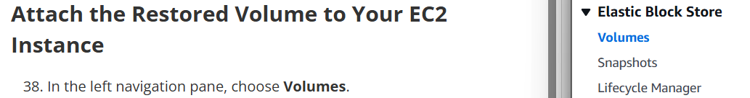
- Select Restored Volume
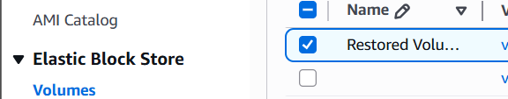
- In the Actions menu, select Attach volume
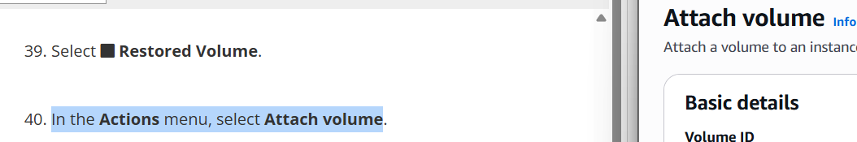
- Choose the Instance field, then select the (Lab) instance that appears
For the Device Name, choose /dev/sdc/ (or any next available identifier) from the dropdown
Choose Attach volume
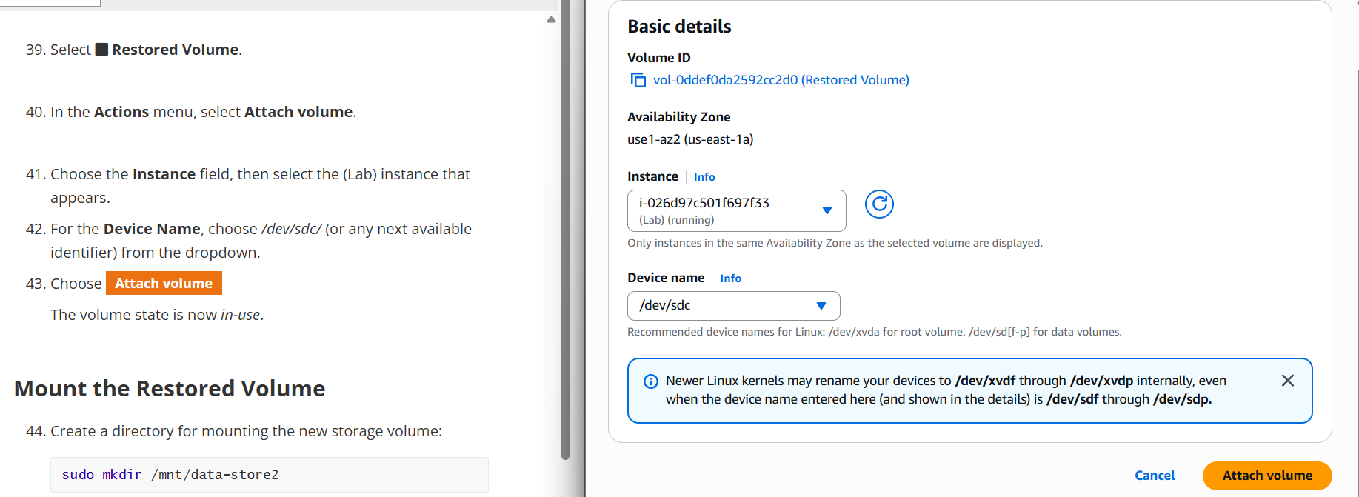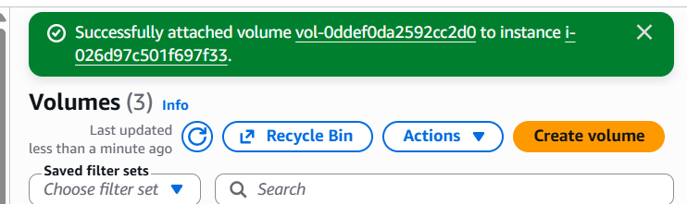

Mount the Restored Volume
- Create a directory for mounting the new storage volume
sudo mkdir /mnt/data-store2
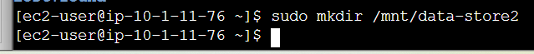
- Mount the new volume
sudo mount /dev/sdc /mnt/data-store2
- Verify that volume you mounted has the file that you created earlier
ls /mnt/data-store2/
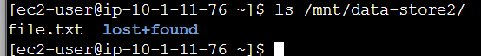

Task 2 – Create S3 bucket and publish static webpage. (Access Sandbox: Sandbox Environment from AWS academy) and follow only the below instruction to access S3 bucket from EC2 instances. Do not follow instruction of Sandbox Environment. Just use Sandbox Environment Lab for S3 bucket.
1. Create an S3 Bucket
        - Sign in to the AWS Management Console.
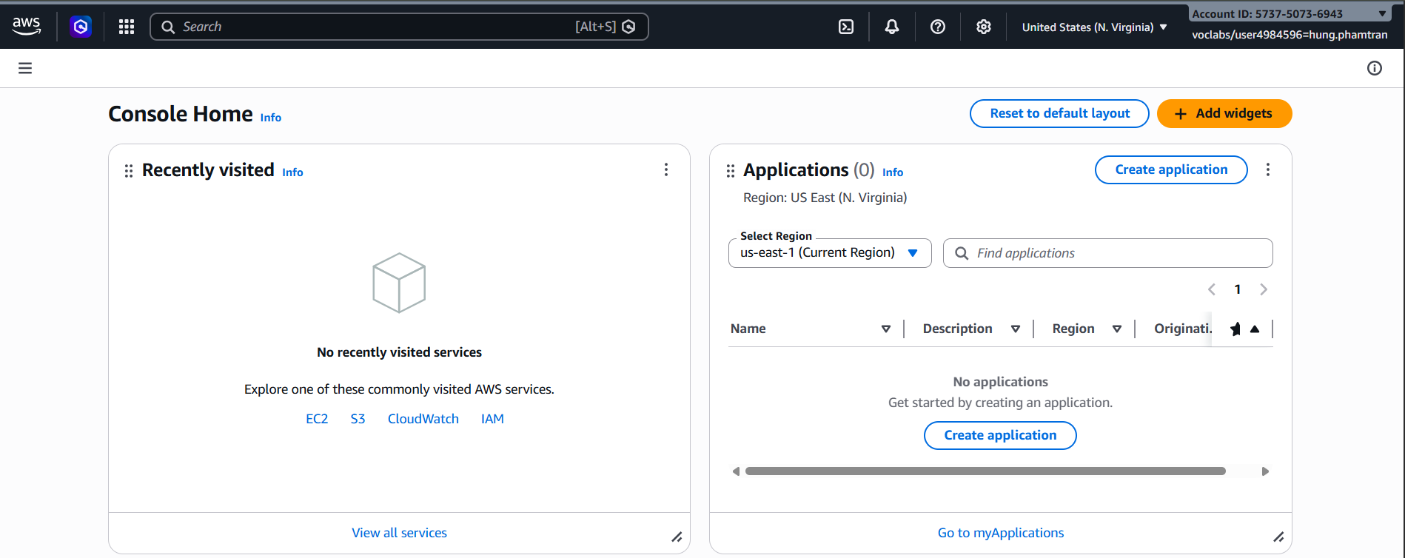
        - Navigate to Amazon S3.
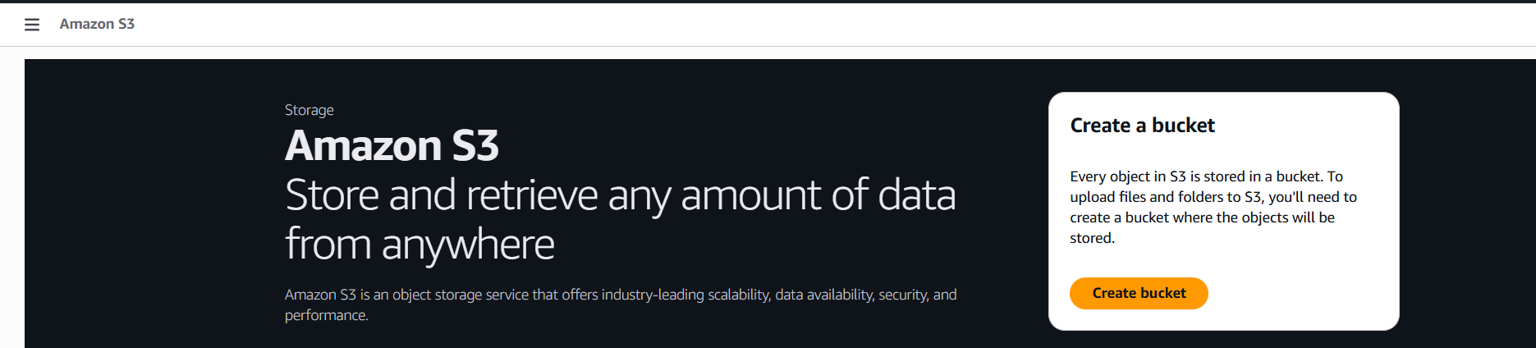
        - Click Create bucket.
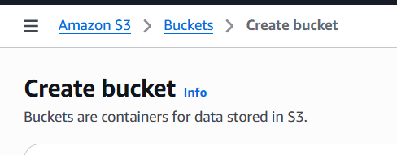
        - Enter a unique bucket name (e.g., my-static-website-bucket).
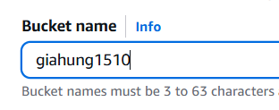
        - Choose a region close to you.
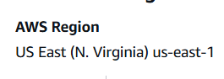
        - Uncheck “Block all public access” (since a public website requires access).
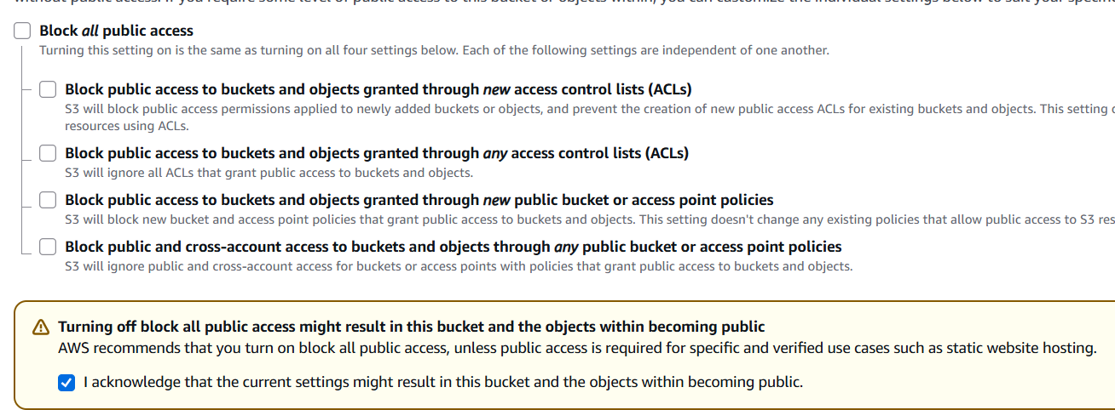
        - Acknowledge the warning and click Create bucket.
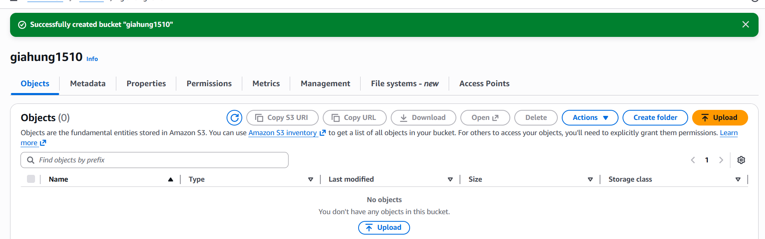
- Upload Website Files
        - Open the bucket you just created.
        - Click Upload → Add files.
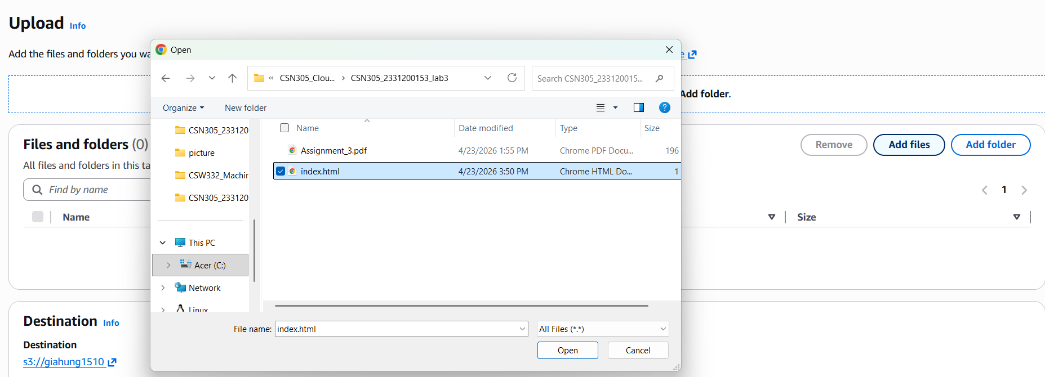
        - Upload the provided index.html.
        - Confirm and complete the upload.
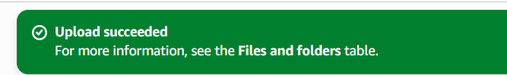
- Configure Static Website Hosting
    - In the bucket, go to the Properties tab.
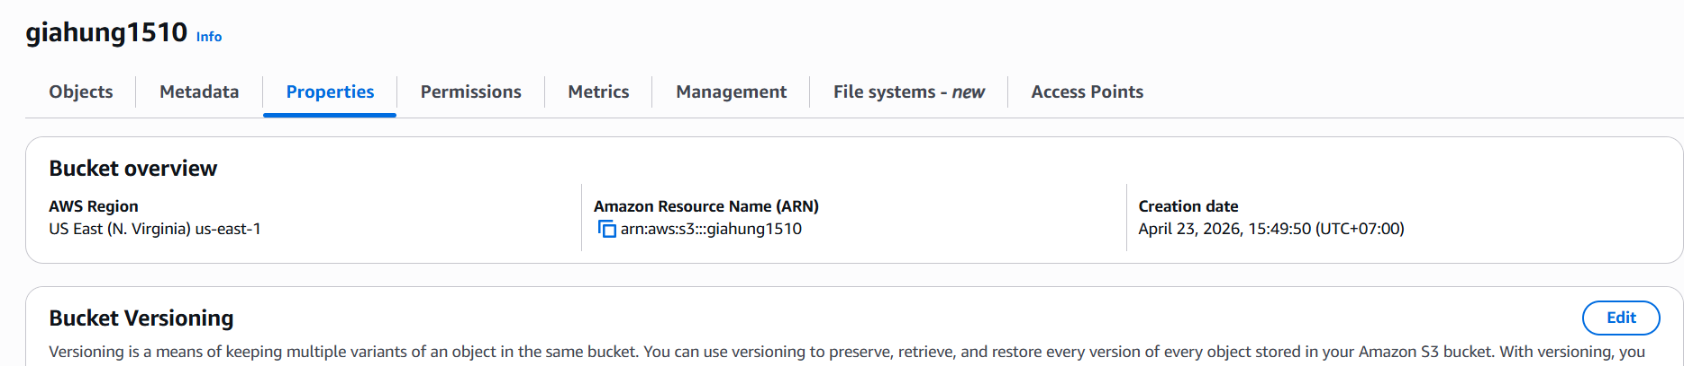
    - Scroll to Static website hosting.
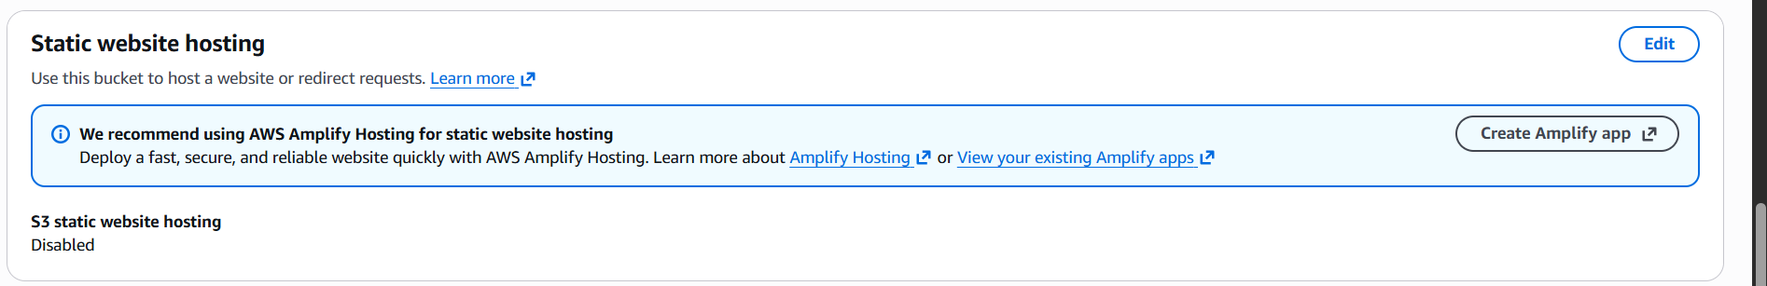
    - Select Enable.
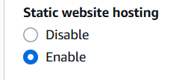
    - Choose Host a static website.
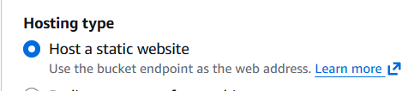
    - For Index document, enter index.html.
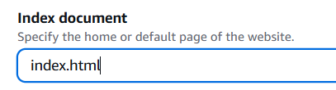
    - Save changes.
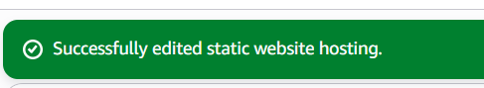
- Set Bucket Policy for Public Access
    - Go to the Permissions tab.
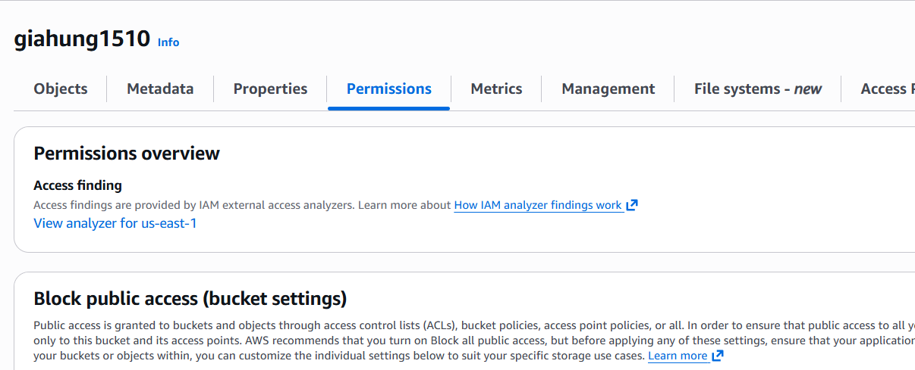
    - Under Bucket Policy, add a policy that allows public read access to your objects:
{  } |  | "Version": "2012-10-17",  "Statement": [  {  "Effect": "Allow",  "Principal": "*",  "Action": "s3:GetObject",  "Resource": "arn:aws:s3:::my-static-website-bucket/*"  }  ]

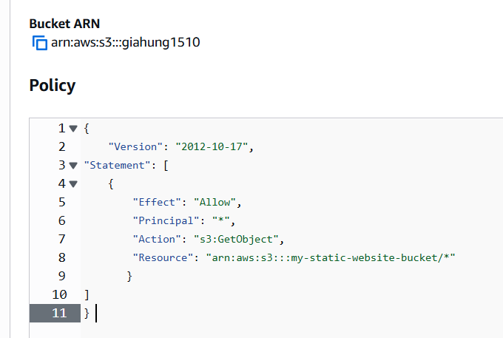
    - Replace my-static-website-bucket with your bucket name.
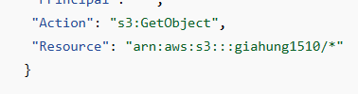
    - Save changes.
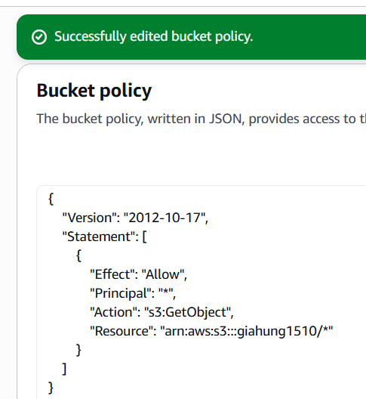
- Test the Website
  - In the Properties tab, under Static website hosting, copy the Endpoint URL.
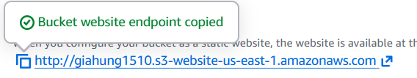
  - Paste it into your browser to see your hosted index.html.
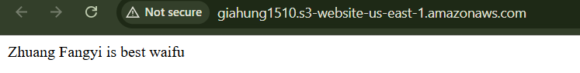

Remember to delete the S3 bucket after you have done to avoid unnecessary costs.
▪ Task 3 – Reflection questions
  - How does Amazon EBS provide persistent storage compared to the default storage of an Amazon EC2 instance?

Answer: The default storage of an EC2 instance is instance store which means all data is lost when the instance is stopped or terminated. EBS (Elastic Block Store) is a separate, persistent storage volume that remains intact even after the EC2 instance is stopped or terminated. EBS volumes exist independently of the instance lifecycle and can be reattached to another instance if needed

  - What is the importance of snapshots in protecting and recovering data in EBS?

Answer: Snapshots are point-in-time backups of an EBS volume stored in Amazon S3. They allow you to restore a volume to a previous state in case of accidental deletion, data corruption, or failure. Snapshots can also be used to create new EBS volumes or copy data across regions, making them essential for disaster recovery and data protection

  - What did you learn about managing storage (attach, detach, reuse) after performing the EBS lab?

Answer: I learned that EBS volumes can be attached to an EC2 instance, formatted, and mounted like a regular disk. They can also be detached from one instance and reattached to another without losing the data. This flexibility makes EBS volumes reusable and independent of any specific instance, which is useful for migrating data or replacing instances

  - Why must “Block all public access” be disabled when hosting a static website on S3?

Answer: By default, S3 blocks all public access to protect sensitive data. When hosting a static website, the files need to be publicly accessible to anyone on the internet. Disabling "Block all public access" is a required step to allow the bucket policy to grant public read access to the website content.

  - What is the role of the index.html file in static website hosting?

Answer: The index.html file serves as the default entry point (home page) of the static website. When a user visits the website URL without specifying a file, S3 automatically serves the index.html file. It acts as the root document that loads first when the site is accessed

  - Why is a bucket policy required to allow public read access, even after uploading files to the bucket?

Answer: Uploading files to a bucket only stores them, it does not automatically make them public. A bucket policy is a permission rule that explicitly grants public read access (s3:GetObject) to the objects in the bucket. Without a bucket policy, the files remain private and any public request will be denied, even if "Block all public access" is turned off

  - Why is an AWS IAM Role needed when accessing or managing an S3 bucket securely?

Answer: An IAM Role allows AWS services (like EC2) to access S3 without hardcoding credentials such as access keys in the application. Instead of storing sensitive credentials, the instance assumes a role with the appropriate permissions. This is more secure because IAM roles use temporary credentials, follow the principle of least privilege, and reduce the risk of credential leakage

