Task 1: The screen display the results after successful login the AWS account
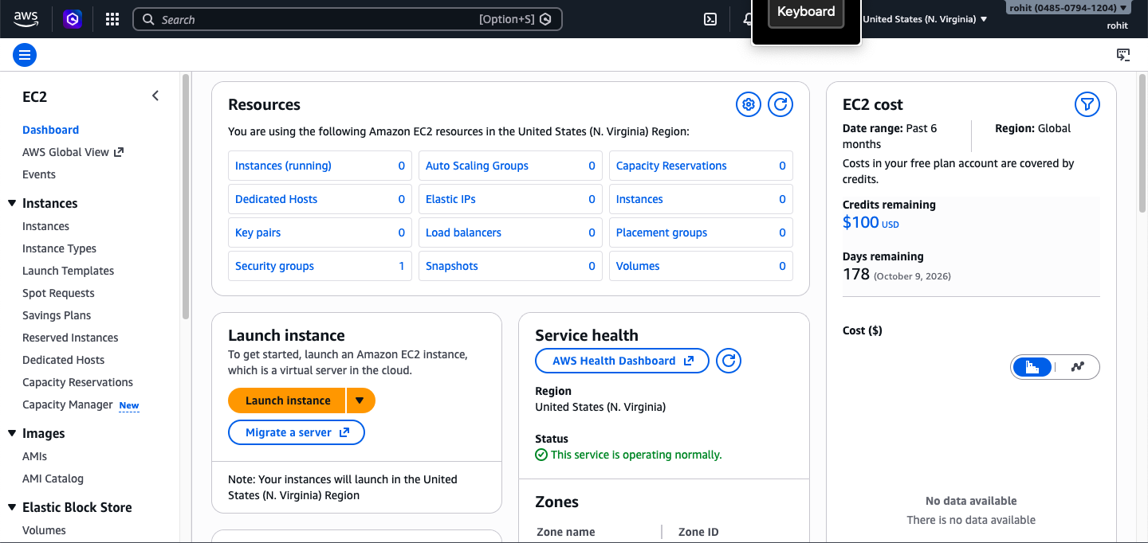
Task 2:
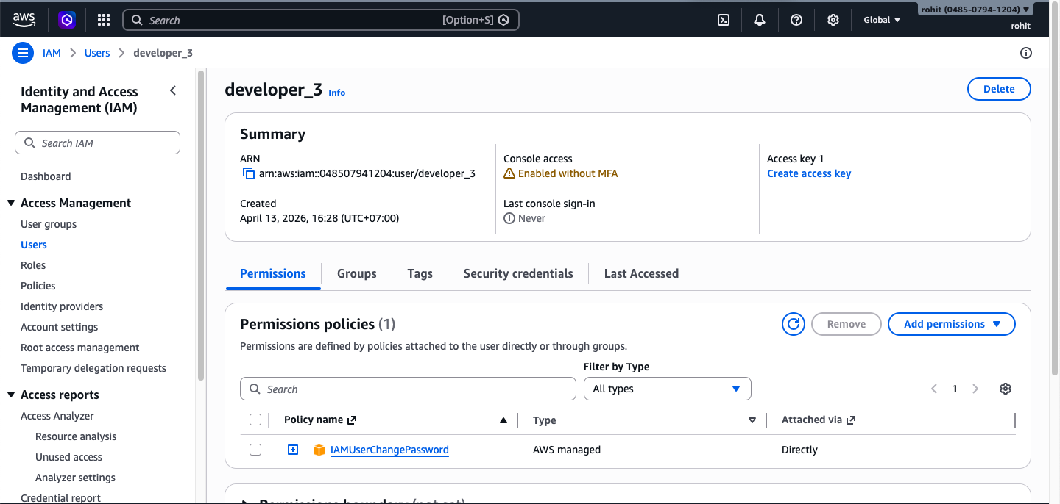
- The screen display the particular user of IAM

- The screen check for the user group from user list.
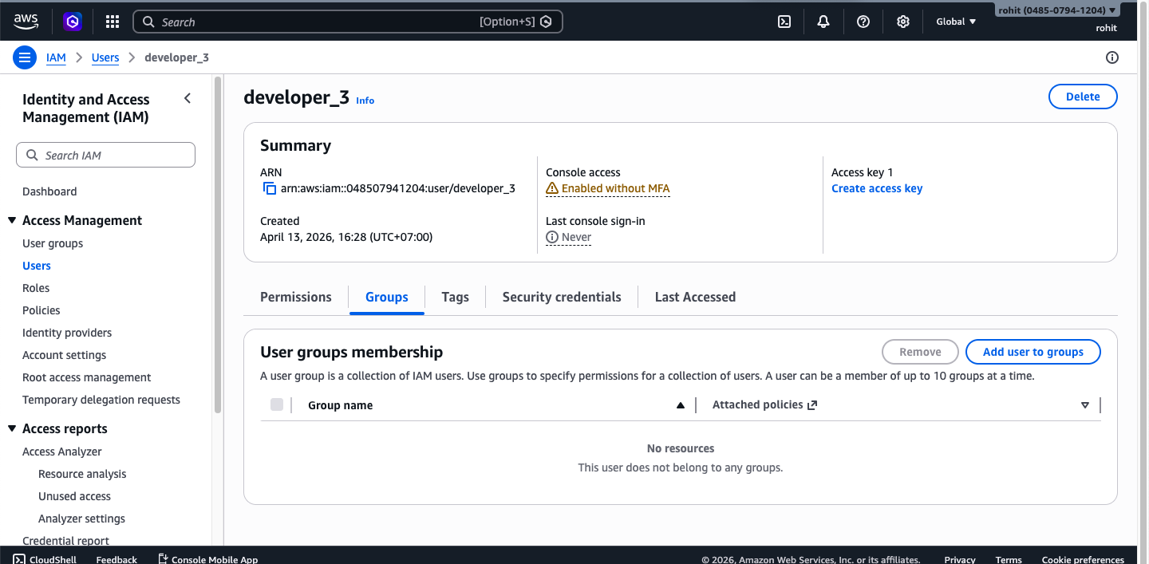

- The screen display the list of user groups
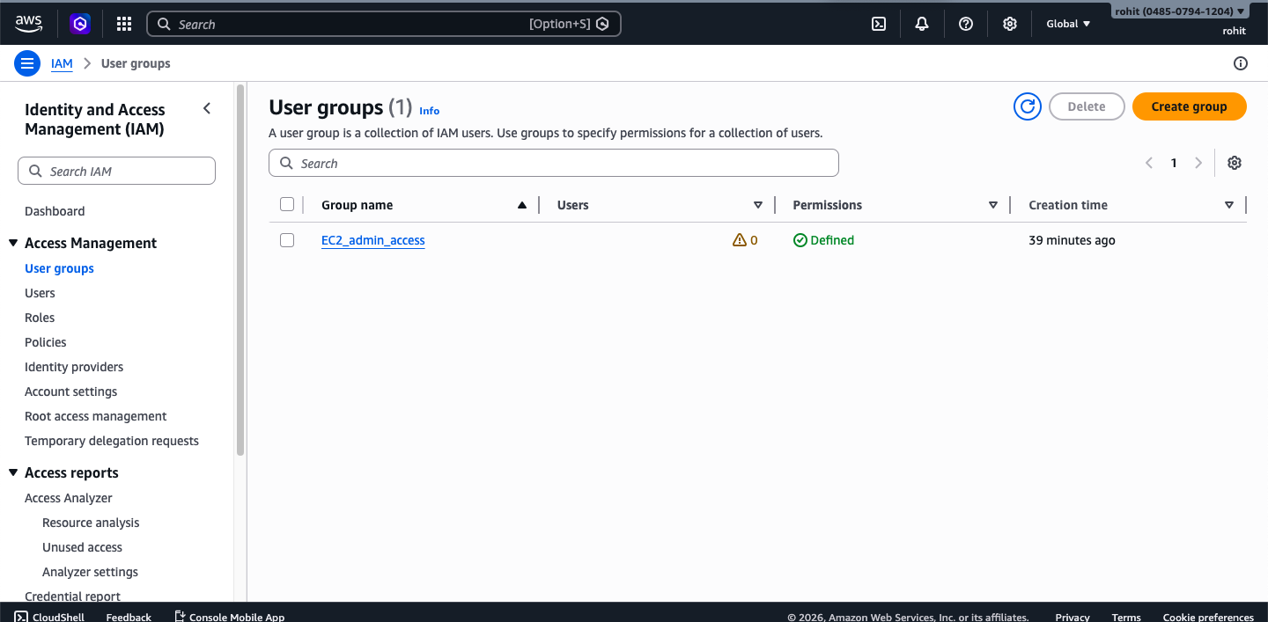
- Display the user groups summary
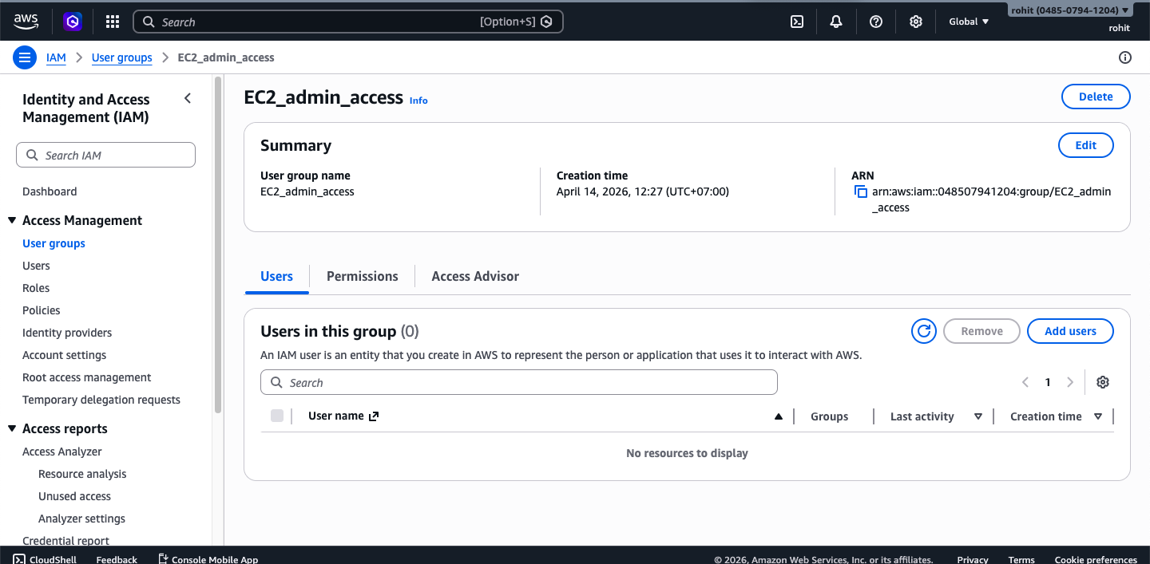
- The screen display to list of users to add in the group. You can select any of the users to add in the particular user group and click to add users button to add it.
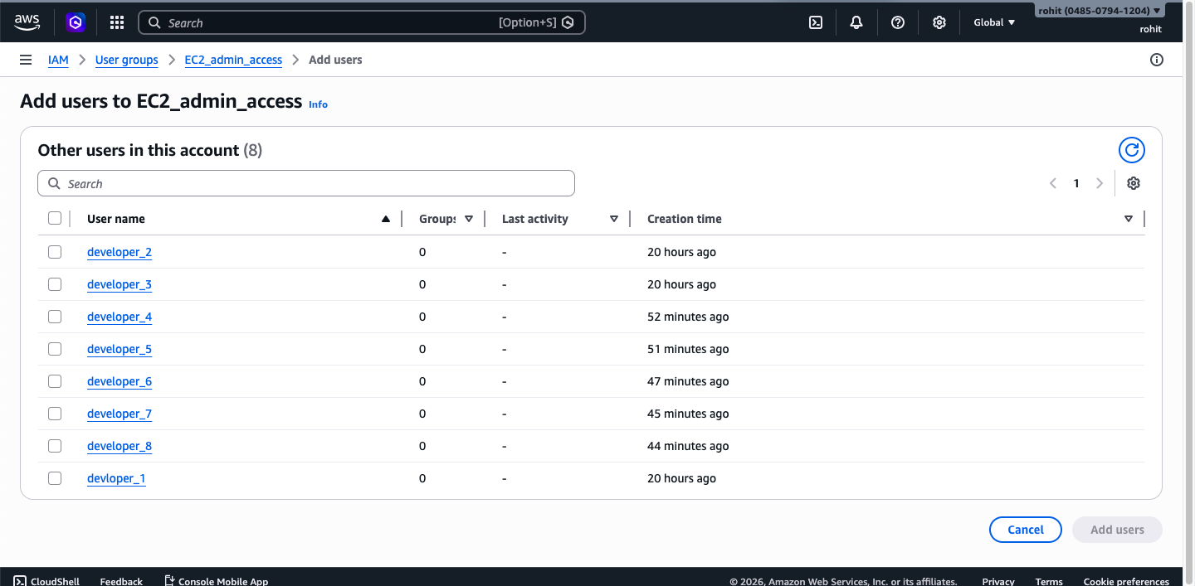
Task 3:
- The screen display the list of user who are added in the user group.
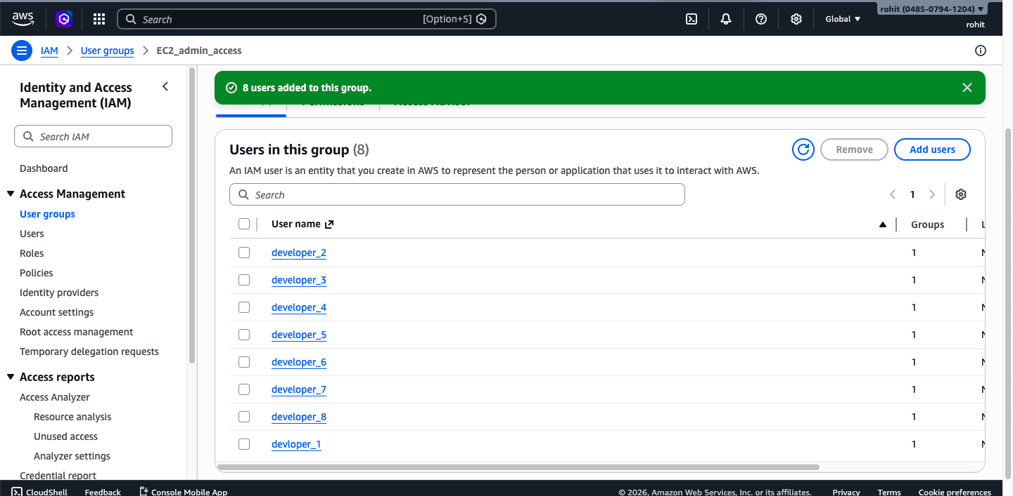
Task 4:
- The screen display the list of S3 bucket. After click on users3bucket. The page navigate to add index.html file to display Static website.
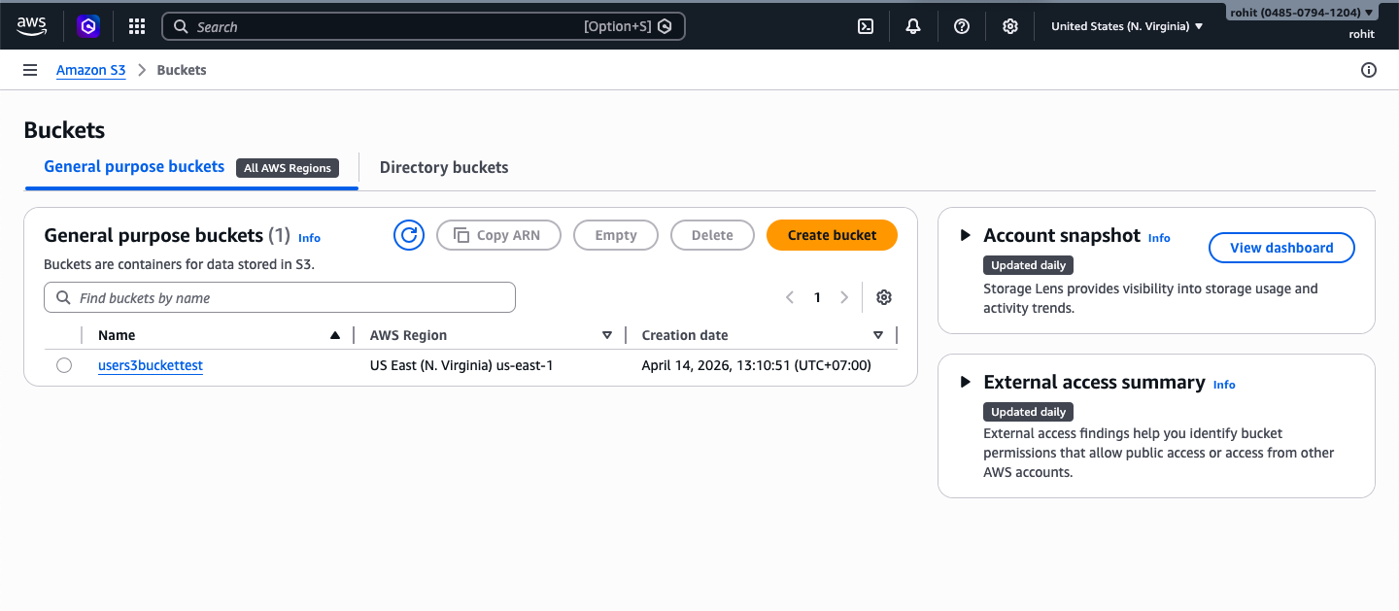

- The screen display to add index.html file in the S3 bucket. By clicking on upload the window will open to upload index.html file.
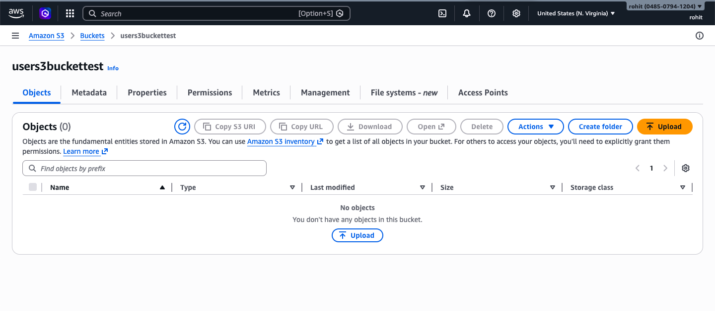
- The screen display the uploaded index.html file in to S3 bucket storage.
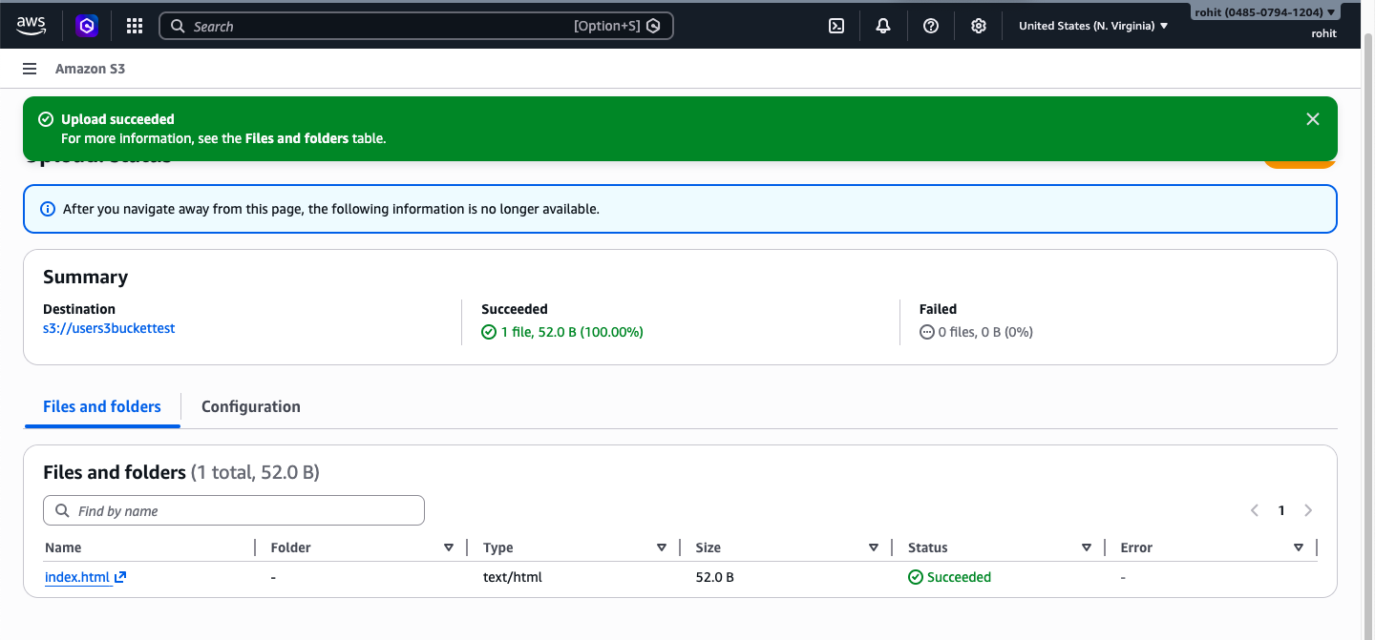
- The screen display the summary of index.html file. In which after click on Open button at top right corner, the static page will open in a browser.

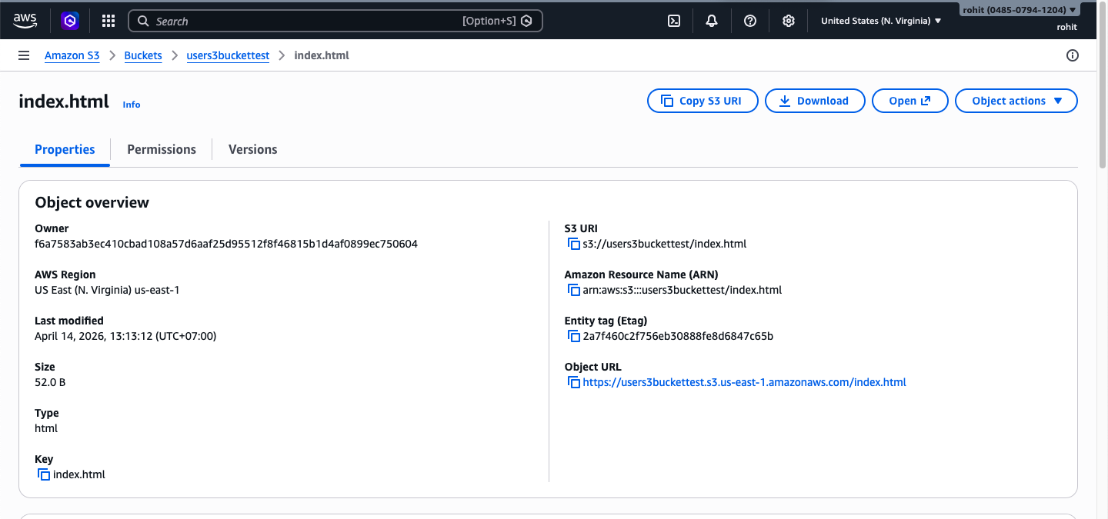

- The screen display the static web pages.
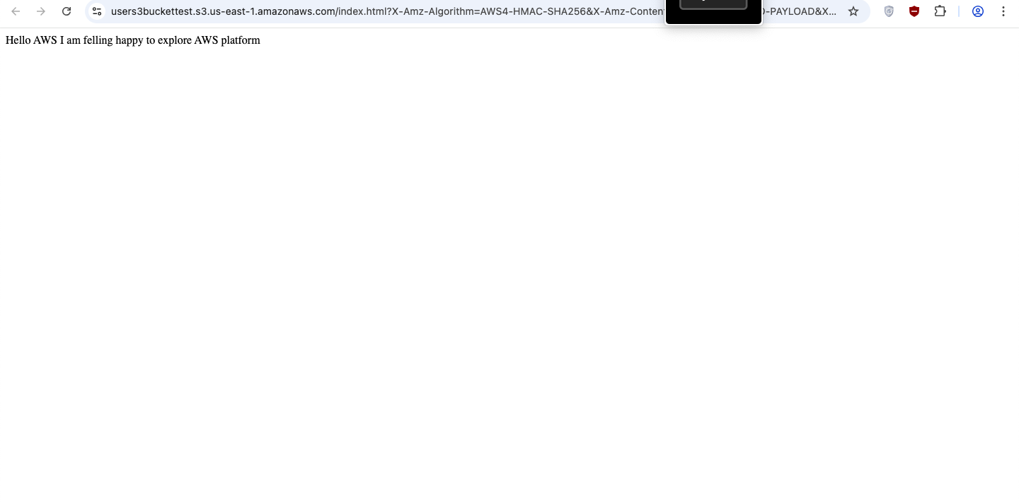
Task 5:
- The screen display the results as error while launching new Instances
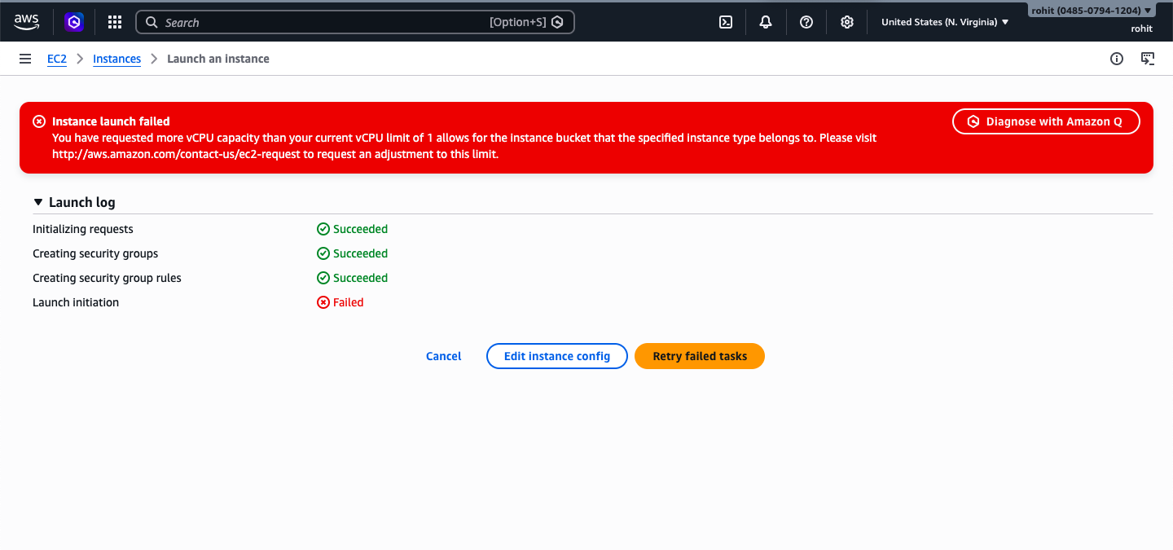

Task 6: The screen display the results after terminating the instances
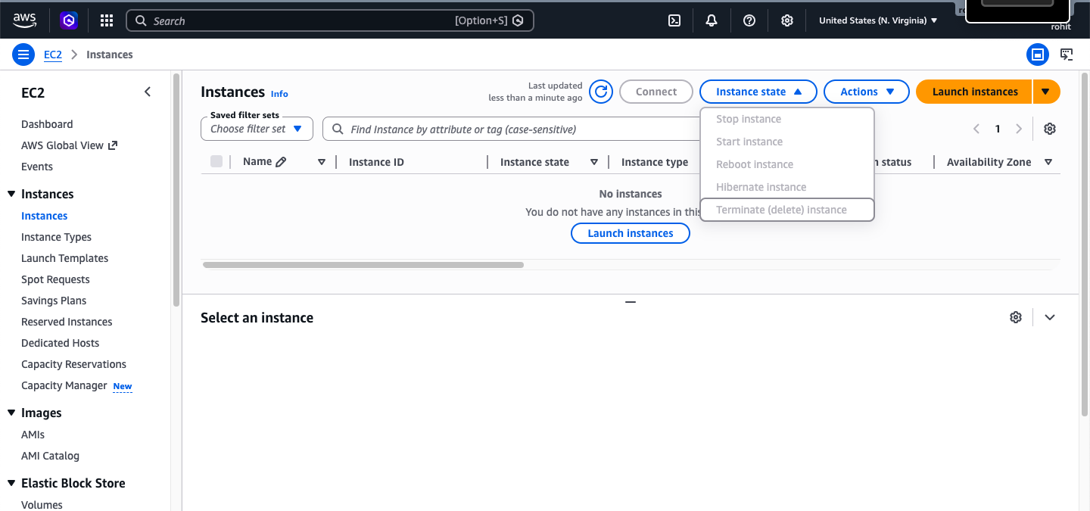

Task 7: Answer the questions given in the assignment.

