# Relational Algebra Exercises

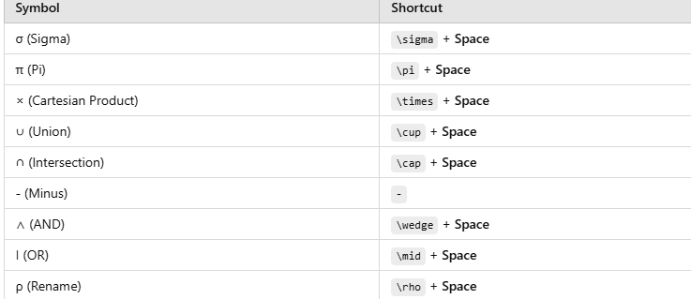

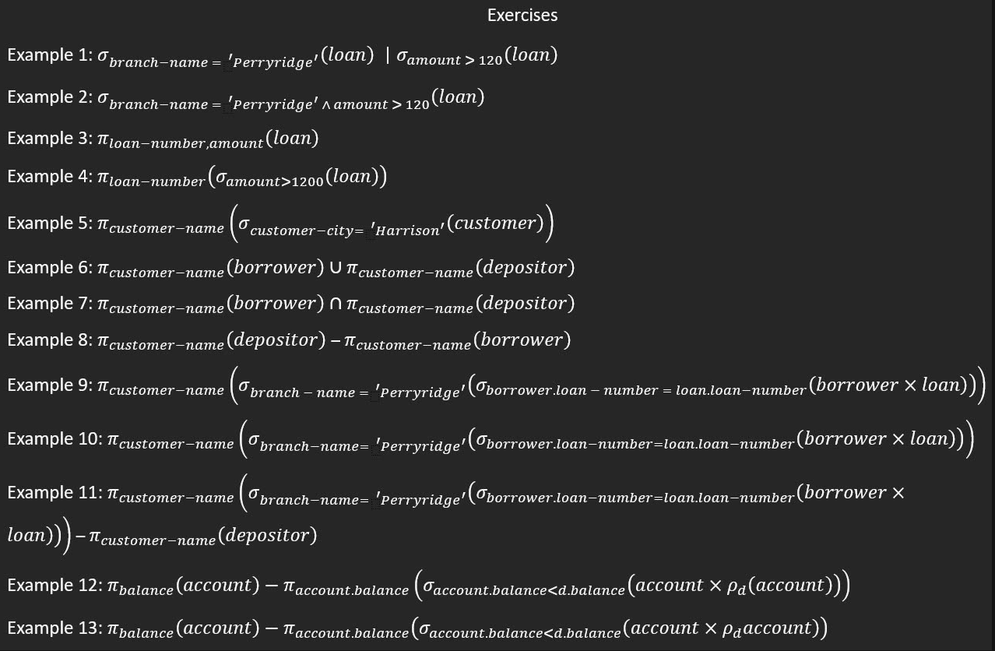

How to do in Word: 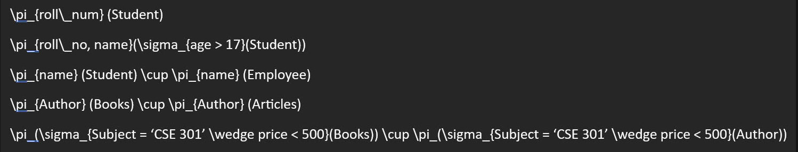

Exercies:

## Example 1

σ_{branch-name='Perryridge'}(loan) ∣ σ_{amount>120}(loan)

## Example 2

σ_{branch-name='Perryridge' ∧ amount>120}(loan)

## Example 3

π_{loan-number, amount}(loan)

## Example 4

π_{loan-number}(σ_{amount>1200}(loan))

## Example 5

π_{customer-name}(σ_{customer-city='Harrison'}(customer))

## Example 6

π_{customer-name}(borrower) ∪ π_{customer-name}(depositor)

## Example 7

π_{customer-name}(borrower) ∩ π_{customer-name}(depositor)

## Example 8

π_{customer-name}(depositor) − π_{customer-name}(borrower)

## Example 9

π_{customer-name}(σ_{branch-name='Perryridge'}(σ_{borrower.loan-number=loan.loan-number}(borrower × loan)))

## Example 10

π_{customer-name}(σ_{branch-name='Perryridge'}(σ_{borrower.loan-number=loan.loan-number}(borrower × loan)))

## Example 11

π_{customer-name}(σ_{branch-name='Perryridge'}(σ_{borrower.loan-number=loan.loan-number}(borrower × loan))) − π_{customer-name}(depositor)

## Example 12

π_{balance}(account) − π_{account.balance}(σ_{account.balance<d.balance}(account × ρ_d(account)))

## Example 13

π_{balance}(account) − π_{account.balance}(σ_{account.balance>d.balance}(account × ρ_d(account)))