CSE302

Pham Tran Gia Hung - 2331200513

Practice Assignment 1

Capture the screen shots of the results for the following questions. Save each screen shot as the

question number. Save all the screen shots in a word file and upload the file into Moodle.

Total Points : 100

1. Capture a screenshot of VMWare Workstation Player after running it.

- I download Ubuntu from Microsoft store

2. Capture the screenshot of Ubuntu after it starts successfully. (10 points)

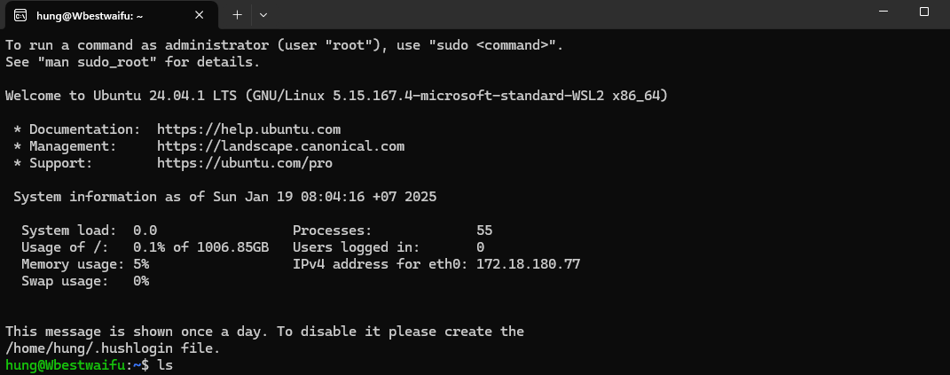

3. List all contents of your current working directory.

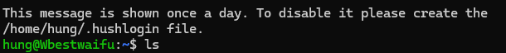

4. List all contents of your current working directory, including hidden files.

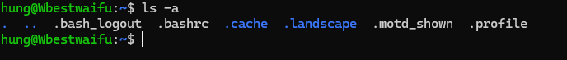

5. Create a directory named as “CSE302”.



6. View the directory.

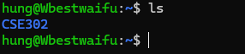

7. Change your current directory towards “CSE302”.



8. Return from “CSE302” directory towards your home directory.



9. Create another directory named as “SCIT”.



10. View the directory.



11. Change your current directory towards “SCIT”.



12. Go to your home directory, and display full path of your current directory.



13. Go to directory “CSE302” and create a file named as “Lab1”.



14. Copy “Lab1” towards another file named as “Lab2” in the same directory.



15. Copy “Lab1” towards another file named as “Practice1” in another directory “SCIT”.



16. Rename the file “Lab1” as “Practice Lab 1”.



17. Delete the file “Lab2”.



18. Delete the directory “SCIT”.



19. Read documentation on the command “ls”.



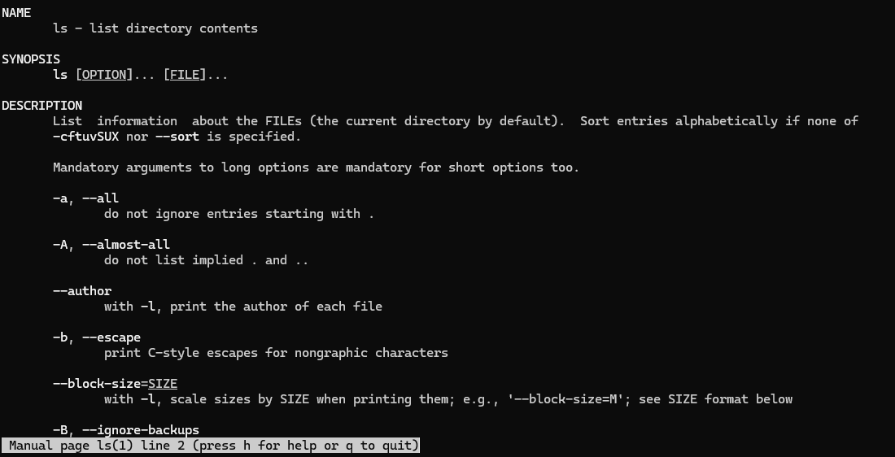

20. Search document for the matching command that have something do with “sort”.

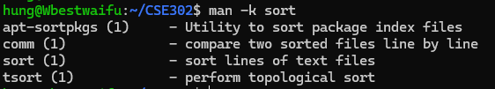

21. Install a software package named as “build-essential”.

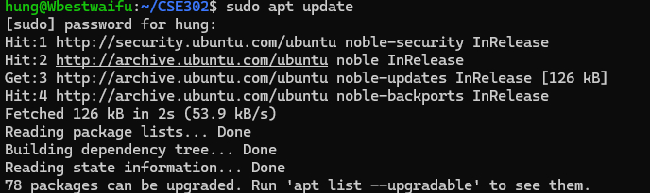

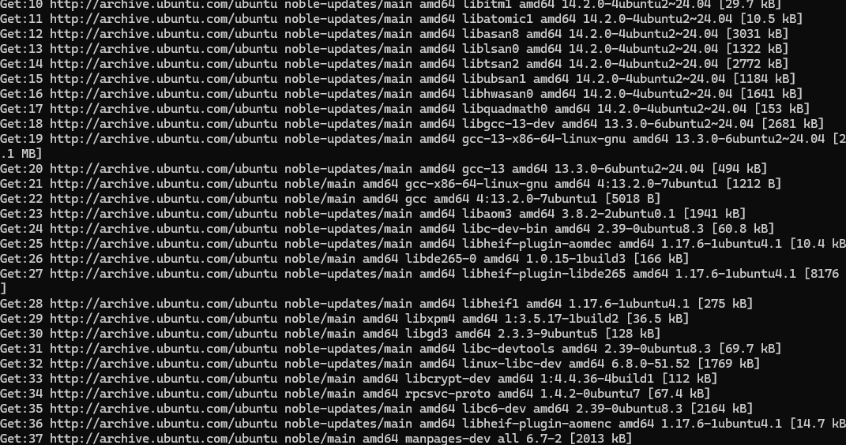

22. Print the version of “gcc” compiler.

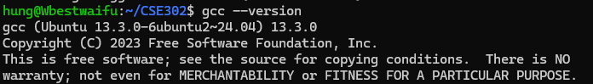

23. Download the following file “https://cdn.kernel.org/pub/linux/kernel/v4.x/linux-

4.17.2.tar.xz” from internet.

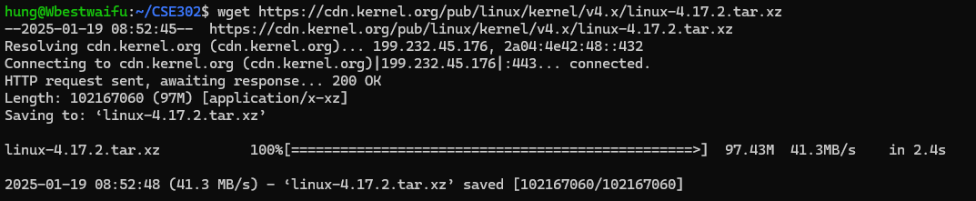

24. Can you view the file inside your current directory?



25. Edit the file “LabInstruction.txt”.

Place the following text in “LabInstruction.txt” and save it.

The laboratory courses offered cover a wide range of disciplines and methodologies aimed at

providing students with the knowledge and practical skills required for advanced studies and

future careers in biotechnology, biomedicine, and academia.



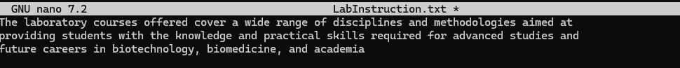

26. Count the number of characters, words, or lines in the file “LabInstruction.txt”.



27. View the content of the file “LabInstruction.txt” in the terminal.



28. Write the output of “man wc” towards a new file “docs_for_wc_program.txt”. [Hints: You

need to create the file “docs_for_wc_program.txt” first.]



29. View the content of the file “docs_for_wc_program.txt”.

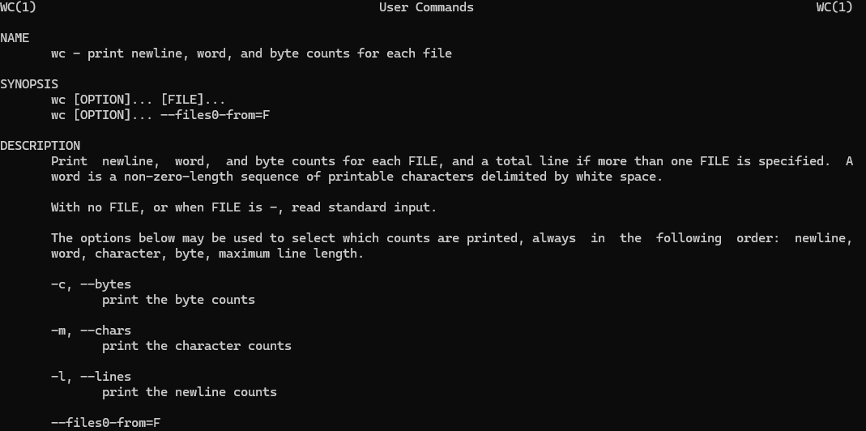 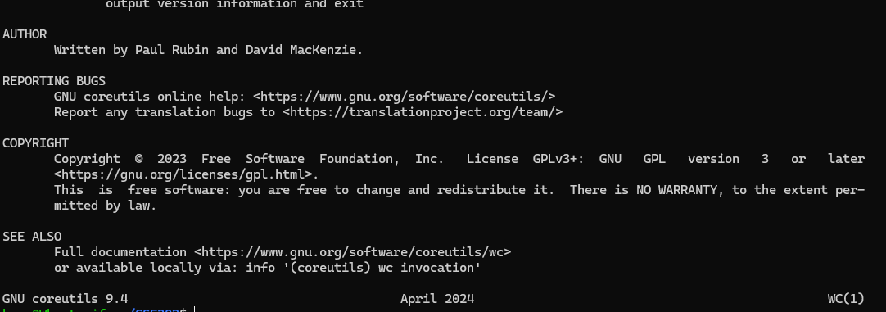

30. Append the output of “man ls” towards the file “docs_for_wc_program.txt”. Again, view the

content of the file.

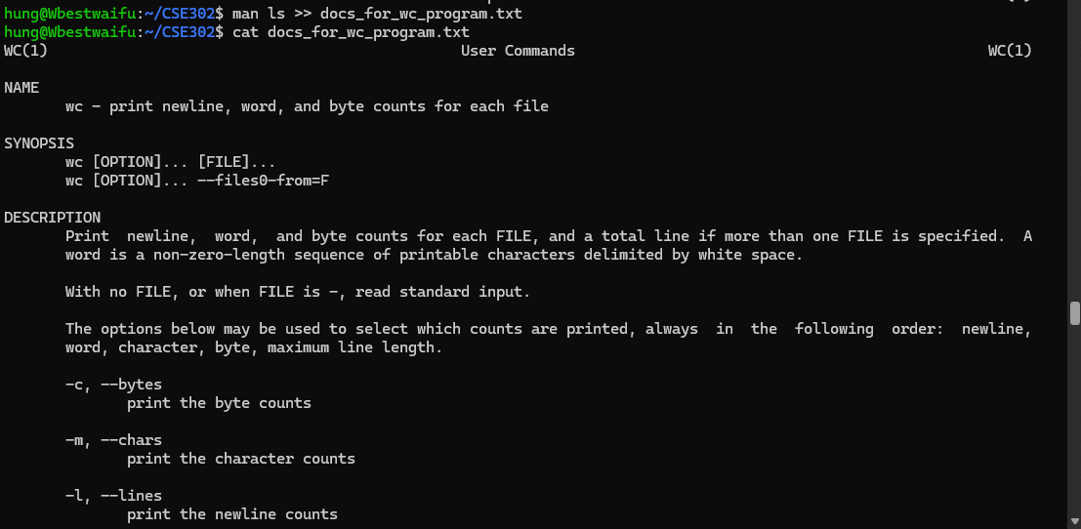 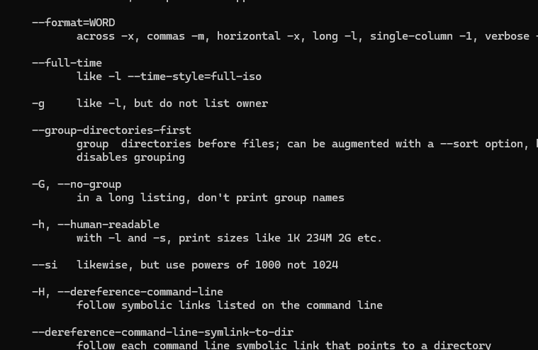 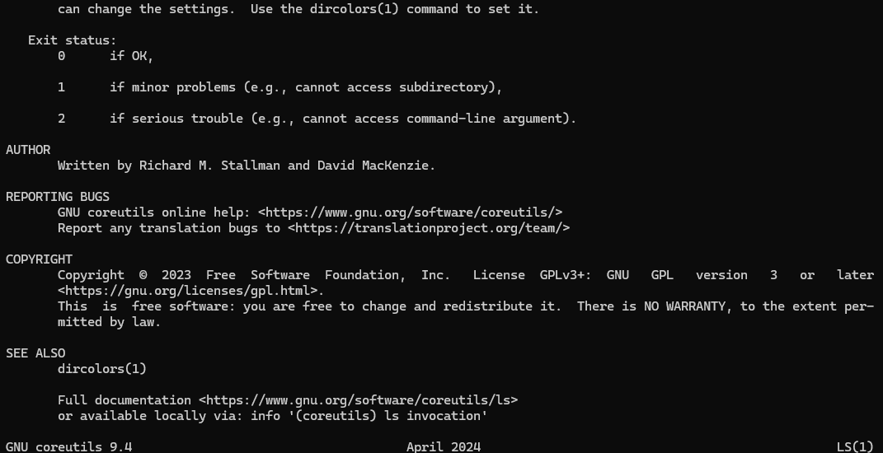

31. Create a text file named “mylist.txt” that contains the following lines:

Cat

dog

horse

cow

Observe that the animals are not listed in alphabetical order.

What do if you need to list them in order? [Hints: You can pull the contents of the file into the

sort command by using the < operator.



