Instructions:
To be eligible for marking, students must follow these steps:
1. At the end of the exam, zip all your submissions with the following format (without brackets):
“[StudentID][ComputerNo][StudentFullName]”
For example:
2431219011_09_NguyenVanHuy
2. Submit the .zip file in Moodle.
Unless otherwise specified, other aspects of the problem are open for students to interpret and decide on their own.
------------------------------------------------------------------------------------------------------------------------------
Question 1 (50 marks) Create test cases for the following problems based on Normal Boundary Value Analysis (BVA). Execute these test cases using JUnit and take screenshots of the results. Your submission must include both the test code and the screenshots.
You are given a java program that classifies triangles based on the lengths of their three sides. The program should determine if the given sides form a valid triangle and, if so, classify the triangle as one of the following types: “EQUILATERAL”, “SCALENE” or “ISOSCELES”. If all three sides are equal, the program output is “EQUILATERAL”. If exactly one pair of sides is equal, the program output is “ISOSCELES”. If no pair of sides is equal, the program output is “SCALENE”. If the sides do not form a valid triangle, the program should return “NOT_A_TRIANGLE”. Additionally, the program should return “OUT_OF_RANGE” cases where the side lengths are out of valid range.
Input:
Three integers: side1, side2 and side3, these values represent the lengths of the sides of a potential triangle. (1<side1, side2, side3 < 11)
Output:
The program should return one of the triangle types based on the provided side lengths.

The code had no bug
Testcode:
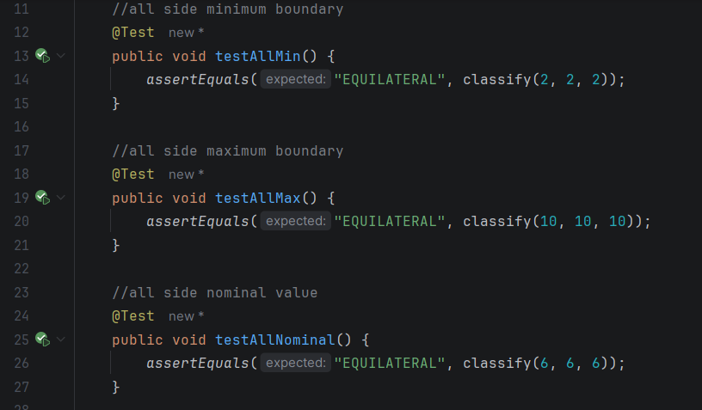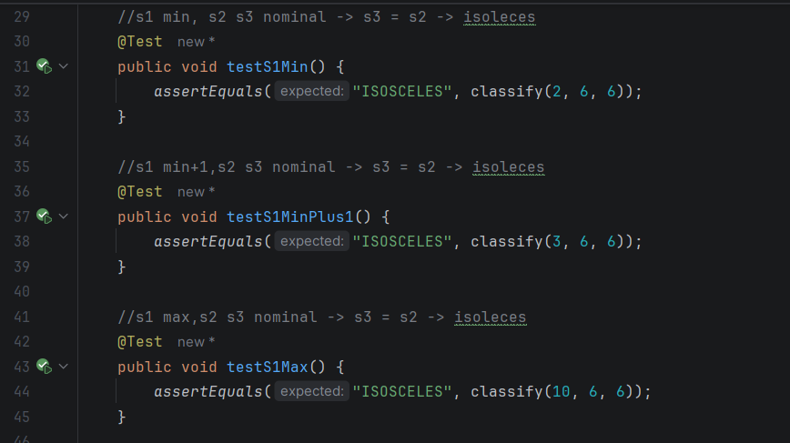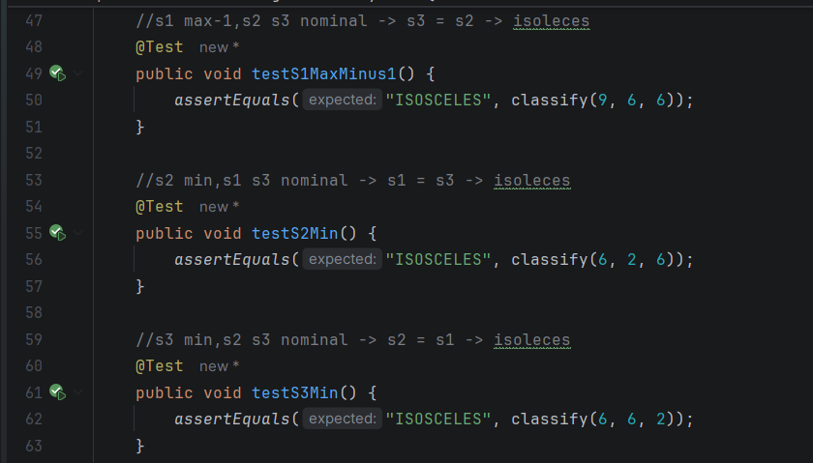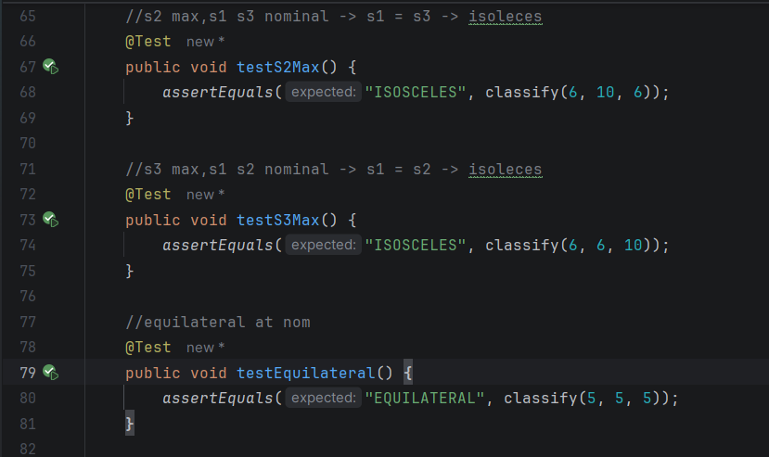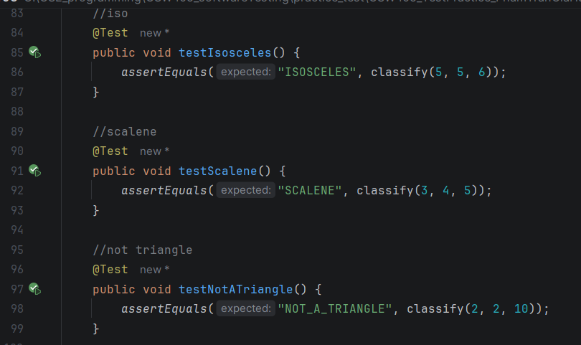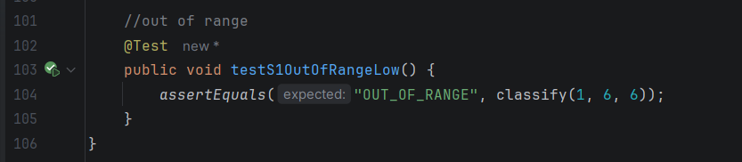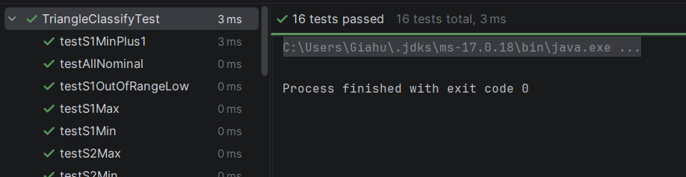

Question 2 (50 marks) Create test cases of the following problems based on Robust Boundary Value Analysis (RBVA). Execute these test cases using JUnit and take screenshots of the results. Your submission must include both the test code and the screenshots.
You are given a java program that calculates the eligibility for a scholarship based on three criteria: GPA, Extracurricular Activities and Volunteer Hours. GPA is the student’s Grade Point Average, GPA is calculated on a 4-point scale and rounded up to one digit after the decimal point. Extracurricular Activities is the number of extracurricular activities the student participates in, extracurricular activities are mandatory and is capped at 10. Volunteer Hours is the total number of volunteer hours the student has completed in the past year, volunteer hours are optional and is capped at 300 hours. There are two types of scholarship: Full scholarship and partial scholarship, the condition to apply for these two scholarships are:
1. Full Scholarship Eligibility:
A student meets all three of these criteria, they are considered eligible for a full scholarship, the program should return “Full scholarship” in this case.
- GPA: The student's GPA must be 3 or higher.
- Extracurricular Activities: The student must have participated in at least 5 extracurricular activities.
- Volunteer Hours: The student must have completed 100 or more volunteer hours.
2. Partial Scholarship Eligibility:
If a student meets these criteria but does not qualify for the full scholarship, they are considered eligible for a partial scholarship, the program should return “Partial scholarship” in this case.
- GPA: The student's GPA must be at least 2.5.
- Extracurricular Activities: The student must have participated in at least 3 extracurricular activities.
- Volunteer Hours: The student must have completed 50 or more volunteer hours.
3. Not Eligible for Scholarship:
If a student does not meet the criteria for either the full or partial scholarship, they are considered not eligible for a scholarship, the program should return “Not eligible” “Partial scholarship” in this case. Additionally, the program should return “Invalid” cases where the inputs are out of valid range.

Bug:
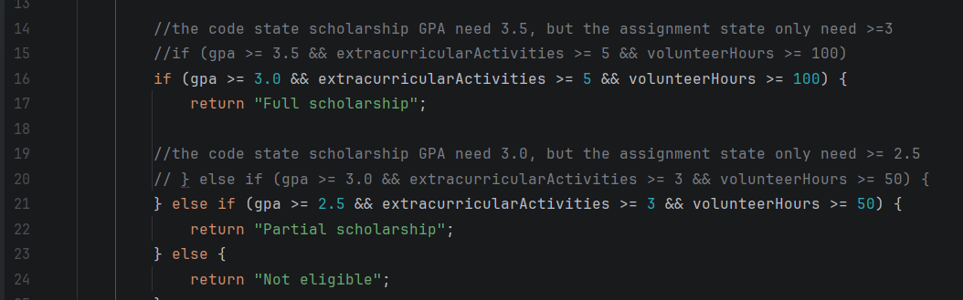

Testcode:
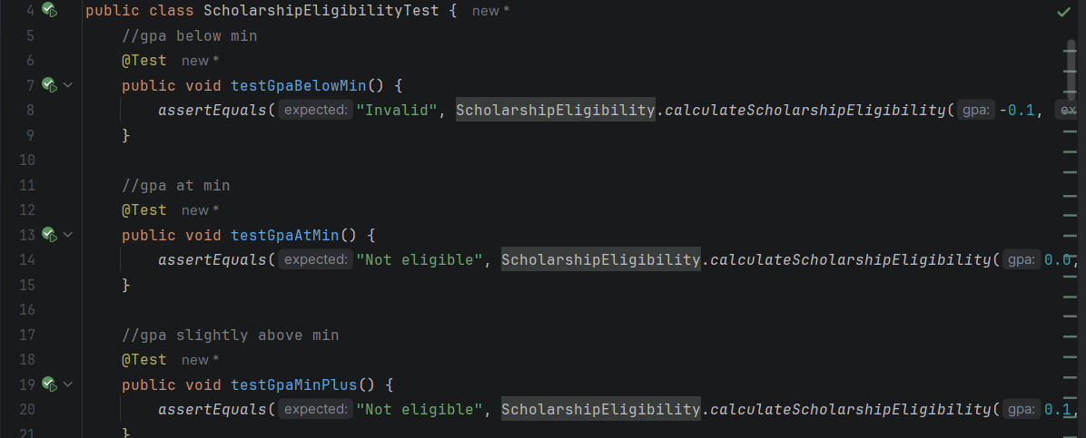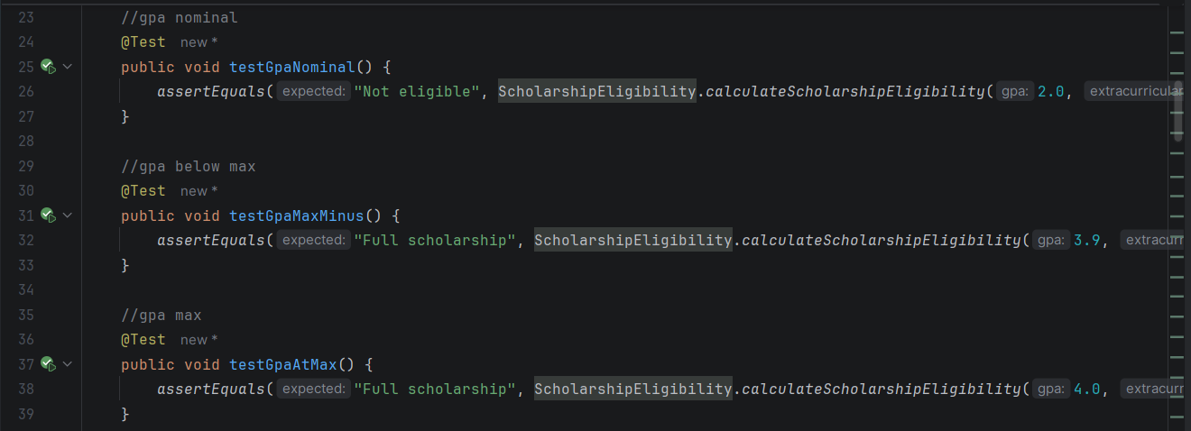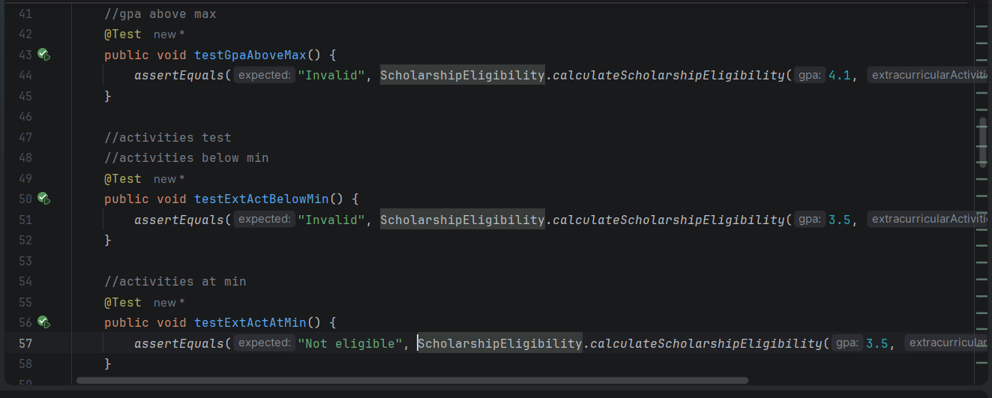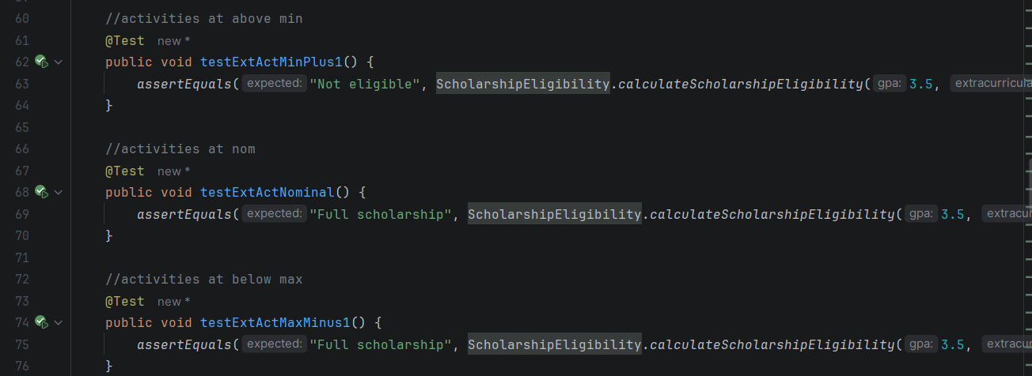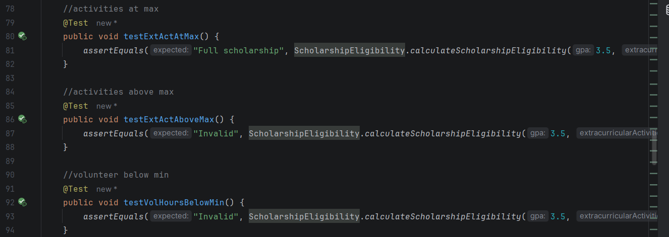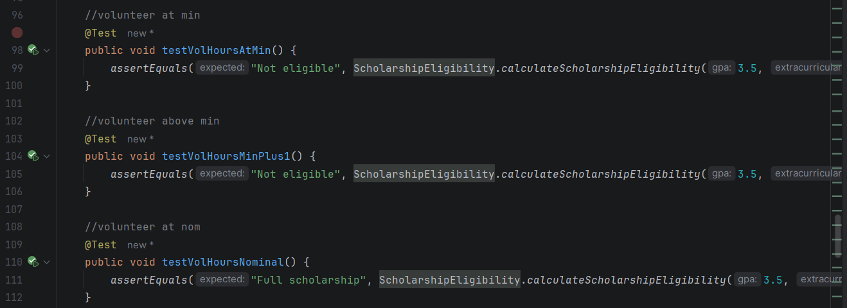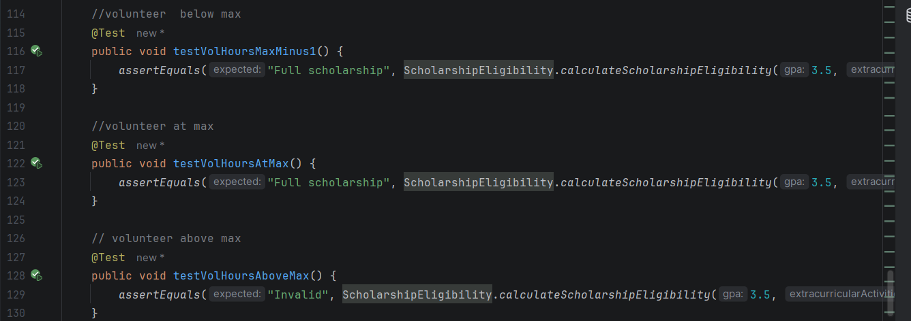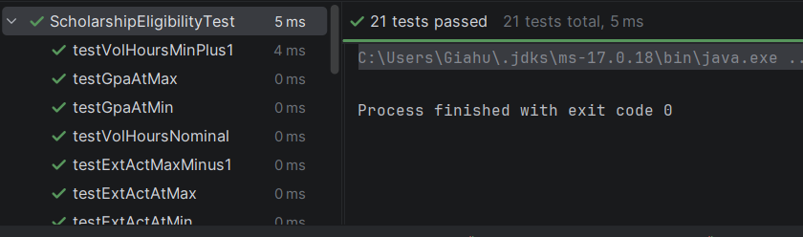

------ End ------
Lecturer’s signature

Cuong Nguyen Xuan

