Phạm Trần Gia Hưng
2331200153
Lab4
Practice Assignment 4
Pit test Report:
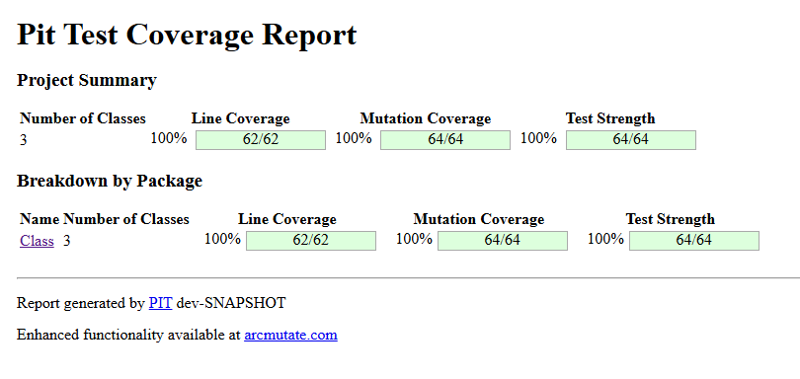
Save the test code, coverage report and mutation report as per question numbers. Make a
zip folder of all the files and upload in Moodle.
1. Set.class represents sets of integers. The elements of a set are stored in an ArrayList. They are
sorted and without duplicates to speed up some operations. Two methods might need an
explanation:
public void section(Set s) { ... }:removes from this set any element that is equal to an element in s.
public boolean containsArithTriple() { ... }: returns true if there are three elements, x, y and z, in
this set such that y - x = z - y.
a. Execute test cases that give you 100% branch coverage for this source code. Upload the test
code and coverage report in Moodle. 10 Points
a. There are bugs in the implementation. Find the bug and write the description of bugs in
Set.java file as a comment. Upload the file alone with the bug-description in Moodle. 5 Points
c. Do mutation test for these test cases to achieve 100% mutation coverage. Submit your
mutation test report and modified test cases in Moodle. 20 Points

Bug:
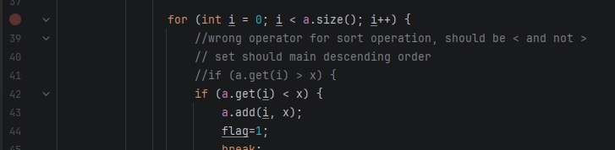
Test Coverage:
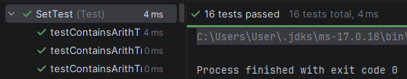

2. Encryption( ) method in EncryptMessage.java file has encrypted an input message in two steps as follows:
➢ Swap the 1st and 2nd character of the message, then swap the 3rd and 4th character, then
the 5th and 6th character and so on. If the length of message is odd, the last character should
not be swapped with any other.
➢ Replace each occurrence of the letter 'a' in the message obtained after the first step by the
letter 'z', each occurrence of 'b' by 'y', each occurrence of 'c' by 'x', etc., and each occurrence
of 'z' in the message obtained by 'a'.
Encryption( ) method only takes lower case alphabets as input.
a. Create and execute test cases to achieve 100% branch coverage. Upload the test code and
coverage report in Moodle. 10 Points
b. The implementation of EncryptMessage.java has bugs. Identify bugs and write the description
of the bugs in the EncryptMessage.java file as a comment. Upload the file alone with the bugdescription in Moodle. 5 Points.
c. Do mutation test for these test cases to achieve 100% mutation coverage. Submit your
mutation test report and modified test cases in Moodle. 20 Points
Bug:
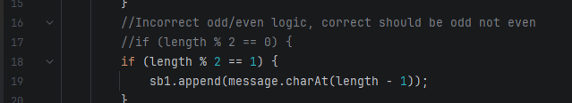
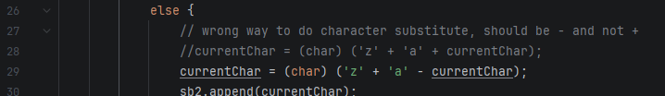

Test Coverage:
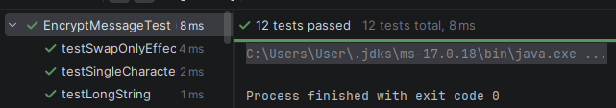

3. fizz_buzz( ) method in FizzBuzz.java file accepts input from 0 to 35. The method returns
“Fizz” if the input number is divided by 3. The method returns “Buzz” if the input number is
divided by 5. The method returns “Fizz!Buzz!”, if the number is divided by both 3 and 5.
Otherwise, the method returns the number itself.
a. Create and execute test cases to achieve 100% branch coverage. Upload the test code and
coverage report in Moodle. 10 Points
b. The implementation of EncryptMessage.java has bugs. Identify bugs and write the description
of the bugs in the EncryptMessage.java file as a comment. Upload the file alone with the bugdescription in Moodle. 5 Points.
c. Do mutation test for these test cases to achieve 100% mutation coverage. Submit your
mutation test report and modified test cases in Moodle. 15 Points

Bug:
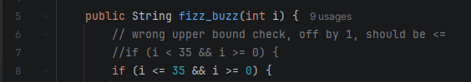

Test Coverage:
