Practice Assignment 3
Phạm Trần Gia Hưng – 2331200153
Save the test code, and coverage report as per question numbers. Make a zip folder of all the files and upload in Moodle.
Test Coverage:
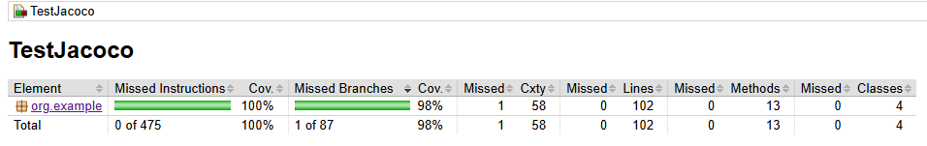
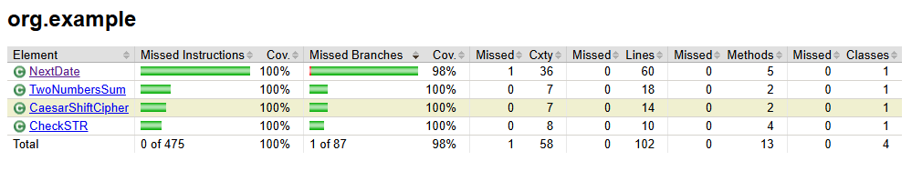
Question 1: addTwoNumbers
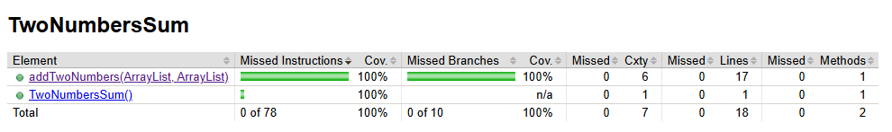
Question 2: CaesarShiftCipher
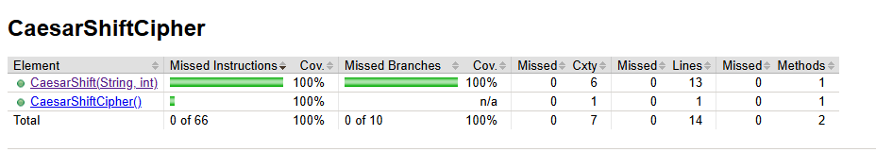
Question 3: NextDate
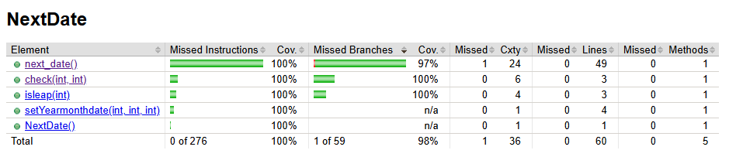
Question 4: ChekcSTR
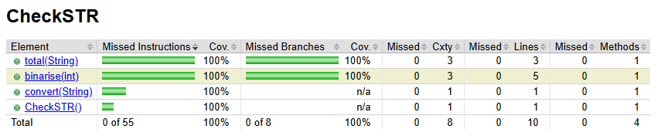
1. The method addTwoNumbers in TwoNumbersSum.java file should add two non-negative integers from which the digits are stored separately in an arraylist. For example, the number 12 would be stored as ArrayList(1,2). You can assume that there are no zeros in the beginning of the ArrayList i.e: not ArrayList(0, 0, 2).
a. Test the attached source code (TwoNumbersSum.java) in order to achieve 100% Branch Coverage. Upload the test code and coverage report in Moodle. 15 Points
b. There are bugs in this implementation. If you find the bug, just write the description of bugs as a comment in the TwoNumbersSum.java file. Upload the file alone with the bug-description in Moodle. 10 Points.
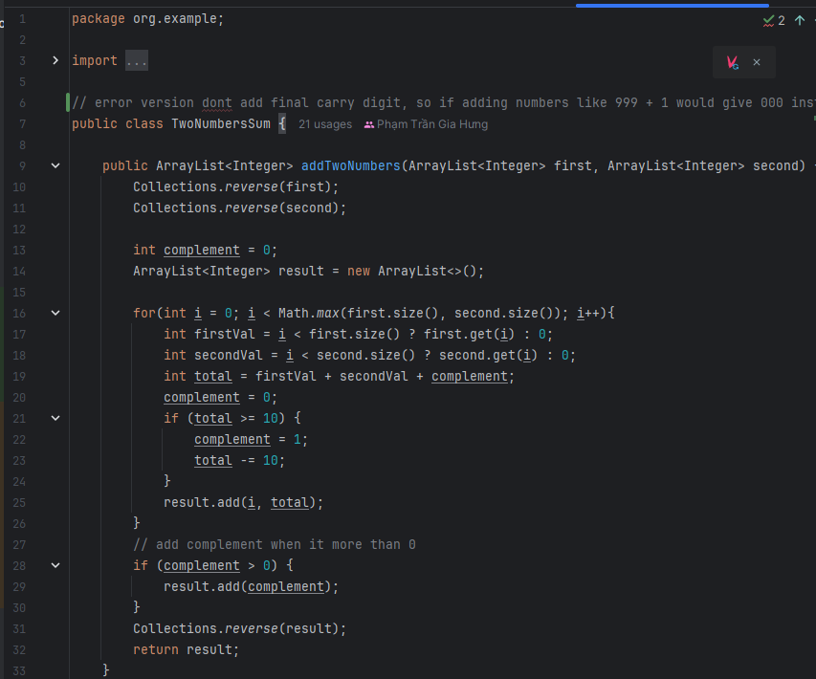
2. The CaesarShiftCipher class is responsible for applying the encryption method Caesar cipher. The rule of this method is to shift letters of a message by a given offset.
Let us say we want to shift the alphabet by 3, then letter a would be transformed to letter d, b to e, c to f, and so on.
Here is the complete matching between original and transformed letters for an offset of 3:
A B C D E F G H I J K L M N O P Q R S T U V W X Y Z
D E F G H I J K L M N O P Q R S T U V W X Y Z A B C
As we can see, once the transformation goes beyond the letter Z, we go back to the start of the alphabet, so that X, Y and Z are transformed into A, B and C, respectively.
public String CaesarShift(String message, int shift) - this method takes input the “message” which have to be encrypted and “shift” which represents the offset. This method will return the encrypted message. For example:
Input: message: ATTACKATONCE, Shift: 4
Output: EXXEGOEXSRGI
The program only takes uppercase alphabets as input.
a. Execute test cases that give you 100% branch coverage for this source code. Upload the test code and coverage report in Moodle. 15 Points
b. There are bugs in the implementation. Find the bug and write the description of bugs in CaesarShiftCipher.java file as a comment. Upload the file alone with the bug-description in Moodle. 10 Points
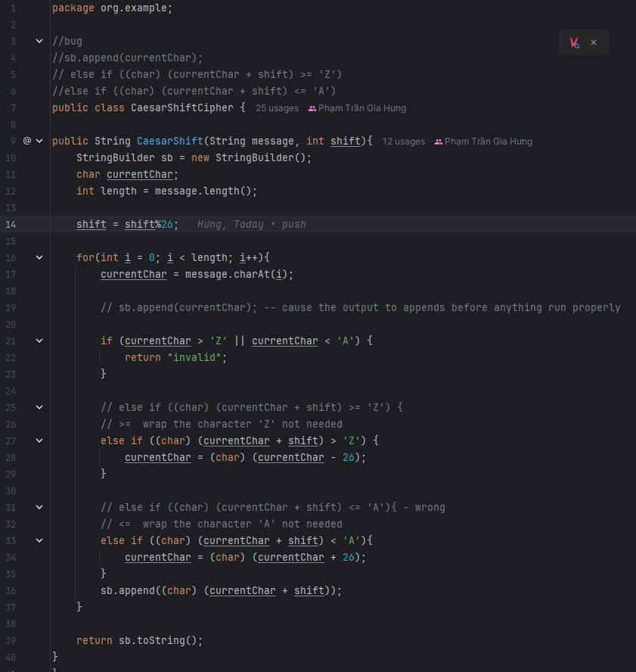

3. NextDate is a function with three variables: month, day, year. It returns the date of the day after the input date. Limitation: 1800-2025
Treatment Summary: If it is not the last day of the month, the next date function will simply, increment the day value. At the end of a month, the next day is 1 and the month is incremented. At the end of the year, both the day and the month are reset to 1, and the year incremented. Finally, the problem of leap year makes determining the last day of a month interesting.
a. Execute test cases that give you 100% branch coverage for this source code. Upload the test code and coverage report in Moodle. 15 Points
b. There are bugs in the implementation. Find the bug and write the description of bugs in Next_Date.java file as a comment. Upload the file alone with the bug-description in Moodle. 10 Points
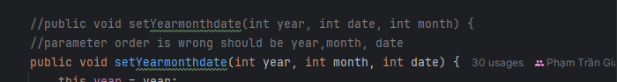
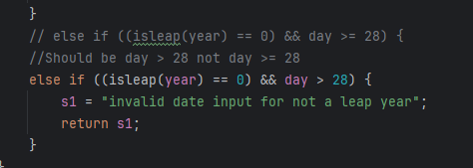
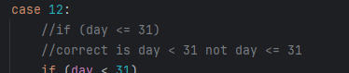

4. The program in ChekcSTR.java file converts an ASCII string to the sum of its characters represented as a Binary string i.e. adds up the values (ASCII) of strings, character by character, and show the sum as a binary digit.
a. Create and execute test cases to achieve 100% branch coverage. Save the test code as .java file. 15 Points
b. The implementation of ChekcStr.java has bugs. Identify bugs and write the description of the bugs in the ChekcStr.java file as a comment. Upload the file alone with the bug-description in Moodle. 10 Points.
