Phạm Trần Gia Hưng 2331200153
Practice Assignment 2
Save the source code, test cases and related test report as per question number. Make a zip folder of all the solutions and upload in Moodle.

- You need to develop a software based on Test Driven Development (TDD). The details of the software you need to implement as follows.
The software will generate Personal Numbers. Let assume, the personal number consist of 10-digit number: YYMMDD-XYZC.
• The first six digits represent the date of birth with year, month and day, for example 640823, which is 23rd of August 1964.
• The following three digits, XYZ, is a serial number, where Z represents the person’s gender. If the person is a female Z is an even number and odd if the person is male.
• The last digit, C, is a checksum and is calculated in the following manner:
◦ Multiply the digits in the date and serial number with 2, 1, 2, 1,...
For example:
6 4 0 8 2 3 – 3 2 3
2 1 2 1 2 1 2 1 2
12, 4, 0, 8, 4, 3, 6,2,6
◦ Add the resulting digits: 1+2+4+0+8+4+3+6+2+6=36
▪ If a multiplication result is larger than 10, it becomes the sum of the digits, for example 12→ 1+2
◦ If the summation [in this case it is 36] is greater than 10, take the last digit from the sum (the 6 in the above example) and subtract it from 10.
In the example it will be 10-6 = 4, the resulting number is the check sum C.
◦ If the result is 10 then the checksum C is 0.
◦ If the result is less than 10, then the checksum C will be the digit itself.
The Personal number class shall have the following methods:
• getDate() should return the date of birth, YYMMDD in some form.
• getYear() only return the year
• getMonth() only return the month
• getSex() return if the person is male of female (returning just Z is not allowed).
• getCheckSum() return the checksum digit
• When instantiating a personal number class, give the personal number to the constructor
as a parameter.
• It shall not be possible to instantiate an invalid personal number. If the instantiation fails an exception shall be thrown.
You are free to choose the types (integers, strings etc.) for your class by yourself.If needed, you can add more member functions, it is then a
At least you should have the following test cases for a class that represents the personal number:
1. A test case for checking the accuracy of checksum calculation
2. A test case for getDate() method
3. A test case for getYear() method
4. A test case for getMonth() method
5. A test case for getSex() method
You should follow TDD. You should have the following steps in your development:
1. Add a test that fails
2. Make the code work
3. Run the test to see if it passes
4. Modify and revise the code (Refactoring)
60 Points

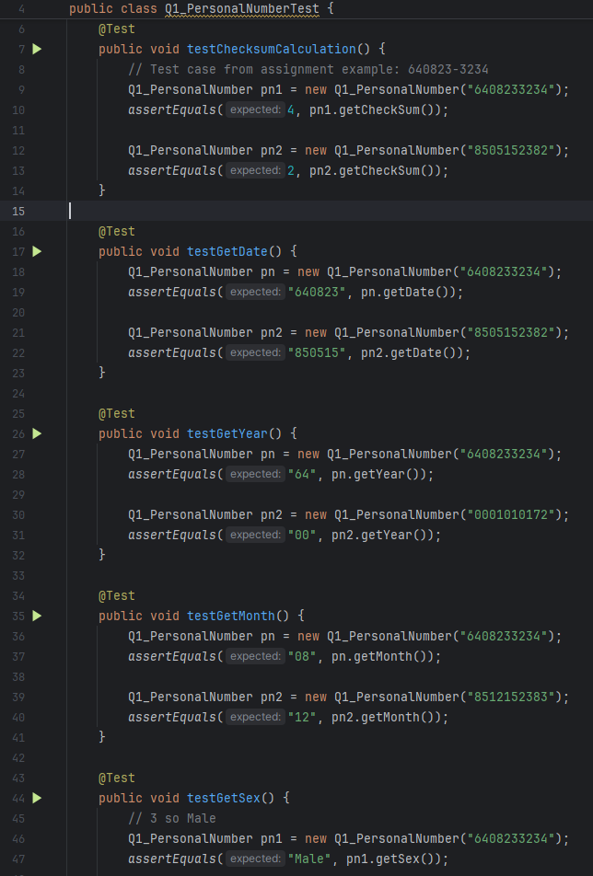
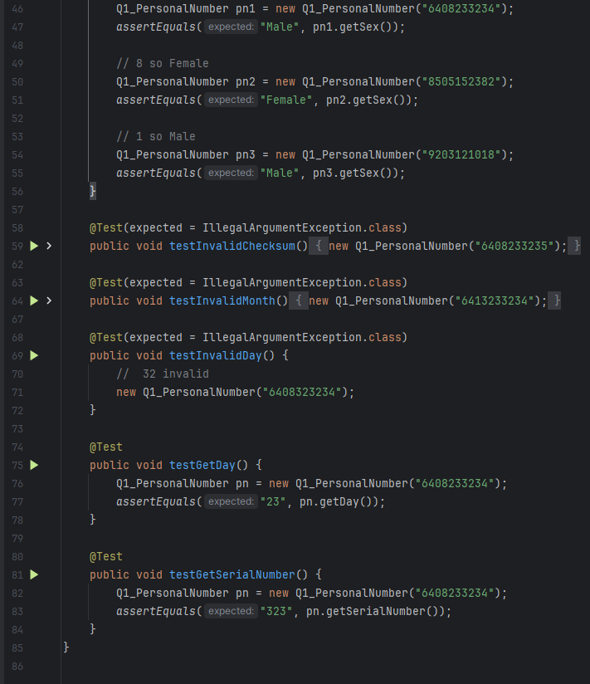
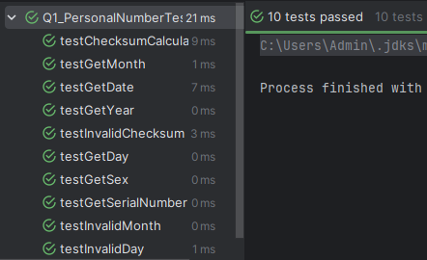

2. You are given a template for the Currency and Money classes. For these two classes, at first, write test cases for the methods of each class, then you have to add code to the methods of these classes (You need to follow Test Driven Development –TDD).The Bank and Account classes were written by a bad programmer. When you are confident that your Money and Currency classes work as intended, write test cases for the Bank and Account classes and find the bugs.
30 Points
Bug:
Account:
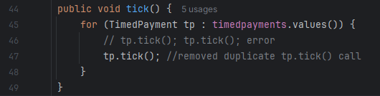

Bank:
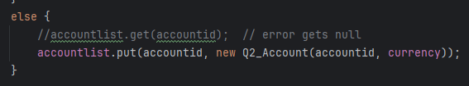
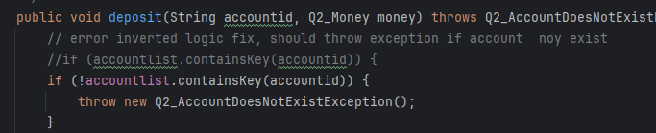
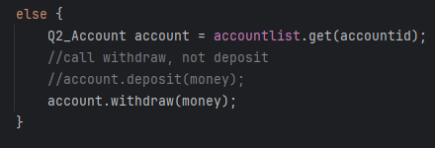
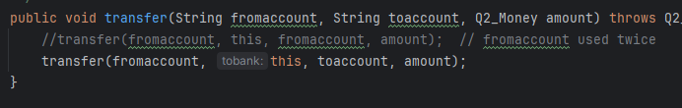

- Account test:
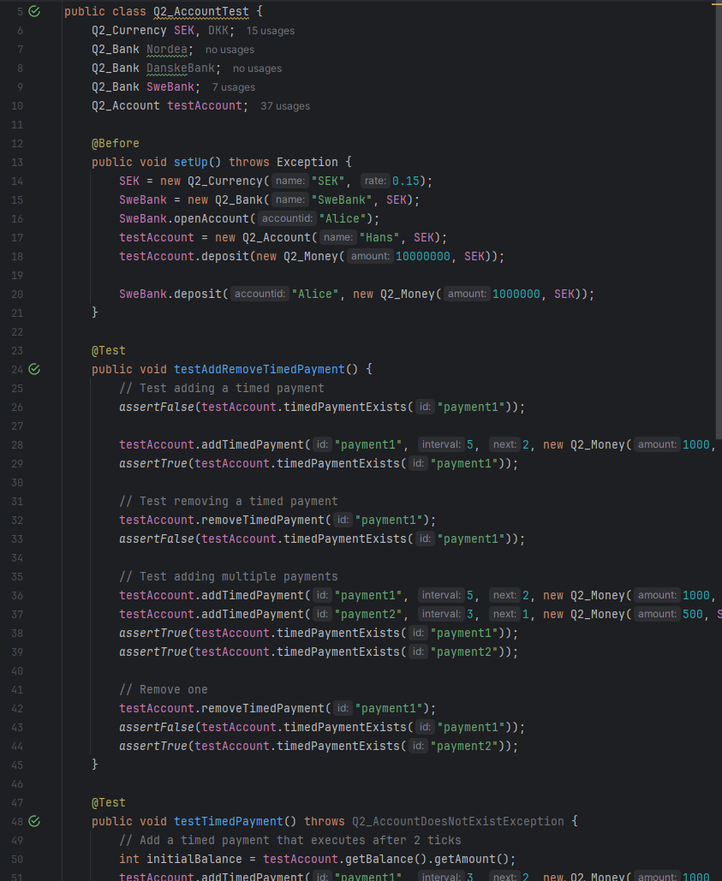
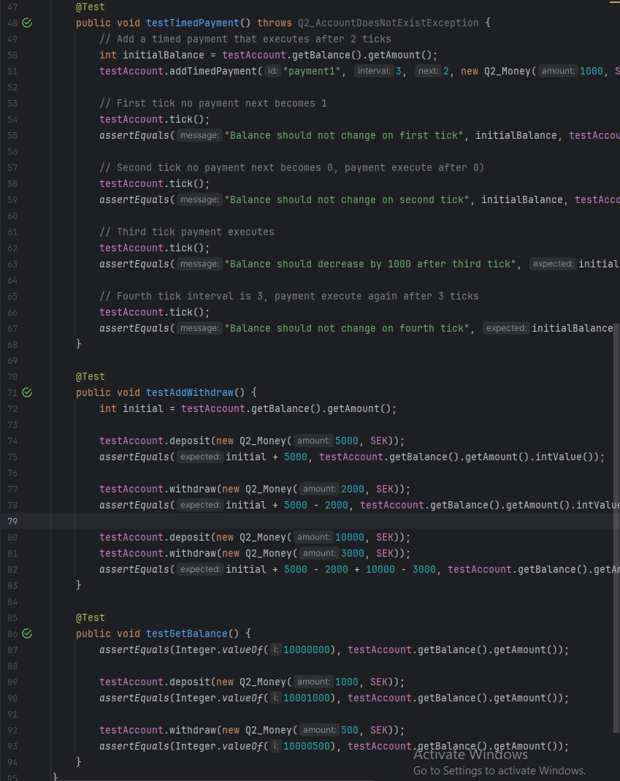
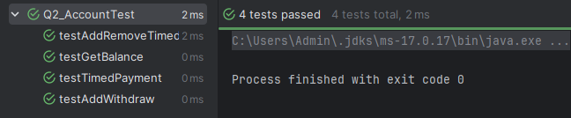

- Bank test:
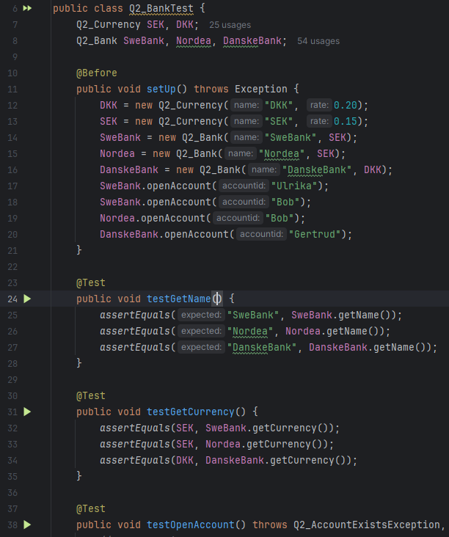
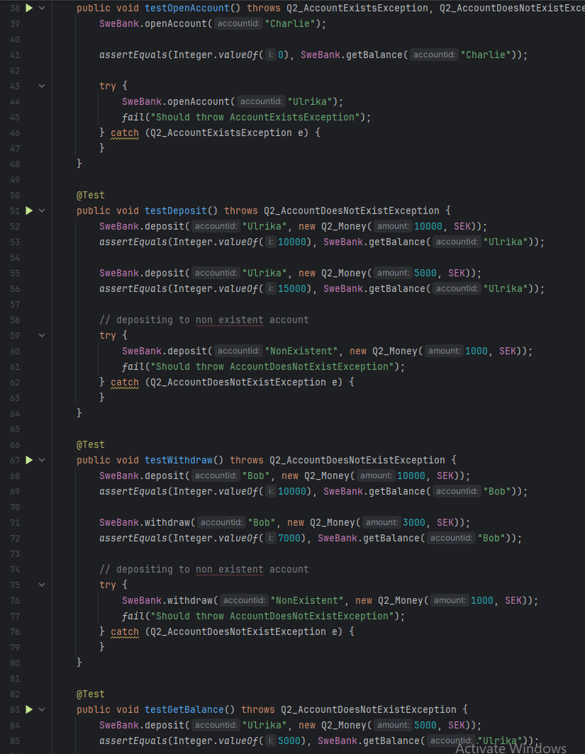
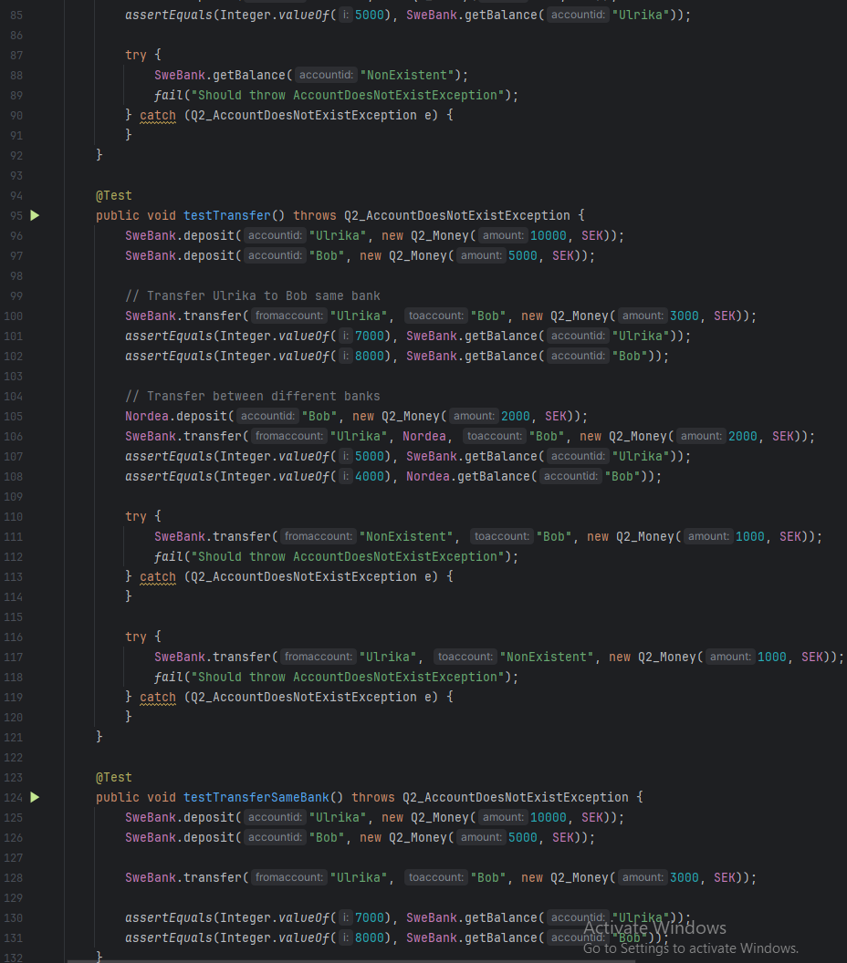
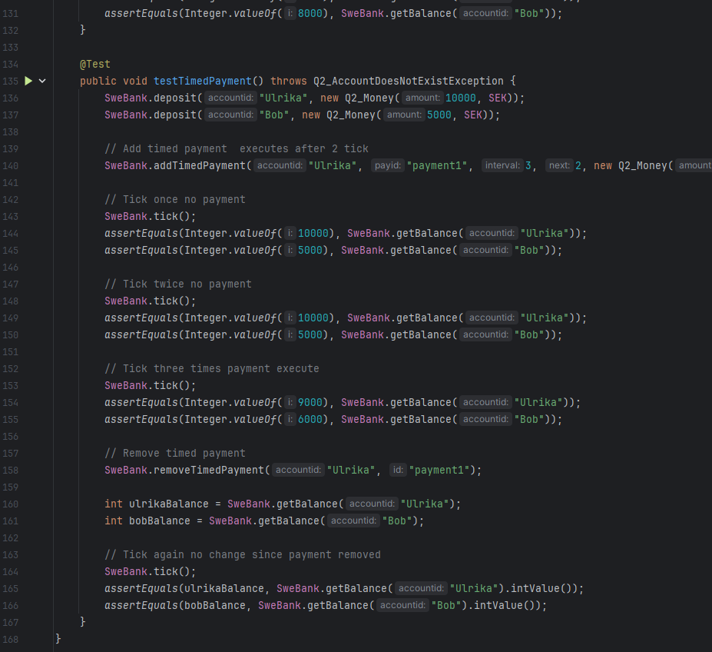
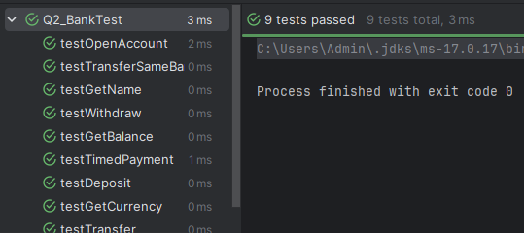

-Currency test
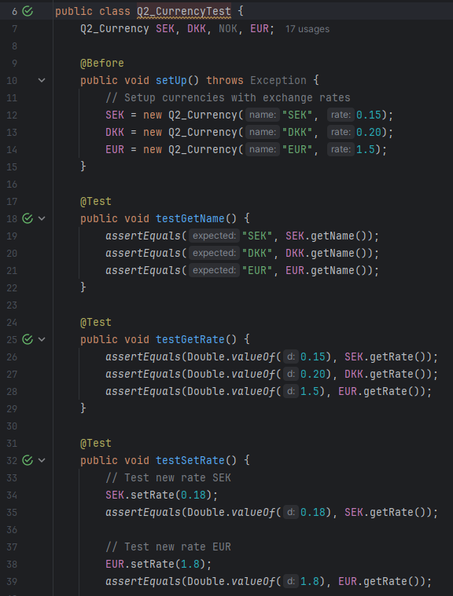
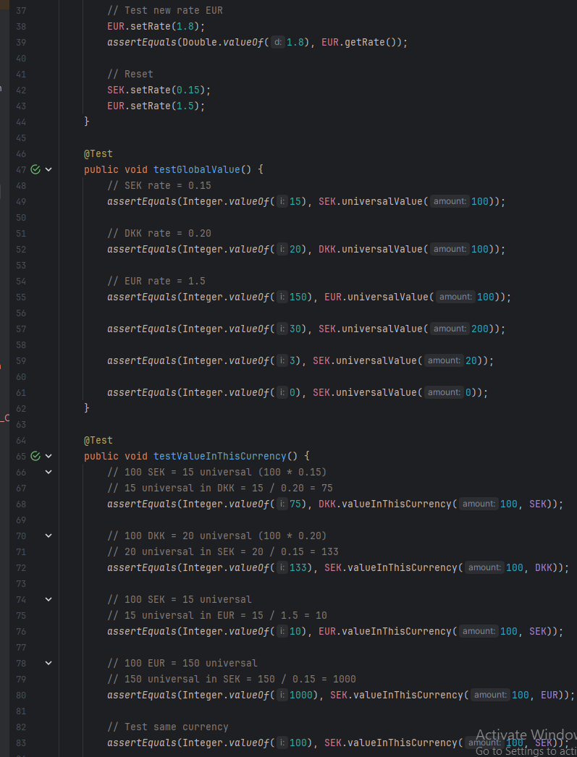
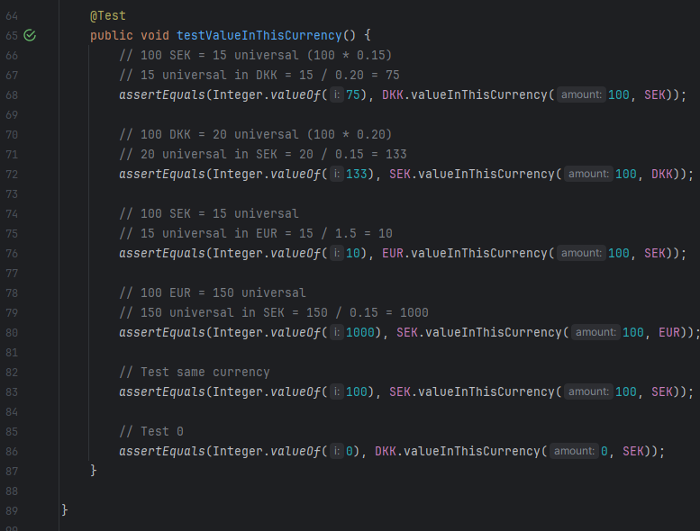
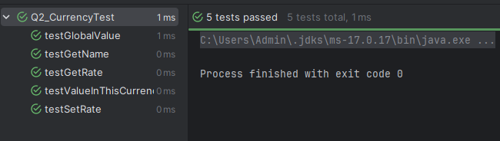

-Money test:
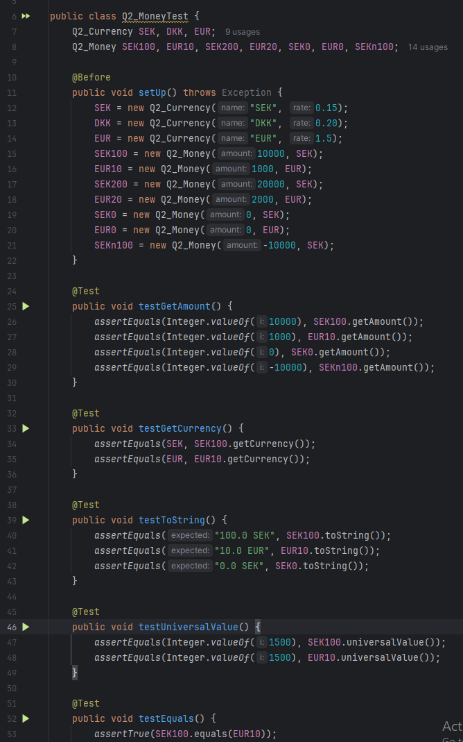
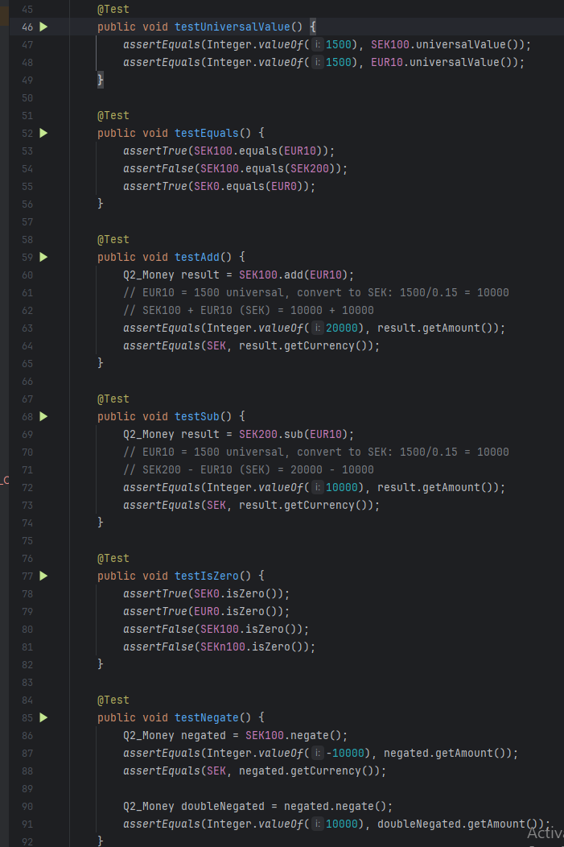
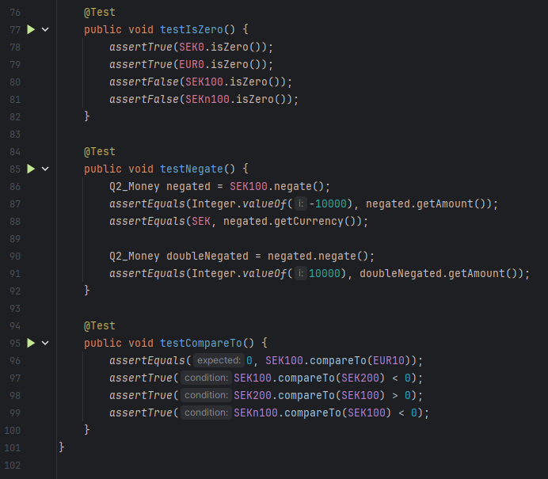
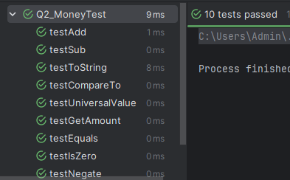

Bonus Points
3. A parking garage has a number of parking spaces for vehicles. The parking garage must keep track of the vehicles that are currently parked there so that it can report the number of parking spaces available and the current value. A parking garage must provide publicly available functions that are called when a vehicle enters and exits the garage. It can throw exceptions if there is insufficient available space in the garage, if a vehicle tries to enter that is already in the garage, or if a car that is not in the garage tries to exit.
Additionally, the garage must provide publicly available functions that report the total capacity of the
garage, the number of available spaces in the garage, and the total money collected. The parking fee is assessed when a vehicle enters the parking garage.
Currently, there are three distinct types of vehicles: cars, low-emission cars, and cargo trucks. Every vehicle has a license number consisting of letters and/or numbers and the number of parking spaces it occupies. Cars have a passenger capacity (i.e., the number of passengers). Trucks have a gross vehicle weight it can transport. Cars take up one space, while trucks take up a number of spaces that is their gross weight divided by 10,000. Cars are charged a rate of $8, low-emission cars are charged half that rate, and trucks are charged $10 per 10,000 pounds of gross weight.Develop a software based on TDD to solve the above problem.60 Points

