Phạm Trần Gia Hưng MSSV:2331200153

- Use the attached files “Circle-Radius.java” and “Circle-Radius-Test.java”. Add the code in the main function to accommodate the last test case that is when test data is "abc"

Bug:

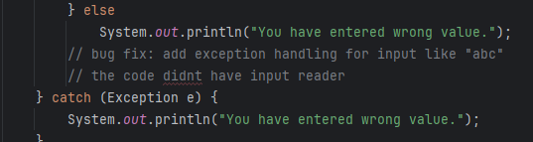
Test:

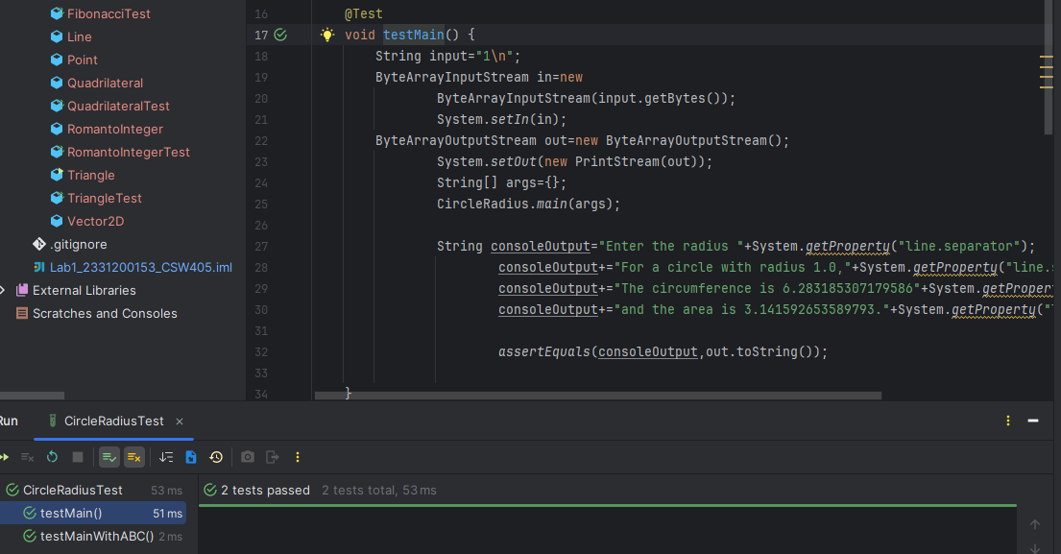
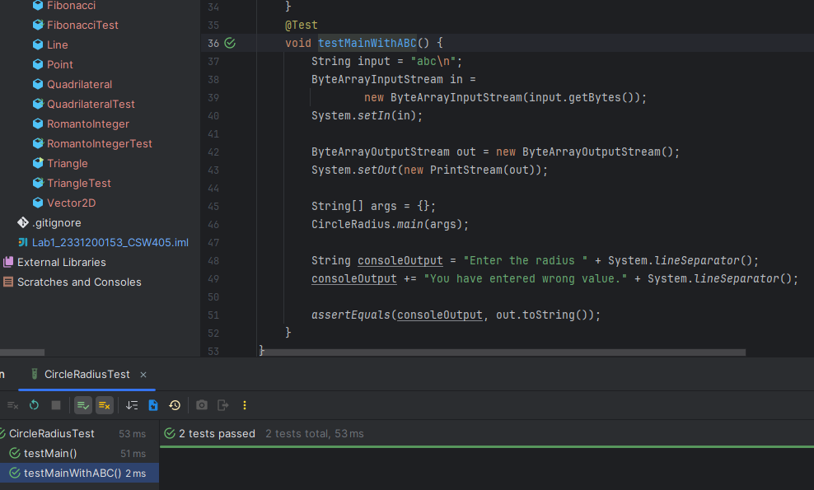

2. Consider the file “RomantoInteger.java”. This program implements a program that converts a Roman numeral that is in form of a String, to an integer. The Roman numeral system is based on seven essential numerals: I, V, X, L, C, D, and M (1, 5, 10, 50, 100, 500, and 1,000, respectively). So, rules are
a. We can’t add more than three of the same Roman numeral together
b. If a numeral comes after a numeral that is larger or equal in value, then it must be added to the numeral before it.
c. Smaller numeral placed before a larger numeral indicates subtraction of that smaller numeral from the larger one.
d. We can’t subtract more than one value from a Roman numeral. Example of test cases for this program:

Bug:
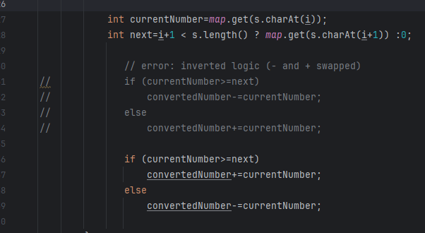

Test:

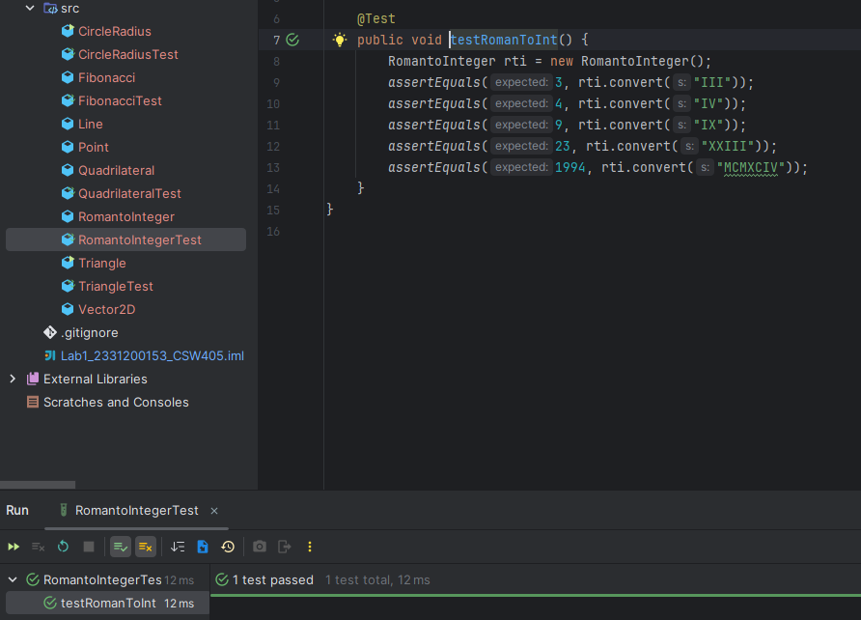

- Consider Triangle.java file. Test the main method and isTriangle() method
Bug:
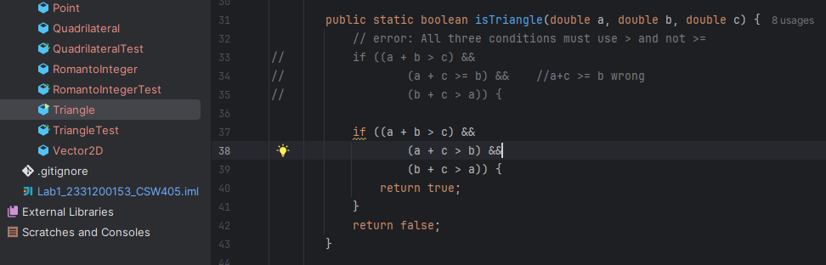

Test:
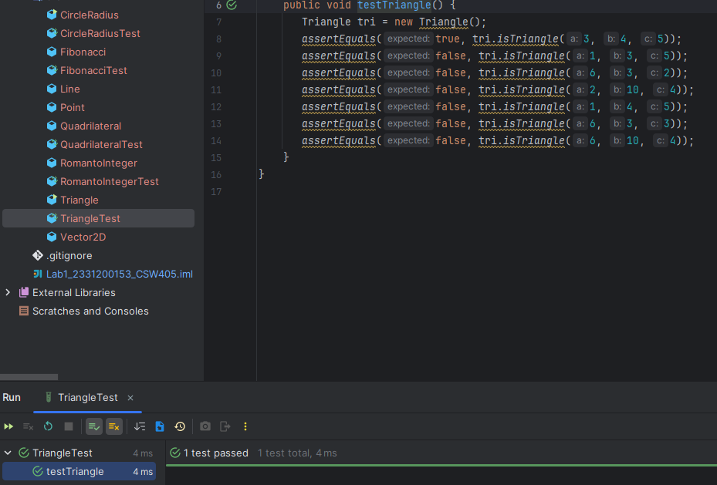

4. Look at the Fibonacci class. This class is an attempt at implementing the recursive method fib, which should generate the nth Fibonacci number. Create test cases for this class and run those test cases using Junit
Bug:
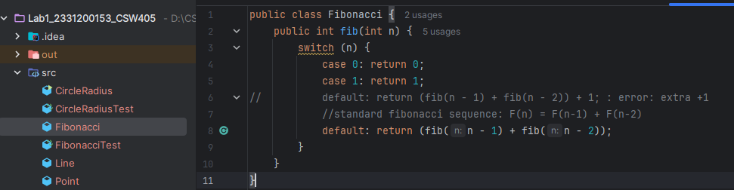

Test:
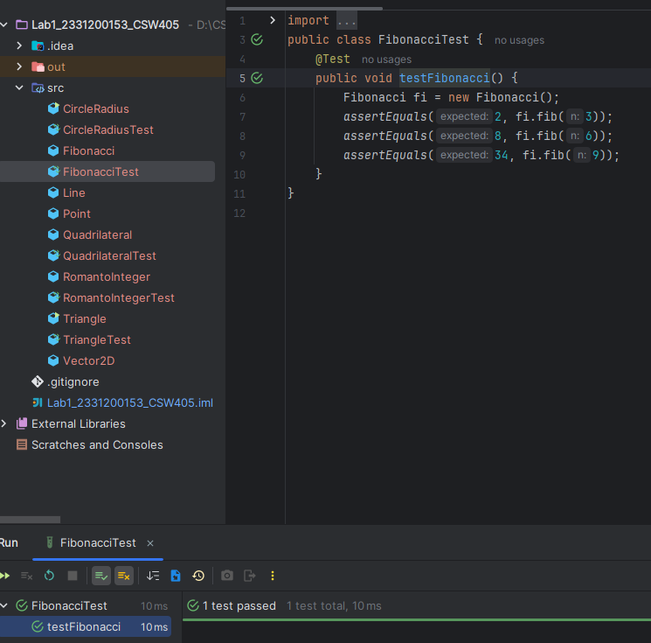

5. The Quadrilateral class denotes a polygon with four sides. It has two methods, isRectangle() and isSquare(). Furthermore, it also uses the classes Point, Line and Vector2D. To find if the polygon is a rectangle, vectors and dot products are used to determine if every corner forms a right angle. To find if the polygon is a square, isRectangle() is used and check if the lengths of all sides are equal

Bug:

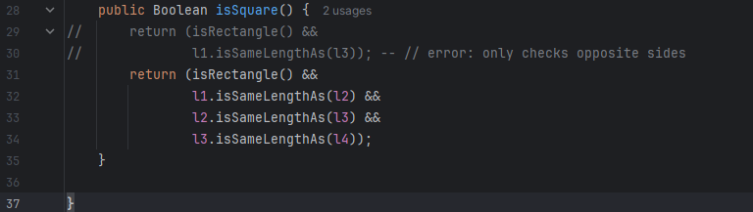

Test:

