Phạm Trần Gia Hưng - 2331200153
Practice Assignment 7

Consider the function find-intersection(m1,c1,m2,c2) in Intersection.java The program computes the intersection point of two straight lines and displays the result. It reads two integer pairs (m1, c1) and (m2, c2) defining the two straight lines of the form y=mx + c.

Create test cases for this program using equivalent class partitions and execute them

Question 1

Bug in intersection:

error: coincidental lines require both conditions: (m1 - m2) == 0 and (c1 - c2) == 0, c1-c2==0 is in the else branch so it only runs when (m1 - m2) != 0 so it an error

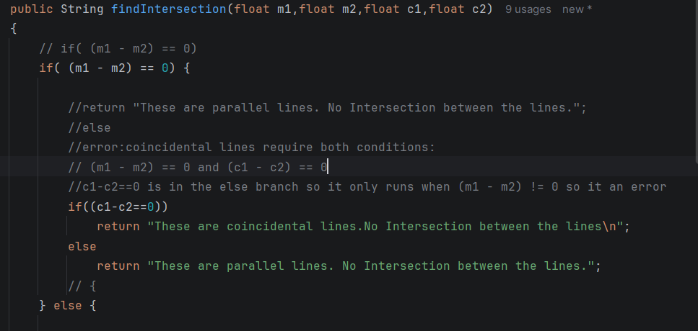

Testcase:

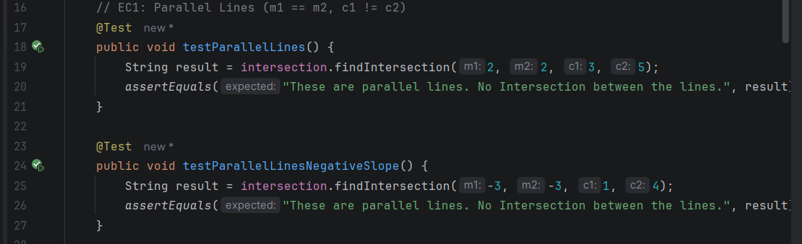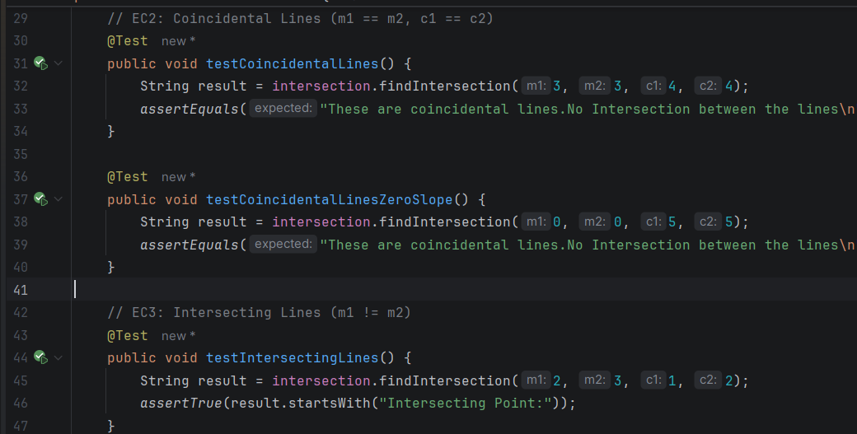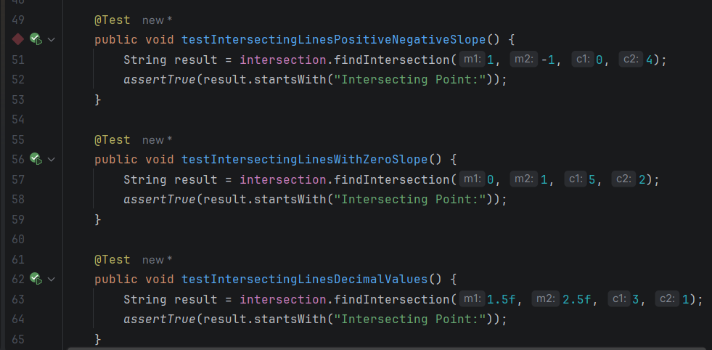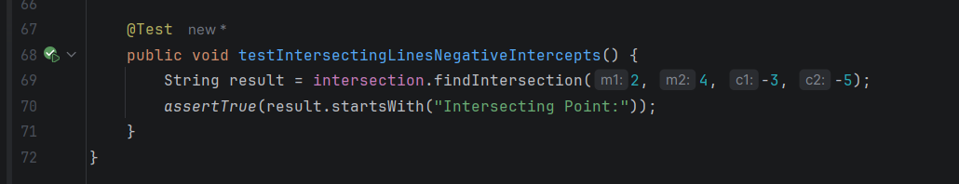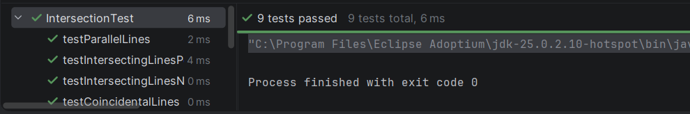

Equivalence Classes:
 | Condition | Description | Expected Output
ec1 | m1 = m2, c1 =/ c2 | Parallel lines | Parallel lines
ec2 | m1 = m2, c1 = c2 | Coincidental lines | Coincidental lines
ec3 | m1 =/ m2 | Intersecting lines | Intersecting Point: X Y
Test Cases:
 | m1 | m2 | c1 | c2 | EC | Expected
tc1 | 2 | 2 | 3 | 5 | ec1 Parallel | Parallel lines
tc2 | -3 | -3 | 1 | 4 | ec1 Parallel | Parallel lines
tc3 | 3 | 3 | 4 | 4 | ec2 Coincidental | Coincidental lines
tc4 | 0 | 0 | 5 | 5 | ec2 Coincidental | Coincidental lines
tc5 | 2 | 3 | 1 | 2 | ec3 Intersecting | Intersecting Point
tc6 | 1 | -1 | 0 | 4 | ec3 Intersecting | Intersecting Point
tc7 | 0 | 1 | 5 | 2 | ec3 Intersecting | Intersecting Point

2. Consider the Quadric_Equation.java file. It determination of the nature of roots of a quadratic equation. Its input are positive integers (say a,b,c) and values may be from interval [0,200]. The program output may have one of the following words.

Not a quadratic equation

Real roots

Imaginary roots

Equal roots.

Test the calculateroot() using Equivalence Class Partition and Boundary Value Analysis

Question 2

Testcase:

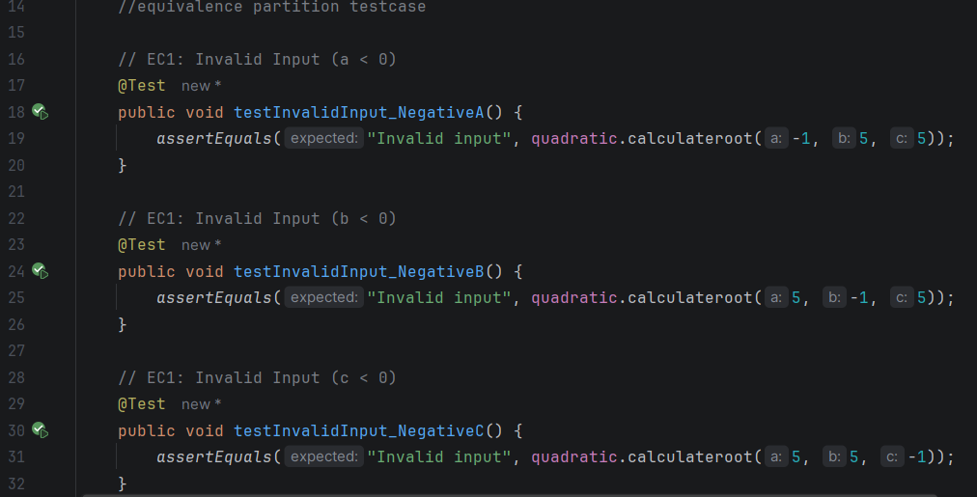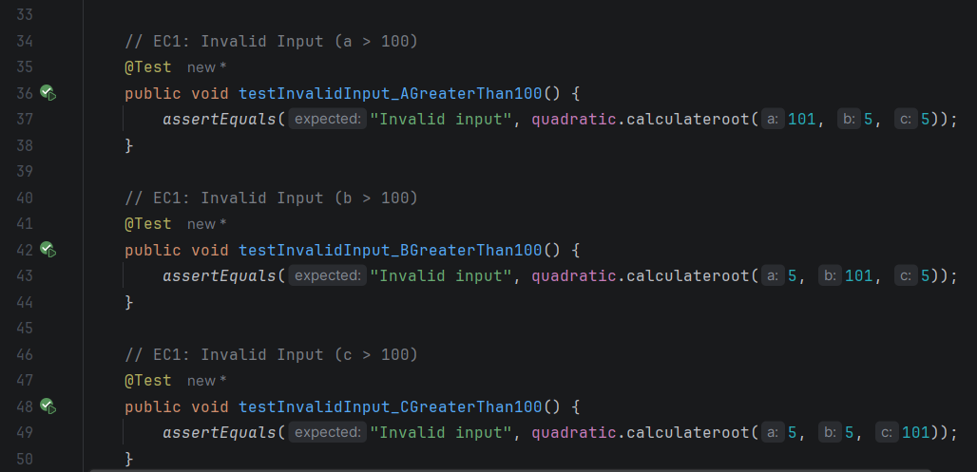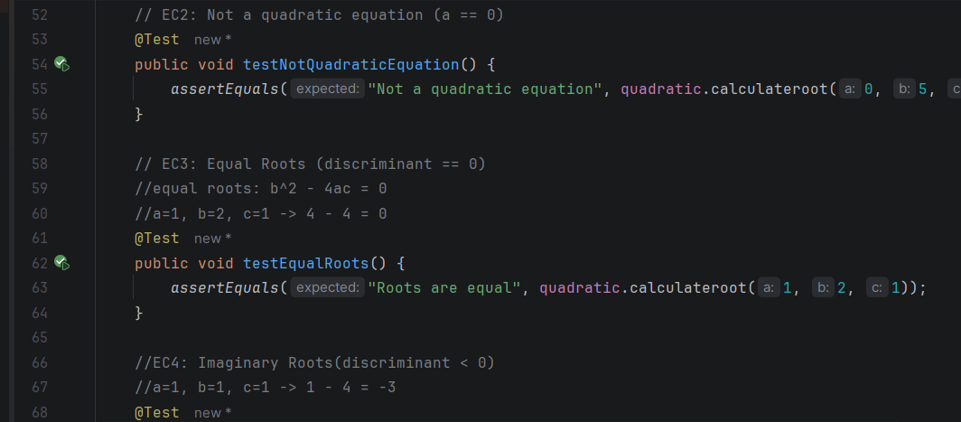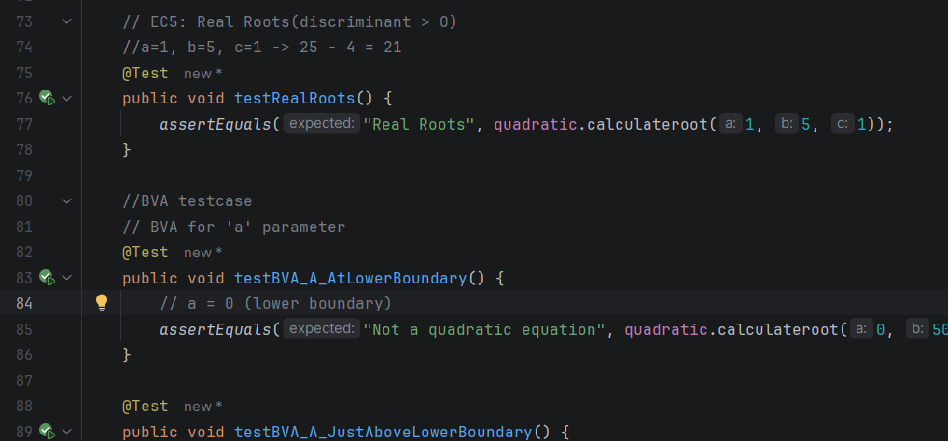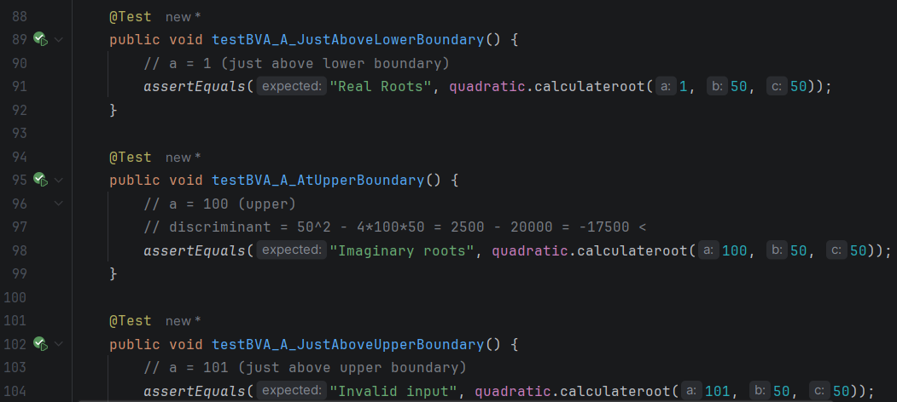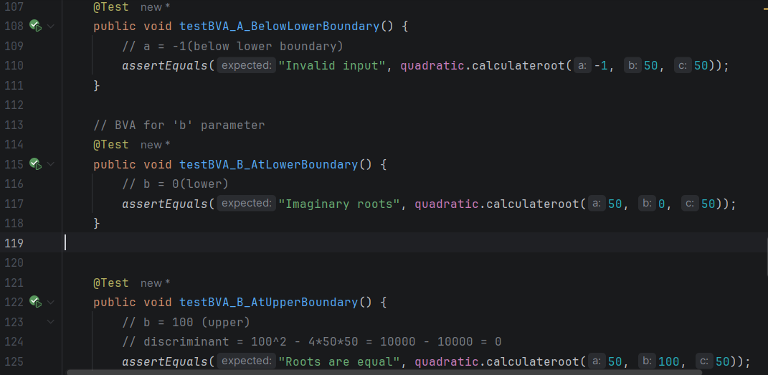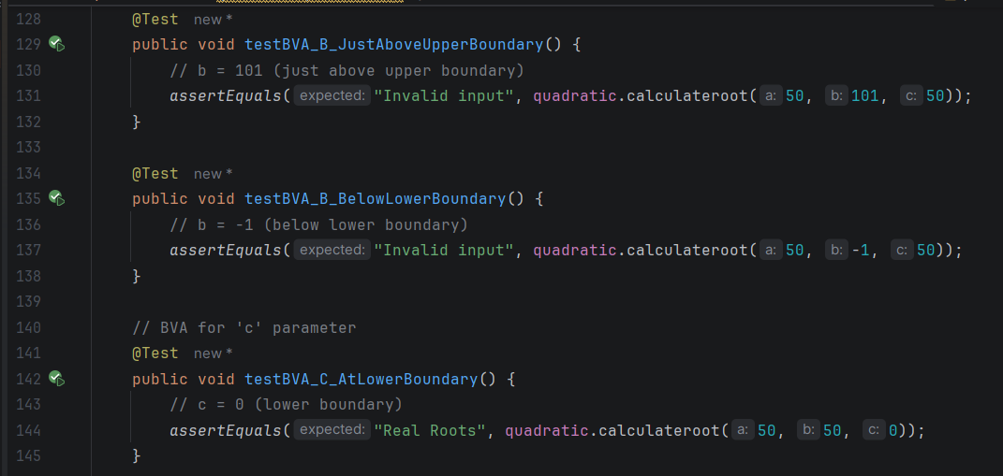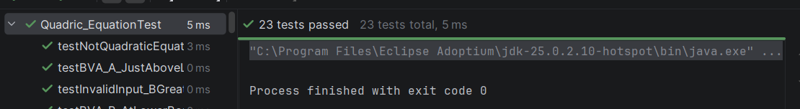

Equivalence Classes:
 | Condition | Expected Output
ec1 | a<0 or b<0 or c<0 or a>100 or b>100 or c>100 | Invalid input
ec2 | a = 0 (with valid b, c) | Not a quadratic equation
ec3 | discriminant (b^2 -4ac) = 0 | Roots equal
ec4 | discriminant (b^2 -4ac) < 0 | imagined roots
ec5 | discriminant (b^2 -4ac) > 0 | real Roots

ECP Test Cases:
Test ID | a | b | c | Discriminant | EC | Expected
tc1 | -1 | 5 | 5 | na | ec1 | Invalid input
tc2 | 5 | -1 | 5 | na | ec1 | Invalid input
tc3 | 5 | 5 | -1 | na | ec1 | Invalid input
tc4 | 101 | 5 | 5 | na | ec1 | Invalid input
tc5 | 0 | 5 | 5 | na | ec2 | Not a quadratic eq
tc6 | 1 | 2 | 1 | 0 | ec3 | Roots equal
tc7 | 1 | 1 | 1 | -3 | ec4 | Imagine roots
tc8 | 1 | 5 | 1 | 21 | ec5 | Real Roots

BVA Test Cases
 | a | b | c | Boundary Tested | Expected
bva1 | 0 | 50 | 50 | a at lower boundary (0) | Not a quadratic eq
bva2 | 1 | 50 | 50 | a just above lower (1) | Real Roots
bva3 | 100 | 50 | 50 | a at upper boundary (100) | Imaginary roots
bva4 | 101 | 50 | 50 | a just above upper (101) | Invalid input
bva5 | -1 | 50 | 50 | a below lower (-1) | Invalid input
bva6 | 50 | 0 | 50 | b at lower boundary (0) | Imagine roots
bva7 | 50 | 100 | 50 | b at upper boundary (100) | Roots equal
bva8 | 50 | 101 | 50 | b just above upper (101) | Invalid input
bva9 | 50 | 50 | 0 | c at lower boundary (0) | Real Roots
bva10 | 50 | 50 | 100 | c at upper boundary (100) | Imagine roots
bva11 | 50 | 50 | 101 | c just above upper (101) | Invalid input

