

Requirement & Design Specification

**PawHouse**

**Version: 1.0**

– Can Tho, January 2025 –

# Member

| # | Full name | Student ID | Account |
| --- | --- | --- | --- |
| 1 | Phan Thành Hưng | CE180265 | HungPT |
| 2 | Võ Chánh Huy | CE181002 | HuyVC |
| 3 | Nguyễn Huỳnh Chấn Hưng | CE180150 | HungNHC |
| 4 | Trương Phú Hưng | CE180618 | HungTP |
| 5 | Trần Hữu Tín | CE180262 | TinTH |
| 6 | Huỳnh Hoàng Huy | CE181847 | HuyHH |

**Revision History**

# 

*A - Added M - Modified D - Deleted

| **Version** | **Date** | **A,M,D** | **Assignee** | **Change Description** |
| --- | --- | --- | --- | --- |
| 0.1 | 12/1/2025 | A | HuyHH | Write base for SRS Document |
| 0.2 | 13/1/2025 | A | HungPT | Draw ERD and write Entities description |
| 0.3 | 13/1/2025 | A | HungNHC | Write SRS - II.4 - Customer Management Screen |
| 0.4 | 13/1/2025 | A | TinTH | Write SRS - II.1 - Login Screen |
| 0.5 | 13/1/2025 | A | HuyVC | Write SRS - II.2 Forgot Password Screen |
| 0.6 | 13/1/2025 | A | HungTP | Write SRS - II.5 - Product Management Screen |
| 0.7 | 13/1/2025 | A | HungPT | Write SRS - II.6 - Order Management Screen |
| 0.8 | 13/1/2025 | A | TinTH | Write SRS - II.2 DashBoard Screen |

Contents

Record of Changes 2

I. Overview 4

1. User Requirements 4

1.1 Actors 4

1.2 Use Cases 4

2. Overall Functionalities 5

2.1 Screens Flow 5

2.2 Screen Descriptions 5

2.3 Screen Authorization 5

2.4 Non-UI Functions 6

3. System High Level Design 6

3.1 Database Design 6

3.2 Code Packages 7

19

# I. Overview

## 1. User Requirements

### 1.1 Actors

*Welcome to* ***PawHouse****, the ultimate website for pet care and a vibrant community for animal lovers! PawHouse is not just a platform for finding valuable information about pet care but also a shared home where people come together to exchange experiences and express their love for pets*

| **#** | **Actor** | **Description** |
| --- | --- | --- |
| 1 | Admin | The administrator of the system who has full access to all features and functionalities. Responsible for managing the website's operations, such as user accounts, product listings, orders, and reports. |
| 2 | Guest | Unregistered users who can browse the website without logging in. Guests can view basic product information, explore content about pet care, and initiate the registration process to become a customer. |
| 3 | Customer | Registered users who have logged into the system. Customers can manage their profiles, place orders, track order history, update payment information, and provide feedback. They are the primary target audience for the platform's services |
| 4 | Staff | Employees who assist in managing daily operations. Staff members can handle tasks such as managing orders, updating product details, and generating reports. They have limited access to administrative features and focus on operational tasks. |
| 5 | Doctor | Veterinary doctors who provide medical services for pets. They can manage appointments, view and update patient (pet) records, write medical reports, prescribe medicines, and communicate with pet owners. |

### 1.2 Use Cases

1. **Guest ,Customer:**

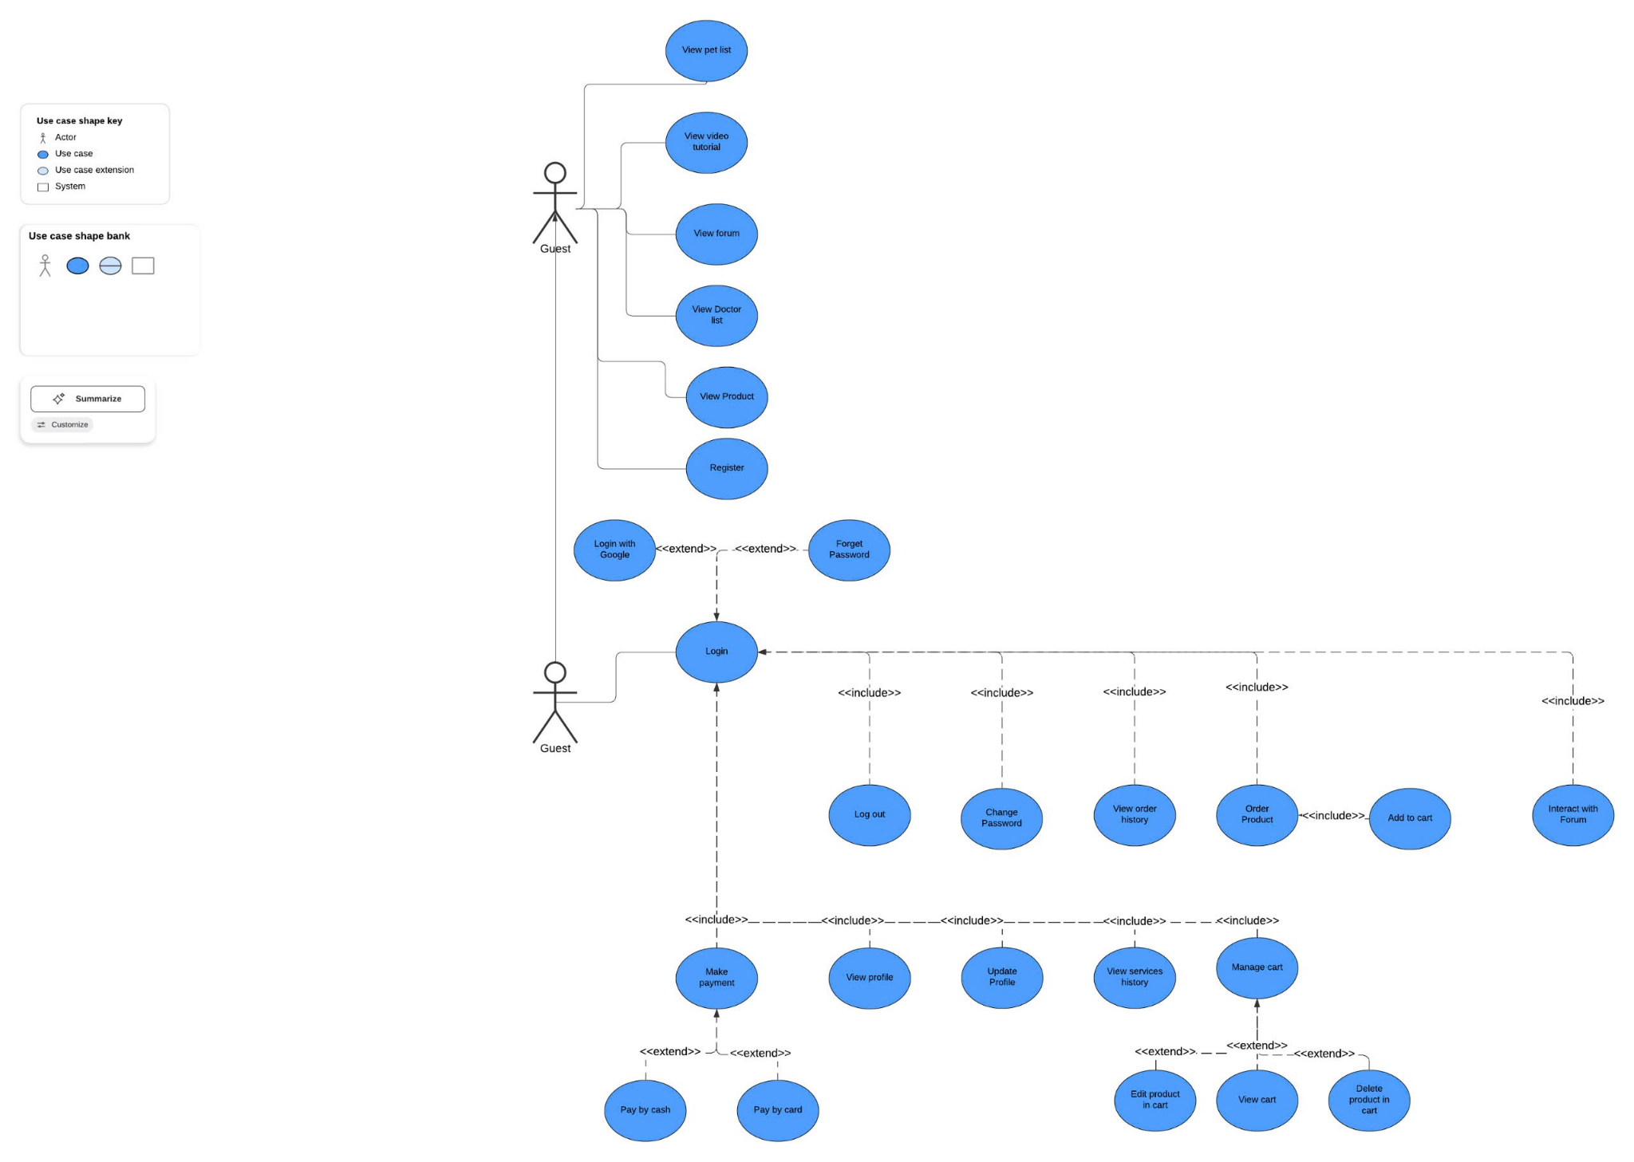

1. **Admin, Staff, Doctor:**

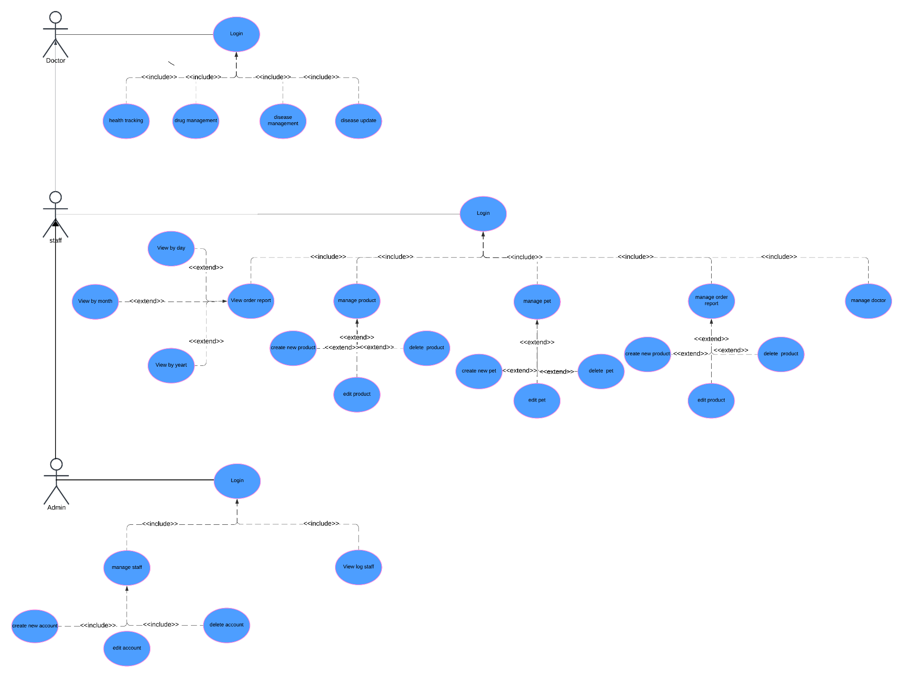

#### b. Descriptions

*This part describes the use cases, you can follow the table form as below*

| **ID** | **Feature** | **Use Case** | **Use Case Description** |
| --- | --- | --- | --- |
| 01 | Login | Login | Allow registered account to log in to the wedsite by email and password |
| 02 | Login with Google | Login with Google | Allow User can login to website with Google Account |
| 03 | Register | Resgister | Allow guests to register a new account to log in to the website |
| 04 | View Profile | View ProFile | Allow guests can view their profile with basic information |

## 2. Overall Functionalities

### 2.1 Screens Flow

*[This part shows the system screens and the relationship among screens. You can draw the Screens Flow for the system in the form of diagram as below. Please note that beside the normal flat screen, we might have the oval notation for pop-up screen (Import Order) or a screen with multiple information tab (Order Details), etc. You may also use text or background format for different visuality purpose]*

### 2.2 Screen Descriptions

*[Provide the descriptions for the screens in the Screens Flow above]*

| **#** | **Feature** | **Screen** | **Description** |
| --- | --- | --- | --- |
| 1 | Order Meals | Create Order | <<Screen Brief description>> |
| 2 | Order Meals | Change Order |  |
| 3 | .. |  |  |

### 2.3 Screen Authorization

| **Screen/Function** | **Role-Guest** | **Role**  **Customer** | **Role**  **Admin** | **Role-Staff** | **Role**  **Doctor** |
| --- | --- | --- | --- | --- | --- |
| **Home** | X | X | X | X | X |
| **Login** | X | X | X | X | X |
| **Login With Google** | X | X |  |  |  |
| **Register** | X | X |  |  |  |
| **Forget Password** | X | X |  |  |  |
| **User** |  | X |  |  |  |
| **Update Profile** |  | X |  |  | X |
| **Changle Password** |  | X |  |  | X |
| **View history order** |  | X |  |  |  |
| **View history medical** |  |  | X |  | X |
| **Logout** |  | X | X | X | X |
| **Cart** |  | X |  |  |  |
| **Payment information** |  | X |  |  |  |
| **Payment** |  | X |  |  |  |
| **Dashboard** |  |  | X | X | X |
| **Confirm Order** |  |  | X | X |  |
| **List Order** |  |  | X | X |  |
| **Update Order** |  |  | X | X |  |
| **Add Product** |  |  | X | X |  |
| **Edit Product** |  |  | X | X |  |
| **Report by day** |  |  | X | X |  |
| **Report by month** |  |  | X | X |  |
| **Manage Appointments** |  |  |  |  | X |
| **View Patient Records** |  |  |  |  | X |
| **Write Medical Reports** |  |  |  |  | X |
| **Prescribe Medicine** |  |  |  |  | X |
| **Communicate with Patients** |  |  |  |  | X |
| **Report by year** |  |  | X | X |  |
| **List** |  |  | X |  |  |
| **Add Staff** |  |  | X |  |  |
| **Edit Staff** |  |  | X |  |  |
| **View Log Staff** |  |  | X |  |  |

### 2.4 Non-UI Functions

*[Provide the descriptions for the functions which have no UI (or not screens), i.e batch/cron job, service, API, etc.]*

| **#** | **Feature** | **System Function** | **Description** |
| --- | --- | --- | --- |
| 1 | <<Feature Name>> | <<Function Name1>> | <<Function Name1 Description>> |
| 2 | … |  |  |

## 3. System High Level Design

### 3.1 ERD

### 3.2. Database Design

*[Provide the tables relationship like example below]*

#### a. Database Schema

#### b. Table Descriptions

| **No** | **Table** | **Description** |
| --- | --- | --- |
| *01* | *<Table name>* | *<Description of the table>*  *- Primary keys: <<list of primary key fields>>*  *- Foreign keys: <<list of foreign key fields>>* |
| *02* | *<Table name2>* | *…* |