

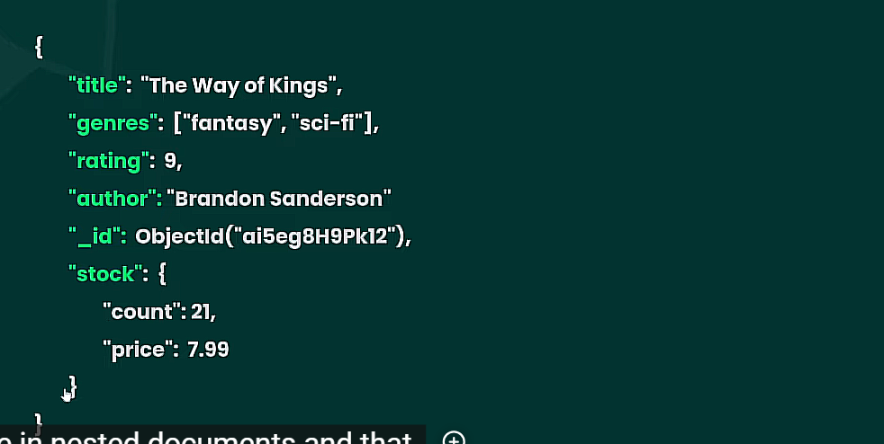

Long nhau

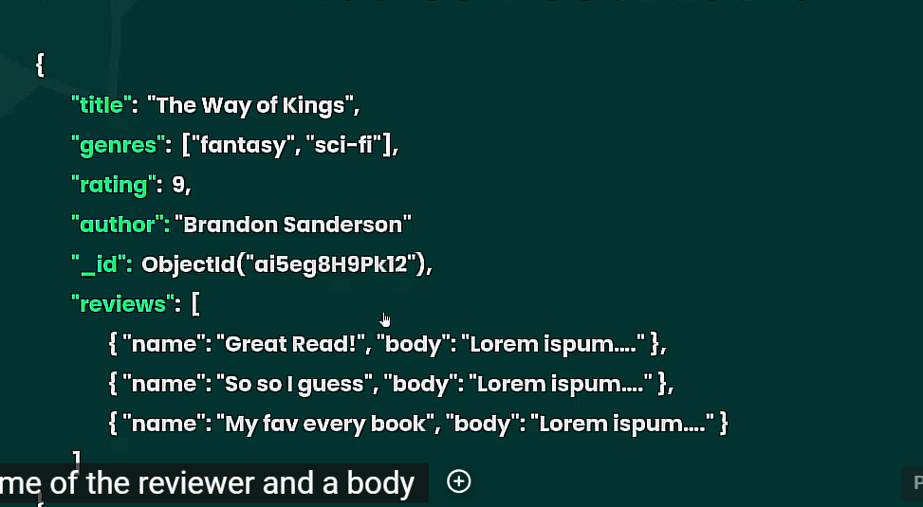

bookstore> db.books.insertMany([{title: "The Light Fantastic", author: "Terry Pratchett", pages: 250, rating: 6, genres: ["fantasy", "magic"], reviews: [{name:"luigi", body: "it was pretty good"}, {name: "bowser", body: "loved it!!"}]}, {title: "The Name of the Wind", "author": "Patrick Rothfuss", page: 500, "rating": 10, genres: ["fantasy"], review: [{name: "peach", body: "one of my favs"}]}, {title: "The Color of Magic", "author": "Terry Pratchett", page: 350, "rating": 8, genres: ["fantasy", "magic"], review: [{name: "luigi", body: "it was ok"}, {name: "bowser", body: "really good book"}]}, {title: "1984", "author": "George Orwell", page: 300, "rating": 6, genres: ["sci-fi", "dystopian"], review: [{name: "peach", body: "not my cup of tea"}, {name: "mario", body: "meh"}]}] )

{

acknowledged: true,

insertedIds: {

'0': ObjectId('65fe897cb7add1f9e28bf203'),

'1': ObjectId('65fe897cb7add1f9e28bf204'),

'2': ObjectId('65fe897cb7add1f9e28bf205'),

'3': ObjectId('65fe897cb7add1f9e28bf206')

}

}