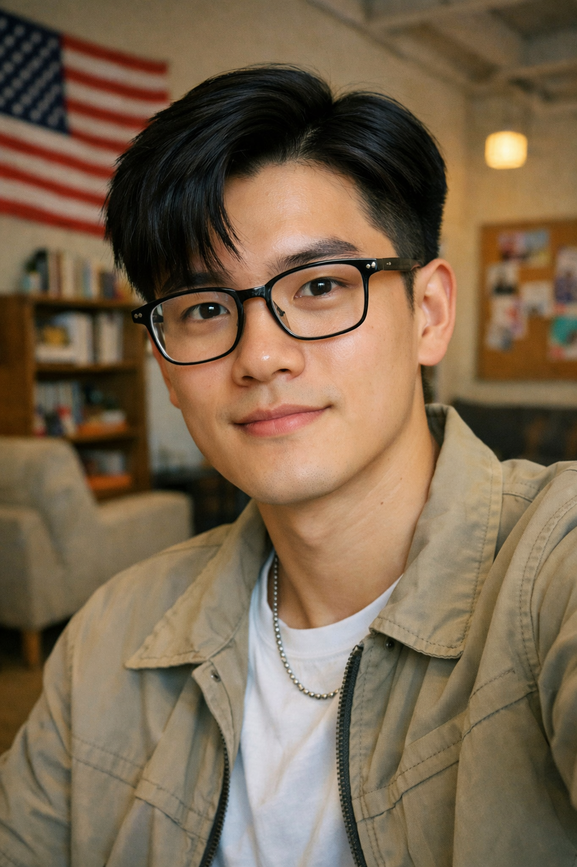
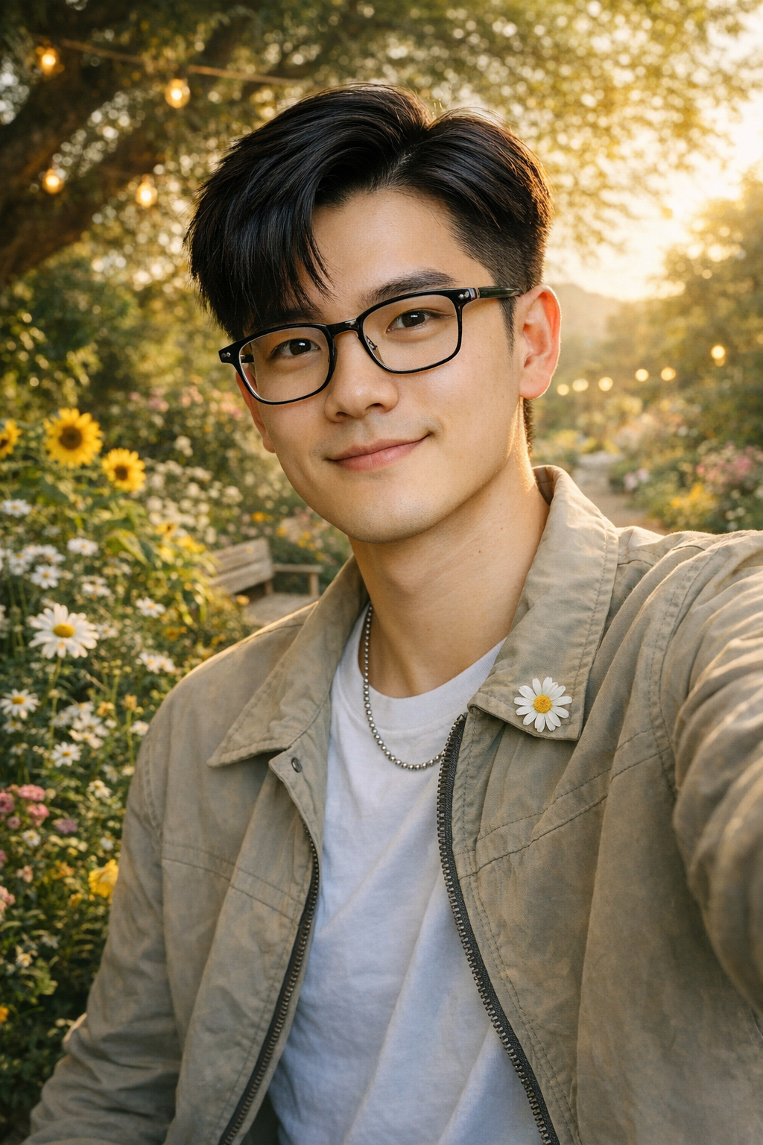
Reflection:
AI has access to a large pool of both visual and nonvisual information, which allows it to create identities based on patterns and existing data. Because of this, the identity AI constructs is mainly a combination of perceptions rather than a true reflection of who a person is. Even when humans are involved in shaping the prompt, the result still lacks authenticity. From my experience, the images generated by ChatGPT from my prompts did not accurately represent my real identity.
AI is very capable of producing images that visually resemble an individual if the input is specific enough. This is made possible by its ability to match data and draw from a wide range of references. However, AI struggles to understand and represent deeper human qualities. Many important aspects of identity are internal, emotional, or value based, which makes them difficult to show through images.
This limitation was especially clear in the second image I generated. When I asked AI to reflect my love for nature, it simply placed me in a natural environment. My connection to nature is not just about scenery but also about values like environmental care and responsibility. Similarly, traits such as treating people kindly or feeling fulfilled in life are abstract and cannot be easily visualized. As a result, the identity created by AI feels incomplete and fails to fully capture who I am.

Tools used:
ChatGPT image generation tool
Prompts (or prompt summary)
Prompt 1: Create a selfie of myself according to this description: I'm a 21-year-old Vietnamese international student at a private liberal arts in the US. I have pretty "squarish" face, wearing glasses, 7/3 side part relaxing black hair, kinda stylish.
Prompt 2: Now alter the selfie that factors in these facts about myself: treat people very nice and love nature, want to advocate for equality and peace, successful in life and always feel fulfilled about everything I did
What the AI generated
The AI generated two realistic looking selfies. The first image focused mainly on my physical appearance and student identity. The second image placed me in a nature themed environment with visual elements like greenery and flowers to represent my love for nature.
What you changed or decided
I did not directly edit the images, but I reflected on how the AI interpreted my prompts. I evaluated what aspects of my identity were emphasized visually and what aspects were missing, especially abstract traits that could not be clearly represented in an image.

