**PRU212_LAB01**

# **Scene1: Level1**

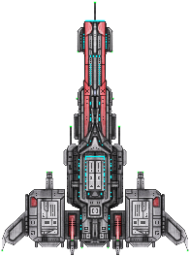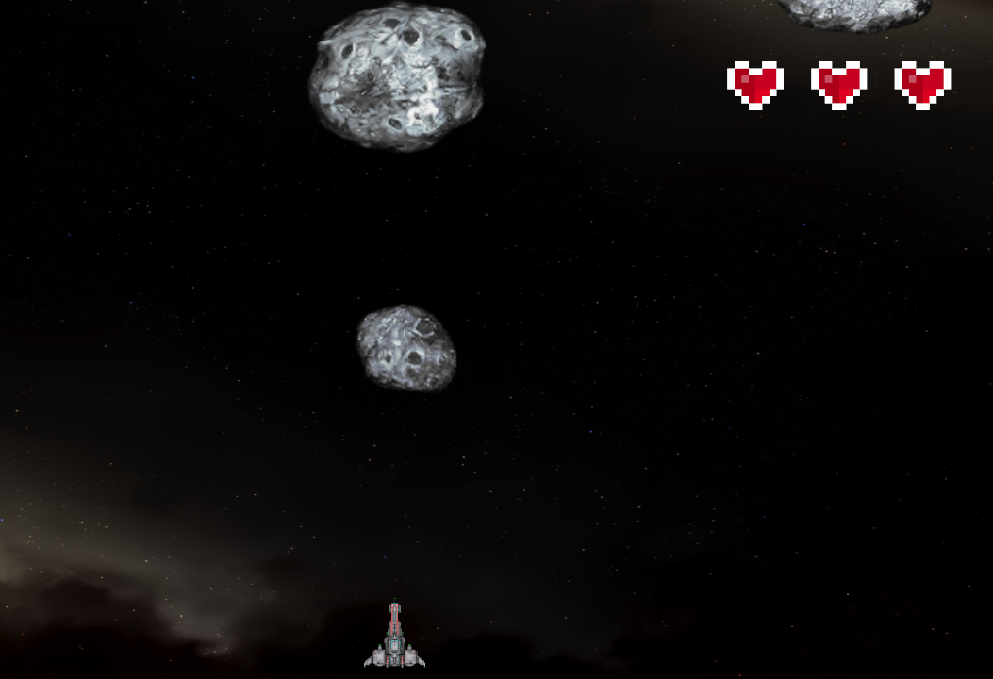

* Winning Condition: Reach Required Scored
* Enemy: Asteroids
* Award:
  + Ring: Add Point
  + Kills on Asteroids: Add Point

# **Scene2: Level2**



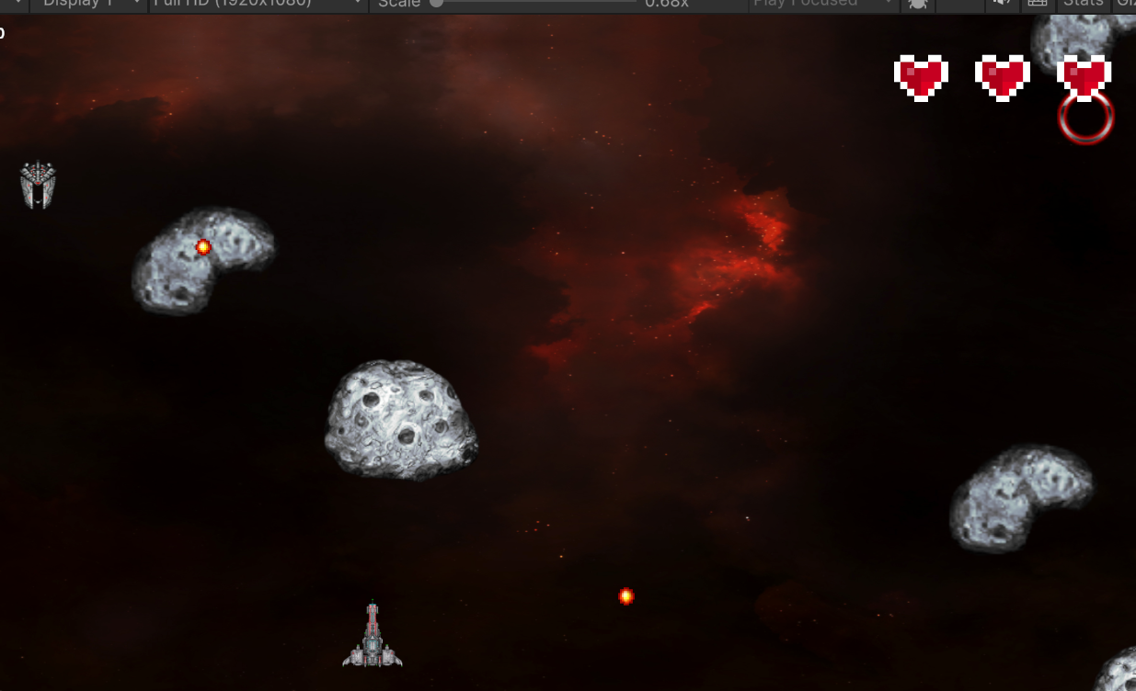

* Winning Condition: Reach Required Scored
* Enemy: Asteroids, Aliens
* Award:
  + Ring: Add Point
  + Kills on Asteroids: Add Point
  + Kills on Aliens: Add Point

# **Scene3: Level3**

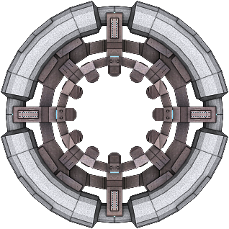

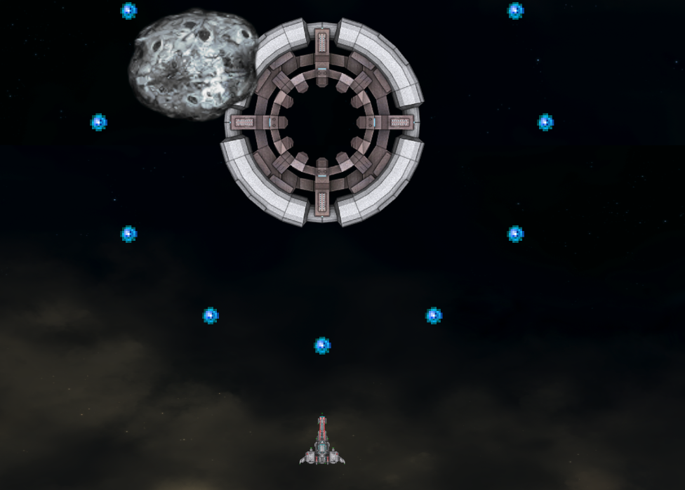

* Winning Condition: Kill boss
* Enemy: Asteroids, Aliens, Boss