Extending Granular Ball Twin Support Vector Machine for Multi-class Classification
Hung.C Nguyen¹[0009-0003-2194-3876] and Quang-Thinh Bui²[0000-0002-7357-2574]
¹ HUTECH University, Ho Chi Minh City, Vietnam
² Tien Giang University, Tien Giang, Vietnam
buiquangthinh@tgu.edu.vn
Abstract. Multi-class classification is a key area in machine learning, with Support Vector Machines (SVMs) and their variant, Twin SVM (TSVM), showing significant effectiveness in various applications. Recently, Granular Ball Twin SVM (GBTSVM) was introduced, combining Granular Computing with TSVM to reduce data noise and enhance performance, and it has been applied in several prior studies to multi-label classification tasks. This paper proposes Granular Ball Twin Support Vector Machine for Multi-class Classification (GBTSVM_MC), a novel method to extend GBTSVM for multi-class tasks. GBTSVM_MC employs two decomposition strategies, One-vs-One (OvO) and One-vs-Rest (OvR), to handle multi-class datasets. It leverages TSVM’s strong classification ability and the computational efficiency of granular balls while improving computation for multi-label issues. To experimental evaluation of the performance of GBTSVM_MCC on diverse datasets along with additional testing on large datasets, thereby verifying the scalability and practical applicability of the model.
Keywords: Key Word: Multi-class Classification, Support Vector Machine, Twin Support Vector Machine, Granular Ball Computing, Noise Resistance, Large Scale Dataset
- Introduction (đã sửa)
In the field of machine learning, classification algorithms have made significant strides, with Support Vector Machines (SVMs) standing out due to their effectiveness in handling multidimensional data and their strong theoretical foundation in statistical learning theory. SVMs have demonstrated success in diverse applications, including disease diagnosis, anomaly detection, and image classification. Originally designed for binary classification, SVMs solve a large quadratic programming problem (QPP) to find the optimal separating hyperplane. However, this design limits their ability to directly address multiclass scenarios and large-scale datasets, prompting the development of advanced variants such as Twin Support Vector Machines (TSVMs). TSVMs enhance efficiency by solving two smaller QPPs instead of a single large one, achieving computation speeds up to four times faster than traditional SVMs. Building on this, the Granular Ball Twin Support Vector Machine (GBTSVM) incorporates granular computing to represent data as granular balls rather than individual points, improving noise immunity and computational efficiency.
The motivation to extend binary classification methods to multiclass settings arises from the growing complexity of real-world datasets, where data often span multiple categories, such as in image segmentation or medical diagnosis. Traditional binary classifiers struggle with challenges like the curse of dimensionality and high computational costs when applied to multiclass problems, necessitating efficient strategies such as One-vs-One (OvO) and One-vs-Rest (OvR). To address these issues, several multiclass models for SVMs have emerged. Among them, the Granular Ball K-Class Twin Support Vector Classifier (GB-TWKSVC) tackles multiclass problems by combining GBTSVM with the One-versus-One-versus-Rest (OvOvR) strategy. Despite its advancements, there remains a need for more adaptive and computationally efficient approaches to handle large-scale datasets effectively.
This paper proposes a novel framework, Granular Ball Twin Support Vector Machine for Multi-class Classification (GBTSVM_MC), which extends GBTSVM to multiclass tasks by employing OvO and OvR decomposition strategies instead of the more complex OvOvR approach. Our method integrates the computational efficiency of TSVM with the robust data representation of granular balls to tackle key challenges in multiclass classification, such as scalability to large-scale data and noise immunity. The contributions of this work are outlined as follows:
- Improved Computational Efficiency for Large-Scale Data: GBTSVM_MC builds on the TSVM framework by breaking down the classification problem into smaller QPPs and uses a fine-grained granular ball representation to reduce the number of input data points. This combined approach significantly lowers computational costs, making the model well-suited for large-scale datasets, as evidenced by experiments on datasets like Global Cancer, which includes up to 50,000 samples.
- Flexible Multiclass Processing with OvO and OvR Strategies: Unlike GB-TWKSVC, which relies on the OvOvR strategy, GBTSVM_MC adopts OvO and OvR methods to decompose multiclass problems into manageable binary subproblems. This flexibility enables the model to adapt to diverse dataset structures, enhancing both accuracy and training speed, as shown by comparative results on various UCI and Kaggle datasets.
- Enhanced Noise Robustness and Scalability: By using granular balls as input units, the model improves resilience to noise and outliers, which is critical for real-world applications with imperfect data. Additionally, extensive testing on subsets of the Global Cancer dataset (ranging from 1,000 to 50,000 samples) confirms the model’s scalability and practical applicability across different datasets and domains.
The structure of this paper is organized as follows. Section 2 provides a comprehensive background and mathematical foundation of related models, including TSVM, GBTSVM, and GB-TWKSVC, which form the basis for the advancements we propose. Section 3 elaborates on the GBTSVM_MC methodology, covering granular ball generation, multiclass classification strategies, and algorithm design. Section 4 presents the experimental setup and results, highlighting the efficiency and scalability of GBTSVM_MC across multiple datasets. Finally, Section 5 discusses the implications of our findings and identifies potential directions for future research.
- Background
  - Related work
Twin Support Vector Machines (TSVM) are a major step forward in solving binary classification problems, providing a different perspective from traditional SVM models. Instead of solving a quadratic programming problem (QPPs) on the entire dataset like traditional SVMs to find the best optimal hyperplane dividing the two datasets, TSVM solves it by two smaller QPPs using a pair of non-parallel hyperplanes, each plane close to one class while far from the other. The idea of the two models is illustrated in Fig. 1. This helps TSVM to both improve classification accuracy and optimize computational costs compared to traditional SVMs, especially with large datasets, about 75% faster with a complexity of $2×O((n/2)³)$.
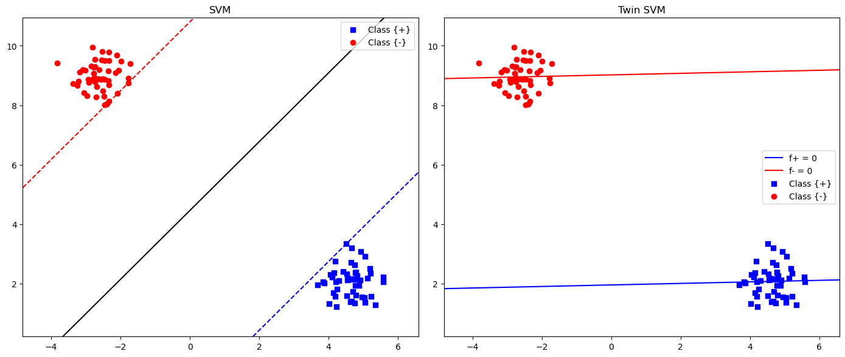
Fig. 1. Comparison of classification ability between SVM and TSVM
Let $D=(x_{i},y_{i}) ; i=1,2,…,N$ where $y_{i}∈\{+1,-1\}$ represents the class label and $x_{i}∈{ R}^{d}$ represent the i-th feature vector, which is the training data set for the binary problem. The main idea of TSVM is to find 2 non-parallel hyperplanes in the n-dimensional input space: $x^{T}w_{1}+b_{1}=0,x^{T}w_{2}+b_{2}=0$.
From here the formula of TSVM is expressed as follows:
$\begin{matrix}\min_{w_{1}, b_{1}, ξ} & \frac{1}{2}(Aw_{1}+e_{1}b_{1})^{T}(Aw_{1}+e_{1}b_{1})+c_{1}e_{2}^{T}ξ, \\ \text{s.t. } & -\left(Bw_{1}+e_{2}b_{1}\right) +ξ≥ e_{2},ξ≥ 0.\end{matrix}$ (1)
$\begin{matrix}\min_{w_{2}, b_{2}, ξ} & \frac{1}{2}(Bw_{2}+e_{2}b_{2})^{T}(Bw_{2}+e_{2}b_{2})+ c_{2}e_{1}^{T}ξ, \\ \text{s.t.} & \left(Aw_{2}+e_{1}b_{2}\right)+ξ≥ e_{1},ξ≥0.\end{matrix}$ (2)
where $w_{1}$ and $w_{2}$ are weight vectors, $b_{1}$ and $b_{2}$ represent bias, $c_{1}$ and $c_{2}$ are tunable parameters, $e_{1}$ and $e_{2}$ are vectors of ones and $ξ$ is the slack variable.
The dual representation of these issues paves the way for more streamlined solutions:
$\begin{matrix} & \max_{α} e_{2}^{T}α-\frac{1}{2}α^{T}G(H^{T}H)^{-1}G^{T}α, \\ & \text{s.t.} 0≤ α≤c_{1}e_{2}.\end{matrix}$ (3)
$\begin{matrix} & \max_{β} e_{1}^{T} β - \frac{1}{2} β^{T} P (Q^{T}Q)^{-1}P^{T} β, \\ & \text{s.t.} 0≤β≤ c_{2} e_{1}.\end{matrix}$ (4)
where $H=P=\left[\begin{matrix}A & e_{1}\end{matrix}\right]$ and $Q=G=\left[\begin{matrix}B & e_{2}\end{matrix}\right]$
The dual problem solutions α and β specify the parameters for the hyperplanes as:
$\begin{matrix}v & =- (H^{T}H)^{-1}G^{T}α,v=\left[\begin{aligned}ω_{1} \\ b_{1}\end{aligned}\right], \\ v^{*} & =- (Q^{T}Q)^{-1}P^{T}β,v^{*}=\left[\begin{aligned}ω_{2} \\ b_{2}\end{aligned}\right].\end{matrix}$ (5)
The classification of a new data point $x_{new}$ is determined by its distance from the two hyperplanes:
$class(x_{new})=sign\left(\frac{∣x_{new}^{T}ω_{1}+b_{2}∣}{∥ω_{1}∥} - \frac{∣x_{new}^{T}ω_{2}+b_{2}∣}{∥ω_{2}∥}\right)$ (6)
with $sign$ representing the classification function. This rule assigns the new point to the class corresponding to the closest hyperplane.
  - Twin k-class Support Vector Machines (Twin-KSVC)
Aiming to apply multi-label classification to TSVM, Twin-KSVC was also introduced by Yitian Xu. Based on the idea of the “1-versus-1-versus rest” (OvOvR) method, two separate sets of samples are selected from k classes and treated as core partitions. This algorithm maps the remaining samples to an intermediate region between these non-parallel hyperplanes, resulting in a ternary output system {-1, 0, +1}.
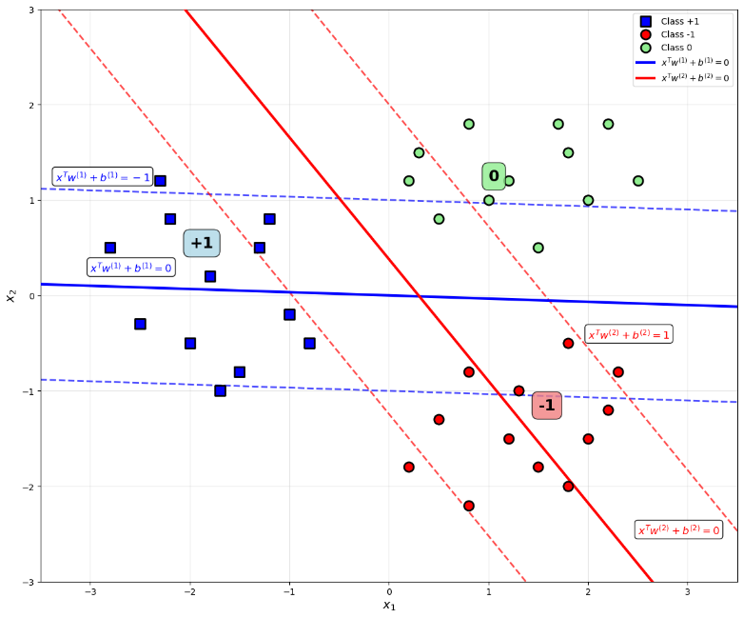
Fig. 2. Visualization of Twin-KSVC
Consider $A∈R^{n_{1}×d}$ and $B∈R^{n_{2}×d}$ representing two sets of centroid samples labeled +1 and -1 respectively. The remaining samples are represented by $C∈R^{n_{3}×d}$ and labeled 0. The mechanism for computing these hyperplanes is obtained by solving the refined QPP pair as follows:
$\begin{matrix}\min_{ w_{1}, b_{1}}\frac{1}{2}∥Aw_{1}+e_{1}b_{1}∥^{2}+c_{1}e_{2}^{T}ξ+ c_{2}e_{3}^{T}η, \\ \begin{matrix}\text{s.t.} -(Bw_{1}+e_{2}b_{1})+ξ≥e_{2},ξ≥0, \\ -(Cw_{1}+e_{3}b_{1})+η≥(1-ε)e_{3},η≥0\end{matrix}\end{matrix}$ (7)
$\begin{matrix}\min_{ w_{2}, b_{2}}\frac{1}{2}∥Bw_{2}+e_{2}b_{2}∥^{2}+c_{3}e_{1}^{T}ξ^{*}+ c_{4}e_{3}^{T}η^{*}, \\ \begin{matrix}\text{s.t.} -\left(Aw_{2}+e_{1}b_{1}\right)+ξ^{*}≥e_{1},ξ^{*}≥0, \\ -\left(Cw_{2}+e_{3}b_{1}\right)+η^{*}≥\left(1-ε\right)e_{3},η^{*}≥0\end{matrix}\end{matrix}$ (8)
where $η$ and $η^{*}∈R^{n_{3}×1}$, and $ξ∈R^{n_{2}×1}$ and $ξ^{*}∈R^{n_{1}×1}$
By using the lagrange function and the Karush–Kuhn–Tucker (KKT) condition, the dual formulation of $\begin{matrix}\min_{ w_{1}, b_{1}}\frac{1}{2}∥Aw_{1}+e_{1}b_{1}∥^{2}+c_{1}e_{2}^{T}ξ+ c_{2}e_{3}^{T}η, \\ \begin{matrix}\text{s.t.} -(Bw_{1}+e_{2}b_{1})+ξ≥e_{2},ξ≥0, \\ -(Cw_{1}+e_{3}b_{1})+η≥(1-ε)e_{3},η≥0\end{matrix}\end{matrix}$ (7) and $\begin{matrix}\min_{ w_{2}, b_{2}}\frac{1}{2}∥Bw_{2}+e_{2}b_{2}∥^{2}+c_{3}e_{1}^{T}ξ^{*}+ c_{4}e_{3}^{T}η^{*}, \\ \begin{matrix}\text{s.t.} -\left(Aw_{2}+e_{1}b_{1}\right)+ξ^{*}≥e_{1},ξ^{*}≥0, \\ -\left(Cw_{2}+e_{3}b_{1}\right)+η^{*}≥\left(1-ε\right)e_{3},η^{*}≥0\end{matrix}\end{matrix}$ (8) is established as shown below:
$\begin{matrix}\max_{γ}-\frac{1}{2}γ^{T}T(U^{T}U)^{-1}T^{T}γ+e_{4}^{T}γ, \\ \text{s.t.} 0 ≤γ≤E.\end{matrix}$ (9)
$\begin{matrix}\max_{ρ}-\frac{1}{2} ρ^{T}P(V^{T}V)^{-1}P^{T}ρ+e_{5}^{T}ρ, \\ \text{s.t.} 0≤ρ≤E^{*}.\end{matrix}$ (10)
for $\begin{matrix}\max_{γ}-\frac{1}{2}γ^{T}T(U^{T}U)^{-1}T^{T}γ+e_{4}^{T}γ, \\ \text{s.t.} 0 ≤γ≤E.\end{matrix}$ (9), the symbols are defined as $U=\left[\begin{matrix} A & e_{1}\end{matrix}\right],V=\left[\begin{matrix}B & e_{2}\end{matrix}\right],G=\left[\begin{matrix}C & e_{3}\end{matrix}\right],T=\left[\begin{matrix}V & G\end{matrix}\right],γ=\left[\begin{matrix}α & β\end{matrix}\right],e_{4}=\left[\begin{matrix}e_{2} & e_{3}\left(1-ϵ\right)\end{matrix}\right]$ and $E = [\begin{matrix}c_{1}e_{2} & c_{2}e_{3}\end{matrix}]$ and likewise with $\begin{matrix}\max_{ρ}-\frac{1}{2} ρ^{T}P(V^{T}V)^{-1}P^{T}ρ+e_{5}^{T}ρ, \\ \text{s.t.} 0≤ρ≤E^{*}.\end{matrix}$ (10).
Therefore, the solution vector $u=\left[w_{1};b_{1}\right]$ and $u^{*}=\left[w_{2};b_{2}\right]$ can be obtained as:
$u=-{\left(U^{⊤}U+δI\right)}^{-1}\left(V^{⊤}α+G^{⊤}β\right)$ (11)
$u^{*}=-{\left(V^{⊤}V+δI\right)}^{-1}\left(U^{⊤}α+G^{⊤}β\right)$ (12)
where $δI$ is regularization term with $δ$ is a very small positive number.
For a new checkpoint $x_{i}$, to determine its class label through the decision function as follows:
$f\left(x_{i}\right)=\left\{\begin{aligned}1,ifx_{i}^{⊤}μ_{1}+eb_{1}>-1+ϵ \\ -1,ifx^{⊤}μ_{2}+eb_{2}<1-ϵ \\ 0,\text{otherwise}\end{aligned}\right.$ (13)
This Twin-KSVC formula provides an optimal solution for multi-class classification, significantly improving computational efficiency and accuracy when processing complex datasets.
  - Granular Ball Twin Support Vector Machines (GBTSVM)
GBTSVM (Granular Ball Twin Support Vector Machines) was proposed by A. Quadir based on the idea of combining the stability of the granular ball computing method and the superior computational efficiency of TSVM. This idea helps the model increase its noise tolerance, thanks to performing calculations based on particles instead of individual data points. At the same time, the computational time is significantly reduced because only a small quadratic programming problem (QPP) needs to be solved for each label, instead of having to handle a large QPP problem for the entire data set.
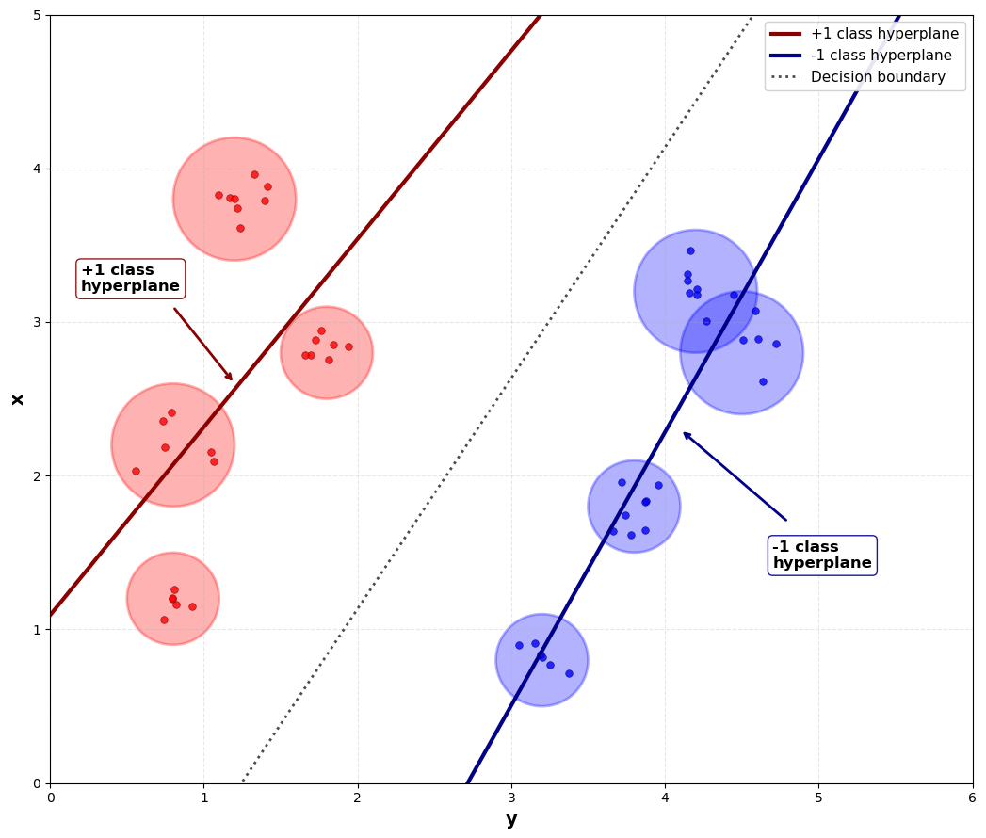
Fig. 3. Visualization of GBTSVM
The mechanism of Granular Ball Computing is a data processing technique to solve the scalability problem with high-dimensional data, by using Granular Balls (GB) defined by the center and radius instead of the entire data points, to reduce the amount of information to be processed and increase the computational efficiency.
To explain it mathematically, let the set of generated GBs be denoted as $S=GB_{i},i=1,2,…,p=\left(\left(c_{i},r_{i}\right),y_{i}\right),i=1,2,…,p$, where $c_{i}$ denotes the center, $r_{i}$ denotes the radius, and $y_{i}$ is the label of the $i-th$ GB. This mechanism is represented in the form of an optimization formula as follows:
$\begin{matrix}min λ_{1}\frac{n}{\sum_{i=1}^{p}{GB_{i}}}+λ_{2}p \\ s.t.pur\left(GB_{j}\right)≥T,j=1,2,…,p\end{matrix}$ (14)
where $λ_{1}$ and $λ_{2}$ are weighting coefficients, and $T$ is the purity threshold, which represents the proportion of samples in the GB with the same label that are in the majority.
After determining the GBs for each layer, the center and radius of these GBs will be provided as input to the GBTSVM in the following manner:
$\begin{matrix}\underset{w_{1}, b_{1}}{min⁡}\frac{1}{2}∥C_{1}w_{1}+e_{1}b_{1}∥^{2}+ d_{1}e_{2}^{T}ξ_{2}, \\ \text{s.t.}-(C_{2}w_{1}+e_{2}b_{1}) +ξ_{2}≥e_{2}+R_{2},ξ_{2}≥\text{0}\text{.}\end{matrix}$ (15)
$\begin{matrix}\underset{w_{2}, b_{2}}{min⁡}\frac{1}{2}∥C_{2}w_{2}+e_{2}b_{2}∥^{2}+d_{2}e_{1}^{T}ξ_{1}, \\ \text{s.t.} (C_{1}w_{2}+e_{1}b_{2})+ξ_{1}≥e_{1}+ R_{1},ξ_{1}≥0.\end{matrix}$ (16)
where $C_{1}$ and $C_{2}$ are the center matrix of GBs for layers +1 and -1, and $R_{1}$ and $R_{2}$ are the radius of GBs.
By applying the Lagrange method and utilizing the K.K.T conditions, deriving the dual form of problem $\begin{matrix}\underset{w_{1}, b_{1}}{min⁡}\frac{1}{2}∥C_{1}w_{1}+e_{1}b_{1}∥^{2}+ d_{1}e_{2}^{T}ξ_{2}, \\ \text{s.t.}-(C_{2}w_{1}+e_{2}b_{1}) +ξ_{2}≥e_{2}+R_{2},ξ_{2}≥\text{0}\text{.}\end{matrix}$ (15) as follows:
$\begin{matrix}\underset{α}{max⁡}α^{T}(e_{2}+R_{2})-\frac{1}{2}α^{T}G(H^{T}H+δI)^{-1}G^{T}α, \\ \text{s.t.} 0≤ α≤d_{1}e_{2}.\end{matrix}$ (17)
where $G= \left[\begin{matrix}C_{1} & e_{1}\end{matrix}\right], H=\left[\begin{matrix}C_{2} & e_{2}\end{matrix}\right]$ and $δI$ is the regularization term to avoid the matrix inversion problem.
Similarly, the Wolfe dual for $\begin{matrix}\underset{w_{2}, b_{2}}{min⁡}\frac{1}{2}∥C_{2}w_{2}+e_{2}b_{2}∥^{2}+d_{2}e_{1}^{T}ξ_{1}, \\ \text{s.t.} (C_{1}w_{2}+e_{1}b_{2})+ξ_{1}≥e_{1}+ R_{1},ξ_{1}≥0.\end{matrix}$ (16) can be derived as follows:
$\begin{matrix}\underset{γ}{max⁡}γ^{T}(e_{1}+R_{1})-\frac{1}{2}γ^{T}H(G^{T}G+δI)^{-1}H^{T}γ, \\ \text{s.t.} 0≤ γ≤d_{2}e_{1}.\end{matrix}$ (18)
As a result, the vectors $u_{1}=\left[w_{1};b_{1}\right]$representing the +1 class and $u_{2}=[w_{2};b_{2}]$ representing the −1 class can be set up as follows:
$u_{1}=-(H^{T}H+δI)^{-1}G^{T}α$ (19)
$u_{2}=(G^{T}G+δI)^{-1}H^{T}γ$ (20)

From here, when a new data point $x$ is classified based on its closest distance to two hyperplanes as described below:
$class(x)=arg\underset{ i∈\{1,2\}}{min⁡}\frac{∣ w_{i}^{T}x + b_{i}∣}{∥w_{i}∥}$ (21)
  - Granular Ball K-Class Twin Support Vector Classifier (GB-TWKSVC)
GB-TWKSVC, introduced by M. A. Ganai, is an improved version of GBTSVM, which moves from binary to multi-class classification using the OvOvR strategy, incorporating GBs representation to increase noise immunity and computational efficiency. In OvOvR, for each pair of classes, two non-parallel hyperplanes are constructed to separate the two selected classes, while the other classes are placed in an "epsilontube" region around the hyperplanes.
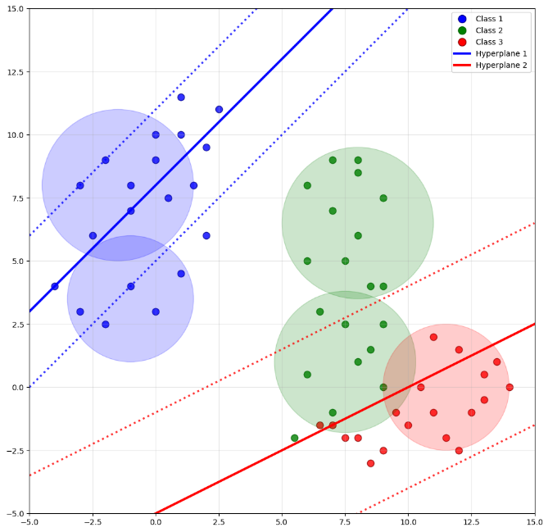
Fig. 4. Visualization for GB-TWKSVC
In GB-TWKSVC, the training dataset is denoted as $\tilde{I}$, which consists of GBs sets $I_{k}$ corresponding to each class $k$.
$\tilde{I} = \bigcup_{k=1}^{K}{I_{k}}$ (22)
Then, to solve the QPP problem, GB-TWKSVC must improve GBTSVM to suit OvOvR is as follows:
$\begin{matrix}\begin{matrix}\underset{ w_{i},b_{i},η_{i},ξ_{j},ξ_{r}}{min⁡}\frac{1}{2}c_{1}(∥w_{i}∥^{2}+b_{i}^{2})+\frac{1}{2}η_{i}^{T}η_{i}+c_{2}e_{j}^{T}ξ_{j}+c_{3}e_{r}^{T}ξ_{r}, \\ \text{s.t.} C_{i}w_{i}+e_{i}b_{i}=η_{i},\end{matrix} \\ -(C_{j}w_{i}+e_{j}b_{i})+ξ_{j}≥e_{j}+R_{j},ξ_{j}≥0, \\ ∣C_{r}w_{i}+e_{r}b_{i}∣+ ξ_{r} ≥e_{r}+R_{r},ξ_{r}≥0.\end{matrix}$ (23)
$\begin{matrix}\begin{matrix}\underset{ w_{j},b_{j},η_{j},ξ_{i},ξ_{r}}{min⁡}\frac{1}{2}c_{4}(∥w_{j}∥^{2}+b_{j}^{2})+\frac{1}{2}η_{j}^{T}η_{j}+c_{5}e_{i}^{T}ξ_{i}+c_{6}e_{r}^{T}ξ_{r}, \\ \text{s.t.} C_{j}w_{j}+e_{j}b_{j}=η_{j},\end{matrix} \\ (C_{i}w_{j}+e_{i}b_{j})+ξ_{i}≥e_{i}+R_{i},ξ_{i}≥0, \\ ∣C_{r}w_{j}+e_{r}b_{j}∣+ξ_{r}≥e_{r}+R_{r},ξ_{r}≥0.\end{matrix}$ (24)
Similar to the Twin-KSVC approach, with $R_{1},R_{2},R_{3}$ being the set of radii of the corresponding class, the dual formulation of $\begin{matrix}\begin{matrix}\underset{ w_{i},b_{i},η_{i},ξ_{j},ξ_{r}}{min⁡}\frac{1}{2}c_{1}(∥w_{i}∥^{2}+b_{i}^{2})+\frac{1}{2}η_{i}^{T}η_{i}+c_{2}e_{j}^{T}ξ_{j}+c_{3}e_{r}^{T}ξ_{r}, \\ \text{s.t.} C_{i}w_{i}+e_{i}b_{i}=η_{i},\end{matrix} \\ -(C_{j}w_{i}+e_{j}b_{i})+ξ_{j}≥e_{j}+R_{j},ξ_{j}≥0, \\ ∣C_{r}w_{i}+e_{r}b_{i}∣+ ξ_{r} ≥e_{r}+R_{r},ξ_{r}≥0.\end{matrix}$ (23) and $\begin{matrix}\begin{matrix}\underset{ w_{j},b_{j},η_{j},ξ_{i},ξ_{r}}{min⁡}\frac{1}{2}c_{4}(∥w_{j}∥^{2}+b_{j}^{2})+\frac{1}{2}η_{j}^{T}η_{j}+c_{5}e_{i}^{T}ξ_{i}+c_{6}e_{r}^{T}ξ_{r}, \\ \text{s.t.} C_{j}w_{j}+e_{j}b_{j}=η_{j},\end{matrix} \\ (C_{i}w_{j}+e_{i}b_{j})+ξ_{i}≥e_{i}+R_{i},ξ_{i}≥0, \\ ∣C_{r}w_{j}+e_{r}b_{j}∣+ξ_{r}≥e_{r}+R_{r},ξ_{r}≥0.\end{matrix}$ (24) is formulated as follows:
$\begin{matrix}\max_{α} & -\frac{1}{2}γ^{T}V(H^{T}H)^{-1}V^{T}α+e_{4}^{T}γ, \\ \text{s.t.} & 0≤α≤F\end{matrix}$ (25)
$\begin{matrix}\max_{ρ} & -\frac{1}{2}ρ^{T}R(G^{T}G)^{-1}R^{T}ρ+e_{4}^{T}ρ, \\ \text{s.t.} & 0≤ ρ≤F^{*}.\end{matrix}$ (26)
for $\begin{matrix}\max_{α} & -\frac{1}{2}γ^{T}V(H^{T}H)^{-1}V^{T}α+e_{4}^{T}γ, \\ \text{s.t.} & 0≤α≤F\end{matrix}$ (25), where $H=\left[\begin{matrix} A & e_{1}\end{matrix}\right],G=\left[\begin{matrix}B & e_{2}\end{matrix}\right],J=\left[\begin{matrix}C & e_{3}\end{matrix}\right],V=\left[\begin{matrix}G & J\end{matrix}\right],γ=\left[\begin{matrix}α & β\end{matrix}\right],e_{4}=\left[\begin{matrix}e_{2}+R_{2} & e_{3}\left(1-ϵ\right)+R_{3}\end{matrix}\right]$ and $F = [\begin{matrix}c_{1}e_{2} & c_{2}e_{3}\end{matrix}]$ and the same calculation for $\begin{matrix}\max_{ρ} & -\frac{1}{2}ρ^{T}R(G^{T}G)^{-1}R^{T}ρ+e_{4}^{T}ρ, \\ \text{s.t.} & 0≤ ρ≤F^{*}.\end{matrix}$ (26).
In this way, the decision vectors $ϑ_{1}=\left[w_{1};b_{1}\right]$ and $ϑ_{2}=[w_{2};b_{2}]$ can be calculated by the formula:
$ϑ_{1}=-{\left(H^{⊤}H\right)}^{-1}(G^{⊤}α+J^{⊤}μ)$ (27)
$ϑ_{2}=-{\left(H^{⊤}H\right)}^{-1}(G^{⊤}α+J^{⊤}μ)$ (28)
The classification of new sample $z∈R^{n}$ is done based on the closest distance to the hyperplanes:
$h(z)=\begin{matrix}min \\ 1,2\end{matrix}⁡\{δ^{1}(z), δ^{2}(z)\}$ (29)
where $δ^{1}(z)=∣z^{T}ω^{(1)}+b^{(1)}∣,δ^{2}(z)=∣z^{T}ω^{(2)}+b^{(2)}∣$ with $\left|.\right|$ represents the normal distance of point $z$ to the hyperplanes.
- Proposed Model: Twin Support Vector Machine for Multi-class Classification (GBTSVM_MCC)
  - Model Overview(mô tả bài toán)
The Granular Ball Twin Support Vector Machine for Multi-class Classification (GBTSVM_MC) model is a novel multi-class classification framework that combines the power of Twin Support Vector Machines (TSVM) and Granular Ball Computing to extend the capabilities of GBTSVM from binary to multi-class classification. The model uses decomposition strategies such as One-vs-One (OvO) and One-vs-Rest (OvR), which are different from the One-versus-One-versus-Rest (OvOvR) strategy in GB-TWKSVC, to efficiently handle multi-class datasets. GBTSVM_MCC leverages the TSVM framework with two smaller quadratic programming problems and represents the data in granular ball form to reduce the number of input data points, thereby improving the computational efficiency.
This combination brings outstanding benefits such as high computational efficiency, noise immunity thanks to the granular ball representation reducing the influence of outliers, and scalability for large-scale multi-class classification tasks. Compared with related methods such as TSVM and GBTSVM which are limited to binary classification, or Twin-KSVC and GB-TWKSVC which apply more complex strategies, GBTSVM_MCC stands out with its flexible and efficient decomposition strategy, becoming a powerful and suitable solution for many practical applications.
  - Granular Ball Generation
The first stage of the proposed model is to generate Granular Ball using the K-means algorithm. This process supports the generation of input data for the system. The calibration is performed based on two main parameters: purity threshold and minimum number in GB. The algorithm is implemented in the following steps.
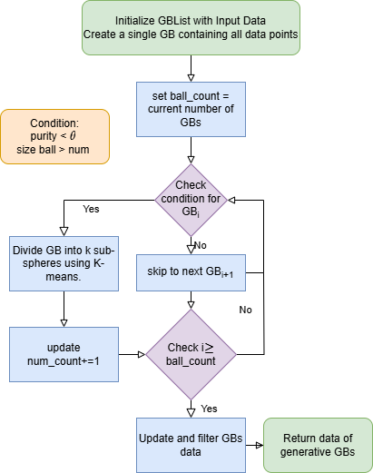
Fig. 5. Process of the GB generation.
- Create an initial GBs containing a single GB, where this GB contains the entire set of data points.
- Loop through each GB in the GBs, check the following two conditions:
  - purity < θ
  - number of points in the GB > num
If either condition is not met, move on to the next GB.
- If both the above conditions are true, perform the partition of the GB into k sub-GBs by applying the K-means algorithm. Then, update the GBs by replacing the original GB with the new sub-GBs and update the total number of GBs in the list.
- Continue performing steps 2 and 3 until there are no more GBs in the GBs that satisfy the condition for partitioning.
- Calculate and update the center, radius, label for each final GB, then filter and return the list of generated GBs.

  - Multi-class Classification Strategy( đề xuất thuật)
  - Mathematical Formulation(so sánh độ phức tạp)

OvO Method.

OvR Method.
  - Algorithm Design and Implementation
- Experiments Result
  - Setup
The experiment was conducted on a personal computer with an Intel Core i5-11300H CPU configuration at 3.20GHz, 24GB RAM and Windows 11 operating system. The programming environment used Python 3.11.7 with supporting libraries such as scikit-learn, numpy and pandas. The datasets were randomly divided into 80% for the training set and 20% for the test set, ensuring the same ratio between classes. The GBTSVM_MC model fine-tuning process was performed through a 5-fold cross-validation method on the training set. The main hyperparameters tuned are listed in Table 2:
Table 2. List of Parameters, Symbols, and Tuning Intervals
Parameters | Symbols | Tuning
Regularization coefficients | c | 0.01, 0.025, 0.05, 0.075, 0.1, 0.25, 0.5
Margin tolerance limit | ϵ | 0.01, 0.025, 0.05, 0.075, 0.1
Granular ball size | num | 1, 2, 3, 4, 5
Purity threshold | pur | 0.85, 0.895, 0.925, 0.97, 0.985
  - Dataset
- To evaluate the performance of GBTSVM_MC, experiments were conducted on 10 multi-class datasets sourced from the UC Irvine Machine Learning Repository and Kaggle. These datasets were carefully selected from various domains and exhibit diversity in sample size, feature dimensionality, and number of classes. Detailed information about each dataset is summarized in Table 1. This diverse selection enables a comprehensive assessment of GBTSVM_MC's capabilities across different levels of complexity, including variations in the number of samples, features, and classes.
Table 1. Overview of multi-class datasets utilized in this experiments
Dataset | Samples | Features | Classes
Hayes-roth | 132 | 5 | 3
Iris | 150 | 4 | 3
Teaching Evaluation | 151 | 5 | 3
Image-segmentation | 210 | 19 | 7
Seeds | 210 | 7 | 3
Glass | 214 | 9 | 6
Ecoli | 327 | 7 | 5
Dermatology | 358 | 4 | 6
Balance | 625 | 4 | 3
Global Cancer | 50000 | 13 | 5
Specially, the Global Cancer dataset obtained from Kaggle is utilized to assess the scalability and computational efficiency of GBTSVM_MC. This dataset is partitioned into three different subset sizes—1,000, 10,000, and 50,000 samples—to systematically evaluate the algorithm's performance and computational scalability across varying data volumes.
  - Result

Table 3.
Dataset |  | GBTSVM_MC(OvO)  (c₁, c₂, ϵ₁, ϵ₂, num, pur) | GTBSVM_MC(OvR)  (c₁, c₂, ϵ₁, ϵ₂, num, pur) | GB-TWKSVC  (c₁, c₂, ϵ₁, ϵ₂, num, pur) | Twin-KSVC  (c₁, c₂, ϵ₁, ϵ₂)
Hayes-roth | Accuracy (%)  Time(s)  Parameters | 74.19  0.0352  0.01, 0.01, 0.01, 0.01, 3, 0.895 | 74.2  0.0130  0.01, 0.01, 0.01, 0.01, 3, 0.895 | 53.57  0.0732  0.01, 0.01, 0.025, 0.025, 2, 0.97 | 57.06  0.0741  0.01, 0.01, 0.075, 0.05
Iris | Accuracy (%)  Time(s)  Parameters | 86.67  0.0189  0.01, 0.01, 0.01, 0.01, 2, 0.985 | 93.33  0.0195  0.01, 0.01, 0.01, 0.01, 2, 0.97 | 98.34  0.0332  0.01, 0.01, 0.025, 0.025, 3, 0.985 | 95.32  0.0352  0.01, 0.01, 0.025, 0.05
Teaching Evaluation | Accuracy (%)  Time(s)  Parameters | 62.5  0.0261  0.01, 0.01, 0.01, 0.01, 3, 0.97 | 68.75  0.0333  0.01, 0.01, 0.01, 0.01, 3, 0.925 | 76.43  0.0525  0.01, 0.01, 0.025, 0.025, 3, 0.97 | 69.35  0.0543  0.01, 0.01, 0.025, 0.025
Image-segmentation | Accuracy (%)  Time(s)  Parameters | 92.85  0.0840  0.01, 0.01, 0.01, 0.01, 1, 0.97 | 90.47  0.0530  0.01, 0.01, 0.01, 0.01, 2, 0.925 | 90.43  0.3967  0.01, 0.01, 0.05, 0.01, 2, 0.925 | 89.65  0.5487  0.01, 0.01, 0.025, 0.025
Seeds | Accuracy (%)  Time(s)  Parameters | 88.09  0.0312  0.01, 0.01, 0.01, 0.01, 2, 0.97 | 100  0.0266  0.01, 0.01, 0.01, 0.01, 2, 0.97 | 98.23  0.0560  0.01, 0.01, 0.025, 0.01, 3, 0.985 | 95.12  0.0624  0.01, 0.01, 0.05, 0.025
Glass | Accuracy (%)  Time(s)  Parameters | 82.14  0.1615  0.01, 0.01, 0.01, 0.01, 2, 0.925 | 84.52  0.0525  0.01, 0.01, 0.01, 0.01, 2, 0.985 | 75.34  0.3205  0.01, 0.01, 0.01, 0.01, 3, 0.925 | 67.93  0.4710  0.01, 0.01, 0.05, 0.025
Ecoli | Accuracy (%)  Time(s)  Parameters | 82.53  0.2992  0.01, 0.01, 0.01, 0.01, 3, 0.85 | 82.52  0.0849  0.01, 0.01, 0.01, 0.01, 3, 0.85 | 92.54  0.8083  0.01, 0.01, 0.025, 0.025, 2, 0.085 | 87.32  1.728  0.01, 0.01, 0.01, 0.025
Dermatology | Accuracy (%)  Time(s)  Parameters | 98.5  0.1075  0.01, 0.01, 0.01, 0.01, 4 0.985 | 96.26  0.0708  0.01, 0.01, 0.01, 0.01, 4, 0.895 | 91,75  0.4103  0.01, 0.01, 0.01, 0.01, 2, 0.97 | 81.21  0.719  0.01, 0.01, 0.075, 0.05
Balance | Accuracy (%)  Time(s)  Parameters | 94.21  0.0533  0.01, 0.01, 0.01, 0.01, 4, 0.97 | 92.48  0.0733  0.01, 0.01, 0.01, 0.01, 1, 0.85 | 89.62  0.1405  0.01, 0.01, 0.01, 0.01, 2 0.97 | 87.52  0.2676  0.01, 0.01, 0.01, 0.01
Global Cancer – 1K | Accuracy (%)  Time(s)  Parameters | 63.07  0.0395  0.01, 0.01, 0.01, 0.01, 4, 0.97 | 62.24  0.0505  0.01, 0.01, 0.01, 0.01, 4, 0.97 | 60.16  0.0518  0.01, 0.01, 0.01, 0.01, 4, 0.97 | 57.58  0.2628  0.01, 0.01, 0.01, 0.025
Global Cancer – 10K | Accuracy (%)  Time(s)  Parameters | 61.53  0.8314  0.01, 0.01, 0.01, 0.01, 3, 0.985 | 60.85  1.5107  0.01, 0.01, 0.01, 0.01, 2, 0.97 | 57.38  1.6211  0.01, 0.01, 0.01, 0.01, 2, 0.925 | 54.65  3.2571  0.01, 0.01, 0.05, 0.05
Global Cancer – 50K | Accuracy (%)  Time(s)  Parameters | 50.28  80.2156  0.01, 0.01, 0.01, 0.01, 1, 0.85 | 50.71  158.9295  0.01, 0.01, 0.01, 0.01, 2, 0.895 | 49.23  155.5041  0.01, 0.01, 0.01, 0.01, 2, 0.895 | 42.78  186.4782  0.01, 0.01, 0.1, 0.1
  - Discussion
- conclusion
Acknowledgments. A third level heading in 9-point font size at the end of the paper is used for general acknowledgments, for example: This study was funded by X (grant number Y).
Disclosure of Interests. It is now necessary to declare any competing interests or to specifically state that the authors have no competing interests. Please place the statement with a third level heading in 9-point font size beneath the (optional) acknowledgments, for example: The authors have no competing interests to declare that are relevant to the content of this article. Or: Author A has received research grants from Company W. Author B has received a speaker honorarium from Company X and owns stock in Company Y. Author C is a member of committee Z.

References
- Author, F.: Article title. Journal 2(5), 99–110 (2016)
- Author, F., Author, S.: Title of a proceedings paper. In: Editor, F., Editor, S. (eds.) CONFERENCE 2016, LNCS, vol. 9999, pp. 1–13. Springer, Heidelberg (2016)
- Author, F., Author, S., Author, T.: Book title. 2nd edn. Publisher, Location (1999)
- Author, F.: Contribution title. In: 9th International Proceedings on Proceedings, pp. 1–2. Publisher, Location (2010)
- LNCS Homepage, http://www.springer.com/lncs, last accessed 2023/10/25

https://archive.ics.uci.edu
https://www.kaggle.com

