**Snake Game for Two updated by Lam, Quoc Hung**

**New features**

- 2 players ( using keyboard player1: up/down/left/right, player2: w/s/a/d to control the snakes). ( blue color/green color snake, food is yellow color and bomb is orange.)

- bomb matrix with pre-defined number of bombs for each game. ( default is 5 bombs, randomly distributed in 32x32 grid).

- Snake will stop fo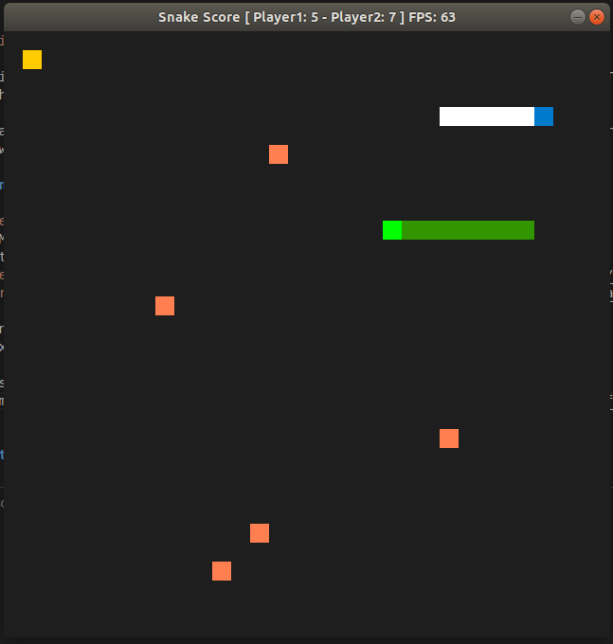r 5 seconds once hit a bomb.

- If snake hits its body, the game will terminate and player will lose the game.

- The snake which has more points will win the game.

