**GAMES SHOP**

**Software Design Specification**

– Hanoi, April 2022 –

**Record of changeS**

|  |  |  |  |
| --- | --- | --- | --- |
| **Date** | **A* M, D** | **In charge** | **Change Description** |
| 14/4/2022 | A | Trần Sơn | Database ERD diagram |
| 18/4/2022 | M | Trần Sơn | Update ERD diagram |
|  |  | Nguyễn Định | Database ERD diagram |
|  |  |  | Update ERD diagram |
|  |  |  |  |
|  |  |  |  |
|  |  |  |  |
|  |  |  |  |
|  |  |  |  |
|  |  |  |  |
|  |  |  |  |
|  |  |  |  |
|  |  |  |  |

*A - Added M - Modified D - Deleted

# Table of Contents

Contents

Table of Contents 3

I. Overview 7

1. Code Packages 7

2. Database Design 9

a. Database Schema 9

b. Table Description 10

II. Code Designs 10

1. User Sign In 11

a. Class Diagram 11

b. Class Specifications 11

c. Sequence Diagram(s) 12

2. Homepage 13

a. Class Diagram 13

b. Class Specifications 13

c. Sequence Diagram(s) 14

3. User Signup 14

a. Class Diagram 14

b. Class Specifications 14

c. Sequence Diagram(s) 16

4. Account Management 17

a. Class Diagram 17

b. Class Specifications 17

c. Sequence Diagram(s) 18

5. Post Management 19

a. Class Diagram 19

b. Class Specifications 20

c. Sequence Diagram(s) 21

6. Post list and detail 22

a. Class Diagram 22

b. Class Specifications 22

c. Sequence Diagram(s) 23

7. Logout 23

a. Class Diagram 23

b. Class Specifications 23

c. Sequence Diagram(s) 24

8. Product Management 25

a. Class Diagram 25

b. Class Specifications 26

c. Sequence Diagram(s) 27

9. Product list and detail 28

a. Class Diagram 28

b. Class Specifications 28

c. Sequence Diagram(s) 29

10. FAQs Management 30

a. Class Diagram 30

b. Class Specifications 31

c. Sequence Diagram(s) 32

11. CMS dashboard 34

a. Class Diagram 34

b. Class Specifications 34

c. Sequence Diagram(s) 35

12. Cart 36

a. Class Diagram 36

b. Class Specifications 36

c. Sequence Diagram(s) 37

13. Add to cart 37

a. Class Diagram 37

b. Class Specifications 37

c. Sequence Diagram(s) 38

14. Review product 39

a. Class Diagram 39

b. Class Specifications 39

c. Sequence Diagram(s) 40

15. Reply review product 40

a. Class Diagram 40

b. Class Specifications 41

c. Sequence Diagram(s) 41

16. Category management 42

a. Class Diagram 42

b. Class Specifications 43

c. Sequence Diagram(s) 44

17. Notification management 45

a. Class Diagram 45

b. Class Specifications 47

c. Sequence Diagram(s) 48

18. Notification list and detail 49

a. Class Diagram 49

b. Class Specifications 50

c. Sequence Diagram(s) 50

19. Change Password 51

a. Class Diagram 51

b. Class Specifications 51

c. Sequence Diagram(s) 52

20. Edit Profile 52

a. Class Diagram 52

b. Class Specifications 52

c. Sequence Diagram(s) 53

21. Reset Password 54

a. Class Diagram 54

b. Class Specifications 54

c. Sequence Diagram(s) 55

22. Promotion code management 55

a. Class Diagram 55

b. Class Specifications 57

c. Sequence Diagram(s) 57

23. Cart Completion(Checkout) 57

a. Class Diagram 57

b. Class Specifications 58

c. Sequence Diagram(s) 59

24. Payment 59

a. Class Diagram 59

b. Class Specifications 60

c. Sequence Diagram(s) 61

25. Order Management 61

a. Class Diagram 61

b. Class Specifications 63

c. Sequence Diagram(s) 64

26. User subscribe 64

a. Class Diagram 64

b. Class Specifications 65

c. Sequence Diagram(s) 65

27. Email Management 67

a. Class Diagram 67

b. Class Specifications 68

c. Sequence Diagram(s) 69

28. Order history and order detail 70

a. Class Diagram 70

b. Class Specifications 70

c. Sequence Diagram(s) 71

# I. Overview

## 1. Code Packages

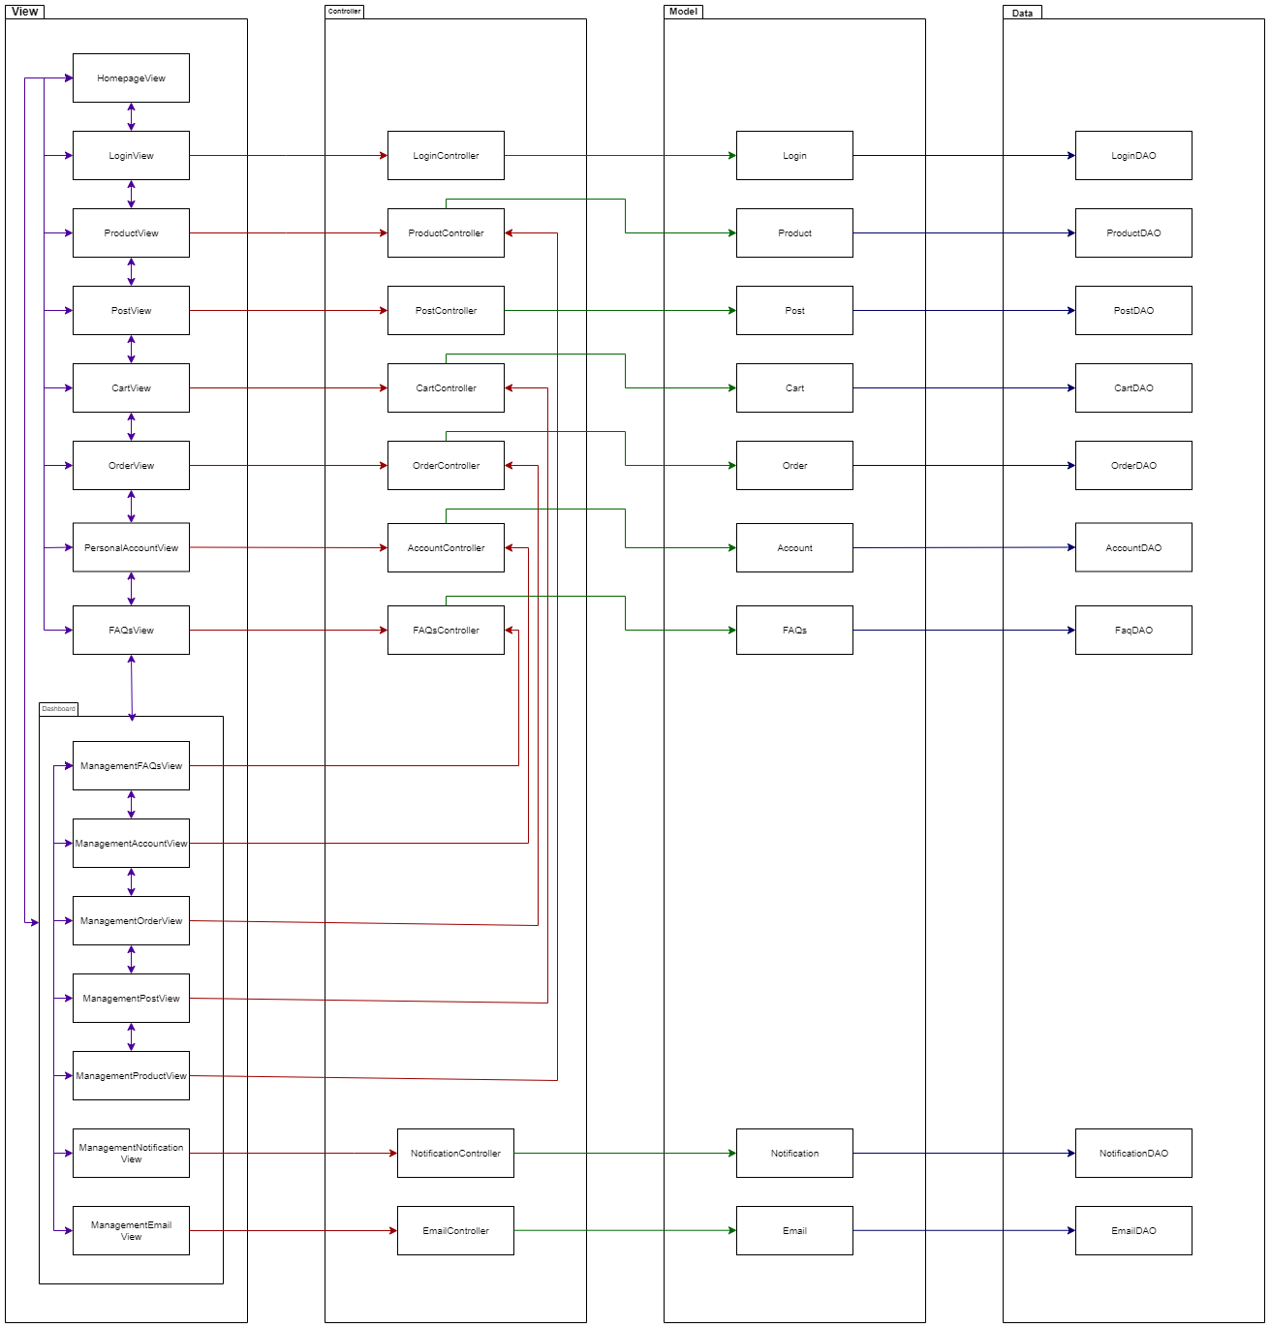

Figure 1.1.1: Code package

***Package descriptions & package class naming conventions***

|  |  |  |
| --- | --- | --- |
| **No** | **Package** | **Description** |
| 01 | view | This package used to contain html/css/js file, besides is assets with image, logo,…  *.jsp, *.css, *.js, … |
| 02 | controller | This package used to contain controller file.  <Object>Controller.java |
| 03 | model | This package used to contain model file.  <Object>.java |
| 04 | data | This package used to contain DAO file, connect between database with model.  <Object>DAO.java |

## 2. Database Design

### a. Database Schema

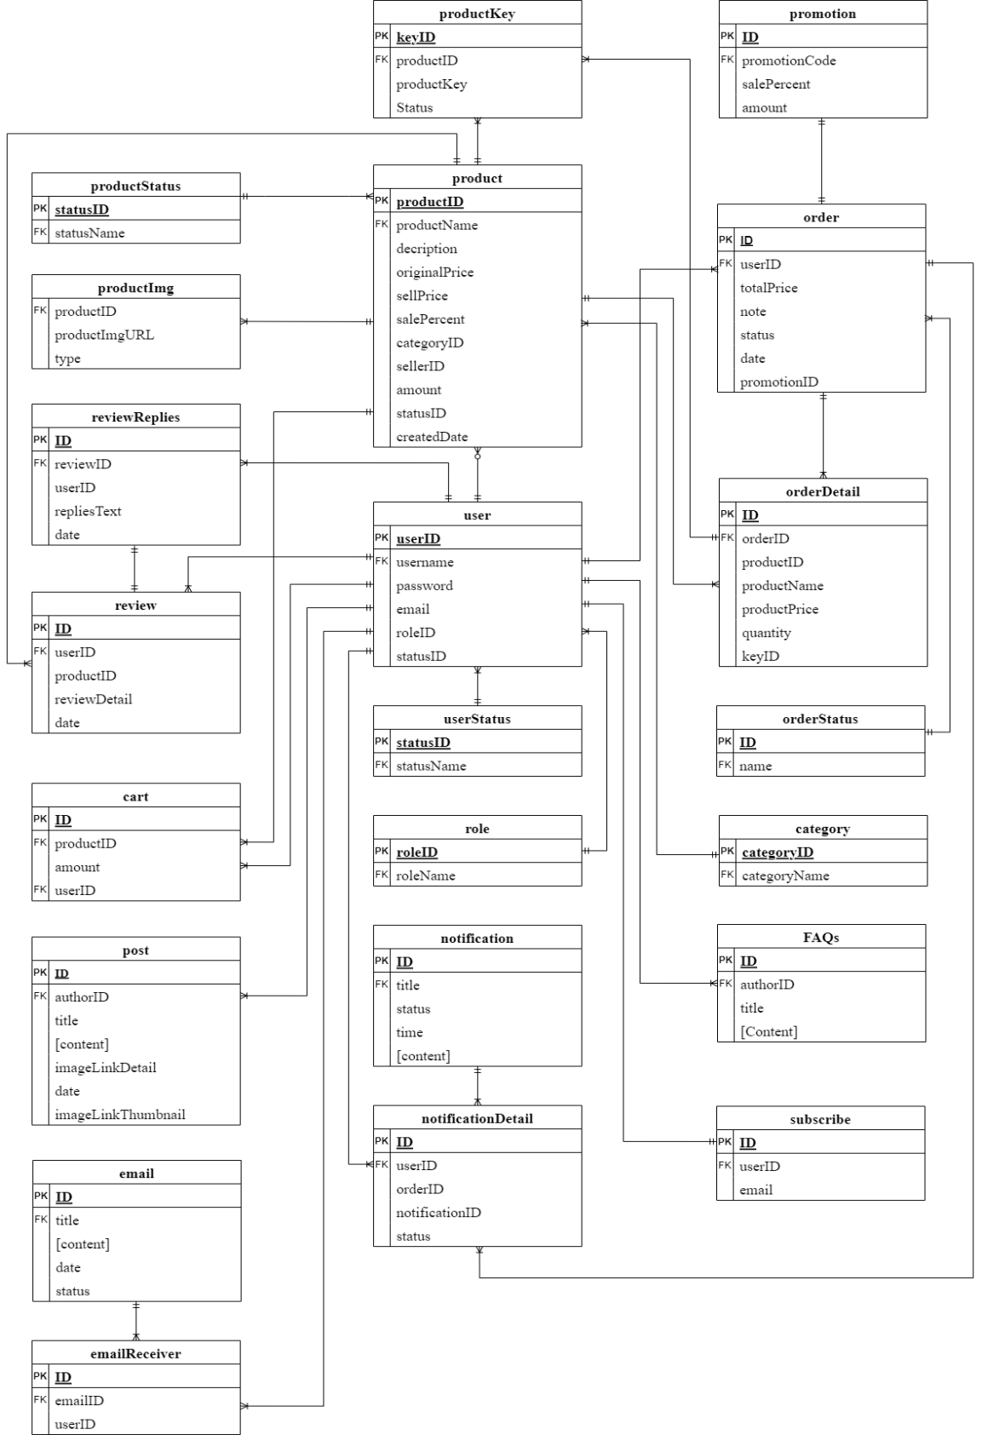

### b. Table Description

|  |  |  |
| --- | --- | --- |
| **No** | **Table** | **Description** |
| 01 | FQAs | Store all common question and answer |
| 02 | products | Store product information |
| 03 | productStatus | Store product’s status information |
| 04 | productImg | Store product image link |
| 05 | reviewReplies | Store staff reply to customer |
| 06 | review | Store user review and information |
| 07 | orders | Store orders information |
| 08 | orderDetail | Store order detailed information |
| 09 | orderStatus | Store order current status |
| 10 | category | Store category information |
| 11 | users | Store user information |
| 12 | userStatus | Store user account status |
| 13 | role | Store roles in system |
| 14 | notifications | Store user notifications |
| 15 | Cart | Store user cart |
| 16 | Blog | Store written blog |
| 17 | notificationsDetail | Detail of notification |
| 18 | productKey | Store key of product |
| 19 | promotionCode | Store promotion code for discount |
| 20 | subscriber | Store information of customer subscribe want receive exclusive update from mail |
| 21 | email | Store email send to users |
| 22 | emailReceiver | List user receive email (auto) |

# II. Code Designs

## 1. User Sign In

### a. Class Diagram

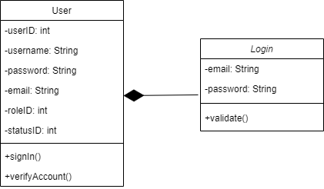

### b. Class Specifications

***SigninClass***

|  |  |  |
| --- | --- | --- |
| **No** | **Method** | **Description** |
| *01* | *Validate* | *Check user input correct email syntax* |

***UserClass***

***Class Methods***

|  |  |  |
| --- | --- | --- |
| **No** | **Method** | **Description** |
| *01* | *Login* | *Input correct username and password to login in to web* |
| *02* | *VerifyLogin* | *After register user must verify account by check email* |

### c. Sequence Diagram(s)

.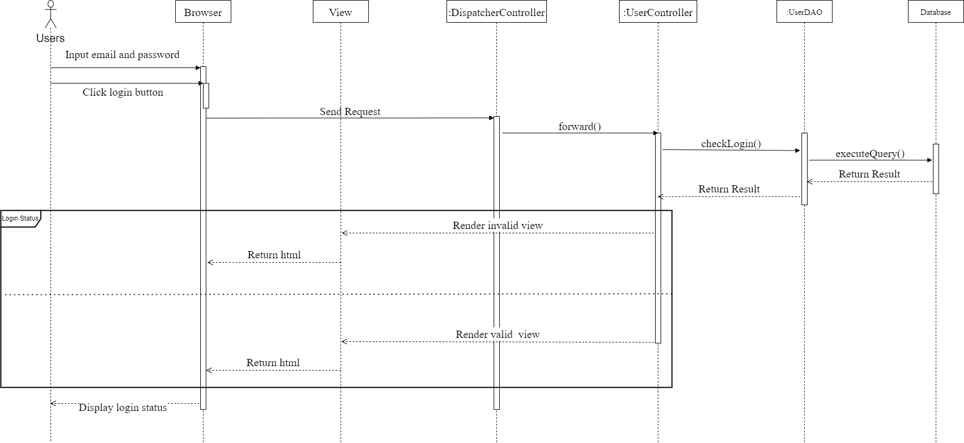

## 2. Homepage

### a. Class Diagram

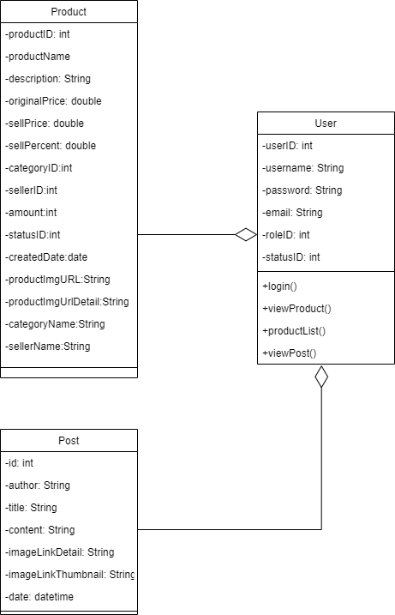

### b. Class Specifications

***UsersClass***

***Class Methods***

|  |  |  |
| --- | --- | --- |
| **No** | **Method** | **Description** |
| *01* | *Login* | *Input correct username and password to login in to web* |
| *02* | *productList()* | *View list product in homepage* |
| *03* | *viewProduct()* | *View product detail from homepage* |
| *03* | *viewPost ()* | *View recent post in homepage* |

### c. Sequence Diagram(s)

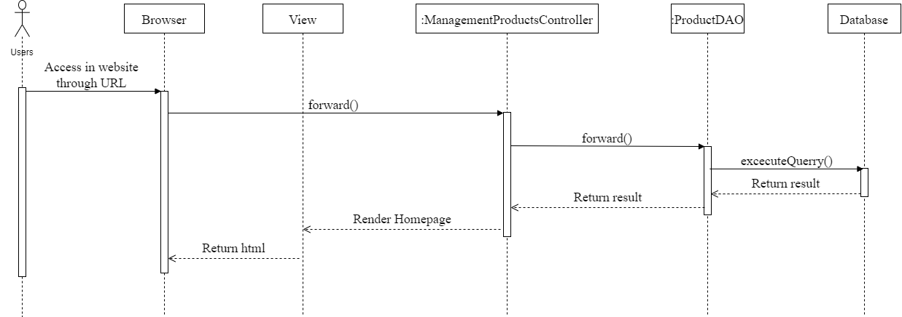

## 3. User Signup

### a. Class Diagram

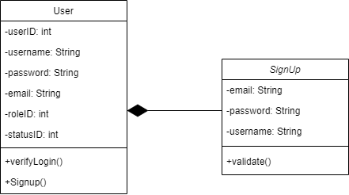

### b. Class Specifications

***UsersClass***

***Class Methods***

|  |  |  |
| --- | --- | --- |
| **No** | **Method** | **Description** |
| *01* | *signup* | *First time use website* |
| *02* | *Login* | *Input correct username and password to login in to web* |
| *03* | *Verifylogin* | *After register user must verify account by check email* |

***SignupClass***

|  |  |  |
| --- | --- | --- |
| **No** | **Method** | **Description** |
| *01* | *Validate* | *Check user input correct email syntax* |

### c. Sequence Diagram(s)

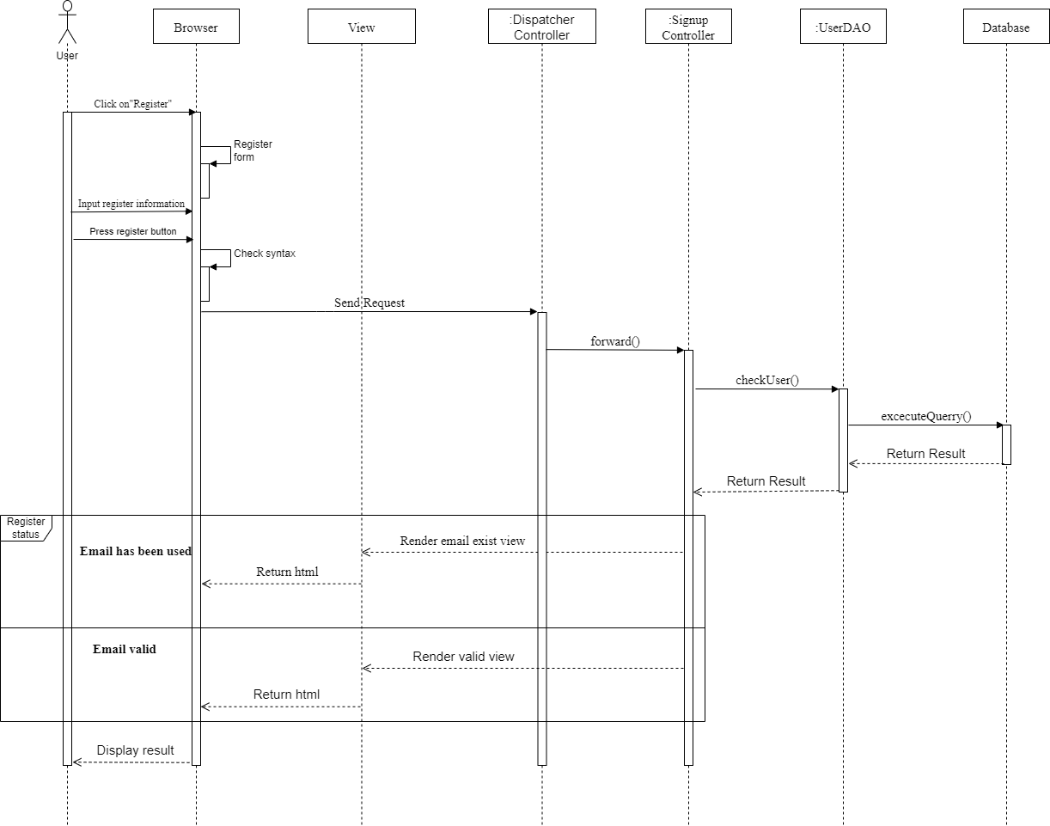

## 4. Account Management

### a. Class Diagram

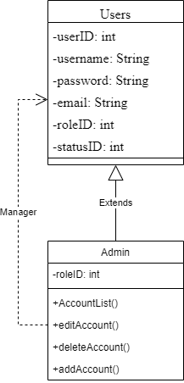

### b. Class Specifications

***AdminClass***

***Class Methods***

|  |  |  |
| --- | --- | --- |
| **No** | **Method** | **Description** |
| *01* | *Edit Account* | *Edit detail account information (role, status)* |
| *02* | *Delete Account* | *Delete account permanent* |
| *03* | *Add Account* | *Add new account for anyrole* |
| *04* | *Account list* | *View list all account* |

### c. Sequence Diagram(s)

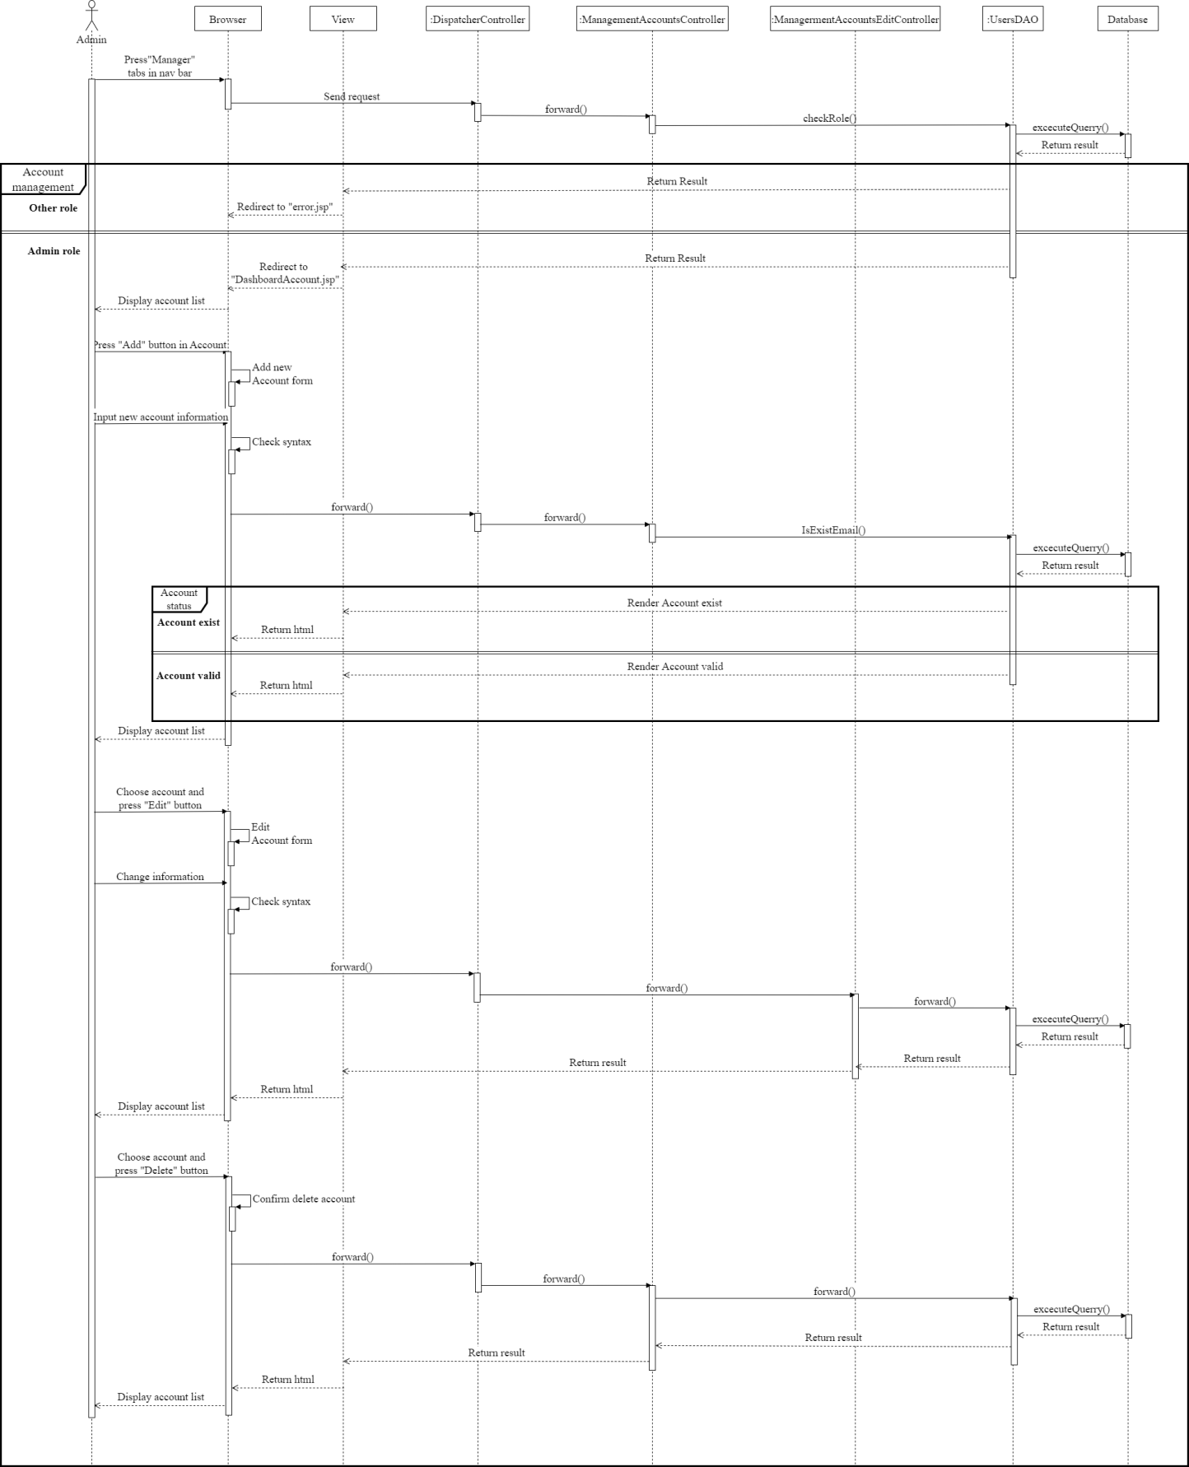

## 5. Post Management

### a. Class Diagram

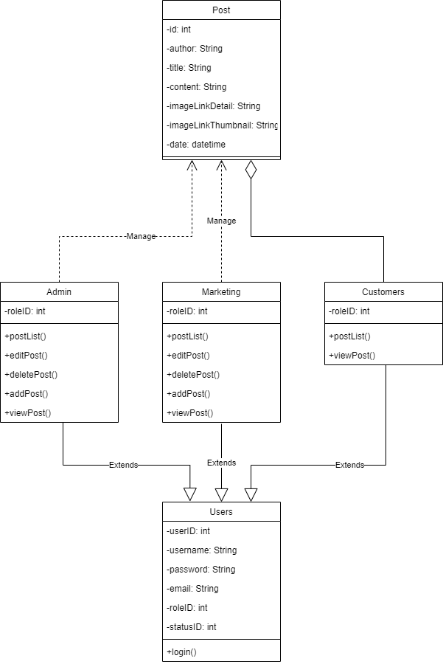

### b. Class Specifications

***Admin class/ marketing class***

***Class Methods***

|  |  |  |
| --- | --- | --- |
| **No** | **Method** | **Description** |
| *01* | *View Post* | *View detail of one specific post* |
| *02* | *Edit Post* | *Edit detail post* |
| *03* | *Delete Post* | *Delete post* |
| *04* | *Add Post* | *Add new post detail* |
| *05* | *Postlist* | *View list all post* |

### c. Sequence Diagram(s)

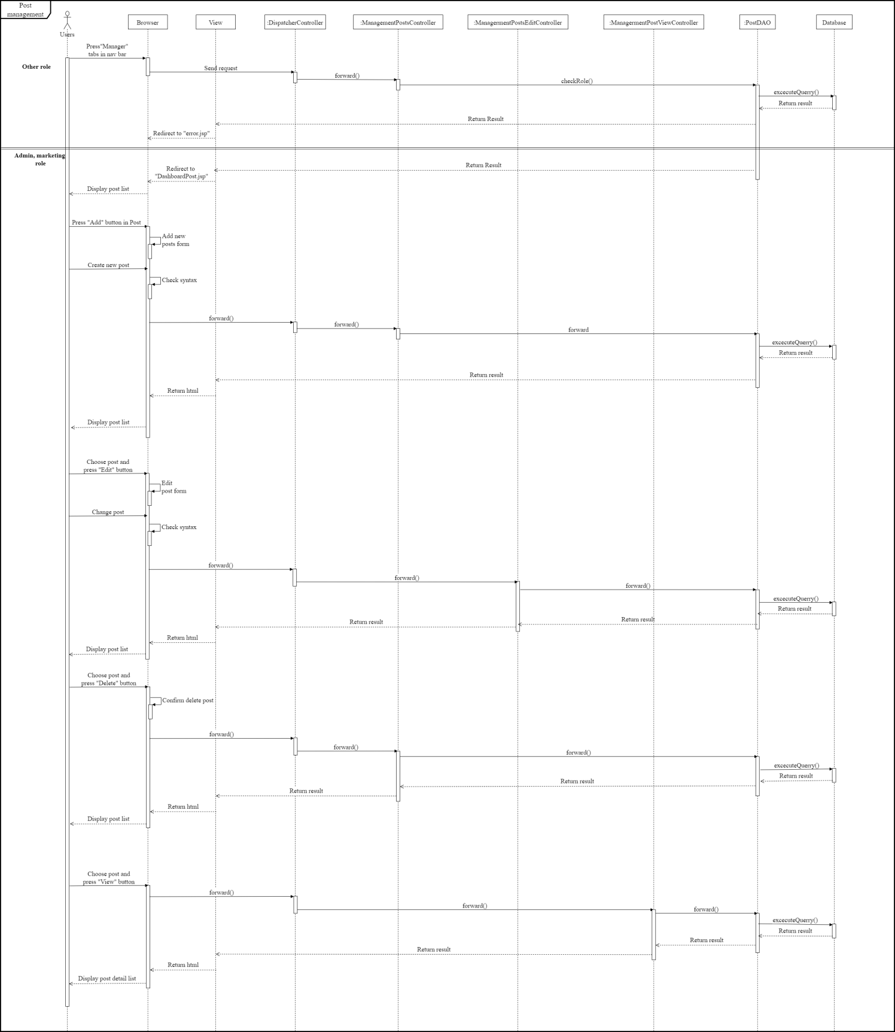

## 6. Post list and detail

### a. Class Diagram

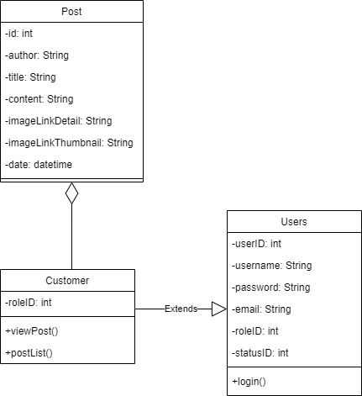

### b. Class Specifications

***UsersClass***

***Class Methods***

|  |  |  |
| --- | --- | --- |
| **No** | **Method** | **Description** |
| *01* | *Login* | *Input correct username and password to login in to web* |

***CustomersClass***

***Class Methods***

|  |  |  |
| --- | --- | --- |
| **No** | **Method** | **Description** |
| *01* | *View Post* | *View detail of one specific post* |
| *02* | *Postlist* | *View list all post* |

### c. Sequence Diagram(s)

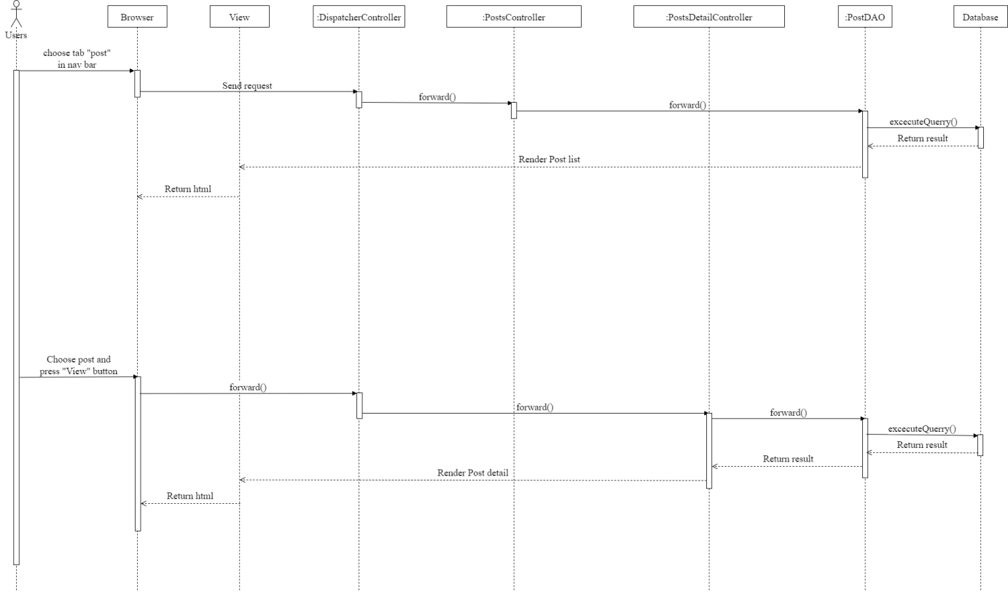

## 7. Logout

### a. Class Diagram

### b. Class Specifications

***LogoutClass***

***Class Methods***

|  |  |  |
| --- | --- | --- |
| **No** | **Method** | **Description** |
| *01* | *Logout* | *Delete user from browser than redirect to homepage* |

### c. Sequence Diagram(s)

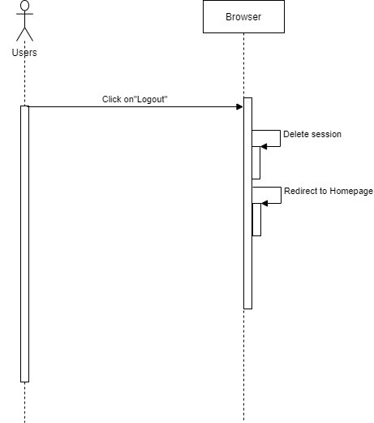

## 8. Product Management

### a. Class Diagram

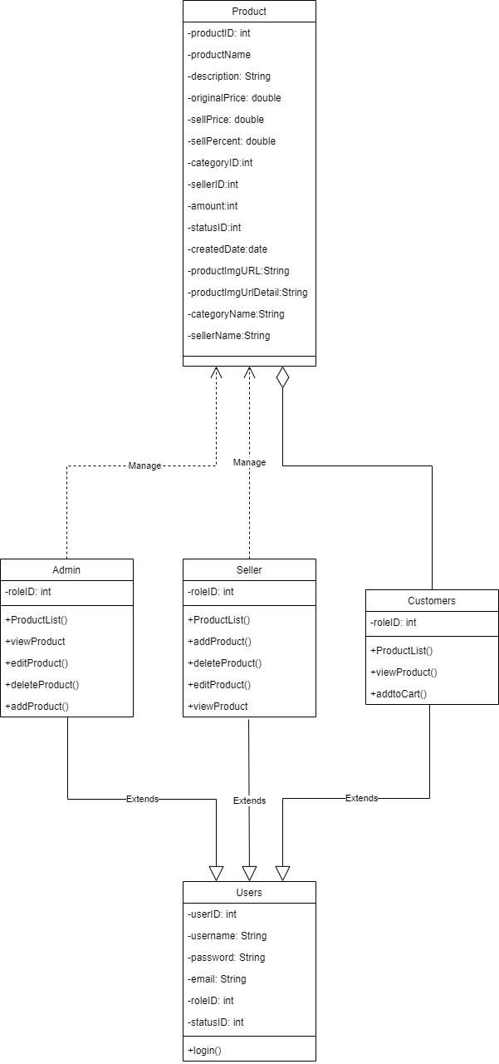

### b. Class Specifications

***UsersClass***

***Class Methods***

|  |  |  |
| --- | --- | --- |
| **No** | **Method** | **Description** |
| *01* | *Login* | *Input correct username and password to login in to web* |

***CustomersClass***

***Class Methods***

|  |  |  |
| --- | --- | --- |
| **No** | **Method** | **Description** |
| *01* | *View Product* | *View detail of one specific product* |
| *02* | *Productlist* | *View list all product* |

***Admin/seller class***

***Class Methods***

|  |  |  |
| --- | --- | --- |
| **No** | **Method** | **Description** |
| *01* | *View Product* | *View detail of one specific product* |
| *02* | *Edit Product* | *Edit detail Product* |
| *03* | *Delete Product* | *Delete product* |
| *04* | *Add Product* | *Add new post product* |
| *05* | *Productlist* | *View list all product* |

### c. Sequence Diagram(s)

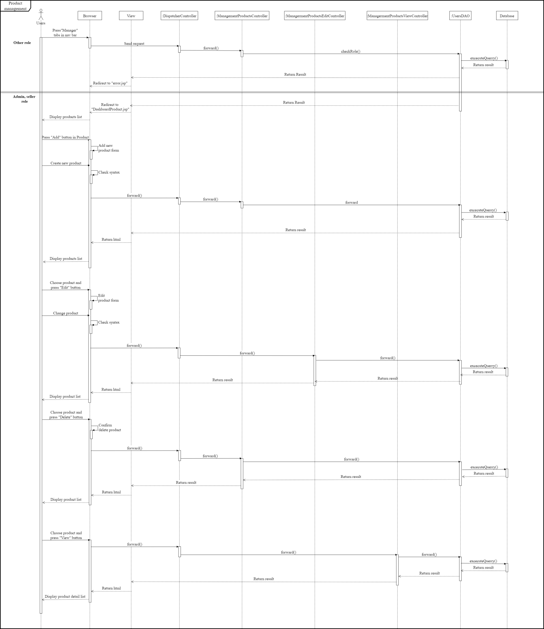

## 9. Product list and detail

### a. Class Diagram

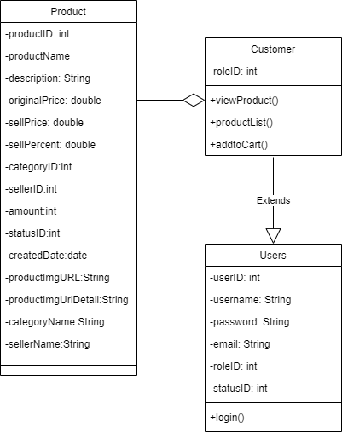

### b. Class Specifications

***CustomersClass***

***Class Methods***

|  |  |  |
| --- | --- | --- |
| **No** | **Method** | **Description** |
| *01* | *Login* | *Input correct username and password to login in to web* |

***CustomersClass***

***Class Methods***

|  |  |  |
| --- | --- | --- |
| **No** | **Method** | **Description** |
| *01* | *View Product* | *View detail of one specific post* |
| *02* | *Productlist* | *View list all post* |
| *02* | *addtoCart* | *Add product to cart* |

### c. Sequence Diagram(s)

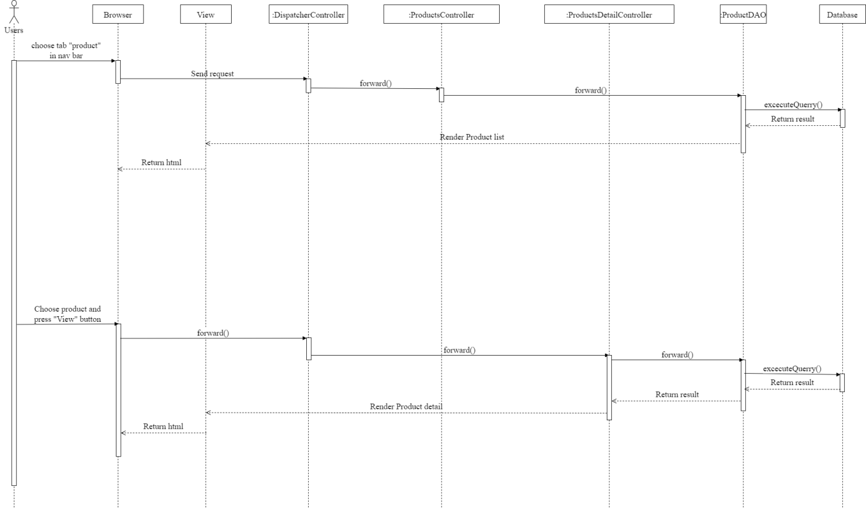

## 10. FAQs Management

### a. Class Diagram

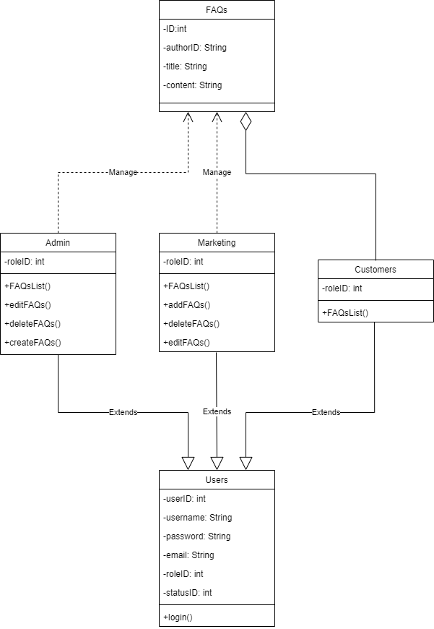

### b. Class Specifications

***UsersClass***

***Class Methods***

|  |  |  |
| --- | --- | --- |
| **No** | **Method** | **Description** |
| *01* | *Login* | *Input correct username and password to login in to web* |

***CustomersClass***

***Class Methods***

|  |  |  |
| --- | --- | --- |
| **No** | **Method** | **Description** |
| *01* | *FAQs list* | *View list FAQs* |

***Admin/marketing class***

***Class Methods***

|  |  |  |
| --- | --- | --- |
| **No** | **Method** | **Description** |
| *01* | *Edit FAQs* | *Edit detail Product* |
| *02* | *Delete FAQs* | *Delete product* |
| *03* | *Add FAQs* | *Add new post product* |
| *04* | *FAQs list* | *View list all product* |

### c. Sequence Diagram(s)

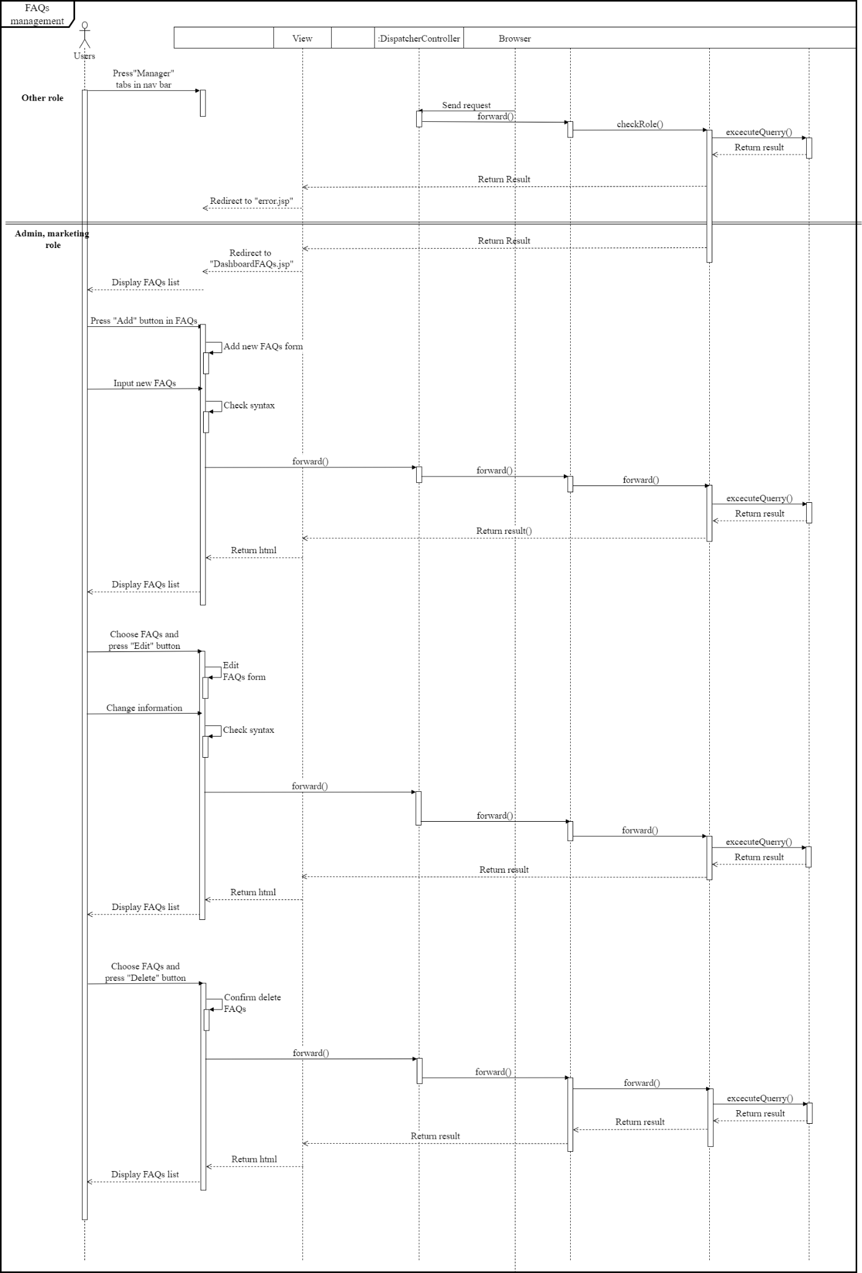

## 11. CMS dashboard

### a. Class Diagram

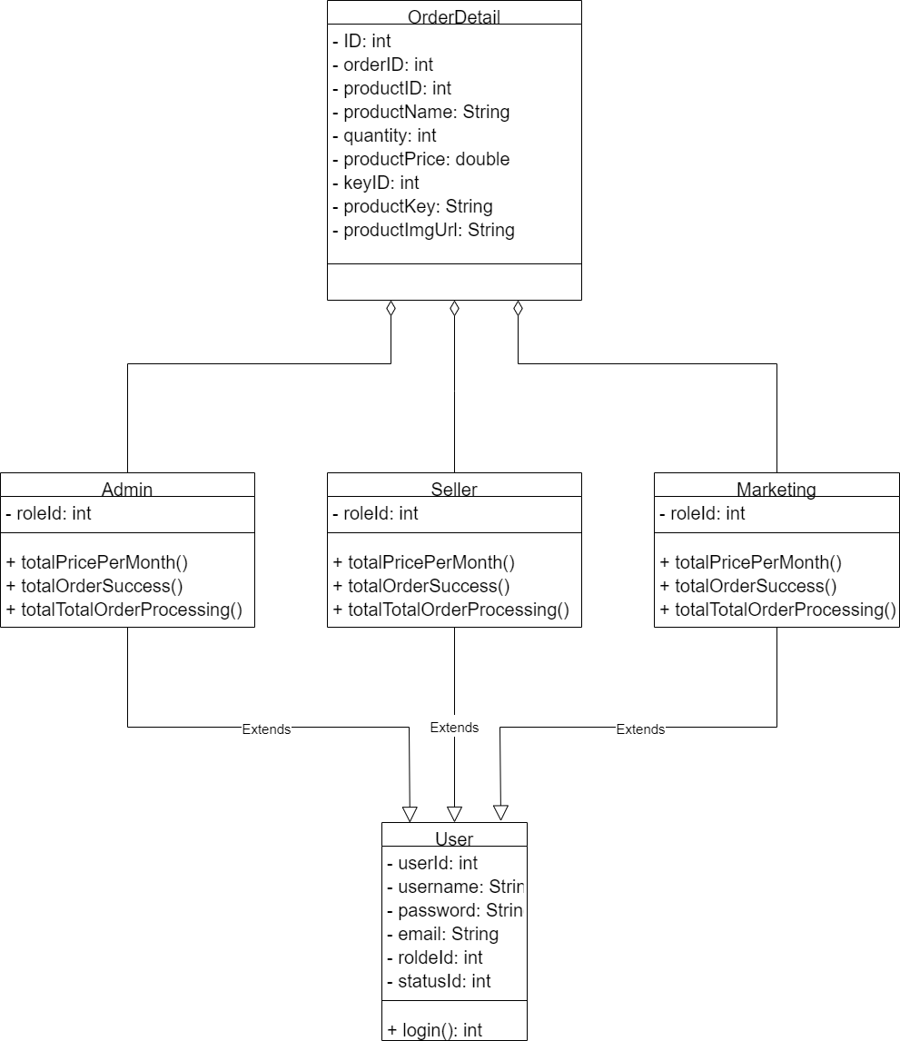

### b. Class Specifications

***UsersClass***

***Class Methods***

|  |  |  |
| --- | --- | --- |
| **No** | **Method** | **Description** |
| *01* | *Login* | *Input the correct username and password to login into web* |

***Admin/Seller/Marketing class***

***Class Methods***

|  |  |  |
| --- | --- | --- |
| **No** | **Method** | **Description** |
| *01* | *totalPricePerMonth()* | *Show the entry list for 12 months* |
| *02* | *totalOrderSuccess()* | *A Total number of successful orders* |
| *03* | *totalTotalOrderProcessing()* | *A Total number of pending orders* |

### c. Sequence Diagram(s)

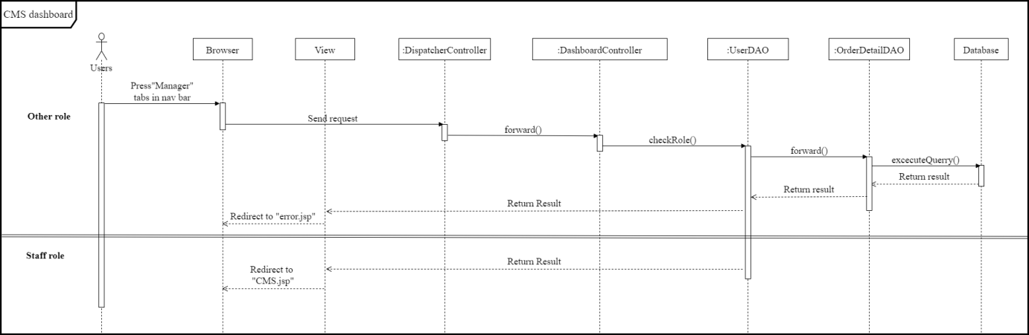

## 12. Cart

### a. Class Diagram

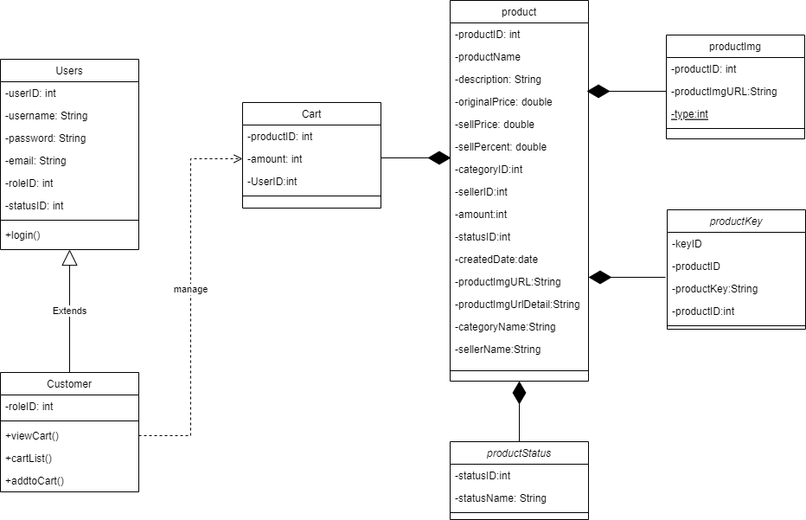

### b. Class Specifications

***UsersClass***

***Class Methods***

|  |  |  |
| --- | --- | --- |
| **No** | **Method** | **Description** |
| *01* | *Login* | *Input correct username and password to login in to web* |

***CustomersClass***

***Class Methods***

|  |  |  |
| --- | --- | --- |
| **No** | **Method** | **Description** |
| *01* | *View Cart* | *View detail of one specific product in cart* |
| *02* | *Cartlist* | *View list all cart customer has choose* |
| *02* | *addtoCart* | *Add product to cart* |

### c. Sequence Diagram(s)

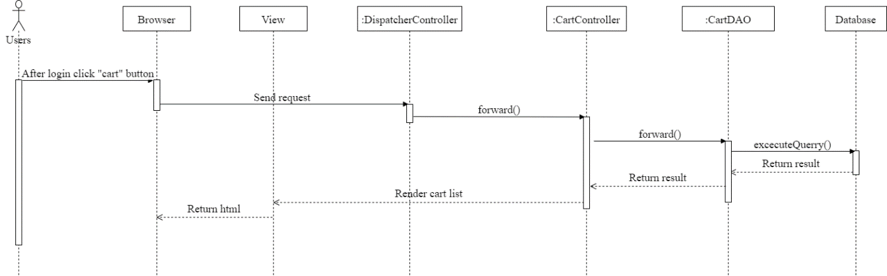

## 13. Add to cart

### a. Class Diagram



### b. Class Specifications

***UsersClass***

***Class Methods***

|  |  |  |
| --- | --- | --- |
| **No** | **Method** | **Description** |
| *01* | *Login* | *Input correct username and password to login in to web* |

***CustomersClass***

***Class Methods***

|  |  |  |
| --- | --- | --- |
| **No** | **Method** | **Description** |
| *01* | *View Cart* | *View detail of one specific product in cart* |
| *02* | *Cartlist* | *View list all cart customer has choose* |
| *02* | *addtoCart* | *Add product to cart* |

### c. Sequence Diagram(s)

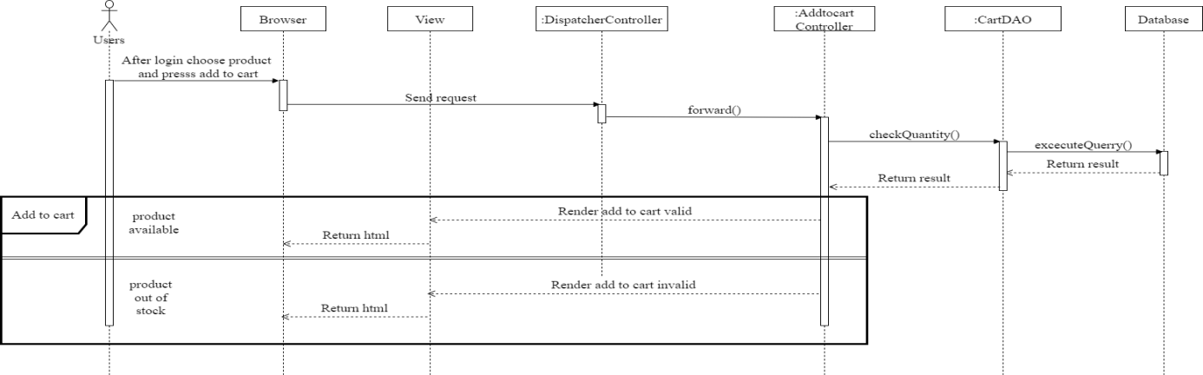

## 14. Review product

### a. Class Diagram

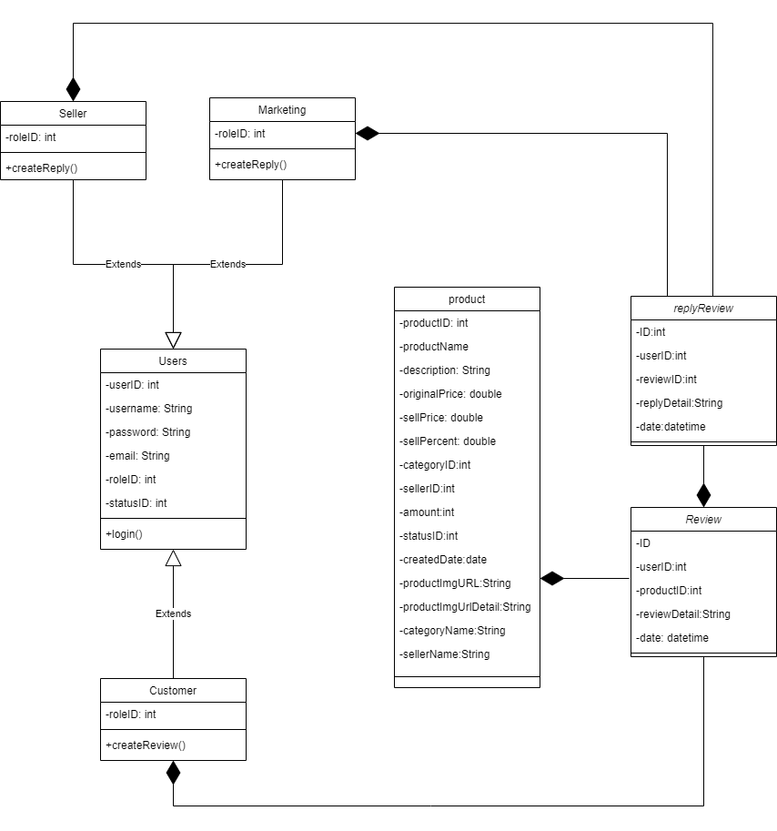

### b. Class Specifications

***UsersClass***

***Class Methods***

|  |  |  |
| --- | --- | --- |
| **No** | **Method** | **Description** |
| *01* | *Login* | *Input correct username and password to login in to web* |

***Seller/marketing class***

***Class Methods***

|  |  |  |
| --- | --- | --- |
| **No** | **Method** | **Description** |
| *01* | *createReview* | *Add new review for product* |

### c. Sequence Diagram(s)

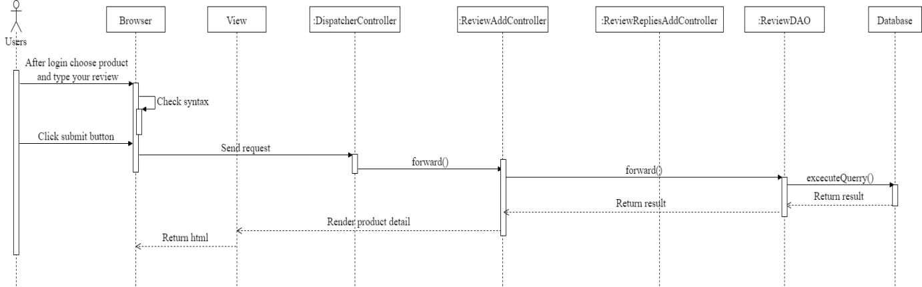

## 15. Reply review product

### a. Class Diagram



### b. Class Specifications

***UsersClass***

***Class Methods***

|  |  |  |
| --- | --- | --- |
| **No** | **Method** | **Description** |
| *01* | *Login* | *Input correct username and password to login in to web* |

***Seller/marketing class***

***Class Methods***

|  |  |  |
| --- | --- | --- |
| **No** | **Method** | **Description** |
| *01* | *createReview* | *Add new review for product* |

### c. Sequence Diagram(s)

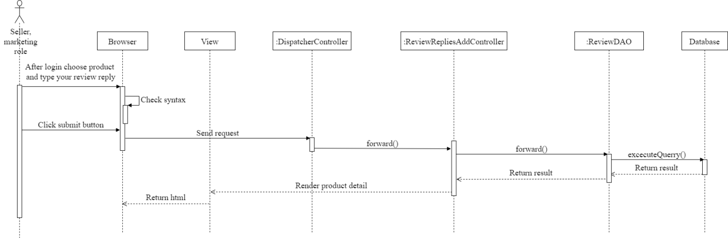

## 16. Category management

### a. Class Diagram

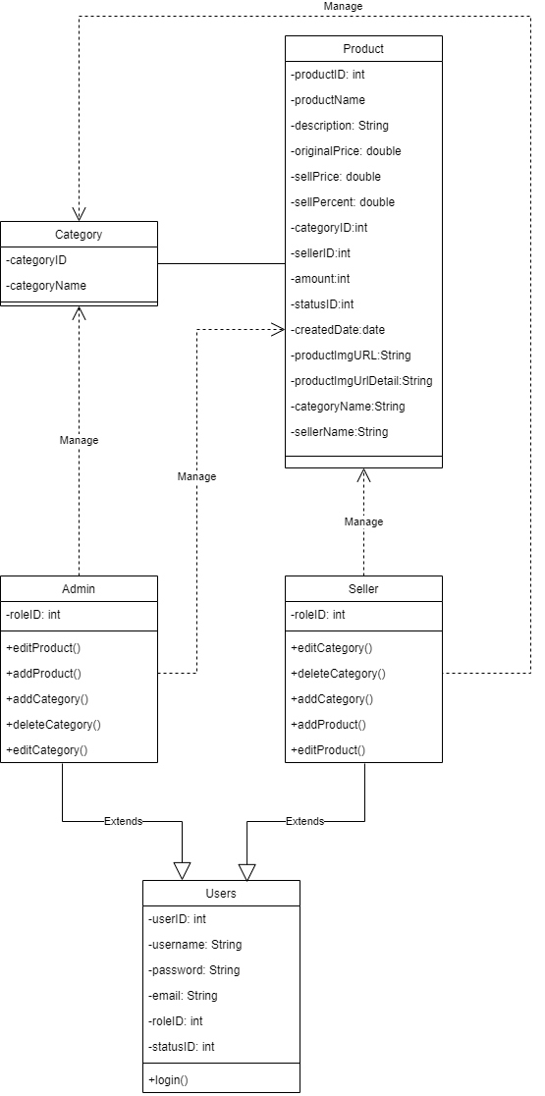

### b. Class Specifications

***UsersClass***

***Class Methods***

|  |  |  |
| --- | --- | --- |
| **No** | **Method** | **Description** |
| *01* | *Login* | *Input correct username and password to login in to web* |

***Seller/admin class***

***Class Methods***

|  |  |  |
| --- | --- | --- |
| **No** | **Method** | **Description** |
| *01* | *editProduct* | *Edit product information* |
| *02* | *addProduct* | *Add new product* |
| *03* | *addCategory* | *Add new category for product* |
| *04* | *editCategory* | *Edit information of category for product* |
| *05* | *deleteCategory* | *Delete category* |

### c. Sequence Diagram(s)

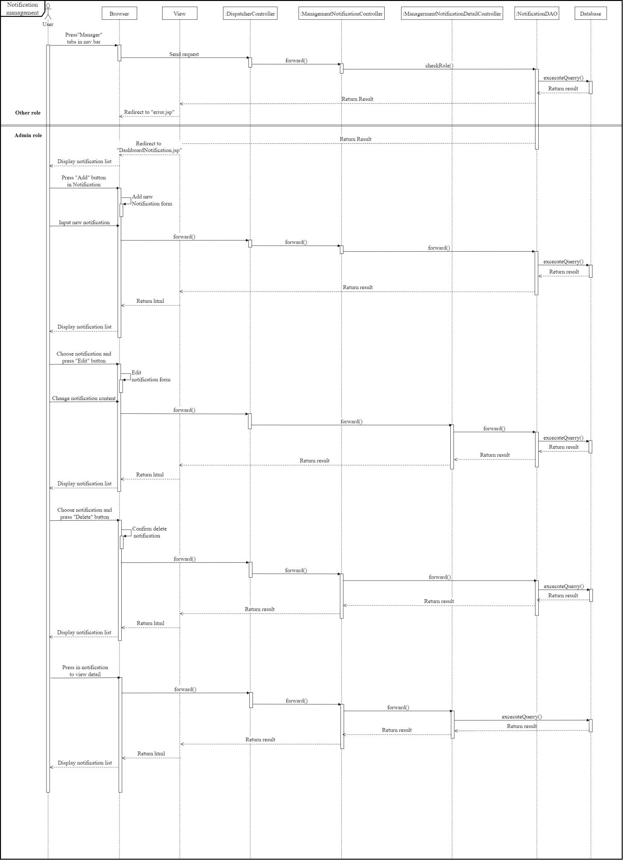

## 17. Notification management

### a. Class Diagram

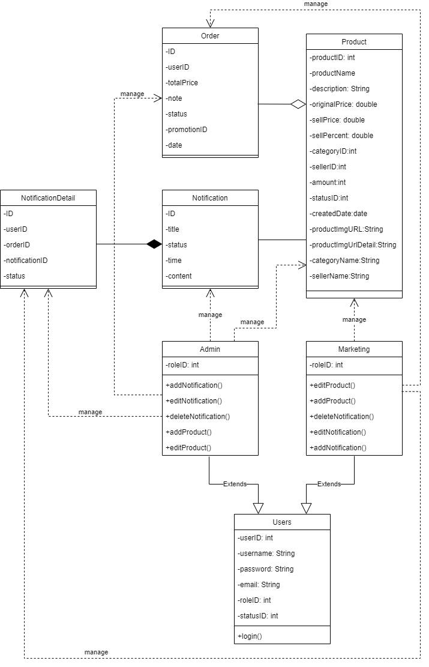

### b. Class Specifications

***UsersClass***

***Class Methods***

|  |  |  |
| --- | --- | --- |
| **No** | **Method** | **Description** |
| *01* | *Login* | *Input correct username and password to login in to web* |

***Marketing/admin class***

***Class Methods***

|  |  |  |
| --- | --- | --- |
| **No** | **Method** | **Description** |
| *01* | *View Notification lists* | *View Notification Management* |
| *02* | *Create Notification* | *Add new Notification for user* |
| *03* | *Detail Notification* | *Detail information of Notification* |
| *04* | *Delete Notification* | *Delete Notification* |

### c. Sequence Diagram(s)

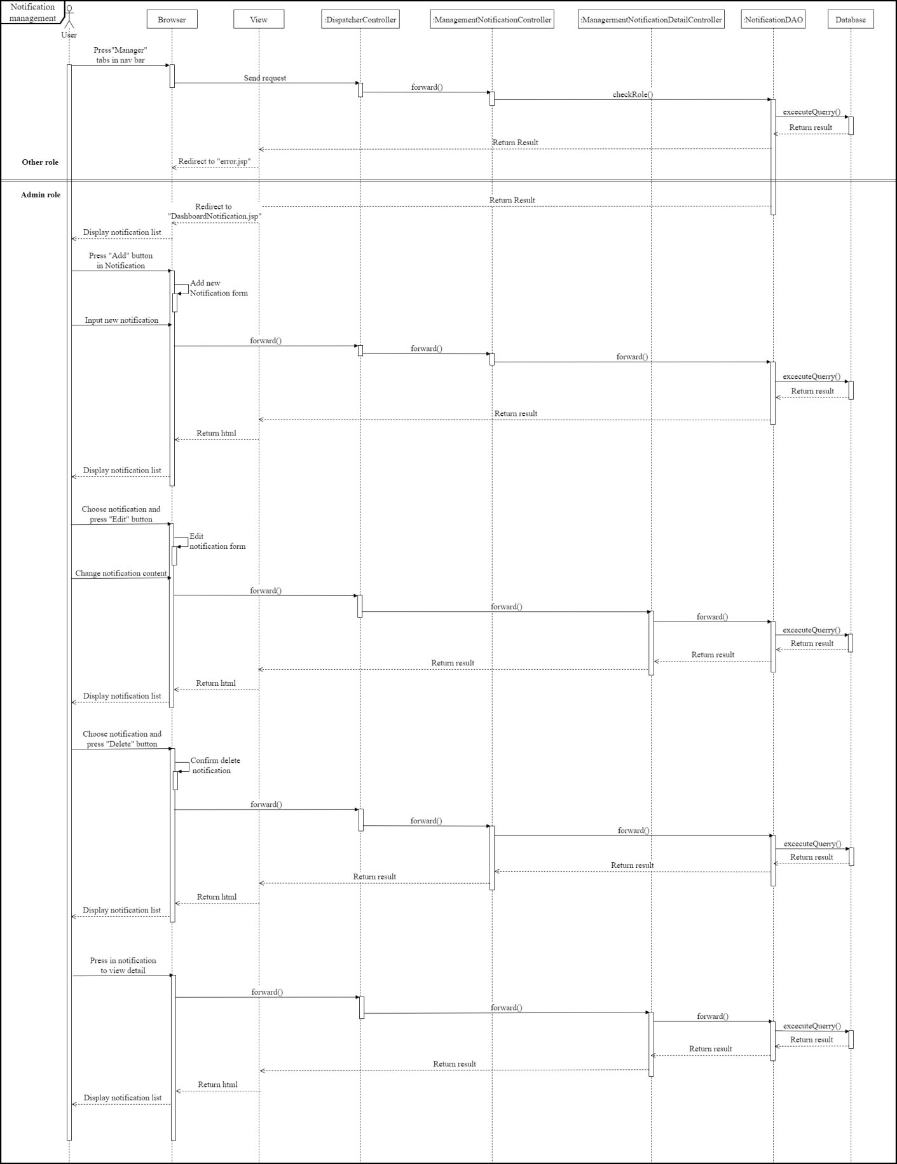

## 18. Notification list and detail

### a. Class Diagram

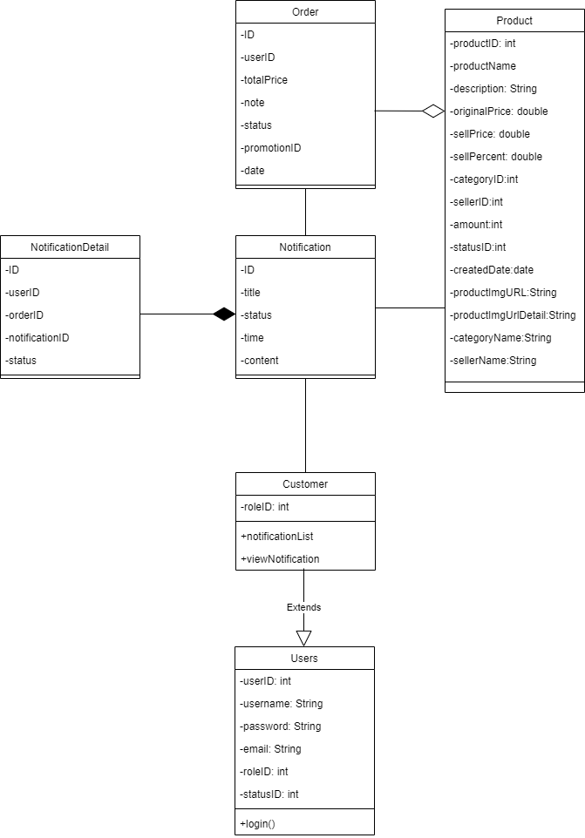

### b. Class Specifications

***UsersClass***

***Class Methods***

|  |  |  |
| --- | --- | --- |
| **No** | **Method** | **Description** |
| *01* | *Login* | *Input correct username and password to login in to web* |

***Marketing/admin class***

***Class Methods***

|  |  |  |
| --- | --- | --- |
| **No** | **Method** | **Description** |
| *01* | *getNotificationByUserId* | *Get Notification of User* |
| *02* | *getNotificationActiveByUserId* | *Get Notification of User is not Read* |
| *03* | *getNotificationById* | *Get Notification Detail Information* |
| *04* | *updateNotificationDetailStatus* | *Change status of Notification to Read* |

### c. Sequence Diagram(s)

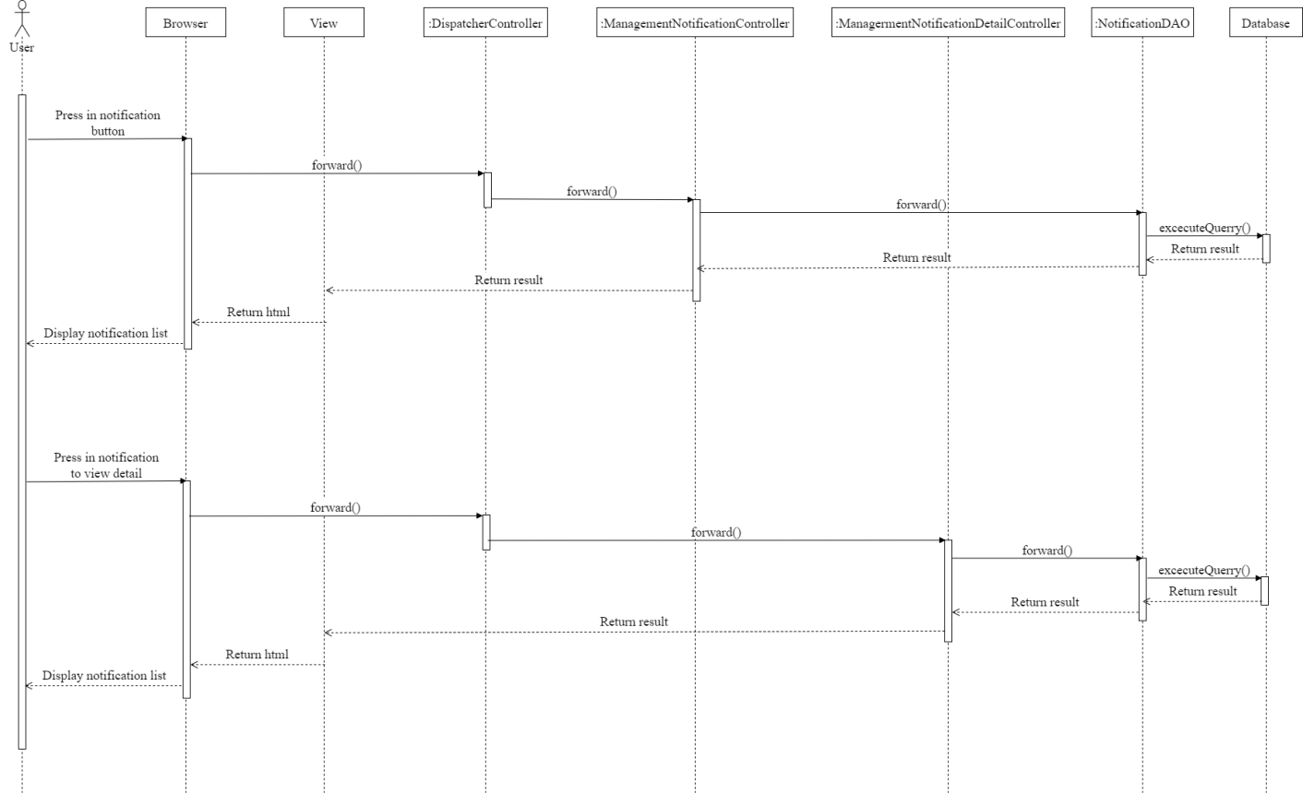

## 19. Change Password

### a. Class Diagram

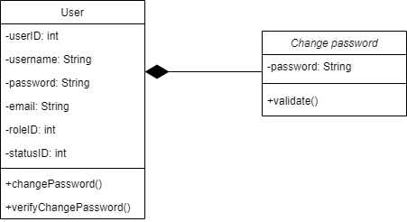

### b. Class Specifications

***UsersClass***

***Class Methods***

|  |  |  |
| --- | --- | --- |
| **No** | **Method** | **Description** |
| *01* | *changePassword* | *Input old password and, new password twice and submit* |
| *02* | *verifyChangePassword* | *Check condition of old password and new password* |

***ChangePasswordClass***

|  |  |  |
| --- | --- | --- |
| **No** | **Method** | **Description** |
| *01* | *Validate* | *Check user input old,new password correct syntax* |

### c. Sequence Diagram(s)

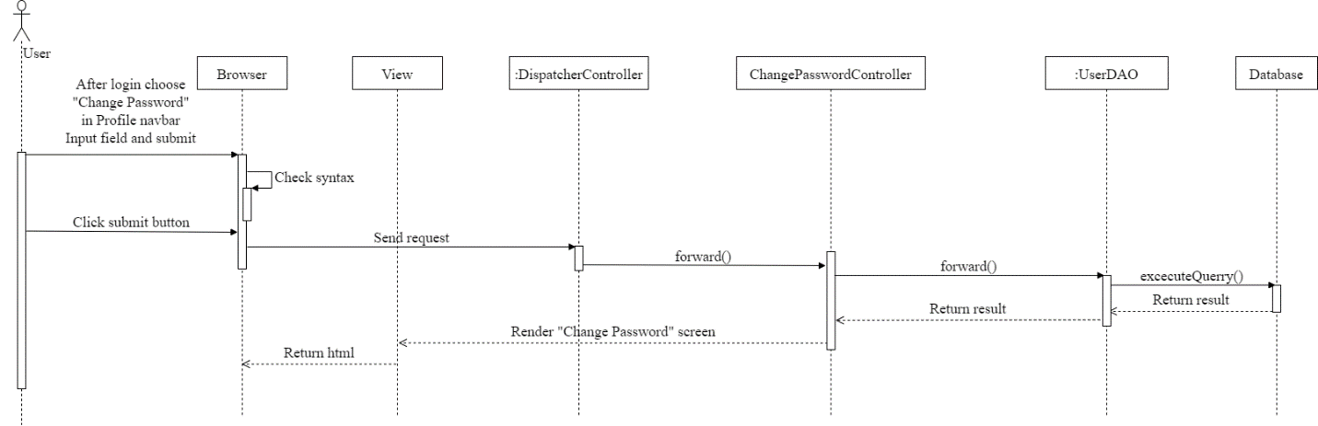

## 20. Edit Profile

### a. Class Diagram

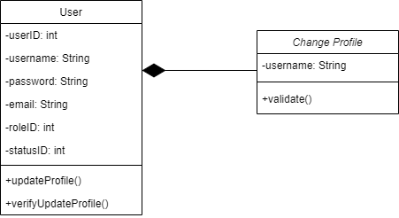

### b. Class Specifications

***UsersClass***

***Class Methods***

|  |  |  |
| --- | --- | --- |
| **No** | **Method** | **Description** |
| *01* | *updateProfile* | *Input new username and submit* |
| *02* | *verifyUpdateProfile* | *Check condition of new username* |

***EditProfileClass***

|  |  |  |
| --- | --- | --- |
| **No** | **Method** | **Description** |
| *01* | *Validate* | *Check user input new username correct syntax* |

### c. Sequence Diagram(s)

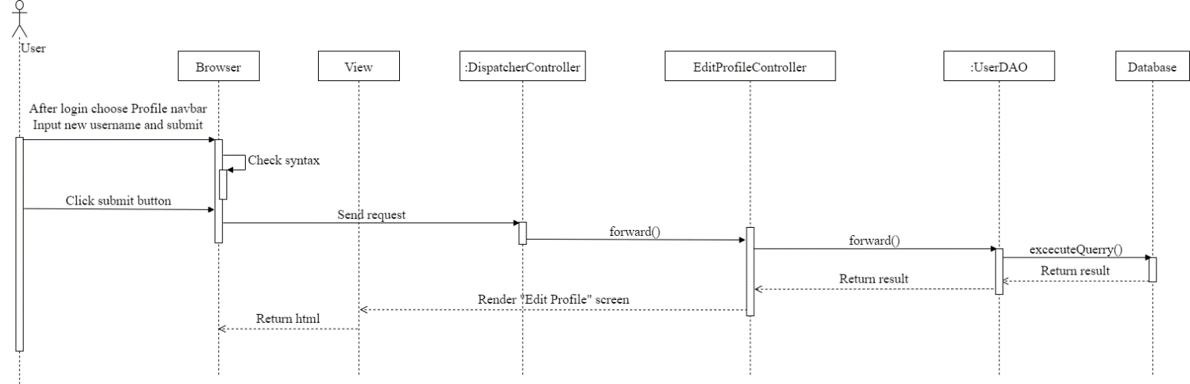

## 21. Reset Password

### a. Class Diagram

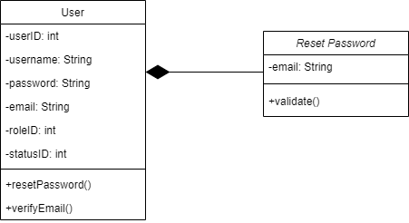

### b. Class Specifications

***UsersClass***

***Class Methods***

|  |  |  |
| --- | --- | --- |
| **No** | **Method** | **Description** |
| *01* | *resetPassword* | *Input email and submit to get reset password link* |
| *02* | *verifyEmail* | *Check condition of email* |

***ResetPasswordClass***

|  |  |  |
| --- | --- | --- |
| **No** | **Method** | **Description** |
| *01* | *Validate* | *Check user input email correct syntax* |

### c. Sequence Diagram(s)

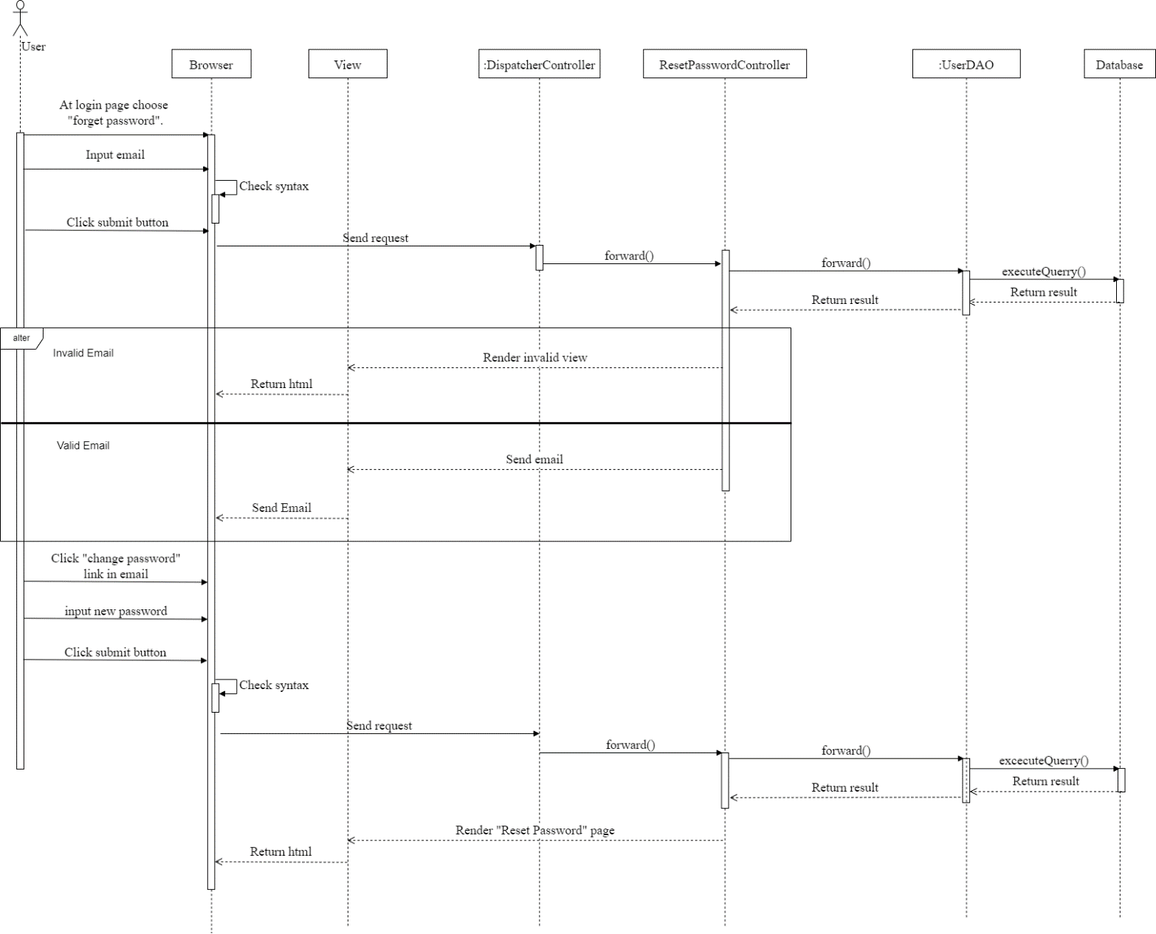

## 22. Promotion code management

### a. Class Diagram

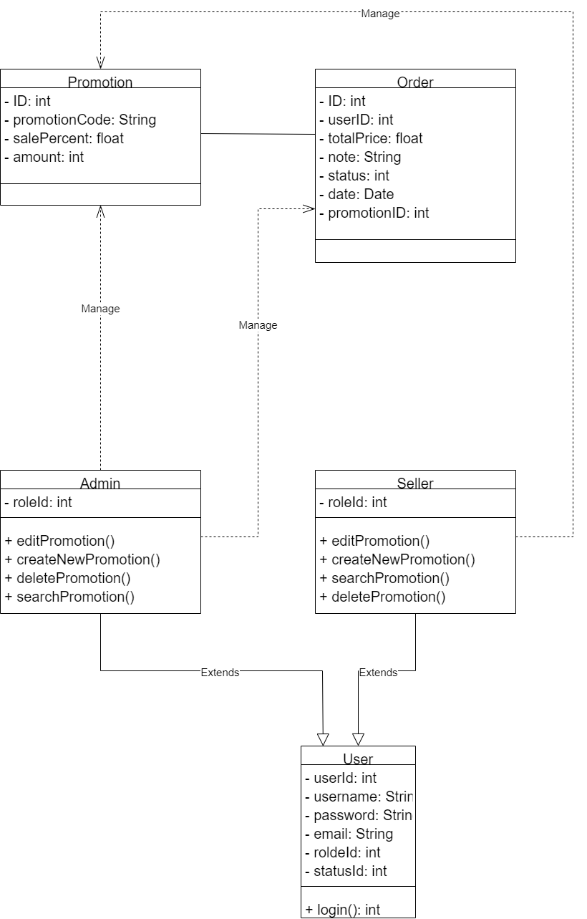

### b. Class Specifications

***UsersClass***

***Class Methods***

|  |  |  |
| --- | --- | --- |
| **No** | **Method** | **Description** |
| *01* | *Login* | *Input correct username and password to login in to web* |

***Seller/admin class***

***Class Methods***

|  |  |  |
| --- | --- | --- |
| **No** | **Method** | **Description** |
| *01* | *editPromotion* | *Edit promotion information* |
| *02* | *createNewProduct* | *Add new promotion* |
| *03* | *searchPromotion* | *Search promotion by promotion code, id* |
| *04* | *deletePromotion* | *Delete promotion* |

### c. Sequence Diagram(s)

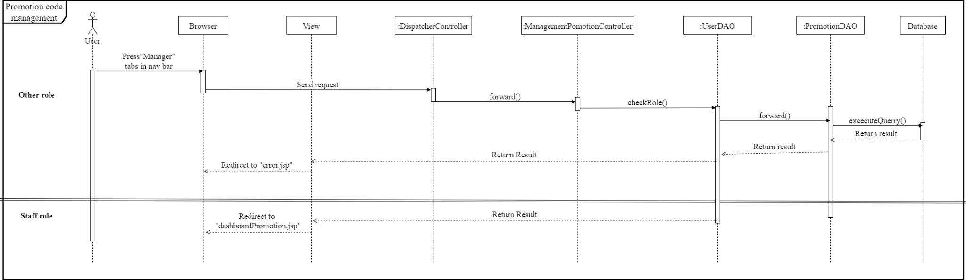

## 23. Cart Completion(Checkout)

### a. Class Diagram

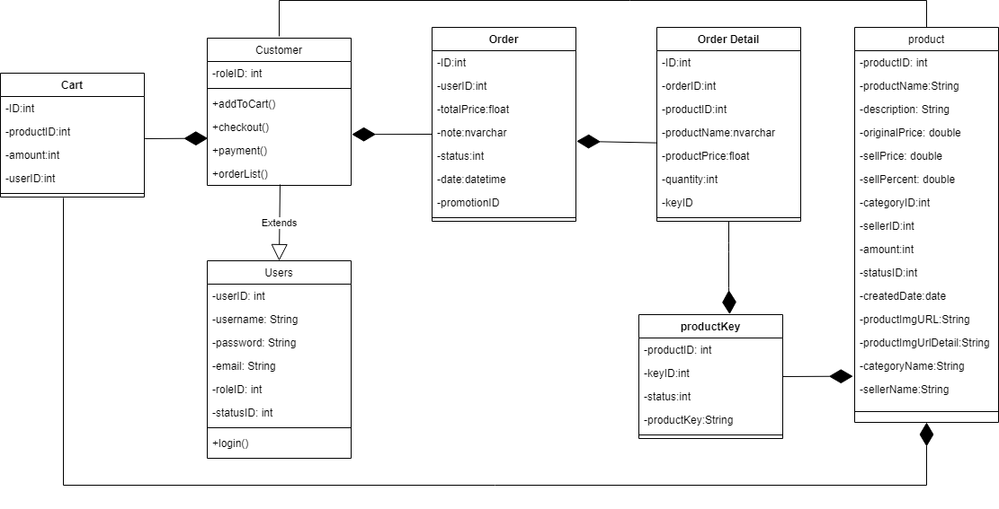

### b. Class Specifications

***UsersClass***

***Class Methods***

|  |  |  |
| --- | --- | --- |
| **No** | **Method** | **Description** |
| *01* | *Login* | *Input correct username and password to login in to web* |

***Customer class***

***Class Methods***

|  |  |  |
| --- | --- | --- |
| **No** | **Method** | **Description** |
| *01* | *addToCart* | *Add products to cart* |
| *02* | *checkOut* | *Check out cart* |
| *03* | *payMent* | *User pay for our order* |
| *04* | *orderList* | *Show list after order* |

### c. Sequence Diagram(s)

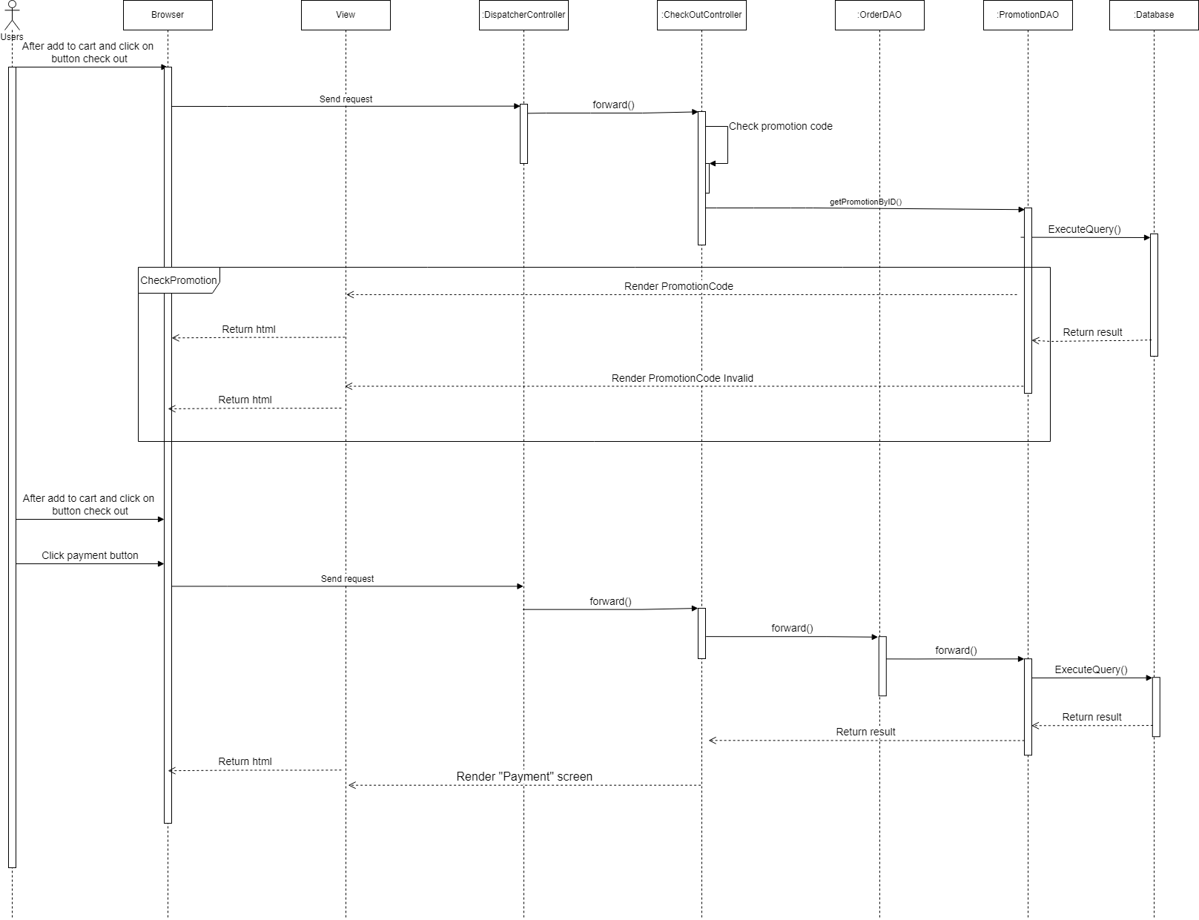

## 24. Payment

### a. Class Diagram



### b. Class Specifications

***UsersClass***

***Class Methods***

|  |  |  |
| --- | --- | --- |
| **No** | **Method** | **Description** |
| *01* | *Login* | *Input correct username and password to login in to web* |

***Customer class***

***Class Methods***

|  |  |  |
| --- | --- | --- |
| **No** | **Method** | **Description** |
| *01* | *addToCart* | *Add products to cart* |
| *02* | *checkOut* | *Check out cart* |
| *03* | *payMent* | *User pay for our order* |
| *04* | *orderList* | *Show list after order* |

### c. Sequence Diagram(s)



## 25. Order Management

### a. Class Diagram

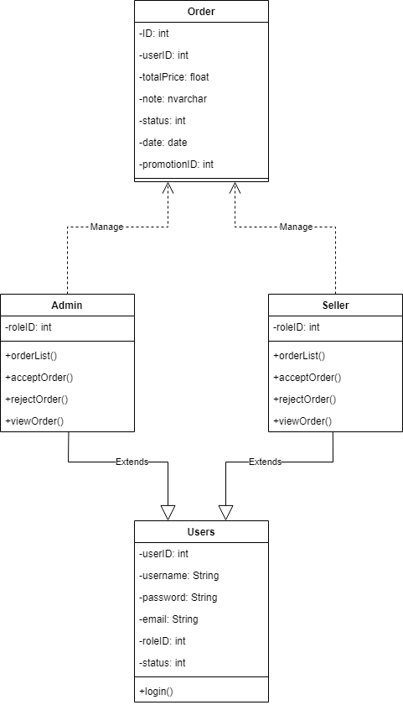

### b. Class Specifications

***UsersClass***

***Class Methods***

|  |  |  |
| --- | --- | --- |
| **No** | **Method** | **Description** |
| *01* | *Login* | *Input correct username and password to login in to web* |

***Admin, Seller class***

***Class Methods***

|  |  |  |
| --- | --- | --- |
| **No** | **Method** | **Description** |
| *01* | *acceptOrder()* | *Accepted user order* |
| *02* | *rejectOrder()* | *Reject user order* |
| *03* | *viewOrder* | *Author view order detail of user* |
| *04* | *orderList* | *Show orders of users* |

### c. Sequence Diagram(s)

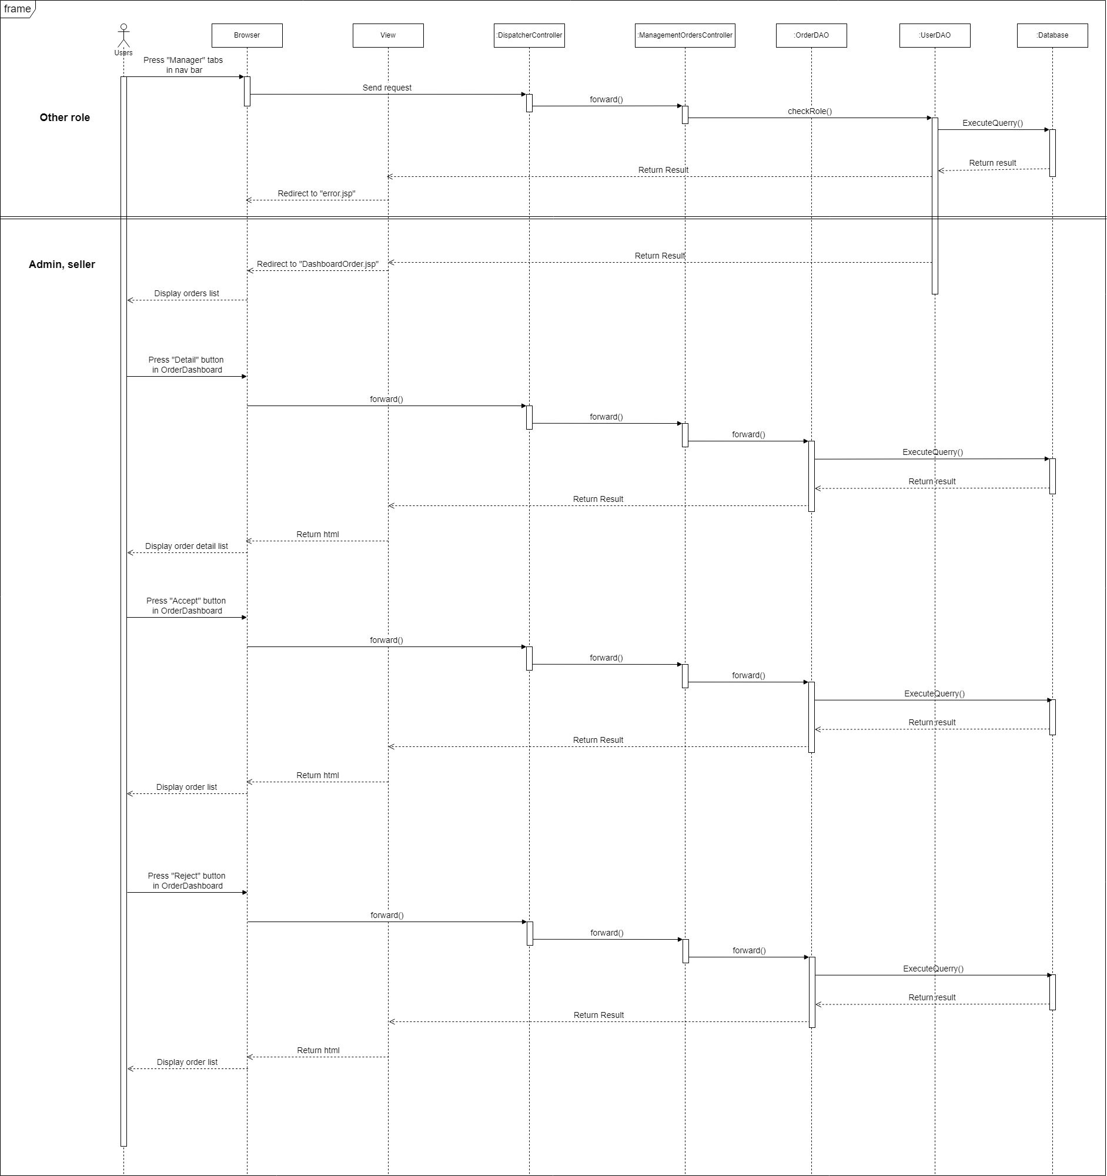

## 26. User subscribe

### a. Class Diagram

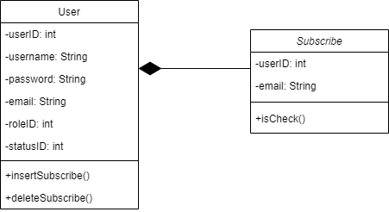

### b. Class Specifications

***User***

**Class Methods**

|  |  |  |
| --- | --- | --- |
| **No** | **Method** | **Description** |
| *01* | *deleteSubscribe()* | *Delete user subscribe email from subscribe database* |
| *02* | *insertSubscibe()* | *Insert new user subscribe email to subscribe database* |

***SubscribeClass***

**Class Methods**

|  |  |  |
| --- | --- | --- |
| **No** | **Method** | **Description** |
| *01* | *isCheck()* | *Check user tick on Subscribe checkbox* |

### c. Sequence Diagram(s)

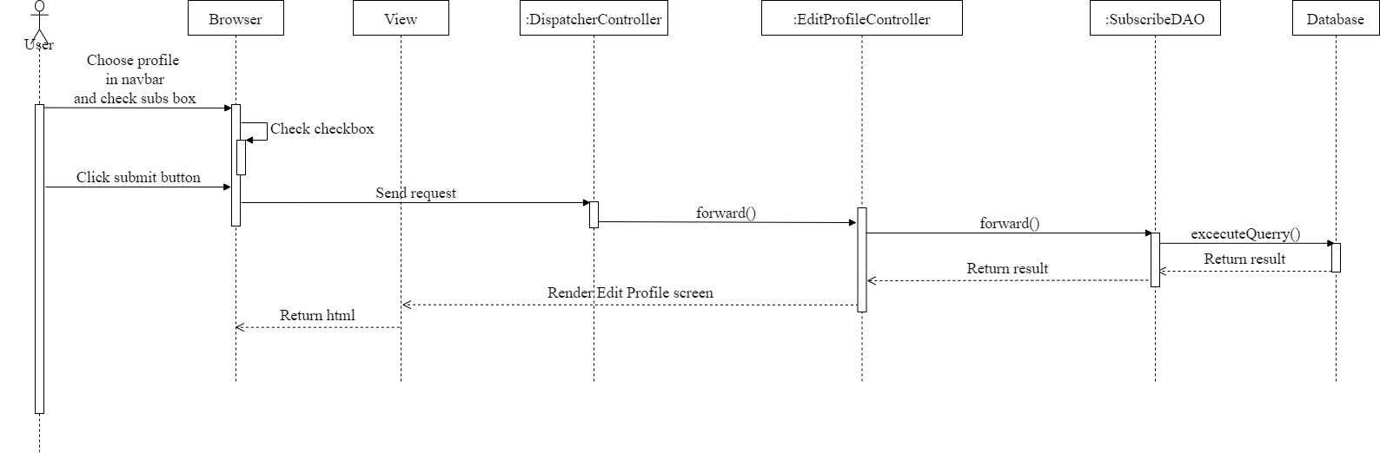

## 27. Email Management

### a. Class Diagram

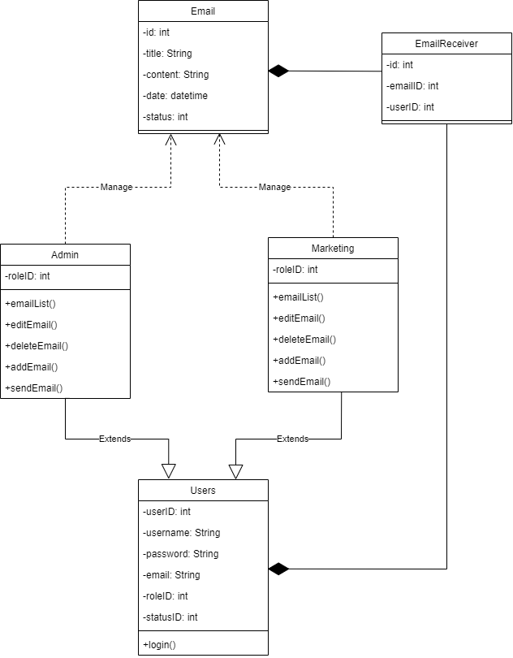

### b. Class Specifications

***Admin class/ marketing class***

***Class Methods***

|  |  |  |
| --- | --- | --- |
| **No** | **Method** | **Description** |
| *01* | *Send Email* | *Send Email to list of type user with emailID and UserID in emailReceiver* |
| *02* | *Edit Email* | *Edit detail Email, title,content* |
| *03* | *Delete Email* | *Delete email* |
| *04* | *Add Email* | *Add new email* |
| *05* | *EmailList* | *View list all email* |

### c. Sequence Diagram(s)

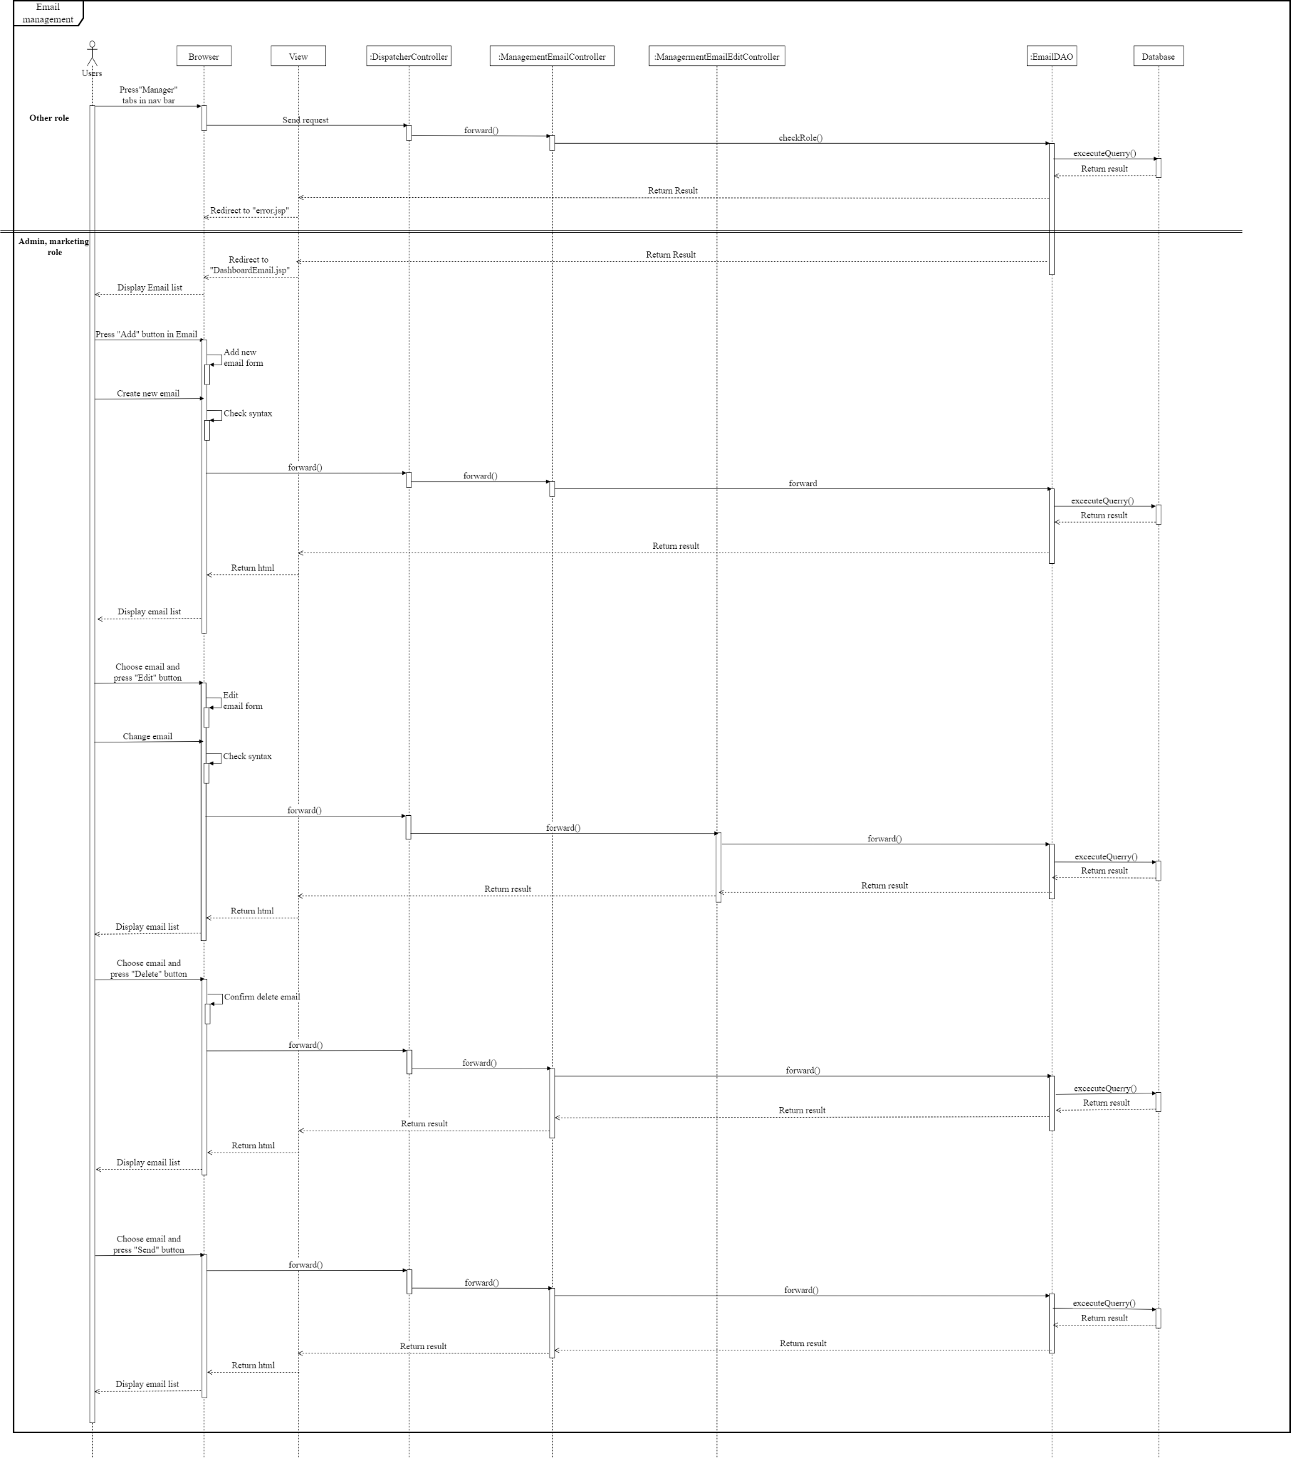

## 28. Order history and order detail

### a. Class Diagram

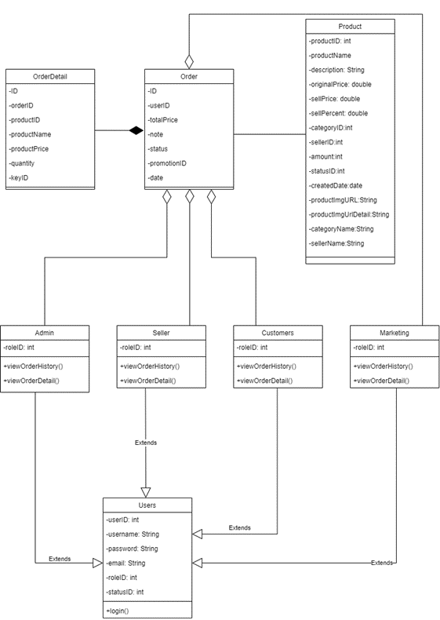

### b. Class Specifications

***UsersClass***

***Class Methods***

|  |  |  |
| --- | --- | --- |
| **No** | **Method** | **Description** |
| *01* | *Login* | *Input correct username and password to login in to web* |

***Admin Seller Customers Marketing class***

***Class Methods***

|  |  |  |
| --- | --- | --- |
| **No** | **Method** | **Description** |
| *01* | *View order history* | *View all order history* |
| *02* | *View order detail* | *View detail of order* |

### c. Sequence Diagram(s)

