**📝 PRACTICAL EXAM – ANDROID DEVELOPMENT WITH MVVM & UI DESIGN**

**⏳ Duration: 90 minutes**

**🔢 Total points: 10**

**🏠 Question 1 (5 points) – Build the Home Screen**

Develop a Home screen that displays a list of products from the mock API:  
🔗 https://fakestoreapi.com/products

**Requirements:**

* Create a Product model with fields: id, title, price, image.
* Implement Repository, ViewModel, Adapter, and Fragment based on the **MVVM architecture**.
* Display the product list using **RecyclerView**, with product images shown using Glide or Coil.
* When a product is tapped, navigate to the Detail screen.

**UI Requirements:**

* Display image, name, and price of each product.
* Show a **ProgressBar** while loading data.
* Handle errors (e.g., show a Toast if API call fails).

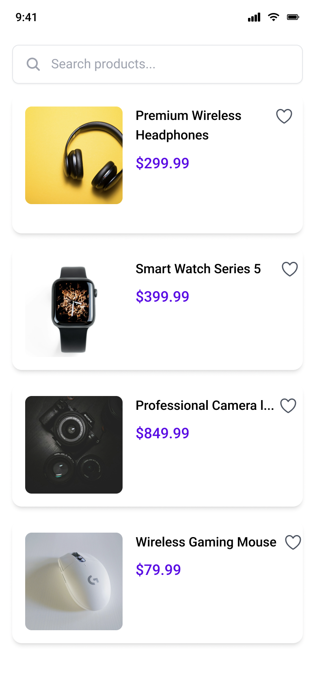

📷 **Take a screenshot of the Home screen**

**📄 Question 2 (3 points) – Build the Detail Screen**

Create a Detail screen to show full product information when a user selects an item from the Home screen.

**Requirements:**

* Pass data from Home → Detail using Intent or Navigation Component (SafeArgs).
* Display UI as the image below, if any field has information you have to display it on UI, otherwise you can hardcode
* Design a clean layout using **ConstraintLayout** or **Jetpack Compose**.

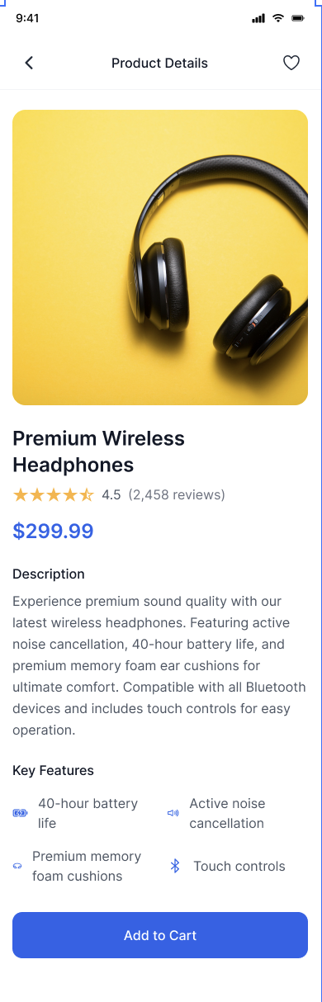

📷 **Take a screenshot of the Detail screen**

**❤️ Question 3 (1 point) – Add "Favorite" Feature**

* Add a heart icon ("❤️") to each product item in the Home screen.
* When the icon is tapped:
  + Toggle the product's isFavorite status.
  + Change the icon's appearance accordingly (e.g., red heart for favorite).
* The list should update the favorite state instantly.

📷 **Take a screenshot showing a product marked as favorite**

**🔍 Question 4 (1 point) – Add Search/Filter Feature**

* Add an **EditText** (Search bar) at the top of the Home screen.
* Filter the product list in real-time based on the title as the user types.

📷 **Take a screenshot showing search in action**

**📋 Grading Yourself:**

| **Question** | **Points** |
| --- | --- |
| Q1 | 0 |
| Q2 | 0 |
| Q3 | 0 |
| Q4 | 0 |
| **Total** | **0** |

**📁 Submission Instructions:**

* Submit your source code in a folder named: YourName as zip file
* Attach screenshots as required.
* Upload to the Assignment thread on EduNext (or your platform).